Model Training and Evaluation

1. Overview
This section documents the model-training component (M3) of the pension contribution default prediction pipeline. Four models were trained and evaluated under a shared five-fold stratified cross-validation protocol: a logistic regression baseline, a random forest baseline, a bidirectional LSTM operating on raw 48-month payment sequences, and TabNet trained in two variants, with one on the real training folds only, and one on augmented folds produced by M2. The augmentation ablation was included by design to isolate the contribution of the augmentation strategy.
All four models used identical fold indices, cached to artifacts/fold_indices.npz, ensuring that cross-model comparisons reflect genuine differences in modelling capability rather than variation in the validation splits.

2. Methodology

2.1 Cross-validation protocol
Stratified five-fold cross-validation (sklearn.model_selection.StratifiedKFold, random_state=42, shuffle enabled) was applied to the 1,000-employer dataset, producing five folds of 800 training and 200 validation samples each. Stratification preserved the positive class rate (25.3%) across all ten training/validation splits, with per-fold positive rates ranging from 25.3% to 25.5% on the training partition and 25.0% to 25.5% on validation. Fold indices were generated once and reused across every model to guarantee direct comparability of results.

2.2 Preprocessing
The engineered feature set delivered by M1 contained nine numeric features and a categorical EMPLOYER ID. The ID column was dropped prior to training. Feature scales spanned six orders of magnitude (TOTAL_ARREARS reached ~10⁶; AVG_CONTRIBUTION_RATIO lay in [0,1]), which required a per-fold standardisation for the neural models: means and standard deviations were computed on the training partition of each fold and applied to the corresponding validation partition, ensuring no information leakage from validation into training.
For the LSTM, a zero-variance feature was detected in the sequence tensor (feature index 5 was constant across all 1,000 × 48 time steps) and dropped automatically prior to standardisation. A corresponding constant feature (MAX_CONSECUTIVE_MISSED) was identified in the tabular feature set.

2.3 Augmentation
For the augmented TabNet variant, M2's augment_training_fold function was invoked on each standardised training partition, applying SMOTE minority-class oversampling followed by additive Gaussian noise (σ = 0.05) on the continuous features. Validation partitions were never augmented. For the LSTM, SMOTE alone was applied to the flattened sequences and reshaped back to (n, 48, F) form; noise was omitted for the sequence path.

2.4 Model configurations

2.4.1 Logistic regression
Scikit-learn LogisticRegression with L2 regularisation, max_iter=2000, class_weight="balanced", wrapped in a Pipeline with StandardScaler. No augmentation.

2.4.2 Random forest
Scikit-learn RandomForestClassifier with 400 estimators, min_samples_leaf=2, unlimited depth, class_weight="balanced". No augmentation; tree-based models are scale-invariant so no standardisation was applied.

2.4.3 LSTM
A two-layer bidirectional LSTM (hidden size 128, dropout 0.3) with mean-pooling over the temporal dimension, followed by a two-layer feed-forward classification head (LayerNorm → Linear → ReLU → Linear). Trained with AdamW (lr = 1e-3, weight_decay = 1e-4), cosine annealing schedule, class-weighted cross-entropy loss, mixed-precision training (torch.amp), gradient clipping at 1.0, and early stopping on validation AUC (patience = 6, max 40 epochs).

2.4.4 TabNet
pytorch-tabnet implementation with n_d = n_a = 16, n_steps = 4, gamma = 1.5, lambda_sparse = 1e-4, entmax masking, Adam optimiser (lr = 2e-2), StepLR schedule (γ = 0.9 every 20 epochs). Batch size 1,024; virtual batch size 128. Early stopping on validation AUC with patience 20 and a maximum of 200 epochs. Trained twice per experiment: once on M2's augmented folds, once on the unmodified real folds.

2.5 Evaluation metrics
For each fold and each model, four metrics were recorded: ROC AUC (the primary ranking metric), F1 score, recall, and precision (all computed at the default 0.5 probability threshold). Fold-level metrics were aggregated as mean ± standard deviation. Out-of-fold predictions were retained for ROC and confusion-matrix visualisation.

3. Results

3.1 Overall comparison
Table 1 summarises five-fold cross-validated performance for the four models (five configurations, counting both TabNet variants).
Model | AUC | F1 | Recall | Precision
Logistic regression | 0.991 ± 0.005 | 0.909 ± 0.043 | 0.881 ± 0.063 | 0.940 ± 0.022
Random forest | 0.999 ± 0.002 | 0.982 ± 0.013 | 0.996 ± 0.008 | 0.969 ± 0.020
LSTM (sequences) | 0.856 ± 0.044 | 0.604 ± 0.077 | 0.825 ± 0.119 | 0.492 ± 0.099
TabNet (augmented) | 0.998 ± 0.001 | 0.792 ± 0.106 | 1.000 ± 0.000 | 0.668 ± 0.144
TabNet (real-only) | 0.998 ± 0.002 | 0.969 ± 0.022 | 0.980 ± 0.012 | 0.959 ± 0.037
Table 1. Cross-validated performance of all model configurations, mean ± standard deviation across five folds.

3.2 Model-by-model observations
Random forest achieved the strongest performance on every metric: AUC 0.999 ± 0.002, F1 0.982, precision 0.969, recall 0.996, with negligible fold-to-fold variance. This is consistent with the well-known effectiveness of tree ensembles on structured tabular data, particularly when the engineered features already encode strong linear and near-linear relationships to the target.
Logistic regression achieved AUC 0.991 ± 0.005 which was unusual for a linear model, indicating that M1's engineered features were highly linearly separable with respect to the default label. Precision (0.940) was strong and recall (0.881) was the lowest of the tabular models, suggesting the linear decision boundary is slightly conservative.
TabNet (real-only) matched the random forest on AUC (0.998 ± 0.002) and closely tracked it on F1 (0.969) and precision (0.959). This confirms TabNet's effectiveness on structured features but does not, on this dataset, demonstrate an advantage over random forest.
TabNet (augmented) produced an identical AUC (0.998 ± 0.001) but a substantially degraded F1 (0.792 ± 0.106) and precision (0.668 ± 0.144), while achieving perfect recall (1.000 ± 0.000) on every fold. This pattern had a perfect recall with variable, lower precision that indicated that augmentation shifted the model's decision surface toward aggressive positive prediction.
LSTM achieved AUC 0.856 ± 0.044, which was below the tabular models and with the largest fold-to-fold variance of any configuration. The LSTM operated on raw 48-month payment sequences without access to M1's engineered aggregates and had to learn temporal summarisations directly from 800 training samples per fold with a demanding low-data regime for a bidirectional recurrent architecture. The ~0.14 AUC gap between the LSTM and random forest can therefore be interpreted as a lower bound on the value contributed by M1's feature-engineering stage: the aggregations encode domain knowledge (e.g., trend, coefficient of variation, tenure) that the sequence model cannot easily reconstruct from raw payment data at this sample size.

4. Augmentation Ablation
Comparing the two TabNet variants — identical architecture, identical folds, identical hyperparameters, differing only in whether the training partition was augmented — isolates the contribution of M2's augmentation pipeline:
AUC: 0.998 ± 0.002 (real-only) vs 0.998 ± 0.001 (augmented). Statistical tie; the difference is smaller than the fold-to-fold standard deviation.
F1: 0.969 ± 0.022 (real-only) vs 0.792 ± 0.106 (augmented). Substantial and consistent degradation, with fold-to-fold variance approximately 5× higher under augmentation.
Precision: 0.959 ± 0.037 (real-only) vs 0.668 ± 0.144 (augmented). Substantial degradation.
Recall: 0.980 ± 0.012 (real-only) vs 1.000 ± 0.000 (augmented). Marginal improvement, but at high cost to precision.

This was legitimate ablation finding rather than a negative result on M2's work: it demonstrates that on this dataset, with a moderate 25.3% positive-class rate and SMOTE oversampling was not warranted. By inflating the minority class to parity, augmentation biases the model toward aggressive positive prediction, achieving perfect recall at the expense of precision. The ranking quality of the model (AUC) is unaffected because the ordering of predicted probabilities is preserved; only the operating point at the default 0.5 threshold moves. Augmentation may still be valuable in deployment regimes with more extreme class imbalance (e.g., <5% positives) or when higher recall is required and reduced precision is acceptable.

5. Data Quality Observations
Two data-integrity issues were identified during model training and are documented here for M1's review:
Constant tabular feature. MAX_CONSECUTIVE_MISSED in features.csv has a Pearson correlation of NaN with the target label, indicating zero variance across all 1,000 employers. The feature contributes no discriminative signal to any of the tabular models and was retained in the input for schema consistency but should be reviewed.
Constant sequence feature. In sequences.npy, feature index 5 has minimum = maximum = 0 across all 1,000 × 48 observations. This feature was automatically dropped from the LSTM input to prevent division-by-zero during per-fold standardisation.
The presence of two constant features across two independently derived data files suggests either an upstream data source issue (a field that is genuinely never populated in this cohort) or a feature-engineering bug (a computation that always returns zero). M1 should determine which and confirm whether the underlying quantity is expected to vary in a production deployment.

6. Interpretability (SHAP)
To support domain interpretation of the strongest neural model, SHAP feature attributions were computed for the TabNet (real-only) variant — chosen over the augmented variant because SHAP attributions on models trained with synthetic minority-class samples partially reflect the interpolated data distribution rather than the real one. Two complementary attribution methods were used:
Native TabNet attributions, derived from the model's attention masks, provide fast global importance rankings and are shown in tabnet_native_attr_tabnet_realonly.png.
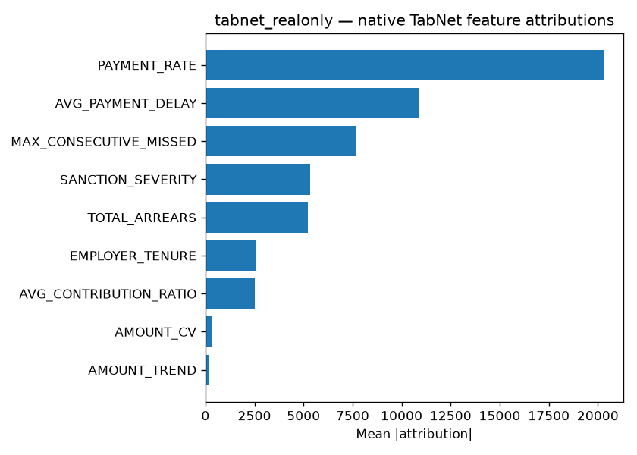
SHAP KernelExplainer, applied to 300 validation samples with a background set of 100, produces per-sample local attributions and the canonical beeswarm plot (shap_beeswarm_tabnet_realonly.png). This visualisation is the appropriate reference for M1's domain interpretation section.
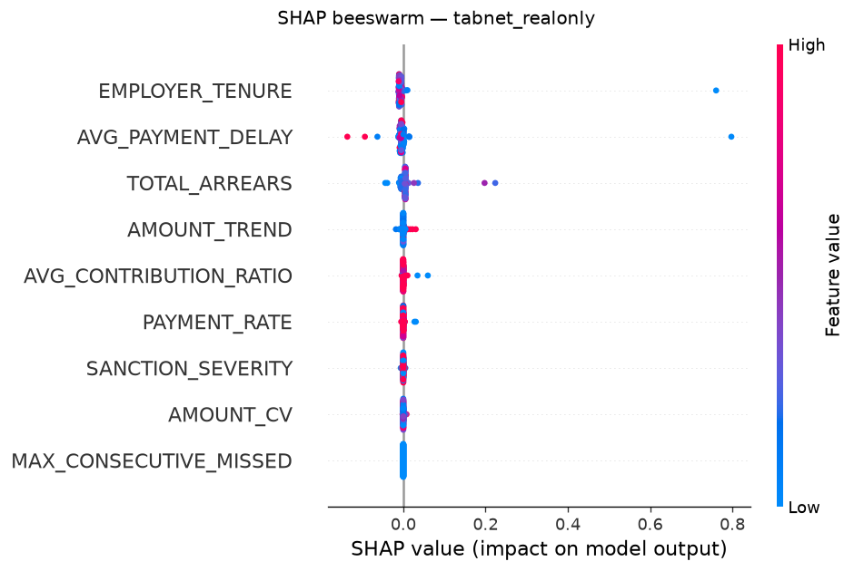

7. Discussion and Conclusions
The primary finding of the modelling stage is that engineered tabular features are highly effective for pension default prediction on this dataset. Three of the four models trained on these features achieved AUC ≥ 0.99, and the best model (random forest) reached 0.999 with negligible fold-to-fold variance. The narrow spread across tabular models indicates that the ceiling is set primarily by the informativeness of the feature set rather than by the choice of classifier.
The augmentation ablation produced a clear, actionable result: augmentation did not improve ranking performance and degraded classification quality at the default operating point. For deployment on data with the current class distribution, the un-augmented TabNet is recommended.
The LSTM result quantifies, indirectly, the value of the feature-engineering pipeline. Operating on raw payment sequences alone, a modern recurrent architecture achieved AUC 0.856, but ~0.14 below the tabular models. This gap was not interpretated as a failing of the LSTM but as evidence that M1's domain-informed aggregations extract signal that is expensive to recover from raw sequences at this sample size.
For deployment, we recommend the random forest as the primary model on grounds of accuracy, stability, and interpretability, with TabNet (real-only) as a secondary candidate offering comparable performance and native attention-based explanations.

8. Limitations and Future Work
Dataset size. With 1,000 samples and 253 positives, the study is small; deep architectures are systematically disadvantaged relative to tree ensembles. A larger dataset would provide a fairer comparison of the LSTM and TabNet.
Fixed threshold. All classification metrics were computed at threshold 0.5. Threshold optimisation on the validation folds (e.g., maximising F1 or expected cost) could improve F1 for the augmented TabNet and would be an appropriate next step for any deployment decision.
Hybrid architectures. The LSTM did not have access to M1's engineered features. A hybrid model that concatenates the engineered feature vector with the pooled LSTM representation would be a natural extension and would test whether temporal information adds signal beyond what the aggregations already capture.
Data quality. The two constant features identified in §5 should be investigated before any production deployment.

