_{CA169 Assignment 1 Lab Report}

_{Submit these pages onwards.}

Date: | 17/03/20
STUDENT NAME: | Conor Joyce
STUDENT NUMBER: | 19425804
PROJECT NUMBER: | 1
MODULE CODE: | CA169
DEGREE:  [CA EC ECSA PSSD] | CA
LECTURER: | Michael Scriney

Declaration
In submitting this project, I declare that the project material, which I now submit, is my own work. Any assistance received by way of borrowing from the work of others has been cited and acknowledged within the work. I make this declaration in the knowledge that a breach of the rules pertaining to project submission may carry serious consequences.

Answer Sheets

Ipconfig exercise
IP address of the machine | 192.168.1.12
MAC address | 00-21-70-0A-45-66

Ping exercise 1
What is displayed?

Usage for the ping command (all possible arguments, syntax, etc)

Ping exercise 2

First part exercise 2

Ping localhost
Paste window here.
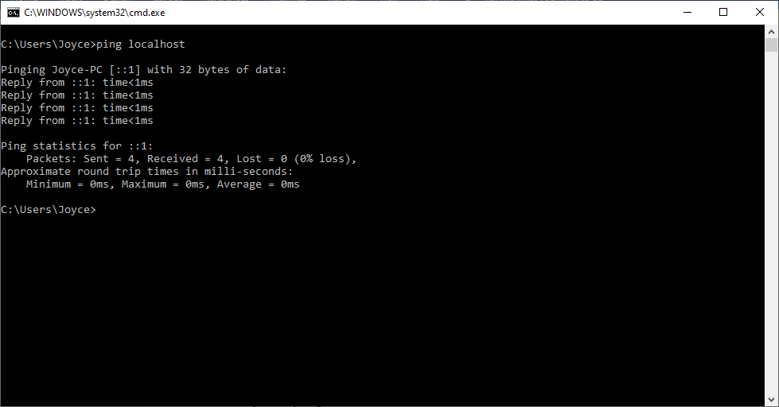

- What information is returned?
- What is the localhost?

Answer 1
- How long it takes to send a packet to localhost and get a response
- Localhost is the current machine

Second part exercise 2
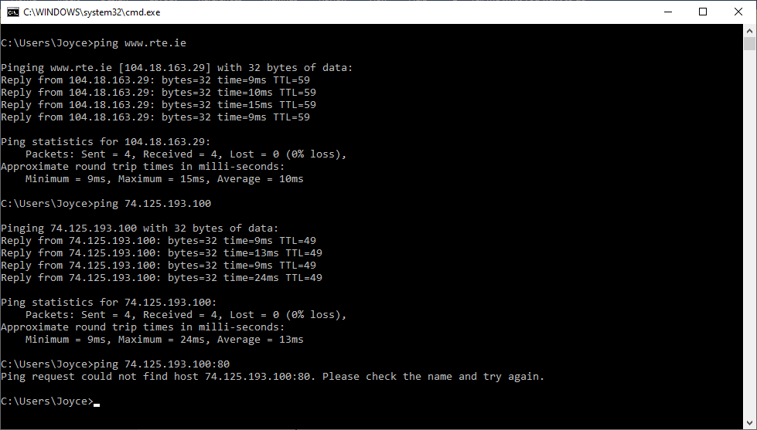
Pinging <url> <IP> with 32 bytes of data (a packet)
Reply from <IP>: bytes:32 (a packet) time=(however long it took)ms ttl (time-to-live, tells whether or not the packet has been in the network too long)
Statistics: packets sent, received, lost
Approx. ping times in ms: min, max, average

For higher marks
- www.rte.ie 104.18.163.29

Owner: RTE Commercial Enterprises Limited
Phone: (01) 2083111
Address: RTÉ,Donnybrook,Dublin 4
Identifying Info: Use CloudFlare and Blacknight
IP address in the US
How I found out: whois lookup and contact page

- 74.125.193.100 google.com

Owner: Google LLC
Phone: +1.2083895740 (registrar abuse number)
Address: Google LLC,1600 Amphitheatre Parkway,
Mountain View, CA 94043,USA
Identifying Info: MarkMonitor is registrar,
IP is in Mountain View, California
How I found out: whois lookup and contact page

- 74.125.193.100:80 also returns google.com

Ping and/or enter into browser the three addresses.
Paste windows here

rte.ie -

74.125.193.100 -
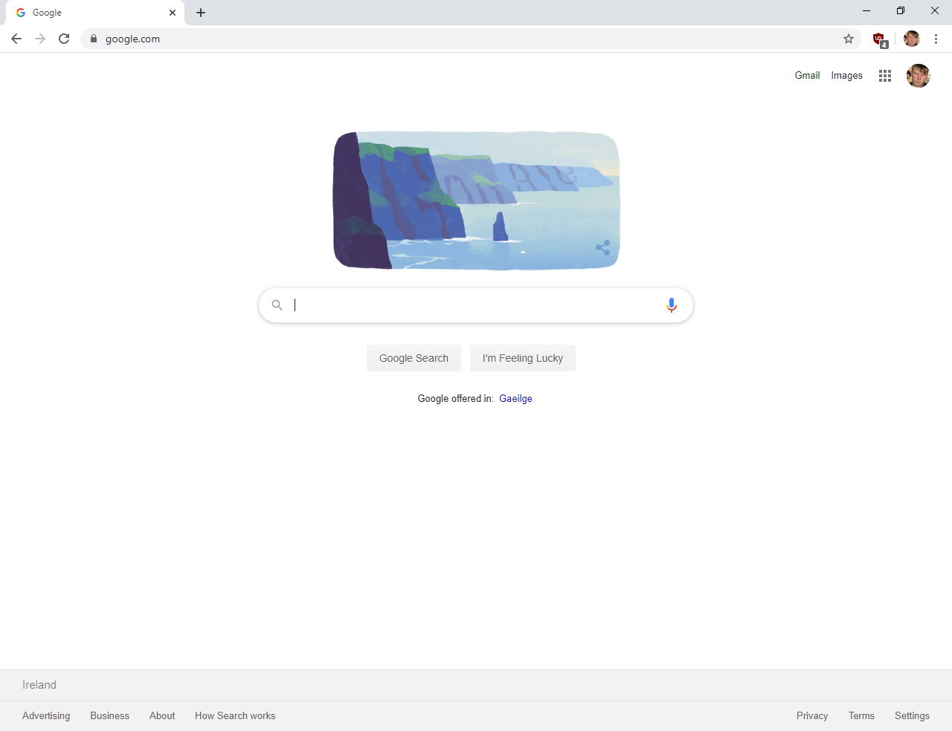
74.125.193.100:80 -

Explain output here, item by item.
rte.ie returns rte.ie
104.18.163.29 returns google.com (this is google’s ip address)
104.18.163.29:80 returns google.com (google’s ip, and http port 80 – also why ping didn’t work)

Exercise 3
Paste window 1
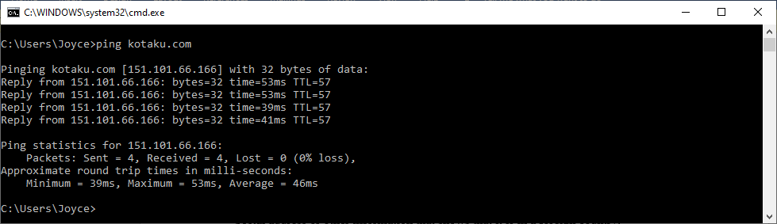

Paste window 2
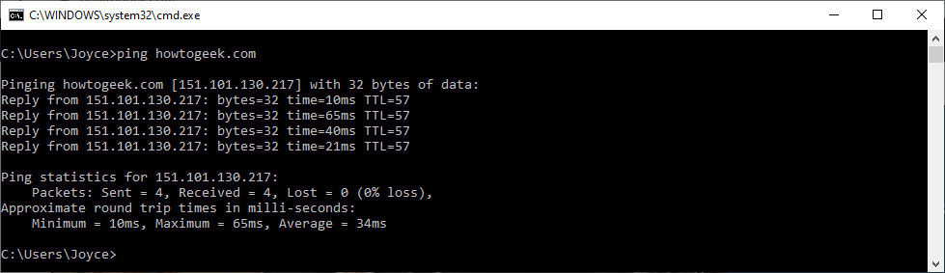

 | Website 1 | Website 2
Name of the website pinged | Kotaku | How-To Geek
What is the IP address returned? | 151.101.66.166 | 151.101.130.217
What is the TTL figure? | 57 | 57
Average round trip time | 45ms | 34ms

Your comments on administrative information that you found by searching on the Internet about the websites from experiment 3. Things like, who owns it, phone numbers, email addresses, registered addresses etc, anything at all that tells us about the website and its administration.
Kotaku
Owner: G/O Media Inc
Contact: DNS Admin
G/O Media Inc
New York, NY, 10036, us
(p) (f)
IP: - California - San Francisco – Fastly
Registrar: CSC CORPORATE DOMAINS, INC.

How-To Geek
Contact: Contact Privacy Inc. Customer 124293465
96 Mowat Ave,
Toronto, ON, M4K 3K1, ca
(p)
IP: - California - San Francisco – Fastly
Registrar: Google LLC

Exercise 4: Netstat exercise

Number of packets received by workstation: 397898

Window here.
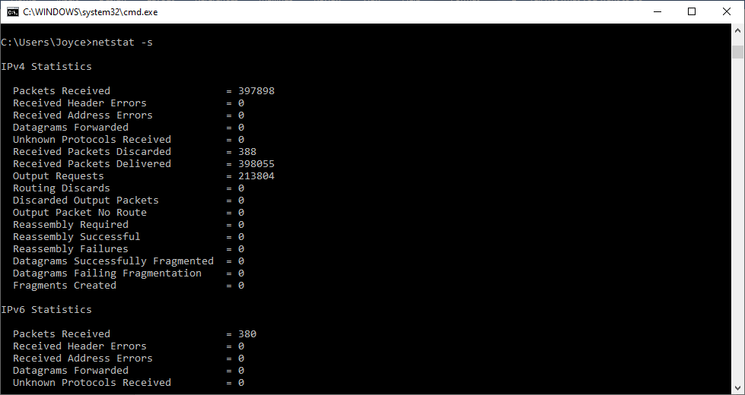

ICMP packets explained:
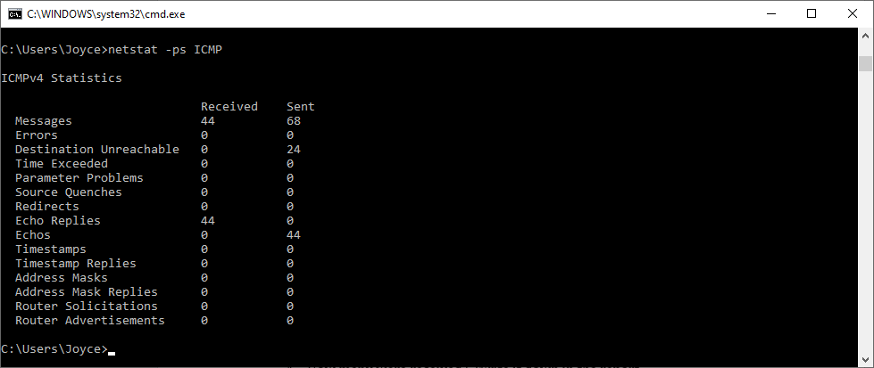

Internet Control Message Protocol:
ICMP gives feedback. Common use is Echo and Echo Reply (ping)

Discuss the connections opened by visiting the DCU website here.
Also, grab the window, showing connections opened as a result of visiting the DCU website.

Netstat –r explained
Display kernel ip routing table

