**Media Analytics**

Conor Joyce - 19425804

In our lecture Dr Suzanna Little came in to talk to us about media and specifically media analytics. She talked about the uses and benefits of analysing media and also the challenges faced in regards to this.

## What is media?

Media comes in many forms, for example images, audio, and video. These forms of media are what we all experience everyday but games and animation are also included in the wider umbrella of media. It is through different mediums such as youtube videos, audio files and blog posts that we perceive media itself. Then we have different modes for understanding this information, such as our sense of hearing for audio files and music, and sight for videos and images.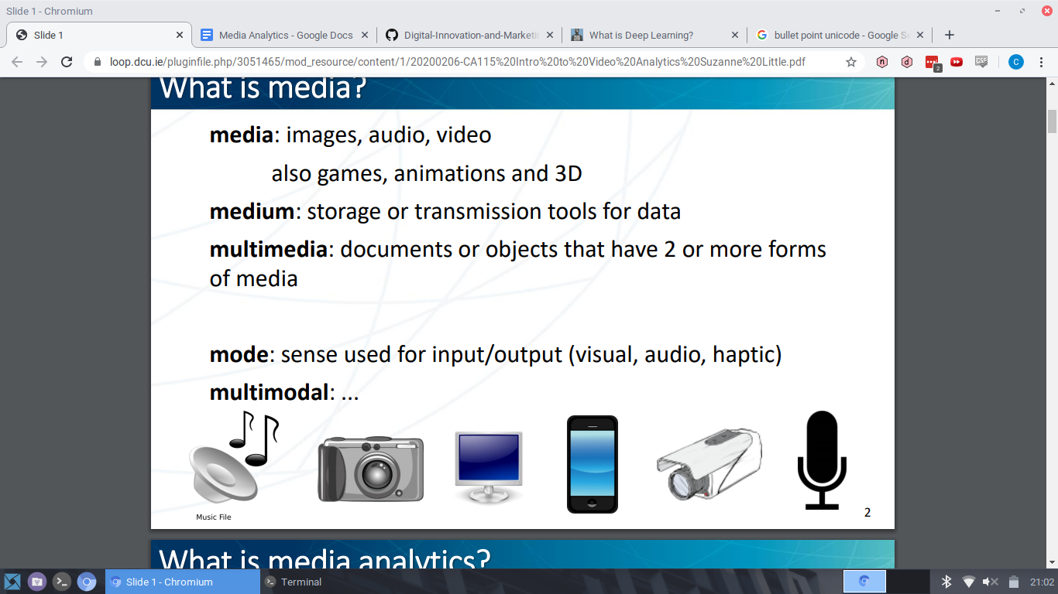

## What is media analytics?

Media analytics is using different forms of media and analysing them to gather information, which can be used for a lot of different applications such as medical use, security, and collecting analytics e.g. tv ratings, social media impact, etc.

Analysing media has a lot of benefits, especially in our technologically advancing society today, but also has its own challenges. For example, when analysing visual media, we need to understand the difference between visual and semantic similarity. Different images could look the same but have completely different meanings behind them, and the opposite applies also - different images could look different but actually be describing the same thing.



* For example these three images look similar, yet describe completely different things.

## Smart Stadium project

A big use for media analytics is the Smart Stadium project in Croke Park. Essentially, Croke Park is at the moment being used as a “testbed” for sensors and different IoT technologies.

Some of the applications in use currently in Croke Park include:

* Analysing noise levels at matches - multiple mics around the stadium output the noise level in dB, which is then processed to increase the accuracy of the data, which can then be used in graphs and analytics.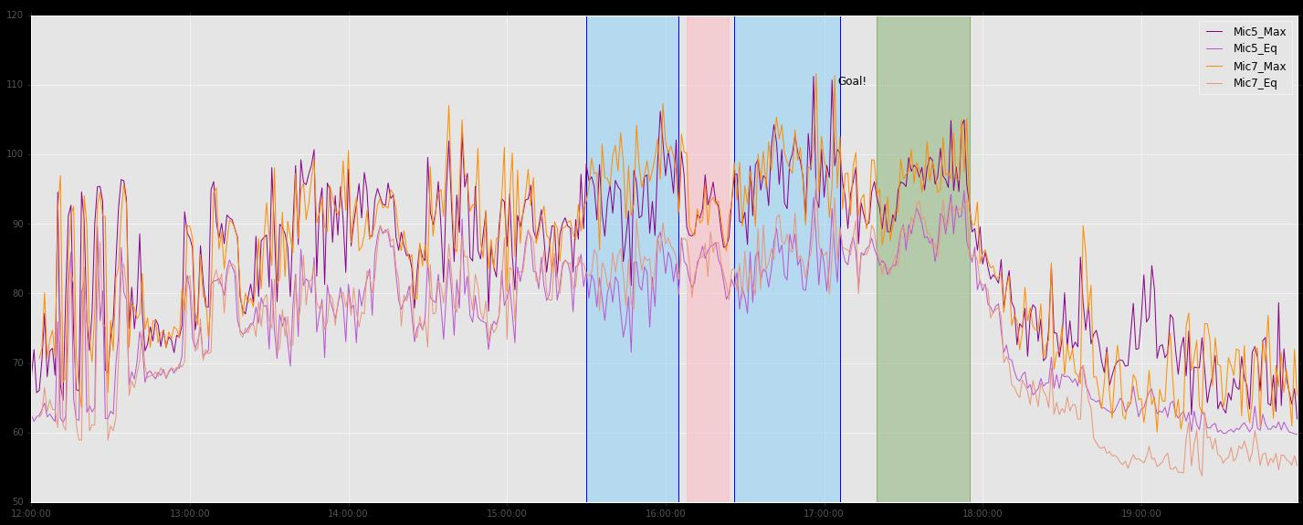

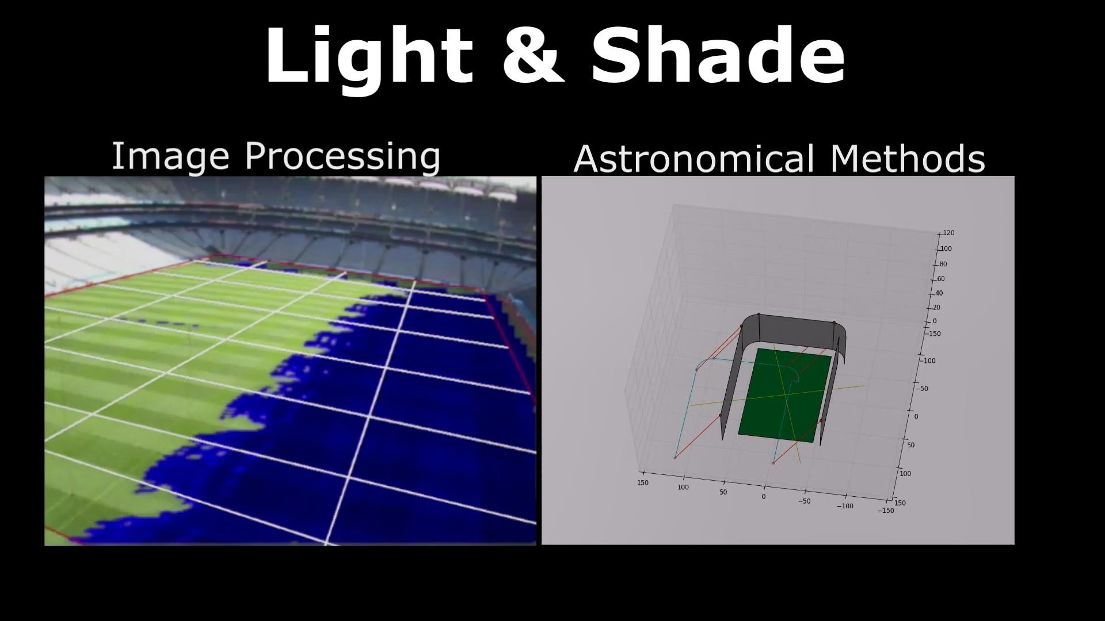

* Monitoring grass growth - collecting images of the pitch and analysing them, monitoring light levels and water on the pitch. Image processing of the pitch to define light and shade regions on the pitch helps understand how the grass is growing and helps with maintenance of the pitch itself.

## Teaching computers to “see”

Teaching computers how to effectively analyse images and understand what they are seeing is an important aspect of the Smart Stadium project and is useful for other applications also such as smart cars, movement of crowds, and identifying objects in an image.

One of the big challenges in regard to this is the fact that a lot of input data is required before computers can even start understanding visual media effectively.

This challenge in particular has been mitigated immensely in recent years due to the rise in deep learning mechanics and optimization of “big data” collection and analysation, and because of these, improvements have been made and using computers to analyse images in much more commonplace nowadays.

## Deep Learning and Big Data

Deep Learning is a form of machine learning, and uses neural networks to process a huge amount of data. Through this process it is possible for computers to effectively “learn” to do certain things, with complex algorithmic processes generated by feeding a neural network lots of input data.

Deep Learning has progressed immensely in recent years because of the availability of more powerful hardware and advances in “big data” processing.

“Big Data” is the collection and use of huge amounts of information, which is used in neural networks and analytics. Dealing with this amount of data has been a big issue in the past, but advances in deep learning have helped progress this field, both fields effectively benefiting the other’s development.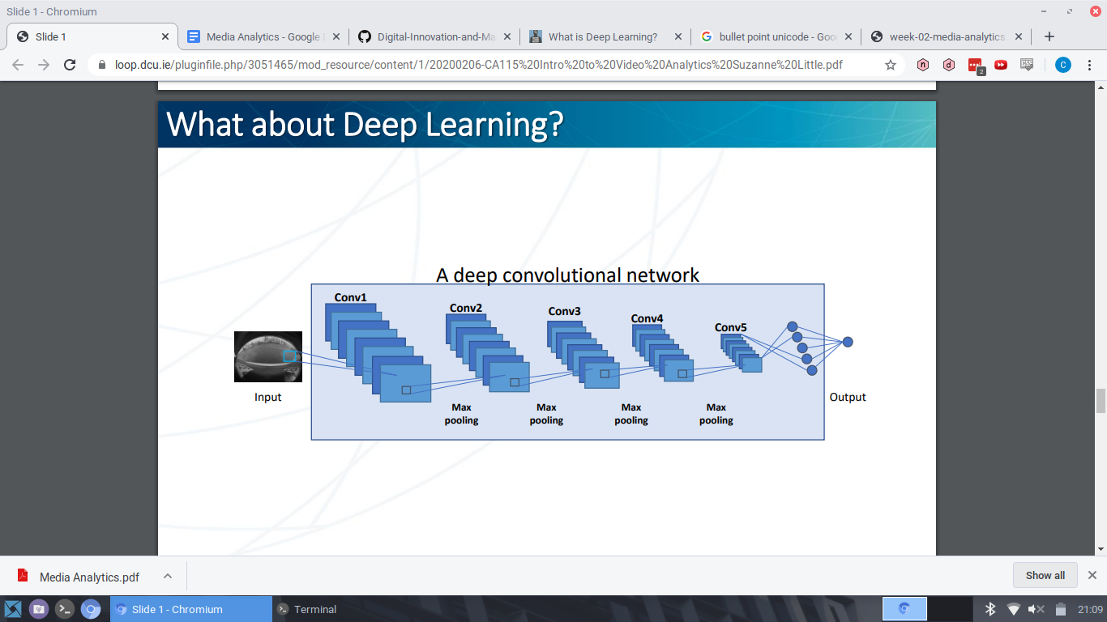

Big Data is also used in huge technology companies such as Facebook and Google for analytics, advertising and optimizing of their websites and services. For example YouTube uses around 15-20 terabytes of data every single day, so improved technologies for dealing with this data is very important

## Final Thoughts

Overall I found Dr Little’s presentation very engaging and interesting and her presentation skills were evident throughout. She interacted with the students and didn’t just read off the slides like a lot of people presenting fall into the habit of doing, which helped a lot with keeping the attention of students.

I also found the topics around Deep Learning and the Smart Stadium project in Croke very interesting. It is clear these technologies have a huge impact and will only continue to affect our lives even more are they advance and become more complex and accessible to everyone.