**Impact of Different Feature Extraction Techniques on Parkinson’s Disease Detection Using Handwriting Data**

**Project Description:**

* **Project Title and Team Members**

**Project Title is** Impact of Different Feature Extraction Techniques on Parkinson’s Disease Detection Using Handwriting Data

**Team members**

* Jaynica Nunna
* Mounika vankayalapati
* Pavithra Namburi
* Krishna Prasad Siddhardha Varma Mudunuri

**Github:**

[**https://github.com/JaynicaNunna/Feature_Engineering_project.git**](https://github.com/JaynicaNunna/Feature_Engineering_project.git)

**Goals and Objectives:**

**Motivation:**

Parkinson's disease (PD) is a neurological disease characterized by a gradual loss of movement skills, speech, and cognitive abilities of the person. Parkinson's disease (PD) is the world's second most common neurodegenerative illness, impacting roughly ten million individual people in general. Neurodegenerative illnesses have grown more common in recent years. The number of persons affected by these terrible illnesses is increasing. Early identification of these disorders is crucial for extending patients' lives. [[2]](https://ieeexplore.ieee.org/iel7/4664312/8643115/08365754.pdf)Handwriting is one of the most basic tests that can be performed, and it is also available to anybody, anytime, with only a piece of paper and a pen. Handwriting is one of the preliminary elements that should be considered.

**Significance:**

This technology has the potential to completely enhance approaches to early identification of Parkinson's disease (PD). By identifying effective feature extraction approaches, there is a chance of developing a tool that not only makes sure but it is also accessible and affordable to a larger audience. [[3]](https://www.researchgate.net/publication/352388162_Handwritten_character_recognition_using_convolutional_neural_network)This endeavour's possible conclusion might result in a dramatic revolution in the global landscape of Parkinson's disease diagnosis and management, thereby changing how we approach and confront this disorder on a worldwide basis.

**Objectives:**

The purpose of this research is to explore the field of Parkinson's Disease (PD) identification using handwriting data by investigating the influence of various feature extraction strategies. The major goal is to evaluate and compare the usefulness of different approaches in establishing accurate Parkinson's disease diagnosis. This project aims to add to the current body of information in the field of simple, cost-effective techniques for early Parkinson's disease diagnosis. [[4]](https://dl.acm.org/doi/abs/10.1145/3626524) This research aims to shed light on innovative approaches that could potentially improve the efficiency and accessibility of diagnostic tools for Parkinson's Disease, developing innovations in early detection and treatment practices through a careful examination of these feature extraction methods.

**Features:**

Histogram of Oriented Gradients(HOG): As you've identified, HOG is effective in capturing edge and gradient structures. For handwriting data, it can help in identifying subtle changes in stroke patterns, which might be indicative of Parkinson's disease.

Local Binary Patterns(LBP): This technique is adept at texture analysis. In the context of handwriting, it could be useful in detecting inconsistencies and irregularities in stroke textures, which are common in Parkinson's patients.

Haralick Features: Derived from the Gray-Level Co-occurrence Matrix (GLCM), Haralick features can capture textural information such as contrast, correlation, and entropy. These features might be sensitive to the textural changes in handwriting caused by the motor symptoms of Parkinson's.

Fourier Descriptors: This method transforms shapes in images (such as handwriting strokes) into the frequency domain. Fourier Descriptors are particularly good at capturing the global shape and outline of writing patterns, which could be altered in Parkinson's patients.

Wavelet Transforms: Wavelets are effective in analyzing handwriting data at various scales and resolutions. They can capture both the frequency and location information of handwriting strokes, making them useful for detecting subtle anomalies in handwriting.

Shape Context: This technique captures the shape information of individual points in the handwriting. It's effective in understanding the spatial distribution of points in handwriting, which can be altered due to the motor symptoms of Parkinson’s disease.

Gabor Filters: These are used to analyze spatial frequencies in images and are effective in texture analysis. They can be used to detect variations in the texture of handwriting strokes, which might be indicative of Parkinson's.

Principal Component Analysis (PCA): Although primarily a dimensionality reduction technique, PCA can be used to extract key features from high-dimensional data. In your case, it can help in identifying the principal components that capture the most variance in handwriting patterns.

Autoencoders (Deep Learning): These are neural networks designed for unsupervised learning of efficient codings. They can be used to learn a compressed representation of handwriting data, capturing essential features in a lower-dimensional space.

T-Distributed Stochastic Neighbor Embedding (t-SNE): This is a non-linear dimensionality reduction technique particularly well-suited for the visualization of high-dimensional datasets. It can help in visualizing the clustering of handwriting patterns from Parkinson’s patients versus control groups.

Skeletal Feature Extraction: This involves analyzing the skeletal structure of handwriting strokes. Features like stroke width, curvature, and junctions can provide valuable insights into motor control impairments in Parkinson’s.

Geometric Feature Extraction: This includes extracting features like loops, line lengths, angles, and intersections in handwriting, which can be altered due to the motor impairments associated with Parkinson's.

We have also created a quantify_image_combined function, which serves as a comprehensive feature extraction tool for image analysis, combining two powerful techniques: Histogram of Oriented Gradients (HOG) and Local Binary Patterns (LBP).

**Related works:**

This collection of research endeavours, spanning studies[[1]](https://www.researchgate.net/publication/328065022_Dynamic_Handwriting_Analysis_for_Supporting_Earlier_Parkinson's_Disease_Diagnosis)through [8], explores various facets of handwriting analysis, particularly in the context of medical and technological applications. Study [1] investigates the potential of dynamic aspects of the handwriting process for early Parkinson's disease detection, revealing promising results in specificity performances and suggesting the feasibility of a handwriting-based decision support tool. Study [[2]](https://ieeexplore.ieee.org/iel7/4664312/8643115/08365754.pdf) delves into online analysis of handwritten trials by Alzheimer's disease (AD) and Parkinson's disease (PD) patients, emphasizing pattern recognition, data collection, feature extraction, and classification challenges. Additionally, the study [[3]](https://www.researchgate.net/publication/352388162_Handwritten_character_recognition_using_convolutional_neural_network) employs Convolutional Neural Networks (CNN) to recognize characters from image datasets, achieving a notable accuracy of 92.91% on handwritten characters. Introducing a novel approach, study [[4]](https://dl.acm.org/doi/abs/10.1145/3626524) presents the Multi-Objective Jaya Convolutional Network (MJCN), a feature learning technique leveraging a unique combination of layers and optimization to extract meaningful features directly from images. Further innovations include an adaptive data augmentation strategy based on Generative Adversarial Networks (GANs) in the study [[5]](https://peerj.com/articles/cs-861/) to address class imbalance in text recognition, demonstrating improved accuracy in text recognition systems. Study [[6]](https://www.irjmets.com/uploadedfiles/paper//issue_3_march_2023/34395/final/fin_irjmets1679028264.pdf) focuses on the creation of a Handwriting character recognition system using artificial neural networks, showcasing the efficiency and resilience of neural networks in identifying handwriting characters. Lastly, a study [[7]](https://www.researchgate.net/publication/332524789_Model_for_Handwritten_Recognition_Based_on_Artificial_Intelligence)proposes a generic approach to enhance handwriting recognition efficiency using genetic algorithms and artificial intelligence, achieving high accuracy in recognizing diverse handwritten typefaces. Together, these research endeavours contribute valuable insights and advancements in the fields of handwriting analysis, medical diagnostics, and artificial intelligence applications.[[8]](https://www.researchgate.net/publication/340405637_A_Comparative_Study_of_Handwriting_Recognition_Techniques)

**Dataset:**

The Handwriting Dataset for Parkinson's Disease (PD) is a specialized collection designed for the investigation and detection of PD through handwriting analysis. Comprising samples from both individuals diagnosed with PD and a control group without neurological disorders, this dataset aims to facilitate the development of non-invasive diagnostic tools leveraging machine learning techniques.

In this dataset, participants were instructed to write specific phrases or sentences, ensuring a consistent and comparable set of data across all samples. For the PD group, the samples are expected to manifest unique characteristics influenced by common PD symptoms like tremors, altered pressure patterns, and reduced dexterity. The control group serves as a baseline for normal handwriting patterns.

The dataset maintains a balance between the PD and control groups to prevent bias in subsequent machine-learning applications. A significant focus has been placed on pre-processing these images for standardization. This includes size normalization, contrast adjustment, and noise reduction, ensuring that the handwriting is clear and consistent for analysis.

**Detail Design of Features:**

The first feature extraction method is called Histogram of Oriented Gradients (HOG), and it uses an image's shape and texture data. HOG may be used to extract characteristics from handwriting samples by utilizing handwriting datasets to identify Parkinson's disease. For HOG to function, the image is divided into tiny cells. Each cell's gradient orientations are then calculated, and a histogram of these orientations is produced. The final feature vector is created by concatenating these histograms.

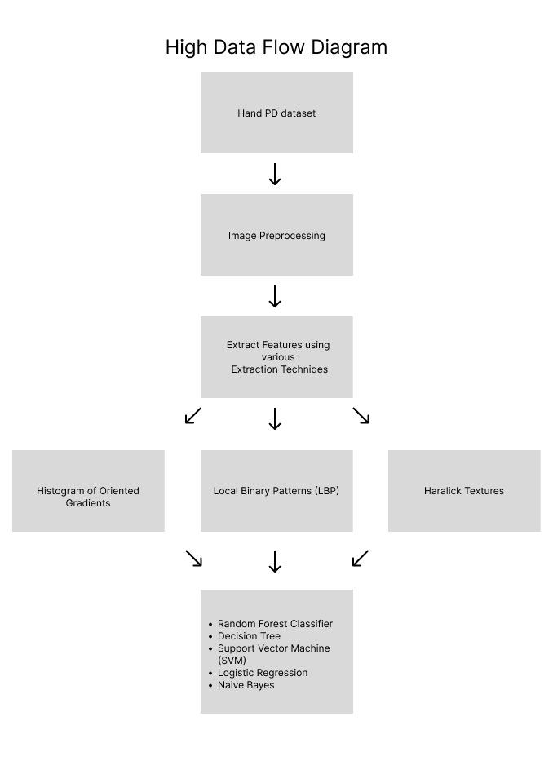

Another important feature extraction method in picture analysis is LBP. Contrasting the intensity values of every pixel with those of its nearby pixels may explain the local texture patterns of an image. LBP may be used to extract texture characteristics from handwriting samples in the context of handwriting datasets for Parkinson's disease identification. The way LBP operates is by encoding the result as a binary pattern after thresholding the pixels that surround each pixel. The final feature vector is a histogram that is produced using these binary patterns.

A set of statistical measurements that characterize an image's texture characteristics are called Haralick features, or texture features. These characteristics may be utilized to describe the texture patterns in the handwriting samples by capturing information about the spatial distribution of pixel intensities. The co-occurrence matrix, which shows the frequency of pixel intensity pairings at various spatial relationships in the image, is analyzed to compute the hard lick characteristics. Several statistical metrics, including homogeneity, contrast, and entropy, may be obtained as features from this matrix.

**Analysis:**

The analysis of handwriting datasets for the Parkinson's disease identification project involves the study of handwriting samples by researchers to find patterns and traits that may suggest the existence of Parkinson's disease. Gathering a dataset of handwriting samples from people with and without Parkinson's disease is usually the first step in the procedure.[5] Written words, phrases, or particular activities intended to capture different elements of handwriting might be included in these examples. From the handwriting samples, researchers then extract traits, some of which are the same as the Histogram of Oriented Gradients (HOG) technique, Local Binary Patterns (LBP) for Texture Analysis, and Haralick features we covered before. These characteristics extract essential information from the handwriting, such as texture patterns.

After the characteristics are recovered, classification models such as a support vector machine (SVM) or neural network use them as input. The handwriting samples in the labelled dataset are matched to the matching Parkinson's disease state, which is used to train the model. The algorithm may be trained to categorize previously unknown handwriting samples into groups related to Parkinson's disease and those unrelated to it. The early diagnosis and monitoring of the illness can be aided by this categorization.

**Implementation:**

1. **Data Collection:** Used Hand Pd dataset.

2. **Preprocessing:** To eliminate noise and standardize the samples, clean and preprocess the handwriting data.

Initially, we purge the data of any noise or extraneous information that might compromise the precision of our models. This might involve managing any missing numbers that may be present, eliminating outliers, and fixing any discrepancies.

To make sure the handwriting samples are on a uniform scale, we then normalize the data. This facilitates the comparison and analysis of characteristics between various people and samples.

From the handwriting data, we could potentially be able to extract pertinent traits. Aspects like stroke length, pen pressure, or curvature are examples of these characteristics, and they can offer important insights into the motor symptoms linked to Parkinson's disease.

Furthermore, to simplify the data while keeping its essential features, we may think about using methods like dimensionality reduction. This may contribute to our models' increased efficacy and efficiency.

The pre-processed data was then divided into training and testing sets. The testing set is used to assess the models' performance and capacity for generalization, whereas the training set is used to train the machine learning models.

3. **Feature Extraction:**

Take pertinent characteristics out of the handwriting data that has already been analyzed. These might be frequency-based features, shape-based characteristics, or statistical features.

Our goal is to extract these elements to capture the distinct handwriting patterns and variations linked to Parkinson's illness. Machine learning algorithms can identify and distinguish between people who have the ailment and those who do not use these features as input.

The models' quality and efficacy in identifying Parkinson's disease are largely dependent on the characteristics used. Experts in the area and researchers carefully choose traits that have a high association with the motor symptoms of Parkinson's disease and have demonstrated encouraging outcomes in prior studies.

After the characteristics are retrieved, they are usually coupled with additional pertinent data to create comprehensive models for the diagnosis of Parkinson's disease, such as demographic information or medical history.

4. **Feature Selection:** Choose the traits that help identify Parkinson's disease and are the most informative. Methods such as feature significance ranking and correlation analysis are available.

choose the features from the retrieved feature set that are most pertinent.

This helps in lowering the dimensionality of the data and raising the models' efficacy and efficiency.

Techniques for choosing features might differ, but they usually entail assessing each feature's significance or applicability. Correlation analysis and hypothesis testing are examples of statistical techniques that may be used for this, as well as machine learning algorithms that rank the features according to how well they forecast the model's work.[3]

Our goal is to enhance the models' performance by minimizing noise, getting rid of unnecessary data, and concentrating on the traits that are most suggestive of Parkinson's disease by choosing the most pertinent attributes.

**5. Model-Based learning:**

Now, a few common machine learning models that are employed to identify Parkinson's disease using handwriting datasets are as follows:[6]

**1.Decision trees:** A simple yet useful machine learning model, decision trees employ a tree-like structure in their decision-making process. Every leaf node represents a class or a prediction, whereas every internal node represents a feature. Both linear and non-linear correlations in the data may be captured using decision trees, which are simple to analyze. They are frequently employed as the foundation for more intricate models, such as random forests. Two formulae are required to create a decision tree; these are provided below and serve as the foundation for the trees.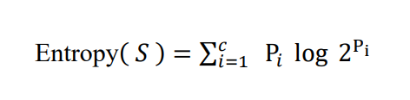

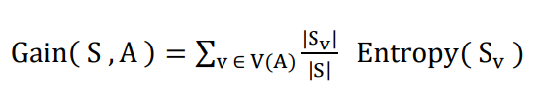

The information gain for each feature in the dataset is determined using entropy, and the dataset is divided based on the characteristic that provides the greatest information gain.

**2. Support vector machine:** SVM is a supervised learning technique that uses a hyperplane to divide data points into distinct groups. The goal is to identify the optimal decision border that maximally divides the classes. By transforming the data into a higher-dimensional space using kernel functions, SVM is capable of handling data that is both linearly and non-linearly separable.

**3.Random Forest:** Using many decision trees, Random Forest is an ensemble learning technique that generates predictions. A single subset of the data is used to train each decision tree, and the combined forecasts of all the trees provide the final prediction. It is well known that Random Forest can handle high-dimensional data and capture intricate feature correlations.

**4.Naive Bayes:** Using the "naive" premise of feature independence, the Naive Bayes method applies the Bayes theorem to probabilistic classification problems. It assumes that a feature's presence in a class is independent of the presence of other features. Although Naive Bayes is computationally efficient and frequently performs well in text classification problems, the distribution of the data may affect how well it works. The classifier is referred regarded as "naive" because, to minimize computing costs, it

"naively" asserts that there is conditional independence between the classes, providing the formula that follows. 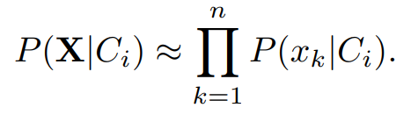

The projected class for a given sample X will be the one with the highest probability.

**5**. **Logistic regression:** A statistical technique called logistic regression is used to forecast binary events. It estimates the likelihood that an event will occur based on the supplied features. Logistic regression can be applied to the diagnosis of Parkinson's disease to forecast a person's likelihood of developing the condition based on characteristics of their handwriting.

The sigmoid function provided by the equation is the foundation of logistic regression. Let x be the sample set, b be the biases, and W be the weights.

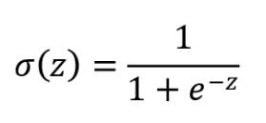

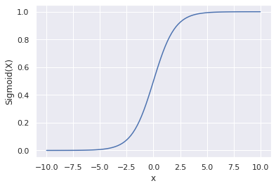

In logistic regression, the log loss function is utilized as the loss function.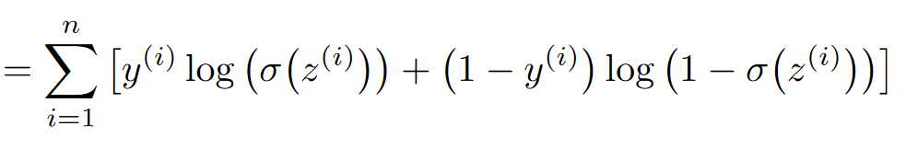

to determine the loss. To obtain the best fit and minimize the loss, the gradient descent technique is used. There will be a threshold function following the application of the sigmoid function.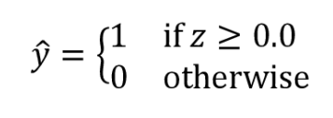

Either 0 or 1 represents the class according to the threshold function. With the major distinction being the use of the Softmax activation function, multinomial logistic regression allows the logistic regression to be extended for several classes in addition to binary classification.

These are only a handful of the models that are frequently applied to handwriting datasets to detect Parkinson's disease. Every model has advantages and disadvantages, and to determine which model is the most accurate and trustworthy for a given dataset, researchers frequently test out several models.

**6**. **Training the Model:** Divide the dataset into sets for testing and training. Utilizing the training data, train various machine learning models, such as neural networks, random forests, and support vector machines (SVM).

To do this, divide the dataset into training and testing sets.

Using the input characteristics and the accompanying labels (whether or not the person has Parkinson's disease), the training set is used to educate the model on how to make correct predictions. The model gains the ability to identify trends and connections between the characteristics and the state of the illness.

We use the testing set to assess the model's performance once it has been trained. This enables us to evaluate the model's generalization performance to fresh, untested data. The model's efficacy in identifying Parkinson's disease is determined by calculating its accuracy, precision, recall, and other performance indicators.

**Preliminary Results:**

**Screenshots from code outputs**

**Outputs for using the HOG feature Extraction technique against various Models**

Area Under the Curve (AUC) scores from Receiver Operating Characteristic (ROC) curves for different classification models

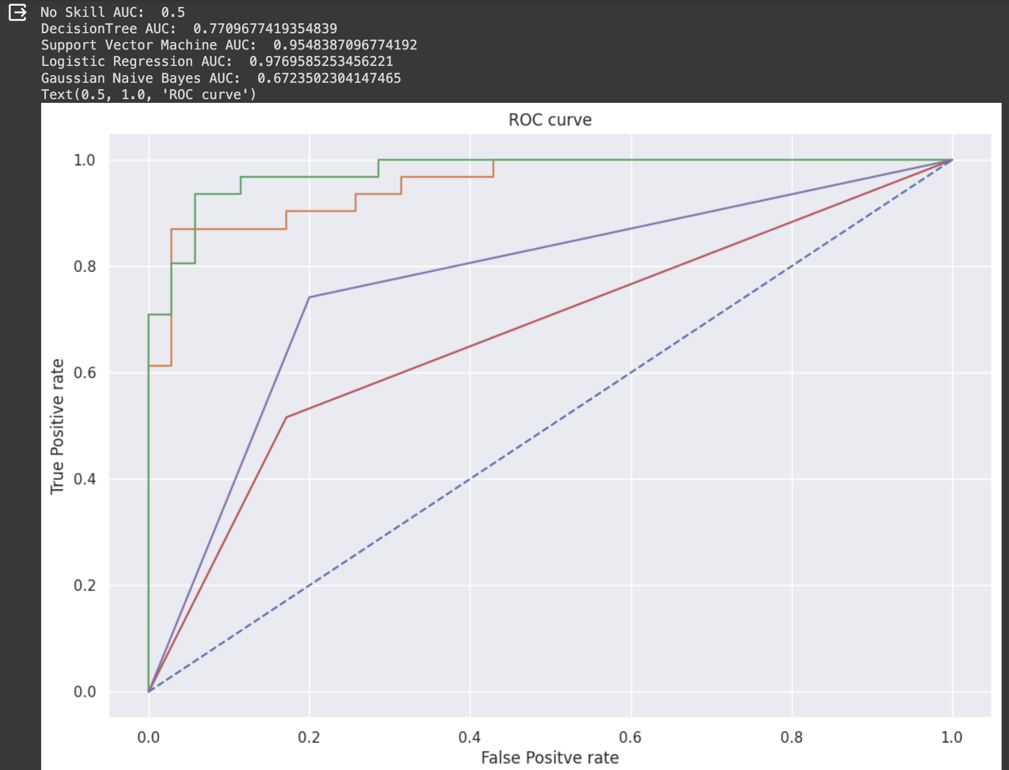

calibration curves for different classification models

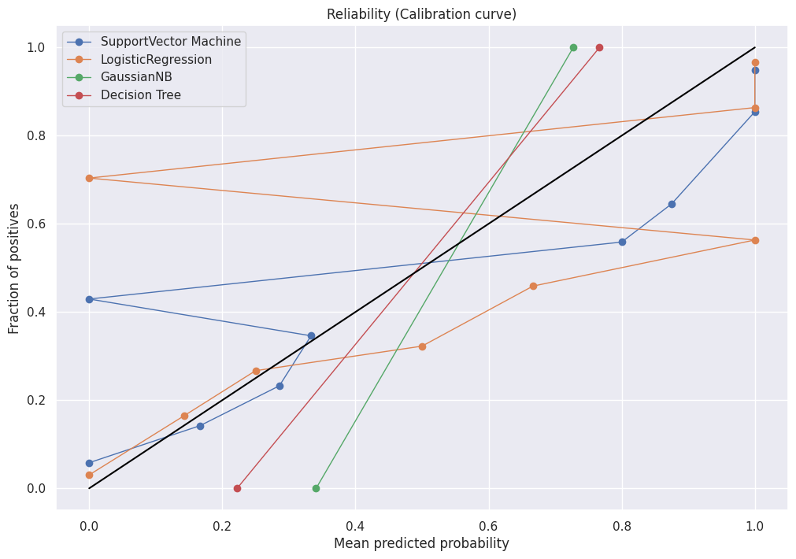

Accuracy for all the models

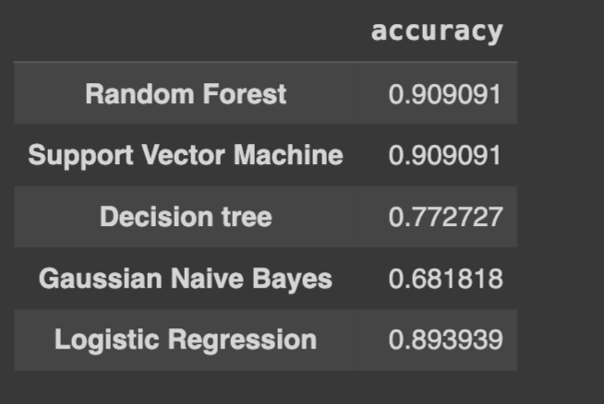

**Outputs for using the LBP feature Extraction technique against various Models**

Area Under the Curve (AUC) scores from Receiver Operating Characteristic (ROC) curves for different classification models

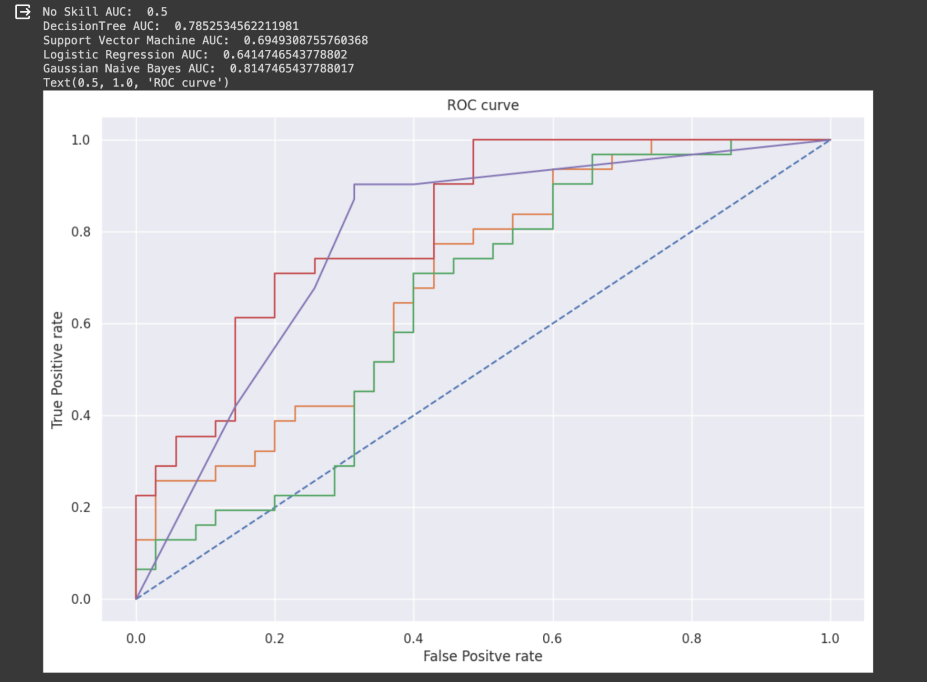

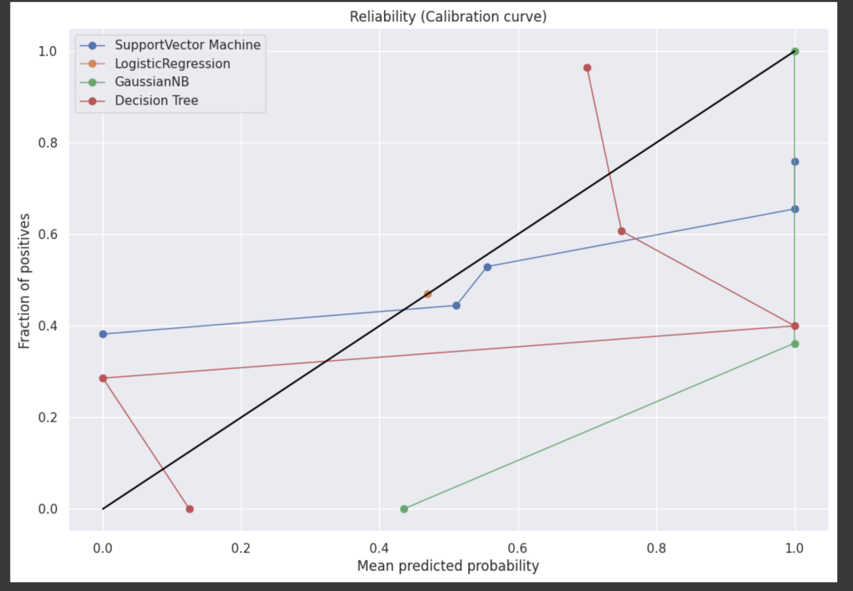

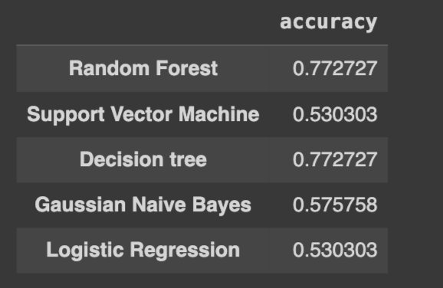

calibration curves for different classification models

Accuracy for all the models

**Outputs for using the Haralick Textures feature Extraction technique against various Models**

Area Under the Curve (AUC) scores from Receiver Operating Characteristic (ROC) curves for different classification models

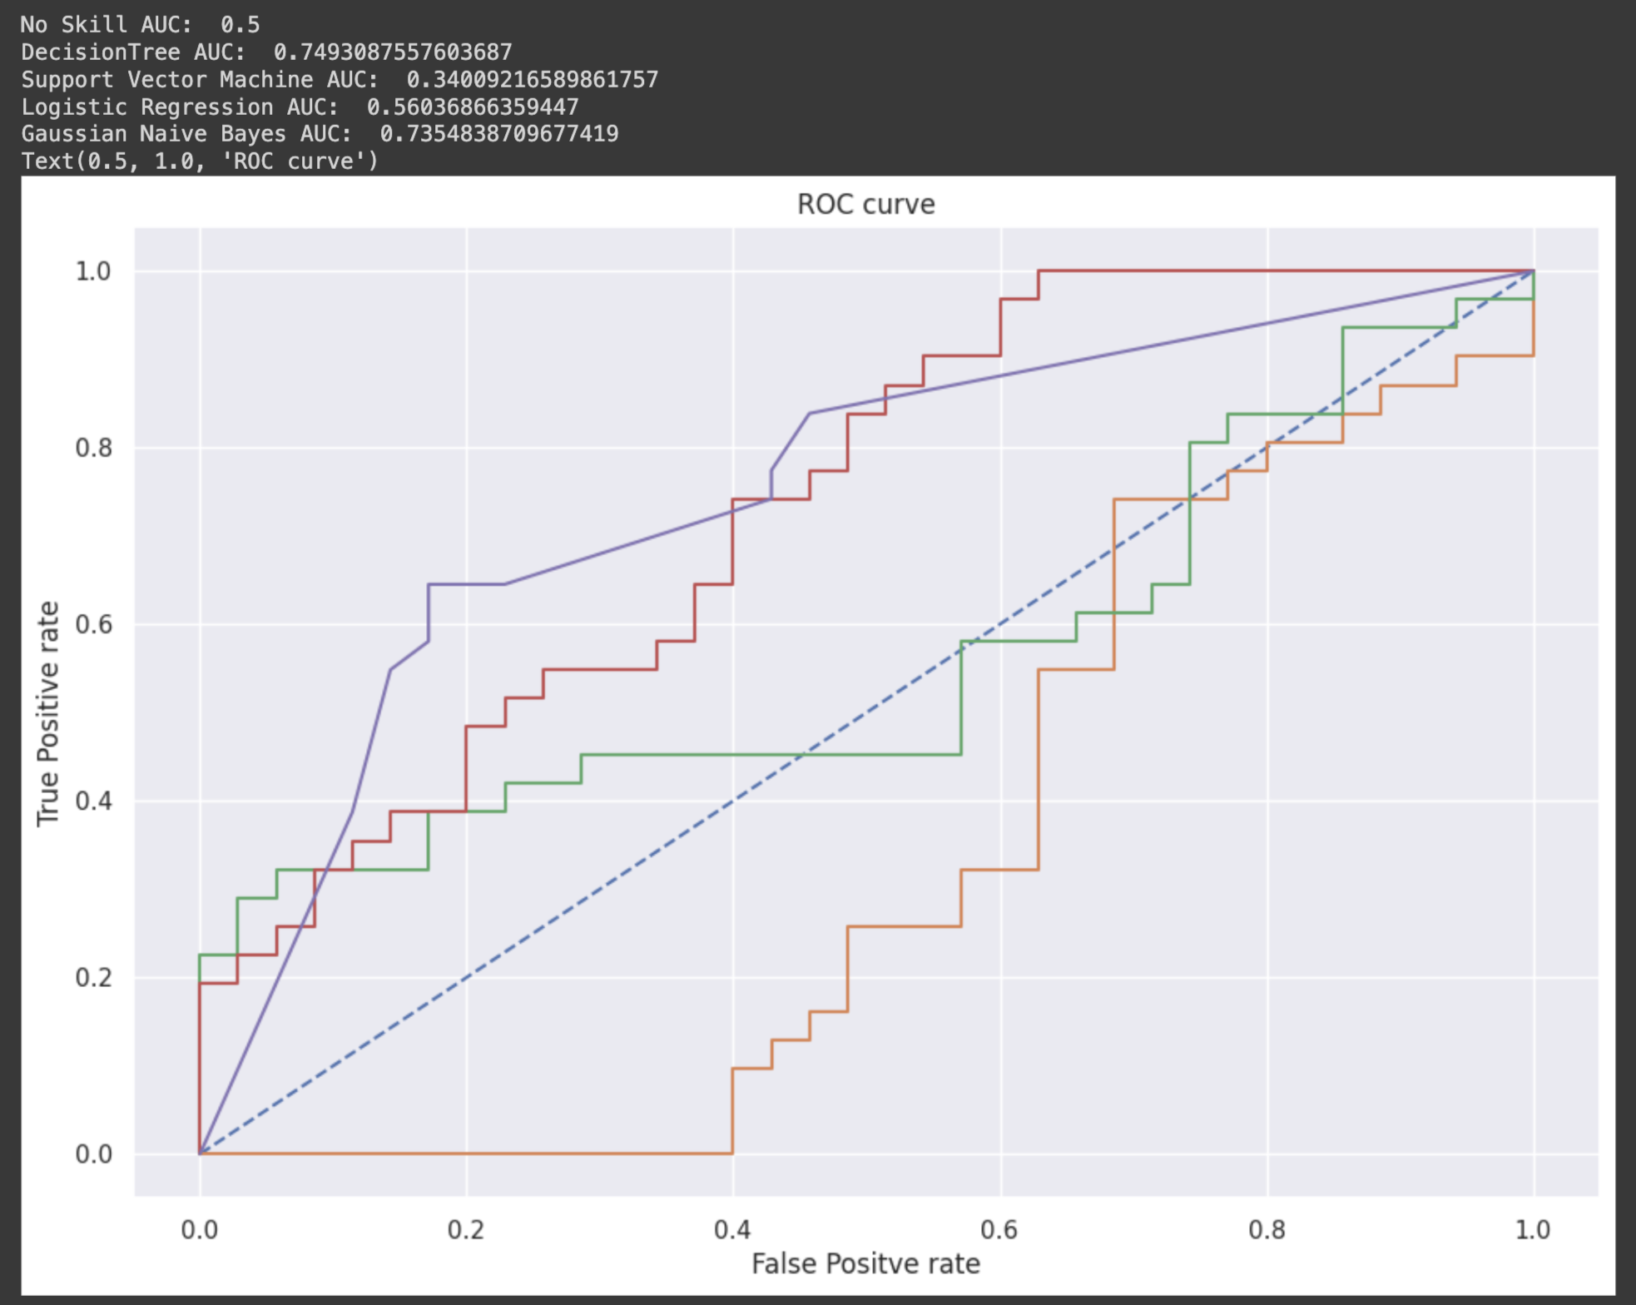

calibration curves for different classification models

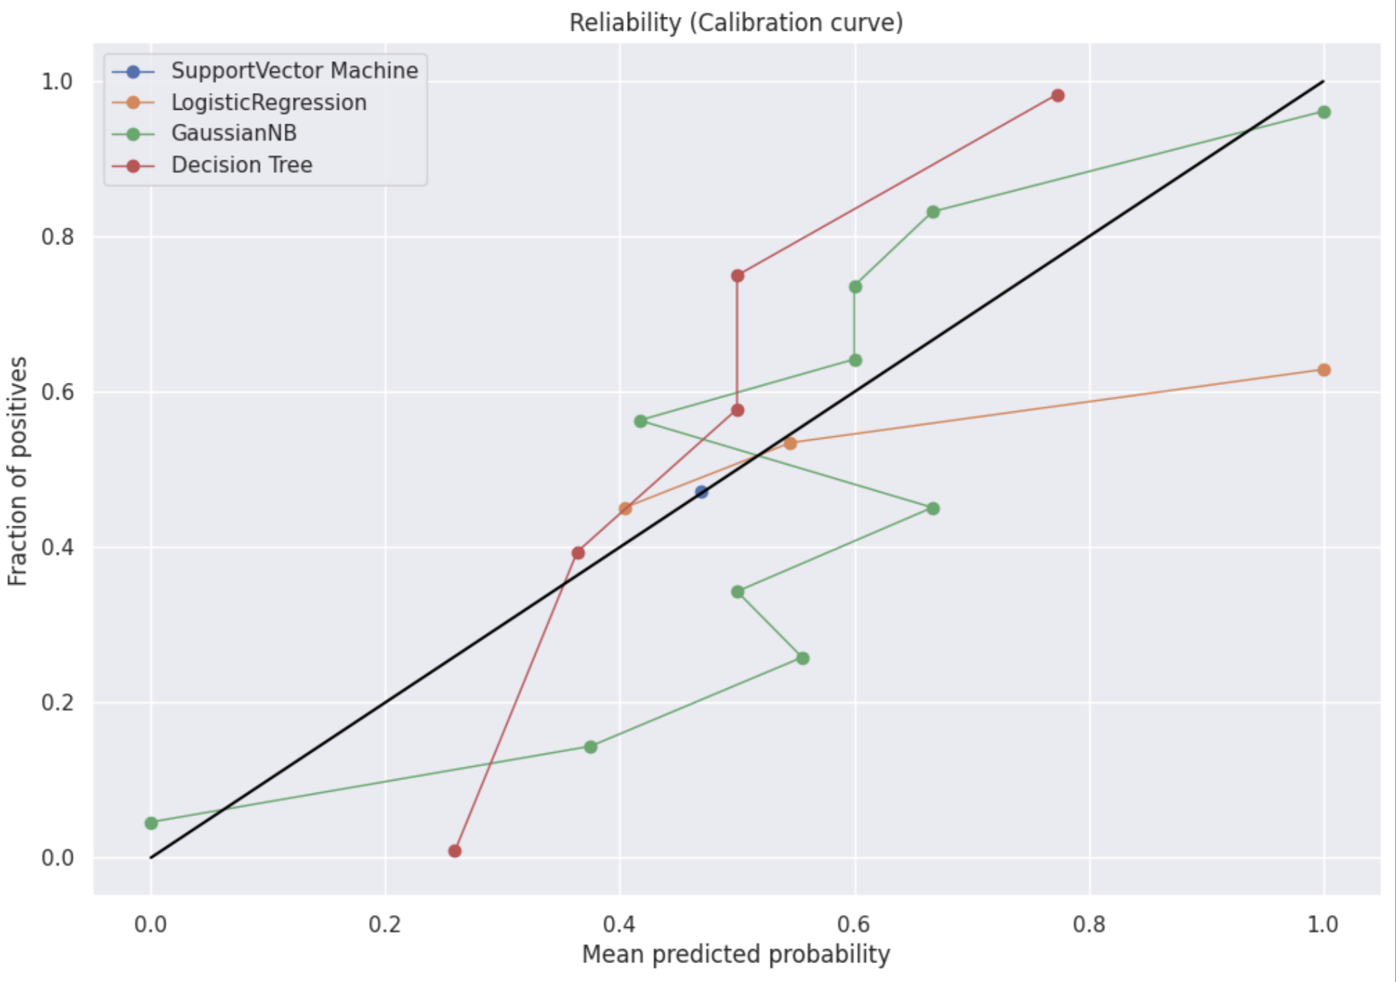

Accuracy for all the models

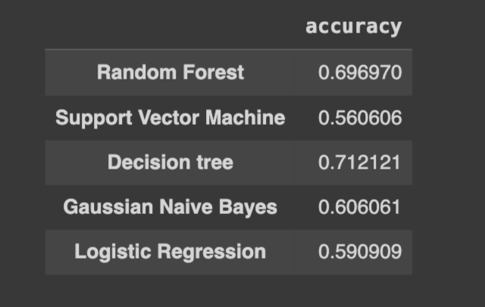

**Outputs for using the HOG and LBP Combined feature Extraction technique against various Models**

Area Under the Curve (AUC) scores from Receiver Operating Characteristic (ROC) curves for different classification models

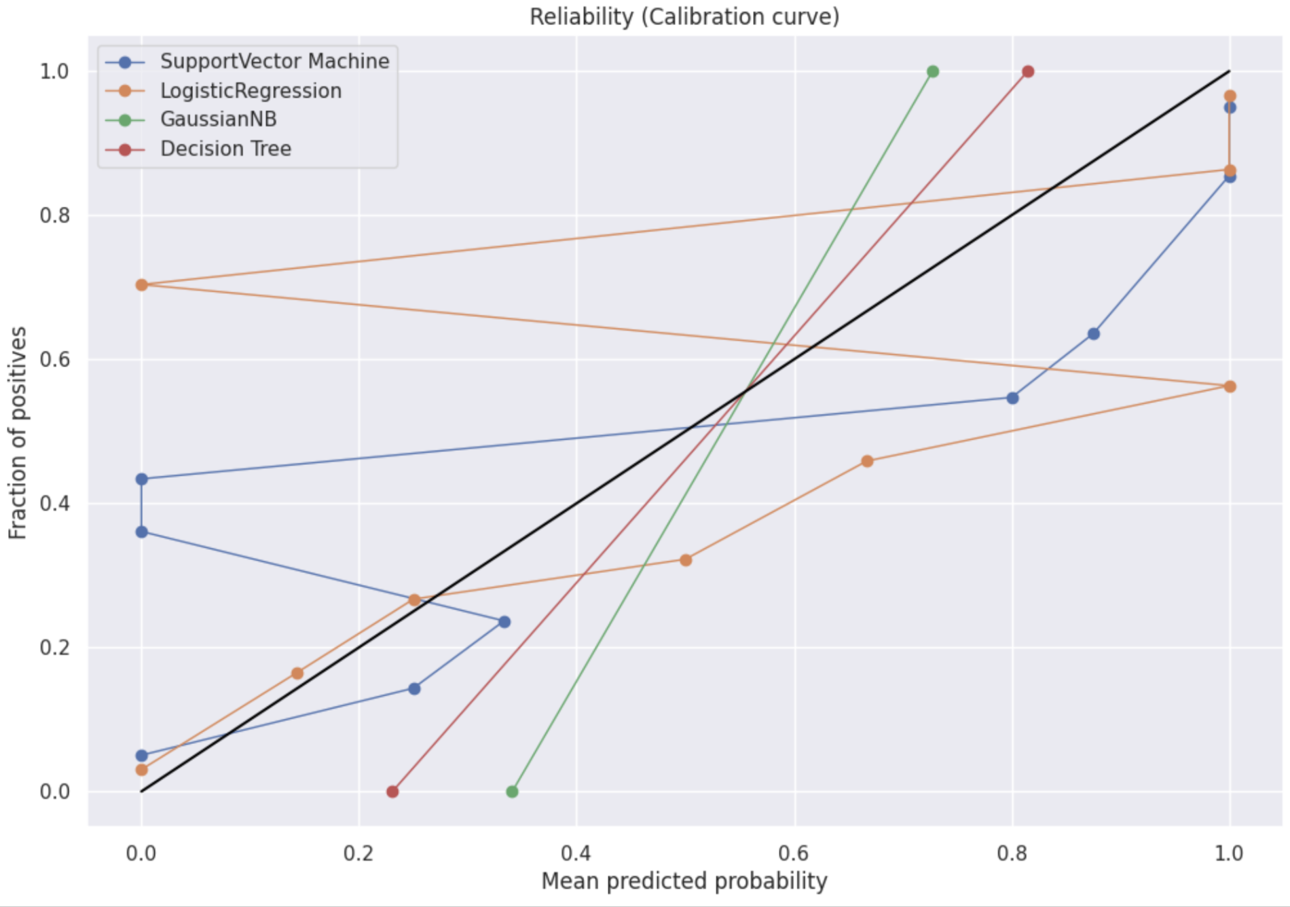

calibration curves for different classification models

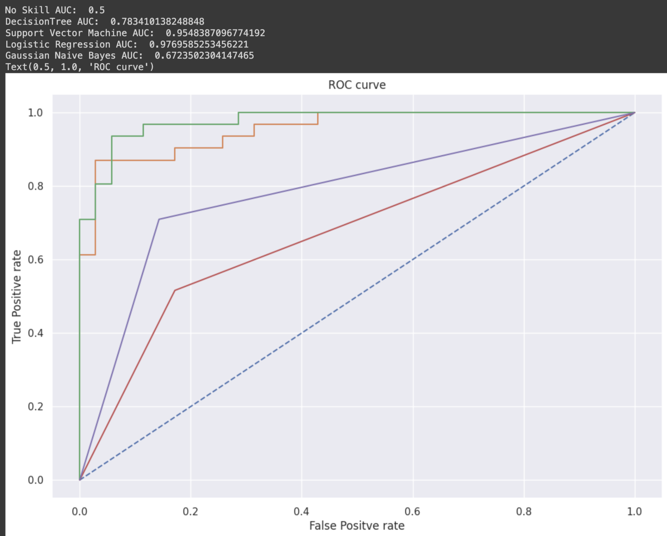

Accuracy for all the models

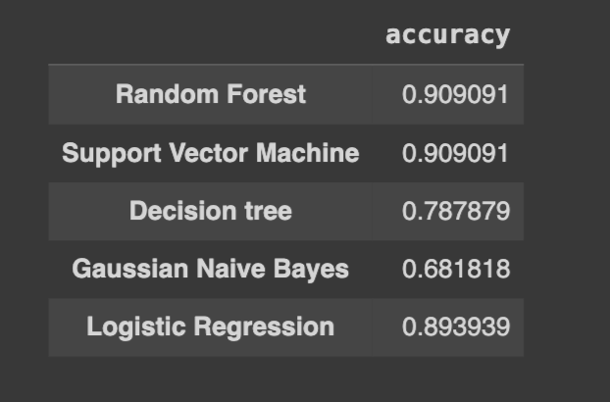

**Project Management:**

There are several important aspects to take into account when it comes to project management for Parkinson's disease detection using handwriting datasets project. The project should be carefully planned, with the goals, objectives, and schedule outlined. Make a timetable, decompose the work, and determine the resources that are required. After that, make sure ethical requirements are satisfied by gathering a representative and varied dataset of handwriting samples from those who have Parkinson's disease and those who do not. Preprocess the acquired data by normalizing the samples, lowering noise, and resizing the pictures.

When the data is prepared, take note of significant traits by extracting pertinent features (e.g., Haralick features) from the handwriting samples. Next, apply strategies such as feature selection to identify the most informative characteristics to enhance the model's functionality. Using the labeled dataset, create a classification model (such as SVM or neural networks) and train it. Utilize measures like accuracy, precision, recall, and F1-score to assess the model's performance. If necessary, iterate through the model and feature selection. Make notes about our progress, procedures, and conclusions while you work on the project. Prepared a thorough report that includes a summary of the project's goals, approach, findings, and recommendations. Collaboration and effective communication among team members are essential for project management success. Monitor your progress often, deal with obstacles, and make any adjustments to your strategy.

**Implementation Status Report**

**Work completed:**

At this point in the project, we have finished several procedures that prepare machine learning models for Parkinson's disease identification utilizing handwriting datasets. Initially, we gathered a wide range of handwriting samples from people who had Parkinson's disease and those who did not. We took care to gather data following ethical standards. After that, we preprocessed the data by normalizing the samples, eliminating noise, and shrinking the photos. This aided in getting the data ready for additional examination.

Following preprocessing, we used the handwriting samples to extract pertinent attributes. These traits and patterns in the handwriting are captured by these aspects. Then, employing strategies like feature selection, we determined which traits were the most instructive. By removing superfluous complexity, this step enhances the performance of our machine learning models.

To categorize the handwriting samples, we ultimately created machine learning models using neural networks and support vector machines (SVM). We used the labeled dataset to train these algorithms so they could identify patterns related to Parkinson's disease.

We are now assessing our models' performance using measures such as F1-score, recall, accuracy, and precision. This will enable us to evaluate the model's classification accuracy for newly discovered handwriting samples.

**Responsibility:**

* Jaynica Nunna: I am responsible for the data preprocessing in removing the duplicates from the dataset. I also performed one of the feature engineering techniques Local Binary Patterns (LBP). And I also got involved in the evaluation of machine learning models like decision trees. I also Involved in some part of the documentation and research.
* Mounika Vankayalapati: I am responsible for one of the feature engineering techniques Histogram and Oriented Gradients for the dataset we have chosen. And I also performed in the evaluation of the machine learning models Naive bayes to check the model performance. And I also Involved in some part of the documentation and research.
* Krishna Prasad siddharadha mudunuri : I am responsible and involved in the data pre processing step for removing the duplicates in the columns and rows, in the dataset. I was also involved in one of the feature engineering techniques Histogram of Oriented Gradients (HOG) and Local Binary Patterns (LBP). And I also performed on a Support vector machine.
* Pavithra namburi : I am responsible and involved in the research part for the document and also involved in the documentation part. And I was also involved in the implementation of one of the feature engineering techniques Harlick features for the dataset. And I was also involved in the evaluation of the machine learning model performing Logistic Regression.

**Contributions:**

**Jaynica Nunna:** I contributed in some part of the documentation part and in feature engineering technique LBP and on performing decision trees.

**Mounika vankayalapati:** I contributed to researching the information on this topic and one feature engineering technique HOG and on performing Naive bayes.

**Krishna Prasad siddharadha mudunuri:** I contributed in the data pre processing part and on one feature engineering technique HOG and LBP and also performed on SVM.

**Pavithra Namburi :** I contributed to the research part to gather useful information which helps our project. And also in one feature engineering technique harlick features and performed machine learning model Logistic regression.

**Work to be completed:**

We still have more work to perform on Parkinson's disease identification using the handwriting datasets project.

Adding new feature extraction techniques like Fourier Descriptors, Wavelet Transforms, Shape Context, Gabor filters, Principal Component Analysis, Autoencoders, T-Distributed Stochastic Neighbour Embedding, Skeletal Feature Extraction, Geometric Feature Extraction and trying to use combinations of them to find the best output is one area we can concentrate on. We can investigate several handwriting sample features that can yield useful information for diagnosing Parkinson's disease.

To have a more thorough grasp of our models' performance in terms of performance metrics, we might think about adding more assessment tools. We can investigate measures like area under the receiver operating characteristic curve (AUC-ROC) or Cohen's kappa coefficient in addition to accuracy, precision, recall, and F1-score. We can improve our Parkinson's disease detection algorithms' accuracy and resilience by adding more characteristics and ‘performance indicators.

**Responsibility:**

**Jaynica Nunna** : I am trying to implement the new feature engineering techniques to get more accurate knowledge on the dataset to help detect the disease. And also trying to implement some more evaluation metrics.

**Mounika vankayalapati** : I will try to implement one of the feature engineering techniques and try to add more characteristics and performance indicators.

**Krishna Prasad siddharadha mudunuri**: I will try to implement another feature engineering technique to get more clarification on this and try to implement with more evaluation metrics to compare with other techniques.

**Pavithra Namburi :** I will also try to implement feature engineering technique and the Cohen's Kappa coefficient for the evaluation metrics and observe with other techniques.

**Issues or Concerns:**

Feature Selection: It might be difficult to decide which of the handwriting samples' qualities are the most instructive. The elements that best depict the pertinent patterns and traits of Parkinson's disease must be carefully chosen.

Overfitting: When our machine learning models work well on training data but don't generalize to fresh, untested data, this is known as overfitting. To avoid overfitting, it's crucial to use strategies like regularization and cross-validation.

**References:**

1. Impedovo, D., Pirlo, G. and Vessio, G., 2018. Dynamic handwriting analysis for supporting earlier Parkinson’s disease diagnosis. Information, 9(10), p.247.

2. Impedovo, D. and Pirlo, G., 2018. Dynamic handwriting analysis for the assessment of neurodegenerative diseases: a pattern recognition perspective. IEEE Reviews in Biomedical Engineering, 12, pp.209-220.

3. Khandokar, I., Hasan, M., Ernawan, F., Islam, S. and Kabir, M.N., 2021, June. Handwritten character recognition using convolutional neural networks. In Journal of Physics: Conference Series (Vol. 1918, No. 4, p. 042152). IOP Publishing.

4.Das, D., Nayak, D.R., Dash, R. and Majhi, B., 2020. MJCN: Multi-objective Jaya Convolutional Network for handwritten optical character recognition. Multimedia Tools and Applications, 79, pp.33023-33042.

5.Eltay, M., Zidouri, A., Ahmad, I. and Elarian, Y., 2022. Generative adversarial network based adaptive data augmentation for handwritten Arabic text recognition. PeerJ Computer Science, 8, p.e861.

6.Madane, V., Ovhal, K. and Bhong, M., 2020. Handwriting recognition using artificial intelligence neural networks and image processing.

7.N. Chumuang and M. Ketcham, "Model for Handwritten Recognition Based on Artificial Intelligence," 2018 International Joint Symposium on Artificial Intelligence and Natural Language Processing

8.P. C. Vashist, A. Pandey and A. Tripathi, "A Comparative Study of Handwriting Recognition Techniques," 2020 International Conference on Computation, Automation and Knowledge Management (ICCAKM).