PENETRATION TESTING REPORT
FOOTPRINTING & NETWORK SCANNING PHASES
W2-PM-FINAL | CYBERSECURITY | NETWORKWALKS
Pentester Name  (Cybersecurity Professional) | Joseph Victor Ese-Osa
Program/Batch | B082-Networkwalks
Date | 17 August 2026
Modules completed | W2-PM1 (Multiple Kali Tools)  W2-PM2(GHDB-Based Footprinting)  W2-PM3(Maltego-Based Footprinting)  W2-PM4(theHarvester Footprinting)  W2-PM5 (Zenmap Scanning)
Client/Target | - Networkwalks (secured written permission already)  - Microsoft(for harvester)  2. My own local LAN Network
Permission secured from client? | Yes
Phases covered | Phase 1: Reconnaissance & Footprinting  Phase 2: Scanning & Network Discovery  Phase 3-5: In Progress

1. Liability Disclaimer
All activities documented in this report were conducted for educational, research, and cybersecurity training purposes. Testing was limited to authorized targets, permitted public-information exercises, and my own isolated local lab network. No unauthorized access, exploitation, disruption, or credential attacks were performed. The techniques described are intended to demonstrate how reconnaissance and network discovery can be used to understand and improve security.

2. Introduction
Week 2 focused on the early stages of ethical hacking: footprinting, reconnaissance, OSINT, and network discovery. I worked through five practical modules using Kali Linux, Windows, and an isolated NAT Network. The exercises helped me understand not only how to run security tools, but also how to interpret the information they reveal and consider its security significance.
Module | Activity | Main Tool(s) | Target / Scope
W2-PM1 | Footprinting with Multiple Kali Tools | WHOIS, WhatWeb, nslookup, curl, WAFW00F, DNSRecon | networkwalks.com
W2-PM2 | GHDB-Based Footprinting | Google Hacking Database search operators | Publicly indexed resources
W2-PM3 | Maltego-Based Footprinting | Maltego CE | networkwalks.com
W2-PM4 | theHarvester Footprinting | theHarvester | microsoft.com – authorized lab exercise
W2-PM5 | Zenmap Network Scanning | Zenmap / Nmap | My isolated 10.0.0.0/24 NAT Network

3. Tools Used
Tool | Purpose
Kali Linux & Windows | Operating systems used for reconnaissance and analysis.
WHOIS | Gather domain registration information such as registrar, dates, and name servers.
WhatWeb | Fingerprint web technologies, server software, CMS, plugins, and client-side libraries.
nslookup | Resolve domain names to IP addresses using DNS.
curl -I | Inspect HTTP response headers returned by the website.
WAFW00F | Identify whether a Web Application Firewall is detectable.
DNSRecon | Enumerate DNS records and related infrastructure information.
GHDB | Use advanced search operators to identify publicly indexed information and resources.
Maltego | Perform visual OSINT and relationship mapping.
theHarvester | Collect publicly available emails, subdomains, hosts, and related information.
Zenmap (Nmap GUI) | Discover live hosts on the authorized local subnet.

4. Activities Performed

4.1 Footprinting and Reconnaissance

4.1.1 WHOIS
Achievement: Gathered publicly available domain registration information, including registrar details, registration dates, and name-server information.

4.1.2 WhatWeb
Achievement: Fingerprinted publicly detectable web technologies and components associated with networkwalks.com.
Findings:
- Web server: Apache
- CMS: WordPress 7.1
- Plugin: WordPress Download Manager 3.3.58
- Server IP: 192.232.216.135
- Client-side library: jQuery 3.7.1
- Public email observed during reconnaissance: info@networkwalks.com

4.1.3 nslookup
Achievement: Resolved networkwalks.com to its associated IP address.

4.1.4 curl -I
Achievement: Inspected the website's HTTP response headers and related publicly discoverable information.
Findings:
- The WordPress REST API was publicly discoverable through /wp-json/.
- The observed cookie included the HttpOnly flag, preventing direct JavaScript access to that cookie.
- Security-related headers including Permissions-Policy and Referrer-Policy were observed.

4.1.5 WAFW00F
Achievement: Detected the web application firewall technology identifiable from the target.
Finding: ModSecurity (SpiderLabs) was identified.

4.1.6 DNSRecon
Findings:
- HostGator-related name-server infrastructure was identified.
- cPanel was discoverable as part of the infrastructure footprint.
- Web and mail services appeared to share an IP address.
- An SPF policy was identified using the ~all SoftFail mechanism.

4.2 GHDB-Based Footprinting
The GHDB exercise demonstrated how advanced Google search operators can locate publicly indexed resources. The activity covered two areas: security-camera interfaces and mathematics PDF resources. No exploitation or unauthorized access was performed.
Security Camera Search
No. | Relevant Dork | Username /Password  (if any)
1 | intitle:"webcamXP" inurl:8080 | ---
2 | intitle:"WebcamXP" | ---
3 | VB Viewer inurl:/viewer/live/ja/live.html | ---
4 | VB Viewer inurl:/viewer/live/ja/live.html | ---
5 | intitle:"WebCamXP 5" | ---
6 | intitle:"WebCamXP 5" | ---
7 | intitle:"WebCamXP 5" | ---
8 | intitle:"WebCamXP 5" | ---
9 | inurl:/view.shtml | ---
10 | inurl:"view.shtml" "Network Camera" | ---

Finding: Multiple publicly indexed results associated with WebCamXP, VB Viewer, and network-camera interfaces were identified. Sensitive IP addresses, live camera URLs, and credentials were deliberately redacted from the public report.
- Mathematics PDF Search
No. | Link | Relevant Dork | Username /Password  (if any)
1 | https://ncm.gu.se/wp-content/uploads/2020/06/10_34_043064_johansson.pdf | filetype:pdf intitle:"Mathematics textbook" | ---
2 | https://www.vaccination.gov.ng/browse/bRsAya/275032/N3_Mathematics__Textbook.pdf | filetype:pdf intitle:"Mathematics textbook" | ----
3 | https://www.siyavula.com/downloads/books/maths/Gr10_Mathematics_Learner_Eng_v11.pdf | filetype:pdf intitle:"Mathematics textbook" | ----
4 | https://www.cambridge.org/gh/files/5716/0223/9119/Essential_Mathematics_Primary_3_Teachers_Guide_9789988897352AR.pdf | filetype:pdf intitle:"Mathematics textbook | ---
5 | https://discrete.openmathbooks.org/pdfs/dmoi4.pdf | filetype:pdf intitle:"Mathematics textbook | ----
6 | http://www.uop.edu.pk/ocontents/AdvancedEngineeringMathematics.pdf | filetype:pdf intitle:"Mathematics textbook | ----
--7 | https://fresh-teacher.github.io/p5/P_5-PRIMARY-FIVE-MATHEMATICS-NOTES%20TERM%201%20-3.pdf | filetype:pdf intitle:"Mathematics textbook | ----
8 | https://ia800705.us.archive.org/24/items/basic-mathematics-serge-lang_20240418/Basic%20Mathematics%20-%20Serge%20Lang.pdf | site:archive.org mathematics textbook filetype:pdf | -----
9 | https://dn790001.ca.archive.org/0/items/unifiedmathemati00karpiala/unifiedmathemati00karpiala.pdf | site:archive.org mathematics textbook filetype:pdf | -----
10 | https://cis.temple.edu/~latecki/Courses/CIS2166-Fall25/RosenDiscreteMath8Ed.pdf | site:edu filetype:pdf mathematics textbook | -----

Finding: The searches returned publicly accessible mathematics textbooks, lecture materials, teachers' guides, and other educational PDFs. These were treated as public educational resources rather than security vulnerabilities.

4.3 Maltego Footprinting
Maltego CE was used to investigate whether publicly available email information related to networkwalks.com could be identified.
- Launched Maltego CE on Windows.
- Created a new investigation graph.
- Added networkwalks.com as the starting Domain entity.
- Selected the Email Address transform.
- Executed the available transform and reviewed the resulting entities.
Result: One email address associated with networkwalks.com was identified. The exercise also demonstrated how Maltego can visually map relationships between entities.

4.4 theHarvester Footprinting
theHarvester was used to gather publicly available information associated with microsoft.com as part of the authorized training exercise.
Baidu search findings:
Category | Finding
IP Addresses | 0
Email Addresses | 0
People | 0
Hosts | 0
All-source search findings:
Category | Finding
ASNs | 8
Interesting URLs | 2
LinkedIn | No results
IP Addresses | 122
Email Addresses | 3
Hosts | 9,968

4.5 Zenmap Network Scanning
Zenmap was used from Kali Linux to perform a ping scan against my isolated NAT Network. The purpose was to identify live hosts within the authorized lab environment.
Scan Detail | Value
Tool | Zenmap (Nmap GUI)
Operating System | Kali Linux
Scan Type | Ping Scan
Target | 10.0.0.0/24
Network | NAT Network (Networklab)
Four live hosts were identified:
IP Address | Identified Device
10.0.0.1 | Network Gateway
10.0.0.2 | Kali Linux
10.0.0.4 | Windows 8
10.0.0.6 | Windows 10
Zenmap displayed two distinct MAC addresses and device/vendor names where available. No ports were listed because the activity was a ping scan rather than a port scan. The scan completed without errors.

5. Risk Analysis / Impact
# | Risk / Finding | Evidence / Observation | Potential Impact | Risk Level
1 | Web technology information exposed | WhatWeb identified Apache, WordPress 7.1, WordPress Download Manager 3.3.58, and jQuery 3.7.1. | Exposed technology and version information can help an attacker identify relevant weaknesses and plan further reconnaissance. | Medium
2 | Server IP address identifiable | nslookup resolved networkwalks.com to 192.232.216.135. | Reveals the network location of the web service and contributes to the organization's infrastructure footprint. | Low
3 | HTTP and API information exposed | curl -I revealed HTTP response headers and the publicly discoverable WordPress REST API endpoint /wp-json/. | This information can assist technology fingerprinting and further enumeration of the website. | Low
4 | WAF technology identifiable | WAFW00F identified ModSecurity (SpiderLabs). | Reveals information about the defensive technology protecting the web application, which may help an attacker understand the security architecture. | Low
5 | DNS infrastructure information exposed | DNSRecon identified nameserver, mail, SPF, and other DNS-related records. | Public DNS information can be combined to build a broader picture of the organization's infrastructure. | Medium
6 | cPanel publicly identifiable | DNS reconnaissance indicated that cPanel was exposed/discoverable. | An externally accessible administrative interface increases the visible attack surface and could attract credential-based attacks. | Medium
7 | SPF SoftFail configuration | DNS enumeration identified an SPF policy using the ~all SoftFail mechanism. | May provide weaker protection against certain email-spoofing scenarios compared with a stricter configuration. | Low–Medium
8 | Multiple live hosts on the lab network | Zenmap identified four live hosts on the authorized 10.0.0.0/24 NAT network. | Demonstrates that active devices within the same network can be discovered and mapped through network scanning. | Low
Overall Observation: These are reconnaissance observations rather than confirmed vulnerabilities. No exploitation or vulnerability validation was performed.

6. Recommendations
# | Recommendation | Purpose
1 | Keep WordPress, plugins, and client-side libraries regularly updated. | Reduces exposure to known vulnerabilities in outdated software components.
2 | Review publicly exposed web-server and technology information. | Minimizes unnecessary information disclosure that could assist technology fingerprinting.
3 | Review the public availability of the WordPress REST API. | Ensure that only information intended for public access is exposed through the API.
4 | Restrict access to cPanel where possible. | Reduces exposure of the administrative interface to unauthorized users and automated attacks.
5 | Review DNS records and remove unnecessary publicly exposed records. | Reduces the amount of infrastructure information available during reconnaissance.
6 | Review and strengthen the SPF configuration. | Helps improve protection against email spoofing and impersonation.
7 | Continue using appropriate security headers and review their configuration regularly. | Helps strengthen browser-side security and reduce unnecessary information exposure.
8 | Maintain an inventory of devices on the internal network. | Ensures that all discovered hosts are known, authorized, and properly secured.
9 | Segment sensitive systems and administrative services from general network access. | Limits what an attacker can discover or reach if one device on the network is compromised.
10 | Perform periodic external footprinting and internal network discovery. | Helps identify newly exposed services, infrastructure, and devices before attackers discover them.

Evidences Collected

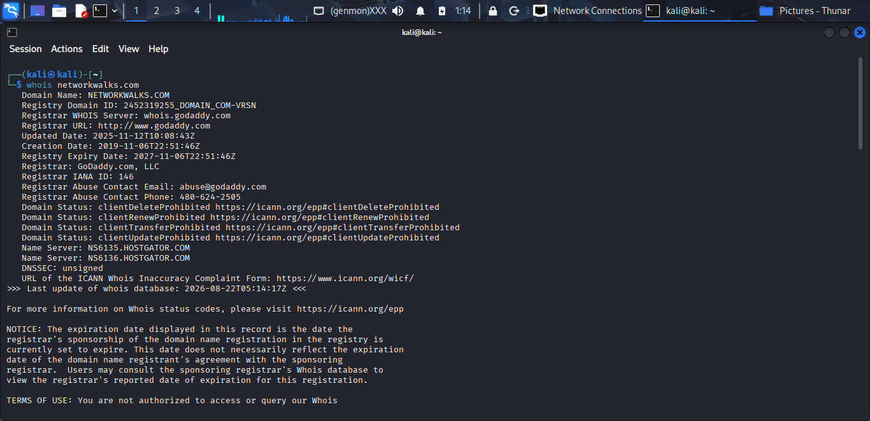

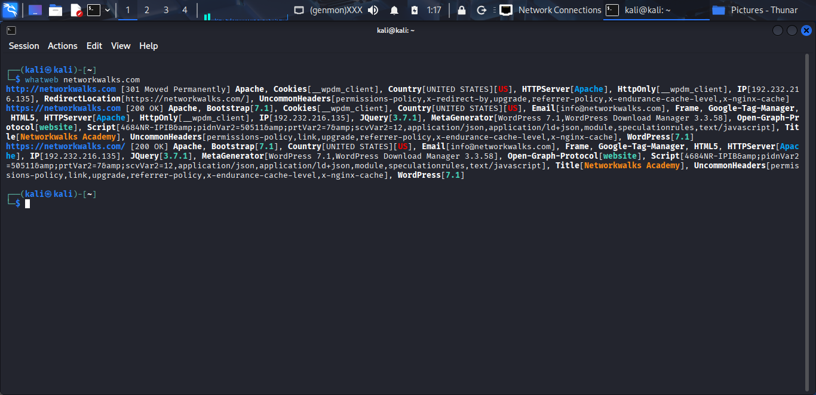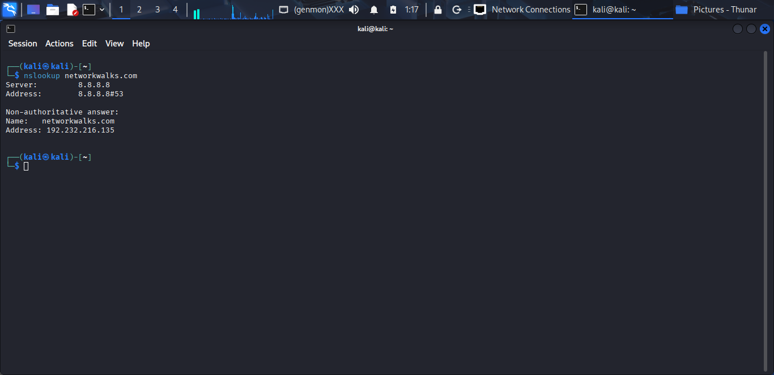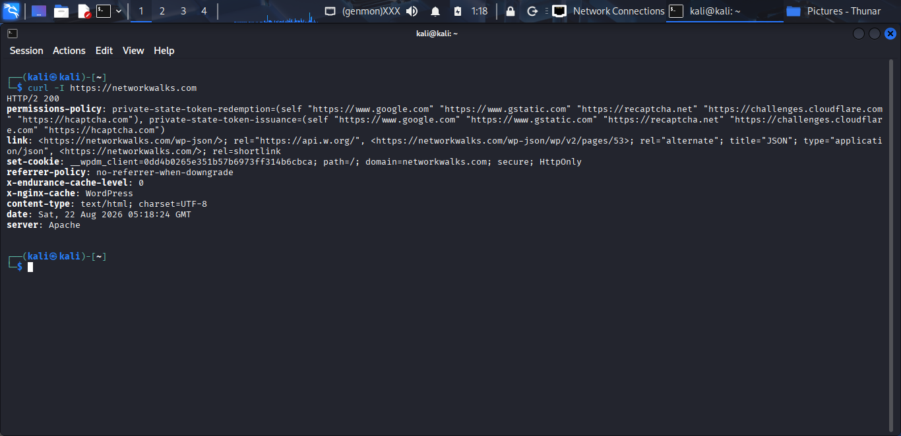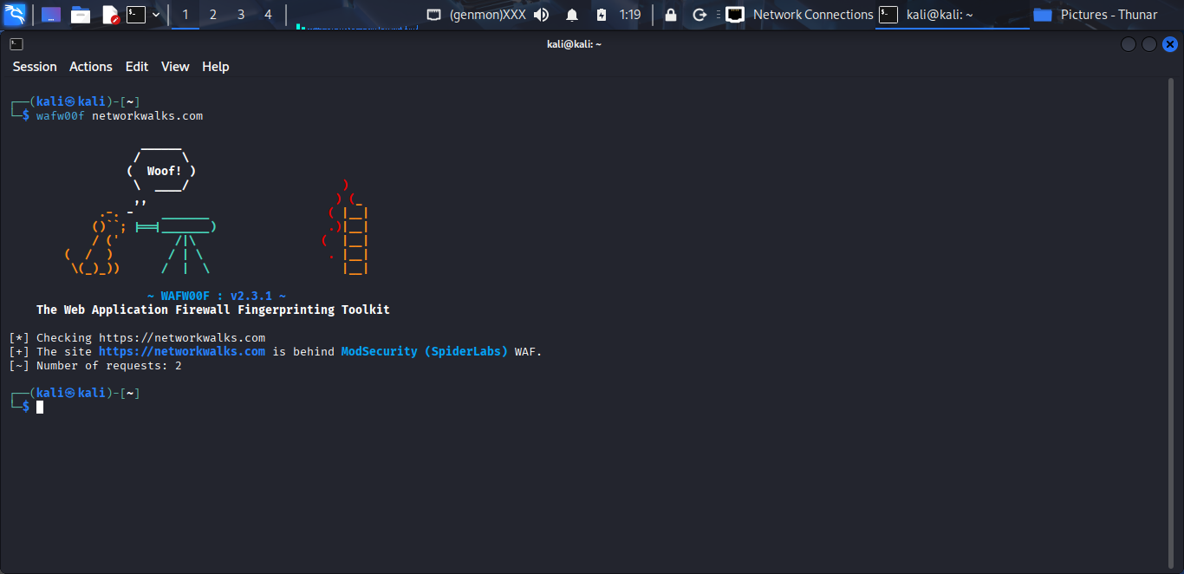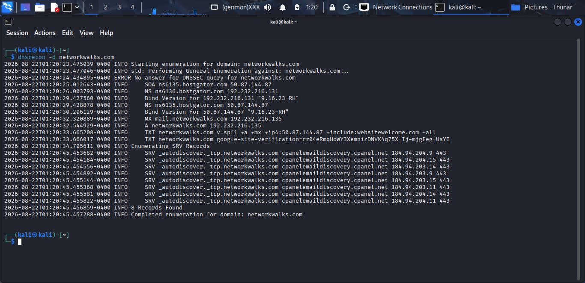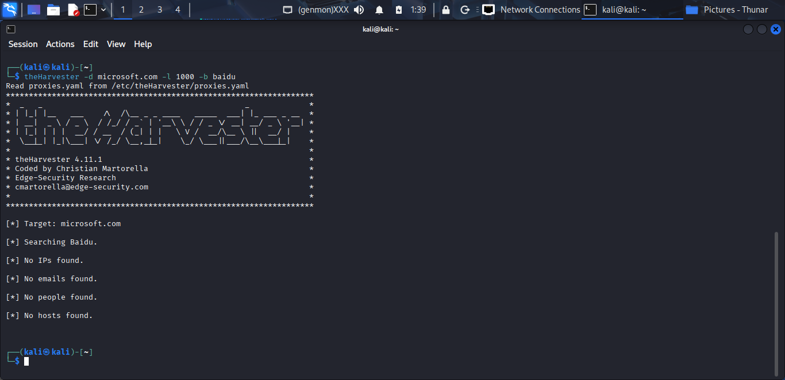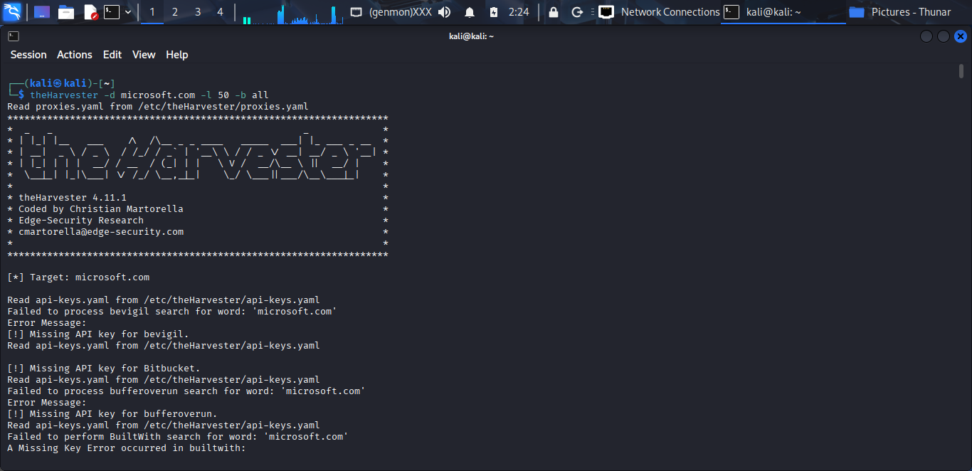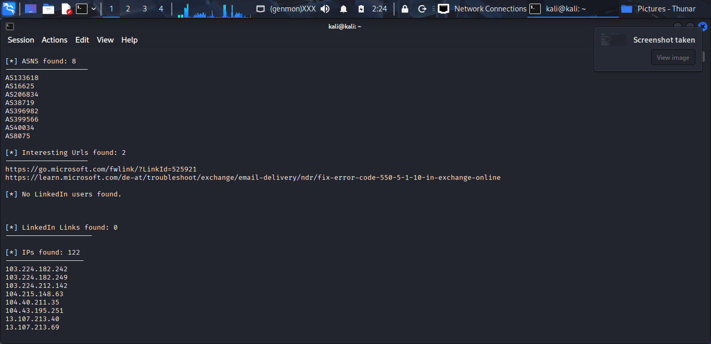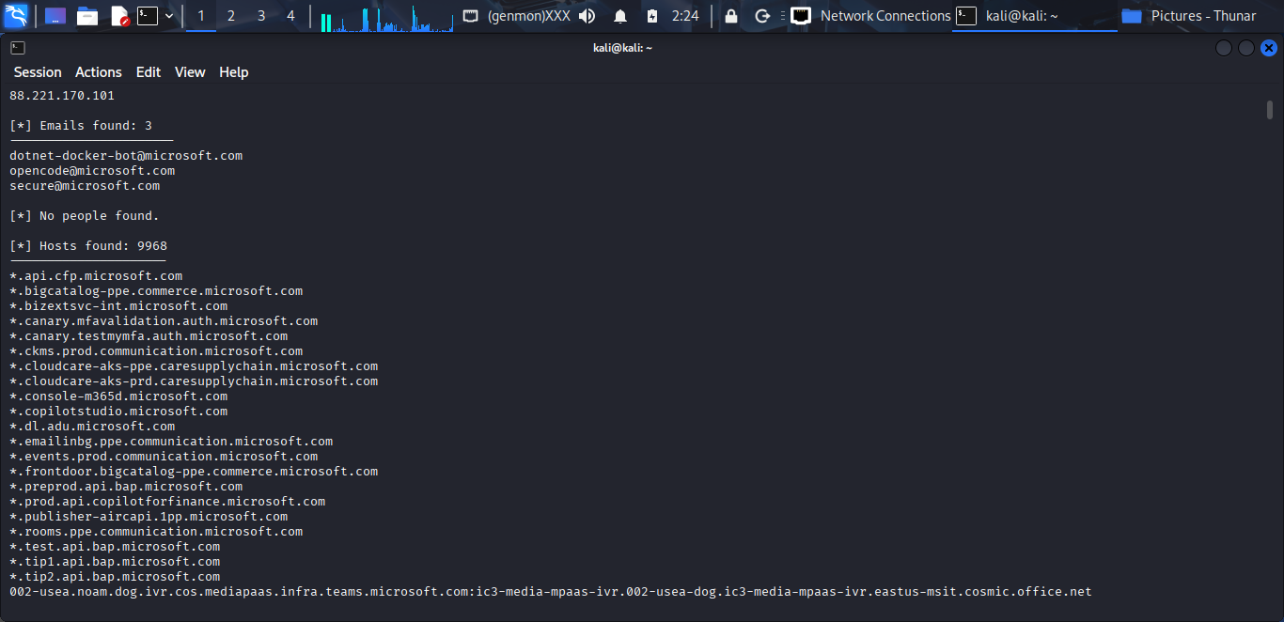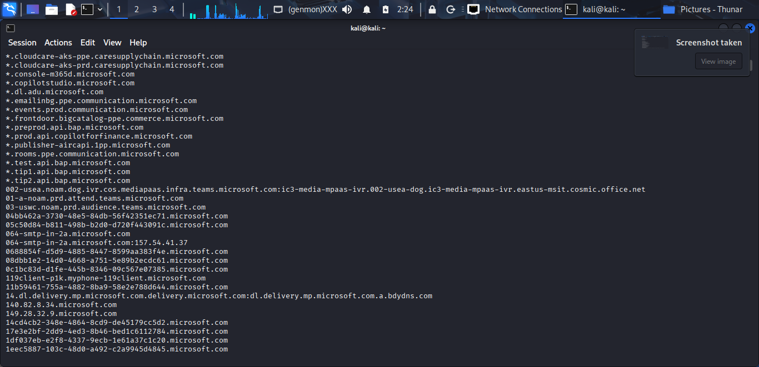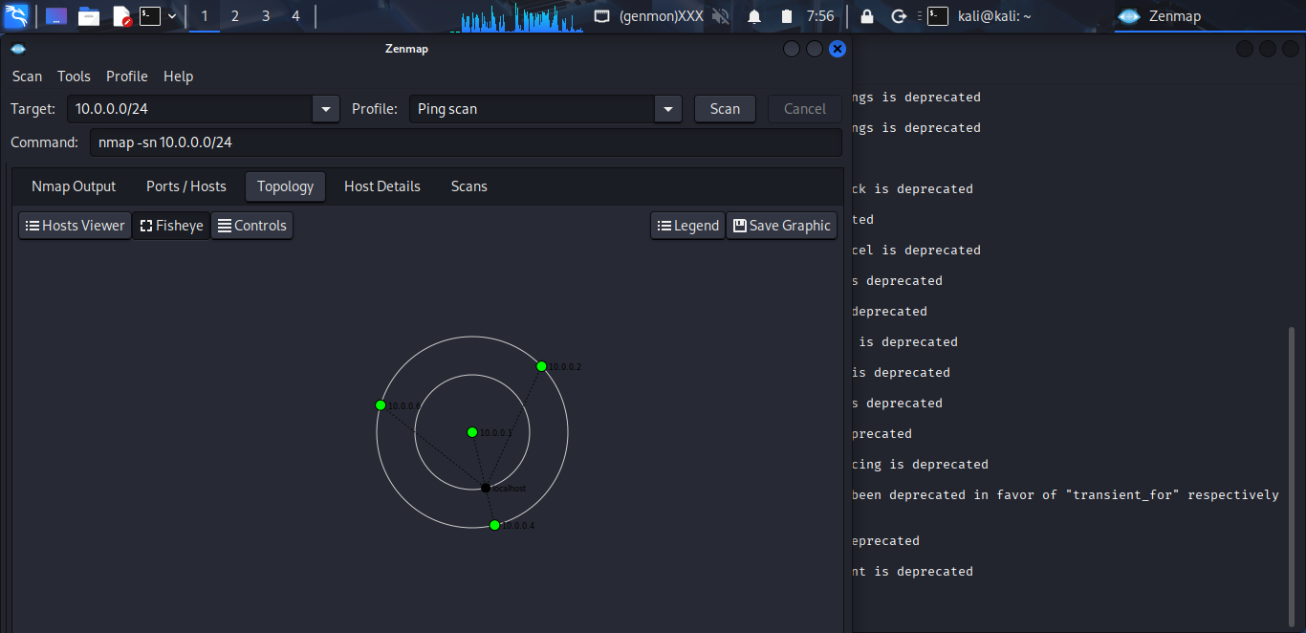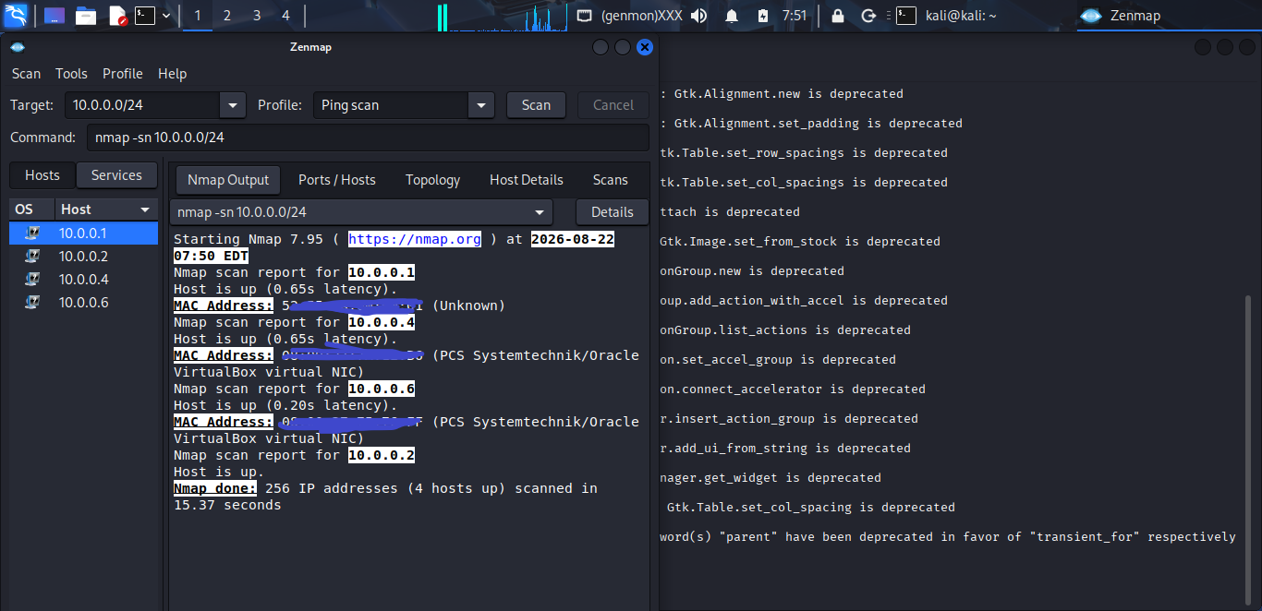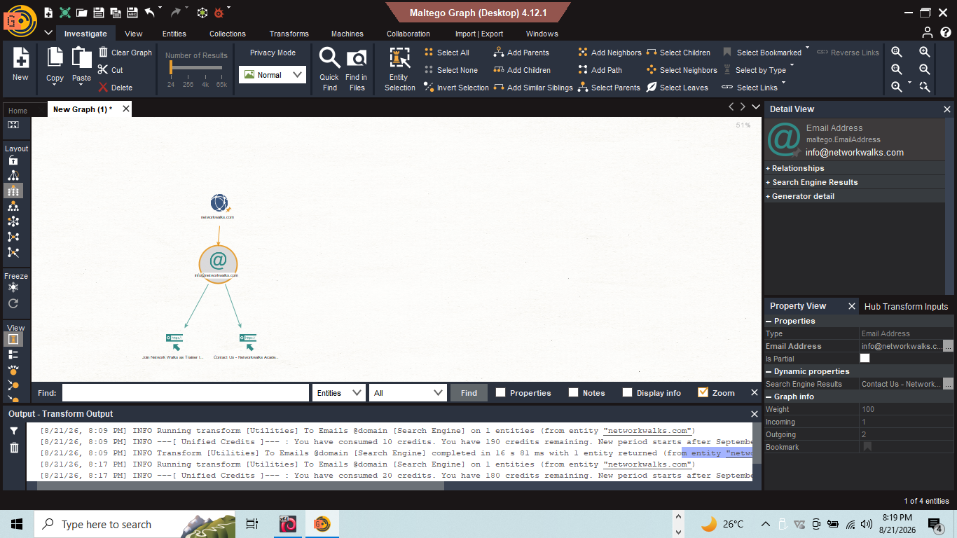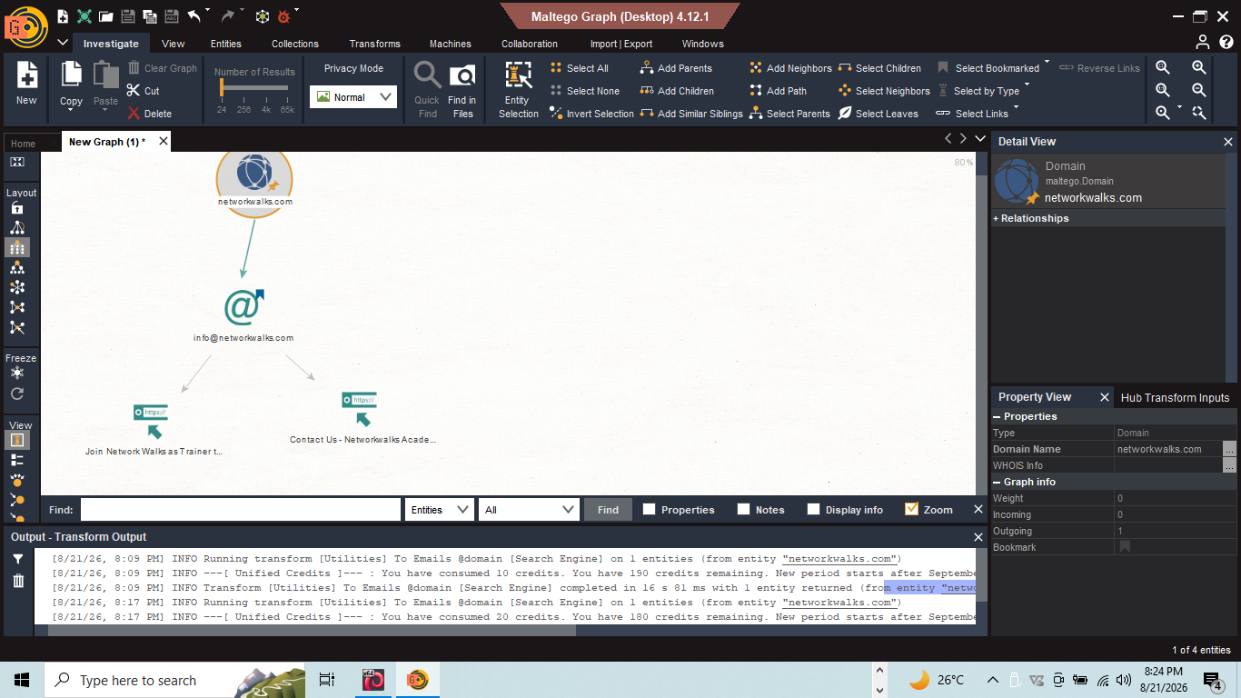

8. Conclusion
Week 2 gave me a more practical understanding of what happens before an actual attack begins. Instead of focusing on exploitation, I learned how much information can already be discovered through simple footprinting and reconnaissance techniques.
Using WHOIS, WhatWeb, nslookup, cURL, WAFW00F, DNSRecon, GHDB, Maltego, theHarvester, and Zenmap, I examined different parts of a target's digital footprint and learned to connect technical observations to their security significance.
One of the biggest lessons for me was that information that appears harmless on its own can become valuable when combined with other findings. The Zenmap exercise also helped me connect reconnaissance concepts to a real isolated lab by identifying live systems on my own network.
Overall, this week strengthened my understanding of reconnaissance as a foundation of penetration testing and showed me why organizations should regularly review what they expose publicly and internally. All activities were performed within the defined educational and authorized scope, with no unauthorized access or exploitation carried out.

