CT5198

Assignment 1

Jason Harney

12461932

Below you can see the output for the python code working as instructed. It asks the user to input a customer count value as an int for each day, it gives a total sum of the customer count value, then it gives the average over the 7 days rounded down to the next whole number as human beings cant be counted in decimal points. It also displays the maximum and minimum values over the 7 days and then prints each day and its corresponding customer count as input by the user.

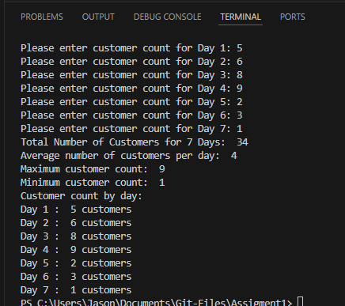

In the following screenshot you can see the cmd prompt commands that committed and pushed my python code file to GitHub.

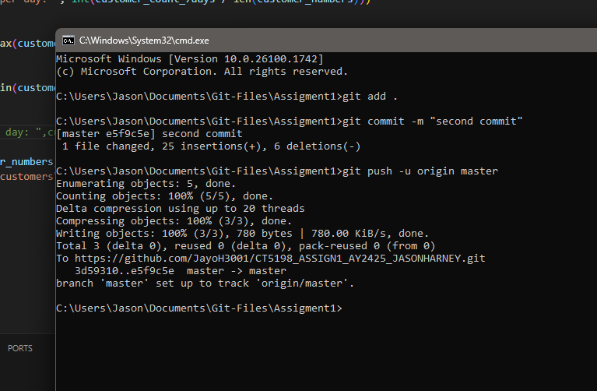

The public GitHub page for my file is at the following URL link: <https://github.com/JayoH3001/CT5198_ASSIGN1_AY2425_JASONHARNEY/blob/master/assignment_1_CT5198.py>