Q-1.

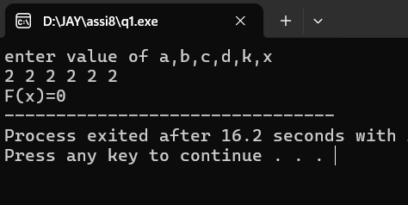

#include <stdio.h>

int main(){

int a,b,c,d,k,x;

printf("enter value of a,b,c,d,k,x \n");

scanf("%d %d %d %d %d %d",&a,&b,&c,&d,&k,&x);

if(x>k){

int f=a\*x\*x\*x-b\*x\*x+c\*x-d;

printf("F(x)=%d",f);

}

else if(x==k){

printf("F(x)=0");

}

else{

int f=-a\*x\*x\*x+b\*x\*x-c\*x+d;

printf("F(x)=%d",f);

}

return 0;

}

Q-2.

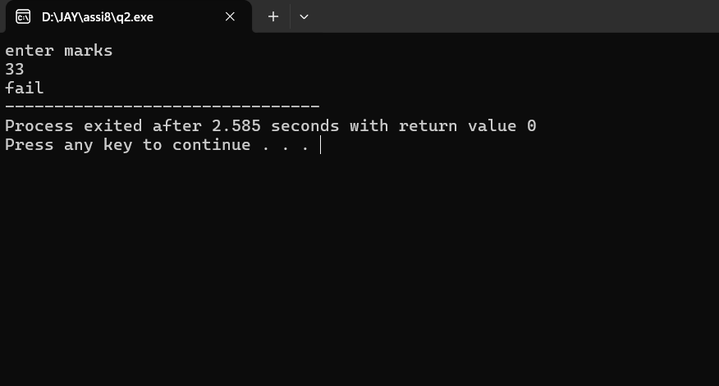

#include <stdio.h>

int main(){

int n;

printf("enter marks\n");

scanf("%d",&n);

if(n<0 || n>100){

printf("invalid input ");

}

else if(n>=80){

printf("Dinstinction");

}

else if(n>=60){

printf("First class");

}

else if(n>=35){

printf("second");

}

else{

printf("fail");

}

return 0;

}

Q-3.

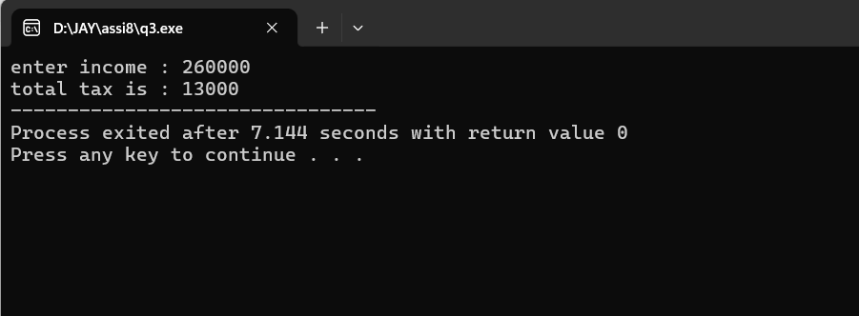

#include <stdio.h>

int main(){

int inc;

int tax;

printf("enter income : ");

scanf("%d",&inc);

if(inc>=250000&&inc<=500000){

tax = inc\*5/100;

}

else if(inc>500000 && inc<=1000000){

tax = 250000\*5/100+(inc-500000)\*20/100;

}

else if(inc>=1000000){

tax = 250000\*5/100 + 500000\*20/100 + (inc-1000000)\*30/100;

}

else{

printf("no tax applicable");

tax=0;

}

printf("total tax is : %d",tax);

return 0;

}

Q-4.

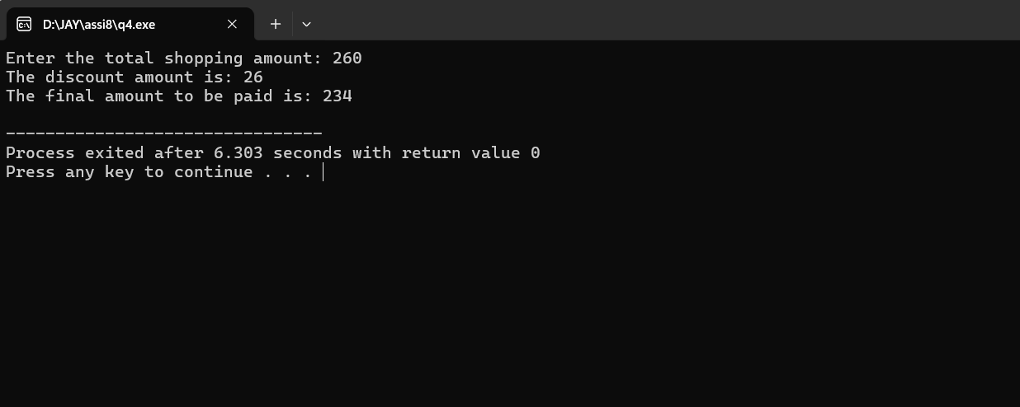

#include <stdio.h>

int main() {

int totalAmount, discount = 0.0, finalAmount;

printf("Enter the total shopping amount: ");

scanf("%d", &totalAmount);

if (totalAmount >= 100 && totalAmount <= 200) {

discount = totalAmount \* 0.05;

} else if (totalAmount > 200 && totalAmount <= 400) {

discount = totalAmount \* 0.10;

} else if (totalAmount > 400 && totalAmount <= 800) {

discount = totalAmount \* 0.20;

} else if (totalAmount > 800) {

discount = totalAmount \* 0.25;

}

finalAmount = totalAmount - discount;

printf("The discount amount is: %d\n", discount);

printf("The final amount to be paid is: %d\n", finalAmount);

return 0;

}

Q-5.

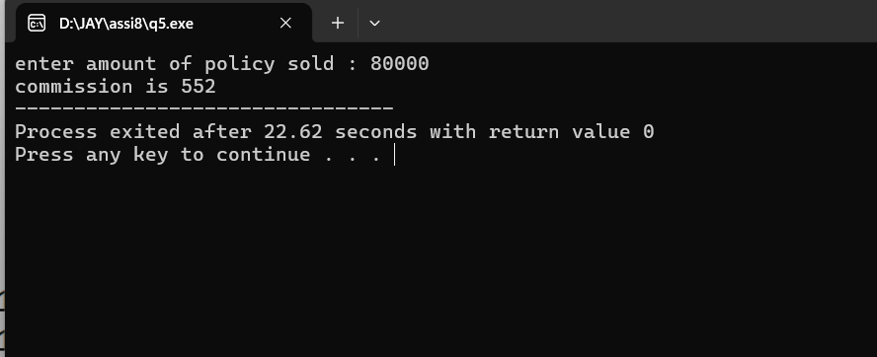

#include <stdio.h>

int main(){

int amount;

printf("enter amount of policy sold : ");

scanf("%d",&amount);

int commission;

if (amount <= 10000)

{ commission = amount \* 0.005;

}

else if (amount > 10000 && amount < 25000)

{

commission = 50 + (amount - 10000) \* 0.006;

}

else {

commission = 140 + (amount - 25000) \* 0.0075;

}

printf("commission is %d",commission);

return 0;

}

Q-6.

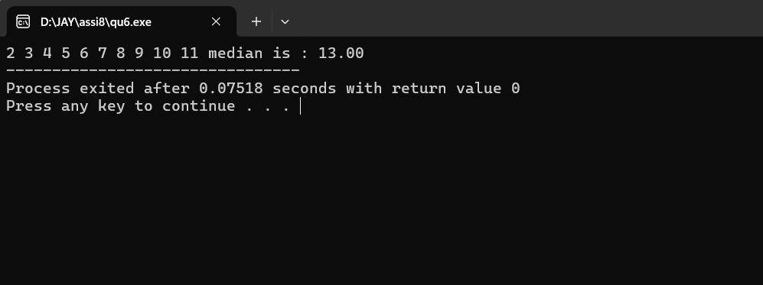

#include <stdio.h>

int main(){

int arr1[5]={5,3,6,7,8};

int arr2[5]={2,9,4,11,10};

int arr3[10];

float median;

for(int i=0;i<10;i++){

if(i<5){

arr3[i]=arr1[i];

}

else{

arr3[i]=arr2[i-5];

}

}

int n=10;

int count=0;

while(count<=n){

for(int j=0;j<n-1;j++){

if(arr3[j]>arr3[j+1]){

int temp=arr3[j];

arr3[j]=arr3[j+1];

arr3[j+1]=temp;

}

}

count++;

}

for(int k=0;k<10;k++){

printf("%d ",arr3[k]);

}

if(n%2==0){

median = arr3[(n/2)-1]+arr3[(n/2)];

}

else{

median = arr3[n/2];

}

printf("median is : %.2f",median);

return 0;

}

Q-7.

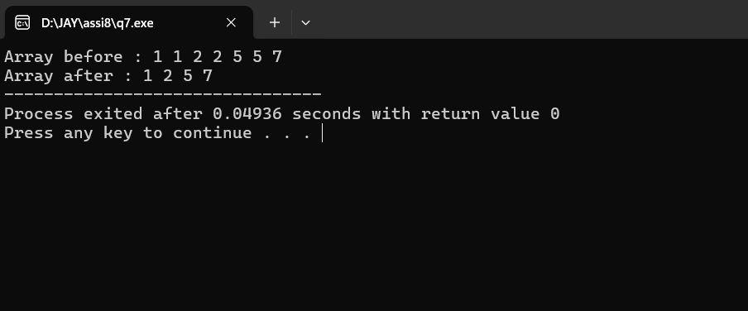

#include <stdio.h>

int main(){

int arr[7]={1,1,2,2,5,5,7};

printf("Array before : ");

for(int i=0;i<7;i++){

printf("%d ",arr[i]);

}

int j=0;

for(int i=1;i<7;i++){

if(arr[i]!=arr[j]){

j++;

arr[j]=arr[i];

}

}

printf("\nArray after : ");

for(int i=0;i<j+1;i++){

printf("%d ",arr[i]);

}

return 0;

}

Q-8.

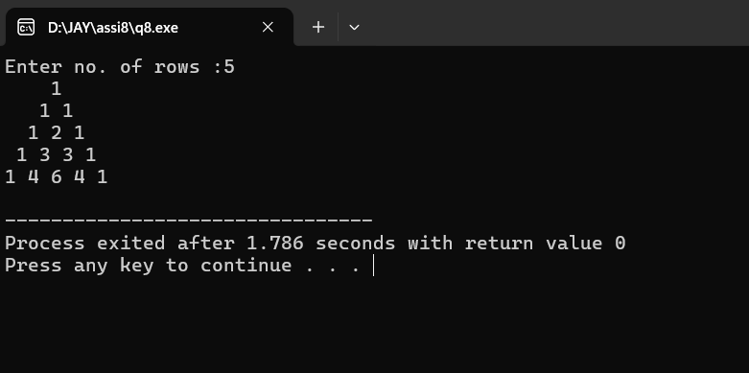

#include <stdio.h>

int com(int n,int m){

if(n==0 || m==0){

return 1;

}

if(m==n){

return 1;

}

int p=1;

for(int i=1;i<=n;i++){

p\*=i;

}

int q=1;

for(int i=1;i<=m;i++){

q\*=i;

}

int t=1;

for(int i=1;i<=(n-m);i++){

t\*=i;

}

return p/(t\*q);

}

int main(){

int r;

com(3,1);

printf("Enter no. of rows :");

scanf("%d",&r);

for(int i=0;i<r;i++){

for(int j=0;j<r-i-1;j++){

printf(" ");

}

for(int k=0;k<=i;k++){

printf("%d ",com(i,k));

}

printf("\n");

}

return 0;

}