**Q.1 Are the HTML tags and elements the same thing?**

**Ans:** Html tags are used to hold the HTML element. Html element is defined by a start tag, some content and end tag.

**Ex:** Tag: <h1>,<h2> etc.

Element: <h1>Hello</h1>

**Q.2 What are tags and attributes in HTML?**

**Ans:** Html tags are used to hold the HTML element. Html attributes are used to describe the characteristic of an Html element in detail.

Ex: <img src= “dog.jpg”> , here sorce of image is attribute name and “dog.jpg” is the attribute value.

**Q.3 What are void elements in Html? With example.**

**Ans:** A void element is an element whose content model never allows it to have contents under any circumstances.

Void elements have attributes.

Void elements cannot have content inside it.

Void elements do not have end tags.

Void elements cannot be nested.

Ex: br, hr,img,input

**Q.4 What are HTML entities? With Example**

**Ans:** Html entities are the reserved characters that are used in Html document. They are not present in your standard keyboard. They are provide a wide range of characters, allowing us to add icons, geometric shapes, mathematical signs etc.

**Ex:**

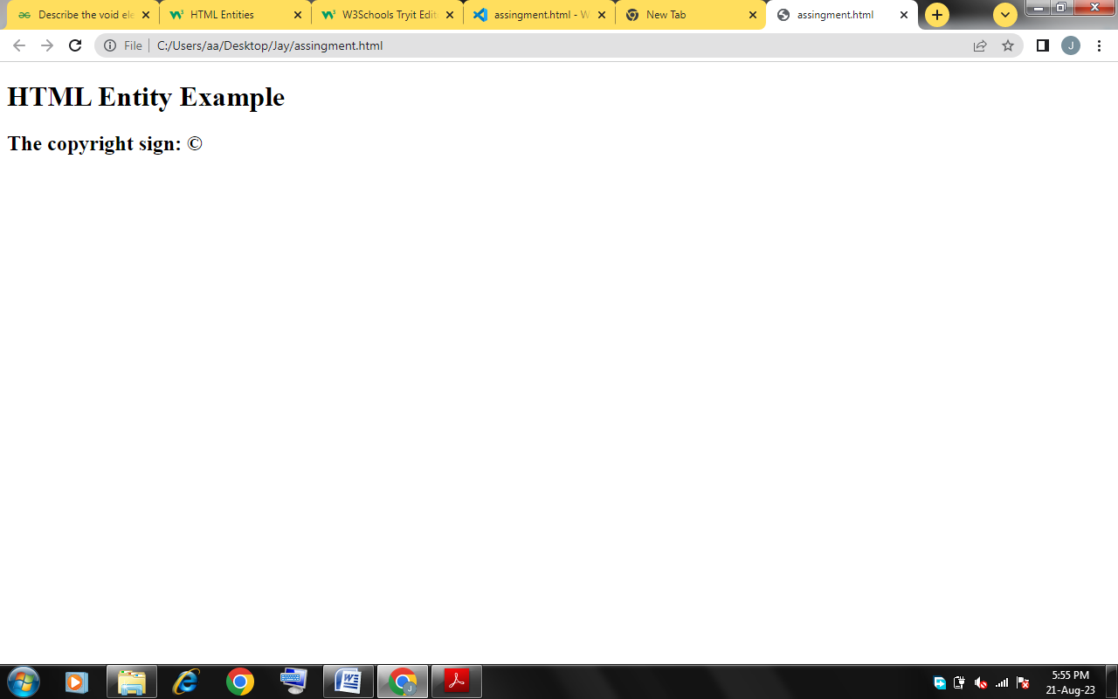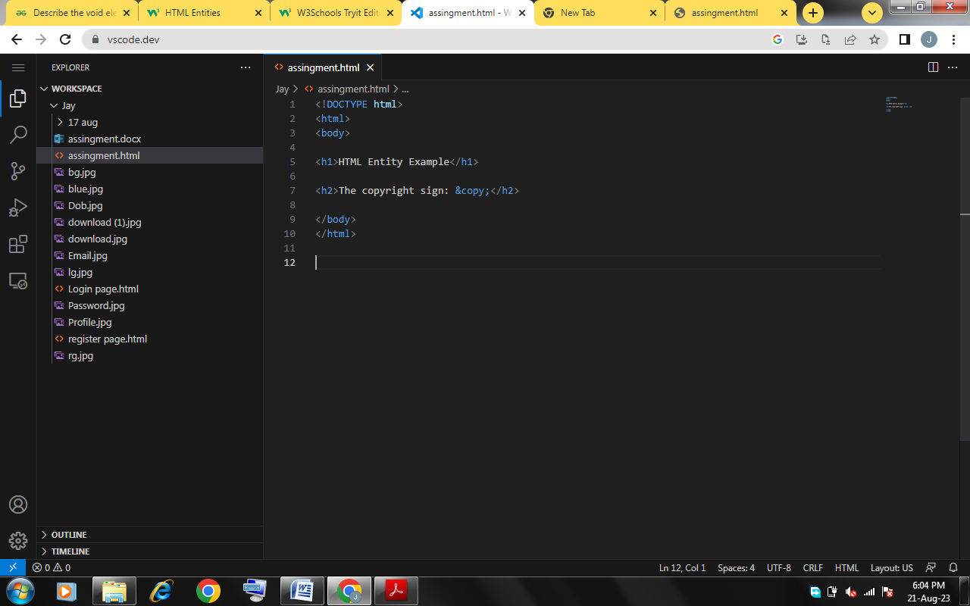

**Q.5 What are different types of lists in Html? With example.**

**Ans.** There are three types of list 1)Order list 2) Unorder list 3) Define list.

Order list - There are total 5 types of order list. Order list start with numbers by default. It can change to alphabets in capital and small letters and Roman number in capital and small.

Unorder list - There are 3 types of unorder list. Disc, circle and square.

Define list - Define list have define title and define description.

**Ex.**

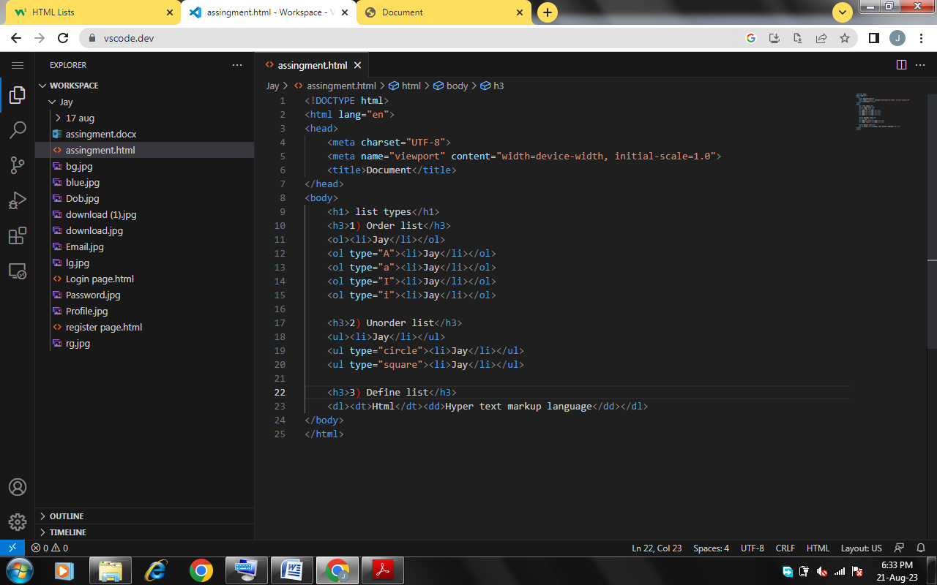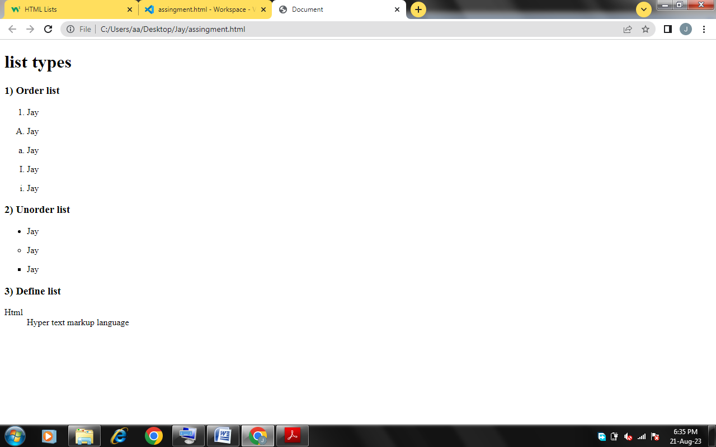

**Q.6 What is the class attribute in Html?**

**Ans:**

* The class is an attribute that specifies one or more class names for an HTML element.
* The class attribute can be used on any HTML element.
* The class name can be used by CSS and JavaScript to perform certain tasks for elements with the specified class name.

**Q.7 What is the difference between the ‘id’ attribute and the ‘class’ attribute of HTML elements?**

**Ans:**  The id attribute is a unique identifier that is used to specify the document. In CSS, the id attribute is written using the # symbol followed by id.

The class attribute is used to specify one or more class names for an HTML element. The class attribute can be used on any HTML element.The class name in CSS stylesheet using **“.”** symbol.

**Q.8 What are the various formatting tags in Html?**

**Ans:** HTML provides many predefined elements that are used to change the formatting of text. The formatting can be used to set the text styles (like – bold, italic, or emphasized, etc.), highlight the text, make text superscript and subscript, etc.

**Ex:** <b>,<strong>, <i>, <em>, <mark>, <del>, <ins> etc.

**Q.9 How is cell padding different from cell spacing ? with example.**

**Ans:** Cellpadding basically defines the space present between a table cell's border and the content present in it. Cellspacing basically defines the space present between individual adjacent cells.

**Ex.**

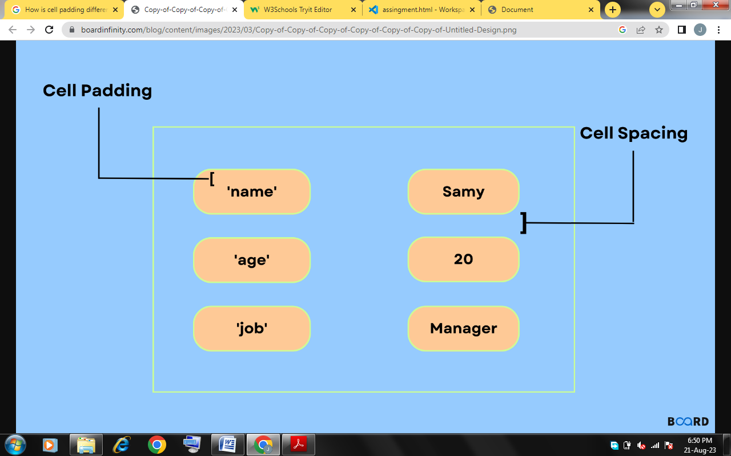

**Q.10 How can we club two or more rows or columns into a single row or column in an HTML table? With Example.**

**Ans:** We use the colspan and rowspan attribute, to merge cells in HTML. The rowspan attribute is for the number of rows a cell should merge, whereas the colspan attribute is for the number of columns a cell should merge. The attribute should be placed inside the <td> tag.

**Ex:**

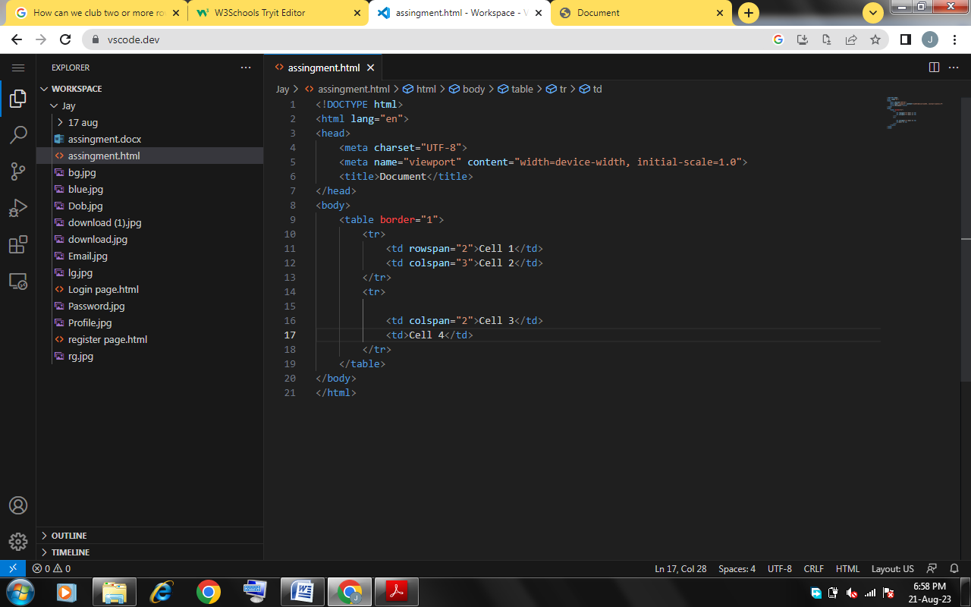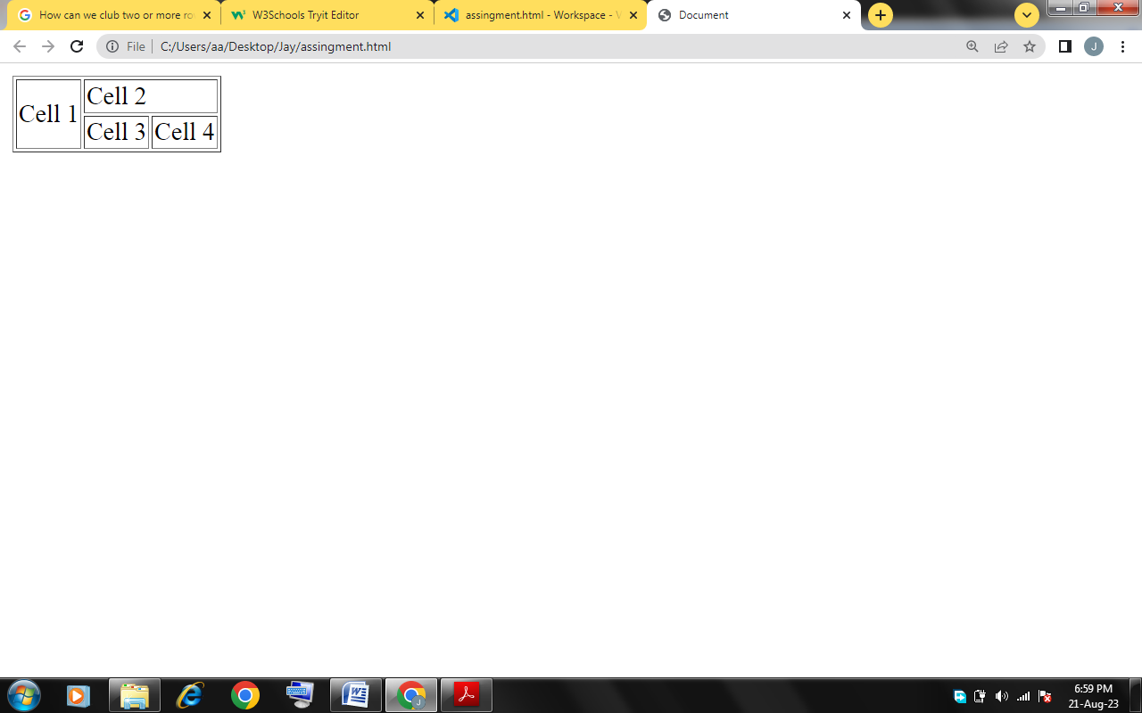

**Q.11 What is the difference between a block-level element and an inline element?**

**Ans:** Block level element use 100% width, inline element covers width according to requirement.

Ex. <h1> to <h6>, <p> are block level element.

<b>, <i>, <u> are inline element.

**Q.12 How to create a Hyperlink in HTML? With Example.**

**Ans:** To make a hyperlink in an HTML page, use the <a> and </a> tags, which are the tags used to define the links. The <a> tag indicates where the hyperlink starts and the </a> tag indicates where it ends. Whatever text gets added inside these tags, will work as a hyperlink. Add the URL for the link in the <a href=” ”>.

**Ex.**

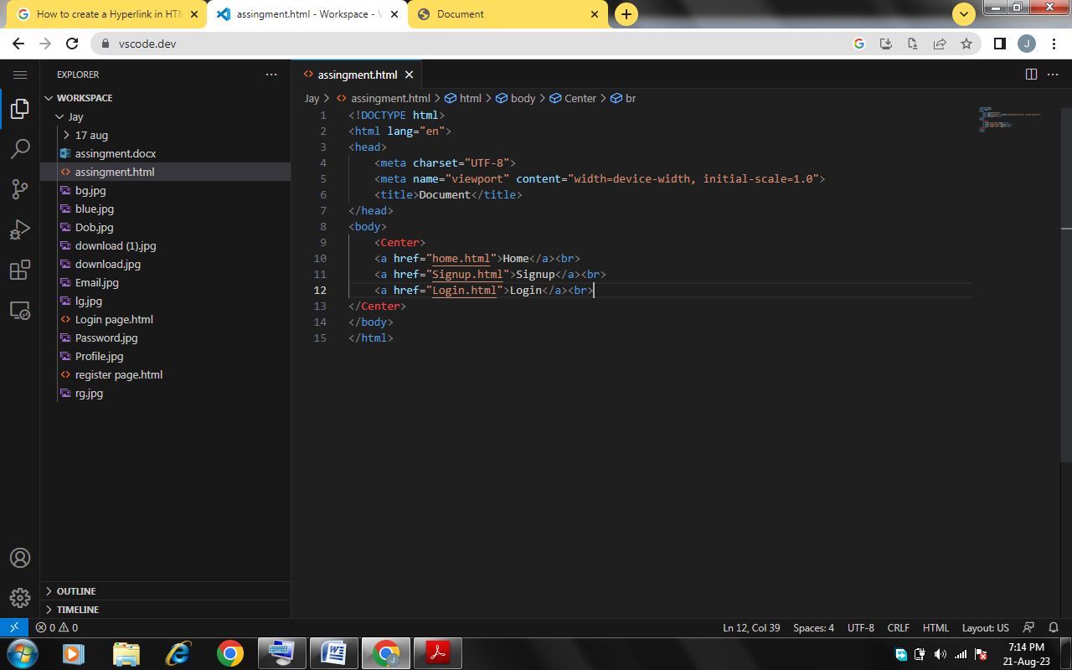 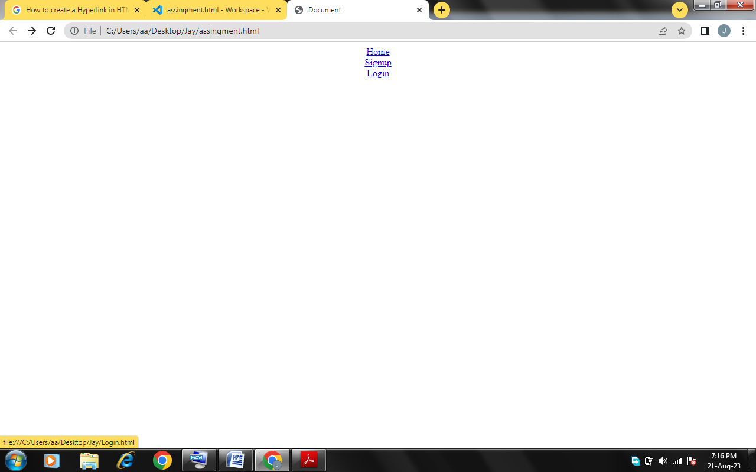

**Q.13 What is the use of an iframe tag? With Example.**

**Ans:** The iframe in HTML stands for **Inline Frame**. The ” iframe ” tag defines a rectangular region within the document in which the browser can display a separate document, including scrollbars and borders. An inline frame is used to embed another document within the current HTML document.

The iframe is basically used to show a webpage inside the current web page. The ‘ **src** ‘ attribute is used to specify the URL of the document that occupies the iframe.

**EX.**

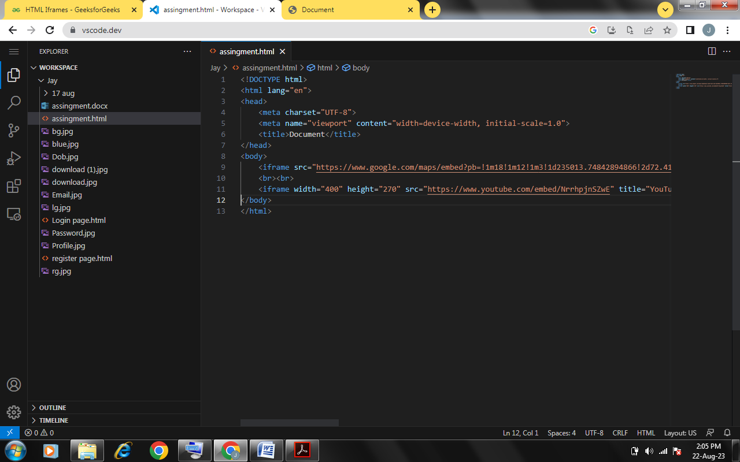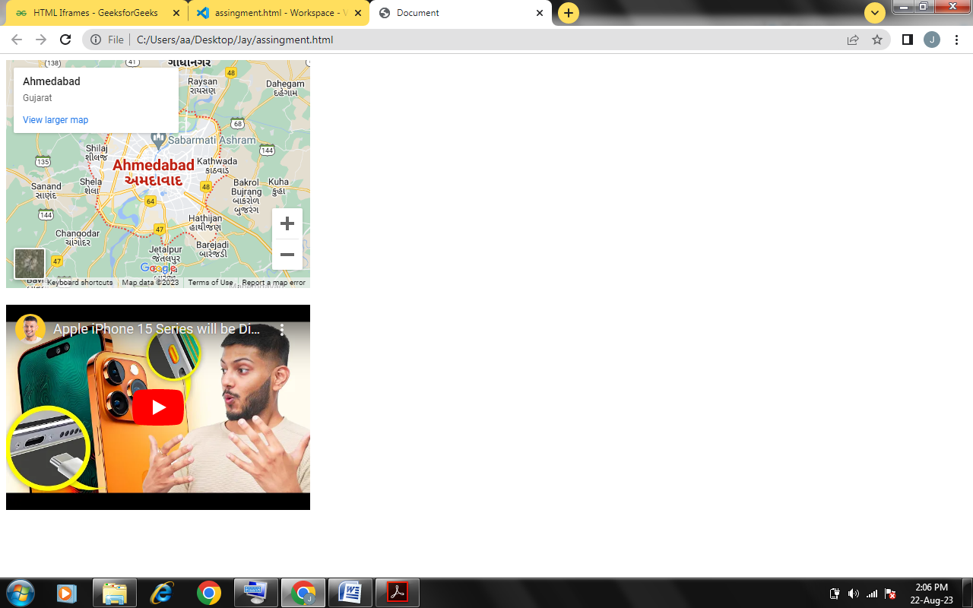

**Q.14 What is the use of a span tag? Explain with example?**

**Ans:** The <span> tag is an inline container used to mark up a part of a text, or a part of a document. The <span> tag is much like the <div> element, but <div> is a block-level element and <span> is an inline element.

**Ex.**

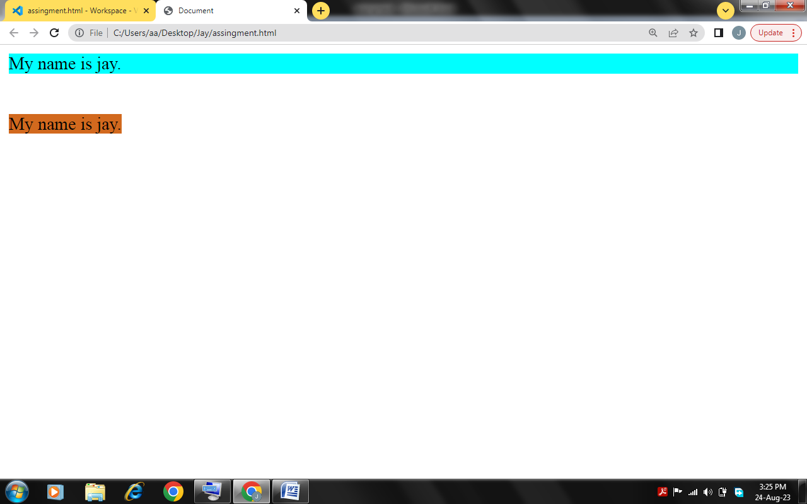

**Q.15 How to insert a picture into a background image of a web page? With Example.**

**Ans:** Simple way to add background image is using the background image attribute inside the <body> tag.

**Ex :**

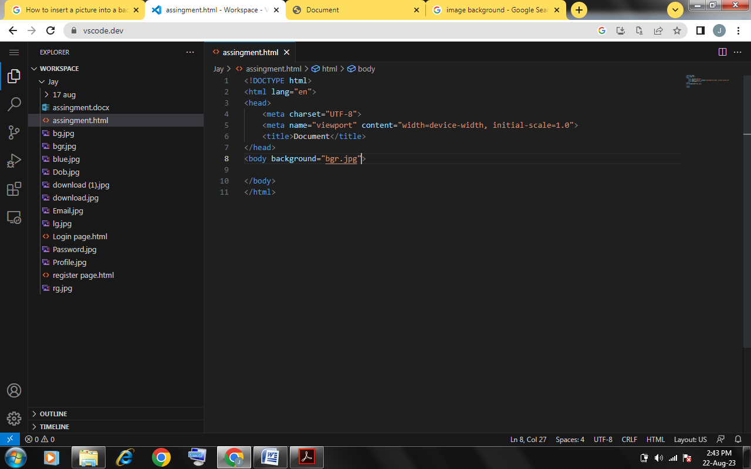

**Q.16 How are active links different from normal links?**

**Ans:** If you left or right-click on active link Visited or Unvisited, it will turn into Red and Underline. Active Links shows that the browser is in the process to load a new resource.

Normal links are unvisited links generally shown in blue color in most of the websites. A link becomes active when you click on it. However the color of the links may vary as they can be customized.

**Q.17 What are the different tags to separate sections of text?**

**Ans:**

* <br> tag – Usually <br> tag is used to separate the line of text. It breaks the current line and conveys the flow to the next line.
* <p> tag – This contains the text in the form of a new paragraph.
* <blockquote> tag – It is used to define a large quoted section.

**Q.18 What is SVG?**

**Ans:**

* SVG stands for Scalable Vector Graphics
* SVG is used to define vector-based graphics for the Web
* SVG defines the graphics in XML format
* Every element and every attribute in SVG files can be animated
* SVG is a W3C recommendation
* SVG integrates with other W3C standards such as the DOM and XSL

**Q.19 What is difference between HTML and XHTML?**

**Ans:** HTML stands for Hypertext Markup Language, whereas XHTML stands for Extensible Hypertext Markup Language. XHTML is basically an extension of HTML, which is stricter than HTML.

**Q.20 What are logical and physical tags in HTML?**

**Ans:**

* Physical tag : These tags are used to provide the visual appearance to the text. Ex. <p>, <code>, <address>, <cite>
* Logical tag : These tags are used to add some logical or semantic value to the text. Ex. <b>, <i>, <u>, <small>