PulseFi: CSI-Based Heart Rate Monitoring — Project Report (Expanded)
ML Assignment Report
Date: March 12, 2026

Abstract
This report summarizes the PulseFi project, a low‑cost Wi‑Fi Channel State Information (CSI) system for non‑intrusive heart‑rate monitoring, and documents the modifications implemented to achieve fast (~5 s) human‑presence detection while preserving a longer‑window regressor for heart‑rate estimation. The report references the Pulse‑Fi paper for system motivation, data collection, processing pipeline, and baseline results, then details the current codebase architecture and the new 5‑second presence classifier, threshold sweeps, and live runtime threading changes that decouple detection from the 30‑second ML regressor.

1. Introduction
Pulse‑Fi proposes CSI‑based physiological sensing as a privacy‑preserving, always‑available alternative to camera systems and contact‑based sensors. The project goals in this codebase are two‑fold: (i) detect the presence of a human in the wireless link, and (ii) estimate heart rate only when a human is present. This report details how the pipeline is implemented in practice, how local data were collected, and how the system was extended with a fast 5‑second presence classifier for responsive live feedback. [1]

2. Related Work (Paper Context)
The Pulse‑Fi paper reviews contact‑based techniques (ECG/PPG/PSG) and non‑contact camera approaches, noting cost, discomfort, or privacy issues. CSI‑based sensing is highlighted as a robust alternative because it uses existing Wi‑Fi infrastructure and captures amplitude variations across subcarriers that correlate with subtle physiological motion. [1]

3. System Overview (Paper + Implementation)
Pulse‑Fi consists of (i) data collection on commodity Wi‑Fi devices, (ii) a CSI signal processing pipeline, and (iii) an LSTM network for heart‑rate estimation. The implementation used in this project follows that structure but adds a two‑stage ML pipeline (presence classifier + BPM regressor) and a fast 5‑second presence detector for low‑latency response. [1]

4. Dataset Collection and Labeling (Expanded)
The paper evaluates Pulse‑Fi on two datasets: the ESP‑HR‑CSI dataset (ESP32‑based) and the E‑Health dataset (Raspberry Pi 4B, 118 participants). The ESP‑HR‑CSI dataset is collected at 80 Hz with 64 CSI subcarriers, and uses a pulse oximeter for ground‑truth BPM. Distances of 1–3 m are included to test robustness. [1]
Local dataset in this project follows the same file interface as the paper: `csi_packets.csv` (CSI amplitudes), `bpm_stream.csv` (sensor BPM stream), and `markers.csv` (human start/end markers). CSI packets are timestamped on the receiver so that both CSI and BPM align to the same clock. Human sessions include explicit start/end markers; stable sessions omit markers and are treated as stable_nonhuman windows in training.
Local session inventory (generated from the repository data directory):
Session | Label | CSI Rows | BPM Rows | Markers
3_trans1_stable | stable | 3979 | 1792 | 0
3_trans2_stable | stable | 3968 | 1978 | 0
4_calm1_human_rest | human | 3995 | 1790 | 2
4_calm2_human_rest | human | 4015 | 1791 | 2
5_2_human_rest | human | 572 | 780 | 1
5_3_human_rest | human | 369 | 128 | 1
5_rest_human_rest | human | 4594 | 1651 | 2
6_1_human_rest | human | 4327 | 1636 | 2
6_2_human_rest | human | 4228 | 1636 | 2
6_3_human_rest | human | 4040 | 1635 | 2
6_4_human_rest | human | 3968 | 1643 | 2
6_5_human_rest | human | 4116 | 1838 | 2
Dataset summary: 12 sessions total (human=10, stable=2). CSI rows per session range from 369 to 4594 (mean 3514.2); BPM rows range from 128 to 1978 (mean 1524.8).

5. Signal Processing Pipeline (Detailed)
The CSI processing pipeline matches the paper’s design: (1) amplitude conversion, (2) DC removal to suppress stationary components, (3) third‑order Butterworth bandpass filtering to isolate the heart‑rate band, (4) Savitzky–Golay smoothing to reduce noise while preserving periodicity, and (5) segmentation into fixed windows for learning. In this implementation, windows are 400 packets (~5 s at 80 Hz) for training/label alignment, and 2400 packets (~30 s) for the long‑window ML regressor at runtime. [1]

6. Model Architecture and Training
The project uses a two‑stage ML strategy: Stage A (classifier) predicts stable vs human; Stage B (regressor) predicts BPM only for human windows. The classifier leverages both the processed CSI window and a periodicity vector computed from per‑subcarrier autocorrelation, which encodes heartbeat‑like periodic structure. The regressor operates on processed CSI alone. Training uses synchronized windows where the BPM label is an overlap‑weighted mean over the exact CSI window, and windows with stale or missing BPM labels are masked from regression.

7. Baseline Results from Pulse‑Fi Paper
The paper reports that longer windows improve accuracy. On the ESP‑HR‑CSI dataset, a 30‑second window achieves MAE ~0.46 BPM; on the E‑Health dataset, a 30‑second window achieves MAE ~0.14 BPM. Table I in the paper summarizes error metrics across window sizes and datasets. [1]

8. Modifications and Improvements Implemented
The project adds a fast 5‑second presence detector and refactors live inference so detection runs independently from the 30‑second regressor. This addresses latency in real‑time use while preserving the longer‑window accuracy for BPM estimation.
Key modifications:
• Implemented 5‑second presence features (raw variance, cross‑correlation, respiratory‑band power ratios, and bandpass‑std).
• Added a threshold sweep tool to select presence thresholds across all sessions.
• Refactored live inference into parallel threads: serial reader, 5‑second presence detector, 30‑second regressor, optional 30‑second ML classifier, and writer.
• Updated the Streamlit dashboard to default to 5‑second presence classification and visualize 5‑second feature values.

9. Empirical Checks on Current Dataset
On the local dataset (n=12, human=10, stable=2), a 5 s bandpass‑std threshold of 0.536 achieved tp=10, tn=2, fp=0, fn=0, with F1=1.00 and balanced accuracy=1.00. This provides a practical fast‑presence rule but should be validated on a larger dataset.

10. Comparison Table (Paper vs Project)
Summary comparison of baseline paper results and current project modifications.
Aspect | Pulse‑Fi Paper | Project Implementation | Notes
Window size for best HR accuracy | 30 s (best MAE) | 30 s regressor retained | Matches paper for accuracy
Fast presence detection | Not a focus | 5 s presence classifier | Adds low‑latency gating
Models | LSTM for HR estimation | Two‑stage: classifier + regressor | Classifier gates regressor
Data | ESP‑HR‑CSI + E‑Health | Local ESP‑style dataset + paper datasets | Local dataset used for sweep
Live runtime | Single pipeline | Threaded: presence + regressor | Decouples latency

11. Live UI Screenshot
Updated Streamlit dashboard showing live detection and BPM readout.
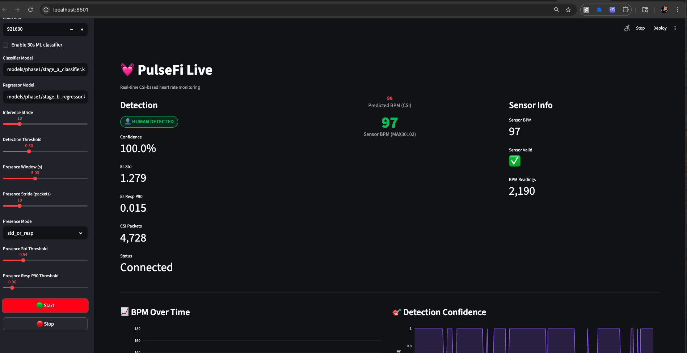

12. Discussion
The fast 5‑second detector reduces latency at the expense of some robustness. However, it is sufficient for presence gating and can be tuned per environment using the sweep tool. The regressor remains 30 s to preserve the paper’s accuracy characteristics. This design aligns with the paper’s observation that longer windows improve HR estimation while shorter windows can still detect presence cues. [1]

13. Limitations
The 5 s detector was tuned on a small local dataset (12 sessions). Thresholds may shift with different rooms, positions, or interference. More diverse data and cross‑environment tests are needed for robust deployment.

14. Future Work
Future improvements include training a dedicated short‑window classifier with more data, adaptive thresholding based on noise floor, and more robust motion rejection to reduce false positives under environmental changes.

15. Conclusion
PulseFi demonstrates accurate CSI‑based HR monitoring using commodity hardware. This project extends the system with a low‑latency presence classifier and a threaded runtime that keeps fast detection responsive without sacrificing 30‑second BPM accuracy. The resulting system is more practical for real‑time use while staying grounded in the validated Pulse‑Fi methodology. [1]

References
[1] P. Kocheta, N. S. Bhatia, and K. Obraczka, "Pulse‑Fi: A Low‑Cost System for Accurate Heart Rate Monitoring Using Wi‑Fi Channel State Information," IoT DI COSS (short paper), 2024.

