**Chapter I**

**Background of the Problem**

**1.1 Introduction**

Hansel & Gretel Early Childhood Education Center was established in June 1996. From its humble beginning as a preschool, the school has successfully advanced its course offerings to include the K-12 Basic Education programs accredited and recognized by the Department of Education (DepEd). As time passed, the institution went on to become Ferndale International School (FIS) and now Ferndale Colleges-Zamboanga Peninsula Inc, offering programs of study that encompass Preschool, Elementary, Junior High School, Senior High School, and College Degree programs. Catering to all groups of students of various nationalities, ethnicities, religions, and exceptionalities, 'Ferndale Colleges' is also home to special education students with physical and learning disabilities under the Center for Exceptional Children (CEC).

The forms that employees of Ferndale Colleges Zamboanga Peninsula Inc. fill out the form are used in the profiling process at the college. It takes time and hassle for the admin to separate the employee's position, employee’s information and department, so the role of human resources is to approve the employee's profiling, manage their department, and let them go. The employee of Ferndale Colleges Zamboanga Peninsula Inc. must complete a profiling process and use a form provided by human resources to request a leave of absence. Employees of the institution must provide regular updates to the office of human resources as it will take a long time for human resources to approve their applications.

Since they need an update from human resources, the employee must visit them or wait for the letter of approval, which takes time away from what they do every day in the current process. According to the role or department and the kind of file—leave file or profiling file—the administrator will struggle to handle all the paperwork. It's possible that the form might disappear or fail to be approved or checked by human resources. This possibility may cause stress, hassle, and problems for them both.

Human resources and employees can benefit from this Employee Management System (EMS). The system makes it easier for the administrator to handle and manage all paperwork by enabling paperless checking and management through the use of a laptop and internet connection. The administrator is capable of overseeing the department and role at Ferndale Colleges Zamboanga Peninsula Inc. Employees can file a leave request or fill up the form for profiling using their devices running Windows, macOS, iOS, or Android as long as there is internet access. They can also verify if the registration or profiling has been approved by the administrator and submit a leave request using their devices, which the admin will then approve. The employee has access to the administrative approval form and the leave history.

This technology has the potential to significantly alter Ferndale Colleges Zamboanga Peninsula Inc. Process-wise, the EMS will offer a high-quality user interface and an easy-to-use system. The institution's current procedure will be improved, requiring less time and effort to manage files.

**1.2 Project Context**

The proposed system is for the Ferndale Colleges Zamboanga Peninsula, Inc. Employee Profiling System which is also managed by the admin of the Colleges. Ferndale Colleges Zamboanga Peninsula, Inc. Employee Profiling System project typically involves the development and implementation of a profiling and managing employees of Ferndale Colleges Zamboanga Peninsula Inc. This project system was to help the Admin and employee of Ferndale Colleges Zamboanga Peninsula, Inc. to improve the managing and profiling of employee and the system could store the data of employee. The Employee Profiling System assures the employee of the Ferndale Colleges Zamboanga Peninsula, Inc. that their employees data is securely stored in the record data.

A Ferndale Colleges Zamboanga Peninsula, Inc. Employee Profiling System is designed to efficiently handle various aspects of manage and profiling control within an Institution. The features of such a system are crucial for ensuring accuracy, reducing costs, and improving overall operational efficiency.

Ferndale Colleges Zamboanga Peninsula, Inc. Employee Profiling System, Institution can streamline their operations, the manual process, and enhance overall efficiency in managing and profiling process of the employee.

The Researchers will develop a web-based system entitled “Ferndale Colleges Zamboanga Peninsula, Inc. Employee Profiling System” that would help the Admin and Employee optimize utilization, offer multifaceted benefits, positively impacting operational efficiency, fast process, and overall managing and profiling performance.

**1.3 Purpose and Description**

1.3.1 Purpose

The main purpose of a system is to automate the current process or managing and employee profiling of Employee Profiling System to help the Ferndale Colleges Zamboanga Peninsula, Inc. to manage the employee profile and employee profiling the by using a web-based system.

1.3.2 Description

An Employee Profiling System (EPS) is a comprehensive software solution designed to automate and optimize the processes involved in managing employee profile and employee profiling within an Institution. This system ensures effective operations, regulatory compliance, and improved Employee profiling by offering a consolidated platform for tracking, monitoring, profiling and managing the Employees information.

Employee Profiling System is a sophisticated solution that plays a pivotal role in revolutionizing employee and managing within an institution. By automating processes, enhancing accuracy, and providing valuable insights, the system contributes to operational efficiency, managing and ultimately, improved the employee profiling process.

* 1. **Objectives**

1.4.1 General Objective

The general objective of this study is aimed to design and develop an Employee Profiling System for Ferndale Colleges Zamboanga Peninsula, Inc. to enhance the establishment process by management of employee data also the process of profiling in terms of efficiency, accuracy, and compliance. And the system will provide a comprehensive and efficient system for managing employee data within institution.

1.4.2 Specific Objectives

These are the following specific objectives of the study:

* To gather all the required information particularly the processes involved during operations procedure from Ferndale Colleges Zamboanga Peninsula, Inc.
* To develop a system module to manage and employee profiling data.
* To design a database that could store the data of the employees.
* To design a User-Interface for employees.
* To test and settle the functionalities of Ferndale Colleges Zamboanga Peninsula, Inc. Employee Profiling System.
* To deploy the developed system Ferndale Colleges Zamboanga Peninsula, Inc. Employee Profiling System.
  1. **Scope and Limitation**

These are the following Scope and Limitation of the system:

1.5.1 Scope

* The Employee can login using their credentials.
* The Employee can register account.
* The Employee can fill-up the form.
* The Employee can edit information.
* The Employee can file a leave.
* The Employee can view leave history.
* The Employee can view the salary position.
* The Admin can login using the credentials
* The Admin can manage the employee.
* The Admin can disapprove employee account.
* The Admin can approve employee account.
* The Admin can manage department.
* The Admin can view dashboard.
* The Admin can manage employee Leave.
* The Admin can add position salary.

1.5.2 Limitation

* The system is not capable without the presence of internet.
* The system is not capable of mobile accessibility.
* The Employee cannot add position salary.
* The Employee cannot add department.
* The Employee cannot edit other information.

**1.6 Definition of Terms**

**HTML** – As stated by Astari S. (August, 2023) HTML stands for HyperText Markup Language. It is a standard markup language for web page creation. It allows the creation and structure of sections, paragraphs, and links using HTML elements (the building blocks of a web page) such as tags and attributes.

**MySQL** – As stated by Mark Drake (December, 2020) MySQL is an open-source relational database management system. As with other relational databases, MySQL stores data in tables made up of rows and columns.

**PHP –** As stated by Raul Toal is an open-source, server-side programming language that can be used to create websites, applications, customer relationship management systems and more.

**Profiling –** Generally speaking, profiling is the process of obtaining and examining information about traits, behaviors, or other aspects of people or groups in order to forecast, evaluate, or classify them. This can be carried out in a number of disciplines, including marketing, psychology, law enforcement, and cybersecurity.

**SQL -** Structured Query Language is known as SQL. It is a common programming language for relational database management. SQL enables users to work with databases in a variety of ways, including data retrieval, updating, deleting, and storing.

**Web-based System –** As stated by Aezion (September, 2022) A web-based system is an application that is accessed via HTTP. The term web-based is usually used to describe applications that run in a web browser.

**XAMPP Server –** As stated by ApacheFriends XAMPP is a completely free, easy to install Apache distribution containing MariaDB, PHP, and Perl. The XAMPP open-source package has been set up to be incredibly easy to install and to use.

* 1. **Significance of the Study**

The researchers planned to design and develop and to develop a system entitled “Ferndale Colleges Zamboanga Peninsula, Inc. Employee Profiling System” is beneficial to the following users:

* **Institution-** For the development of an Employee Profiling System, they are the clients. By creating and providing a web-based Ferndale Colleges Zamboanga Peninsula, Inc. Employee Profiling System, the Institution enhancing the employee profiling process and the admin can manage easily the employees data. Furthermore, by offering a complete solution that satisfies the requirements of the admin, Ferndale Colleges Zamboanga Peninsula, Inc. can improve employee retention and satisfaction. A Ferndale Colleges Zamboanga Peninsula, Inc. Employee Profiling System may experience significant effects from the Employee Profiling System, especially if they operate in the Institution technology sector.
* **Employees –** The employee describing system of Ferndale Colleges Zamboanga Peninsula Inc. offers benefits to the employee. Employees can also use the system to file for leaves of absence by using a laptop and an internet connection. The employee profiling system is improving and enhancing the process of profiling. The employee can easily file a leave then viewing and approving by the admin this process can make the system improve and enhance.
* **Future Researchers -** Complete the capstone project in an insightful way and develop the employee profiling system for Ferndale Colleges Zamboanga Peninsula Inc. This research allows us, the researchers, to gain more knowledge about the management and institution profiling process. It helps us researchers to look into, assess, and document innovative techniques and industry best practices. A well-designed web-based system can improve the profiling system's efficiency and accuracy, which is crucial for the institution. The system reduces hassle, increases employee satisfaction, helps us, the researchers, learn more, and enhances the profiling process. It might also have a favorable effect on the Institution.

**Chapter II**

**Review Related Literature and Studies**

**2.1 Review Related Literature**

**2.1.1 Surface water quality profiling using the water quality index, pollution index and statistical methods: A critical review**

As stated by MM Mahbubul Syeed, et al. (March 2023) Since surface water is the primary source for the majority of water demands, it is highly susceptible to contamination. The overpopulation, extensive industrialization, fast urbanization, and poor sanitation all contribute to the exaggeration of this problem. For this reason, thorough surface water quality measurement and knowledge extraction are essential to guaranteeing clean and safe water consumption. As a result, surface water quality profiling has attracted a lot of scholarly interest in recent decades and yielded a substantial volume of research findings. In order to identify current research trends and hotspots and to synthesize and organize the body of existing material, this study undertakes a thorough systematic literature review. Reported results suggest that the terrain of fresh surface water includes 13 distinct water sources that are predominantly used in 5 sectors. These sectors often cause the water pollution in the form of industrial effluents, agricultural runoffs, and domestic sewage. For profiling the water quality, around 23 Water Quality Index (WQI) models, and 10 Pollution Index (PI) models are used in research. These models often use several water quality parameters. This study reports an exhaustive taxonomy of 69 prominent quality parameters in three categories which will support their adoption for these models. Finally, the limitations of the current manual water quality measurement approaches are summarized to propose a set of seven requirements for the tech-intensive water quality profiling research and system development.

**2.1.2 Microfluidic strategies for the isolation and profiling of exosomes**

According to Junjie Bai, et al. (November, 2022) Exosomes are extracellular vesicles at the nanoscale that transport a variety of payloads and are important for illness diagnosis and therapy as well as intercellular communication. However, the absence of efficient procedures for separating exosomes from complex matrixes hinders both the therapeutic application of exosomes and their heterogeneous/functional identity. The creation of appropriate platforms is essential for exosome modification and profiling. Among those, microfluidic systems have been proved to be among the most optimal ways. The current review covered the latest developments in microfluidic-based protocols, such as size-based micro-devices, immune-affinity-based microchips, and multi-approaches integration microfluidic devices, for the accurate manipulation and efficient separation of exosomes. The combination of advanced techniques with nano/microfluidic chip for individual exosomes imaging or assay and the isolation of single exosome with microfluidics are presented. The opportunities and challenges of intelligent algorithms and machine learning in multi-dimensional profiling of individual exosomes are also highlighted.

**2.1.3** **Fiber-type shifting in sarcopenia of old age: proteomic profiling of the contractile apparatus of skeletal muscles**

As mentioned by Paul Dowling, et al. (January, 2023) One of the main characteristics of frailty syndrome is the progressive decrease of skeletal muscle mass and the corresponding decline in contractile strength. Sarcopenia in the elderly is characterized by substantial muscle atrophy and can significantly reduce overall quality of life in old age. It is intimately linked to age-related neurological deficits. Proteomic studies of human senescent skeletal muscles using mass spectrometry, along with animal models of sarcopenia, have significantly enhanced our comprehension of the molecular and cellular effects of muscular atrophy and related fiber-type shifting in aging. This review describes proteome-wide changes in atrophying skeletal muscles identified by mass spectrometry, emphasizing contractile proteins as putative indicators of altered fiber-type distribution patterns. The observed trend of fast-to-slow transitions in individual human skeletal muscles during the aging process is most likely linked to a preferential susceptibility of fast-twitching muscle fibers to muscular atrophy. Studies with senescent animal models, including mostly aged rodent skeletal muscles, have confirmed fiber-type shifting. The proteomic analysis of fast versus slow isoforms of key contractile proteins, such as myosin heavy chains, myosin light chains, actins, troponins and tropomyosins, suggests them as suitable bioanalytical tools of fiber-type transitions during aging.

**2.1.4 Making sense of algorithmic profiling: user perceptions on Facebook**

As reported by Moritz Büchi, et al. (March 2023) In numerous social sectors and behaviors, including as banking, marketing, law, social engagement, and the consumption and production of culture, algorithmic profiling has grown more commonplace. Even though scholars are starting to look into algorithmic profiling from many angles, there are still few socio-technical studies on algorithmic profiling that take users’ common views into account. This article builds on previous user-centered research by examining people’s perceptions and awareness of algorithmic profiling, particularly as it relates to social media and targeted advertising. In order to better understand Facebook users’ reactions to and comprehension of algorithmic profiling when it is made visible, we ran an online survey. The methodology relied on qualitative accounts as well as quantitative data from 292 Facebook users in the United States and their reactions to their algorithmically inferred ‘Your Interests’ and ‘Your Categories’ sections on Facebook. The results illustrate a broad set of reactions and rationales to Facebook’s (public-facing) algorithmic profiling, ranging from shock and surprise, to accounts of how superficial – and in some cases, inaccurate – the profiles were. Taken together with the increasing reliance on Facebook as critical social infrastructure, our study highlights a sense of algorithmic disillusionment requiring further research.

**2.1.5 Dynamic study of bifurcation, chaotic behavior and multi-soliton profiles for the system of shallow water wave equations with their stability**

As mentioned by Muhammad Hamza Rafiq, et al. (April 2023) This work aims to explore, from many angles, the deeper properties of the system of shallow water wave equations that explain the turbulence in the atmosphere and seas. Simplified Hirota’s approach helps to construct multi-soliton structures like 1-soliton, 2-soliton, and 3-soliton solutions. We use Mathematica software to graphically depict the found solutions in 3D, 2D, and contour plots for the purpose of physical demonstration and visual presentation. In order to help reduce the dimension by one or into an ordinary differential equation, the analyzed system’s Lie group invariant transformations and symmetry reductions are found using the Lie symmetry technique. Further, the qualitative behavior of the time-dependent dynamical system is observed using the Bifurcation and chaos theory. The phase portraits of bifurcation are observed at the equilibrium point of a planar dynamical system. We discuss various tools to identify chaos (random and unpredictable behavior) in autonomous dynamic systems, such as 3D phase portraits, 2D phase portraits, time series, and Poincaré maps. At various initial conditions, the sensitivity and modulation instability analyses are also presented, and it is discovered that the investigated system is stable, as a small change in the initial conditions does not cause an abrupt change in solutions. The findings of this investigation will contribute in the overall depiction of soliton theory and nonlinear dynamical systems.

**2.1.6 The mathematical and wave profile analysis of the Maccari system in nonlinear physical phenomena**

As stated by SM Yiasir Arafat, et al. (December 2022) A prominent model in optics, quantum mechanics, hydrodynamics, plasma physics, and other domains is the two-dimensional nonlinear complex coupled Maccari system. Using the auxiliary equation technique, we have examined many broad-spectral soliton solutions to the given system in this article. The answers found can be characterized as an integration of the exponential, trigonometric, hyperbolic, and rational functions. For a better understanding of the waves, we have depicted the combined two- and three-dimensional structures of the obtained solutions. As seen in the 2D figure, it is found that is the most significant and effective parameter that influences the change in wave type. There has also been discussion of the effects of other parameters. The numerical results show that the approach is reliable, straightforward and potent to examine other nonlinear evolution equations that emerged in optics, nonlinear physics, applied mathematics, and engineering.

**2.1.7 Multi-omics microsampling for the profiling of lifestyle-associated changes in health**

According to Xiaotao Shen, et al. (January 2023) The reactive nature of current healthcare practices makes minimal use of clinical and physiological data, which is sometimes gathered months or years apart. Geographical constraints, the expense and discomfort of in-clinic venepuncture, low sampling frequency, and the shallow depth of molecular measurements further limit the identification and profiling of blood biomarkers in clinical and research contexts. Here, we present a method for regularly obtaining physiological data from wearable sensors together with thousands of metabolites, lipids, cytokines, and proteins in 10 μl of blood for analysis. We show the advantages of such frequent and dense multi-omics microsampling in two applications: the assessment of the reactions to a complex mixture of dietary interventions, to discover individualized inflammatory and metabolic responses; and deep individualized profiling, to reveal large-scale molecular fluctuations as well as thousands of molecular relationships associated with intra-day physiological variations (in heart rate, for example) and with the levels of clinical biomarkers (specifically, glucose and cortisol) and of physical activity. Combining wearables and multi-omics microsampling for frequent and scalable omics may facilitate dynamic health profiling and biomarker discovery.

**2.1.8 Comprehensive profiling of an aging immune system reveals clonal GZMK+ CD8+ T cells as conserved hallmark of inflammaging**

Based on Denis A Mogilenko, et al. (December 2020) There is currently a dearth of systematic knowledge regarding immunological aging on a whole-body level. We used flow cytometry-based validation, single-cell RNA and antigen receptor sequencing, and age-associated changes in immune cells across several animal organs. We have established both common and organ-specific immunological changes and have found a subset of CD8+ T (Taa) cells that are distinct from T effector memory (Tem) cells that express granzyme K (GZMK). Taa cells displayed indicators of tissue homing and exhaustion, were highly clonal, and had distinct epigenetic and transcriptional signatures. They also evolved in response to an older host environment. The main source of GZMK, which boosted non-immune cells’ inflammatory capabilities, was activated Taa cells. In humans, proportions of the circulating GZMK+CD8+ T cell population that shares transcriptional and epigenetic signatures with mouse Taa cells increased during healthy aging. These results identify GZMK+ Taa cells as a potential target to address age-associated dysfunctions of the immune system.

**2.1.9 Blockchain-Orchestrated Intelligent Water Treatment Plant Profiling Framework to Enhance Human Life Expectancy**

As stated by Dhruv Sarju Thakkar, et al. () Degradation of water quality has become increasingly important during the last ten years for a variety of reasons. Water quality is influenced by pollution, population increase, and climate change. Water pH levels can be disturbed by contaminants including bacteria, heavy metals, and excess nitrogen and phosphorus, which can be extremely dangerous to human health. Even though the Internet of Things (IoT) has made it possible to balance pH levels by adding fluoride and chlorine after disinfection, a number of security flaws (such as distributed denial of service, data manipulation, and session hijacking) still affect how well water treatment facilities operate. This causes people to consume polluted water, which has many adverse effects on human health and reduces life expectancy. To address this critical concern, we propose a novel approach integrating artificial intelligence(AI) and blockchain technology into water treatment plant management. Our methodology utilizes a standard water quality dataset, which has features such as pH and total hardness, which is used for binary classification, indicating water as potable or not potable. We employ various AI classifiers such as stochastic gradient descent classifier (SGDC), decision tree (DT), Naïve Bayes (NB), K nearest neighbours (KNN), and logistic regression (LR). Furthermore, an InterPlanetary File System(IPFS)-based public blockchain is integrated to resist the data manipulation attack, where the potable water sample is securely stored in the blockchain’s immutable ledger. The proposed model is evaluated using various performance metrics such as confusion matrix analysis, learning curve assessment, training accuracy, and blockchain scalability. Notably, the DT model emerges as the best-performing classifier with an accuracy of 99.41% and scalability of 35 with 120 data transactions.

**2.1.10 Development of a web-based resident profiling tool to support training in practice-based learning and improvement**

As reported by Jason A Lyman, et al. (March 2019) Residency programs are being forced by a number of causes to specifically address practice-based learning and improvement (PBLI); however, there aren’t many information tools available to support this kind of training. We created, put into use, and assessed an online application that gives University of Virginia Health System Internal Medicine residents population-based reports of their ambulatory clinical experiences. To find possible areas for practice improvement, residents use Systems and Practice Analysis for Resident Competencies (SPARC). Thirty-three (65%) of 51 residents completed a survey assessing SPARC’s usefulness, with 94% agreeing that it was a useful educational tool. Twenty-six residents (51%) completed a before–after study indicating increased agreement (5-point Likert scale, with 5=strongly agree) with statements regarding confidence in ability to access population-based data about chronic disease management (mean [SD] 2.5 [1.2] vs. 4.5 [0.5], p < .001, sign test) and information comparing their practice style to that of their peers (2.2 [1.2] vs. 4.6 [0.5], p < .001).

**2.2 Review Related Studies**

**2.2.1 Profiling and Classification of IoT Devices for Smart Home Environments**

As mentioned by Sudhir Kumar Das, et al. (January 2022) is Developing a robust classification system especially for Internet of Things (IoT) device profiling is the aim of this research. The primary objective is to support ongoing research that detect abnormal activity in Smart Home IoT devices with remarkably high accuracy rates by utilizing a variety of machine learning approaches. Because the proposed architecture incorporates many forms of anomalous activity detection, it is well-positioned to play a significant role in supporting IoT security in the future. Our technological impetus is derived from the tremendous processing power and sophisticated networking capabilities of IoT smart sensors. Notably, these sensors have the potential to be manipulated for malicious purposes only on a single sensed data point rather than the complete collection of collected data from sensors, such as temperature, humidity, light, and voltage measurements. Such a threat lowers the detection effectiveness of many machine learning algorithms and has a substantial impact on the accuracy of aberrant behavior detection. To identify occurrences of alteration in one specific data point among the four potential data points collected by a single sensor, we compared and used different classifiers in our investigations, including the Decision Tree Classifier, KNeighbors Classifier, Support Vector Classifier (SVC), Logistic Regression, AdaBoost Classifier, Random Forest with Extreme Gradient Boost (XGBRF) Classifier, Random Forest Classifier, Light Gradient Boosting Machine (LGBM) Classifier, Gradient Boosting Classifier, and XGB Classifier. The results showed that the Gradient Boosting Classifier algorithm using random search attained an 85.96% detection accuracy, indicating a somewhat lower vulnerability to such changes. As a result, the Gradient Boosting Classifier algorithm with random search was the foundation for the carefully constructed suggested framework, which used four hyperparameter tuning mechanisms for comparison.

**2.2.2 Applicability of spatial planning system package for the LADM Turkey country profile**

As mentioned by Okan Yılmaz and Mehmet Alkan (January 2024) The future of land management and urban development is greatly influenced by spatial planning. Although land registration data is required for processes related to spatial planning, it is also likely that land registration data will alter in response to decisions made on specific plans. Creation of the Land Administration Domain Model (LADM) Edition II: Taking into account the strong relationship between the two systems, it also sought to add spatial plan data to its current conceptual model. The purpose of the study is to provide a conceptual model of Turkey’s spatial planning system in the framework of the LADM Turkey country profile. This article researches the capability of the proposed conceptual model for representing spatial planning data with instance‐level diagrams and the implementation opportunities of a technical model. To demonstrate the functionality of the proposed model, the zoning status certificate, which contains spatial plan and land registration data and is provided to inform about the legal conditions before development, is chosen as the mission. The results show that the LADM Turkey country profile extended with spatial planning system data can represent spatial plan data and be implemented in a technical model to support land administration applications.

**2.2.3 Automated Wood Carving Profiling using Modified Autocollimator Setup**

According to Riya Tomar and S Natarajan (March 2024) Chiselling, the technique of utilizing a chisel and a mallet to achieve a specific shape profile in a wooden block, is a part of wood carving. The perfection of the shape profile in the chiseled wooden block is determined by a precise measurement equipment. While automated technologies can measure a wooden block’s dimensions and compare the results with reference profile information, they cannot measure the block’s shape profile. Using machine vision, which requires the usage of a camera and a processing system, is one of the solutions. Due to the accumulation of wooden dust on the camera lens, which impedes the process of acquiring images, it is only used for shape analysis of chiselled wood blocks and not during the chiselling process. So, we propose a technique for measuring the shape profile of wooden blocks during the chiselling process itself. This technique is not susceptible to wooden dust accumulation. The entire shape profiler is designed as an embedded module with custom hardware and software components.

**2.2.4 Student profiling system for an agent-based educational system on Korea**

As mentioned by Jane W Kwok, et al. (September 2021) The rapid expansion of the Internet and World Wide Web has led to an increasing interest in web-based educational systems. But these self-study programs still fall short of real classroom environments in a number of ways, which makes them inert. They frequently lack enthusiasm in the students by being slow and boring. These technologies cannot recognize a pupil’s unique learning difficulties or provide customized assistance to a particular learner, unlike human teachers. Our project’s main goal is to create a system for student profiling that stores learning and interaction histories for each individual student who has utilized an online learning environment. Our system will provide the functions of recording students’ learning activities, providing webbased assessments to students, measuring students’ academic performance, and allowing teachers to analyze students’ activities.

**2.2.5 Student Profiling and Grade Evaluation System (SPGES) Eastern Samar State University’s College**

According to Rowena P Capada, et al. (July 2020)This study examined the pre-enrollment procedures at Eastern Samar State University’s College of Computer Studies. In particular, it sought to create and assess an integrated Student Profiling and Grade Evaluation System (SPGES}). The system consists of five modules: student profiling, student directory, grade sheet importation in Excel, grade evaluation, and subject list generation. The system was evaluated using the ISO 9126 Software Quality Model (SQM) in order to test its quality. The SQM questionnaire focuses on 6 (six) software characteristics☹1) functionality;(2) reliability;(3) usability;(4) efficiency;(5) maintainability; and (6) portability. Evaluation results revealed that the SPGES is strongly acceptable in terms of these 6 (six) software characteristics.

**2.2.6 User interaction-based profiling system for android application tuning Korea Advanced Institute of Science and Technology (KAIST)**

As stated by Seokjun Lee, et al. (September 2019)Mobile application quality should be improved by taking into account a number of variables, including the variety of users’ spatiotemporal usage patterns and the device’s resource consumption, which includes battery life. Despite the fact that application tuning should take this practical issue into account, the lack of application usage data makes it challenging to guarantee the effectiveness of this procedure at the development stage. A user interaction-based profiling method is suggested in this paper to get beyond the drawbacks of development-level program debugging. With our approach, fine-grained process-level application monitoring allows for the examination of both energy consumption and device behavior. By providing fine-grained information, including user interaction, system behavior, and power consumption, our system provides meaningful analysis for application tuning. The proposed method does not require the source code of the application and uses a web-based framework so that users can easily provide their usage data. Our case study with a few popular applications demonstrates that the proposed system is practical and useful for application tuning.

**2.2.7 A practice-profiling system for residents**

As mentioned by Mark Callahan, et al. (August 2022) A strategy frequently employed by managed care organizations, providers are being assessed and measured more and more as part of quality, credentialing, and payment programs. Nevertheless, because residency training rarely uses these assessments, new doctors entering the field have little exposure to or knowledge of these metrics. The authors successfully created a three-part practice-profiling system in 1998 for internal medicine residents at their institution, which includes an online faculty evaluation program, disease-management profiles for diabetes and hypertension, and measures of patient satisfaction. A ten-question patient survey that focuses on problems with physician-patient communication is used in the patient-satisfaction profile. The diabetes and hypertension disease-management profiles use the resident’s own patients to profile process and outcome measures for common chronic ambulatory conditions. The faculty-evaluation profile is conducted over the Internet, and allows the resident to compare faculty evaluations with those of his or her peer group. Residents receive the profiles as a packet in a scheduled session with a faculty supervisor twice each year. A total of 120 residents are profiled annually for the above measures. Residents rated the program very highly, and found the profiling program to be instructive and effective feedback. As payers and regulators increasingly use physician profiling, residents will benefit from learning the strengths and weaknesses of profiling systems early in their training.

**2.2.8 Profiling system for depressive disorder patient using web based approaches**

As stated by Lucyantie Mazalan, et al. (March 2020) The concept, development, and deployment of a profile system for patients with depressive disorders are presented in this research. The suggested system allows medical organizations that diagnose and treat individuals with mental problems to start using a computerized medical record through the use of a web-based methodology. The current manual patient profiling will be replaced by the work provided here. It has significant ramifications for the timely and effective delivery of vital patient profiles, pharmacy operations, and correct medication histories to the relevant healthcare providers in the future.

**2.2.9 Androidperf: A cross-layer profiling system for android applications**

According to Lei Xue, et al. (June 2020)One useful method for identifying and locating different issues with Android applications, such as performance bottlenecks and security flaws, is to profile the apps themselves. While numerous dynamic app profiling tools have been put forth, their ability to address Android’s multi-layered architecture limits their ability to identify problems arising from the platform itself or from suboptimal inter-layer communication. Because apps often operate in Dalvik virtual machines (DVMs), which are processes within Android’s customized Linux kernel, it should be noted that even a basic DVM operation can result in several function calls at various tiers. In this work, we present AndroidPerf, a cross-layer solution for Android app profiling that spans the DVM, system, and kernel layers. It is composed of two subsystems: one that instrumentates all levels to gather performance data and collects control flow and data flow information using cross-layer dynamic taint analysis, and another that performs instrumentation on all layers. We have implemented AndroidPerf in 9,125 lines of C/C++ and 1,016 lines of Python scripts along with some modifications to Android’s framework. Besides evaluating its functionality and overhead, we have applied AndroidPerf to reveal real performance issues through case studies.

**2.2.10 User profiling for university recommender system using automatic information retrieval**

As stated by Sumitkumar Kanoje, et al. (April 2019)The process of extracting, integrating, and identifying keyword-based data to create a structured profile and then visualizing the knowledge derived from these discoveries is known as user profiling. User profiling assists in tailoring a system to the needs of the individual user. Consequently, one of the key ideas in user profiling or personalization is the retrieval of pertinent user data, which can be applied to resolve complex issues with recommender systems, such as item classification and ranking based on user interests. In order to create a structured profile, we want to locate, retrieve, and integrate keyword-based data from multiple online sources. This study focuses on the subject of user profiling. In order to extract knowledge from the profiled data, we also conduct certain experiments on it.

**Chapter III**

**Research Design and Methodology**

This chapter outlines the research design and methodology employed in the development and implementation of the Ferndale Colleges Zamboanga Peninsula Inc. Employee profiling system. The research approach, data collection methods, and software development process are detailed to provide a comprehensive understanding of the study's execution.

**3.1 Modified Waterfall Model**

Requirement Analysis

System Design

Implementation

Testing

Deployment

Maintenance

*Figure 3.1: Modified Waterfall Model*

Figure 3.1 demonstrates the development cycle that the researchers followed to move forward with the proposed project. This was followed by the researchers to arrange every application for the proposed system and make use of the time required to meet Ferndale Colleges Zamboanga Peninsula Inc. Employee profiling system.

**3.1.1 Requirement Analysis**

In this phase in order to address the company's narrow scope of work, researchers conducted interviews during this phase and plan to propose a Employee profiling system. In order to accomplish this, the researchers collected data regarding the problem and circumstances at Ferndale Colleges Zamboanga Peninsula Inc. in addition to the existing profiling and file a leave or Employee’s Profiling procedure. Consequently, the researchers asked a Ferndale Colleges Zamboanga Peninsula Inc. employee and admin to walk them through the process. This made it possible for the researchers to create a plan that will enable the stock management system for Ferndale Colleges Zamboanga Peninsula Inc.

**3.1.2 Design**

In this phase, based on the information the clients provide, the researchers recommend to the clients that they develop a manual process prototype. Following the process and the main problem's examination in this stage. The logical and physical designs of a prototype system are started by the researchers. In terms of physical design, these are the User Interfaces, and they follow the establishment's style, typeface, and color palette. These are the logically designed backend process flows for the data. for the designed user interface the researchers use a Photoshop and for color palette the researcher use a color hunt for better color combination and for logo design the researchers use canva. For the backend design or the logical designed the researcher use star UML.

**3.1.3 Implementation**

In this phase, after the researchers have completed their prototype and the client has approved all of the system's requirements, the developer can now start building the system using PHP and Vanilla Javascript for the IDE the researcher use Visual Studio Code for the version control the researcher use git. Because the Ferndale Colleges Zamboanga Peninsula Inc. Employee profiling system is able to use the internet connection for Institution purposes, operate the system with grace and user friendly.

**3.1.4 Testing**

In this phase after the researchers and developers have finished, the system will be tested with clients to see if they have any changes or feedback. They will be able to handle changes at the appropriate time and date. The following completion of the research, the clients will answer several questionnaires regarding the system. This will give the researchers a sense of how well-liked the system is by users as well as information about any problems or errors with the system. Subsequently, the researchers will use the SUS questionnaire to conduct a beta test for users and an alpha test for the IT institution, also referred to as IT experts and any related field to the Information Technology.

**3.1.5 Deployment**

The system will be handed over to the Ferndale Colleges Zamboanga Peninsula Inc. Administrator or the human resources in charge of managing the employee’s information, manage the department and position the developers and researchers during this deployment phase. The system is already capable of conducting proper management.

**3.1.6 Maintenance**

During this maintenance phase, the client can easily contact the developer if there is an issue with the system, and the developer will take care of it and resolve it right away.

**3.2 Requirement Documentation**

The researchers request for a letter to conduct the data gathering and a letter for the approval of conducting in the establishment with the permission of the S Ferndale Colleges Zamboanga Peninsula Inc. for the Requirement Documentation for the system requirement. The researcher planning or gather data information to the Institution Ferndale Colleges Zamboanga Peninsula Inc. on research can make all the difference to the results of this research project and the researchers conducted an interview in Ferndale Colleges Zamboanga Peninsula Inc. room with the client as part of data gathering for the requirement of the system needed to provide each module of the system. The researcher done to the system, the researchers will be having a survey test to the system if the system if already done so that they can be having a survey questionnaire to the clients and the researchers conduct an observation process to the Ferndale Colleges Zamboanga Peninsula Inc. human resources office on how the manual process of the work at A Ferndale Colleges Zamboanga Peninsula Inc. human resources office, as the name implies, is a way of collecting data through observing. The observation data collection method is classified as a participatory study, because the proponents have to immerse in the setting where her respondents are, while taking notes and/or recording.

**3.2.1 Planning**

The researchers planned to discuss or gather data information to the Institution on research can make all the difference to the results of this research project. The researchers were able to create a set of plans to guide the team through the project execution and closure phases with the use of planning.

**3.2.2 Interview**

An interview is essentially a structured conversation where one participant asks questions, and the other provides answers. The researchers conducted an interview in Ferndale Colleges Zamboanga Peninsula Inc. human resources office with the client as part of data gathering.

**3.2.3 Survey**

Survey Research is defined as the process of conducting research using surveys that researchers send to survey respondents.  Survey is also known as a quantitative method for collecting information from a pool of respondents by asking multiple survey questions. The study proponents conducted a survey among the employee in the Ferndale Colleges Zamboanga Peninsula Inc. human resources offices The researchers proposed system will be developed based on the survey responses.

**3.2.4 Observation**

Observation, as the name implies, is a way of collecting data through observing. The observation data collection method is classified as a participatory study, because the proponents have to immerse in the setting where her respondents are, while taking notes and/or recording.

**3.3 Requirement Specification**

**3.3.1 Software Requirement**

|  |  |
| --- | --- |
| **Software** | **Purpose** |
| Visual Studio Code | Platform to build the web based system |
| Design Diagram/Star UML | To draw ERD.DFD and CD DFD |
| Xampp or wampserver | Used as localhost too create database for this project |
| Google/Firefox/ Microsoft Edge | A browser to search information / system |

*Table 3.1 List of Software Requirement*

**3.3.2 Hardware Requirement**

|  |  |
| --- | --- |
| **Hardware** | **Purpose** |
| Laptop and PC/processor | Acer Core i3- Core i3-8145U CPC @ 2800 GHz 12Hz used to develop this project for the document PC Acer Intel(R) Core(TM) |
| Hard disk/SSD | Utilized as a backup choice for any data and document files. |
| RAM | 8 GB RAM/256 GB |

*Table 3.2 List of Hardware Requirement*

**3.4 System Architecture**

|  |  |  |
| --- | --- | --- |
| **User**  **layers** | A yellow person holding a computer  Description automatically generatedAdmin | A yellow person holding a computer  Description automatically generated  Employee |
| **Network Layer** |  |  |
| **Data Link Layer** |  | Wan / Lan with IP Addresses router |
| **Application**  **Layers** |  | Ferndale Colleges Zamboanga Peninsula Inc. Employee Profiling System |
| **Logical Layers** | * The admin login using credentials. * The admin can manage employee. * The employee can manage department. * The employee can position. * The admin can add position salary. * The admin can approve or denied employee. * The admin can approve or denied employee’s file leave. * The admin can print employee information. * The admin can approve or denied employee profiling. | * The employee can register. * The employee can fill up the form for profiling. * The employee can file a leave. * The employee can view the history leave. * The employee can edit information. * The employee can login using credentials * The employee can view the salary position. * The employee can search the other employee information. |
| **Database Layer** | Setting Database Icon - Download in Colored Outline Style |  |

*Figure 3.2 Architecture Design*

In this figure 3.2 illustrates this system architecture process in this system. The admin will be the user layers in this phase of the system architecture; network layers will provide a signal or Wi-Fi connection; data link layers will allow admin and users to share the system; the application layer will serve as the system's title; logical layers will house the operations of each module; and then, the database system will automatically store all of the transactions.

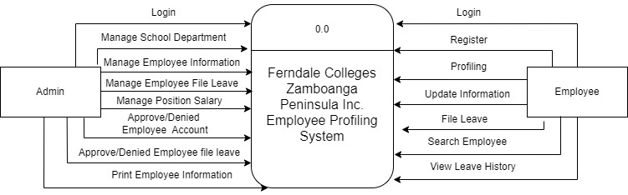**3.5 Context Diagram**

*Figure 3.3 Context Diagram Employee Profiling System(EMS)*

In this figure 3.3 shows The Context Diagram for the Employee Profiling System at Level 0. displays the two entities, admin and employee, and each entity's data flow or module function for the "ferndale colleges zamboanga peninsula Inc. Employee profiling system" that entitis can do to the system. The majority of the administrative data flow is more manageable, but the employee data flow includes information about filing leaves, searching, and profiling.

**3.6 Data Flow Diagram 0**

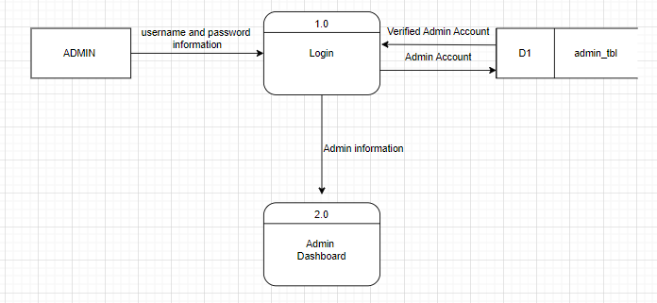3.6.1 Admin Login Process

*3.1 Admin Login Process*

In this figure 3.1 it shows the admin login process. The admin entity enter a username and password flow to the login process the admin account verify to the admin_tbl. The admin account is exist in admin_tbl therefor the data flow with the value of admin information to the admin dashboard.

3.6.2 Employee Login Process

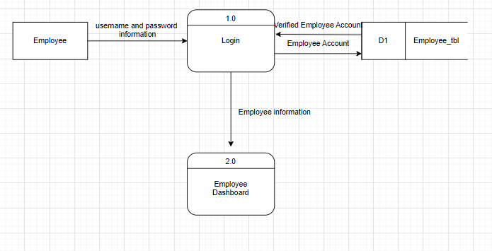

*3.2 Employee Login Process*

In this figure 3.2 it shows the employee login process. The employee entity enter a username and password flow to the login process then check the employee account to the employee_tbl. The employee account is exist in employee_tbl therefor the data flow with the value of employee information to the employee dashboard.

3.6.3 Employee Registeration Process

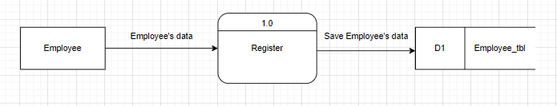

*3.3 Employee Registration Process*

In this figure 3.3 it shows the Employee Registration process. To start The resgitration the the employee entity need to input a employee’s data for the record the in flows to the registeration process when the enitity done the register process it will save the employee’s data to the employee_tbl.

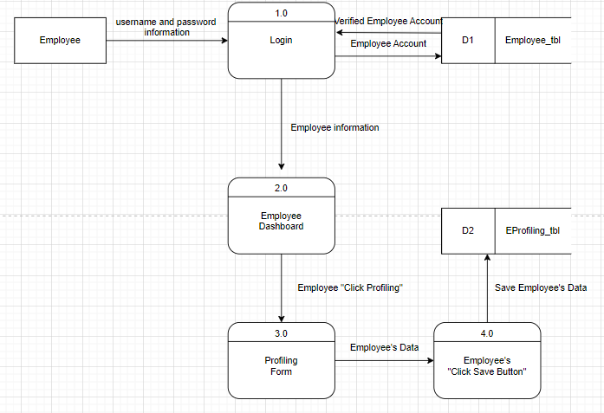3.6.4 Employee Profiling Process

*3.4 Employee Profiling Process*

In this figure 3.4 it shows the Employee Profiling Process. The employee entity enter a username and password flow to the login process then check the employee account to the employee_tbl. The employee account is exist in employee_tbl therefor the data flow with the value of employee information to the employee dashboard. The Employee entity click the profiling to show the profiling form. The Employee need to input employee’s data after fill up the form the employee will click the save button after clicking the button it will save to the employee’s data to the EProfiling_tbl.

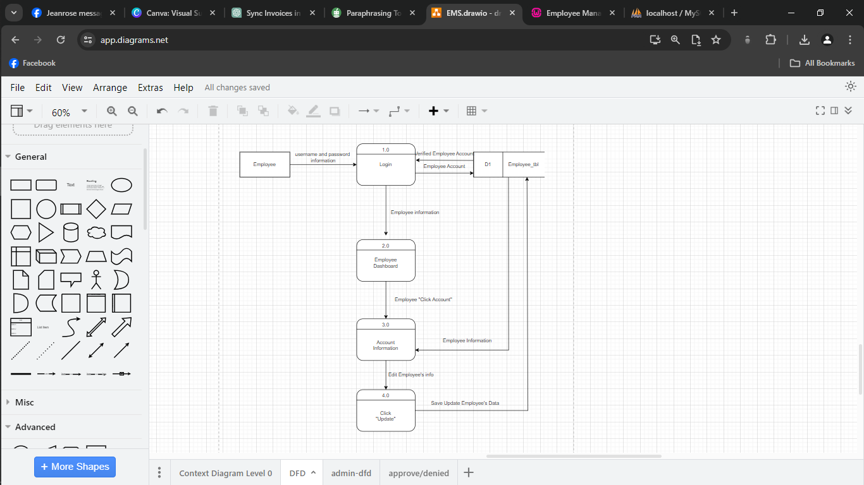3.6.5 Employee Edit Information Process

*3.5 Employee Edit Information Process*

In this figure 3.5 it shows the Employee Edit Information Process. The employee entity enter a username and password flow to the login process then check the employee account to the employee_tbl. The employee account is exist in employee_tbl therefor the data flow with the value of employee information to the employee dashboard. To edit the account information the employee will click the account and it display the account information from the Employee_tbl. The employee will clikc edit to update the employee’s data after updating the data the employee will click update button and it will save the updated employee’s data to the employee_tbl.

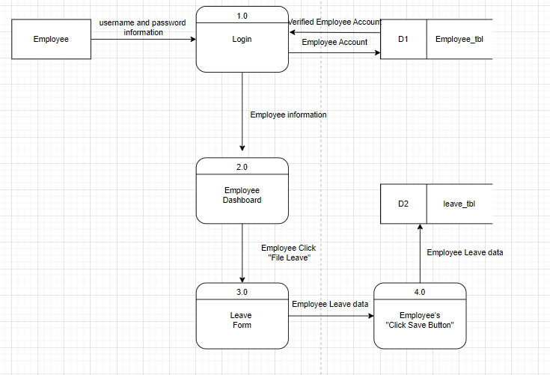3.6.6 Employee File Leave Process

*3.6 Employee File Leave Process*

In this figure 3.6 it shows the Employee File Leave Process. The employee entity enter a username and password flow to the login process then check the employee account to the employee_tbl. The employee account is exist in employee_tbl therefor the data flow with the value of employee information to the employee dashboard. The employee will click the file leave after clicking it shows the file leave form. The employee need to fill up the file leave after fill up the file leave form the employee will click the save button and it will save to leave_tbl.

3.6.7 Admin Add Department Process 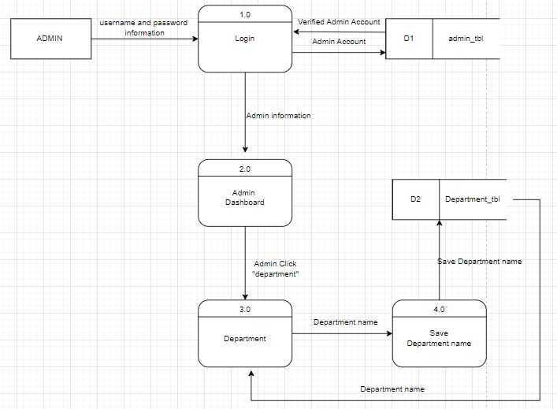

*3.7 Admin Add Department Process*

In this figure 3.7 it shows the Admin Add Department Process. The admin entity enter a username and password flow to the login process the admin account verify to the admin_tbl. The admin account is exist in admin_tbl therefor the data flow with the value of admin information to the admin dashboard. The admin will click the department name then it display all the department register. The admin will add department name after adding new department the admin will click the save button then the department name will save to the department_tbl.

3.6.8 Admin Add Employee Position Process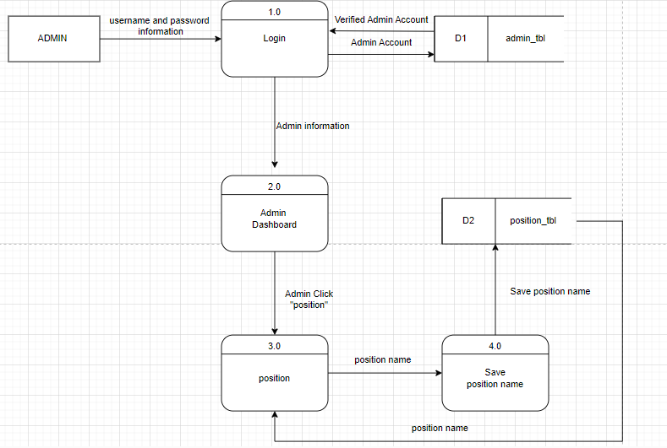

*3.8 Admin Add Employee Position Process*

In this figure 3.8 it shows the Admin Add Employee Position Process. The admin entity enter a username and password flow to the login process the admin account verify to the admin_tbl. The admin account is exist in admin_tbl therefor the data flow with the value of admin information to the admin dashboard. The admin will click the position name then it display all the position register. The admin will add position name after adding new position the admin will click the save button then the position name will save to the position_tbl.

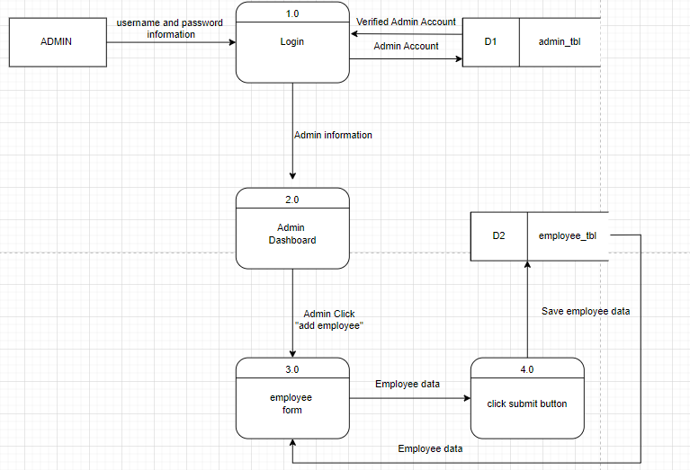3.6.9 Admin Add New Employee Process

*3.9 Admin Add New Employee Process*

In this figure 3.9 it shows the Admin Add New Employee Process. The admin entity enter a username and password flow to the login process the admin account verify to the admin_tbl. The admin account is exist in admin_tbl therefor the data flow with the value of admin information to the admin dashboard. The admin will click the add employee name then it display all the employee register. The admin will input all the employee’s data after adding employee’s data the admin will click the save button then the employee’s data will save to the employee_tbl.

3.6.10 Admin Delete Department Process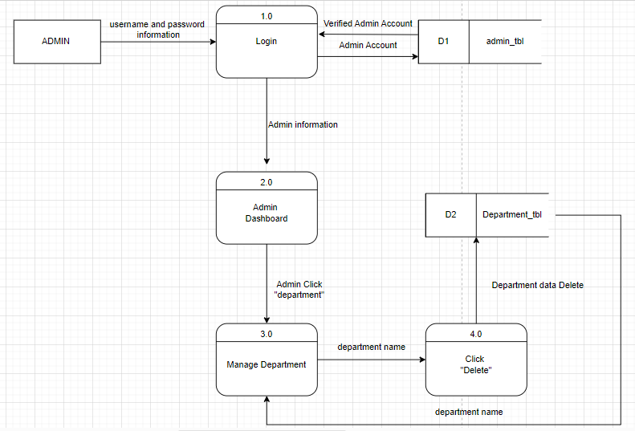

*3.10 Admin Delete Department Process*

In this figure 3.10 it shows the Admin Delete Department Process. The admin entity enter a username and password flow to the login process the admin account verify to the admin_tbl. The admin account is exist in admin_tbl therefor the data flow with the value of admin information to the admin dashboard. The admin will click the departname then it display all the department register. The admin will pick a department name to delete and click delete button the department data will permanent delete to the department_tbl.

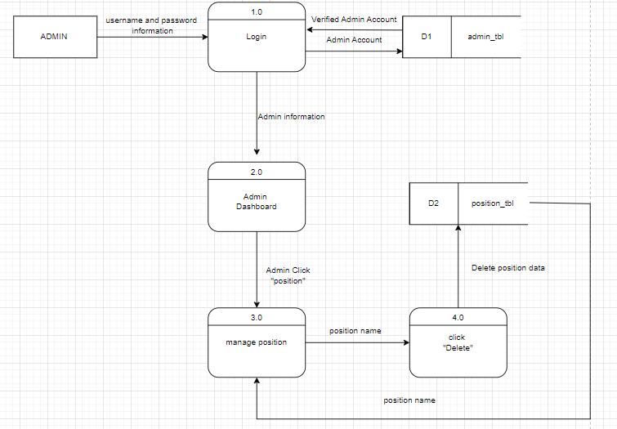3.6.11 Admin Delete Position Process

*3.11 Admin Delete Position Process*

In this figure 3.11 it shows the Admin Delete Position Process. The admin entity enter a username and password flow to the login process the admin account verify to the admin_tbl. The admin account is exist in admin_tbl therefor the data flow with the value of admin information to the admin dashboard. The admin will click the position then it display all the position register. The admin will pick a position name to delete and click delete button the position data will permanent delete to the position_tbl.

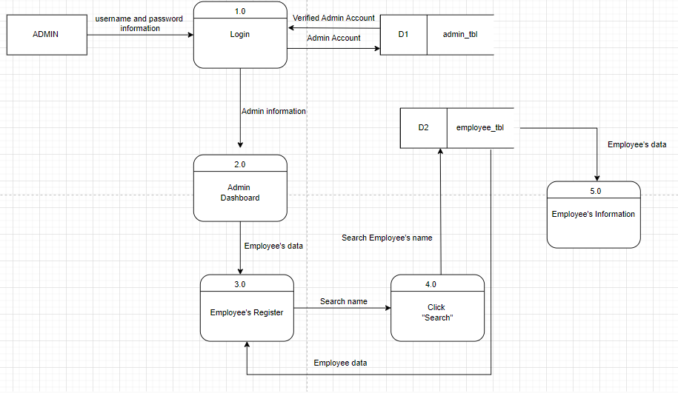3.6.12 Search Employee Process

*3.12 Search Employee Process*

In this figure 3.12 it shows the Search Employee Process. The admin entity enter a username and password flow to the login process the admin account verify to the admin_tbl. The admin account is exist in admin_tbl therefor the data flow with the value of admin information to the admin dashboard. It will display all the employees register the admin will input the employee’s name or ID then click search it will check in the employee_tbl then it will display the employee’s information search.

3.6.13 Print Employee Details Process 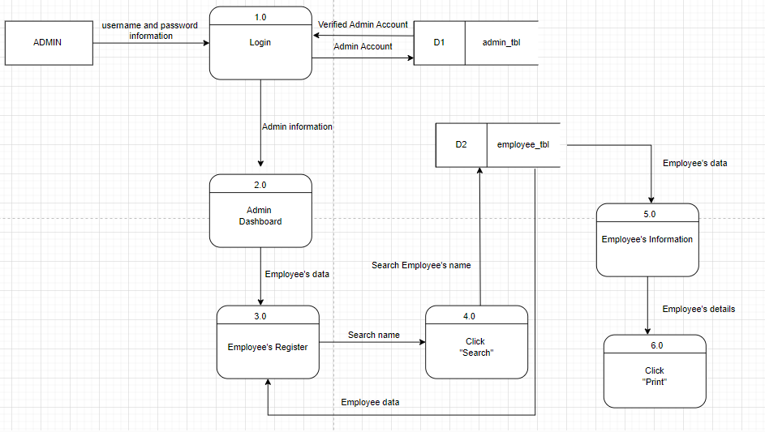

*3.13* *Print Employee Details Process*

In this figure 3.13 it shows the Print Employee Details Process. The admin entity enter a username and password flow to the login process the admin account verify to the admin_tbl. The admin account is exist in admin_tbl therefor the data flow with the value of admin information to the admin dashboard. It will display all the employees register the admin will input the employee’s name or ID then click search it will check in the employee_tbl then it will display the employee’s information search. The admin will click the print button to print the employee’s details.

3.6.14 Approve/Denied Employee form Process

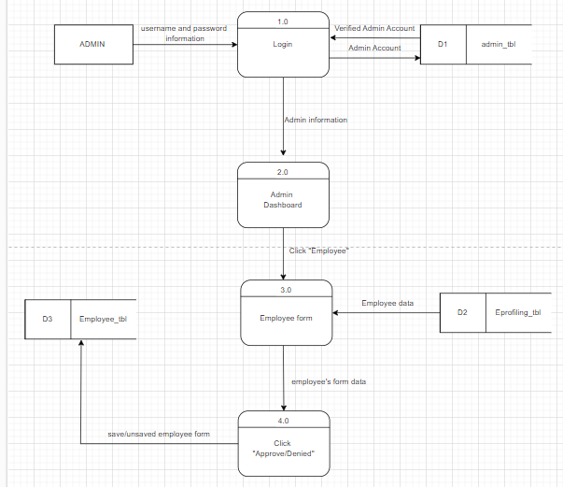

*3.14* *Approve/Denied Employee form Process*

In this figure 3.14 it shows the Approve/Denied Employee form Process. The admin entity enter a username and password flow to the login process the admin account verify to the admin_tbl. The admin account is exist in admin_tbl therefor the data flow with the value of admin information to the admin dashboard. The admin will click the manage employee It will display all the employee’s profiling form. The admin will click either approve or denied the form after that the employee’s form will save or unsaved to the employee_tbl.

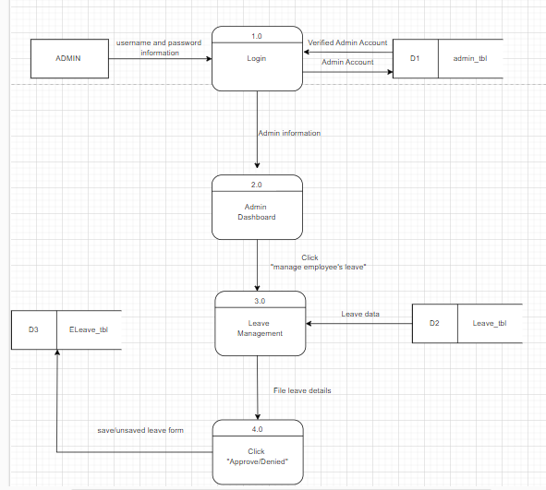3.6.15 Approve/Denied Leave form Process

*3.15* *Approve/Denied Leave form Process*

In this figure 3.15 it shows the Approve/Denied Leave form Process. The admin entity enter a username and password flow to the login process the admin account verify to the admin_tbl. The admin account is exist in admin_tbl therefor the data flow with the value of admin information to the admin dashboard. The admin will click the leave management it will display all the employee’s requesting leave form. The admin will click either approve or denied the form after that the employee’s leave from will save or unsaved to the Eleave_tbl.

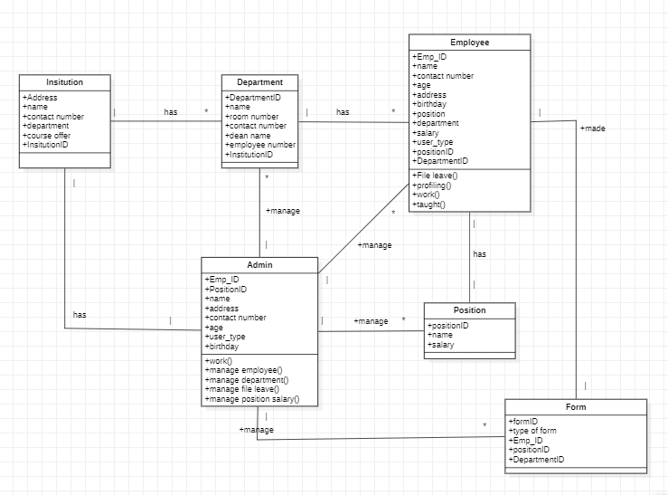**3.7 Class Diagram**

*Figure 3.16 Class Diagram*

In this figure 3.16 shows the Class Diagram process of the Ferndale Colleges Zamboanga Peninsula Inc. In this system, this is the data transaction of each module process in the system, and all data input by employee and admin will be automatically saved on the EMS.