ACADEMIC INTERNSHIP PROJECT REPORT
E-Commerce Customer Satisfaction
& Delivery Performance Analysis
Data Analytics with AI

Student Name | AMJURI JAY RAJ
Internship | Data Analytics with AI - Academic Internship Project
Project Title | E-Commerce Customer Satisfaction & Delivery Performance Analysis

Prepared using Python, Pandas, Streamlit, Plotly and IBM Bob

1. Abstract
This project analyses customer satisfaction and delivery performance in an e-commerce environment using the Olist Brazilian E-Commerce Public Dataset. The study focuses on whether delivery timeliness is associated with customer review scores and identifies delivery issues across product categories, customer states and time periods. Six related datasets were cleaned, merged and analysed in Python. An interactive Streamlit dashboard was developed to present key performance indicators, exploratory charts, trends and business recommendations. The final analysis contains 99,441 total orders, including 96,470 delivered orders. Of the delivered orders, 89,936 were on time and 6,534 were delayed, producing a 93.2% on-time delivery rate. The average delivery time was 12.1 days and the average review score was 4.16 out of 5. Delayed orders had a substantially lower average review score (2.27) than on-time orders (4.29), showing a strong association between delivery timeliness and customer satisfaction.

2. Problem Statement
An e-commerce company wants to improve customer satisfaction by understanding how delivery performance affects customer experience. Historical order, delivery, product, customer and review data are analysed to identify delayed deliveries, measure delivery performance, discover product categories and customer locations associated with lower satisfaction, and generate actionable business recommendations. An interactive dashboard is used to communicate delivery and customer-satisfaction KPIs.

3. Objectives
- Measure total, delivered, on-time and delayed orders.
- Calculate on-time rate, delay rate, average delivery time and average review score.
- Compare customer review scores for on-time and delayed deliveries.
- Identify states with higher delay rates or longer delivery times.
- Identify product categories with delivery and satisfaction problems.
- Study monthly order volume, review-score and on-time-delivery trends.
- Present the results through an interactive Streamlit dashboard.
- Provide data-driven business recommendations based on the observed results.

4. Dataset Description
The project uses the public Olist Brazilian E-Commerce dataset, which contains anonymised e-commerce transactions from Brazil. The analysis uses six CSV files.
Dataset File | Purpose
olist_customers_dataset.csv | Customer IDs and customer state/location.
olist_orders_dataset.csv | Order status and purchase, delivery and estimated-delivery timestamps.
olist_order_items_dataset.csv | Order-item and product relationships used for category analysis.
olist_order_reviews_dataset.csv | Customer review scores and review information.
olist_products_dataset.csv | Product information and product-category identifiers.
product_category_name_translation.csv | English translations for product-category names.

5. Tools and Technologies
- Python - core programming language for data processing and application logic.
- Pandas - data loading, cleaning, merging, aggregation and KPI calculation.
- Streamlit - interactive web dashboard.
- Plotly - interactive charts and visualisations.
- Statsmodels - supports the fitted OLS trendline used in the delay-versus-review scatter chart.
- IBM Bob - AI-assisted project planning, implementation, testing and validation.
- Kaggle - source of the Olist public dataset.

6. Data Preparation and Methodology

6.1 Data Cleaning
- Loaded and validated all six required CSV files.
- Converted purchase, delivery and estimated-delivery fields to date/time values.
- Checked missing values, duplicates and impossible delivery-time records.
- Resolved 551 duplicate review records using a consistent latest-valid-review rule.
- Validated that there were no negative delivery times and no delivery-time records above 365 days in the final delivered-order data.
- Kept delivery KPIs at order level to avoid double counting.

6.2 Data Integration
Customer, order and review information was merged into an order-level analytical dataset. A separate item/category-level dataset was maintained for product-category analysis. This design allows every item category in a multi-item order to participate in category analysis without multiplying order-level delivery KPIs.

6.3 Engineered Measures
Measure | Definition
Delivery Time (days) | Actual delivery date - purchase date
Estimated Delivery Time (days) | Estimated delivery date - purchase date
Delay Days | Actual delivery date - estimated delivery date
Delayed Flag | Delayed when Delay Days > 0
On-Time Flag | On time when the delivered order is not late
Order Month | Month extracted from purchase date for time-trend analysis

7. Key Performance Indicators
KPI | Result
Total Orders (all statuses) | 99,441
Delivered Orders | 96,470
On-Time Orders | 89,936
Delayed Orders | 6,534
On-Time Delivery Rate | 93.2%
Delay Rate | 6.8%
Average Delivery Time | 12.1 days
Average Estimated Delivery Time | 23.4 days
Average Review Score | 4.16 / 5
Orders with Review | 95,824
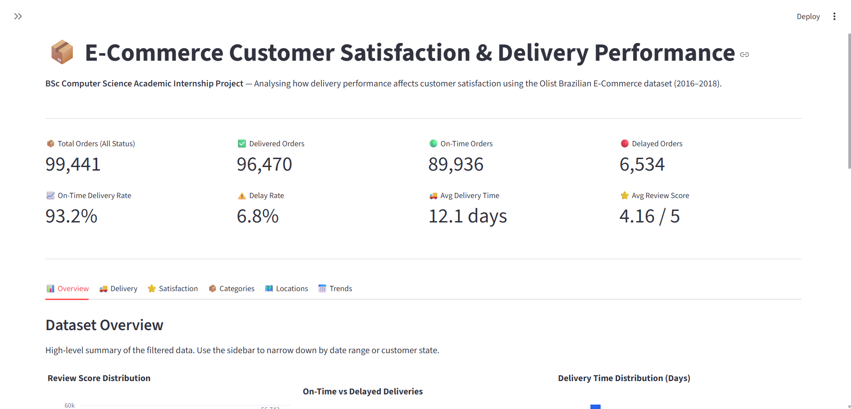
Figure 1. Dashboard header and principal KPIs.
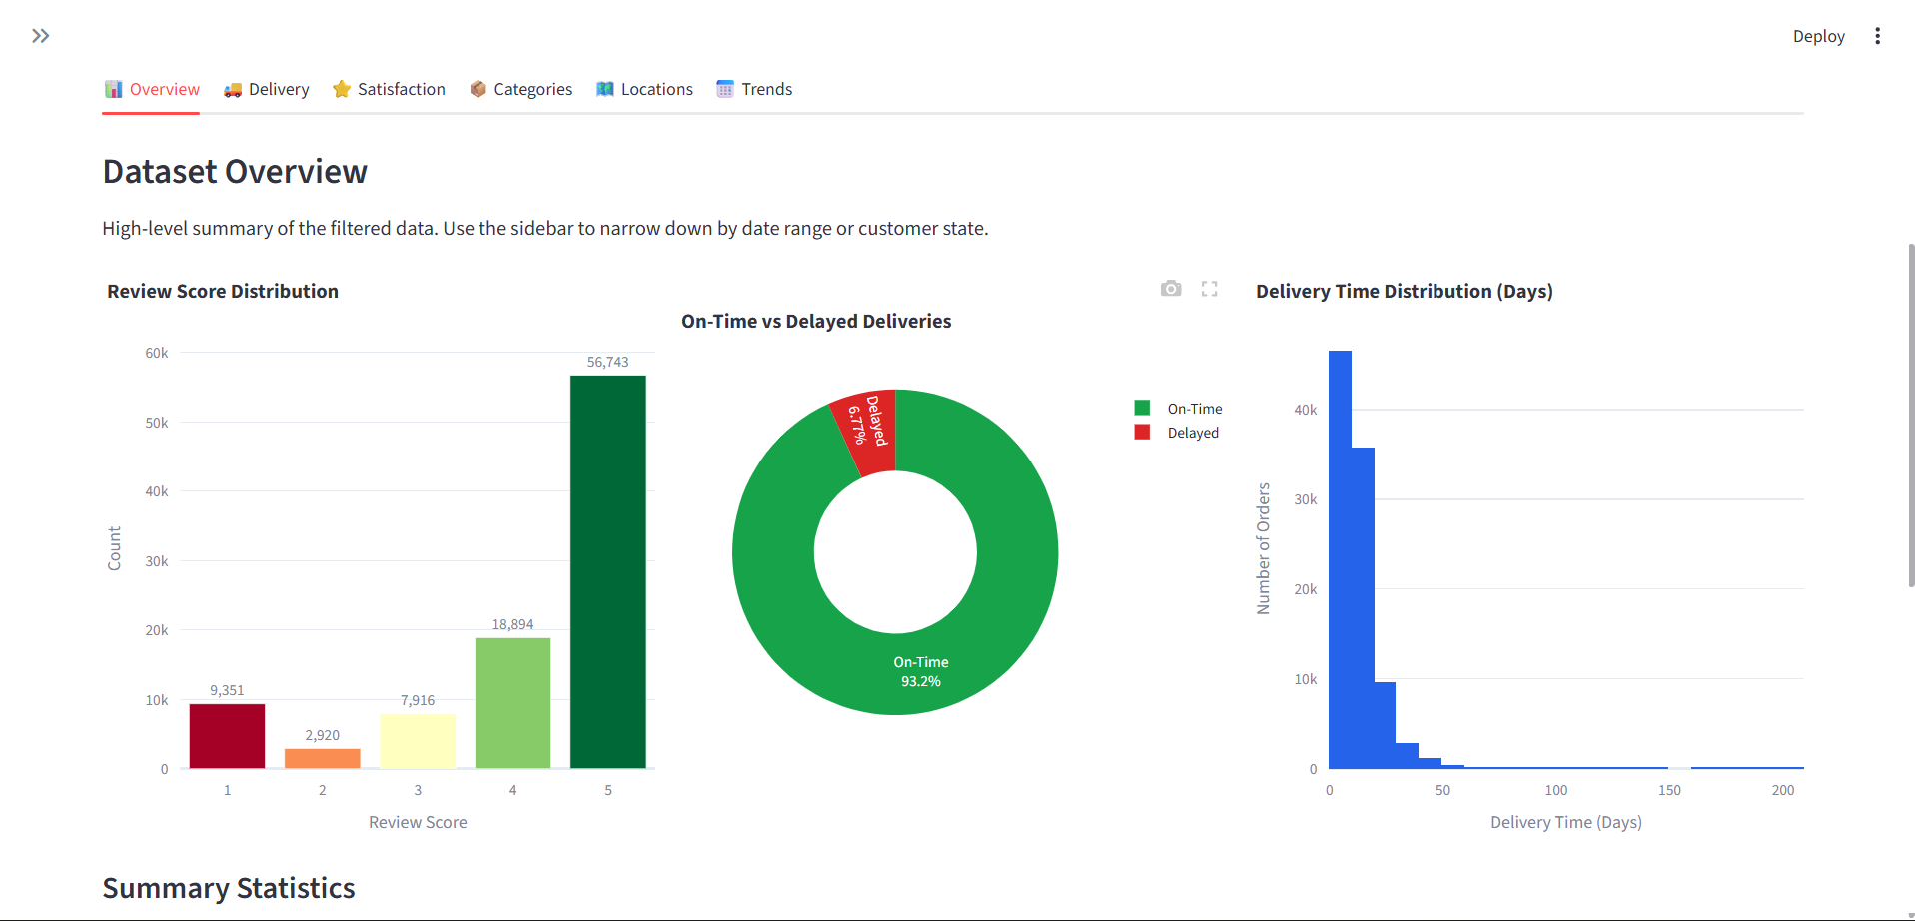
Figure 2. Overview charts: review distribution, delivery status and delivery-time distribution.

8. Analysis and Findings

8.1 Delivery Performance
The average actual delivery time was 12.1 days, compared with an average estimated delivery time of 23.4 days. Overall, 93.2% of delivered orders arrived on time and 6.8% were delayed. The average delay measure across all delivered orders was -11.9 days; the negative value means that orders generally arrived before their estimated delivery date rather than being late.
State-level results show meaningful geographic differences. AL recorded the highest displayed delay rate at 21.4%, while RR had the highest displayed average delivery time at approximately 29.0 days.
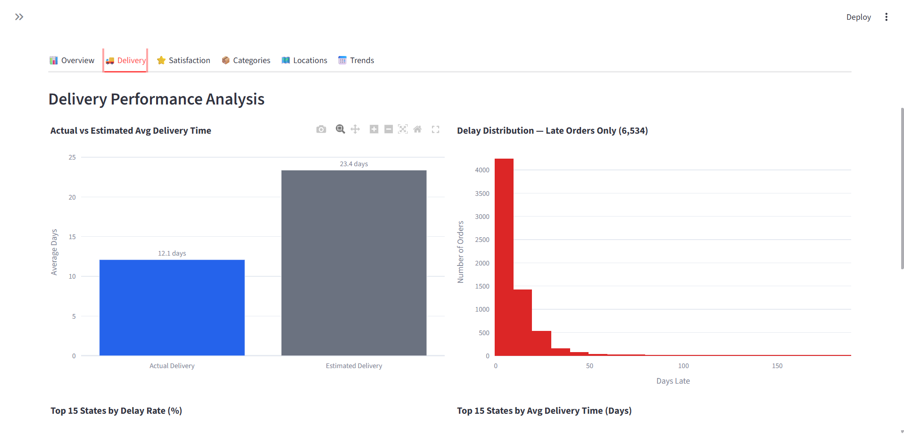
Figure 3. Delivery performance: actual vs estimated delivery time and late-order distribution.

8.2 Customer Satisfaction
Delivery timeliness is strongly associated with review scores in the analysed data. On-time deliveries received an average review score of 4.29 out of 5, whereas delayed deliveries received 2.27 out of 5, a difference of 2.02 points. The review-score distribution also shows that on-time deliveries are concentrated at four and five stars, while delayed orders contain a much larger share of low ratings. Because this is observational data, the analysis identifies an association and does not prove that delivery delay alone causes lower customer ratings.
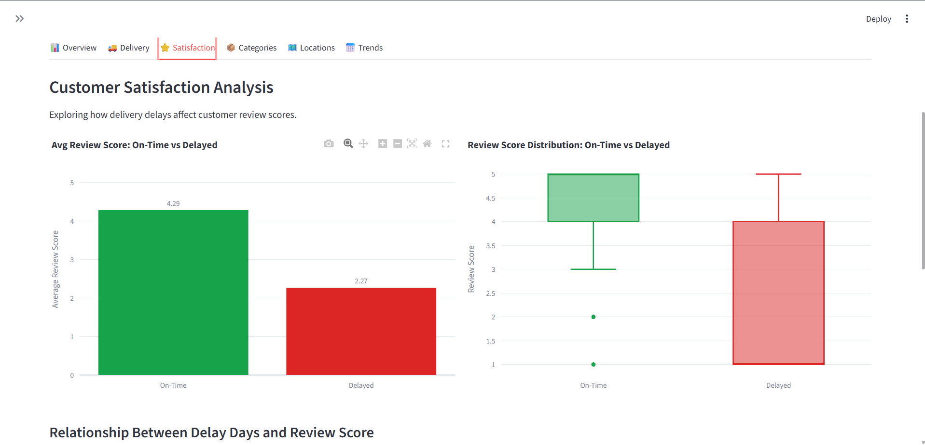
Figure 4. Customer satisfaction comparison for on-time and delayed deliveries.

8.3 Product Category Analysis
Product-category analysis is performed at item level so that all categories in multi-item orders are represented. A minimum item-count filter is used to reduce noise from very small categories. Among the qualifying categories shown in the dashboard, office_furniture stands out: it has the longest average delivery time (20.4 days), the lowest average review score (3.51/5) and the highest displayed category delay rate (8.0%). In contrast, books_general_interest has the highest displayed average review score at 4.51/5.
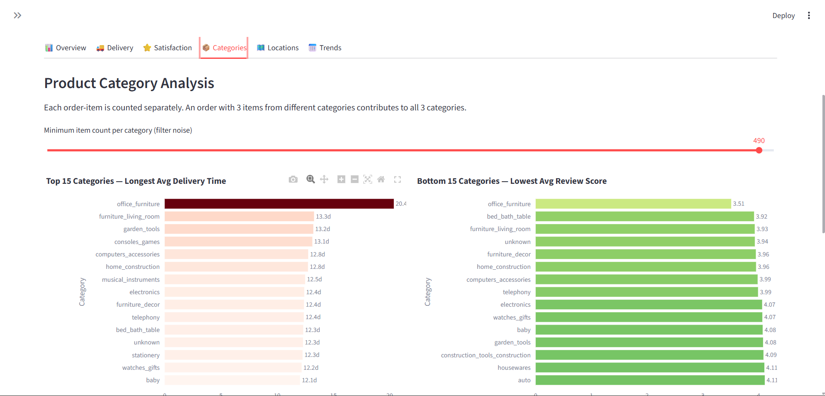
Figure 5. Product-category delivery-time and review-score analysis.

8.4 Location Analysis
The state analysis compares customer satisfaction, delay rate and order volume. AL has the highest delay rate at 21.4%. MA has the lowest displayed average review score at 3.83. SP has the largest delivered-order volume with 40,494 orders, an average review score of 4.25 and a relatively low delay rate of 4.5%.
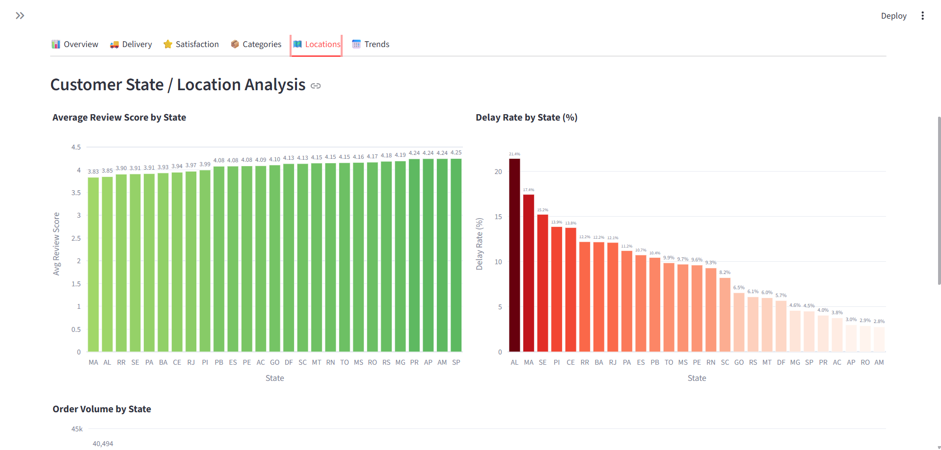
Figure 6. Customer state/location analysis.

8.5 Time-Based Trend Analysis
Monthly charts show how delivered-order volume, average review score and on-time delivery rate changed across the available 2016-2018 period. Order volume increased substantially after the early months of the dataset. Review scores were generally around four or above through most of the higher-volume period, while the on-time rate remained high but showed noticeable monthly dips. Very early months contain low volumes, so extreme early values should be interpreted cautiously.
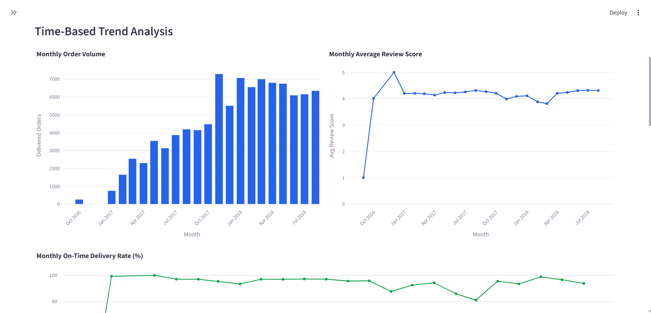
Figure 7. Monthly order-volume and average-review-score trends.

9. Key Business Findings
- On-time deliveries average 4.29/5, while delayed deliveries average 2.27/5 - a 2.02-point gap.
- AL records a 21.4% delay rate, the highest among the states highlighted by the dashboard's qualifying criteria.
- MA has the lowest displayed state-level average review score at 3.83.
- office_furniture has the longest average delivery time among qualifying categories at 20.4 days.
- office_furniture also has the lowest qualifying category average review score at 3.51/5.
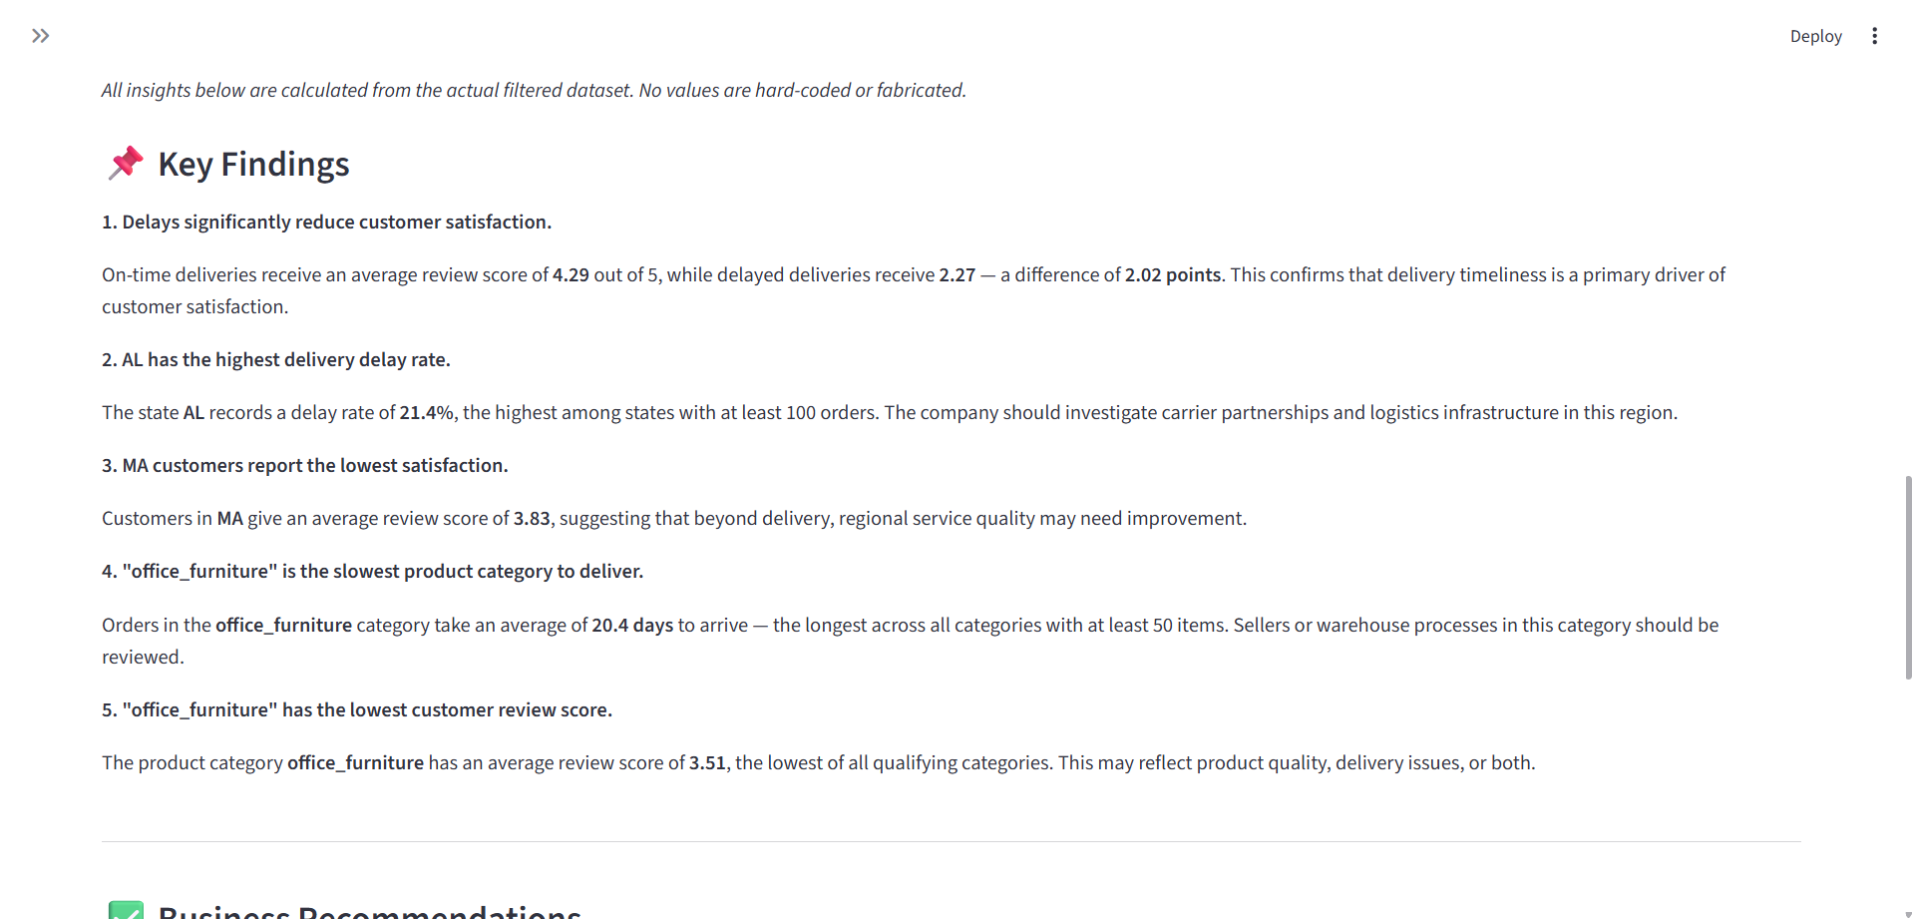
Figure 8. Data-driven key findings generated from the dashboard calculations.

10. Business Recommendations
- Prioritise on-time delivery improvement because delayed orders are associated with substantially lower customer ratings.
- Investigate logistics and last-mile carrier performance in AL, where the observed delay rate is especially high.
- Review fulfilment, warehouse handling and carrier selection for office_furniture, which combines slow delivery with low customer ratings.
- Investigate product listings, product quality and customer complaints for office_furniture rather than assuming delivery is the only source of dissatisfaction.
- Review delivery-estimate accuracy by region and category so promised dates remain realistic and useful to customers.
These recommendations are based on patterns in the historical dataset. Operational changes should be tested and monitored before concluding that any single intervention will cause an improvement in review scores.
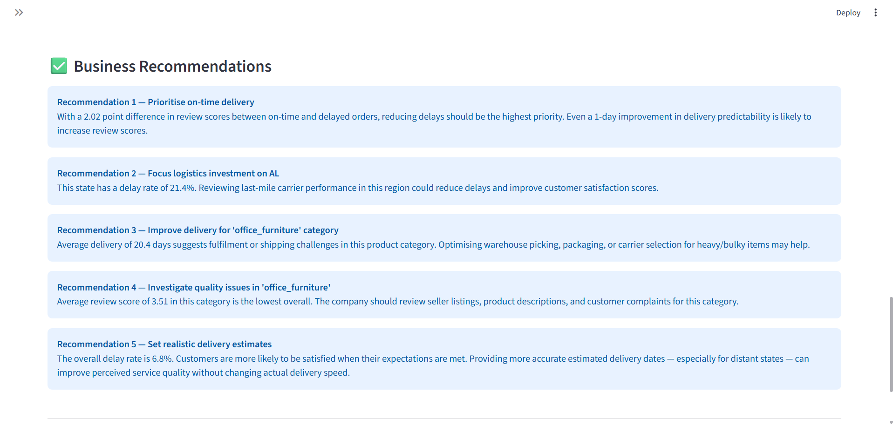
Figure 9. Business recommendations displayed in the Streamlit dashboard.

11. Dashboard Features
- Eight KPI cards covering orders, delivery performance and customer satisfaction.
- Sidebar filters for date range and customer state.
- Six analysis tabs: Overview, Delivery, Satisfaction, Categories, Locations and Trends.
- Interactive Plotly charts with hover, zoom and export controls.
- Separate order-level and item/category-level analysis to maintain correct aggregation.
- Dynamic business insights and recommendations calculated from the currently filtered data.

12. Limitations
- The dataset covers historical Brazilian e-commerce transactions from 2016-2018 and should not be treated as current market performance.
- The analysis is observational; associations between delays and review scores do not by themselves establish causation.
- Customer satisfaction is represented primarily by review score and may also be affected by product quality, seller service, price and other factors.
- Some state/category comparisons can be sensitive to sample size, so minimum-count filters are used where appropriate.
- The project does not include a machine-learning prediction model because the project objective is descriptive and diagnostic analytics.

13. Conclusion
The project successfully transformed six related e-commerce datasets into a validated analytical pipeline and interactive dashboard. The results show strong overall delivery performance, with 93.2% of delivered orders arriving on time, but also identify specific areas where performance can be improved. The clearest customer-experience pattern is the large review-score gap between on-time and delayed orders. Geographic analysis highlights AL for delay performance, while category analysis highlights office_furniture for both delivery time and customer ratings. These findings demonstrate how data analytics can turn operational transaction data into practical business insights while maintaining appropriate caution about causal claims.

14. Project Files
File | Purpose
app.py | Streamlit dashboard and visual analysis.
data_processing.py | Data loading, cleaning, merging and feature engineering.
requirements.txt | Python package dependencies.
README.md | Project overview, dataset information and setup instructions.
ecommerce-satisfaction-plan.md | Implementation plan and task tracking.
data/ | Six source CSV files used by the project.

15. Dataset Source
Olist Brazilian E-Commerce Public Dataset, distributed through Kaggle. The README for the project should retain the dataset source information so the analysis can be reproduced.

