ADANI UNIVERSITY
Faculty of Engineering Sciences and Technology (FEST)
Department of Computer Science and Engineering (AI-ML)
PROJECT-BASED LEARNING (PBL) - FINAL REPORT
Course: ECSCT24301 - Foundation of AI | Academic Year 2026-27
Sudoku Solver Using Constraint Satisfaction
Comparing Backtracking, MRV, Degree Heuristic, Forward Checking and AC-3 (MAC)
Track: Applied AI Project Track (Optimization & Scheduling, Unit 2)
Team member | Enrollment number
Jayraj Chauhan | 2410111015
Om Patel | 2410111112
Parth Prajapati | 2410111138
Supervisor: Ms. Alpa Rupala
Submission date: November 2026 (Stage 4 - Final Submission & Viva Voce)

Abstract
Sudoku is a compact constraint satisfaction problem (CSP) whose all-different structure also underlies timetabling and crew rostering. This project models a 9x9 Sudoku as a CSP with 81 variables, bitmask domains over 1-9 and 27 all-different units, and implements five complete solvers with identical instrumentation: plain backtracking (baseline), backtracking with Minimum-Remaining-Values (MRV), MRV with the degree heuristic as tie-breaker, forward checking (FC), and maintaining arc consistency with AC-3 (MAC). A harness records nodes generated, backtracks, constraint checks, domain prunings and wall-clock time on 109 solvable instances (90 generated 9x9 puzzles with 24-40 givens and unique solutions, four well-known hard puzzles, and 15 generated 16x16 boards) plus 13 invalid or unsolvable inputs, under a 5 s (9x9) or 15 s (16x16) limit.
On medium 9x9 puzzles (fewer than 32 givens) the baseline needed 95,046 nodes on average and timed out on 2 of 49, whereas MRV needed 624 (98.4% fewer) and MAC 289 (99.4% fewer); FC was fastest in wall-clock time (10 ms versus 27 ms for MAC) because its nodes are cheap. The 16x16 tests expose the limits: the baseline solved only 6 of 15 boards, BT+MRV 14, and FC and MAC 12 each, evidence of heavy-tailed runtimes and per-node overhead in pure Python. We prove that h(n) = number of unassigned cells is admissible and consistent, show that doubling it is inadmissible and that counting undecided cells is admissible but inconsistent, verify that AC-3 never removed a solution value (0 of 16,200 cells), and show that FC accepts 2,164 of 11,112 trial assignments that AC-3 refutes at once. Code, 30 automated tests, a Streamlit demonstrator and reproducible results accompany the report.

1. Introduction and Background

1.1 Real-world significance
A Sudoku asks for a completion of a partially filled grid so that every row, column and box contains each symbol exactly once. Although it is a puzzle, its constraint structure - a set of variables that must take pairwise different values within overlapping groups - is the same all-different pattern that appears in university timetabling (no two events share a room or a student group in one slot), crew and shift rostering, frequency assignment and register allocation. Generalised n^2 x n^2 Sudoku is NP-complete (Yato & Seta, 2003), so the study of how much search can be avoided by ordering heuristics and constraint propagation is directly transferable to those optimisation and scheduling problems.

1.2 Scope and objectives
The project follows the Applied AI Project Track of the course. It formulates Sudoku as an intelligent-agent problem, implements one baseline and four progressively stronger CSP solvers, measures them on instances of increasing difficulty and size, analyses the properties of the heuristics involved, and delivers an interactive prototype that accepts unseen and even invalid inputs. The objectives are:
- to model the task formally (PEAS, state space, transition model, goal test, cost) and to validate input before searching;
- to implement Basic Backtracking (baseline), Backtracking + MRV, MRV + Degree, Forward Checking and AC-3 (MAC) with identical metrics;
- to quantify how much each technique reduces nodes, backtracks and time on 9x9 puzzles of varying hardness and on 16x16 boards;
- to state and test the formal properties (completeness, optimality, time and space complexity, admissibility and consistency) and to document failure modes.

1.3 Foundational AI principles used
Sudoku is a satisfaction problem rather than a path-cost optimisation problem. We therefore use the CSP view of search (Russell & Norvig, 2021): variables, finite domains and constraints; depth-first search over partial assignments (backtracking); variable-ordering heuristics that implement the fail-first principle (MRV and degree); and inference that shrinks domains before and during search (forward checking and arc consistency). Constraint propagation by AC-3 follows Mackworth (1977); the combination of search with propagation after each assignment is the MAC strategy.

2. Problem Formulation and Environment Modeling

2.1 Problem statement
Given a partial 9x9 Sudoku, complete it so that each row, column and 3x3 box contains the digits 1-9 exactly once, or correctly report that the input is invalid (the givens already clash) or unsolvable (no completion exists). Scalability is tested on 16x16 boards (symbols 1-9 and A-G, 4x4 boxes).

2.2 PEAS specification
Table 1. PEAS description of the Sudoku AI solver
Component | Sudoku AI solver
Performance measure | Correct solution; minimal nodes, backtracks and runtime; safe handling of bad input; clear trace of decisions
Environment | 9x9 (and 16x16) grid with givens and row/column/box constraints
Actuators | Assign a digit, prune domains, backtrack, output solution and trace
Sensors | Grid contents, cell domains, peers, the user-supplied puzzle

2.3 Environment properties
Table 2. Task-environment properties
Property | Value | Justification
Observability | Fully observable | The whole grid and all domains are known at every step.
Determinism | Deterministic | Assigning a digit has exactly one outcome.
Dynamics | Static | The puzzle does not change while the agent thinks.
States / actions | Discrete | Finite grid, finite digit set.
Agents | Single-agent | No opponent or cooperating agent.
Knowledge | Known | The rules (constraints) are fully specified.

2.4 Formal CSP definition
A puzzle of order N (N = 9 or 16) defines the CSP <X, D, C>. The variables are X = {X(r,c) : cell (r,c) is empty}; each has a domain D(X) subset of {1..N}, initially {1..N}. The constraints C are 3N all-different constraints, one per row, column and box (27 for 9x9, 48 for 16x16). We decompose each all-different into binary inequality constraints X_i != X_j for every pair of cells that share a unit (peers); a 9x9 cell has 20 peers and a 16x16 cell 39. The set of peers is the neighbourhood in the constraint graph, and its size is the degree used by the degree heuristic.

2.5 State-space formulation
Table 3. Problem formulation
Element | Definition
State | A partial assignment of digits to cells that violates no constraint (and, for FC/MAC, the current domains).
Initial state | The validated user puzzle: givens assigned, all other cells unassigned. Invalid puzzles are rejected before search.
Actions | choose an unassigned cell X; assign a value v in D(X); propagate (FC or AC-3); backtrack when a domain becomes empty.
Transition model | Result(s, assign(X, v)) = s with X = v and, with inference, v removed from the domains of X's peers.
Goal test | Every cell is assigned and every row, column and box contains each digit exactly once (is_solution).
Path cost | 1 per assignment. Every solution path has the same length E = number of empty cells, so all solutions cost E.
Search effort | Nodes generated, backtracks, constraint checks, domain prunings, time (the quantities we minimise).
Size of the state space and branching factor. With E empty cells the search tree has depth E and at most 9 successors per node, so the unpruned space contains at most 9^E assignments; for a 24-clue puzzle (E = 57) this is about 10^54. The 16x16 boards of our benchmark have on average 116, 134 and 149 empty cells for the three densities (16^149 is about 10^179). Uninformed backtracking has an effective branching factor of 9 at the root of every subtree (avg_branching = 9.00 in the logs); MRV, FC and MAC reduce the average number of values tried per expanded node to about 1.0-1.1 in our measurements, because the cell chosen usually has a single candidate.
The pipeline followed for every stage of the project is summarised in Figure 1.
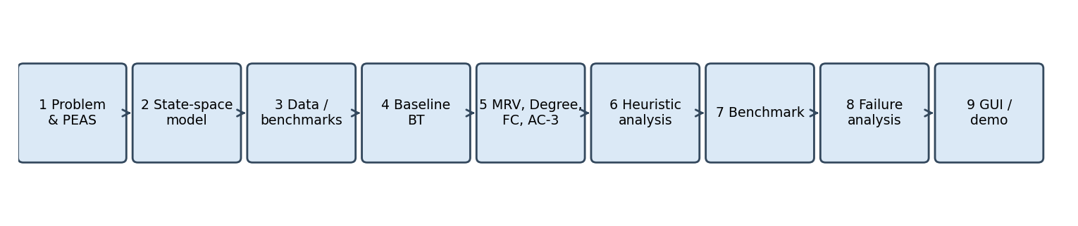
Figure 1. End-to-end AI engineering pipeline followed in this project.

3. Literature Review and Related Work
Although a literature review is mandatory only for the Research Track, we place the project in the context of the work on which it builds.
- Arc consistency. Mackworth (1977) introduced the AC-1 to AC-3 family of algorithms that make a network of binary constraints arc consistent by repeatedly revising domains against a queue of arcs. AC-3 is the propagation engine of our MAC solver.
- Fail-first search and forward checking. Haralick and Elliott (1980) compared tree-search variants for CSPs, introduced forward checking and advocated choosing the variable with the fewest remaining values - the origin of the MRV heuristic that Russell and Norvig (2021) present together with the degree heuristic.
- Maintaining arc consistency. Bessiere and Regin (1996) showed that enforcing arc consistency after every assignment (MAC) combined with fail-first heuristics outperforms forward checking on hard problems, a result we test on Sudoku.
- All-different filtering. Regin (1994) gave a matching-based filtering algorithm for the all-different constraint that is stronger than its binary decomposition; Simonis (2005) studied Sudoku as a constraint problem and compared several such propagation strengths. Our AC-3 works on the binary decomposition and is therefore weaker, which explains why search is still needed (Section 8).
- Complexity and puzzle structure. Yato and Seta (2003) proved that finding another solution to generalised Sudoku is ASP-complete and the problem NP-complete; McGuire, Tugemann and Civario (2014) proved that no 9x9 puzzle with 16 givens has a unique solution, so 17 clues are the minimum - our '17-clue' benchmark puzzles are at that extreme.
- Practical solvers and data. Norvig (2006) describes constraint propagation plus search that solves every Sudoku in milliseconds; his easy50, top95 and hardest sets are standard benchmarks. Radcliffe (2020) publishes three million puzzles with difficulty ratings on Kaggle. Dechter (2003) and Russell and Norvig (2021) provide the textbook treatment of the techniques used.
Our contribution is a controlled, fully instrumented ablation: the same code base, metric definitions, time limits and instance sets are used for the baseline and for each added technique, so that the effect of each heuristic or propagation level can be read directly from the results.

4. Methodology and Algorithmic Architecture

4.1 Overall architecture
Figure 2 shows the processing chain. The input is parsed and validated (length, symbols, duplicate givens in any unit); only rule-consistent puzzles reach the CSP model. Each solver repeats the cycle SELECT-VARIABLE, ASSIGN, INFERENCE, with backtracking when the inference empties a domain, and the goal test is evaluated first on every call.
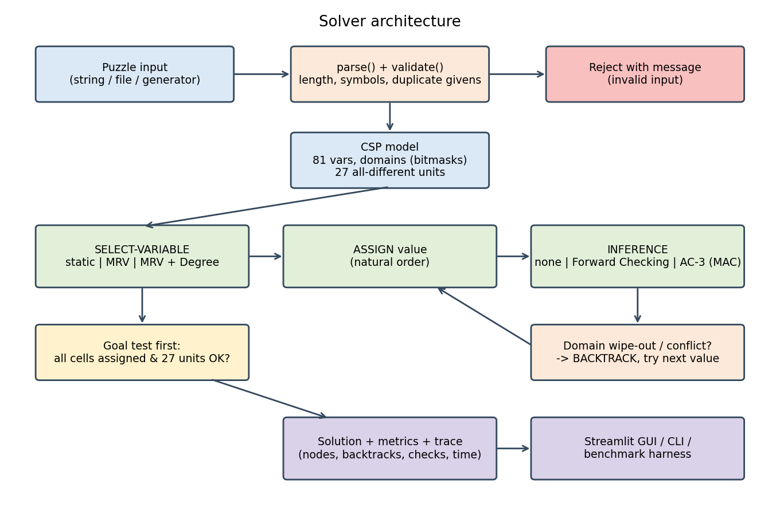
Figure 2. Architectural flowchart of the solver.

4.2 Baseline: basic backtracking (BT)
Depth-first search over partial assignments with a static, row-major variable order and values tried in ascending order. A value is accepted if it differs from every already-assigned peer; each peer comparison counts as one constraint check. There is no pruning of domains, so a contradiction is discovered only when some later cell has no legal digit.
function BT(assignment):
if no unassigned cell: return assignment # goal test
X <- first unassigned cell (row-major)
for v in 1..N:
if v differs from every assigned peer of X: # constraint checks
assign X = v; nodes += 1
result <- BT(assignment)
if result != failure: return result
unassign X; backtracks += 1
return failure

4.3 Variable-ordering heuristics: MRV and degree
Minimum Remaining Values selects the unassigned cell whose set of legal digits is smallest, implementing the fail-first principle: a cell with one candidate is forced, a cell with none exposes a dead end immediately. In the BT+MRV and BT+MRV+DEG solvers the legal digits are recomputed from the peers at every node (no stored domains), which makes MRV expensive in checks but keeps these solvers directly comparable to the baseline. The degree heuristic breaks MRV ties by choosing the cell with the most unassigned peers, i.e. the variable that constrains the largest part of the remaining problem: key(X) = (|D(X)|, -deg(X), index(X)).

4.4 Forward checking (FC)
FC maintains explicit bitmask domains. After assigning X = v it removes v from the domain of every peer of X and fails immediately when a domain becomes empty. Domain changes are recorded on a trail so that backtracking restores them exactly. FC is combined with MRV + degree ordering.
function FC-assign(X, v):
dom[X] <- {v}
for each peer p of X: # one constraint check per peer
if v in dom[p]:
trail.push(p, dom[p]); dom[p] <- dom[p] - {v}; prunes += 1
if dom[p] is empty: return failure # domain wipe-out
return ok

4.5 Maintaining arc consistency with AC-3 (MAC)
An arc (X_i, X_j) is consistent if every value of D(X_i) has a supporting value in D(X_j). For the constraint X_i != X_j a value b of D(X_i) lacks support exactly when D(X_j) = {b}, so a revision is a constant-time bitmask test. MAC runs AC-3 as pre-processing over all arcs and again after every assignment, seeded with the arcs (peer, X); every domain that shrinks to a singleton cascades through its own neighbours. Compared with FC, MAC therefore detects contradictions that are several assignments away (Section 8.2). The queue-based algorithm (Mackworth, 1977) is:
function AC-3(queue of arcs):
while queue not empty:
(Xi, Xj) <- queue.pop(); revisions += 1
if D(Xj) = {b} and b in D(Xi): # b has no support in Xj
D(Xi) <- D(Xi) - {b}; prunes += 1
if D(Xi) is empty: return failure
for each peer Xk of Xi, Xk != Xj: # Xk's arcs must be rechecked
queue.push((Xk, Xi))
return ok

4.6 Heuristic properties: admissibility and consistency
The course asks for the formal status of heuristics. In Sudoku every solution path from a state with u unassigned cells contains exactly u assignments, each of cost 1, so the true remaining cost is h*(n) = u(n). We examined three candidate estimates and tested them on every edge visited by the search of 80 puzzles (10,751 edges).
Table 4. Formal heuristic properties and the counter-examples found during the trial phase
Heuristic | Admissible (h <= h*) | Consistent (h(n) <= 1 + h(n')) | Evidence
h_u(n) = number of unassigned cells | Yes (h = h*) | Yes (equality) | 0 violations in 10,751 edges
h_2(n) = 2 * h_u(n) | No | No | overestimates on 10,751 of 10,751 edges (e.g. u = 1: h = 2 > h* = 1)
h_s(n) = cells with |D| > 1 | Yes (h_s <= h_u) | No | 3,030 violating edges, largest single-step drop 52
Proof for h_u. Along any edge n -> n' (one assignment) u(n') = u(n) - 1 and c(n, n') = 1, hence h_u(n) = 1 + h_u(n') = c(n, n') + h_u(n'), which is consistency with equality; at a goal u = 0. Because h_u equals h*, it is admissible and any search using it expands only nodes on cost-optimal paths. Since g(n) + h_u(n) = E for every node, f is constant and A* gives no guidance in Sudoku; this is why the useful heuristics are the ordering heuristics (MRV, degree), which never influence optimality or completeness but strongly influence the size of the tree. Counter-example for h_s. During the trials, a state with h_s = 56 moved to a state with h_s = 54 after a single assignment (h_u went 56 -> 55); consistency would require h_s(n) <= 1 + h_s(n') = 55, but 56 > 55. Propagation made two further cells unique at once, so the estimate falls faster than the true cost.
Soundness of AC-3 and the FC/AC-3 gap. We solved 200 unique-solution puzzles, ran the AC-3 pre-processing and checked every cell: none of the 16,200 cells lost its solution value (108,443 other candidates were removed), which is the empirical counterpart of the soundness theorem. Conversely, in 11,112 trial assignments, forward checking accepted 2,164 (19.5%) that AC-3 refutes at once; FC is strictly weaker, as the theory predicts.

4.7 Theoretical properties of the algorithms
Table 5. Completeness, optimality, time and space complexity (N = 9, E = empty cells, e = 1,620 arcs, d = 9)
Algorithm | Completeness | Optimality | Time | Space
BT | Complete | Trivial (all solutions cost E) | O(9^E) | O(E)
BT+MRV | Complete | Trivial | O(9^E) worst case; far smaller in practice | O(E)
BT+MRV+DEG | Complete | Trivial | same bound; tie-breaking only | O(E)
FC | Complete | Trivial | O(9^E) worst; O(peers) per assignment | O(E + N^3) trail
MAC (AC-3) | Complete | Trivial | O(9^E) worst; AC-3 O(e*d^3) per call | O(E + N^3) trail
Completeness holds for all five because the pruning performed by FC and AC-3 only removes values that appear in no solution, and the variable and value orderings only permute the order in which the finite tree is explored. Sudoku is a satisfaction problem: every solution has cost E, so 'optimal' is trivial; the project distinguishes finding a valid solution from minimising search effort, which is what the heuristics improve. Time is exponential in the worst case for all solvers (the problem is NP-complete); the techniques change the constant in the exponent in practice. Space is linear in the depth plus the trail, which holds at most N^3 domain changes along one path (729 for 9x9, 4,096 for 16x16), so memory is never the bottleneck here.

5. Implementation Details
Table 6. Technology stack
Item | Choice
Language / runtime | Python 3.11+ (developed and tested on 3.12)
Libraries | NumPy, pandas (benchmark tables), Matplotlib (figures), pytest (tests), Streamlit (GUI)
Repository | GitHub-ready package sudoku_csp/ with app.py, tests/, results/, docs/
Reproducibility | All instances generated with seed 2026; every figure and table is produced by python -m sudoku_csp.figures

5.1 Key data structures and state indexing
- Cells are indexed row-major (cell = r*N + c). Units are stored as 3N tuples of cell indices (rows, columns, boxes) and peers[c] is precomputed once per board size (20 or 39 neighbours).
- Domains are integer bitmasks: digit v corresponds to bit v-1, so removing a value, testing membership, counting candidates (bit_count) and detecting singletons (d & (d-1) == 0) are single machine operations.
- FC and MAC use a trail of (cell, old domain) pairs and a stack of assigned cells; backtracking pops back to the marks saved before the assignment, so no state is copied.
- Search results are returned in a Result record (status, solution, nodes, expanded, backtracks, checks, prunes, revisions, max depth, time, optional trace).

5.2 Edge-case handling
- Input validation: wrong length, illegal characters and duplicate givens in a row, column or box are rejected with a message naming the cells; invalid puzzles are never searched (6 of 6 invalid test cases rejected with 0 nodes by every solver).
- Unsolvable puzzles: rule-consistent puzzles that have no completion are reported as 'unsolvable' after the search space is exhausted.
- Resource limits: a node limit and a wall-clock limit abort a run cleanly and report 'timeout'; a time-out is never presented as a solution or as a proof of unsolvability.
- Multiple solutions: the solvers return the first solution; a solution counter (limit 2) is used by the generator to guarantee uniqueness of benchmark puzzles. The empty grid is solvable and returns a valid grid.
- Tracing: every assignment and backtrack can be logged (up to a cap) to reproduce exact decision sequences.

5.3 Software testing
A pytest suite of 30 tests passes. It covers the topology (27 units, 20 and 39 peers), parsing and validation (several malformed inputs, duplicate givens), correct solutions that respect the givens for all five solvers, agreement of the solvers on a unique-solution puzzle, empty and full boards, detection of unsolvable puzzles, time-out reporting, counting of multiple solutions, a 16x16 board, trace recording, and the puzzle generator.

6. Experimental Design and Setup

6.1 Benchmark problem sets
Table 7. Instance families (all solvable families have a known solution; 9x9 puzzles are unique-solution)
Family | Instances | Givens | Size class | Purpose
9x9 sweep c40, c36, c32 | 45 | 40, 36, 32 | small | easy: propagation nearly solves the puzzle
9x9 sweep c29, c26, c24 | 45 | 29, 26, 24 | medium | increasing difficulty / state-space depth (up to 57 empty cells)
Named hard puzzles | 4 | 17-22 | medium | Inkala 2012, Norvig 'hardest' and 'hard1', a 17-clue puzzle
16x16 at 55 / 48 / 42 % given | 15 | 140 / 122 / 107 (mean) | large | scalability; generated, solvable by construction
Invalid inputs | 6 | - | edge | duplicate givens in a row, column or box (9x9 and 16x16)
Unsolvable inputs | 7 | - | edge | rule-consistent but without a completion
The 9x9 puzzles are generated from random completed grids by removing cells while a solution counter confirms uniqueness; the size classes follow the guideline's small / medium / large scheme (small: at least 32 givens, medium: fewer than 32 givens or a named hard puzzle, large: 16x16). Each of the 109 solvable instances is run with all five solvers (545 runs), plus 13 edge-case inputs.
Data sources. The proposal names Norvig's easy50, top95 and hardest sets and Kaggle's Radcliffe collection. The harness loads them directly (--extra option; scripts/fetch_data.py downloads Norvig's files), and the four named puzzles above are among the widely circulated hard puzzles. The runs reported below use the generated families and these named puzzles; the same command line adds the full Norvig and Kaggle files without any code change. An own generator supplies the invalid, unsolvable and 16x16 instances, exactly as planned in the proposal.

6.2 Test harness
benchmark.py builds the instances, runs every solver with the same limits (5 s for 9x9, 15 s for 16x16), verifies each reported solution against the goal test and the givens (0 incorrect results in 545 runs) and writes one CSV row per run. Metrics: nodes generated, expanded nodes, backtracks, constraint checks, values pruned, AC-3 revisions, maximum depth, average branching factor and elapsed time. Time-outs are counted and plotted at the cap, so they are lower bounds. Experiments ran on a single CPU core in CPython; absolute times depend on the machine, relative comparisons do not.

7. Results and Comparative Analysis

7.1 Benchmark summary
Table 8. Benchmark summary over all solvable instances (means per instance; time limit 5 s for 9x9, 15 s for 16x16)
Size | Algorithm | Solved | T/O | Time (s) | Nodes | Backtracks | Checks
small | BT | 45/45 | 0 | 0.002 | 370 | 325 | 24,004
 | BT+MRV | 45/45 | 0 | 0.002 | 47.2 | 2.2 | 21,881
 | BT+MRV+DEG | 45/45 | 0 | 0.003 | 46.7 | 1.7 | 21,768
 | FC | 45/45 | 0 | 0.001 | 46.7 | 1.7 | 1,651
 | MAC | 45/45 | 0 | 0.003 | 45.3 | 0.3 | 8,618
medium | BT | 47/49 | 2 | 0.572 | 95,046 | 94,993 | 6,545,803
 | BT+MRV | 49/49 | 0 | 0.044 | 624 | 569 | 405,073
 | BT+MRV+DEG | 49/49 | 0 | 0.077 | 642 | 587 | 433,686
 | FC | 49/49 | 0 | 0.010 | 642 | 587 | 12,663
 | MAC | 49/49 | 0 | 0.027 | 289 | 234 | 83,958
large | BT | 6/15 | 9 | 9.385 | 650,268 | 650,187 | 130,679,107
 | BT+MRV | 14/15 | 1 | 2.126 | 6,134 | 6,007 | 18,864,357
 | BT+MRV+DEG | 10/15 | 5 | 5.427 | 10,004 | 9,905 | 34,622,442
 | FC | 12/15 | 3 | 3.641 | 149,505 | 149,390 | 5,539,994
 | MAC | 12/15 | 3 | 4.759 | 25,448 | 25,334 | 15,508,900

On small puzzles all five solvers succeed within milliseconds and the differences are modest in absolute terms (BT: 370 nodes, MAC: 45), although BT already backtracks 325 times per puzzle while MAC almost never does (0.27). The medium class shows the decisive effect of the heuristics: BT needs 95,046 nodes on average and times out twice, MRV reduces this to 624 (98.4%), and MAC to 289 (99.4%). FC and MAC need far fewer constraint checks than the MRV-only variants (12,663 and 83,958 against about 4 x 10^5), because stored domains replace repeated peer scans.

7.2 State-space depth versus execution time
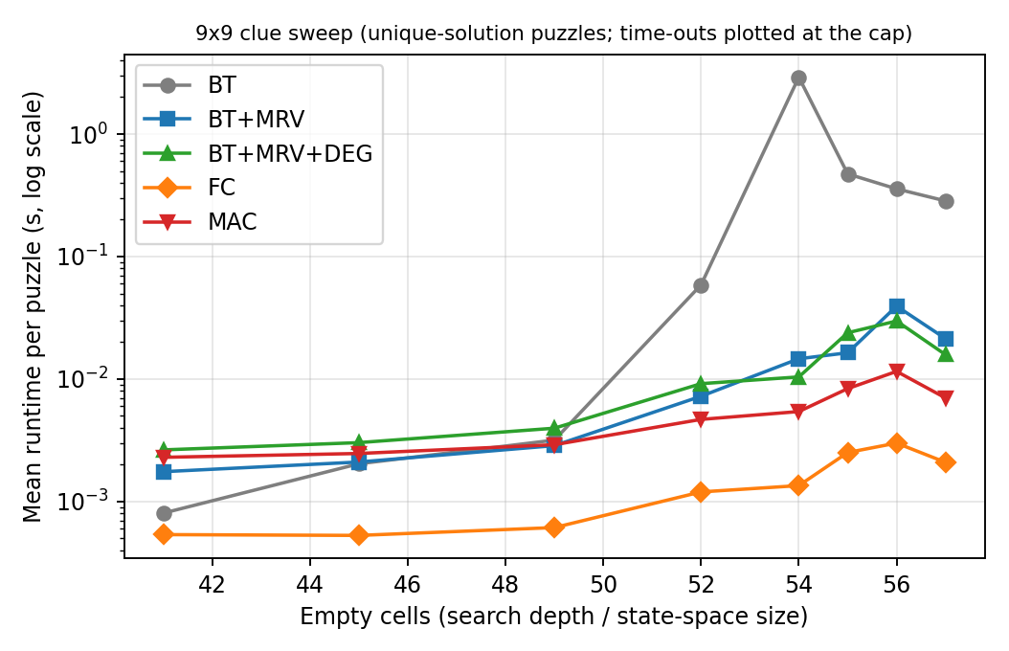
Figure 3. Mean runtime versus number of empty cells (search depth) on 9x9 puzzles; log scale.
Runtime of the baseline explodes once more than about 50 cells are empty (mean 2.9 s at 54 empty cells, with time-outs counted at the 5 s cap), whereas MRV, MAC and FC grow by at most one order of magnitude over the whole sweep. FC is the fastest at every depth; MAC is slower per puzzle than FC although it expands fewer nodes, because every assignment triggers a queue-based propagation in interpreted Python.

7.3 Problem complexity versus nodes generated
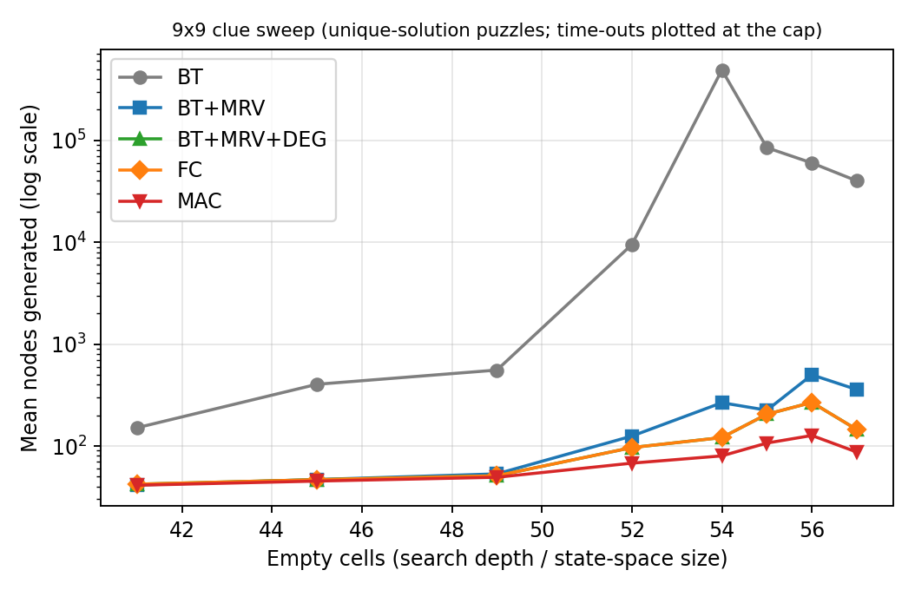
Figure 4. Mean nodes generated versus number of empty cells on 9x9 puzzles; log scale.
Table 9. Mean nodes generated per 9x9 clue level
Givens | Empty | BT | BT+MRV | BT+MRV+DEG | FC | MAC
40 | 41 | 151 | 41.4 | 42.2 | 42.2 | 41.2
36 | 45 | 403 | 46.9 | 46.7 | 46.7 | 45.3
32 | 49 | 556 | 53.3 | 51.1 | 51.1 | 49.3
29 | 52 | 9,480 | 125 | 96.5 | 96.5 | 67.9
26 | 55 | 87,813 | 229 | 205 | 205 | 106
24 | 57 | 80,742 | 386 | 201 | 201 | 106

With 40 givens all solvers generate about 41-151 nodes, i.e. close to the number of empty cells, so the puzzle is essentially solved by propagation. Below 30 givens the baseline needs between 9 x 10^3 and 9 x 10^4 nodes against 68-386 for the heuristic solvers, a reduction of two to three orders of magnitude. Figure 5 shows the same trend for backtracks.
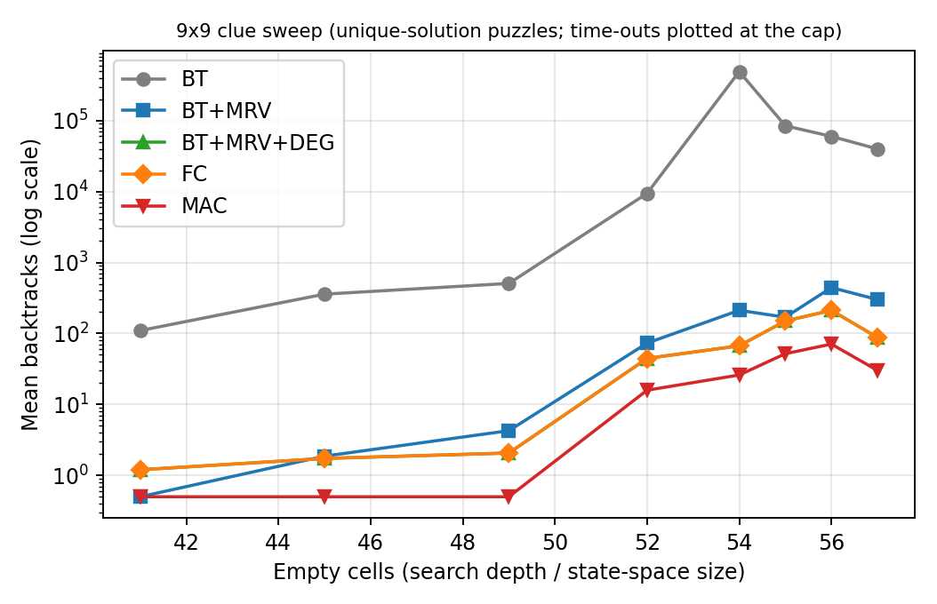
Figure 5. Mean backtracks versus number of empty cells (log scale).

7.4 Search-tree pruning efficiency
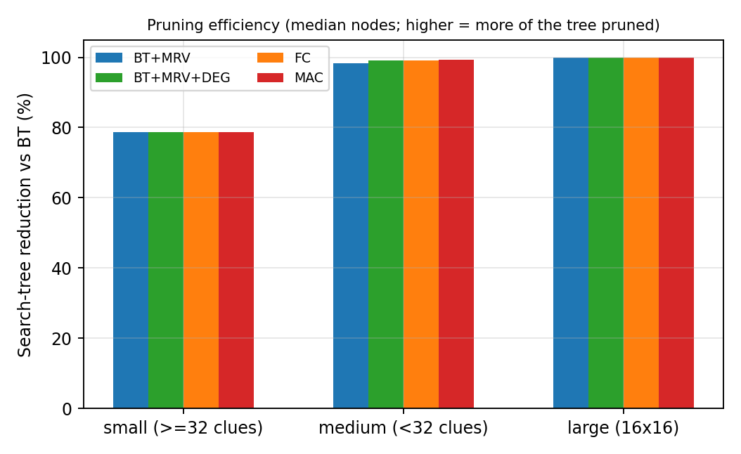
Figure 6. Reduction of the search tree relative to basic backtracking (median nodes).
Table 10. Search-tree reduction relative to BT (percentage of nodes avoided, median per class)
Size class | BT+MRV | BT+MRV+DEG | FC | MAC
large | 99.89 % | 99.97 % | 99.97 % | 99.98 %
medium | 98.41 % | 99.11 % | 99.11 % | 99.39 %
small | 78.67 % | 78.67 % | 78.67 % | 78.67 %
The guideline's pruning plot targets adversarial search; for a CSP the corresponding quantity is the share of the backtracking tree that an ordering or propagation technique avoids. MRV alone removes 78.7% of the nodes on small puzzles and over 98% on medium ones; adding propagation brings the reduction to 99.4% (medium) and 99.98% (large). The gain from forward checking and MAC over MRV is small on easy puzzles but decisive on harder instances.

7.5 Named hard puzzles
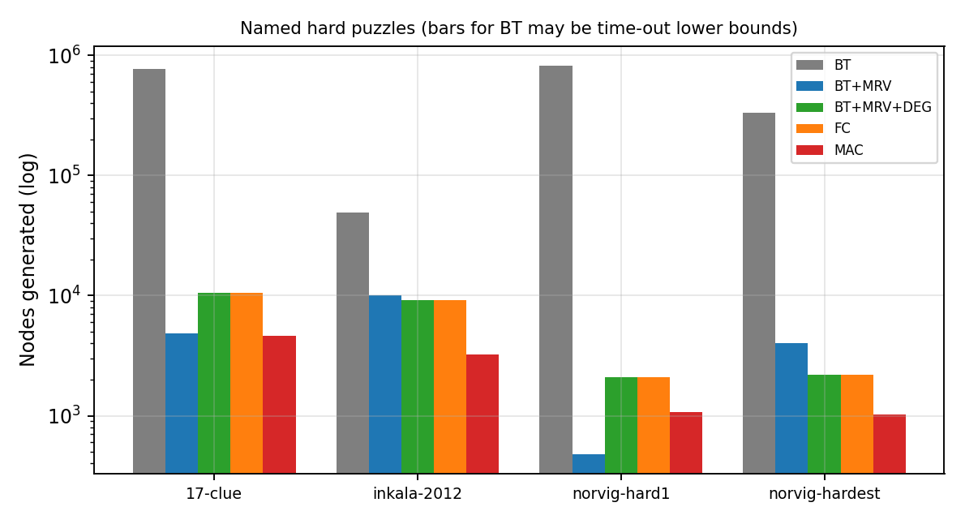
Figure 7. Nodes generated on four well-known hard puzzles (BT bars include time-outs).
Table 11. Nodes generated on the named hard puzzles
Puzzle | BT | BT+MRV | BT+MRV+DEG | FC | MAC
17-clue | 775,296 | 4,835 | 10,478 | 10,478 | 4,609
inkala-2012 | 49,558 | 10,101 | 9,171 | 9,171 | 3,252
norvig-hard1 | 826,240 | 481 | 2,090 | 2,090 | 1,079
norvig-hardest | 335,637 | 4,036 | 2,206 | 2,206 | 1,025

MAC generates the fewest nodes on three of the four puzzles (1,025 to 4,609); on 'hard1' BT+MRV was lower (481 against 1,079 nodes). BT needs between 5 x 10^4 and 8 x 10^5 nodes (it hit the 5 s limit on two of them). Interestingly, adding the degree tie-breaker to MRV is not always beneficial: it helps on the Norvig 'hardest' and Inkala puzzles but needs more nodes on 'hard1' (2,090 against 481) and on the 17-clue puzzle (10,478 against 4,835). Tie-breaking changes the exploration order and with chronological backtracking a single unlucky early choice can cost thousands of nodes.

7.6 Scalability on 16x16 boards
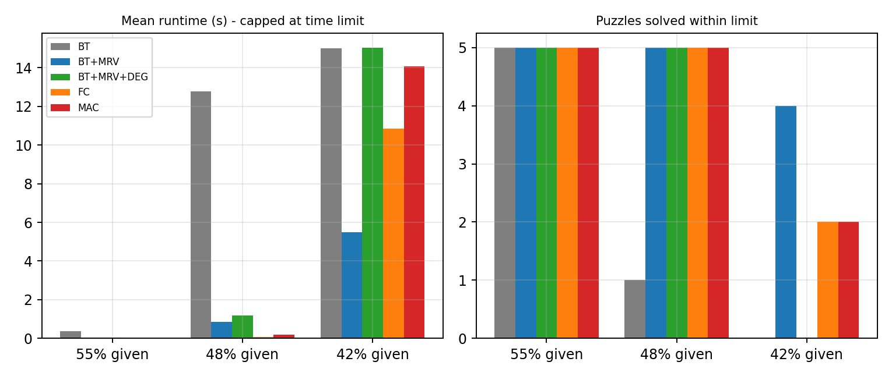
Figure 8. 16x16 boards: mean runtime (capped at 15 s) and number of puzzles solved per density of givens.
The 16x16 results are the least favourable to propagation in our Python implementation. Within 15 s the baseline solved 6 of 15 boards, BT+MRV 14, BT+MRV+DEG 10, FC 12 and MAC 12. The median times tell a different story from the means: FC solved the median board in 8 ms and MAC in 38 ms, against 365 ms for BT+MRV, so the propagating solvers are much faster on typical instances, while a few boards produce extremely long runs for every solver (heavy-tailed behaviour, Section 8.2). The 16x16 boards are generated without a uniqueness guarantee and may have many solutions or none that are easy to reach with a fixed value order.

7.7 Nodes versus constraint checks
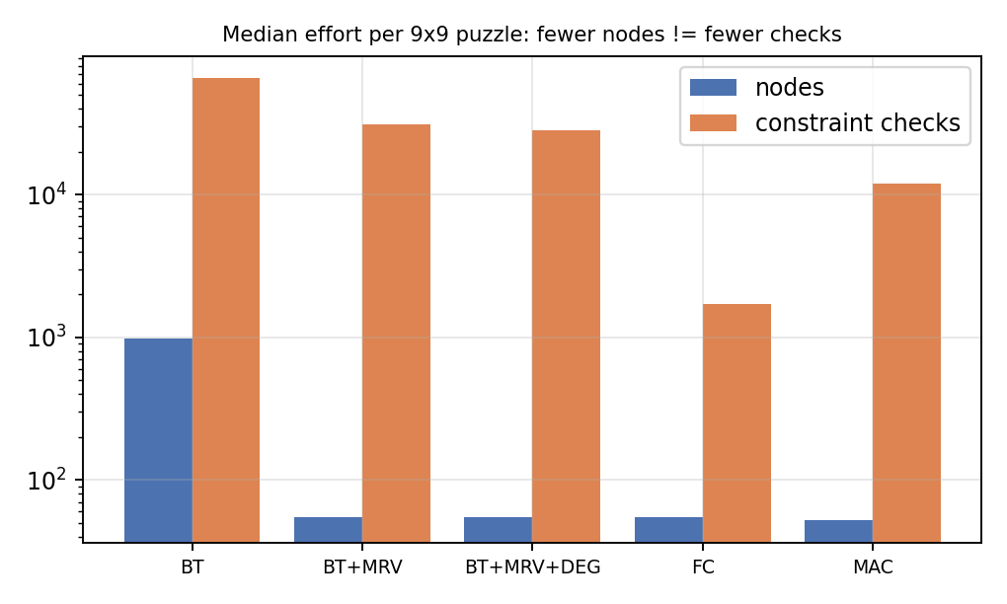
Figure 9. Median nodes and constraint checks per 9x9 puzzle.
The number of constraint checks is not directly comparable across solver families: BT variants count one pairwise test X_i != X_j, FC counts one peer visited, and AC-3 counts one value-support test per revision. Within a family the numbers are informative: FC uses roughly 30 times fewer checks than BT+MRV, and MAC trades more checks than FC for fewer nodes (e.g. 83,958 against 12,663 checks on the medium class, with 289 against 642 nodes).

7.8 Invalid and unsolvable inputs
Table 12. Correctly handled edge cases (correct / cases)
Case | BT | BT+MRV | BT+MRV+DEG | FC | MAC
invalid | 6/6 | 6/6 | 6/6 | 6/6 | 6/6
unsolvable | 1/7 | 7/7 | 7/7 | 7/7 | 7/7
All five solvers reject the six invalid puzzles before any search. The seven unsolvable puzzles are proved unsolvable by all four domain-aware solvers at the root (0 nodes), because some cell sees all nine digits among its peers; the baseline cannot see this without exhausting the tree and timed out on six of seven. Note that these constructed unsolvable puzzles are the easiest kind for propagation; unsolvable puzzles whose contradiction is deeper would require genuine search.

8. Error Analysis and Scalability Bottlenecks

8.1 Time-outs and state-space explosion
Of 545 solving runs, 23 hit the time limit: 11 for BT (2 medium, 9 large), 5 for BT+MRV+DEG, 3 each for FC and MAC and 1 for BT+MRV, all on 16x16 boards except the two BT time-outs on medium puzzles. A 24-clue 9x9 puzzle has up to 9^57 (about 10^54) assignments; a 16x16 board with 42% givens up to 16^149 (about 10^179). Without inference the baseline can only discover a contradiction when it eventually reaches a cell with no legal digit, so a wrong early assignment is explored to an enormous depth before being undone (thrashing).

8.2 Suboptimal decisions and heavy tails
- Chronological backtracking: when a dead end is found, the search undoes the most recent assignment even if the real culprit is much earlier. Conflict-directed backjumping and restarts are the standard remedies and are listed as future work.
- Value ordering: all solvers try digits in ascending order. On 16x16 boards a poor fixed order explains why a few instances consume the whole budget for every solver; the least-constraining-value heuristic or randomised restarts would flatten this tail.
- Degree tie-breaking: in Sudoku most unassigned cells have similar degree, so the degree heuristic is a weak and sometimes harmful tie-breaker (Section 7.5); BT+MRV+DEG and FC share an identical search tree (equal node counts in Tables 8 and 11) and differ only in cost per node.
- AC-3 on the binary decomposition cannot detect hidden singles or Hall-set violations; we measured that FC accepts 19.5% of trial assignments that AC-3 refutes, but even AC-3 leaves cells with several candidates, so search remains necessary on hard puzzles.

8.3 Memory and implementation overheads
Space is not a bottleneck: the trail along one path holds at most N^3 domain changes (729 for 9x9, 4,096 for 16x16). The practical limit is time per node. FC and MAC spend extra work on pruning (about 7 x 10^5 prunes per 16x16 puzzle on average for FC) and MAC additionally maintains a queue, so in interpreted Python MAC's cost per node is several times that of FC (about 6x on the medium class: 0.09 ms against 0.014 ms). An implementation in a compiled language, or all-different filtering that exploits units rather than pairs, would shift the balance further towards propagation.

8.4 Edge cases
Invalid input is detected and explained before search. Unsolvable input is proved by exhaustion (propagation solvers) or ends in a time-out (baseline). Puzzles with multiple solutions, including the empty grid, return the first solution found; the report's benchmark puzzles are unique-solution, so every solver must return the same grid (checked by the tests). No cycles are possible, since every step assigns a new variable and the depth strictly increases.

9. Interactive System Demonstration
The prototype is delivered both as a Streamlit web interface (streamlit run app.py) and as a command-line tool. The interface lets the user choose an example, a generated puzzle (9x9 or 16x16, with seed and number of givens) or paste an arbitrary puzzle; select one of the five algorithms and a time limit; view the solution with the givens in black and the agent's digits in blue; replay the decision sequence step by step; and compare all five algorithms on the same puzzle with a table and a bar chart.
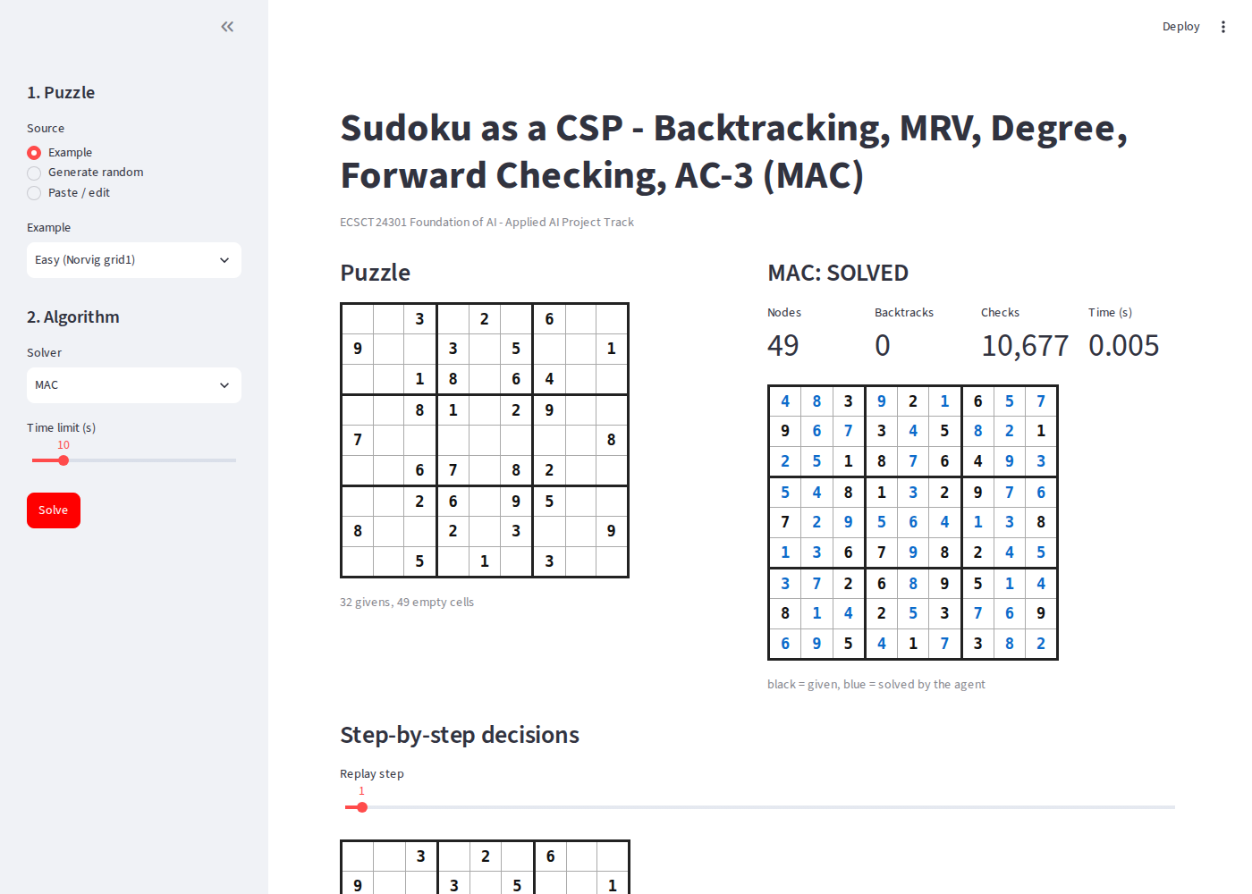
Figure 10. Streamlit interface: easy puzzle solved with MAC, metrics and step replay.
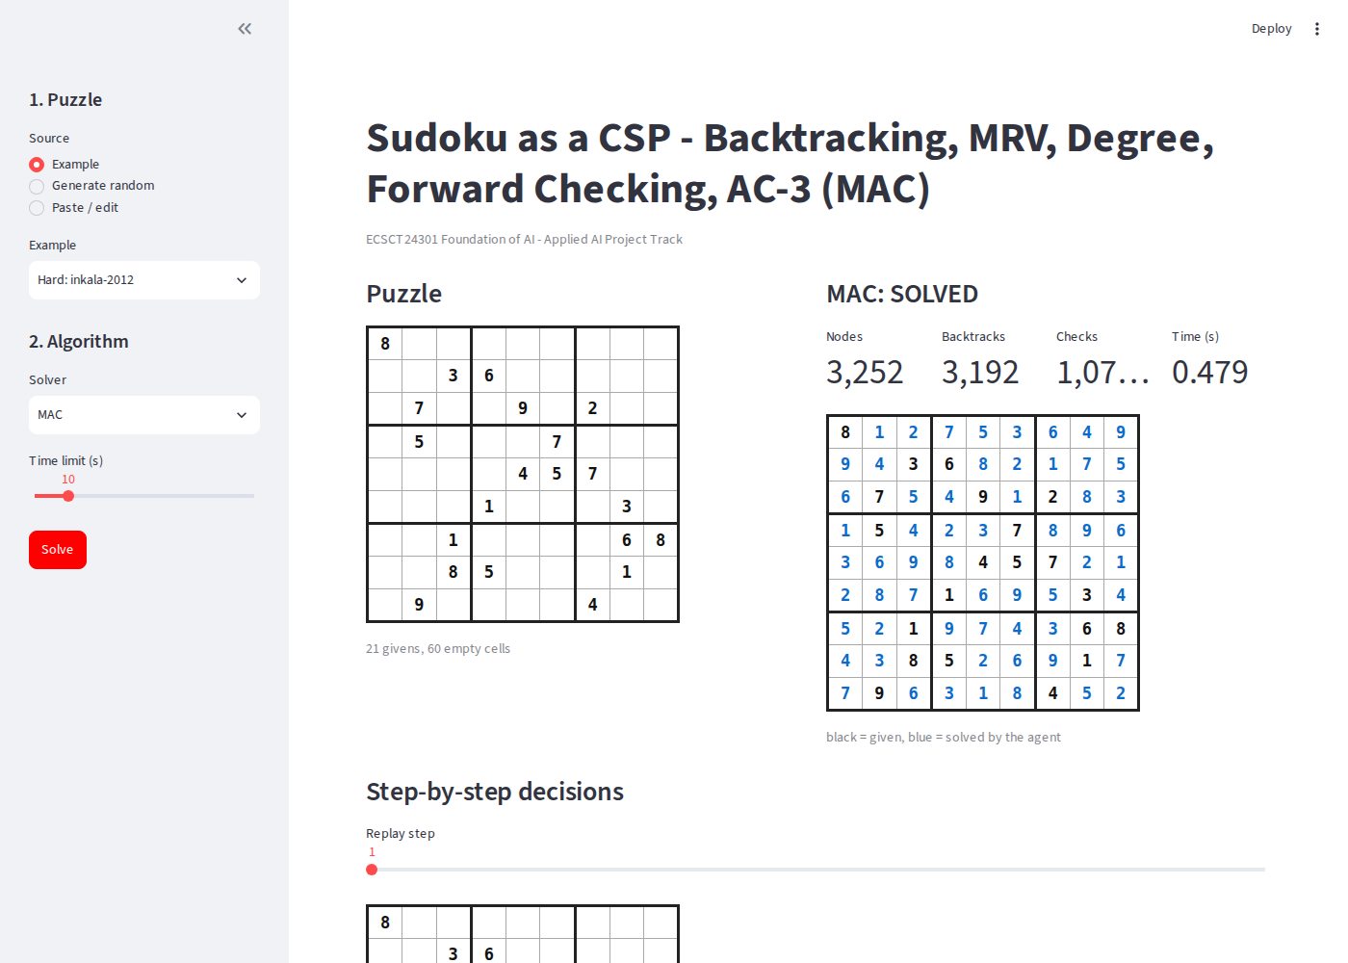
Figure 11. Streamlit interface: Inkala's 21-clue puzzle solved with MAC (3,252 nodes).
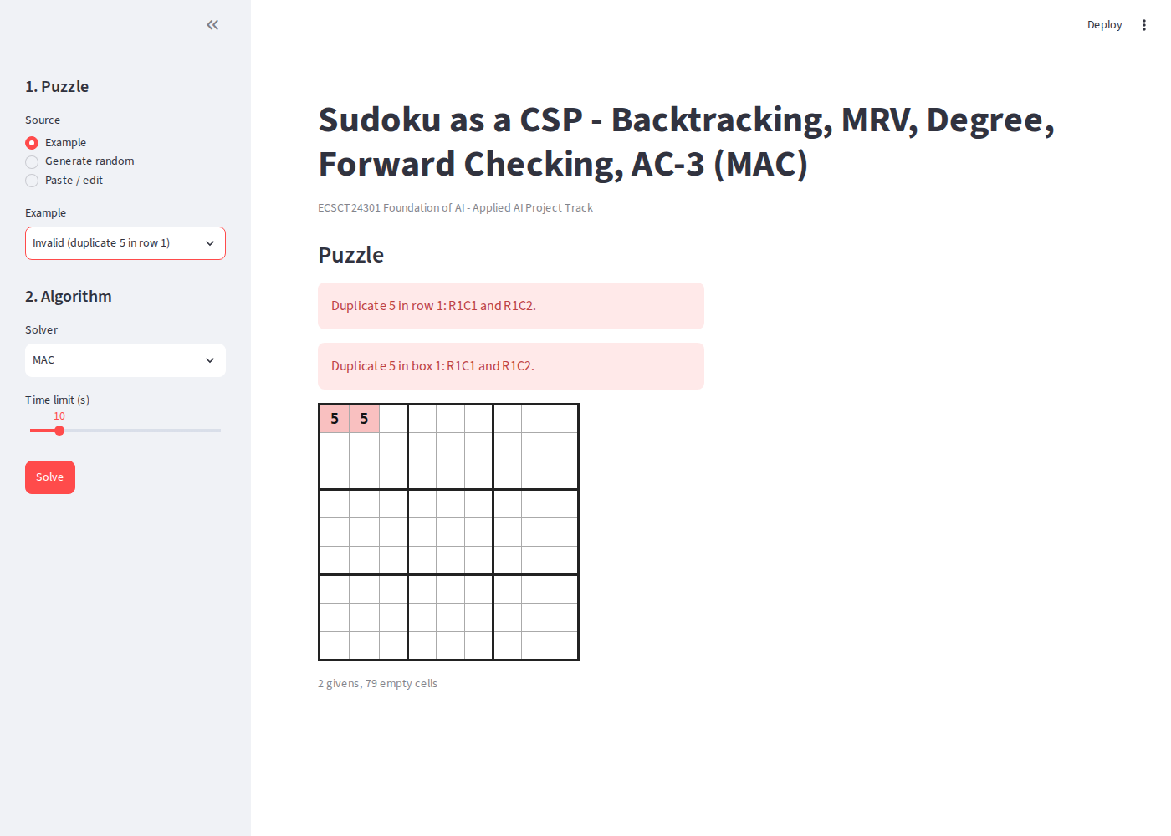
Figure 12. Error handling: duplicate givens are highlighted and the search is skipped.
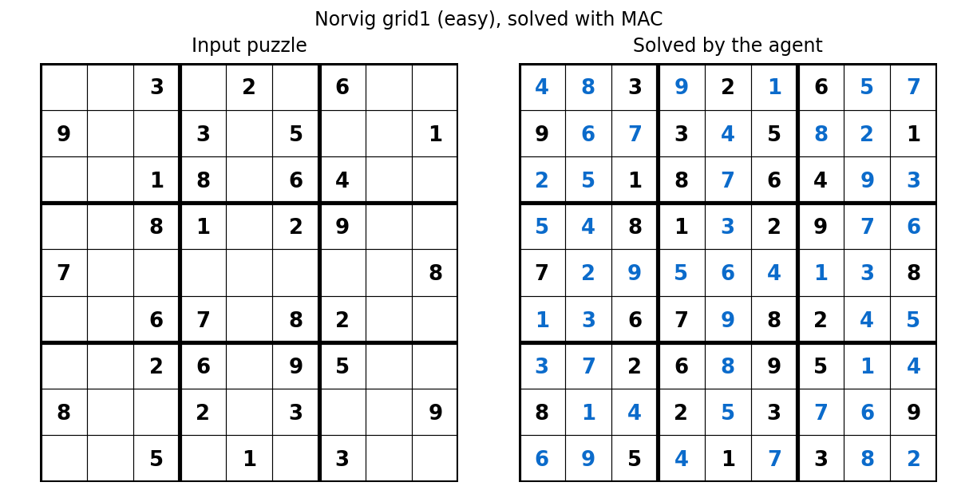
Figure 13. Easy puzzle before and after solving (black: givens, blue: agent).

9.1 Demonstration logs: exact decision sequences
The logs below are produced by the solvers' trace facility (results/logs/ contains the complete logs for BT, BT+MRV+DEG, FC and MAC on both puzzles). For the easy puzzle (30 givens) the AC-3 pre-processing already reduces every cell to a single candidate (81 remaining candidates for 81 cells), so MAC makes 49 forced assignments with no backtracking:
[pre ] AC-3 pre-processing done; total remaining candidates = 81
[ 1] ASSIGN R5C2 = 2 (chosen from 1 candidate)
[ 2] ASSIGN R1C8 = 5 (chosen from 1 candidate)
[ 3] ASSIGN R5C8 = 3 (chosen from 1 candidate)
[ 4] ASSIGN R9C2 = 9 (chosen from 1 candidate)
[ 5] ASSIGN R1C1 = 4 (chosen from 1 candidate)
[ 6] ASSIGN R2C5 = 4 (chosen from 1 candidate)
[ 7] ASSIGN R3C8 = 9 (chosen from 1 candidate)
[ 8] ASSIGN R4C2 = 4 (chosen from 1 candidate)
[ 9] ASSIGN R7C9 = 4 (chosen from 1 candidate)
[ 10] ASSIGN R6C2 = 3 (chosen from 1 candidate)
[ 11] ASSIGN R8C5 = 5 (chosen from 1 candidate)
[ 12] ASSIGN R9C1 = 6 (chosen from 1 candidate)
[ 13] ASSIGN R2C8 = 2 (chosen from 1 candidate)
[ 14] ASSIGN R5C7 = 1 (chosen from 1 candidate)
For Inkala's puzzle, FC repeatedly chooses cells with two candidates, so the log shows genuine decisions and later backtracks:
Decision sequence (first 120 events):
[ 1] ASSIGN R8C7 = 3 (chosen from 2 candidates, pruned 8 values)
[ 2] ASSIGN R7C7 = 5 (chosen from 2 candidates, pruned 6 values)
[ 3] ASSIGN R9C9 = 2 (chosen from 2 candidates, pruned 10 values)
[ 4] ASSIGN R9C8 = 7 (chosen from 1 candidate, pruned 7 values)
[ 5] ASSIGN R8C9 = 9 (chosen from 1 candidate, pruned 6 values)
[ 6] ASSIGN R5C9 = 1 (chosen from 2 candidates, pruned 7 values)
[ 7] ASSIGN R9C3 = 5 (chosen from 2 candidates, pruned 3 values)
[ 8] ASSIGN R3C3 = 4 (chosen from 2 candidates, pruned 11 values)
[ 9] ASSIGN R2C2 = 1 (chosen from 2 candidates, pruned 6 values)
[ 10] ASSIGN R1C2 = 2 (chosen from 2 candidates, pruned 9 values)
[ 11] ASSIGN R2C1 = 5 (chosen from 2 candidates, pruned 4 values)
[ 12] ASSIGN R3C1 = 6 (chosen from 1 candidate, pruned 7 values)
[ 13] ASSIGN R9C1 = 3 (chosen from 1 candidate, pruned 7 values)
...
Status=solved nodes=9171 expanded=8237 backtracks=9111 checks=174999 prunes=39208 max_depth=59 time=0.0948s
Command-line use is equally simple, for example: python -m sudoku_csp.cli solve "<81 characters>" --algo MAC --trace 40, or python -m sudoku_csp.cli random --size 16 --clues 150 --algo FC; malformed input produces a clear message instead of an exception.

10. Conclusion and Future Work

10.1 Summary of findings
- Heuristics and propagation reduce the search dramatically: on medium 9x9 puzzles MRV removes 98.4% of the baseline's nodes and MAC 99.4%; the baseline times out on puzzles that the other solvers solve in milliseconds.
- Fewer nodes do not automatically mean less time: FC was the fastest solver overall, and MAC's fewer nodes are offset by the cost of queue-based propagation.
- The degree heuristic is a weak tie-breaker for Sudoku; it was sometimes harmful.
- h(n) = number of unassigned cells is admissible and consistent (equal to the true cost), whereas 2h is inadmissible and the count of undecided cells is admissible but not consistent; AC-3 was empirically sound (no solution value removed) and FC is strictly weaker than AC-3.
- On 16x16 boards, search effort is heavy-tailed; the median instance is solved quickly by FC and MAC but individual boards exhaust the budget for all solvers.

10.2 Deployment challenges and real-world transfer
In a timetabling or rostering system the constraints are richer than all-different (capacities, preferences, soft constraints) and instances are larger, so the lessons carry over qualitatively: use fail-first ordering, propagate after every decision, expect heavy-tailed runtimes and design for time limits and restarts. Input validation and explanatory error messages, as implemented here, are essential in practice.

10.3 Limitations and future work
- Add the full Norvig (easy50, top95, hardest) and Kaggle sets to the benchmark, which the harness already supports, and report confidence intervals over more instances.
- Implement stronger propagation (hidden singles, naked pairs, Regin's all-different filtering) and compare it with AC-3 on the binary decomposition.
- Add value ordering (least-constraining value), conflict-directed backjumping and randomised restarts to attack the heavy tails on 16x16 boards.
- Re-implement the hot loops in a compiled language or with NumPy bit operations; compare local-search and SAT-based formulations.
- Extend the model to timetabling instances to validate the transfer argument empirically.
- Ethical note: Sudoku solving raises no privacy or fairness issues, but in scheduling applications the constraints encode human preferences and the effect of automated decisions on people should be reviewed.

References
Bessiere, C., & Regin, J.-C. (1996). MAC and combined heuristics: Two reasons to forsake FC (and CBJ?) on hard problems. In Principles and Practice of Constraint Programming - CP 1996 (LNCS 1118, pp. 61-75). Springer.
Dechter, R. (2003). Constraint processing. Morgan Kaufmann.
Haralick, R. M., & Elliott, G. L. (1980). Increasing tree search efficiency for constraint satisfaction problems. Artificial Intelligence, 14(3), 263-313.
Mackworth, A. K. (1977). Consistency in networks of relations. Artificial Intelligence, 8(1), 99-118.
McGuire, G., Tugemann, B., & Civario, G. (2014). There is no 16-clue Sudoku: Solving the Sudoku minimum number of clues problem via hitting set enumeration. Experimental Mathematics, 23(2), 190-217.
Norvig, P. (2006). Solving every Sudoku puzzle. https://norvig.com/sudoku.html
Radcliffe, D. G. (2020). 3 million Sudoku puzzles with ratings [Data set]. Kaggle.
Regin, J.-C. (1994). A filtering algorithm for constraints of difference in CSPs. In Proceedings of the 12th National Conference on Artificial Intelligence (AAAI-94) (pp. 362-367). AAAI Press.
Russell, S., & Norvig, P. (2021). Artificial intelligence: A modern approach (4th ed.). Pearson.
Simonis, H. (2005). Sudoku as a constraint problem. In Proceedings of the 4th International Workshop on Modelling and Reformulating Constraint Satisfaction Problems (pp. 13-27).
Yato, T., & Seta, T. (2003). Complexity and completeness of finding another solution and its application to puzzles. IEICE Transactions on Fundamentals of Electronics, Communications and Computer Sciences, E86-A(5), 1052-1060.

