Software Requirements Specification
for
Cash-Up
Version 1.0 approved
Prepared by Team 37
Submitted to CDAC Mumbai
Batch Sep22

Table of Contents

1. Introduction 1
1.1 Purpose
1.2 References 1
2. Overall Description 2

2.1 Product Perspective 2
2.2 Product Features 2
2.3 User Classes and Characteristics 2
2.4 Operating Environment 2
2.5 Design and Implementation Constraints 2
2.6 User Documentation 2
2.7 Assumptions and Dependencies 3

3. System Features 3

3.1 System Feature 1 3
3.2 System Feature 2 (and so on) 4

4. External Interface Requirements 4
4.1 User Interfaces 4
4.2 Hardware Interfaces 4
4.3 Software Interfaces 4
4.4 Communications Interfaces 4
5. Conclusion 5

ACKNOWLEDGMENT

Success will be crowned to people who made it a reality but the people whose constant guidance and encouragement made it possible will be crowned first on the eve of success. This acknowledgement transcends the reality of formality when we would like to express deep gratitude and respect to all those people behind the screen who guided, inspired and helped us for the completion of our project work. We consider ourself lucky enough to get such a good project. This project would add as an asset to our profile. We would like to express our thankfulness to our project guide, Pranav Sir for his constant motivation and valuable help through the project work. We also extend our thanks to CDAC Mumbai members for their co-operation during the course. Finally we would like to thank our team members for their cooperation to complete this project.

ABSTRACT

Cash-Up is a subscription/bill payment platform designed to ease your accounting and tracking.
The purpose of the platform is to provide a platform to apps to advertise their plans and at the same time allow user to ease their payment track their expenditure and also get returns on the same.
The Main Objective of the project is providing you Hassle-free subscriptions and expense tracking all in one space.Also Cash-Up is worth using as it rewards you with amazing Tokens which later you can use as per your convenience.Which means simply pay your expenses and get amazing rewards

Introduction

1.1 Purpose
The purpose of the platform is to provide a platform to apps to advertise their plans and at the same time allow user to ease their payment track their expenditure and also get returns on the same.
The Main Objective of the project is providing you Hassle-free subscriptions and expense tracking all in one space
Team List:
Name | Email Id
Jayraj Bitake | Jayrajbitake1@gmail.com
Prashant Tambe | tambeprashant33@gmail.com
Amey Bhoite
M S Rajeev | rajeevfair008@gmail.com
Yogesh Survase

1.3 References
- Database Programming with JDBC and Java by George Reese.
- Wikipedia, URL: http://www.wikipedia.org.
- Google, URL: http://www.google.co.in
- https://Javatpoint.com/

2. Overall Description

2.1 Product Perspective

Cash-Up is a subscription/bill payment platform designed to ease your accounting and tracking.
The purpose of the platform is to provide a platform to apps to advertise their plans and at the same time allow user to ease their payment track their expenditure and also get returns on the same.

Providing you Hassle-free subscriptions and expense tracking all in one space.
“Cash-Up” amazing rewards simply by paying your expenses.

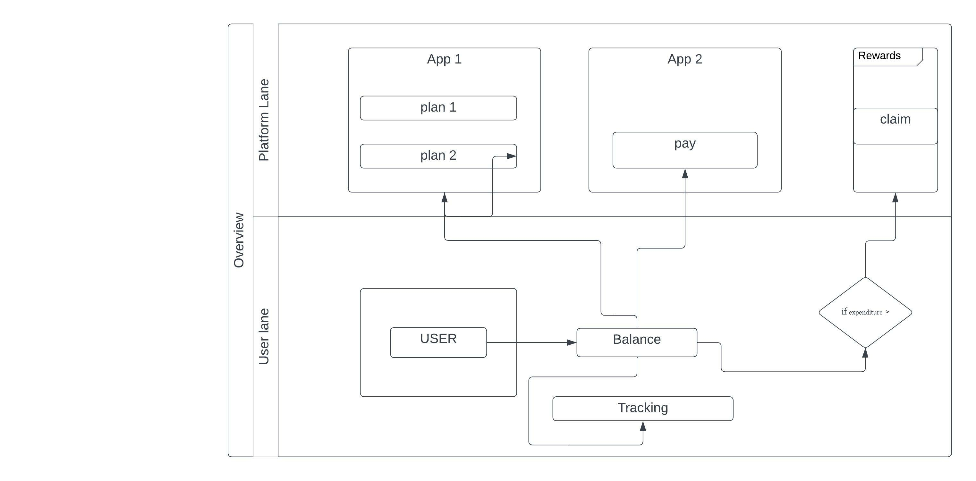

Figure 2.1 Overview

2.2 Product Features

2.2.1 One Stop easy pay
Use a billing and payment system to handle recurring payments and manage subscriptions. Manage and automate the subscription process, including billing, renewal, and cancellation.

2.2.3 Making your expense tracking simpler
Set spending limits: Determine how much you can afford to spend in each category, and track your expenses to make sure you stay within your limits.

Regularly review and adjust: Review your expenses regularly to make sure you are sticking to your budget, and adjust it as needed to better reflect your spending habits.

2.2.3 Single platform for comparisons
Use our websites to find the best deals on products or services you're interested in. Read reviews on product review sites to see how products compare to each other and find the best option for you.

2.2.4 USER reward system for use of platform
Take advantage of group buying to get discounts/rewards on products or services by purchasing in a bulk. Purchase based reward system to increase user retention and also boost the platform appeal and overall value.

2.2.5 Providing a platform for subscription based businesses
Host your food-delivery, OTT or any other subscription based application’s plans on our platform to get more user engagement through our platform’s user-base, advertise your brand directly to the end users by providing rewards to the user pool.

2.3 User Classes and Characteristics

2.3.1 ADMIN

The admin class overlooks the vendor and the user. The admin has to register first then log in and it could access the vendor details, grant him permission to post his app’s subscriptions, revoke them and also delete the vendor in case of fraudulent activities. Similarly, Admin also looks after the user info and can ban/delete any user in case of misconduct also admin can notify users baed on their subscription info.

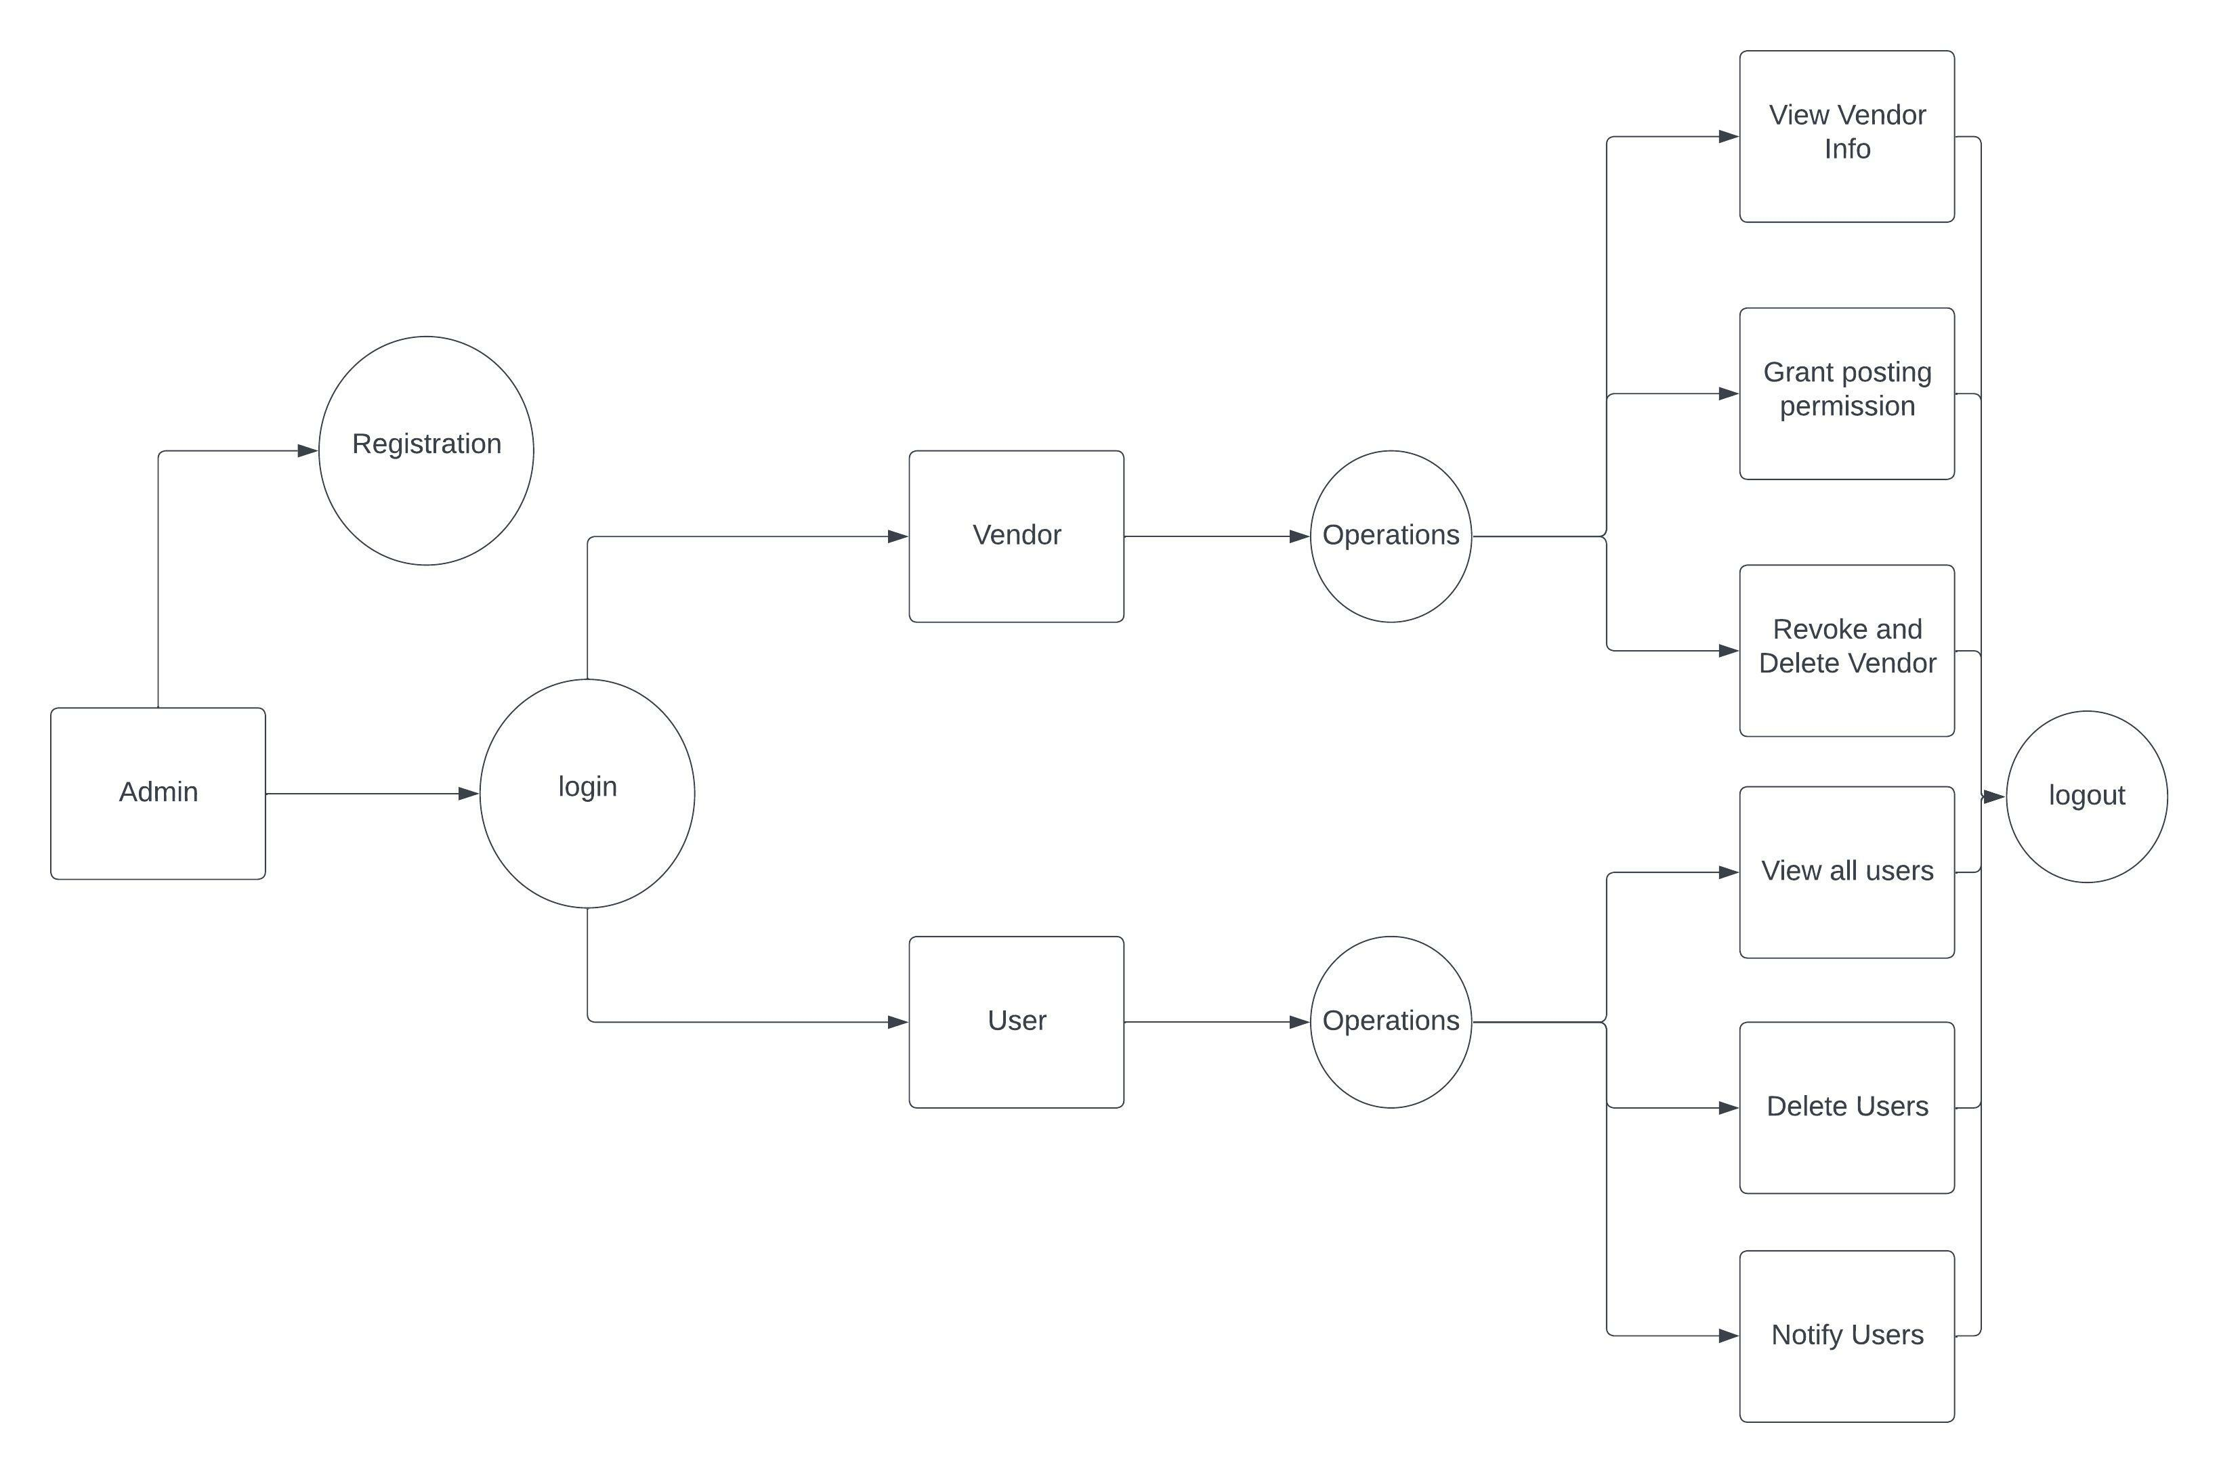
Figure 2.2 Admin DFD

2.3.2 VENDOR

The Vendor can host his application’s subscriptions on the platform by creating his profile and getting approved by the admin. Vendor can update delete view his profile info and host new subscriptions, update and delete them. Also add and remove application specific rewards.

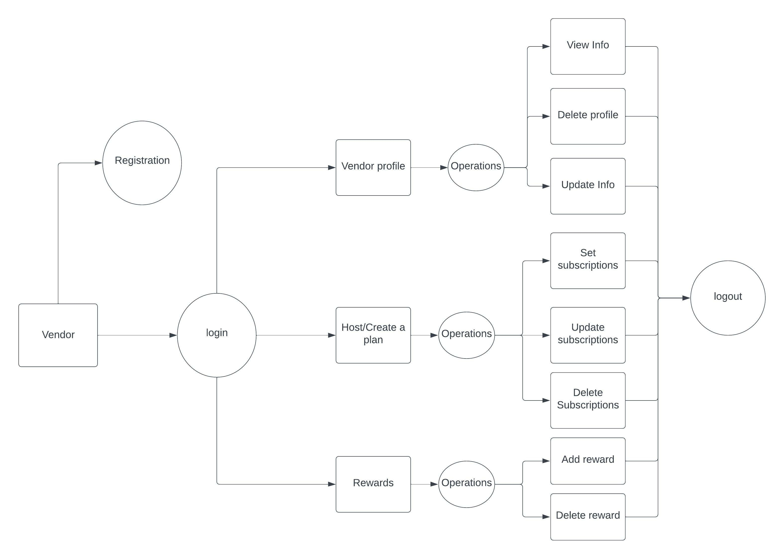
Figure 2.3 Vendor DFD

2.3.3 USER DFD

The User needs to register before interacting with the platform. User can view his info update his profile or delete it. User can update his platform balance and spend it on different subscriptions also at the same time view the same and track their expenses. The balance once empty can be updated, also after certain amount of expenditure user is eligible to claim a reward in the rewards section.

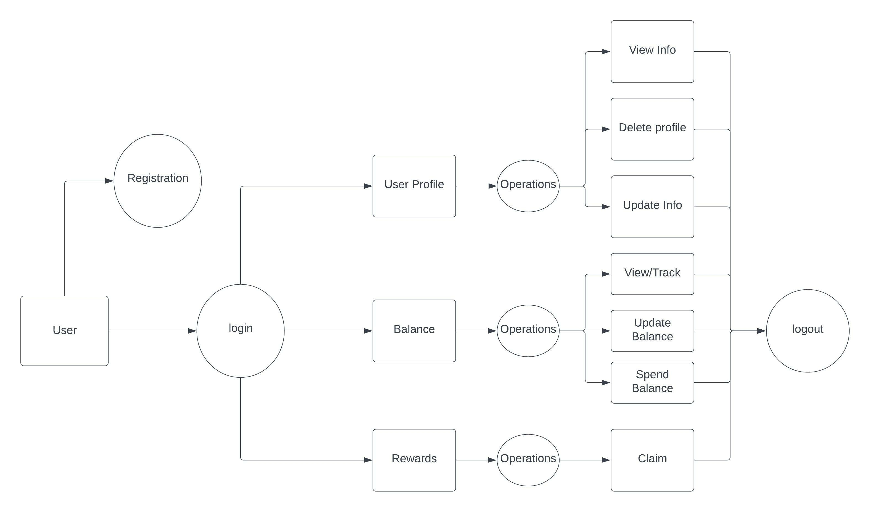

Figure 2.4 User DFD

2.4 Operating Environment

Cash-Up operating environment involves the following components:
Web server: A web server is used to host the platform and make it accessible to users through the internet.

Database server: A database server is used to store information such as product data, customer information, and order details which be on managed on MySql.

Application server: An application server handles the processing of requests from users and communicates with the database server.

Payment gateway: A payment gateway is used to process online transactions securely, an integrated payment gateway Api will be used.

Security measures: Security measures such as role based logins and different level authentication with spring security.

Analytics: Analytic tools are used to track user expenditure tracking, sales data, and customer behavior to help improve the platform.
In addition to the above components, our platform may also use additional tools and services such as email marketing, customer relationship management (CRM) solutions.
窗体底端

2.5 Design and Implementation Constraints
As per the time and hardware scope of the project the following design and implementation constraints are possible:

Scalability: The website may not be able to handle a large volume of traffic and transactions, and be able to scale as a production level website.

Search Engine Optimization (SEO): The website may not be optimized for search engines, including appropriate use of keywords, meta descriptions, and alt tags, to improve visibility and attract organic traffic.

2.6 User Documentation

User Interface:

The UI of the platform eases the information on how to interact with the software product, including navigation, input methods, and feedback mechanisms.
Error Messages:

A list of error messages that the software may display, along with explanations and potential solutions in order to guide the user on spot and prevent and delay or difficulty of use.

2.7 Assumptions and Dependencies

- Launching a paralleled ICO(Initial Coin Offering) token to cash up for rewards based on subs.
In order to increase user retention and create a greater role of the user in the platform’s worth the web3 and blockchain part of the project comes into picture, Introduction of new technology and digital currency to create a reward system to further the platform.

- Token is tradable on chain or would act as a voucher on app.
The reward token can be traded as a voucher or against the blockhain’s currency through a liquidity pool

- Also represents as a share of the app’s base value increasing user retention.
The application’s token would be shared as a reward which would be held against the blockchain’s currency on which the smart contract is deploye on acting as a share of the platform.
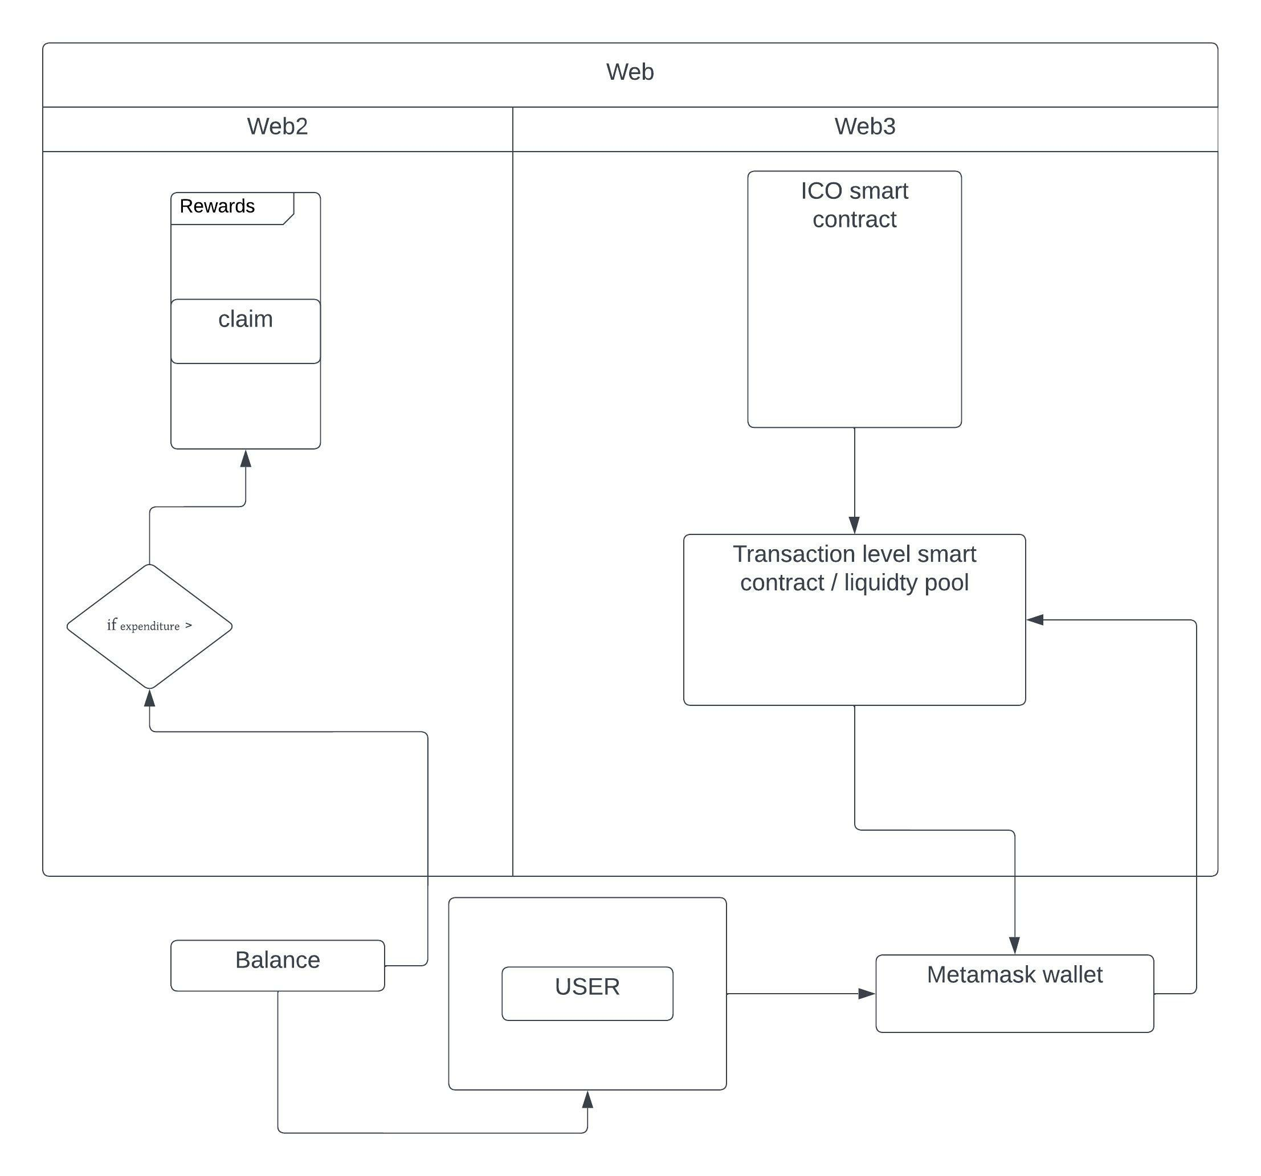
Figure 2.5 Future Scope

ER DIAGRAM

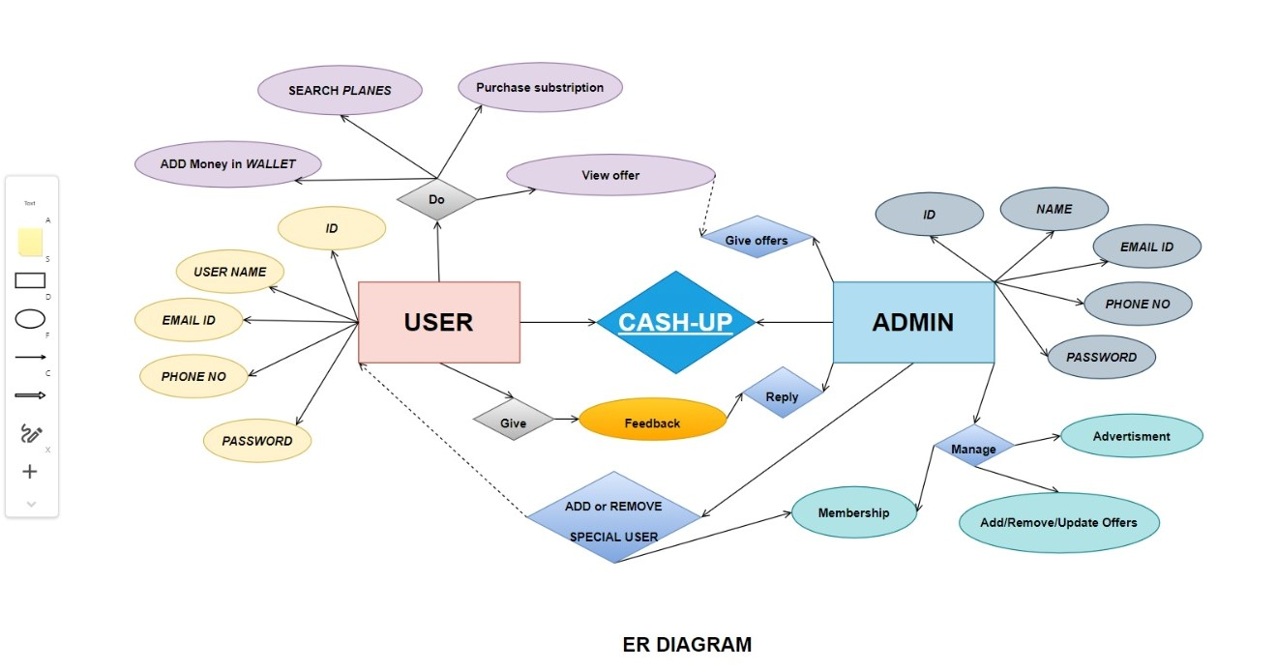

3. System Features

3.1 One Stop easy pay

Use a billing and payment system to handle recurring payments and manage subscriptions. Manage and automate the subscription process, including billing, renewal, and cancellation.

3.2 Making your expense tracking simpler

Set spending limits: Determine how much you can afford to spend in each category, and track your expenses to make sure you stay within your limits.

Regularly review and adjust: Review your expenses regularly to make sure you are sticking to your budget, and adjust it as needed to better reflect your spending habits.

3.3 Single platform for comparisons

Use our websites to find the best deals on products or services you're interested in. Read reviews on product review sites to see how products compare to each other and find the best option for you.

3.4 USER reward system for use of platform

Take advantage of group buying to get discounts/rewards on products or services by purchasing in a bulk. Purchase based reward system to increase user retention and also boost the platform appeal and overall value.

3.5 Providing a platform for subscription based businesses

Host your food-delivery, OTT or any other subscription based application’s plans on our platform to get more user engagement through our platform’s user-base, advertise your brand directly to the end users by providing rewards to the user pool.

4. External Interface Requirements

4.1 User Interfaces

The software provides good graphical interface for the user and the administrator can operate on the system, performing the required task such as create, update, viewing the details of the transcations.

A first-time user of the web portal should see the log-in page when he/she opens the portal. If the user has not registered, he/she should be able to do that on the log-in page. It will also have a remember me button.If the user is not a first-time user.

• The user interface must be customizable by the administrator.

• All the modules provided with the software must fit into this graphical user interface and accomplish to the standard defined

• The design should be simple and all the different interfaces should follow a standard template

• The user interface should be able to interact with the user management module and a part of the interface must be dedicated to the login/logout module

4.2 Hardware Interfaces

• Operating system: window

• Hard disk :40 GB

• RAM: 256 MB

• Processor : Pentium (R)Dual-core CPU

4.3 Software Interfaces

This software package is developed using java as front end which is supported by sun micro system. Microsoft SQL Server as the back end to store the database.
Operating System: Windows XP, windows 10 and higher versions.
Language: Java Runtime Environment, React JS(front end)
Database: MS SQL Server (back end)

Soltware Platform: Browser :

- Mozilla Fire-Fox v12.0 or higher

- Google Chrome V27.0.1453.116m or higher.

- Java language

- Eclipse

- MS SQL server
- React JS

4.4 Communications Interfaces

The communication between the client and the server wil be done through internet.

5 Conclusion

The purpose of the platform is to provide a platform to apps to advertise their plans and at the same time allow user to ease their payment track their expenditure and also get returns on the same.
The Main Objective of the project is providing you Hassle-free subscriptions and expense tracking all in one space.Also Cash-Up is worth using as it rewards you with amazing Tokens which later you can use as per your convenience.Which means simply pay your expenses and get amazing rewards

