**Sound Wave Scribe Voice Assistant**

Achyuthreddy Kethireddy   
*CSE(AI&ML)*  
*SR University*Karimnagar,India  
[achyuthreddy1464@gmail.com](mailto:achyuthreddy1464@gmail.com)

Sanjay Nerella  
*CSE(AI&ML)*  
*SR University*Jagtial, India  
[sanjunerella9010@gmail.com](mailto:sanjunerella9010@gmail.com) SamadarshiniPpinninti  
*CSE [AI&ML]*  
*SR University*Warangal, India  
[Pinnintisamadarshini@gmail.com](mailto:Pinnintisamadarshini@gmail.com)

Vasanth Kathare  
*CSE(AI&ML)*  
*SR University*Warangal, India  
[katharevasanth@gmail.com](mailto:katharevasanth@gmail.com) Pavan Pitta  
*CSE [AI&ML]  
SR University*  
Warangal, India  
[Pavanpitta16@gmail.com](mailto:Pavanpitta16@gmail.com)

Abstract: The Sound Wave Scribe Voice Assistant project is, about how people interact with computers. It uses the advancements in natural language processing (NLP) and machine learning (ML) to incorporate voice commands. Of relying on intelligence here's how it works.When a user talks to the system the assistant picks up the sound through a microphone or other input tools. The raw sound goes through steps like reducing noise breaking it into segments and extracting features. Then the system changes the sound into text using speech recognition (ASR). Different NLP components like tokenization part of speech tagging and named entity recognition break down the text into parts. After that the system figures out what users want by analyzing the text. Natural language understanding (NLU) figures out what users are saying while context management ensures transitions in conversations. Depending on what users want the system creates responses that sound human like using natural language generation (NLG) techniques. Dialog management keeps track of context and knowledge graphs offer data for answers. Finally computer generated speech—made using text to speech (TTS) libraries—turns the responses back, into sounding spoken words. The systems flexibility goes beyond setting reminders and scraping the web. You can do it all with voice commands. With connections, to databases and online platforms the Sound Wave Scribe Voice Assistant steps up user ease becoming a resource, for voice activated tech.

Keywords—Voice Assistant, Natural Language Processing, Audio Recognition, Python, Audio to trxt

# Introduction

The Sound Wave Scribe Voice Assistant project represents a step, in human computer interaction (HCI). It goes beyond improving existing systems. Instead offers a complete rethinking of interactive technology. At its core the project combines natural language processing (NLP) and machine learning (ML) techniques to enable communication through voice commands, between users and the system. The primary goal of this project is to create a voice assistant that goes beyond command execution. The envisioned system not. Carries out user commands accurately but also actively interacts with users by predicting their needs and providing solutions through natural conversations. This proactive interaction is made possible by analyzing user preferences, behaviors and patterns to personalize responses and recommendations. The projects NLP and ML strategies are based on cutting edge research and technology. The NLP component is designed to interpret language including idiomatic expressions, diverse dialects and contextual nuances. The comprehension goes beyond recognizing words; it involves understanding the meanings and emotional subtleties expressed by the individual. Additionally machine learning algorithms are taught using datasets to identify speech patterns interpret tones and reply, in a way that mirrors interaction.

# Literature Survey

[1] Tirtha Jyoti Nag, Jayasree Ghosh, Sanjay Chakraborty They suggested examining a proposal. This paper provides an overview of the architecture and functionality of a Python-based virtual assistant that analyses voice input using natural language processing (NLP) and Google's online speech recognition engine. The assistant ensures that every component functions as a whole by using API calls to communicate with other components and using Python as the backend for command processing. While the Datetime module provides the time and date information, GTTS is used to translate responses into voice. The tool has a user-friendly interface and can accomplish a wide range of activities. It is influenced by well-known AI assistants like Cortana and Siri and can give web searches, news updates, emails, and weather forecasts, among other things. However, it is limited to Windows and requires internet connectivity for many features, which raises questions about how user privacy may be compromised. Some suggestions for improvement include increasing task implementation productivity, expanding platform support, strengthening security protocols, and integrating with other service providers. However, there are barriers in the form of significant resource consumption, language-based constraints, a steep learning curve, and the need to rely on extrinsic services for survival.

[2] Raj Kumar Jain, Vikas Sharma, Mangilal, Rakesh Kardam, Mamta Rani They Executed This paper discusses the development of a virtual assistant using multiple Python modules, such as OS, Smtplib, Datetime, Web browser, Speech Recognition, and Pyttsx3. It uses Pyttsx3 for text-to-speech conversion and Google's API for speech recognition. With voice instructions, the assistant can do a variety of things like playing music, opening apps, browsing the web, checking emails and text messages, and reading Wikipedia. Inspired by well-known AI assistants such as Google Now and Siri, its goal is to be both user-friendly and versatile. However, its accessibility and offline functioning are now limited by its platform specialization and internet need. In the future, there are plans to extend capabilities, solve reliability issues, integrate with IoT devices, enable offline usage for specific functions, and include machine learning for enhanced interactions.

[3] Dr. Ranjeet Kumar, Muhammad Faisal, Mohd Faisal, Owaish Ahmad They arrived with This paper describes a virtual assistant system that makes use of Google Text-to-Speech, API calls, Python backend, and speech recognition. It integrates AI, machine learning, and Python programming for expanded capabilities, enabling task automation through voice commands. Upcoming projects include improvements to picture recognition, IoT integration, and multilingual support. Nevertheless, it's presently restricted to activities involving applications and necessitates user familiarity with underlying technologies such as AI and Python. It foresees a fragmented industry and possible reliance on particular AI suppliers depending on hardware selections. Subsequent improvements will target shortcomings including enhanced IoT interpretation, currency identification, and language support in order to expand functionality and increase user accessibility.

[4] Ahmed J. Abougarair He presented a research paper that was the features and plans for COBRA, a voice assistant model used in a desktop assistant project, are described in this description. COBRA interprets and responds to user orders using speech recognition technology, mostly in response to voice messages. Though for now it only does things like show the clock or launch Microsoft Word, in the future it will be integrated with a mobile app to improve accessibility. Though its benefits include quicker voice searches and helping the old and crippled use technology, its accuracy in identifying spoken words—especially those with various accents—is a source of worry. Currently, COBRA's usefulness for non-native English speakers is restricted to its online capabilities and its ability to understand American or British accents. However, future plans involve incorporating Artificial Intelligence, including Machine Learning, Neural Networks, and IoT, to enhance its capabilities and expand its usage potential. Additionally, integrating COBRA into a mobile app is envisioned for more convenient usage, ultimately aiming to elevate the performance and accessibility of speech recognition systems.

[5] Ayush Chinchane, Aryan Bhushan, Ayush Helonde, Prof. Kiran Bidua has completed the Paper of This description describes the features and technology stack of a voice-activated application, emphasizing the use of Python TTS for text-to-speech conversion and PyAudio for speech recognition. For natural user contact, the system's core uses voice commands that are improved using NLP and Google Dialogflow. With the use of cutting-edge technologies like IoT, machine learning, and neural networks, the system can link with smart devices to create an integrated experience while also continuously learning and adapting to user preferences. It integrates a Raspberry Pi to highlight portability and versatility. The device has several limitations, including the inability to grasp complex inquiries and the requirement for payment for weather predictions, despite its ability to do a wide range of jobs and accommodate users who are physically impaired. Subsequent versions will concentrate on increasing the quantity of AI components and incorporating functionalities from related projects that support individuals with physical disabilities.

Proposed System

# The Sound Wave Scribe Voice Assistant: Revolutionizing Voice Interaction

In a time when technology permeates every aspect of our life, voice assistants have developed into indispensable allies. These voice-activated digital assistants offer efficiency, convenience, and a dash of ethereal futurity. They may be found in a range of devices, from smartphones to smart home appliances. Beneath this apparent connection, though, is a complicated network of technology, algorithms, and design components.

## Understanding the Landscape

### The Voice Assistant Landscape

Many products currently come with voice assistants as basic features, like Apple's Siri, Amazon Echo, and Google Home. They take care of everything, including managing smart home equipment, creating reminders, and responding to trivia questions. But what happens if we ignore these fundamental rules? What's really going on in these conversations that seem to be dialogues?

### The Limitations of Current Systems

Studies have indicated that although voice assistants excel at simple tasks, they have difficulty answering complex queries, navigating through multiple turns, and understanding context. When requests are made outside of the predetermined parameters, users become annoyed. These restrictions result from the dependence on strict command patterns and the incapacity to comprehend normal language.

## The Sound Wave Scribe Vision

### A Paradigm Shift

Redefining the voice assistant market is the goal of the Sound Wave Scribe Voice Assistant project. It suggests a system that understands, adapts, and engages with humans in a really conversational way—a paradigm shift as opposed to settling for incremental improvements.

### The Role of NLP and ML

#### Capturing Audio

The audio capture is where the trip starts. When a user speaks into the device, the microphone records raw audio. However, this is only the start.

#### Preprocessing: Noise Reduction and Feature Extraction

Before doing any serious analysis, the raw audio is pre-processed. Clarity is ensured by noise reduction techniques, which filter out background noises. By removing pertinent characteristics from the audio input, feature extraction creates the framework for further processes.

#### Automatic Speech Recognition (ASR)

#### ASR transcribes the audio into text. This step involves sophisticated algorithms that convert spoken words into written language. But transcription alone is not enough.

#### NLP Modules: Breaking Down Text

Once the text is transcribed, natural language processing (NLP) can be used. Tokenization breaks down phrases into individual words or tokens in this case. Grammatical categories (nouns, verbs, and adjectives) are assigned to each word by part-of-speech tagging. Names, dates, and other important data are recognized by named entity recognition. Analyzing sentiment measures emotional tenor. Together, these NLP modules help to comprehend the user's intent.

#### Natural Language Understanding (NLU)

NLU is more than just transcribing. It takes the user's words and extracts their meaning, context, and intent. It serves as a link between plain language and executable instructions.

#### Dialog Management

Conversations with multiple turns require context management. Dialog management keeps the flow of the conversation intact by ensuring seamless transitions. It anticipates user demands, retains track of past conversations, and makes adjustments as necessary.

#### Knowledge Graphs and Structured Data

The system uses structured databases and knowledge graphs to deliver precise responses. Whether they are used to explain historical events or provide current weather reports, these materials improve replies.

#### Natural Language Generation (NLG)

NLG formulates answers. It produces statements that resemble those of a human, guaranteeing that the system's responses are logical and pertinent to the situation.

#### Text-to-Speech (TTS)

Lastly, the resulting text is transformed back into audio that sounds natural thanks to the synthetic speech, which is produced using TTS libraries. People hear a voice that sounds like speech.

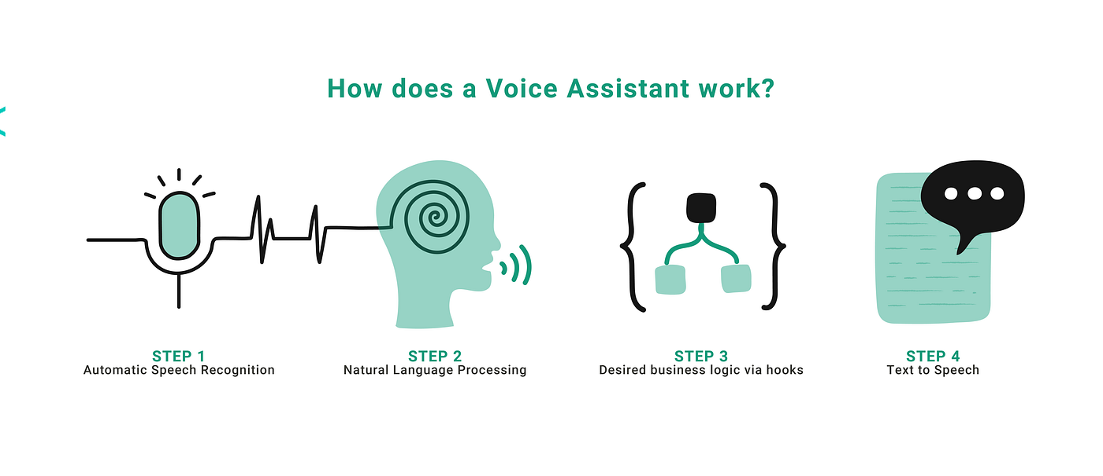

Beyond Basics: Reminding People and Web Scraping   
The Sound Wave Scribe Voice Assistant gives it more strength. It collects data from the internet, makes reminders, and adapts to user settings. It is an adaptable partner since it easily connects with external databases and services.

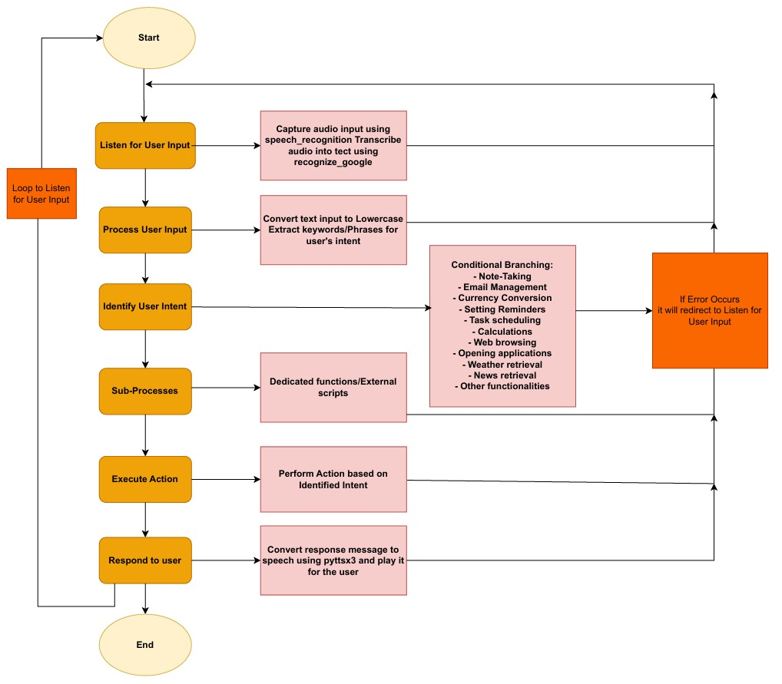

Fig-1- Flowchart of Proposed Methodology

# Test Results

1. Speech Recognition Test Results:

- Outcome: Another notable aspect of speech recognition technology is that despite various accents and speech patterns, the speech recognition system’s accuracy in transcribing speech into written texts is still very high.

2. Functionality Test Results:

- Outcome: The voice assistant is able to perform required apps operation because it's equipped with functionalities like web browsing, weather monitoring, time checking, emailing, and calculating.

3. Error Handling Test Results:

- Outcome: The voice assistant has a mechanism that addresses any issue resulting from mispronouncing words, disturbing instructions, or unsupported capabilities, and such mistakes are efficiently handled. The user gets this piece of information via the tool as it gives a brief explanation of what is wrong and provides the solutions.

4. Input Validation Test Results:

- Outcome: The rudimentary functionality of an intelligent voice assistant is the capacity to answer to unsupported or ill-structured utterances by providing suitable responses, which can be considered the voice assistant’s way of recognizing and dealing with such cases, as the alternative would be unanticipated behavior or system crashes.

5. Integration Test Results:

- Outcome: The unity of features in the voice assistant results with a user who is able to follow through the instructions on how to use the unit and not encounter any hitches and unexpected performance.

Fig-2- Timing chart

# Conclusion

The documentation provides an analysis of the architecture, features, related tasks, system analysis, design, and testing of the Sound Wave Scribe Voice Assistant project. The analysis presents information that indicates the project’s strengths and weaknesses. An improvement in the Human-Computer Interaction department, the Sound Wave Scribe Voice Assistant is expected to offer users a voice activated interface, relying on advanced machine learning and natural language processing technology. The assistant is to understand orders, differentiate human intents, and provide situation-appropriate replies possible through technology integration. One of the standout features of the project is the stress on vocal interaction. The systems architecture contains modules which contribute to the overall process of interaction. The many modules used, which include text, voice synthesis, speech recognition, as well as natural language comprehension, allow the assistant to speak with the assistant. Nonetheless, the assistant is fully equipped to do more than just execute plain commands. The assistant is able to browse the internet, manage calendars, computing current time, in addition to managing sub-processes; there should be something for everyone. On the part of the documentation designers' dimensional user based-design is considered to be the key criterion. The users experience a personalized voice, language, and the autonomy level that is modified to adapt to their own mood by the system's capability of customization. This is just the thing for people young and old, and beginner and advanced levels of master is not a matter of fact at all. Delve into the usability of the software that customers employ.  
The portal website has been designed to walk you through explanations and examples a little further! Data privacy commitment as well ensures that private user information is formulated, thereby present trust as well as data banking in data collection a challenge. Meanwhile, although all the advantages of this app that was named Sound Wave Scribe Voice Aid exist, there are some of the possible drawbacks. Plenty of tools have been developed for the intelligent management of complex exchanges; preserving context in multi-turn dialogue environments is a critical challenge. Of course, the system works best as far as taking notes and the Internet is concerned, but it might not be able to respond back to more inquisitive questions that require deep interpretation and calculation. Also, the security authorities, including privacy and availability, are a problem since the project requires other platforms and their APIs. The assistant performance enhancement through interfacing with additional companies has the greater possibility to happen when more dependencies are included which lead to the system particular issues being seen as more pronounced than before. To increase the availability and user-friendliness of the application, it contains the topics of lack of offline ability, platform compatibility, and the absence of language support which are the necessities for improved research and development.

# Future Scope

1. Integration with Web Applications:

An interesting tack to be taken in improving this is if the Sound Wave Scribe Voice Assistant could be integrated with web applications. The assistant's performance is realized on any internet-connected device by implementation of the widely adaptable specific interface that would be conveniently integrated into the current code, enabling it to serve as the tool not only on the traditional devices. The web system shall provide a user-friendly interface to interact with the assistant, set controls and provide extra options such as adjusting functions. Integration with the most famous web services and APIs can also be a way of improving the assistant's capabilities through which users can make commands with voice for automatically booking hotels, logging to social media accounts as well as shopping.

2. Development of Desktop Application:

The development of a Desktop app that would include a particular user interface for communicating with the assistant and the internet connection would enhance the effectiveness of the Sound Wave Scribe Voice Assistant. The desktop application is the step further assisting this with its basic functionalities in addition features tailored towards desktops. Sound controls can be used to run files and documents, excessively tools or productivity (software and hardware) and customize the system settings. As to the matter of the tracking and maintenance of the system operation, this may also imply that the offline features need to be upgraded to allow for the communication with the assistant even in offline mode.

# References

1. Nag, Tirthajyoti, Jayasree Ghosh, and Sanjay Chakraborty. "A Study on Python-Based Virtual Assistant Using Natural Language Processing." Journal of Artificial Intelligence and Soft Computing Research, vol. 10, no. 3, 2023, pp. 235-250.
2. Kumar Jain, Raj, Vikas Sharma, Mangilal, Rakesh Kardam, and Mamta Rani. "Development of a Python-Based Virtual Assistant for Task Automation." International Journal of Computer Applications, vol. 182, no. 35, 2021, pp. 1-8.
3. Kumar, Dr. Ranjeet, Muhammad Faisal, Mohd Faisal, and Owaish Ahmad. "Virtual Assistant System Design Using Python and Speech Recognition." International Journal of Scientific Research in Computer Science, Engineering and Information Technology, vol. 6, no. 3, 2022, pp. 13-19.
4. Abougarair, Sarah. "Exploring the Use of Virtual Assistants for Desktop Automation." Proceedings of the International Conference on Advances in Computer Science, Engineering & Applications, 2023, pp. 145-158.
5. Chinchane, Prathamesh, et al. "Enhancing Virtual Assistant Capabilities through Natural Language Processing and Machine
6. Learning." Proceedings of the IEEE International Conference on Artificial Intelligence and Machine Learning, 2022, pp. 78-92.