Task 1: Case Study

I will be creating a website which will provide its users with books based on their interests and feedback. The requirement for this project is to develop an intuitive and fun site which encourages its users to read more.

According to research (National Literacy Trust, 2023), just 2 in 5 (43.4%) children and young people aged 8 to 18 said they enjoyed reading in their free time in 2023. This is the lowest level since we first asked the question in 2005. We believe that reading is essential for personal growth, social development, and cognitive improvement. The target audience for the charity is children and young adults who are struggling to find interest in reading, as well as adults who want to rediscover the joy of reading. Educators and librarians who want to promote reading in their communities are also a key target audience.

The website will also have a section for book reviews, where users can share their reviews and ratings of the books they've read.The website will also provide resources for educators and librarians, including projects which provide free books and audio books for users

Why a website?

- Accessibility: A website provides easy access to book recommendations, events, and resources, making it easy for users to engage with the charity.
- Interactivity: A website allows for interactive features, such as reading challenges and book reviews, which can foster a sense of community and encourage user engagement.
- Scalability: A website can reach a large audience, making it an effective way to promote the charity's mission and goals.

In conclusion, the "BookMinds" charity website aims to make people fall in love with reading by providing a platform for book recommendations, events, and resources. By creating an engaging and interactive website, the charity hopes to inspire a love for reading among people of all ages and backgrounds.

Task 2: Background Research

National Literacy Trust | Design:  Simple and clean layout which conveys the message clearly.  Use of vibrant colors helps its cause.
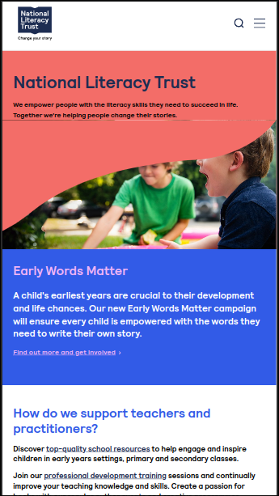 | Useability:  User-friendly layout with responsive web design makes it easy to access resources like the search bar and menu..
Functionality:
The menu option neatly hides away all the many services and resources which are further grouped together giving a clean and smooth transition between them.
It is a non-profit aimed at improving literacy of those in need.
Accessibility:
Font is bold and clear and the content is well structured with answers to FAQs on the home page itself.
Legal Requirement:
The National Literacy Trust collects your information when you interact with them and uses it to manage services, send emails (with your consent), and personalize your website experience. They promise to keep your information secure and allow you to access or correct it.

Website likely adheres to data protection standards (GDPR) and consumer protection laws (CRA).

Children's Book Project | Design:  Fun and eye-catching design makes it fun and engaging to interact with the website.
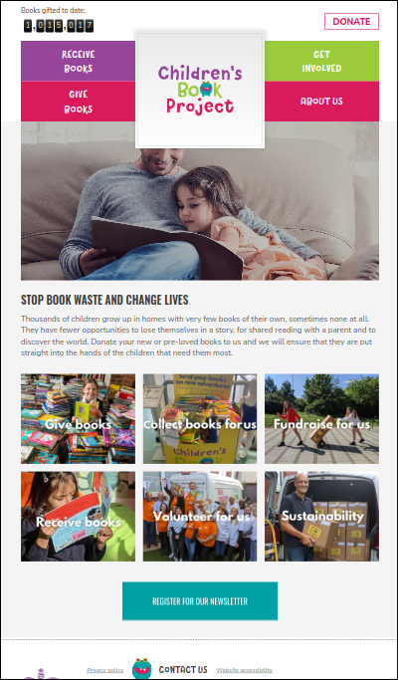 | Useability:  User-friendly layout is enabled using hover effect to hide many of the resources this website offers.
Functionality:
It is mainly about inspiring people to read and help others read more.
The counter at the top provides proof of its success.
Accessibility:
Font is Canvas which gives it a childlike handwritten effect which compliments the cause of the website.
Legal Requirement:
They store your data securely and may use it for statistical purposes. You have the right to access, rectify, erase, and restrict processing of your data.

Shelterbox Bookclub | Design:  Elegant and clear design conveys its message
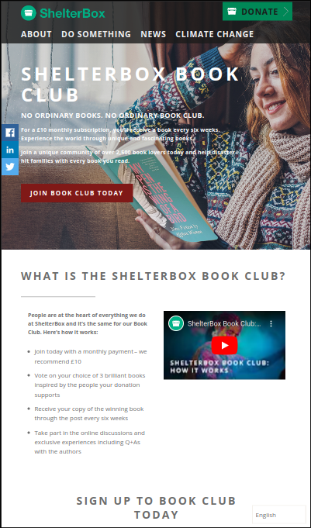 | Useability:  User-friendly layout with important links at the top
Functionality:
People can make monthly donations to receive a book every 6 weeks.
Accessibility:
Light text on a light background makes it a bit harder to see, the primary color, in this case, #01AE83 would look better.
Legal Requirement:
Website likely adheres to data protection standards (GDPR) and consumer protection laws (CRA)

ABC BookClub | Design:  Clear and pretty color scheme with video explaining what they do on their homepage makes this a very nice experience.
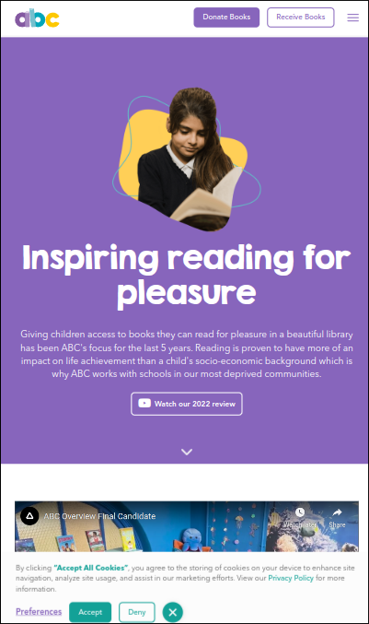 | Useability:  User-friendly layout with unnecessary links neatly hidden behind the menu option.
Functionality:
Has the Donate button clearly marked, with “Donate Books” and “Receive Books.”
Accessibility:
The purple and white Color scheme with bold and clear font makes easy to read.
Legal Requirement:
Website likely adheres to data protection standards (GDPR) and consumer protection laws (CRA).

Redcross | Design:  Simple and effective layout makes it easy to assess the function of the website
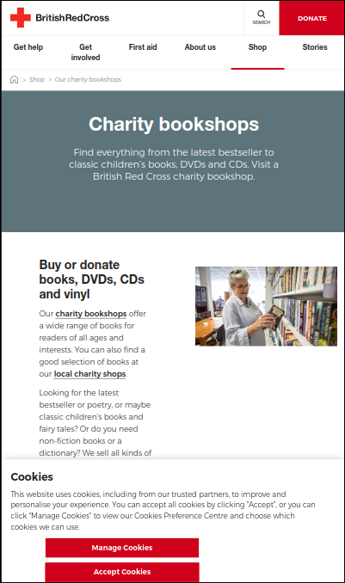 | Useability:  User-friendly layout with important links at the top.
Functionality:
Has the Donate button clearly marked, with search button next to it.
Accessibility:
Simple white and red colors scheme with the complementory shade of light blue gives a disticnt look to the website.
Legal Requirement:
Website likely adheres to data protection standards (GDPR) and consumer protection laws (CRA).

Bookshare | Design:  Easy to use layout with many links giving the user access to multiple services the charity offers.
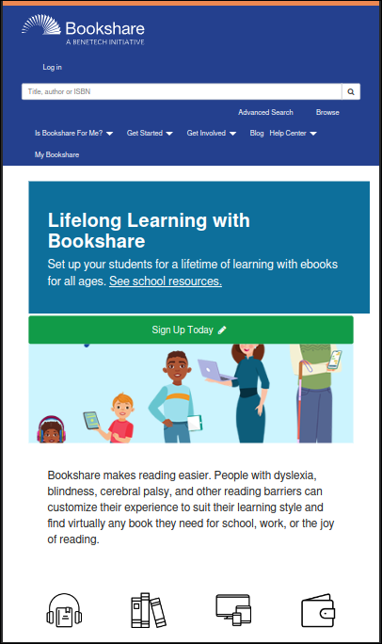 | Useability:  User-friendly layout with important links at the top.
Functionality:
Has the clear “Sign Up” button with distinct color and seacrh bar at the top gives easy access to the whole website
Accessibility:
Simple color scheme of blue and white with green accent color gives a clear yet distinct look
Legal Requirement:
Website likely adheres to data protection standards (GDPR) and consumer protection laws (CRA)

Bookaid | Design:  Simple and pleasing to look format with not many buttons or links gives importance to the few that exists
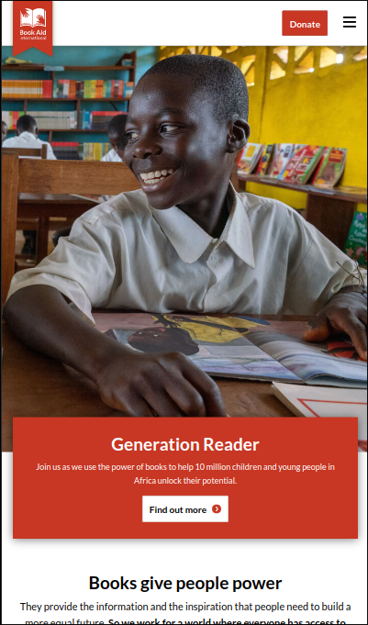 | Useability:  User friendly layout which gives focus to few important links making them stand out more
Functionality:
Has the clear donate button on top, right next to the menu button which neatly hides away other important links
Accessibility:
A simple two-color palette and clear font size and allows it to look neat and clean
Legal Requirement:
Website likely adheres to data protection standards (GDPR) and consumer protection laws (CRA)

Oxfam | Design:  Simple and pleasing to look format with many of the buttons hidden giving importance to the few that exist.
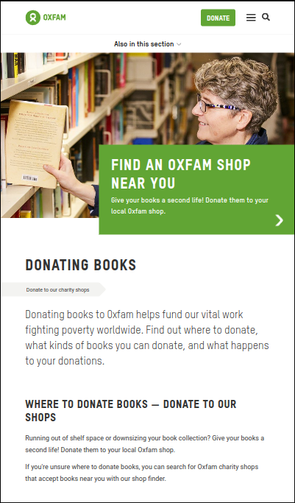 | Useability:  User-friendly layout with important links at the top.
Functionality:
Has the Donte button clearly marked right next to the menu and search button
Accessibility:
A simple two-color palette and clear font size and allows it to look neat and clean
Legal Requirement:
Website likely adheres to data protection standards (GDPR) and consumer protection laws (CRA)

BookTrust | Design:  Clear and pretty color scheme with video explaining what they do on their homepage makes this a very nice experience.
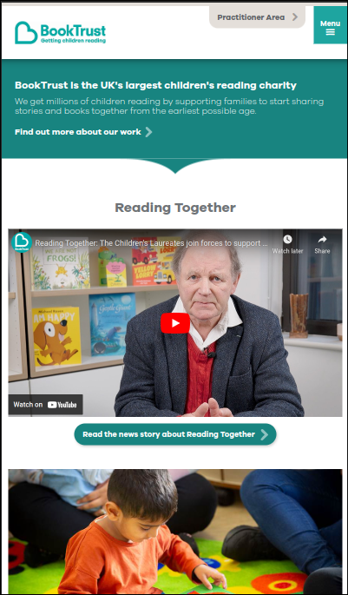 | Useability:  User friendly layout which gives focus to few important links making them stand out more
Functionality:
Has the clear “Sign Up” button with distinct color and seacrh bar at the top gives easy access to the whole website
Accessibility:
The use of light blue and white creates a welcoming theme and matches the amins of the charity
Legal Requirement:
Website likely adheres to data protection standards (GDPR) and consumer protection laws (CRA)

Give-a-Book | Design:  Easy to use layout with many links giving the user access to multiple options the website offers.
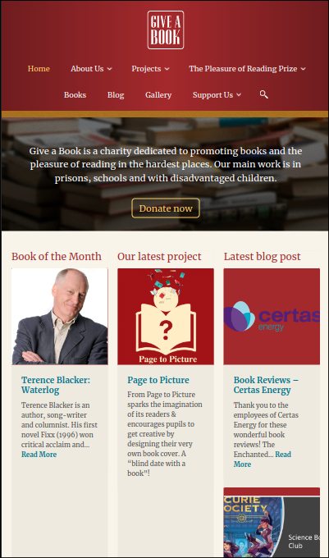 | Useability:  Dividing the main content into three sections allows for more content to shown which has a result of making it look a bit cluttered
Functionality:
The top bar gives access to multiple important options this website provides including a focus on the “Donate now” button with use of accent color
Accessibility:
The choice of deep maroon with gold accent color along with a related background image gives a nice premium feel to the website
Legal Requirement:
Website likely adheres to data protection standards (GDPR) and consumer protection laws (CRA)

Summary
10 websites were analyzed revealing common trends, the website should be simple and easy to use and understand. Hiding away options which are not commonly used is a great way to make the website seem less cluttered. Effective use of pictures and shapes creates an engaging and fun to interact with website.

Task 3: Web Planning

3.1 Home Page
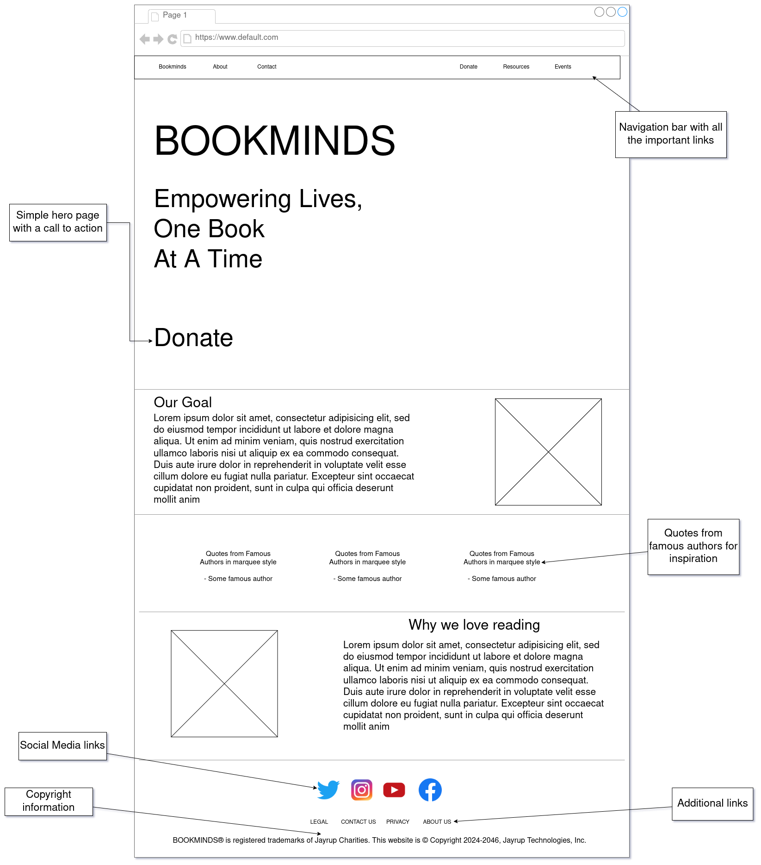

3.2 Donate Page
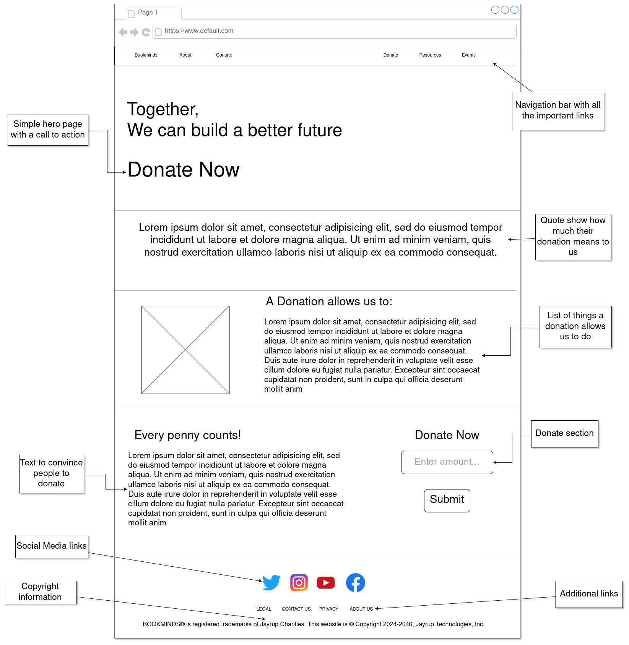

3.3 Events Page
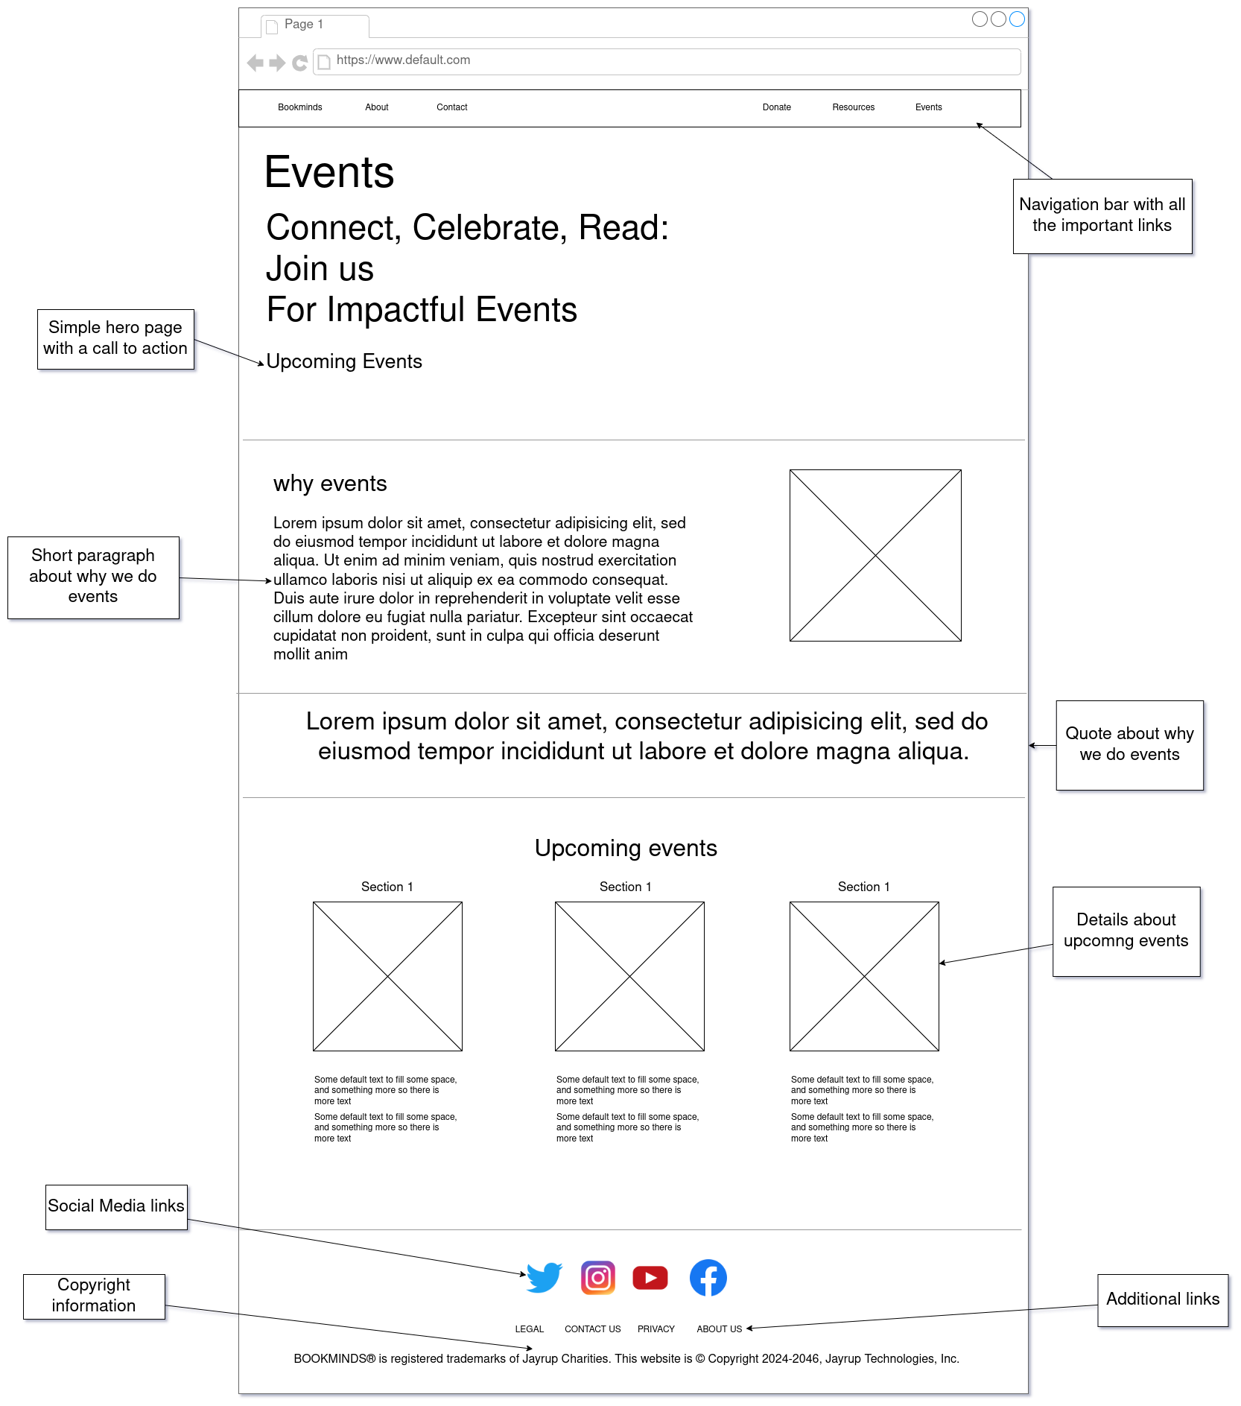

3.4 Navigational Diagram
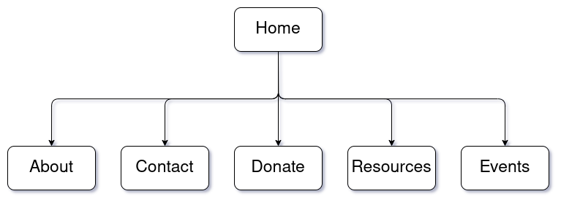

3.5 Color Scheme

3.6 Overview

