Honeycomb Prototype V1: Task Scenarios
Team A17, CS 3803-DCA, Fall 2026
Honeycomb is a free web app for Georgia Tech undergraduates. It imports Canvas deadlines and Google Calendar, takes quick entries for everything else, and ranks it all into one "Do this next" card. This prototype uses sample data, so do not enter real links or passwords. Log in with the details already filled in.
Prototype link: https://jays-hub.github.io/honeycomb-v1/
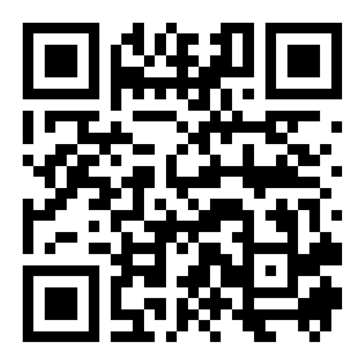
The link opens a Prototype menu. Start each scenario from there.

Scenario 1: Tonight's deadlines
It is 7:00 PM on Sunday, Nov 8. You have several deadlines tonight and may not finish them all, so you want to protect your grades. You just remembered a HIST 2111 Reading Quiz that is not in the app yet. It is due tonight at 9:00 PM, should take about 45 minutes, and is worth 3% of your course grade.
Log in and add the quiz. Find out which task to start first and why it ranks first. Find out how long the task after it should take, and which task would cost you the least if you run out of time. Then pretend you finished the top task and mark it done. You aren't up for the task that comes next, so skip it for now and see what the card suggests instead.

Scenario 2: First-time setup and a wrong date
It is Sunday, Nov 8. You are a first-year student opening Honeycomb for the first time. Your classes are in Google Calendar, your deadlines are in Canvas, and you do not want to type assignments in by hand.
Log in and connect your Canvas calendar feed and Google Calendar using the sample data provided. Your instructor just moved MATH 1554 Homework 9 to Friday, Nov 13 at 11:59 PM, but Canvas still shows Wednesday, Nov 11. Correct the date in Honeycomb and confirm that the new date appears and the homework moves in your ranked list.

Scenario 3: Balancing the week
It is 7:00 PM on Sunday, Nov 8. You are in the robotics club and work shifts at the campus recreation center. You want to see where your whole week stands, including everything outside of class.
Open your week and find your next work shift. See what Honeycomb says to do next, and why. Check how many Clubs tasks are done. Add a task called "Book room for robotics meeting" to Clubs using only a title. Then mark "Order motor parts" done and confirm that the Clubs progress count changes.

