MINI PROJECT REPORT

**Food Ordering System**

**NAME: -** Jayashree Barik

**PS NO: -**40020588

**TABLE OF CONTENTS**

|  |  |  |
| --- | --- | --- |
| **SERIAL NO.** | **CONTENT** | **PAGE NO.** |
| 1 | Introduction | 3 |
| 2 | Features | 3 |
| 3 | 4W’s 1-H | 3-4 |
| 4 | SWOT Analysis | 4 |
| 5 | Design | 5-6 |
| 6 | Test plan | 7 |
| 7 | Output | 8-10 |

**INTRODUCTION: -**

The online food ordering system can be defined as a simple and convenient way for customers to purchase food online without going to the restaurant. As per this system, the customer visits the restaurant’s app, browse through the various food items available there and goes ahead and selects and purchases the item they need. The entire project work is done using c.

**FEATURES: -**

The key features of the Food Ordering System are:

* Easy to use
* Displays menu
* Provides option to choose
* Generates bills

**4W’s 1-H: -**

**WHY:**

* This project will make the work of sellers and customers easier.
* Easy to use.
* Reduces manpower.
* Less time consuming.
* Easy to maintain in future prospect.

**WHAT:**

* To place and receive order without going to the restaurant physically.

**WHERE:**

* Restaurants
* Fast-food centers

**WHEN:**

* While ordering food without going to the restaurant.
* HOW:
* Using C programming language, we can provide a flexible code to develop the application and also provide better service to the customer.
* Detailed Requirements

**HOW:**

* Using C programming language, we can provide a flexible code to develop the application and also provide better service to the customer.

**SWOT ANALYSIS: -**

|  |  |
| --- | --- |
| **Strength**   1. The strength of my project is its flexible and secure. 2. It reduces man power. 3. Its cost effective and less time consuming. | **Weakness**   1. This project is only suitable for small restaurants. 2. It’s not fully automated. 3. Since most of the restaurants has their own websites to provide such facilities, I need to improve my project by adding more customer friendly features. |
| **Opportunity**   1. First of all, I want to implement this project in small restaurants to prove myself then I can implement it largely by creating my own opportunity through them. 2. It will help both the customers and sellers. | **Threats**   1. If the application is not password protected any unauthorized person can get access to this application and can make miss use of it. |

**DESIGN: -**

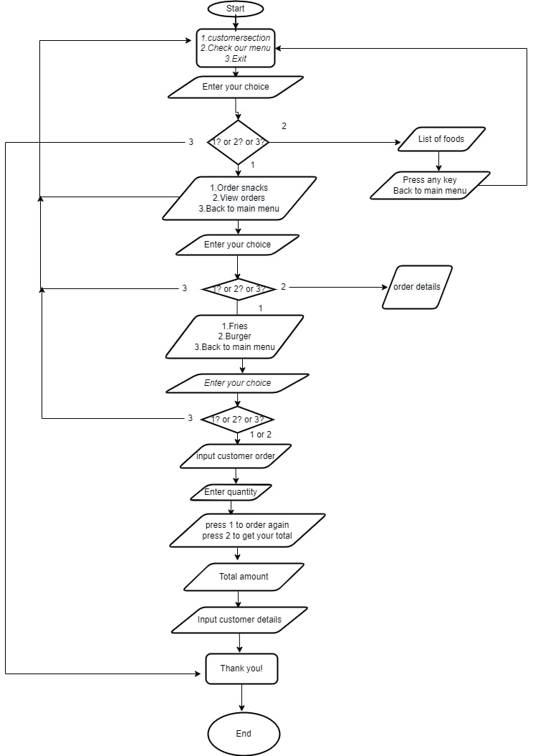

[Diagram-1]

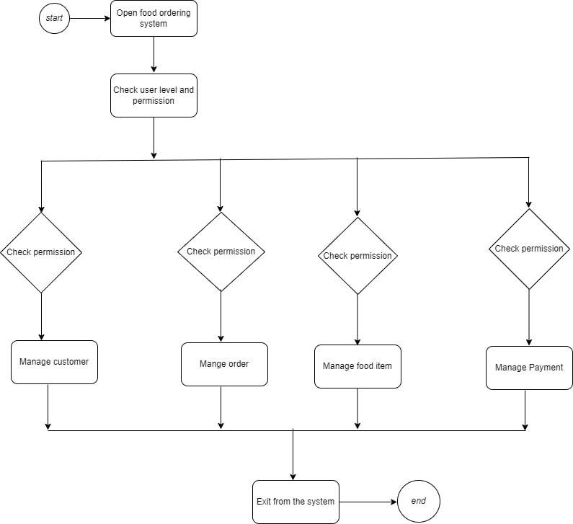

[Diagram-2]

**TEST PLAN: -**

**High-level Test Plan: -**

|  |  |  |  |  |  |
| --- | --- | --- | --- | --- | --- |
| **Test id** | **Description** | **Ex I/P** | **Ex O/P** | **Actual output** | **Type of test** |
| **1** | Select what you want | 1 or 2 or 3 | Your selected option will be display. | Your selected option will be display. | Requirement  based |
| **2** | Select the amount of order | Enter quantity | Your selected item and amount will be displayed. | Your selected item and amount will be displayed. | Requirement  based |

[Table-1]

**Low-level Test Plan: -**

|  |  |  |  |  |  |
| --- | --- | --- | --- | --- | --- |
| **Test id** | **Description** | **Ex I/P** | **Ex O/P** | **Actual output** | **Type of test** |
| **1** | Entering customer’s name | Enter first and last name | Customer’s full name | Customer’s full name | Requirement based |
| **2** | Entering customer’s phone number | Enter the mobile number | Customer’s mobile number | Customer’s mobile number | Requirement based |

[Table-2]

**OUTPUT: -**

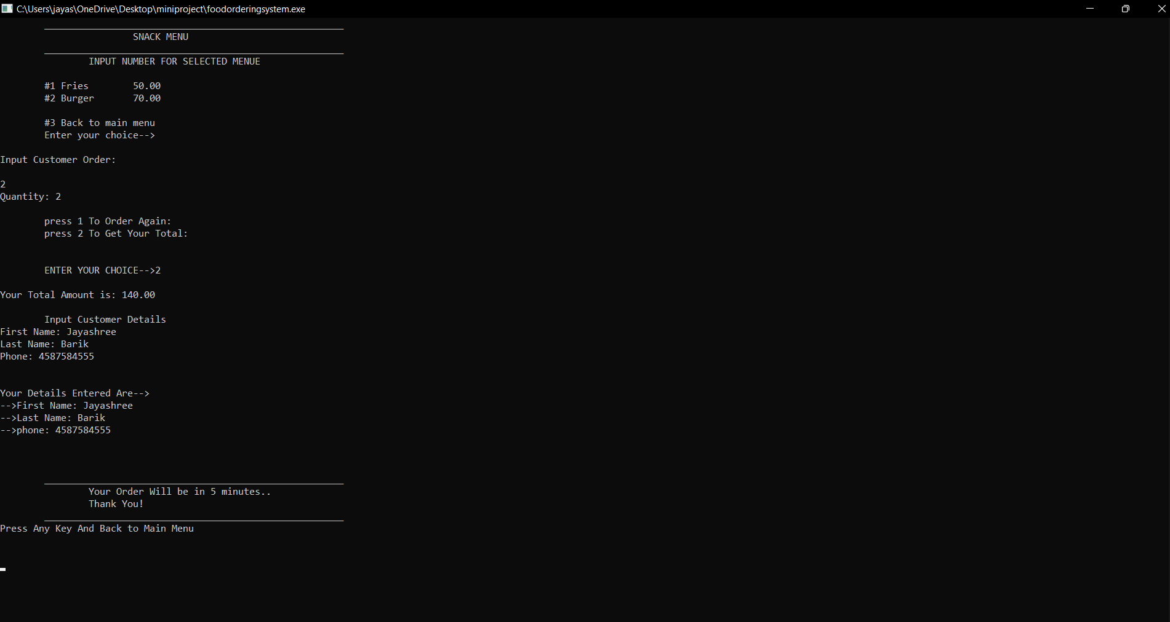

[Image-1]

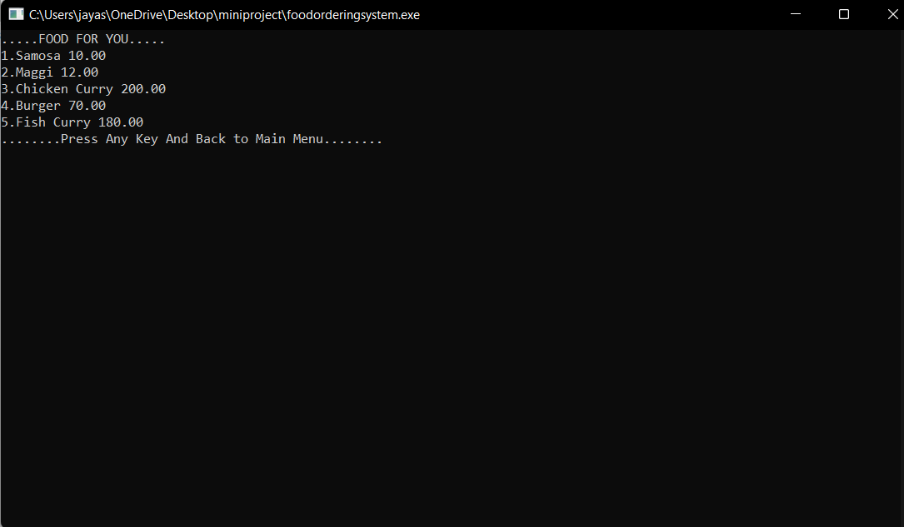

[Image-2]

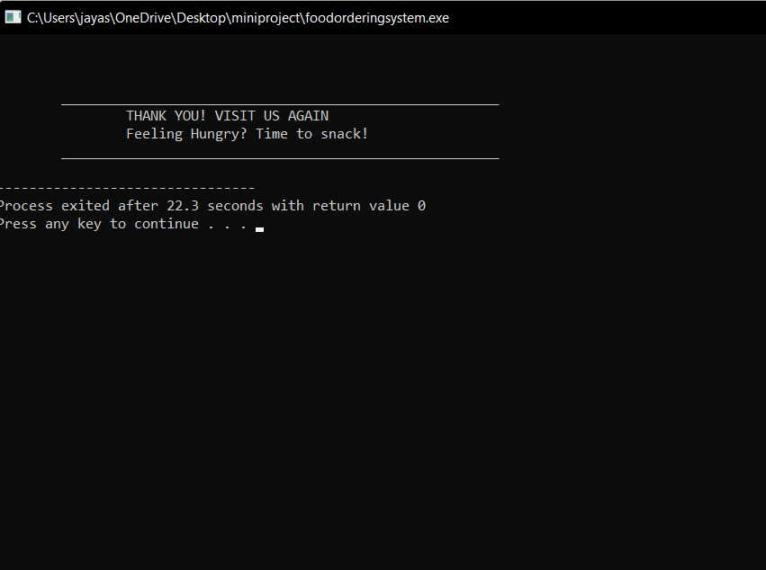

[Image-3]