CSI 5340 Assignment 1

Name: Jayshil Patel

Introduction

The problem at hand involves understanding the relationship between a real-valued random variable X and its corresponding dependent variable Y, which is affected by both a cosine function of X and a zero-mean Gaussian random variable Z.

The objective is to design and analyze polynomial regression models without prior knowledge of the true underlying relationship between X and Y. Specifically, we seek to investigate the impact of model complexity, sample size, and noise variance on the model's fitting capabilities and generalization performance. The experiment is structured to evaluate the Mean Squared Error (MSE) as a metric for both in-sample (Ēin) and out-of-sample (Ēout) performance, shedding light on the trade-offs and optimizations necessary for constructing effective regression models.

Initial considerations

Because of Efficient computation and almost similar outcomes ,I have used Mini-Batch Gradient descent because that was the fastest when compared to Gradient Descent and Stochastic Gradient descent. Learning Rate for all the gradient descent was 0.001 and did 2000 iterations for all 3 types of Gradient Descent methods. Batch size for Mini-Batch Stochastic Gradient Descent was 50.

Effect of Dataset on Mean-Squared Error with variance of 0.05. With different model complexities.

The Effect of Dataset size have huge impact on errors, especially testing errors.

[Without Regularization]

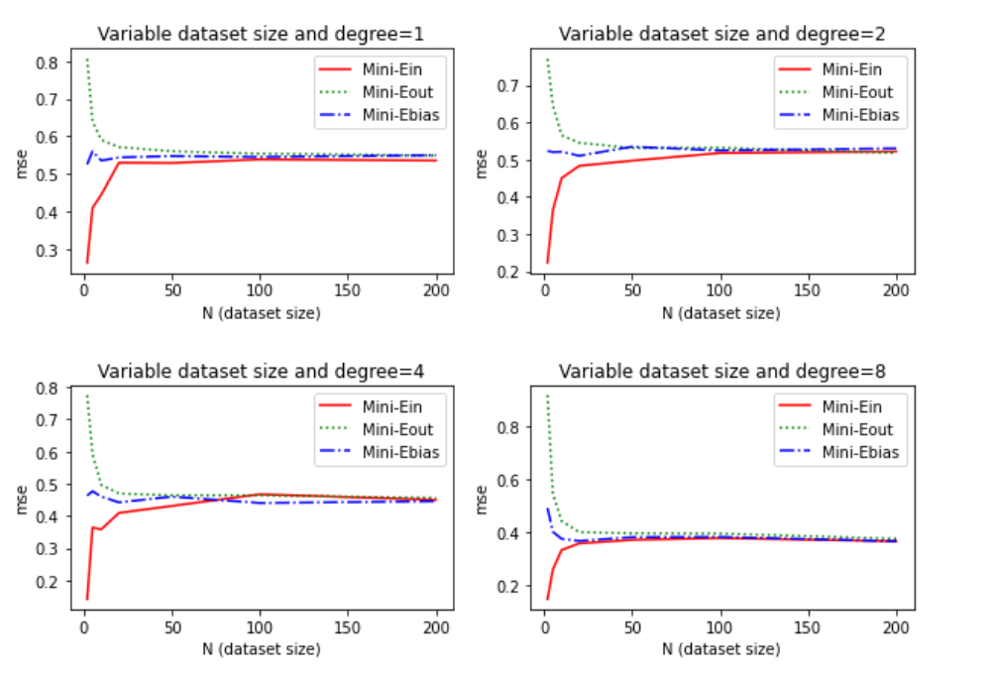

Initially we can observe that the Ein(training error or

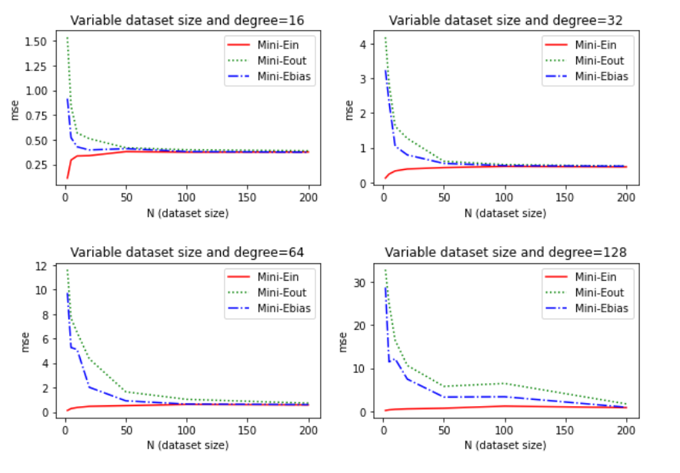

Effect of Dataset on Mean-Squared Error with variance of 0.2. With different model complexities.