**Trello vs. Monday.com: Agile Software Tools Research Report**

**Trello**

**1. Features & Capabilities**

**Kanban Boards**

* Visual task management with boards, lists, and cards.
* Drag-and-drop interface to move tasks between different workflow stages.

**Task Management**

* Create, assign, and manage tasks using detailed cards.
* Add due dates, checklists, labels, attachments, and comments.

**Automation (Butler)**

* Automates repetitive tasks such as task assignments, status updates, and notifications.

**Power-Ups (Integrations)**

* Expands functionality by integrating with apps like Slack, Google Drive, GitHub, Jira, and more.

**Collaboration & Communication**

* Comments, mentions, and file sharing enable real-time team communication.
* Notifications keep team members informed of updates and changes.

**Multiple Views**

* Offers Timeline, Calendar, Dashboard, and Table views (Premium feature).

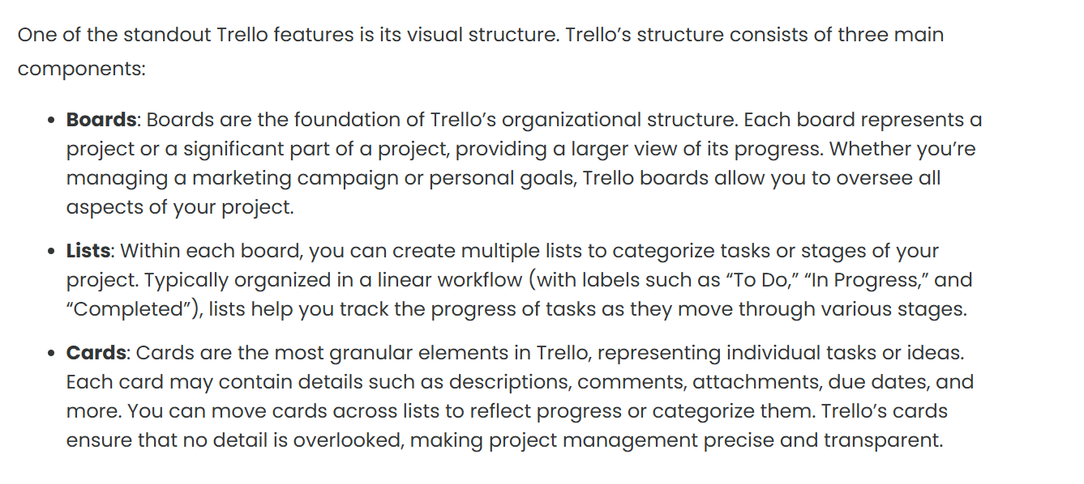

**2. Advantages & Disadvantages**

**Advantages**

✅ Intuitive and easy to use, requiring minimal training.

✅ Flexible customization to fit different workflows.

✅ Free plan available with essential features.

✅ Wide range of Power-Ups for extended capabilities.

✅ Supports Agile and Scrum methodologies.

**Disadvantages**

❌ Lacks built-in reporting and advanced analytics.

❌ Heavy reliance on Power-Ups for additional functionality.

❌ Not as feature-rich as dedicated Agile project management tools like Jira.

❌ Can become cluttered with large, complex projects.

**3. Installation & Setup**

* **Trello is cloud-based**, requiring no local installation.
* Accessible via web browsers, mobile apps (iOS and Android), and desktop apps.

**4. Learning Curve**

* **Beginner-friendly:** Most users can get started within a few hours.
* **Advanced features like automation and integrations** may require 1–2 weeks to master.

**5. Compatibility & Integration**

* **Integrates with:** Jira, GitHub, Slack, Google Drive, Microsoft Teams, Zoom, Salesforce, and over 100 other apps.
* **Supports API customization** for advanced integrations and automation.

**6. Scalability & Performance**

* Works well for **small to medium-sized teams**.
* Can become **overwhelming for large enterprises** managing multiple complex projects.
* Performance remains stable unless too many Power-Ups and automations are used simultaneously.

**7. Pricing & Licensing**

* **Free Plan:** Includes basic features for individuals and small teams.
* **Standard Plan ($5/user/month):** Advanced checklists and unlimited boards.
* **Premium Plan ($10/user/month):** Includes multiple views, advanced admin controls, and calendar.
* **Enterprise Plan (Custom pricing):** Enhanced security, control, and admin features for large organizations.

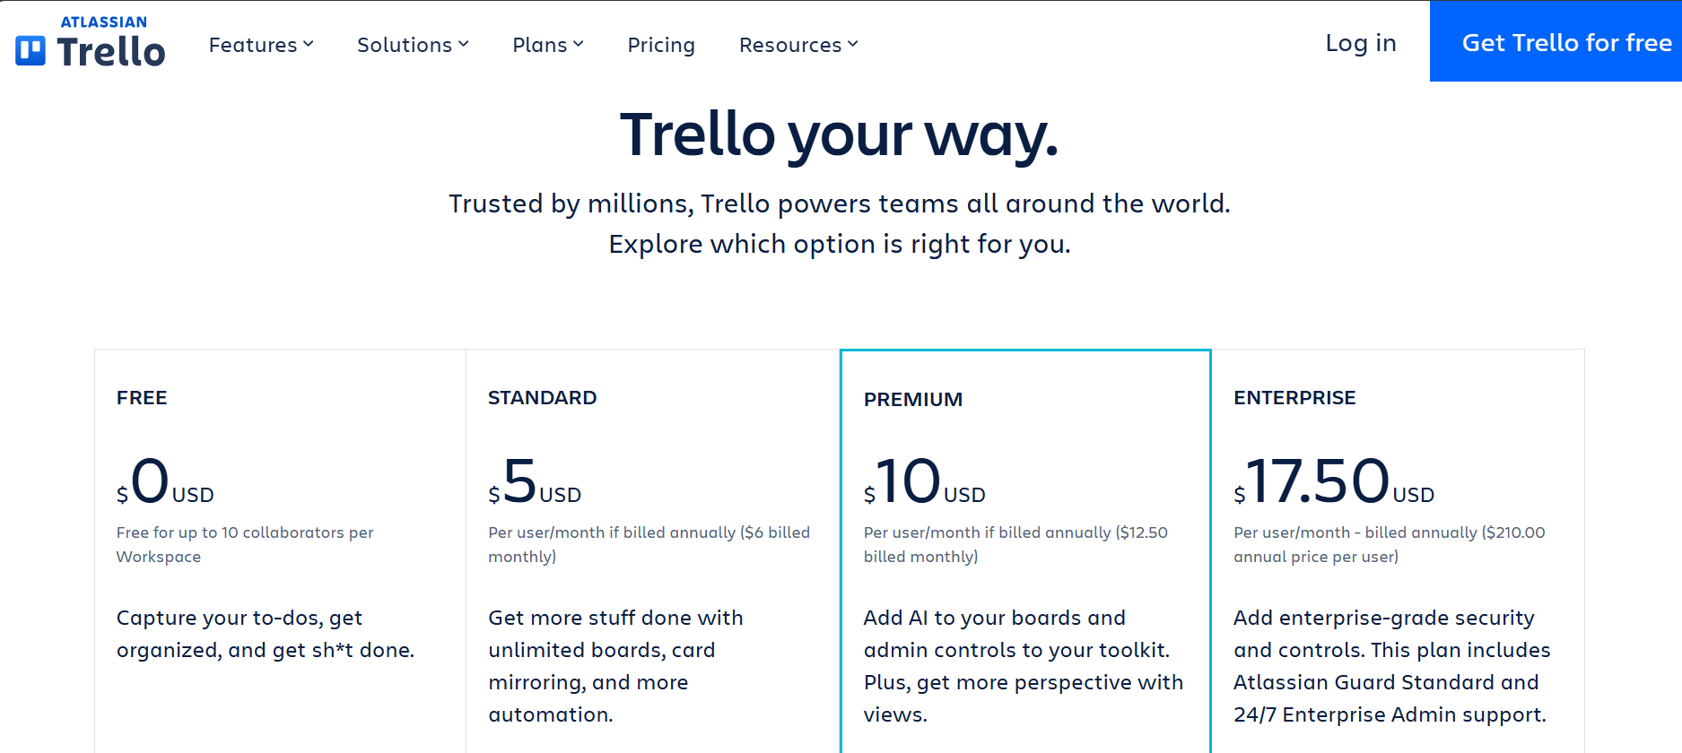

**8. Support & Community**

* **Help Centre & Documentation:** Detailed guides and FAQs available.
* **Community Forum:** Active user discussions and troubleshooting.
* **Customer Support:** Email support for free users; priority support for paid users.
* **Training Resources:** Webinars and online courses available.

**9. Security & Compliance**

* **Data Encryption:** Uses TLS encryption for secure communication.
* **Compliance Certifications:** GDPR, SOC2, ISO 27001 certified.
* **Access Controls:** Admin controls for user permissions and roles.
* **Two-Factor Authentication (2FA)** available.

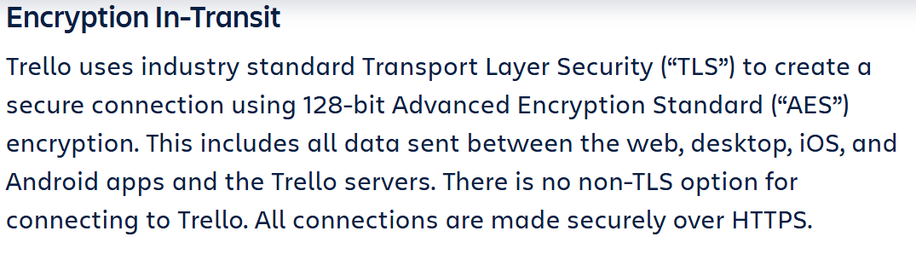

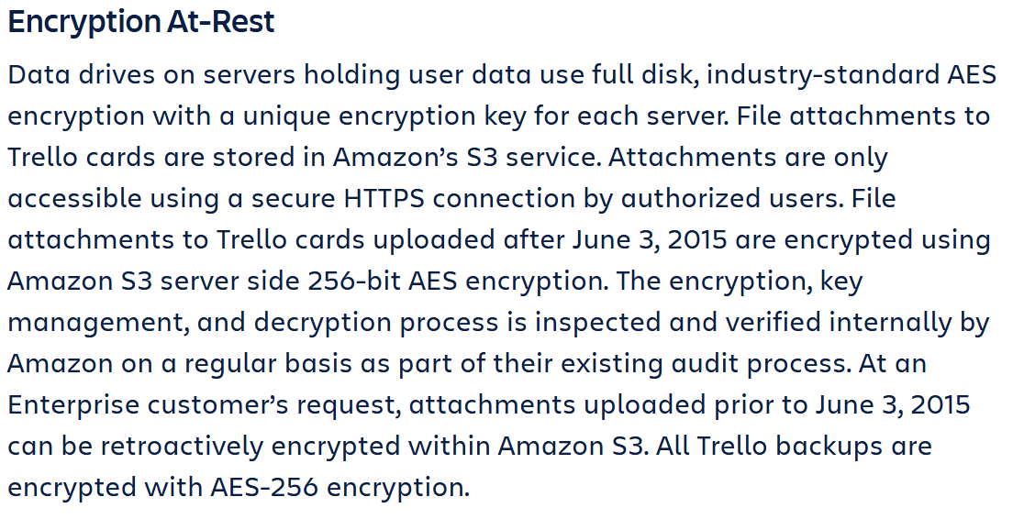

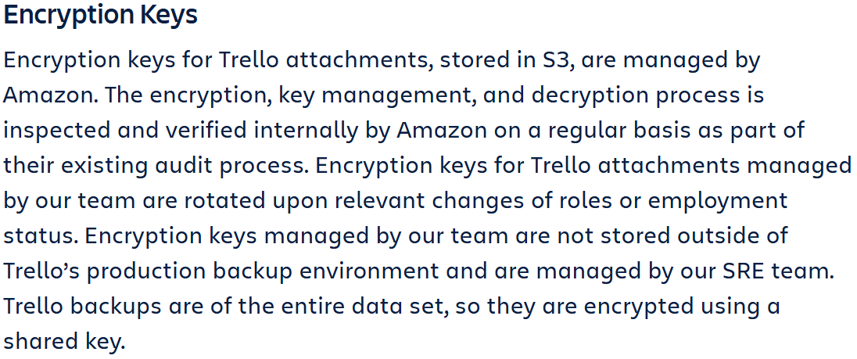

**10. Real-World Use Cases**

* **Tech Startups:** Used for Agile sprint planning and task tracking.
* **Marketing Teams:** Organizing campaigns and content calendars.
* **Software Development Teams:** Managing backlogs, bug tracking, and feature releases.
* **Remote Teams:** Keeping track of collaborative tasks and workflows.

**Short Demo / Explanation of Agile Workflow in Trello**

1. **Create a Kanban Board**
   * Set up lists like “Backlog,” “To Do,” “In Progress,” and “Done.”
2. **Add Tasks as Cards**
   * Assign team members, due dates, checklists, and labels to each card.
3. **Move Cards Through Workflow**
   * Drag and drop tasks from “To Do” → “In Progress” → “Done.”
4. **Automate Repetitive Actions**
   * Set up Butler automation to notify team members or assign tasks based on triggers.
5. **Monitor Progress Using Power-Ups**
   * Use reporting integrations like Google Sheets or Dashboard view to analyse work progress.

**Monday.com**

**1. Features & Capabilities**

**Customizable Workflows**

* Supports Kanban, Gantt, Calendar, and Timeline views.
* Drag-and-drop interface for seamless task movement.

**Task & Project Management**

* Create, assign, and manage tasks with detailed fields.
* Set priorities, dependencies, and deadlines for projects.

**Automation**

* Automate repetitive tasks like status updates, notifications, and approvals.
* Custom workflow automation with triggers and rules.

**Integrations**

* Connects with tools like Slack, Microsoft Teams, Google Drive, GitHub, Zoom, Jira, and over 200+ apps.

**Collaboration & Communication**

* Comments, mentions, file sharing, and team updates in real-time.
* Centralized dashboard for project tracking and team discussions.

**Advanced Reporting & Analytics**

* Built-in reporting tools to track project progress and performance metrics.
* Customizable dashboards with data visualization options.

**2. Advantages & Disadvantages**

**Advantages**

✅ User-friendly interface with drag-and-drop functionality.

✅ Highly customizable workflows to fit different project needs.

✅ Powerful automation capabilities to save time.

✅ Strong integration ecosystem with 200+ third-party tools.

✅ Multiple views for enhanced project visibility.

**Disadvantages**

❌ Higher pricing compared to simpler task management tools.

❌ Can be overwhelming for new users due to extensive features.

❌ Limited free plan with restrictions on features.

❌ Complex projects may require additional customization and onboarding time.

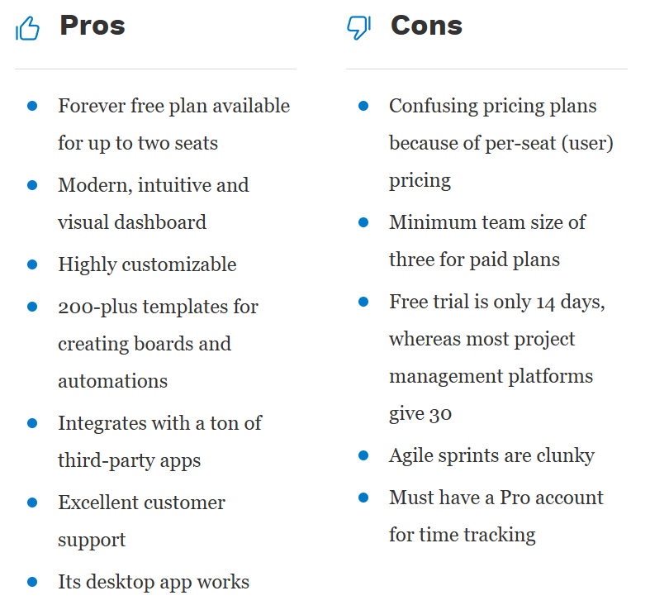

**3. Installation & Setup**

* **Monday.com is cloud-based**, requiring no local installation.
* Available on web browsers, mobile apps (iOS and Android), and desktop applications.

**4. Learning Curve**

* **Beginner-friendly for basic use**; users can get started within a few hours.
* **Advanced features like automation and reporting** may take 1–2 weeks to master.

**5. Compatibility & Integration**

* **Integrates with:** GitHub, Slack, Google Drive, Microsoft Teams, Jira, Zoom, Salesforce, and more.
* **API support for custom integrations** and automation workflows.

**6. Scalability & Performance**

* **Well-suited for small to large teams and enterprises.**
* Performance remains stable even with multiple automation rules and integrations.
* Can handle complex workflows and large datasets efficiently.

**7. Pricing & Licensing**

* **Free Plan:** Limited features for up to 2 users.
* **Basic Plan ($8/user/month):** Includes unlimited items and priority support.
* **Standard Plan ($10/user/month):** Adds timeline, calendar, and integrations.
* **Pro Plan ($16/user/month):** Advanced automation, time tracking, and reporting.
* **Enterprise Plan (Custom pricing):** Enhanced security, compliance, and admin features.

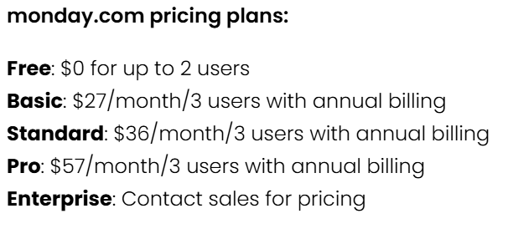

**8. Support & Community**

* **Help Centre & Documentation:** Comprehensive guides and FAQs.
* **Community Forum:** Active discussions and troubleshooting support.
* **Customer Support:** 24/7 email, chat, and priority support for higher-tier plans.
* **Training Resources:** Webinars, courses, and live training options.

**9. Security & Compliance**

* **Data Encryption:** TLS encryption for secure data transfer.
* **Compliance Certifications:** GDPR, ISO 27001, HIPAA, and SOC2 certified.
* **Access Controls:** Advanced user permissions and role-based access.
* **Two-Factor Authentication (2FA)** for additional security.

**10. Real-World Use Cases**

* **Software Development Teams:** Used for sprint planning, backlog tracking, and product launches.
* **Marketing Teams:** Managing campaigns, content calendars, and performance tracking.
* **HR & Recruitment:** Streamlining hiring pipelines, onboarding, and team collaboration.
* **Sales & CRM:** Tracking leads, managing pipelines, and automating customer workflows.
* **Remote Teams:** Keeping distributed teams aligned with shared projects and communication tools.

**Short Demo / Explanation of Agile Workflow in Monday.com**

1. **Set Up a Project Board**
   * Create a board with lists for “Backlog,” “In Progress,” and “Done.”
2. **Add Tasks & Assign Team Members**
   * Define each task with deadlines, priorities, and dependencies.
3. **Utilize Automation**
   * Set up rules to auto-assign tasks, update statuses, and send notifications.
4. **Monitor Progress with Dashboards**
   * Use built-in analytics to track performance and identify bottlenecks.
5. **Collaborate in Real Time**
   * Use comments, file sharing, and mentions for seamless team communication.

**Conclusion**

* **Trello** is ideal for small teams needing a simple, visual project management tool.
* **Monday.com** is better suited for larger teams requiring advanced automation and reporting.

### ****Bibliography****

#### **Trello References**

1. Cloudwards. (2025). Trello Review 2025. Retrieved from https://www.cloudwards.net/trello-review
2. Project-Management.com. (n.d.). What is Trello? Features and Use Cases. Retrieved from https://project-management.com/what-is-trello
3. Trello. (n.d.). Trello Pricing Plans. Retrieved from https://trello.com/pricing
4. Trello. (n.d.). Trello Operations and Security. Retrieved from https://trello.com/en/legal/security

#### **Monday.com References**

1. Forbes. (n.d.). Monday.com Review: Features, Pros & Cons. Retrieved from https://www.forbes.com/advisor/business/software/mondaycom-review
2. Monday.com. (n.d.). Monday.com Pricing: Which Plan Is Right for You?. Retrieved from https://monday.com/blog/product/monday-com-pricing-which-plan-is-right-for-you
3. Monday.com. (n.d.). Monday.com Products Pricing and Features. Retrieved from https://support.monday.com/hc/en-us/articles/4407832195602-monday-products-pricing-and-features
4. Monday.com. (n.d.). Monday.com Pricing and Plans. Retrieved from https://monday.com/pricing