SHEET -8 – FILE COMPRESSION -I

**1. Tar Archive**

a. Create a tar archive file of your home directory – tar -cvf backup.tar .



b. Create a tar archive file – tar -cvf etcbackup.tar /etc ( become root )



c. Move the etcbackup.tar to another directory root/Backups

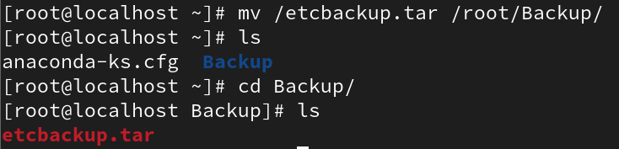

d. Create tar.gz file – tar -cvfz etcbackup.tar.gz /etc

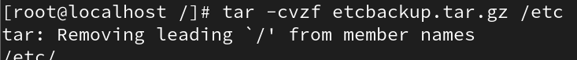

e. Move the gz file to root/Backups

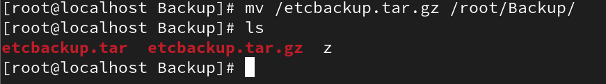

f. Create a tar.gz archive file of your home directory

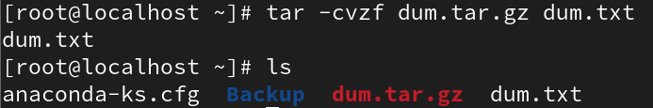

g. Create tar.bz2 archive file – tar -cvfj etcbackup.tar.bz2 /etc

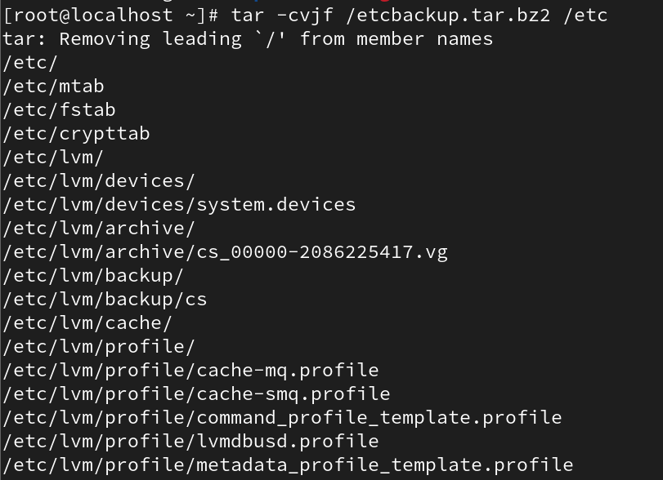

h. Move the bz file to root/Backups and compare the archive files using ls -lh

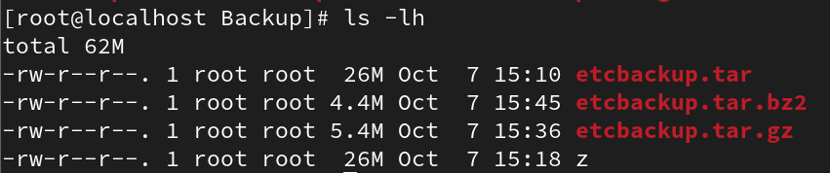

i. Create tar.bz2 file of your home directory

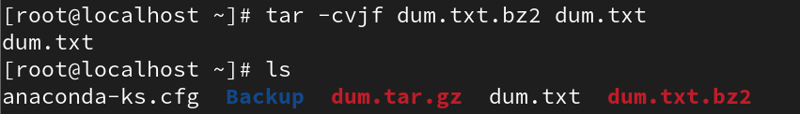

j. Untar files in the present directory

i. tar -xvf backup.tar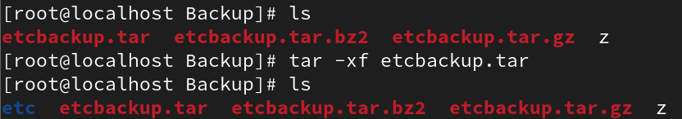

k. Untar files in specified directory

i. Tar -xvf backup.tar -C /tmp/backup (create dir tmp/backup under your home directory)

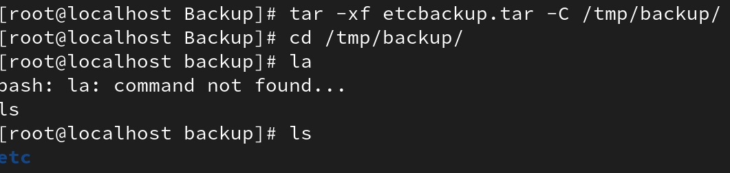

l. Create tar archive file of a directory CEO under your home directory named CEOBackup.tar



m. List all files under CEOBackup.tar using tar -tvf CEOBackup.tar

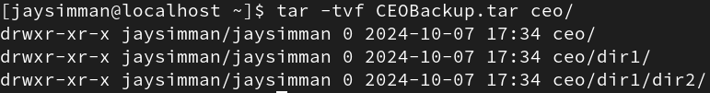

n. Add more files and directories to CEOBackup.tar using

i. tar -rvf CEOBackup.tar fil1 file 2 file3 / dir1 dir2

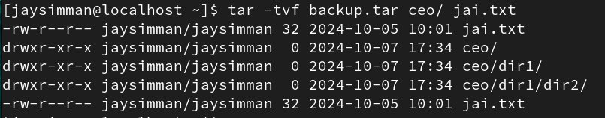

o. Untar single files / multiple files and dirs using

i. tar -xvf CEOBackup.tar file1 file2 file3 /dir1 dir2



p. Delete a file or directory from the tar acrchive using

i. tar --delete -f CEOBackup.tar file1 /dir1

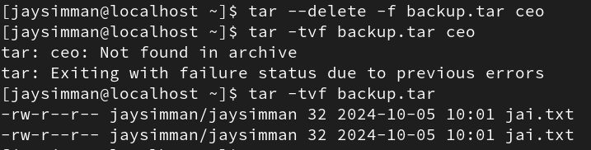

**2. Gzip archive**

a. Create a gzip archive of file(s)

i. gzip filename



ii. gzip filename1 filename2 filename3



b. Create a gzip file keeping the original file

i. gzip -k filename

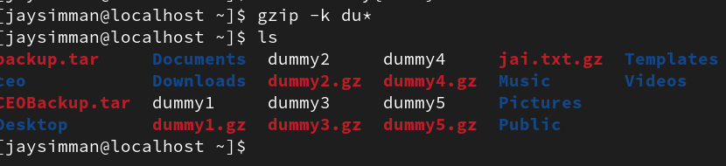

c. check out gzip -v filename cmd

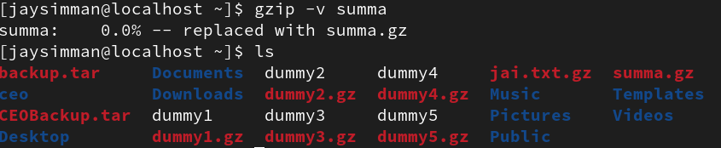

d. Create a gzip file for tar archive file CEOBackup.tar

i. gzip CEObackup.tar (this way you can archive the directory and then apply gzip for

compression)

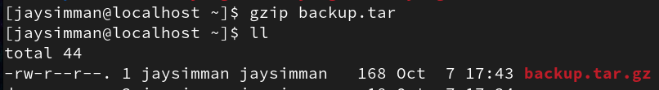

e. Create a gzip file for directory with subdirectories and files and observe

i. gzip -r dirname



f. decompress gzip files

i. gzip -d filename(s)

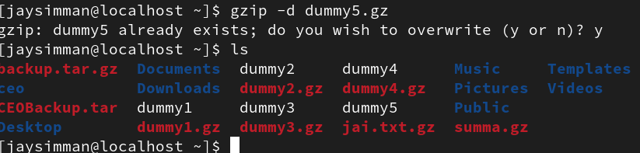

ii. gunzip filename(s)



iii. gzip -dr dirname



iv. gunzip -r dirname



v. gzip -dk filename (keeping the compressed file)

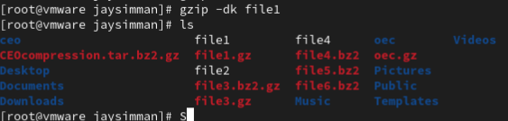

g. list the contents of gzip file/dir

i. gzip -l filename.gz



ii. gzip -lr dirname

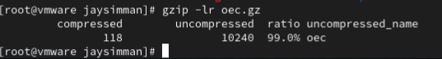

**3. bzip2 archive**

a. Create a bzip2 archive of file(s)

i. bzip2 filename



ii. bzip2 filename1 filename2 filename3



b. Create a bzip2 file keeping the original file

i. bzip2 -k filename



c. check out bzip2 -v filename cmd



d. Create a bzip2 file for tar archive file CEOBackup.tar

i. bzip2 CEObackup.tar (this way you can archive the directory and then apply gzip for

compression)

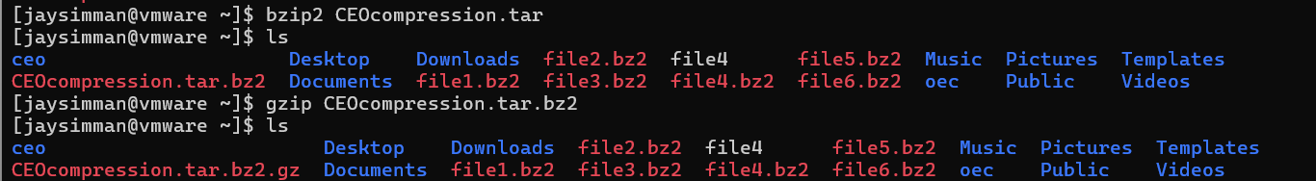

e. decompress bzip2 files

i. bzip2 -d filename(s)



ii. bunzip2 filename(s)

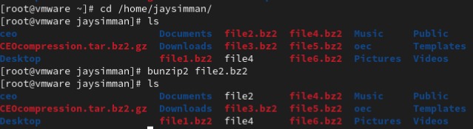

iii. bzip2 -dk filename (keeping the compressed file)

