**SHEET-9 –USER ACCOUNT MANAGEMENT -II**

1. Create a user named raina with the following properties

a. uid (-u)

b. gid (-g)

c. comment (-c)

d. home directory(-d)

e. shell (-s) 

2. set the password for user raina

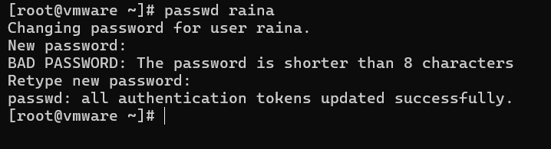

3. check the status of password using – passwd –S username



4. check the userinfo values in etc/passwd.

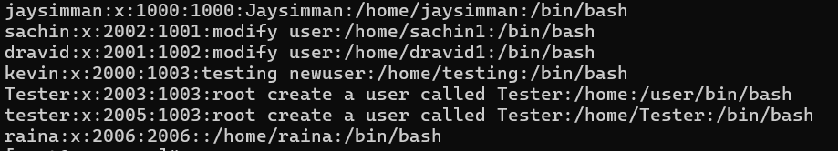

5. Create a new user dhoni without home directory (useradd –M Username)

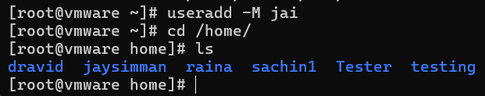

6. Create another user virat with account expiry date (useradd –e ‘yyyy-mm-dd’ username)

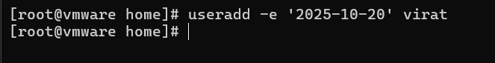

7. Check the user virat info using chage –l username

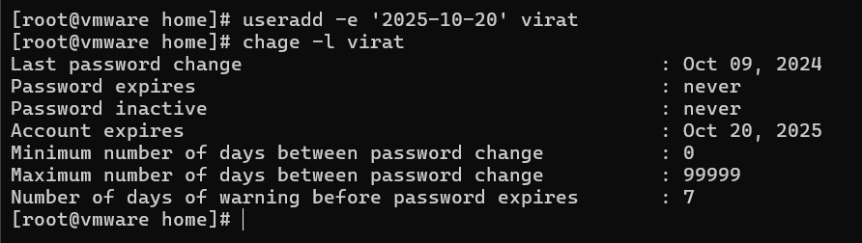

8. Change the user dhoni properties using usermod cmd.

a. Uid

b. Gid

c. Comment

d. Home directory

e. Accout expiry date

f. Username as mahendra – usermod –l newname oldname



9. Check all these values in /etc/passwd and chage –l username cmd



10. Lock the password for user raina using passwd –l username and check its status.

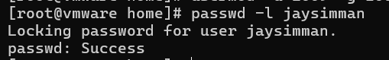

11. Login with user raina from user other than root and observe.

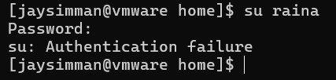

12. Now unlock password for user raina using passwd –u username and check its status.

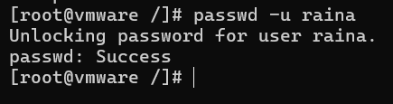

13. Login with user raina from user other than root and observe

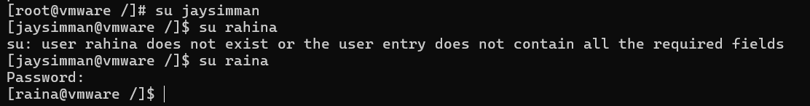

14. Now lock the user account of raina using usermod –L username and check.



15. Unlock the user account of raina using usermod –U username and check.



16. Using chage cmd ,perform the following

a. Chage –l username – to check the properties of password (account aging info).

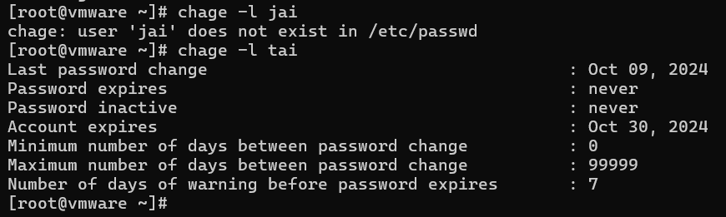

b. It can be found in /etc/shadow file also.



c. Min days for password reset –m.



d. Max days for password reset –M.



e. Warning before password change –W.

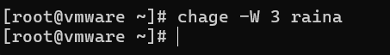

f. Inactive days –after which the account will be disabled –I.

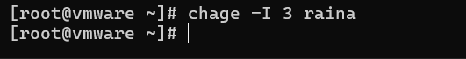

g. Last password change date –d.

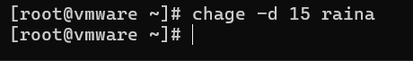

h. Account expiry date –E

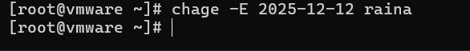

i. Check whether all these properties are updated .(chage –l username).

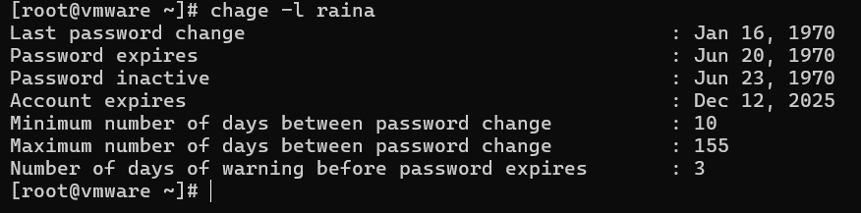

17. Create another user kohli and set kohlis password

a. Now change last password change date as 0 for kohli(chage –d 0 username)

b. Login into kohli and check .

18. Use groupmod cmd to perform the following for an existing user raina and group sports.

a. Add user raina to group sports using usermod –aG grpname username

b. Add user mahendra to group sports (primary group) – usermod –g gid/gname username

i. Use id username cmd to check the groups of user.

c. Check the details in etc/group file.

d. Use gpasswd –a user group to add user kohli to sports

e. Check the details in etc/group file

f. Change the groupid of sports to 4000 – groupmod –g GID groupname

g. Change the groupid of user kohli to 4002 – groupname –g GID username

h. Change the groupname from sports to sportpersons – groupmod –n newgrp oldgrp.

i. Check the details in etc/group file.

19. Check the default values using useradd –D.

20. Check the default values using cat /etc/default/useradd.

21. Run ls –l on /home and /var/spool/mail and observe the user directories.

22. Delete a user and chk the mail dircectory.

23. Run ls –la on /etc/skel directory and observe the default directories and files .(when creating a new user all. these will be created in /home/newuser).

24. Use cmds id username, id –un username ,id –gn username

25. Use w ,last and whoami cmd and observe the result.

26. Cat /etc/login.defs file and see the default values.

