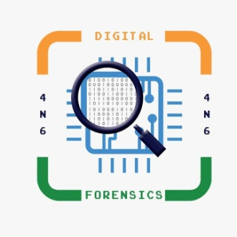**ARTIFICIAL INTELLIGENCE ON DIGITAL FORENSIC**

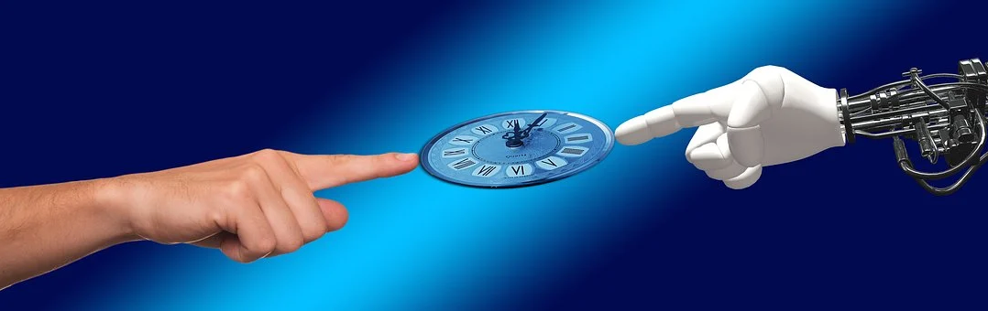**ARTIFICIAL INTELLIGENCE (AI)**

Artificial Intelligence is related to computer science, it is machine or computer system able to perform tasks that ordinarily require human intelligence or a machine that are intelligent. The ideal characteristic of artificial intelligence is its ability to rationalize and take actions that have the best chance of achieving a specific goal.

It is categorised into four types:-

**Reactive Machine**:- AI systems are those that are purely reactive. These type of machines cannot use their past experiences as the basis for the decisions they make. One concrete example is IBM's Deep Blue.

**Limited Memory system**:- AI machines are capable of looking at their past and applying learnings to current challenges. Example such as self-driving cars. These AI systems observe the direction and speed of other vehicles on the road which prevent the collision.

**Theory of Mind Machine**:- These machines are believed to have thoughts and emotions that impact their behaviors and perceptions.

**Self-Aware systems**:- AI systems that can form representations of themselves. These machines will exhibit consciousness or self-awareness.

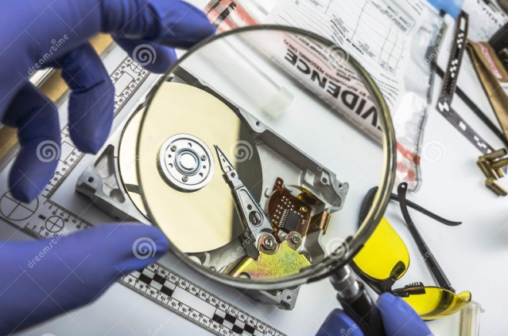**DIGITAL FORENSICS**

Digital Forensic is a branch of Forensic science and it is defined as the process of preservation, identification, extraction, and documentation of computer evidence which can be used by the court of law. It is a science of finding evidence from digital media like a computer, mobile phone, server, or network. It is first presented by 1970.

**HISTORICAL PERSPECTIVE OF DIGITAL FORENSIC INVESTIGATION**

In the first investigation, the financial fraud is proven from the suspect’s computer. The first prosecuted computer crime was reported in 1996. The computer crime is defined as when the computer is the major effect for offense and facilitates the tool to Figure . Taxonomy of digital investigations. 3 Advancing Automation in Digital Forensic Investigations Using commission a crime [2]. The first prosecuted computer crime was reported in Texas, USA, in 1996 [3] and resulted in a 5-year sentence. In 1990, computer-based digital crimes started to grow with the increasing popularity of the computers and the Internet. The computer forensic is developed as the independent field in the late 1990s and in the early 2000s. The CSI surveys report that almost 46% among the respondents were affected by some kind of computer crimes [4]. The 2010 Gallup surveys reports that 11% of the American adult become victim of computer- or Internetrelated crimes in their homes. This ratio is 6–8% more than the last 7 years. A survey conducted by “Australian Company Crime Survey” [5], estimated that A$ 2,000,000 financial fraud and information breaches occurs in 2006. Company Crime Survey, its estimated A$ 2,000,000 financial fraud and information breaches in lost revenue. The term digital forensic is used nowadays with the advent of new digital devices with increasing number of frequency of use for investigation purposes (Figure 1).

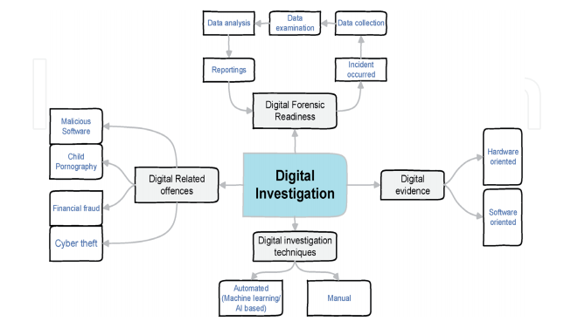

Figure 1: Taxonomy of Digital Forensic investigation

**CONTRIBUTION OF AI IN DIGITAL FORENSIC**

As you know we are in digital era where most of the criminal is used the digital media to commit a crime Algorithms already play a significant role in helping digital forensics investigators analyze the vast amount of data that is created by mobile devices and stored on the cloud. Like many industries, demand outstrips supply when it comes to qualified, trained professionals who can sift through the backlog of digital forensics data relevant to modern criminal cases. Artificial Intelligence (AI) can help automate some processes and more quickly flag content or insights that would otherwise take investigators longer to uncover. AI functions can help with spotting and identifying elements in photos and videos, observing commonalities in communication, location, and times, and based on history, make educated guesses about where and when the next incident or crime might occur.

That being said, there is a trust factor to overcome with AI in digital evidence in criminal investigations. When evidence in a case is presented, the attorneys, judges, and jury members must grasp the broad concept of artificial intelligence in order to accept and feel comfortable with it’s growing role in digital forensics and in many modern criminal investigations. Just human logic on complex decisions can be traced back and debated on any particular issue, it’s imperative that AI functions have logs and so its conclusions are transparent and can be fully litigated.

**CONCLUSION**

AI in digital forensics is still at a very early stage, but it does have a lot to offer the digital forensics community. Human beings will still have a role in criminal investigations. AI is a tool, but it’s not an investigator. We’re far away from that, if we ever get there at all. So while it’s important to understand and harness this tool, it’s equally not to conflate AI as analogous to an investigator. AI to digital forensics can be split into two areas – (1) where AI is used to help automate an individual part of the forensic process (e.g. to look for a particular file type) and (2) where AI is used to guide the expert in their task.

**REFERNCES**

* https://medium.com/@virajrathod951997/ai-on-digital-forensics-8c6af1d3f795
* https://www.forbes.com/sites/quora/2019/06/05/how-does-ai-contribute-to-digital-forensics/#599972c7c20a
* Article the use of AI in Digital forensic: A Introduction By Dr Faye Mitchell.
* Advancing Automation in Digital Forensic Investigations Using Machine Learning Forensics DOI: http://dx.doi.org/10.5772/intechopen.90233

**ABOUT AUTHOR**

My name is Jyoti Singh from New Delhi. I am pursuing PG Diploma in Journalism and Mass Communication from IGNOU University. I have completed M.Sc Forensic Science from SHUATS, Allahabad (U.P). I have worked around various field of Forensic Science. I have certification in Forensic Ballistics, cyber security and internship experience in Forensic Serology from Forensic Science Laboratory, Chanakyapuri New Delhi and I have gained some experience in Crime Scene Investigations while training under Delhi police and UP Police crime branch.