Density Functional Theory and it’s Uses in Computational Chemistry.

Jayson Baker, David Hoxley, and David Wilson.

An Introductory Text to the PHY3PRJ Project undertaken in 2025 by Jayson Baker as Supervised by David Hoxley, and with help from David Wilson.

Table of Contents

Investigating Molecular Orbitals, Natural Bond Orbitals and Electron Density Using WebMO. 2

Investigating Molecular Orbitals, Natural Bond Orbitals and Electron Density Using WebMO.

**Abstract**

*The program WebMO was used to calculate the Molecular Orbitals, Natural Bond Orders and Electron Density of a lone carbon atom, carbon monoxide (CO), chloromethane (CH3Cl), Ethylene (C2H4), Benzene (C6H6), and three tautomers of N-heterocyclic Carbene (NHC). The 1s and 2p orbitals of a lone carbon atom were calculated as a simple test of WebMO’s accuracy. The calculation was then run on our molecules to gauge the reactivity of each species by analysing both the separate molecule’s HOMOs and LUMOs. The ‘Natural Bond Orbitals’ calculation was run on Chloromethane to view the types of bond orbitals. The ‘Bond Order’ calculation was used to identify the kind of bonding present, and the electrostatic potential mapped the distribution of electrons. It was fournd that….*

**Introduction**

The foundation of reactivity is built upon electronic structure. WebMO was used to visualise and analyse electronic structures, including electron density, molecular orbitals, and natural bond orbitals. This analysis was used to further chemical understanding of electronic structure.

**Background**

Molecular Orbitals (MOs) are mathematical functions which describe the behaviour of electrons in a molecule. The Highest Occupied Molecular Orbital (HOMO) and the Lowest Unoccupied Molecular Orbital (LUMO) gauge molecular properties and reactivity. HOMO is associated with nucleophilic characteristics[1]. Whereas LUMO is associated with electrophilic characteristics[2]. The gap between the HOMO and LUMO is inversely proportional to the reactivity. Thus, stable molecules have large HOMO-LUMO gaps and highly reactive molecules have the inverse. The shape and location of the HOMO and LUMO can be used to predict how and where a reaction will occur.

Natural Bond Orbitals (NBOs) are transformations of MOs into a structure that represent Lewis structures[3]. They are designed to be the single best structure of a molecule; however, this is not always possible. NBOs help to visualise the electronic structure and bonding in molecules.

Bond Orders are a simple mathematical indicator of bond strength and is defined by the following equation.

The calculated bond order is a representation of how many bonds are present. For example H2 has a Bond Order of 1 and a single bond between the two H atoms. C2H4 has a Bond Order of 2 and double bonds between the two C atoms present.

**SEMINAR 8 PLACEHOLDER TITLE**

**Materials and Methods**

The investigation was conducted using the web program, ‘*WebMO*.’ It is a java scripted frontend over a gaussian based engine. The program was used to calculate and visualise the species in Table 1. Before starting each of the calculations the molecules were constructed and their geometries optimised using WebMO’s *‘Geometry Optimization’* calculation at the *‘B3LYP’* theory and the *‘Routine: 6-31G(d)’* basis set.

**Table 1.:** Species and WebMO Calculations.

|  |  |  |  |
| --- | --- | --- | --- |
| **Chemical Species:** | **Formula:** | **Structure:** | **WebMO Calculation** |
| **Carbon Atom.** | C |  | Molecular Orbital |
| **Carbon Monoxide.** | CO | Carbon monoxide - American Chemical Society | Molecular Orbital |
| **Chloromethane.** | CH3Cl | Chloromethane - American Chemical Society | Molecular Orbital |
| **Ethylene.** | C2H4 | Ethylene - American Chemical Society | Molecular Orbital, Natural Bond Orbital, and Bond Order. |
| **Benzene.** | C6H6 | Benzene - American Chemical Society | Molecular Orbital, Natural Bond Orbital, and Bond Order. |
| **nNHC.** | C3H4N2 |  | Molecular Orbital, Natural Bond Orbital, and Bond Order. |
| **aNHC.** | C3H4N2 |  | Molecular Orbital, Natural Bond Orbital, and Bond Order. |
| **IMID.** | C3H4N2 |  | Molecular Orbital, Natural Bond Orbital, and Bond Order. |

First the Molecular Orbitals of the lone Carbon atom were calculated using the *‘Molecular Orbital’* calculation at the *‘B3LYP/6-31G(d)’* level of theory. The calculation was used to show the expected *s* and *p* Atomic Orbitals of Carbon. Then the MOs of Carbon Monoxide (CO) were calculated using the same method as above. Using the calculation, the HOMO of CO was then found and investigated. Thirdly the same calculation was applied to Chloromethane (CH3Cl) to highlight the characteristics of the LUMO. Ethylene (C2H4) was then run under three separate calculations the *‘Molecular Orbital’* calculation, a *‘Natural Bond Orbital’* calculation, and the *‘Bond Orders’* calculation. All of the calculations were made at the *‘B3LYP/6-31G(d)’* level of theory. The MO calculation was made to gauge the reactivity, based on the HOMO, the NBO calculation showed the occupancy of the various orbitals, and the Bond Order calculation was made to confirm the bond orders of the bonds present in ethylene. The same three calculations were made with Benzene (C6H6) and the three tautomers[4] of NHC. Finally, the electrostatic potential of the IMID tautomer was shown using a built in function of WebMO’s MO calculations.

**Results**

In the following figures, the CPK conventional colours of atoms are followed: the colours of the atomic and molecular orbitals conform to the convention that, blue represents positive and red represents negative in the Bonding Orbitals, and green being positive with yellow being negative in the Anti-Bonding Orbitals[5].

|  |  |
| --- | --- |
|  | the 1s orbital |
|  | ... |

**Fig 1: Comparison of the** calculated, s and p Atomic Orbitals of Carbon with the values form the orbotron [ref]. . In this figure the yellow and white represent the positive and negative solutions to the wave function.

(a) 1s atomic orbital of a lone carbon atom (b) etc c)etc)

**Figure 1** (top left) shows the calculated 1s atomic orbital of a lone carbon atom. The calculated orbital matches with the literature present of a 1s orbital. **Figure 2** (top right) shows the literature 1s Atomic Orbital as taken from the University of Sheffield site *‘The OrbitronTM’* created, and updated by, Prof. Mark J. Winter, of the Department of Chemistry at the University of Sheffield. **Figure 3** (bottom left) shows the calculated 2p Atomic Orbital of a lone carbon atom. The calculated orbital matches the literature sources of the 2p Atomic Orbital. **Figure 4** (bottom right) shows the literature 2p Atomic Orbital as taken from the University of Sheffield site *‘The OrbitronTM’* created, and updated, by Prof. Mark J. Winter of the Department of Chemistry at the University of Sheffield. In this figure the yellow and white represent the positive and negative solutions to the wave function.

**Fig 5.:** The HOMO of a Carbon Monoxide Molecule cal;culated using webMO.

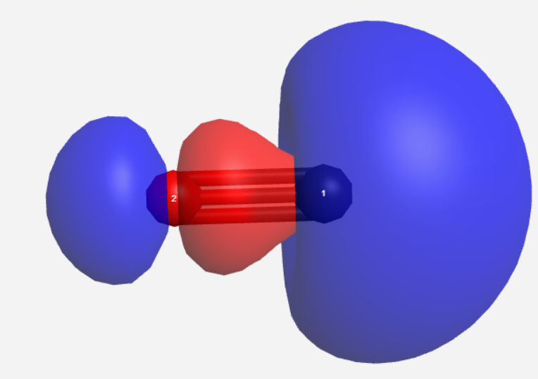

Figure 5 shows the calculated HOMO of the CO molecule. The orbital is a combination of the C atom’s bonding 1s atomic orbital and the O atom’s bonding 2p atomic orbital. The Molecular Orbital is also shown to be ‘in-line’ with the triple bond present in the CO molecule.

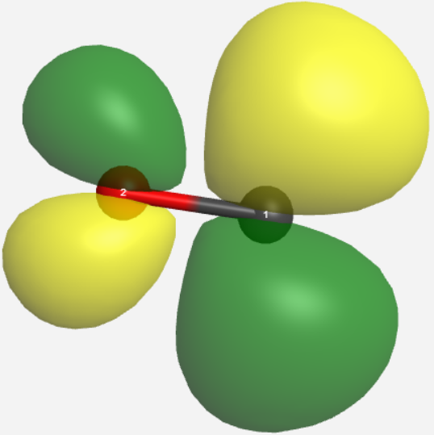

**Fig 6.:** The calculated LUMO of a Carbon Monoxide Molecule. The red thing is…. The black thing is… the numbers 1 and 2 mean….

Figure 6 shows the calculated LUMO of the CO molecule. The orbital is a destructive combination of the antibonding p atomic orbitals, specifically the π* antibonding present in both the C and O atoms. The Molecular Orbital is also shown to be perpendicular with the triple bond present in the CO molecule.

**Fig 7.:** The LUMO of Chloromethane (CH3Cl).

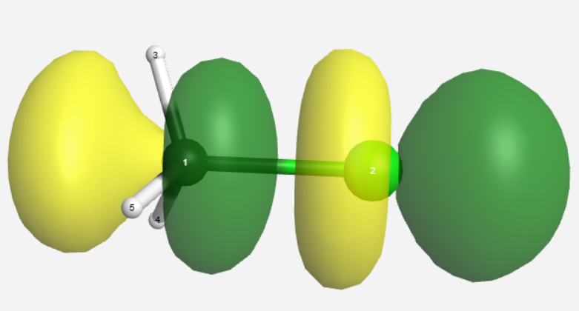

Figure 7 shows the calculated LUMO of the CH3Cl molecule. The orbital is a destructive combination of the antibonding p atomic orbitals, specifically the σ* antibonding present in both the C and Cl atoms. The Molecular Orbital is also shown to be ‘in-line’ with the single bond present between the C and Cl atoms.

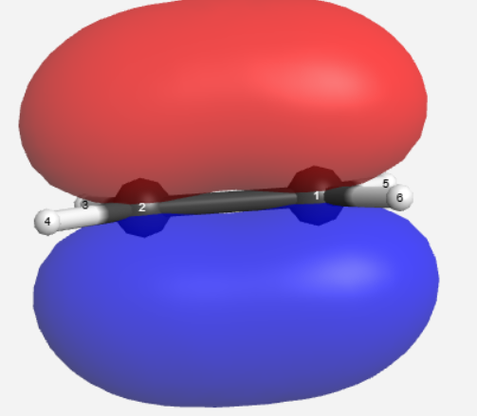

**Fig 8.:** The HOMO of Ethylene (C2H4).

Figure 8 shows the calculated HOMO of the C2H4 molecule. The orbital is a constructive combination of the bonding 2p orbitals present in the C atoms. The Molecular Orbital is also shown to be perpendicular with the double bond present in the C2H4 molecule.

**Table 2.:** The Calculated Natural Bond Orbitals of Ethylene (C2H4).

|  |  |  |  |
| --- | --- | --- | --- |
| **Orbital:** | **Type:** | **Location/variant.** | **Occupancy:** |
| **1** | Bond. | C1-C2 π-bond. | 1.9999 |
| **2** | Bond. | C1-C2 σ-bond. | 1.9965 |
| **3** | Bond. | C1-H5 σ-bond. | 1.9872 |
| **4** | Bond. | C1-H6 σ-bond. | 1.9872 |
| **5** | Bond. | C2-H3 σ-bond. | 1.9872 |
| **6** | Bond. | C2-H4 σ-bond. | 1.9872 |
| **7** | Core. | C1 1s Orbital. | 1.9992 |
| **8** | Core. | C2 1s Orbital. | 1.9992 |

Table 2 shows that the orbitals 1-6, arbitrary numbering provided by WebMO, are all bonding orbitals with orbital 1 being the π-bond between the C atoms, orbital 2 being the σ-bond between the C atoms, Orbitals 3-6 being the σ-bonds present between the C atoms and the H atoms, and orbitals 7-8 being the 1s atomic orbitals present in the separate C atoms. The occupancy of each orbital is also shown to be approximately 2 which is expected.

**Table 3.:** The Calculated Bond Orders of Ethylene (C2H4).

|  |  |  |  |  |  |  |
| --- | --- | --- | --- | --- | --- | --- |
| **Atom:** | **C1:** | **C2:** | **H3:** | **H4:** | **H5:** | **H6** |
| **C1** | 0.00 |  |  |  |  |  |
| **C2** | 2.035 | 0.00 |  |  |  |  |
| **H3** | 0.01 | 0.93 | 0.00 |  |  |  |
| **H4** | 0.01 | 0.93 | 0.00 | 0.00 |  |  |
| **H5** | 0.93 | 0.01 | 0.00 | 0.02 | 0.00 |  |
| **H6** | 0.93 | 0.01 | 0.02 | 0.00 | 0.00 | 0.00 |

In Table 3 the bond order between the various atoms in the Ethylene molecule. For example, C1 has a bond order of 0 with itself, 2 with C2, 0 with H3 and H4, and 1 with H5 and H6. The bond orders are computational calculated as real numbers however they are often recorded as multiples of n½, because of the mathematical definition of bond orders.

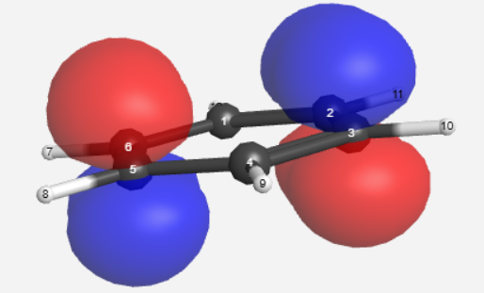

**Fig 9.:** The Calculated HOMO of Benzene (C6H6).

Figure 9 shows the calculated HOMO of the C6H6 molecule. The orbital is a constructive combination of the bonding 2p orbitals present in the C atoms. The Molecular Orbital is also shown to be perpendicular with the double bonds present in the C6H6 molecule.

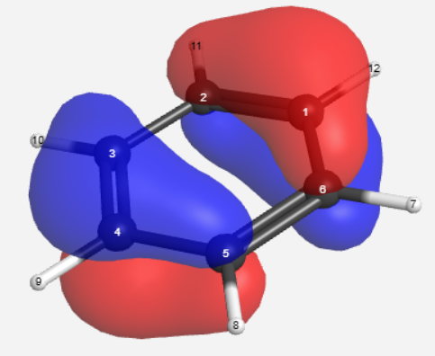

**Fig 10.:** The calculated HOMO-1 of Benzene (C6H6).

Figure 10 shows the HOMO-1 of Benzene (C6H6), the penultimate occupied molecular orbital. The orbital is a constructive combination of the p orbitals present in all of the carbon atoms with a node ‘cutting’ across the symmetrical centre bonds. This shows the aromaticity of the benzene ring, and combined with the other HOMO (Fig9), shows the delocalised nature of the electrons present in C6H6.

**Table 4.:** CalculatedNatural Bond Orbitals of Benzene (C6H6).

|  |  |  |  |
| --- | --- | --- | --- |
| **Orbital** | **Type** | **Location/variant.** | **Occupancy** |
| **1** | Bond. | C1-C2 σ(35.21%) π(64.75%) Bond. | 0.99834 |
| **2** | Bond. | C2-C1 σ(35.21%) π(64.75%) Bond. | 0.99834 |
| **3** | Bond. | C1-C2 π(99.96%) Bond. | 0.99898 |
| **4** | Bond. | C2-C1 π(99.96%) Bond. | 0.99898 |
| **5** | Bond. | C1-C6 σ(35.21%) π(64.75%) Bond. | 0.99834 |
| **6** | Bond. | C6-C1 σ(35.21%) π(64.75%) Bond. | 0.99834 |
| **7** | Bond. | C1-H12 σ(29.55%) π(64.75%) Bond. | 1.23128 |
| **8** | Bond. | H12-C1 σ(100%) Bond. | 0.76406 |
| **9** | Bond. | C2-C3 σ(35.21%) π(64.75%) Bond. | 0.99834 |
| **10** | Bond. | C3-C2 σ(35.21%) π(64.75%) Bond. | 0.99834 |
| **11** | Bond. | C2-H11 σ(29.55%) π(70.4%) Bond. | 1.21279 |
| **12** | Bond. | H11-C2 σ(100%)Bond. | 0.76406 |
| **13** | Bond. | C3-C4 σ(35.21%) π(64.75%) Bond. | 0.99834 |
| **14** | Bond. | C4-C3 σ(35.21%) π(64.75%) Bond. | 0.99834 |
| **15** | Bond. | C3-C4 π(99.96%) Bond. | 0.99898 |
| **16** | Bond. | C4-C3 π(99.96%) Bond. | 0.99898 |
| **17** | Bond. | C3-H10 σ(29.55%) π(70.4%) Bond. | 1.23128 |
| **18** | Bond. | H10-C3 σ(100%) Bond. | 0.76406 |
| **19** | Bond. | C4-C5 σ(35.21%) π(64.75%) Bond. | 0.99834 |
| **20** | Bond. | C5-C4 σ(35.21%) π(64.75%) Bond. | 0.99834 |
| **21** | Bond. | C4-H9 σ(29.55%) π(70.40%) Bond. | 1.23128 |
| **22** | Bond. | H9-C4 σ(100%) Bond. | 0.76406 |
| **23** | Bond. | C5-C6 σ(35.21%) π(64.75%) Bond. | 0.99834 |
| **24** | Bond. | C6-C5 σ(35.21%) π(64.75%) Bond. | 0.99834 |
| **25** | Bond. | C5-C6 π(99.96%) Bond. | 0.99898 |
| **26** | Bond. | C6-C5 π(99.96%) Bond. | 0.99898 |
| **27** | Bond. | C5-H8 σ(29.55%) π(70.40%) Bond. | 1.23128 |
| **28** | Bond. | H8-C5 σ(100%) Bond. | 0.76406 |
| **29** | Bond. | C6-H7 σ(29.55%) π(70.40%) Bond. | 1.23128 |
| **30** | Bond. | H7-C6 σ(100%) Bond. | 0.76406 |
| **31** | Core. | C1 (s). | 1.99909 |
| **32** | Core. | C2 (s). | 1.99909 |
| **33** | Core. | C3 (s). | 1.99909 |
| **34** | Core. | C4 (s). | 1.99909 |
| **35** | Core. | C5 (s). | 1.99909 |
| **36** | Core. | C6 (s). | 1.99909 |

In Table 4 the Natural Bond Orbitals of C6H6 are shown. The Natural Bond orbitals also help us to understand the aromatic/delocalised nature of Benzene. The Natural Bond Orbitals present in the C bonds are combinations of the C s and p atomic orbitals showing a sp2 *‘hybridised’* structure[6].

**Table 5.:** Bond Orders of Benzene(C6H6).

|  |  |  |  |  |  |  |  |  |  |  |  |  |
| --- | --- | --- | --- | --- | --- | --- | --- | --- | --- | --- | --- | --- |
| **Atom:** | **C1:** | **C2:** | **C3:** | **C4:** | **C5:** | **C6** | **H7** | **H8** | **H9** | **H10** | **H11** | **H12** |
| **C1** | 0.00 |  |  |  |  |  |  |  |  |  |  |  |
| **C2** | 1.44 | 0.00 |  |  |  |  |  |  |  |  |  |  |
| **C3** | 0.01 | 1.44 | 0.00 |  |  |  |  |  |  |  |  |  |
| **C4** | 0.11 | 0.01 | 1.44 | 0.00 |  |  |  |  |  |  |  |  |
| **C5** | 0.01 | 0.11 | 0.01 | 1.44 | 0.00 |  |  |  |  |  |  |  |
| **C6** | 1.44 | 0.01 | 0.11 | 0.01 | 1.44 | 0.00 |  |  |  |  |  |  |
| **H7** | 0.00 | 0.01 | 0.00 | 0.01 | 0.00 | 0.92 | 0.00 |  |  |  |  |  |
| **H8** | 0.01 | 0.00 | 0.01 | 0.00 | 0.92 | 0.00 | 0.00 | 0.00 |  |  |  |  |
| **H9** | 0.00 | 0.01 | 0.00 | 0.92 | 0.00 | 0.01 | 0.00 | 0.00 | 0.00 |  |  |  |
| **H10** | 0.01 | 0.00 | 0.92 | 0.00 | 0.01 | 0.00 | 0.00 | 0.00 | 0.00 | 0.00 |  |  |
| **H11** | 0.00 | 0.92 | 0.00 | 0.01 | 0.00 | 0.01 | 0.00 | 0.00 | 0.00 | 0.00 | 0.00 |  |
| **H12** | 0.92 | 0.00 | 0.01 | 0.00 | 0.01 | 0.00 | 0.00 | 0.00 | 0.00 | 0.00 | 0.00 | 0.00 |

Table 5 shows the bond orders between the various elements in Benzene. It is shown that the carbon ring has a more delocalised characteristic than that of a traditional double bond, where the bond order is exactly two. However here in the benzene the C atoms traditionally thought of as being double bonded only have a bond order of ~1.5. This is already known in literature and is a confirmation.

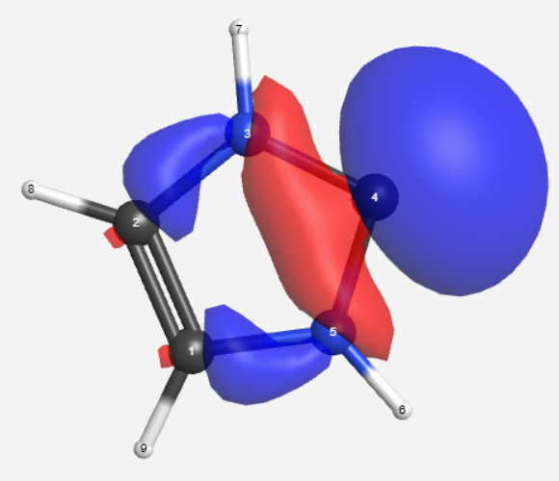

**Fig 12.:** The HOMO of the nNHC Tautomer.

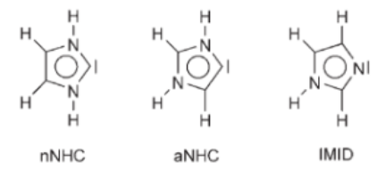

**Fig 11.:** The three Tautomer’s of N-heterocyclic Carbene (NHC).

Figure 12 shows the HOMO of the aNHC Tautomer. The nucleophilic character of the molecule is shown in the lone pair present in the *‘peak’* C atom in the ring similar to the nNHC Tautomer. The orbitals are the result of interference between the two N atoms’ p atomic orbital and the *‘peak’* C atom’s s atomic orbital.

Figure 13 shows the HOMO of the aNHC Tautomer. The Nucleophilic character of the molecule is shown in the lone pair present in the *‘peak’* C atom in the ring similar to the nNHC Tautomer. The orbitals are the result of interference between the two N atoms’ p atomic orbital and the *‘peak’* C atom’s s atomic orbital.

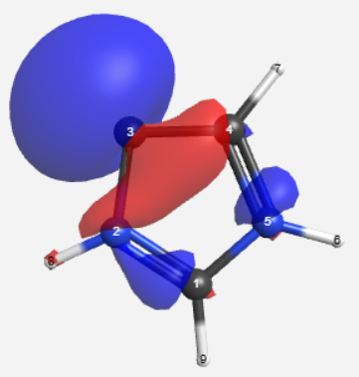

**Fig 13.:** The HOMO of the aNHC Tautomer.

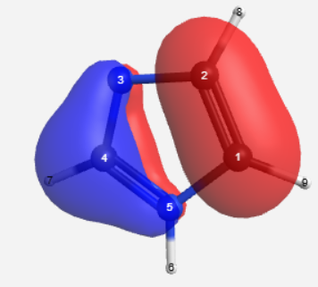

**Fig 14:** The HOMO of the IMID Tautomer.

Figure 14 shows the HOMO of the IMID Tautomer. The molecular orbital is shown to have a node between two, p molecular orbitals.

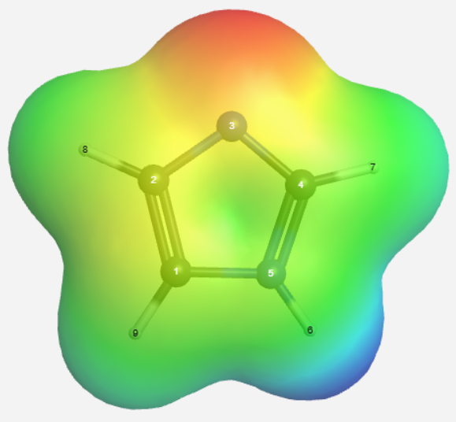

**Fig 15.:** The Electrostatic Potential of the IMID Tautomer.

The Electrostatic Potential of the IMID Tautomer of nNHC shown in Figure 15 visualises the theoretical spread of the electrons present in the molecule using a gradual shift from Red, being high density of electrons, to Blue, being the inverse.

Using the Molecular Orbital calculation on a lone Carbon atom the following orbitals were produced. (**Fig 1** & **Fig 3**) The calculated orbitals follow the expected shapes as seen in literature (**Fig 2** & **Fig 4.**). The calculations on the lone carbon were carried out to ensure accuracy in the WebMO program and show that it functions for simple MOs.

The nucleophilic character of the HOMO is shown in the visualisation obtained by the MO calculation of CO (**Fig 5.**) The nucleophilic characteristic of CO is shown through the large blue sphere, representing the lone pair present on the C atom. This shows that CO is a sigma donor[7] on the Carbon atom, this is expected as CO is commonly used as a ligand in organometallic chemistry[8] with the C atom forming a sigma bond[9] with the metal centre. In the same CO molecule, the electrophilic nature of the LUMO is shown by the 3p shape of the LUMO itself (**Fig 6.**). This electrophilic character explains how CO can also be used as a π donor[10] in organometallic chemistry. As a π-donor the CO molecule donates electrons to bind to the metal perpendicular to its present triple bond.

The Electrophilic character of chloromethane and it’s receptibility to Sn2[11] reactions is shown by the calculated LUMO (**Fig 7.**). The molecule has a large empty orbital on the carbon opposite the chlorine; this is where a potential nucleophile can attack. This attack results in a transition state where both the chlorine and the electrophile are bonded to the methyl group. The state is short lived however as the electrons in C-Cl bond are returned to their initial atoms. The formula for the general Sn2  reaction of CH3Cl is shown as:

The HOMO of ethylene shows that it has nucleophilic properties and is readily accessible to an electrophilic reaction (**Fig 8.**). Whereas both the HOMO (**Fig 9.**) and HOMO-1 (**Fig 10.**) of Benzene show that the aromaticity of the ring protects the molecule from a direct electrophilic reaction and is thus less reactive than the Ethylene.

The HOMO of both the nNHC (**Fig 12.**) and aNHC (**Fig 13.**) tautomer distinctly show the presence of the lone pair of the *‘peak’* Carbon atom. The lone pair is shown to be in an s atomic orbital of the referenced Carbon. However, in the IMID tautomer (**Fig 14**), the HOMO shows a distinct node separating the N-C=N side of the molecule from the C=C side. This is the result of constructive interference in the p atomic orbitals of the double bonded carbons, and the p atomic orbitals of the N-C=N atoms forming two separate, and distinct p molecular orbitals. The structure of the HOMO shows that the IMID tautomer has π-acceptor characteristics.

**Conclusion:**

WebMO was used to understand Electronic Structure and the *‘Molecular Orbital’*, *‘Natural Bond Orders’*, *‘Bond Orders’*, calculations including wait times and functions. Working through the program also furthered understanding of how WebMO is designed and how to extract the calculated data from the program.

**References: (IEEE)**

[1] D. Wilson, *Quantum Chemistry, Section 8: ’Molecular Orbitals, Natural Bond Orbitals, Electron Density’*. La Trobe University.

[2] J. McMurry, *Organic Chemistry* 9th edition. Cengage Learning.

[3] M. J. Winter. ‘1s atomic orbital’, *The Orbitron*. Accessed: Sep 02, 2025. [Online] Available: <https://winter.group.shef.ac.uk/orbitron/atomic_orbitals/1s/index.html>

[4] M. J. Winter. ‘2p atomic orbital’, *The Orbitron*. Accessed: Sep 02, 2025. [Online] Available: <https://winter.group.shef.ac.uk/orbitron/atomic_orbitals/2p/index.html>

Variations in Density Functional Theory Methods and Basis Sets.

1. *That is the characteristic for the readiness for a chemical species donate an electron pair to form a bond.*
2. *That is the characteristic for the readiness of a chemical species to receive an electron pair to form a bond.*
3. *Lewis Structures are diagrams that show lone pairs, geometry, and formal charges of molecules.*
4. S*tructural isomers that readily interconvert.*
5. *Electrons are of course always negative, the ‘positivity’ and ‘negativity’ of the orbitals is related to the algebraic solutions of the corresponding wave functions.*
6. *Hybridisation only exists as a model to help understand molecular geometry and bonding, not as a thing in the ‘real’ world.*
7. *A chemical species willing to donate a pair of electrons to the sigma orbital of a separate species. A metal in Organometallic Chemistry.*
8. *A chemical species willing to donate a pair of electrons to a metal centre.*
9. *The sharing of an electron pair between two sigma orbitals.*
10. *A chemical species willing to donate a pair of electrons to the pi orbital of a separate species.*
11. *A Substitution chemical reaction involving the nucleophilic attack of an electrophile.*