Use Case Diagram

Assignment

Using the provided template, create a series of use cases appropriate to your project for this month.
Then create a use case diagram illustrating the main use cases and any actors involved in those processes. Evaluate your use cases, perform the necessary research, and test your solutions as needed.

Grading Breakdown

First use case | 20%
Second use case | 20%
Third use case | 20%
Use case diagram | 20%
Evaluation | 20%

Use Case 1: Create a New Habit
Actor: User Goal: Add a new habit to track (e.g., “Meditate for 10 minutes”)
Flow:
- User selects “Add Habit” from the dashboard.
- System prompts for habit name, frequency, and goal type.
- User enters details and confirms.
- System stores the new habit and integrates it into the tracking system.
- Dashboard updates to include the new habit in visualizations and feedback loops.
Postconditions:
- Habit is saved and ready for daily logging.
- Visual and sound feedback systems are linked to the new habit.

Use Case 2: Review Habit History
Actor: User Goal: View historical data and trends for a specific habit
Flow:
- User selects a habit from the dashboard.
- System displays a timeline graph showing completion streaks, missed days, and overall consistency.
- User can filter by week, month, or custom date range.
- System overlays motivational milestones (e.g., “Longest streak: 14 days”).
Postconditions:
- User gains insight into their performance.
- Data is used to inform future suggestions and feedback.

Use Case 3: Receive Motivational Challenge
Actor: System (initiated by user interaction or inactivity) Goal: Encourage user engagement through a personalized challenge
Flow:
- System detects a drop in habit consistency or user inactivity.
- It generates a motivational challenge (e.g., “Complete 3 habits daily for the next 5 days to unlock a new visual upgrade”).
- User accepts or declines the challenge.
- If accepted, system tracks progress and provides enhanced feedback.
- Upon completion, system rewards user with a visual upgrade (e.g., new tree in garden, badge, sound effect).
Postconditions:
- User re-engages with the dashboard.
- System reinforces positive behavior through gamification.

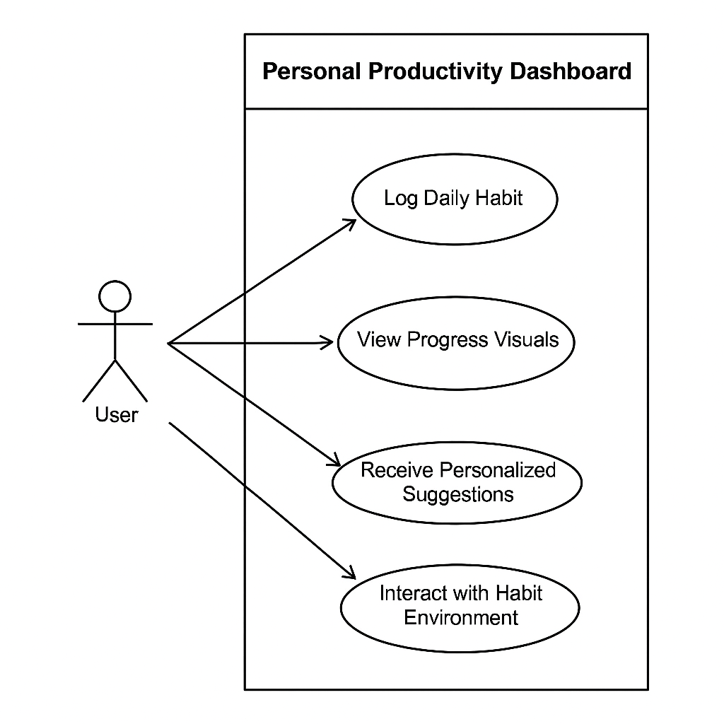

- Actor: User
- Use Cases:
  - Create New Habit
  - Review Habit History
  - Receive Motivational Challenge
- System Boundary: Personal Productivity Dashboard
This diagram complements your earlier one and shows how your app supports deeper engagement and personalization. If you’d like, I can now help you build a class diagram or sequence diagram to show how the internal systems work together.

