Practical Project 2 Report
Course: CST8002
Student Name: Jiaxiang Yuan
Student ID: 041146063
Date: 2025-06-16

Evidence of Learning
Unit Testing
This project includes unit tests for the RecordManager class, covering add, edit, delete, and search operations. Key points:
- Unit tests are located in the tests/test_record_manager.py file, lines 5-45.
- For example, test_add_record verifies that after adding a new record, the list size increases and the data matches expected values.
- Example snippet from test_record_manager.py (lines 15-25):
def test_add_record(self):
new_record = Record("Milk", "Type2", "2020-02-01", "2020-02-28",
"Station B", "ProvinceB", "12.0", "0.2", "6.0")
self.manager.add_record(new_record)
self.assertEqual(len(self.manager.get_all_records()), 2)
self.assertEqual(self.manager.get_all_records()[1].station_name, "Station B")
These tests ensure the correctness of core data management functions.

Program Architecture
The project adopts a Layered Architecture, organized as follows:
- presentation folder contains the UI logic, e.g., main.py as the program entry point.
- business folder handles business logic, such as the RecordManager class.
- model folder contains data model classes, e.g., Record.
- persistence folder manages data persistence, including file read/write operations.
This separation aligns with MVC principles, improving maintainability and scalability.

UML Diagrams (Description)
- Package Diagram shows relationships and dependencies between layers.
- Class Diagram details class structures and attributes/methods for RecordManager and Record.
- Sequence Diagram demonstrates the flow of the “save records to file” feature, illustrating how user actions invoke business and persistence layers.
(Insert UML diagrams or screenshots here)

Program Demonstration via Screenshots
This section presents screenshots showing program features:
- Displaying records
- Adding new records
- Editing existing records
- Deleting records
- Reloading and saving records
All screenshots include my full name Jiaxiang Yuan for verification.
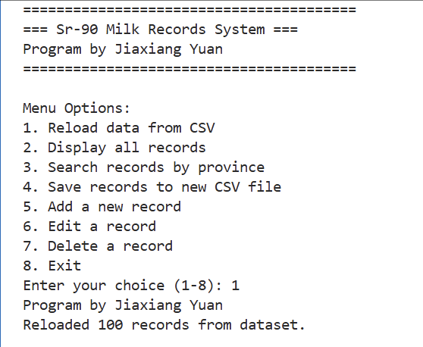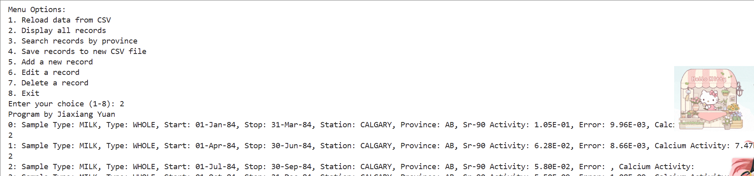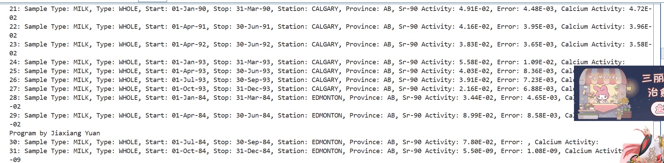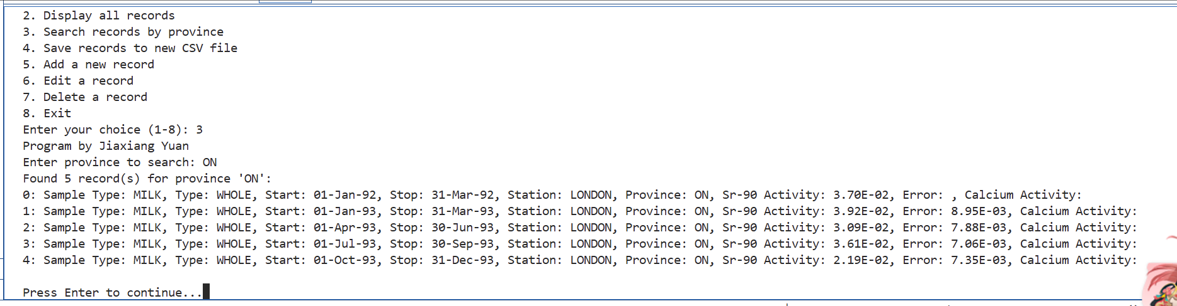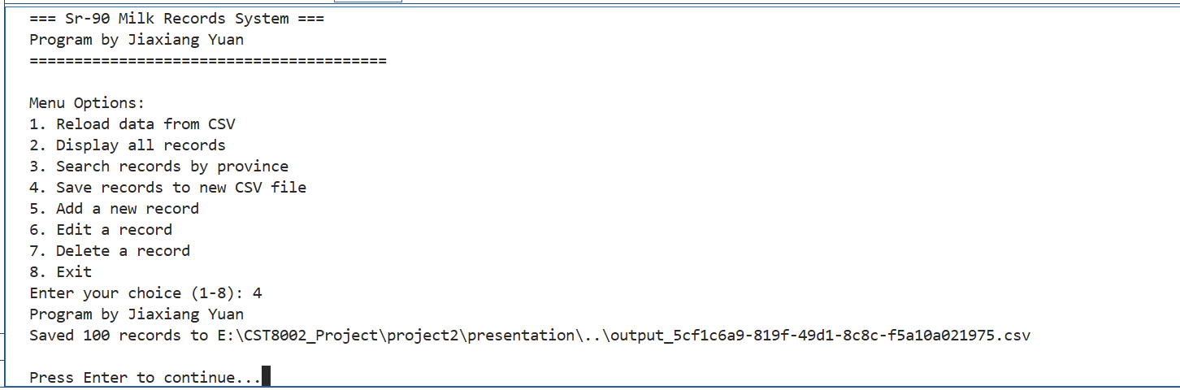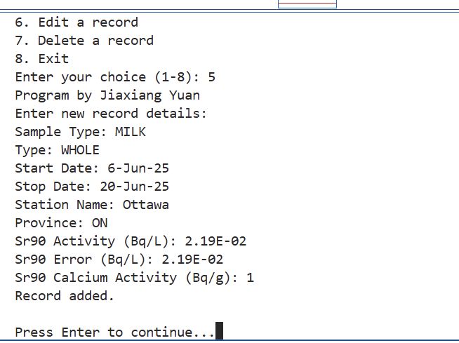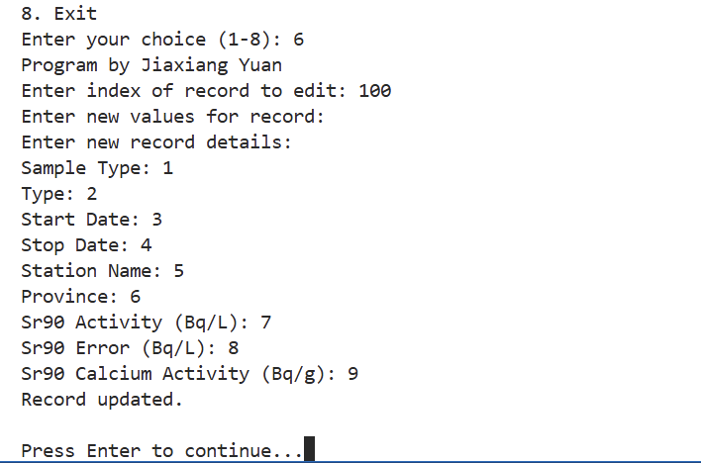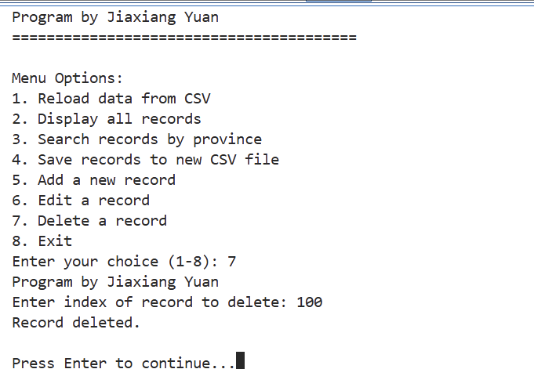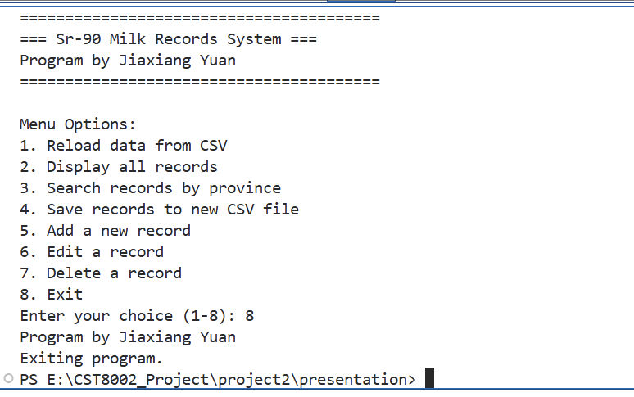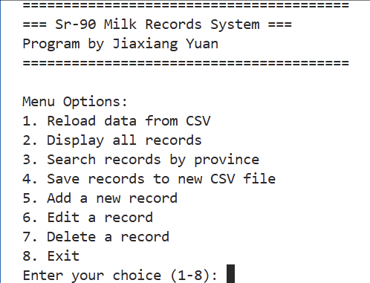
Unit Testing Demonstration via Screenshots

The following screenshot displays the unit test run results, showing all tests passing within the unittest framework, including my full name Jiaxiang Yuan.
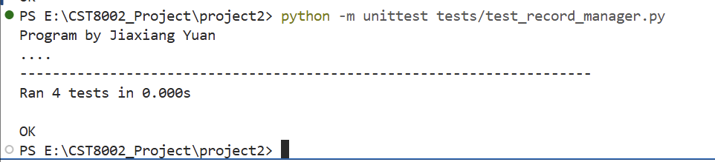

Source Code Commenting Examples

model/record.py
"""
model/record.py
Defines the Record data model for Sr-90 Milk dataset.
Program by Jiaxiang Yuan
"""
class Record:
"""
Data Transfer Object for Sr-90 milk record.
"""
def __init__(self, sample_type, type_, start_date, stop_date,
station_name, province, sr90_activity,
sr90_error, sr90_calcium_activity):
self.sample_type = sample_type
self.type_ = type_
self.start_date = start_date
self.stop_date = stop_date
self.station_name = station_name
self.province = province
self.sr90_activity = sr90_activity
self.sr90_error = sr90_error
self.sr90_calcium_activity = sr90_calcium_activity
def __str__(self):
"""
String representation of a Record object for display.
"""
return (f"Sample Type: {self.sample_type}, Type: {self.type_}, "
f"Start: {self.start_date}, Stop: {self.stop_date}, "
f"Station: {self.station_name}, Province: {self.province}, "
f"Sr-90 Activity: {self.sr90_activity}, Error: {self.sr90_error}, "
f"Calcium Activity: {self.sr90_calcium_activity}")

persistence/file_handler.py
"""
persistence/file_handler.py
Handles file input/output for Sr-90 Milk Records.
Program by Jiaxiang Yuan
"""
import csv
import uuid
from model.record import Record
def load_records_from_csv(file_path, max_records=100):
"""
Load records from CSV file, up to max_records, using latin-1 encoding.
Returns a list of Record objects.
"""
records = []
try:
with open(file_path, newline='', encoding='latin-1') as csvfile:
reader = csv.DictReader(csvfile)
for i, row in enumerate(reader):
if i >= max_records:
break
record = Record(
sample_type=row.get("Sample Type/ Type d'échantillon", "").strip(),
type_=row.get("Type", "").strip(),
start_date=row.get("Start Date/ Date de Début", "").strip(),
stop_date=row.get("Stop Date/ Date de Fin", "").strip(),
station_name=row.get("Station Name/ Nom de Station", "").strip(),
province=row.get("Province", "").strip(),
sr90_activity=row.get("Sr90 Activity/ Activité (Bq/L)", "").strip(),
sr90_error=row.get("Sr90 Error/ Erreur (Bq/L)", "").strip(),
sr90_calcium_activity=row.get("Sr90 Activity/Calcium / Activité/Calcium (Bq/g)", "").strip()
)
records.append(record)
except FileNotFoundError:
print(f"File not found: {file_path}")
except Exception as e:
print(f"Error reading file: {e}")
return records
def save_records_to_csv(file_path, records):
"""
Save list of Record objects to CSV file with UTF-8 encoding.
"""
try:
with open(file_path, 'w', newline='', encoding='utf-8') as csvfile:
fieldnames = [
"Sample Type/ Type d'échantillon",
"Type",
"Start Date/ Date de Début",
"Stop Date/ Date de Fin",
"Station Name/ Nom de Station",
"Province",
"Sr90 Activity/ Activité (Bq/L)",
"Sr90 Error/ Erreur (Bq/L)",
"Sr90 Activity/Calcium / Activité/Calcium (Bq/g)"
]
writer = csv.DictWriter(csvfile, fieldnames=fieldnames)
writer.writeheader()
for r in records:
writer.writerow({
"Sample Type/ Type d'échantillon": r.sample_type,
"Type": r.type_,
"Start Date/ Date de Début": r.start_date,
"Stop Date/ Date de Fin": r.stop_date,
"Station Name/ Nom de Station": r.station_name,
"Province": r.province,
"Sr90 Activity/ Activité (Bq/L)": r.sr90_activity,
"Sr90 Error/ Erreur (Bq/L)": r.sr90_error,
"Sr90 Activity/Calcium / Activité/Calcium (Bq/g)": r.sr90_calcium_activity
})
print(f"Saved {len(records)} records to {file_path}")
except Exception as e:
print(f"Error saving file: {e}")
def generate_uuid_filename():
"""
Generate a unique filename using UUID.
"""
return f"output_{uuid.uuid4()}.csv"

business/record_manager.py
"""
business/record_manager.py
Business logic for managing Sr-90 milk records in-memory.
Program by Jiaxiang Yuan
"""
from model.record import Record
class RecordManager:
"""
Manages a collection (list) of Record objects with CRUD operations.
"""
def __init__(self):
self.records = []
def load_records(self, records_list):
"""
Replace current records with a new list of Record objects.
"""
self.records = records_list
def get_all_records(self):
"""
Return the list of all records.
"""
return self.records
def find_records_by_province(self, province):
"""
Find and return all records matching a given province (case-insensitive).
"""
return [r for r in self.records if r.province.lower() == province.lower()]
def add_record(self, record):
"""
Add a new Record object to the collection.
"""
self.records.append(record)
def edit_record(self, index, new_record):
"""
Replace the Record at given index with new_record.
Returns True if successful, False if index out of range.
"""
if 0 <= index < len(self.records):
self.records[index] = new_record
return True
else:
return False
def delete_record(self, index):
"""
Delete the Record at given index.
Returns True if successful, False if index out of range.
"""
if 0 <= index < len(self.records):
del self.records[index]
return True
else:
return False

presentation/main.py
"""
presentation/main.py
Console UI for Sr-90 Milk Records System.
Program by Jiaxiang Yuan
"""
import os
import sys
# Adjust import paths if needed (if you run from project root)
sys.path.append(os.path.abspath(os.path.join(os.path.dirname(__file__), '..')))
from persistence.file_handler import load_records_from_csv, save_records_to_csv, generate_uuid_filename
from business.record_manager import RecordManager
from model.record import Record
DATASET_FILE = os.path.join(os.path.dirname(__file__), '..', 'dataset', 'nms_strontium90_milk_ssn_strontium90_lait.csv')
PROGRAMMER_NAME = "Program by Jiaxiang Yuan"
def print_header():
print("=" * 40)
print(f"=== Sr-90 Milk Records System ===")
print(PROGRAMMER_NAME)
print("=" * 40)
def print_menu():
print("\nMenu Options:")
print("1. Reload data from CSV")
print("2. Display all records")
print("3. Search records by province")
print("4. Save records to new CSV file")
print("5. Add a new record")
print("6. Edit a record")
print("7. Delete a record")
print("8. Exit")
def display_records(records):
if not records:
print("No records to display.")
return
for i, r in enumerate(records):
print(f"{i}: {r}")
if (i + 1) % 10 == 0:
print(PROGRAMMER_NAME)
def input_record_data():
"""
Prompt user for record fields and return a Record object.
"""
print("Enter new record details:")
sample_type = input("Sample Type: ").strip()
type_ = input("Type: ").strip()
start_date = input("Start Date: ").strip()
stop_date = input("Stop Date: ").strip()
station_name = input("Station Name: ").strip()
province = input("Province: ").strip()
sr90_activity = input("Sr90 Activity (Bq/L): ").strip()
sr90_error = input("Sr90 Error (Bq/L): ").strip()
sr90_calcium_activity = input("Sr90 Calcium Activity (Bq/g): ").strip()
return Record(sample_type, type_, start_date, stop_date,
station_name, province, sr90_activity,
sr90_error, sr90_calcium_activity)
def main():
record_manager = RecordManager()
# Load data at startup
print_header()
print(f"Loading dataset from: {DATASET_FILE}")
records = load_records_from_csv(DATASET_FILE)
record_manager.load_records(records)
print(f"Loaded {len(records)} records.\n")
while True:
print_header()
print_menu()
choice = input("Enter your choice (1-8): ").strip()
print(PROGRAMMER_NAME)
if choice == '1':
# Reload data from CSV
records = load_records_from_csv(DATASET_FILE)
record_manager.load_records(records)
print(f"Reloaded {len(records)} records from dataset.")
elif choice == '2':
# Display all records
all_records = record_manager.get_all_records()
display_records(all_records)
elif choice == '3':
# Search by province
prov = input("Enter province to search: ").strip()
found = record_manager.find_records_by_province(prov)
print(f"Found {len(found)} record(s) for province '{prov}':")
display_records(found)
elif choice == '4':
# Save records to new CSV file
filename = generate_uuid_filename()
save_path = os.path.join(os.path.dirname(__file__), '..', filename)
save_records_to_csv(save_path, record_manager.get_all_records())
elif choice == '5':
# Add a new record
new_rec = input_record_data()
record_manager.add_record(new_rec)
print("Record added.")
elif choice == '6':
# Edit a record
idx_str = input("Enter index of record to edit: ").strip()
if idx_str.isdigit():
idx = int(idx_str)
if 0 <= idx < len(record_manager.get_all_records()):
print("Enter new values for record:")
new_rec = input_record_data()
record_manager.edit_record(idx, new_rec)
print("Record updated.")
else:
print("Index out of range.")
else:
print("Invalid index.")
elif choice == '7':
# Delete a record
idx_str = input("Enter index of record to delete: ").strip()
if idx_str.isdigit():
idx = int(idx_str)
if record_manager.delete_record(idx):
print("Record deleted.")
else:
print("Index out of range.")
else:
print("Invalid index.")
elif choice == '8':
print("Exiting program.")
break
else:
print("Invalid choice. Please select 1-8.")
input("\nPress Enter to continue...")
if __name__ == "__main__":
main()

tests/test_record_manager.py
"""
tests/test_record_manager.py
Unit test for RecordManager class.
Program by Jiaxiang Yuan
"""
import unittest
from business.record_manager import RecordManager
from model.record import Record
class TestRecordManager(unittest.TestCase):
@classmethod
def setUpClass(cls):
print("Program by Jiaxiang Yuan")
def setUp(self):
self.manager = RecordManager()
self.record1 = Record("Milk", "Type1", "2020-01-01", "2020-01-31",
"Station A", "ProvinceA", "10.5", "0.1", "5.0")
self.manager.add_record(self.record1)
def test_add_record(self):
new_record = Record("Milk", "Type2", "2020-02-01", "2020-02-28",
"Station B", "ProvinceB", "12.0", "0.2", "6.0")
self.manager.add_record(new_record)
self.assertEqual(len(self.manager.get_all_records()), 2)
self.assertEqual(self.manager.get_all_records()[1].station_name, "Station B")
def test_edit_record(self):
updated_record = Record("Milk", "Type1-Updated", "2020-01-01", "2020-01-31",
"Station A", "ProvinceA", "11.0", "0.1", "5.5")
result = self.manager.edit_record(0, updated_record)
self.assertTrue(result)
self.assertEqual(self.manager.get_all_records()[0].type_, "Type1-Updated")
def test_delete_record(self):
result = self.manager.delete_record(0)
self.assertTrue(result)
self.assertEqual(len(self.manager.get_all_records()), 0)
def test_find_records_by_province(self):
found = self.manager.find_records_by_province("ProvinceA")
self.assertEqual(len(found), 1)
found_none = self.manager.find_records_by_province("NonExistent")
self.assertEqual(len(found_none), 0)
if __name__ == "__main__":
unittest.main()

References
- [1] git-scm.com - Git Basics - Tagging
- [2] git-scm.com - Git Branching - Branches in a Nutshell
- [3] medium.com - GUID vs UUID vs ULID: Understanding Unique Identifiers
- [4] uml-diagrams.org - UML Package Diagrams Overview

