Hosting steps:

npm install -g firebase-tools

firebase login

firebase init

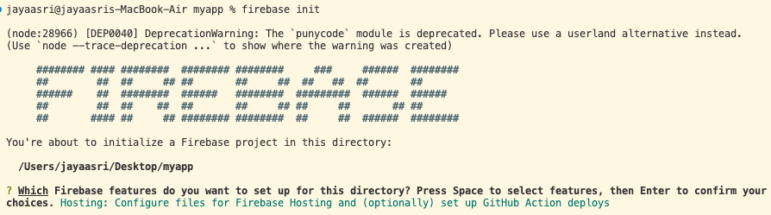

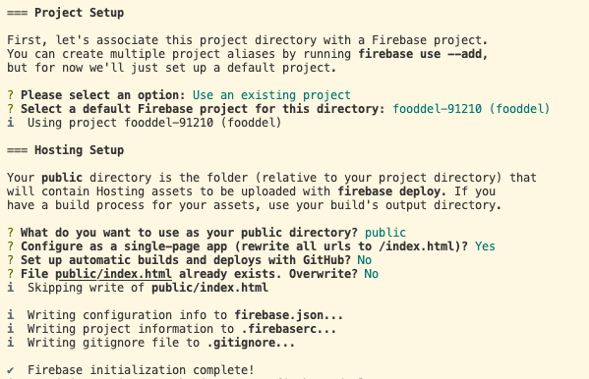

firebase deploy