LearnWise
AI-Powered Language Learning Platform

SOFTWARE DESIGN DOCUMENT
Class Diagrams · Sequence Diagrams · Activity Diagrams · State Diagrams

Document Version | 1.0
Standard | IEEE Std 1016 — Software Design Descriptions
Classification | Technical Reference – Stakeholder Presentation
Backend | FastAPI (Python 3.10) · PostgreSQL · SQLAlchemy ORM
AI / ML | Groq LLaMA-3-8B-8192 · OpenAI Whisper (on-premise)
Frontend | React 18 · Redux Toolkit · Axios · Vite
Date | April 2026

Table of Contents
1. System Context & Architecture Overview
2. Section 1 — Class Diagrams
2.1 CD-01: Backend Database Models
2.2 CD-02: Backend Core & Services
2.3 CD-03: Backend API Routers
2.4 CD-04: Frontend State Management & API
2.5 CD-05: Frontend Pages & Components
3. Section 2 — Sequence Diagrams
3.1 SD-01: User Registration Flow
3.2 SD-02: Activity Submission & AI Grading
3.3 SD-03: Speech Transcription (Whisper STT)
3.4 SD-04: Admin Create Pair & Server Startup
4. Section 3 — Activity Diagrams
4.1 AD-01: User Registration & Login
4.2 AD-02: Dashboard Load & Render
4.3 AD-03: Activity Execution General Flow
4.4 AD-04: STT Recording Flow
4.5 AD-05: Progress Advancement & XP Unlock
5. Section 4 — State Diagrams
5.1 SM-01: User Account Lifecycle
5.2 SM-02: JWT Token Lifecycle
5.3 SM-03: UserLanguageProgress Curriculum
5.4 SM-04: ActivityCompletion & Activity Page
5.5 SM-05: Service Layer State Machines

1. System Context & Architecture Overview
LearnWise is a full-stack AI-powered language learning platform. Learners progress through a hierarchical curriculum: Language Pair → Month → Block → Activity. Each block contains 8 distinct activity types. Open-ended activities (writing, speaking, pronunciation, reading, vocabulary, lesson) are graded in real-time by the Groq LLaMA-3 API. Multiple-choice activities use a deterministic local scoring engine. Audio activities are transcribed using an on-premise OpenAI Whisper model. All progression data is persisted to PostgreSQL, with XP accumulation and social leaderboards driving engagement.

Architecture Overview
Browser (React 18 + Redux Toolkit + Axios + Vite)
↕ HTTPS / REST JSON API
FastAPI Backend (Uvicorn · Python 3.10)
├── Routers: Auth · Users · Progress · Validate · Speech
│ Leaderboard · Friends · Admin · Content
├── Services: GroqService · WhisperService · ScoringService · ContentService
└── Core: Security (JWT+bcrypt) · Database (SQLAlchemy) · Config · Dependencies
↕ SQLAlchemy ORM
PostgreSQL Database
↕ External HTTP / Local Process
Groq Cloud API (LLaMA-3-8B-8192) OpenAI Whisper (on-premise small model)

Curriculum Hierarchy: Language Pair (e.g. hi-ja) → Month (1–3) → Block (1–6) → Activity (8 types per block). Total per pair: 3 × 6 × 8 = 144 activities, each addressed by a unique activity_seq_id (1–144).

Section 1 — Class Diagrams
Class diagrams document the static structure of the LearnWise platform following UML 2.5 notation. Each diagram shows classes with their attributes (typed and constrained), methods, stereotypes, and inter-class associations with multiplicities. Layers are organized from database models through to frontend components.

CD-01 — Backend Database Models Layer
SQLAlchemy ORM classes mapped to PostgreSQL tables: users, user_language_progress, activity_completions, friend_requests. Shows all foreign key relationships, cascade rules, and unique constraints.
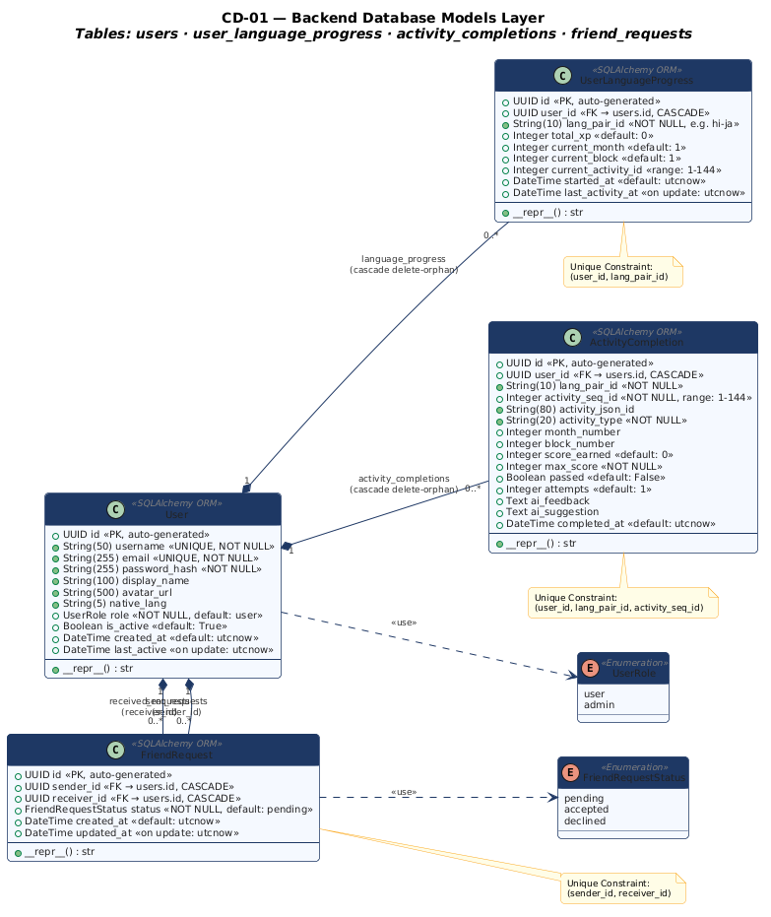

CD-02 — Backend Core & Services Layer
Configuration singleton (Settings), database session factory (Database), authentication utilities (Security, Dependencies), and all four service classes (ScoringService, GroqService, WhisperService, ContentService) with their dependencies.
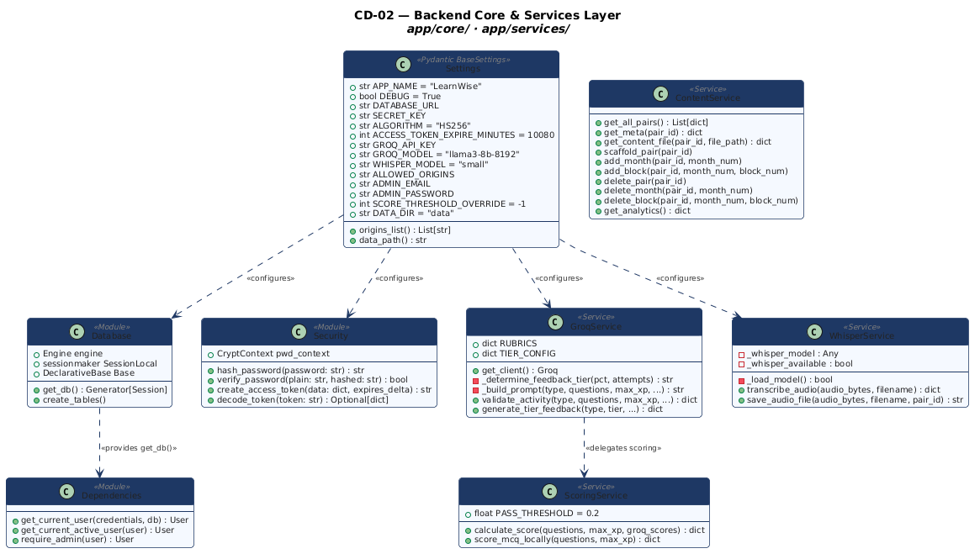

CD-03 — Backend API Routers Layer
All eight FastAPI routers registered under the /api prefix. Each router shows its URL prefix, authentication dependencies, and complete endpoint signatures with parameter and return types.
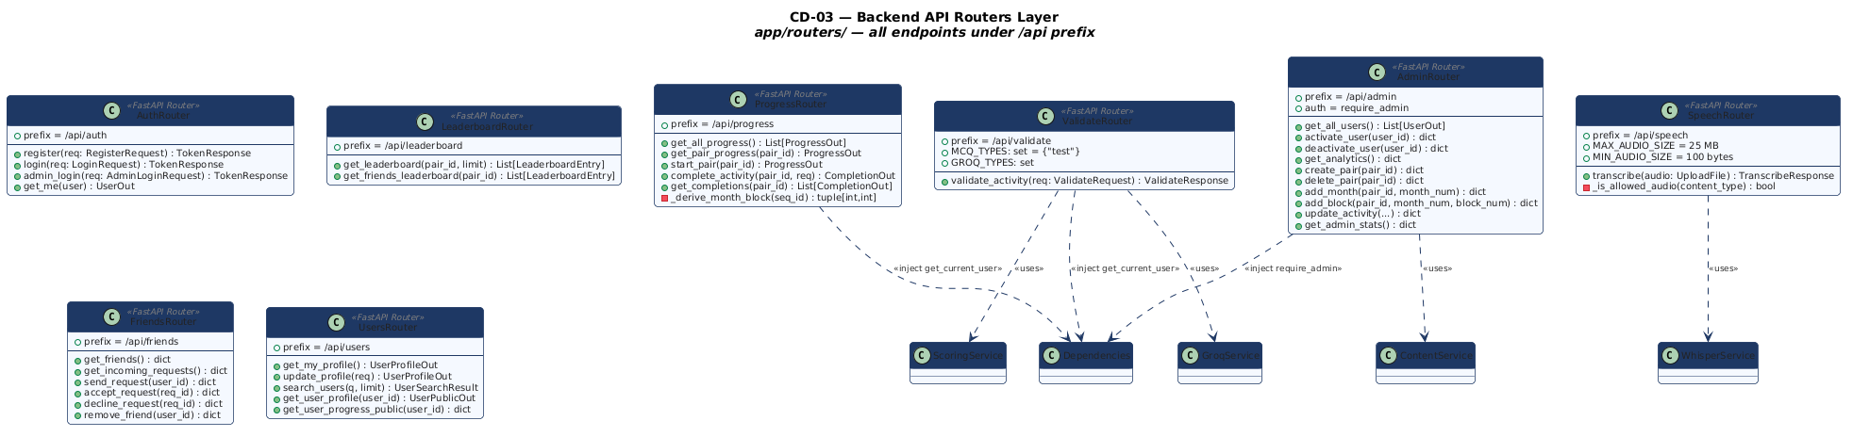

CD-04 — Frontend State Management & API Client Layer
Redux Toolkit slices (authSlice, progressSlice, UISlice) with their state shapes, synchronous reducers, and async thunks. Axios client instance with request/response interceptors and all four API module classes.
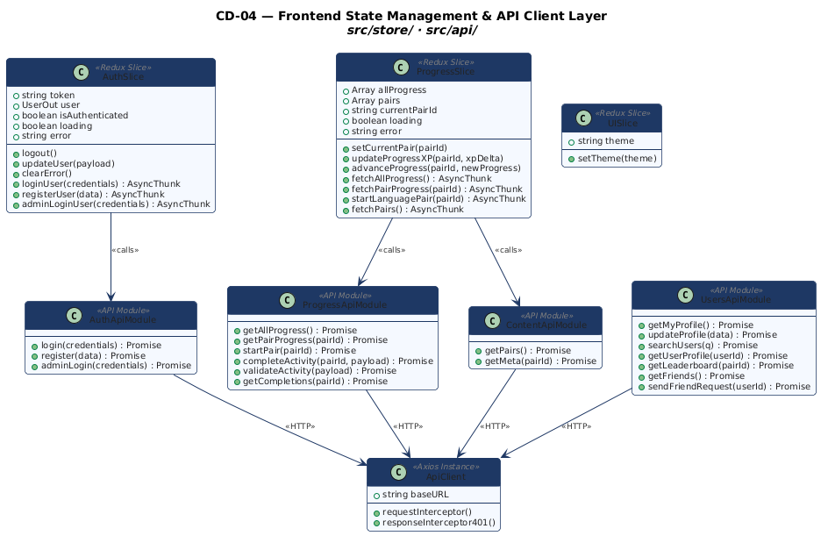

CD-05 — Frontend Pages & Components Layer
React component hierarchy from App router through ProtectedRoute/AdminRoute guards, DashboardPage, ActivityRouter, all eight activity pages, and shared UI components (ScoreModal, AudioRecorder, AudioPlayer).
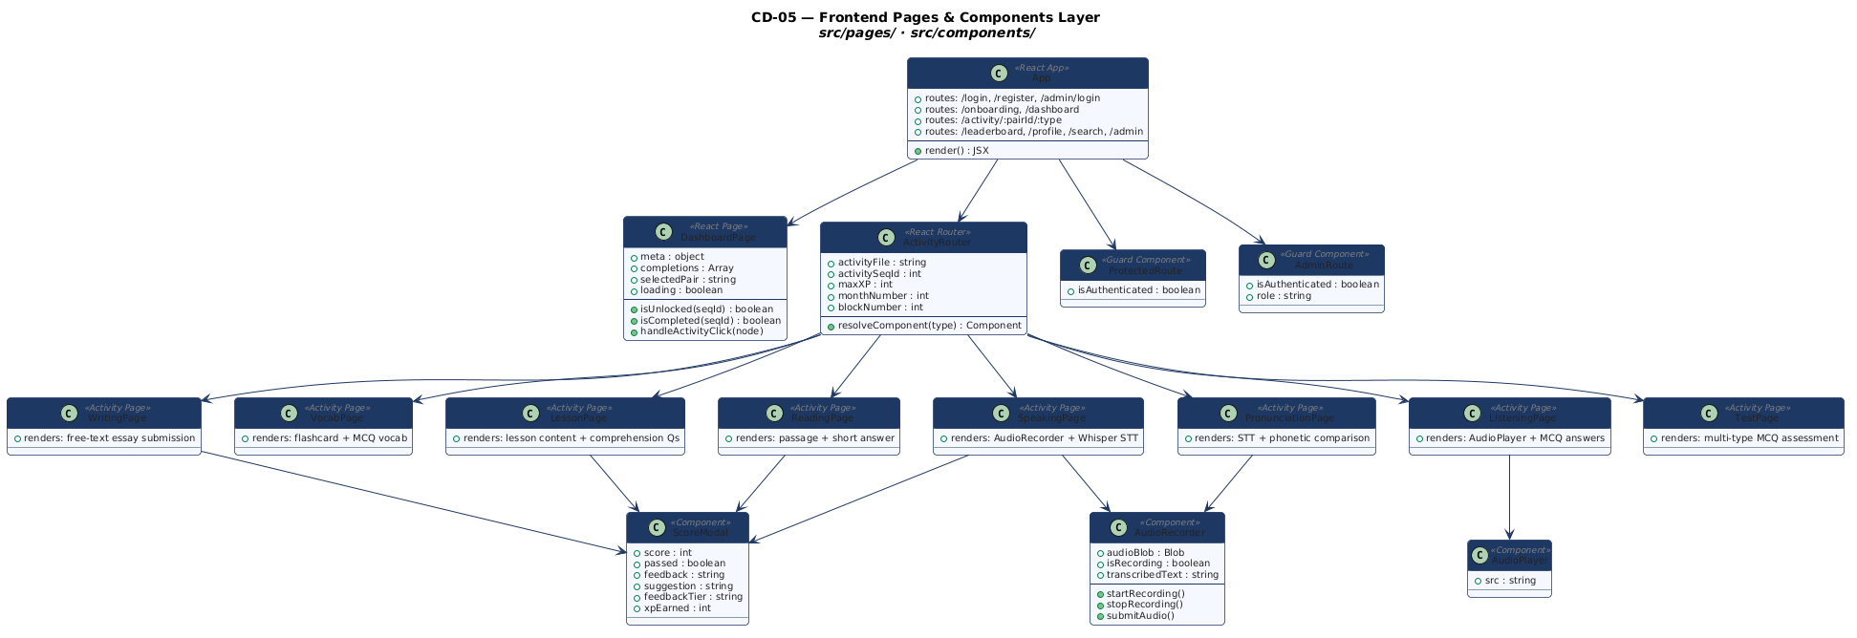

Section 2 — Sequence Diagrams
Sequence diagrams document time-ordered message exchanges between actors and system components. Each diagram specifies all participants (lifelines), synchronous and asynchronous messages, return values, alt/else conditional frames, opt optional frames, par parallel frames, and loop frames.

SD-01 — User Registration Flow
Complete message sequence from form submission through Pydantic schema validation, duplicate detection, bcrypt hashing, database insertion, JWT issuance, and Redux state hydration ending with navigation to /dashboard.
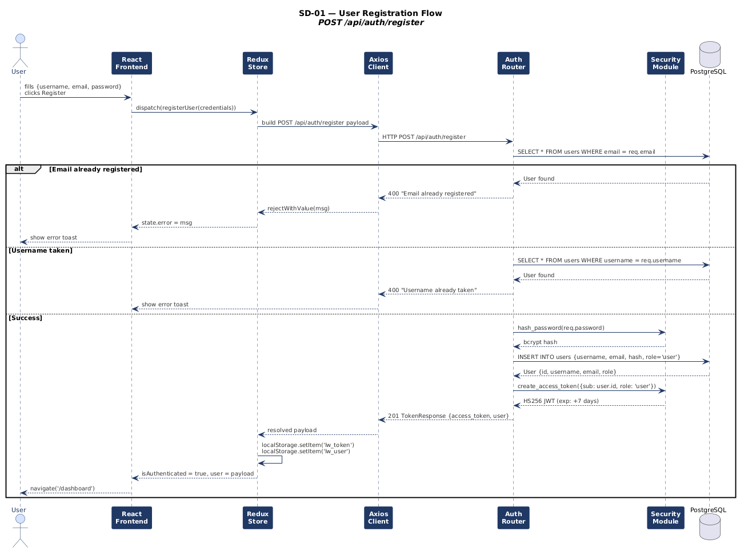

SD-02 — Activity Submission, AI Grading & Progress Recording
Full pipeline from Submit click through MCQ/Groq branching, LLaMA-3 API call, ScoringService calculation, feedback tier determination, optional second Groq call, SCORE_THRESHOLD_OVERRIDE application, and completion recording with XP and activity unlock logic.
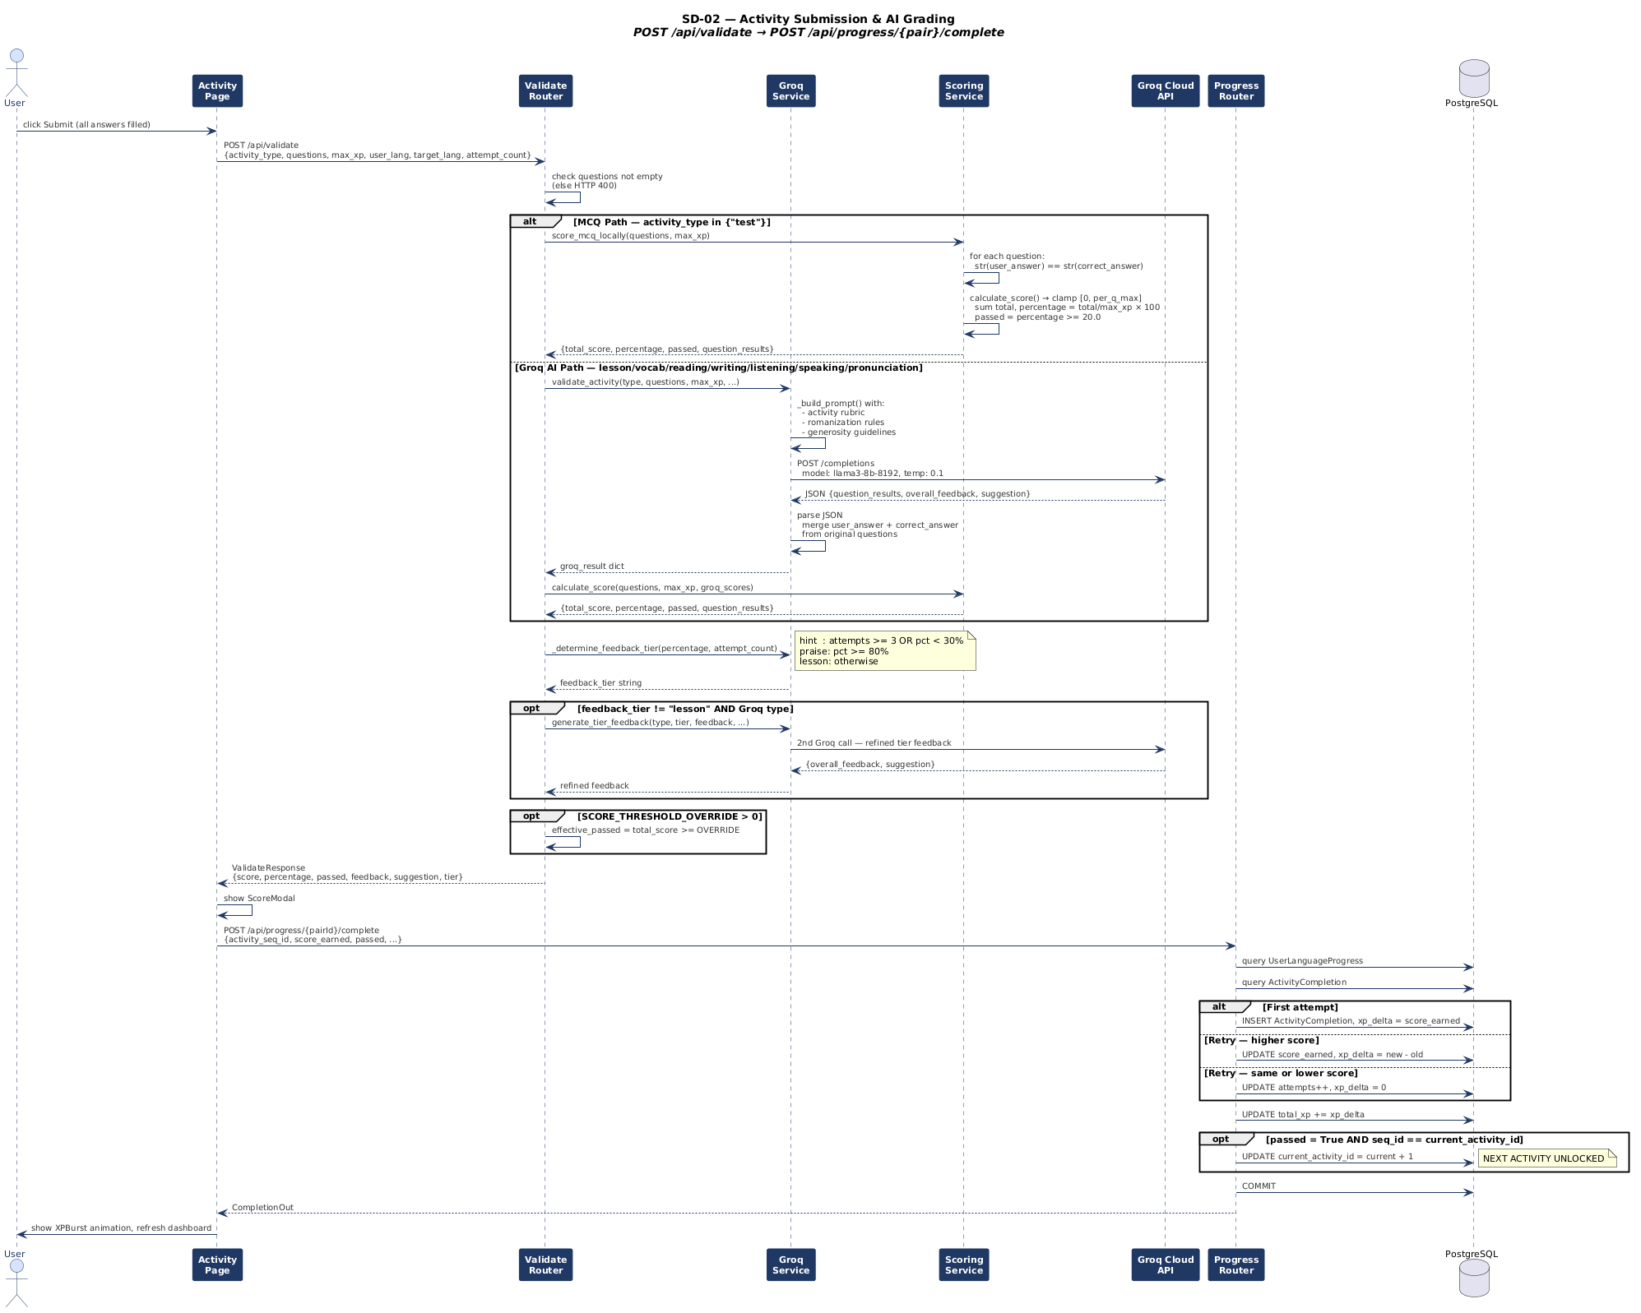

SD-03 — Speech Transcription — Whisper STT Pipeline
Complete audio-to-text sequence: MediaRecorder capture, blob assembly, multipart POST, MIME and size validation in SpeechRouter, lazy Whisper model loading, ffmpeg transcoding to 16kHz WAV, Whisper inference, and the is_mock=True fallback path for graceful degradation.
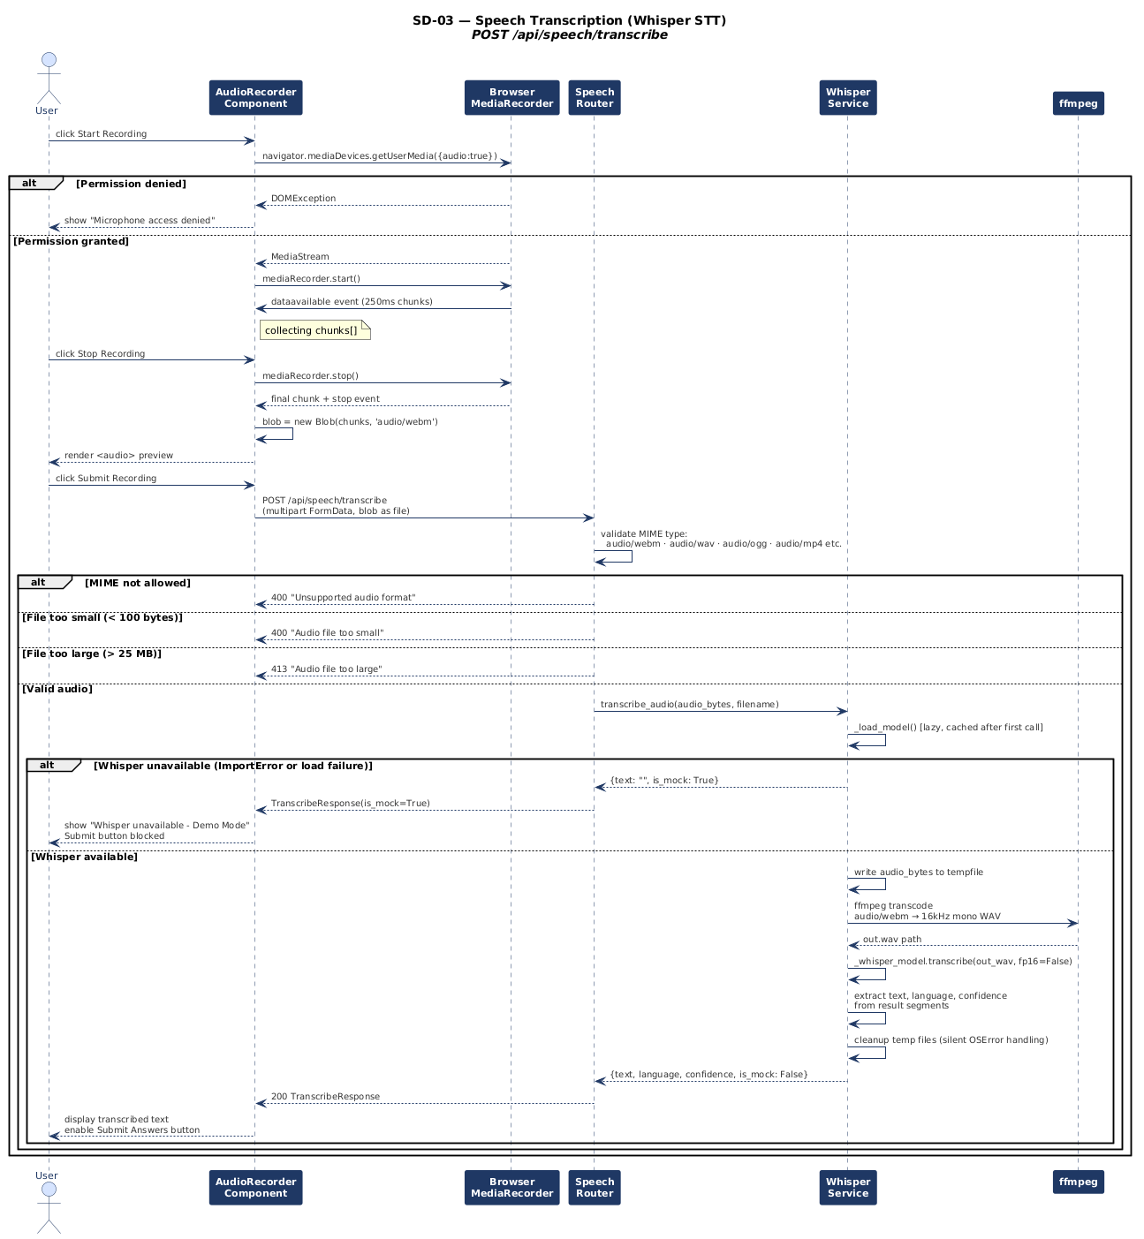

SD-04 — Admin: Create Language Pair & Server Startup Initialization
Two flows: (1) Admin scaffolding a complete language pair curriculum (144 JSON files) via ContentService. (2) Uvicorn lifespan startup sequence: table creation, admin seeding, upload directory, CORS middleware, static mounts, and router registration.
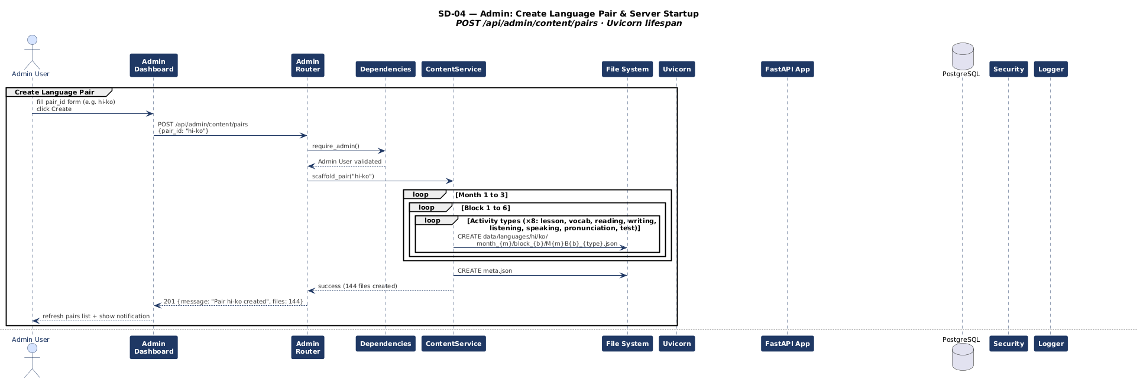

Section 3 — Activity Diagrams
Activity diagrams use swimlanes to show which actor or system component is responsible for each action. Decision nodes (diamonds) show guard conditions. Fork/join nodes show parallel execution. Each diagram covers a complete user journey from start to end node.

AD-01 — User Registration & Login Activity Flow
Swimlanes: User · Frontend · Backend · Database. Full flow including client-side validation, Pydantic schema validation, email/username uniqueness checks, bcrypt hashing, JWT issuance and localStorage persistence.
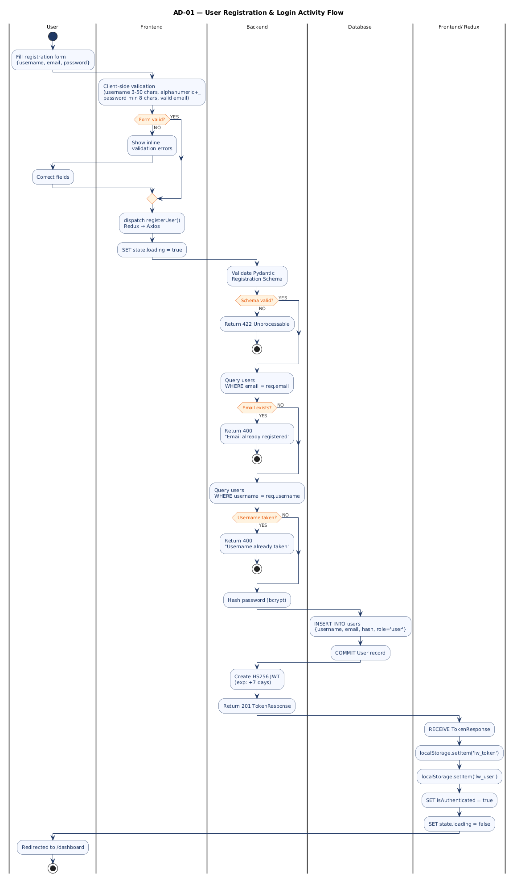

AD-02 — Dashboard Load & Activity Roadmap Render
Swimlanes: User · DashboardPage · Redux Store · Backend · File System. Parallel fetch of progress and pairs, followed by sequential meta and completions fetches, roadmap construction, and node state determination (unlocked/locked/completed).
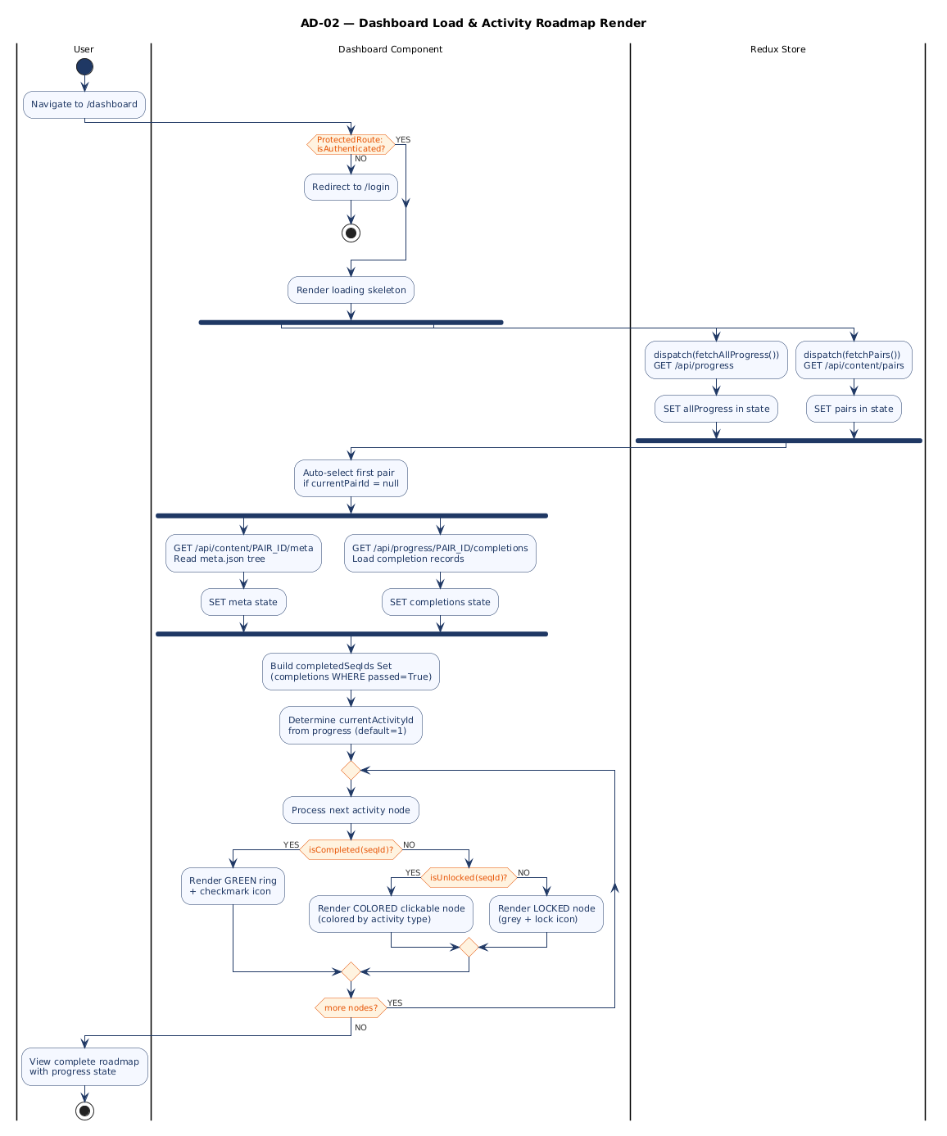

AD-03 — Activity Execution — General Flow (All Activity Types)
Swimlanes: User · Activity Page · Backend Validate · Groq Service · Scoring Service · Backend Progress · Database. MCQ vs Groq branching, feedback tier logic, threshold override, XP delta calculation, and progression unlock mechanism.
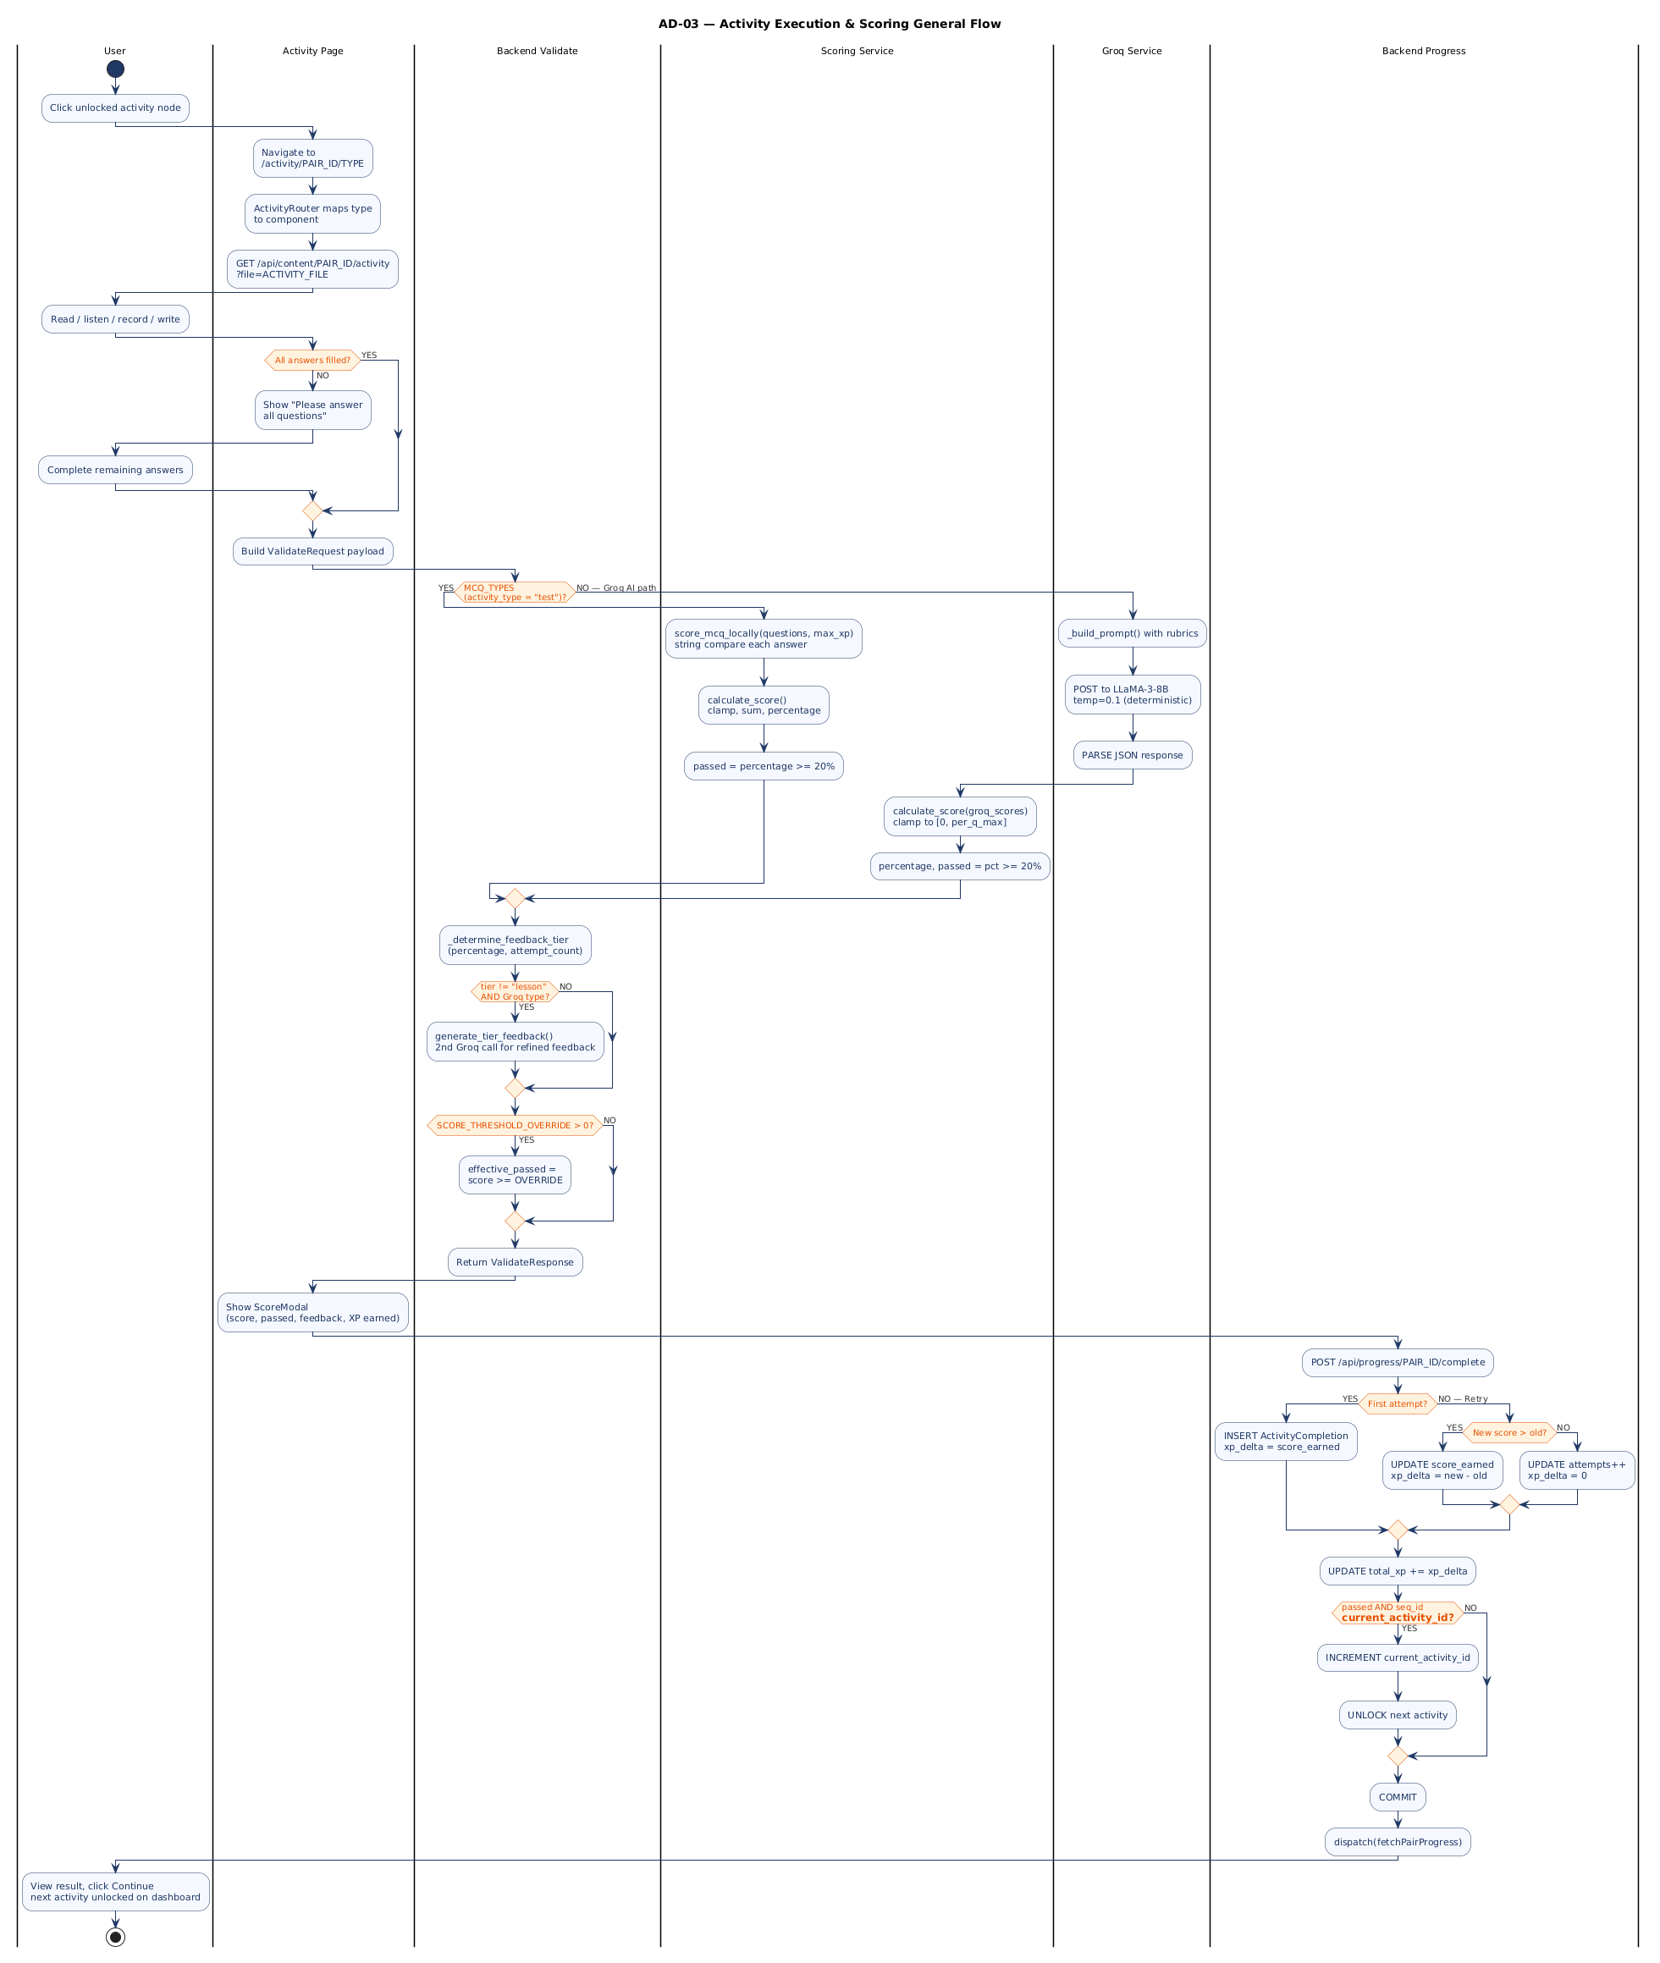

AD-04 — STT Recording Flow — Speaking & Pronunciation Activities
Swimlanes: User · AudioRecorder Component · Browser API · Backend Speech Router · Whisper Service. Full MediaRecorder lifecycle, audio blob handling, MIME/size validation, ffmpeg transcoding, Whisper inference, and is_mock fallback path.
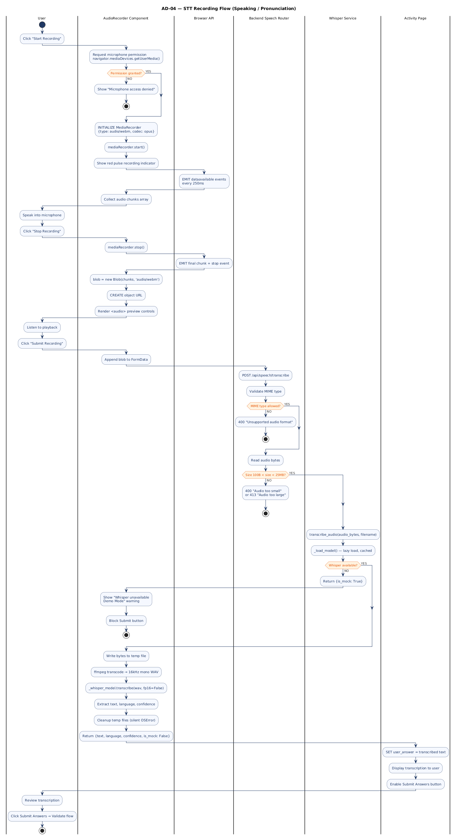

AD-05 — Progress Advancement & XP Unlock Logic
Swimlanes: Progress Router · Database. Detailed internal flow of the complete_activity endpoint: SCORE_THRESHOLD_OVERRIDE application, month/block derivation formula, first-vs-retry branching, XP delta calculation, current_activity_id increment, and commit cycle.
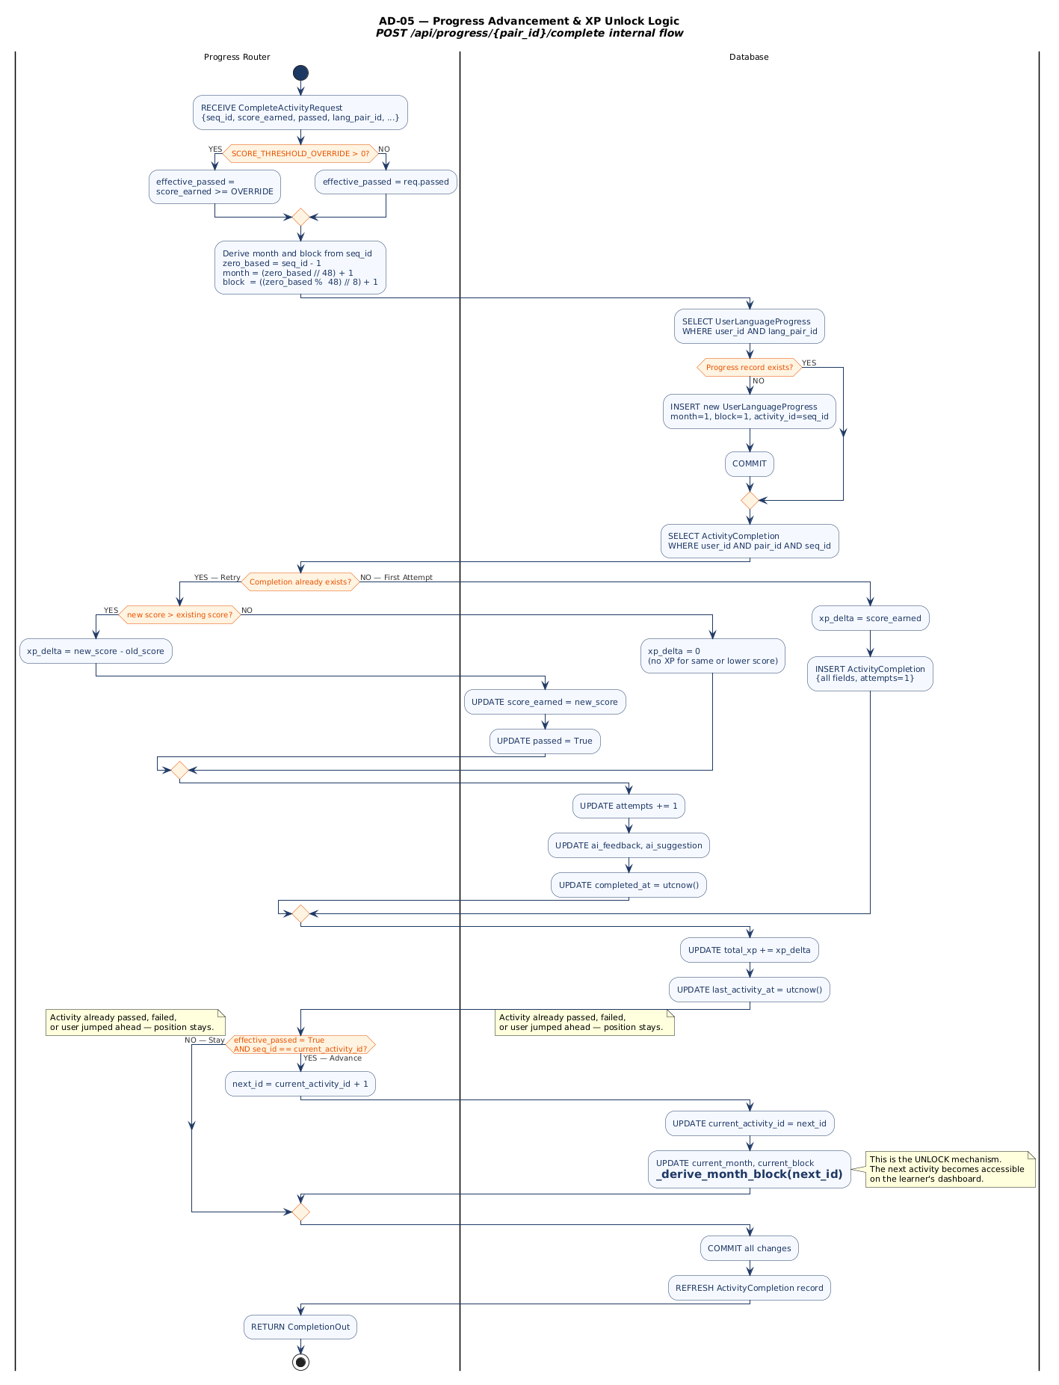

Section 4 — State Diagrams
State diagrams document every stateful entity in the platform. Each machine specifies all discrete states, entry/exit actions, transition events with guard conditions and actions, composite (nested) states, and initial/final pseudostates.

SM-01 — User Account Lifecycle
Entity: User database record. States: UNREGISTERED → REGISTERED_ACTIVE ↔ LOGGED_IN ↔ LOGGED_OUT ↔ DEACTIVATED. Covers admin activate/deactivate, JWT-based session management, and ADMIN_ROLE composite sub-state.
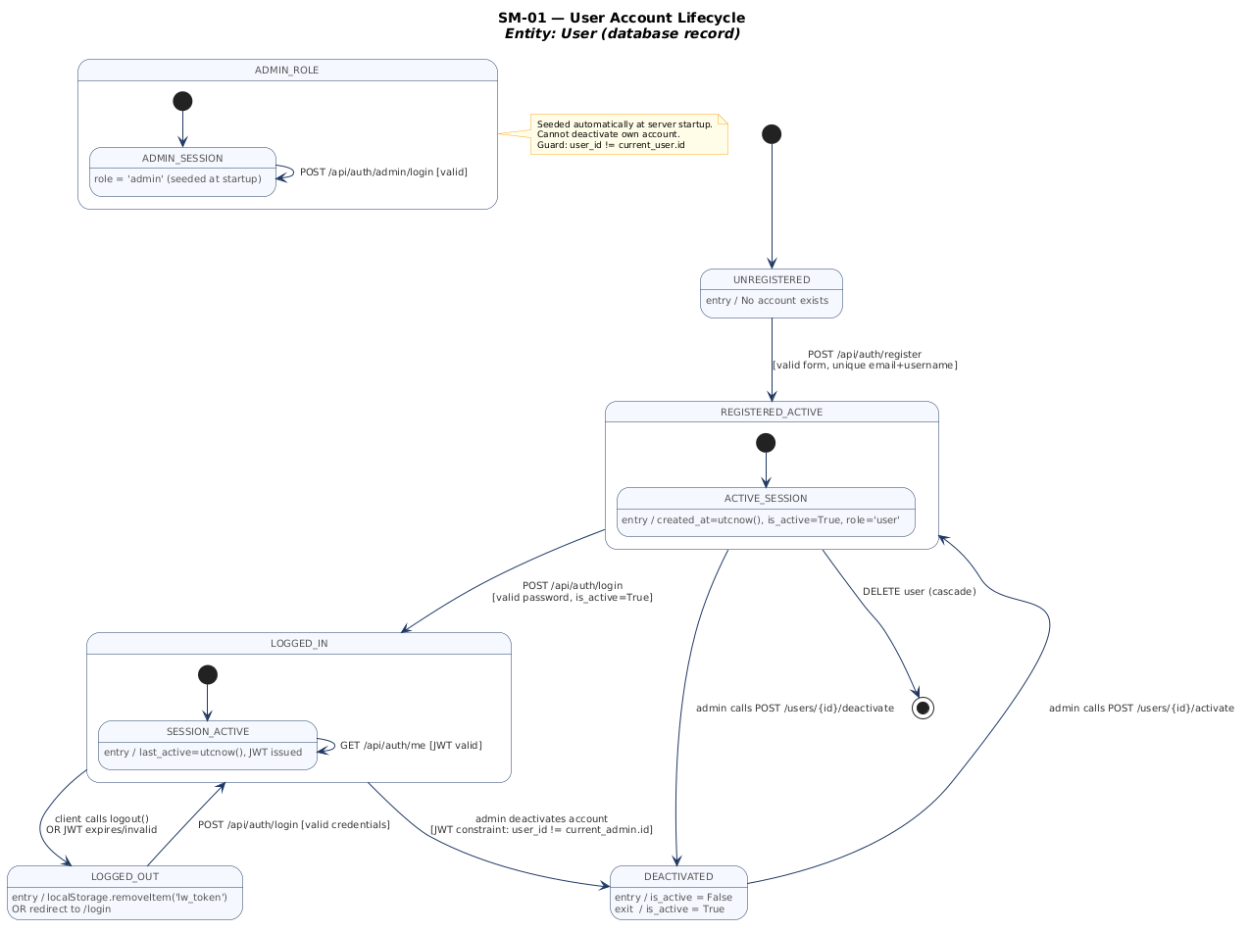

SM-02 — JWT Token Lifecycle
Entity: Bearer Token (security.py and src/api/client.js). Complete lifecycle from DOES_NOT_EXIST through ACTIVE decode states (VALID/INVALID/EXPIRED) to CLEARED with role-based redirect logic (admin → /admin/login, user → /login).
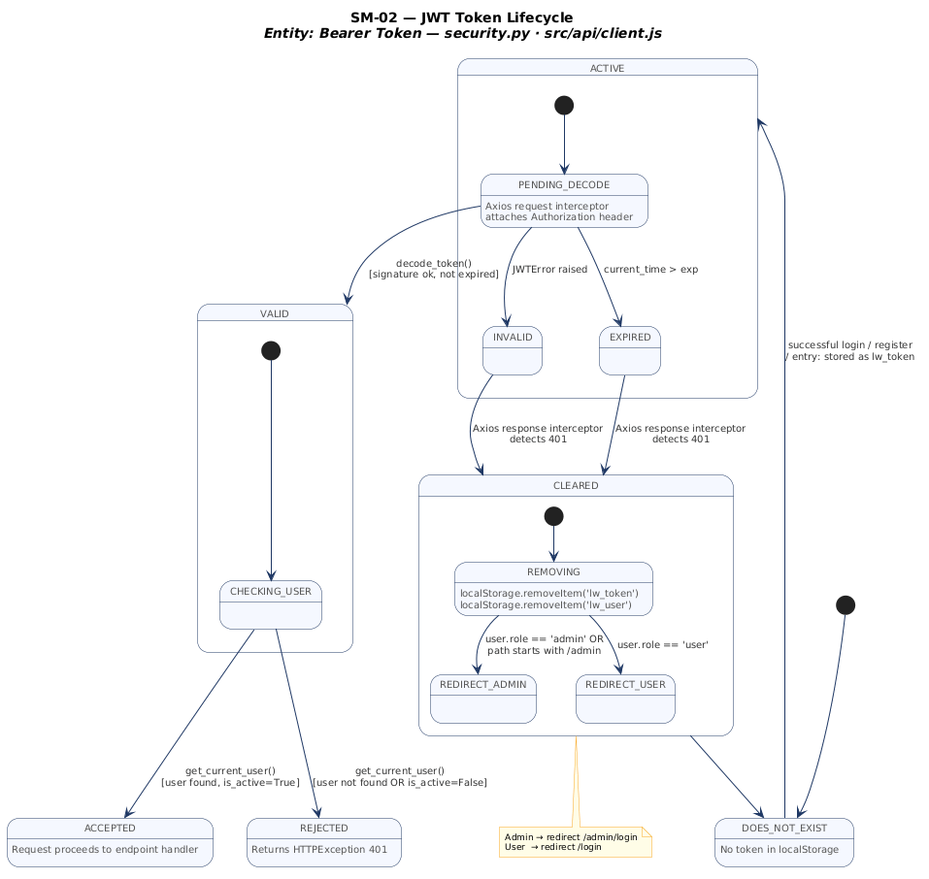

SM-03 — UserLanguageProgress — Curriculum Progression Machine
Entity: UserLanguageProgress database record. Composite states: ACTIVITY_POSITION (AT_ACTIVITY_N advancing 1→144) and XP_LEVEL (BEGINNER→INTERMEDIATE→ADVANCED). Month/block derivation formula documented in state notes.
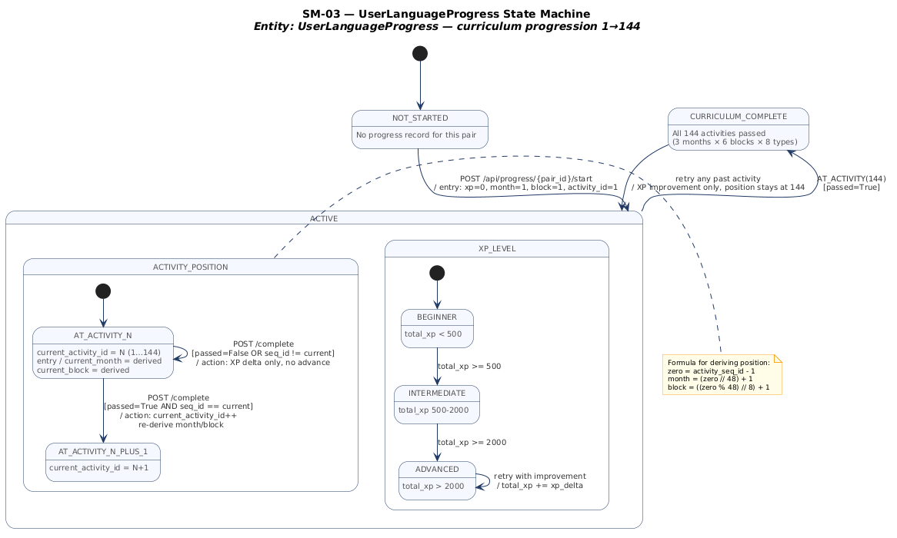

SM-04 — ActivityCompletion Record & Activity Page States
Two machines on one diagram: (1) ActivityCompletion DB record (NEVER_ATTEMPTED → ATTEMPTED → FAILED/PASSED). (2) ActivityPage React component (LOADING → CONTENT_READY → ANSWERING/RECORDING → SUBMITTING → PASSED/FAILED).
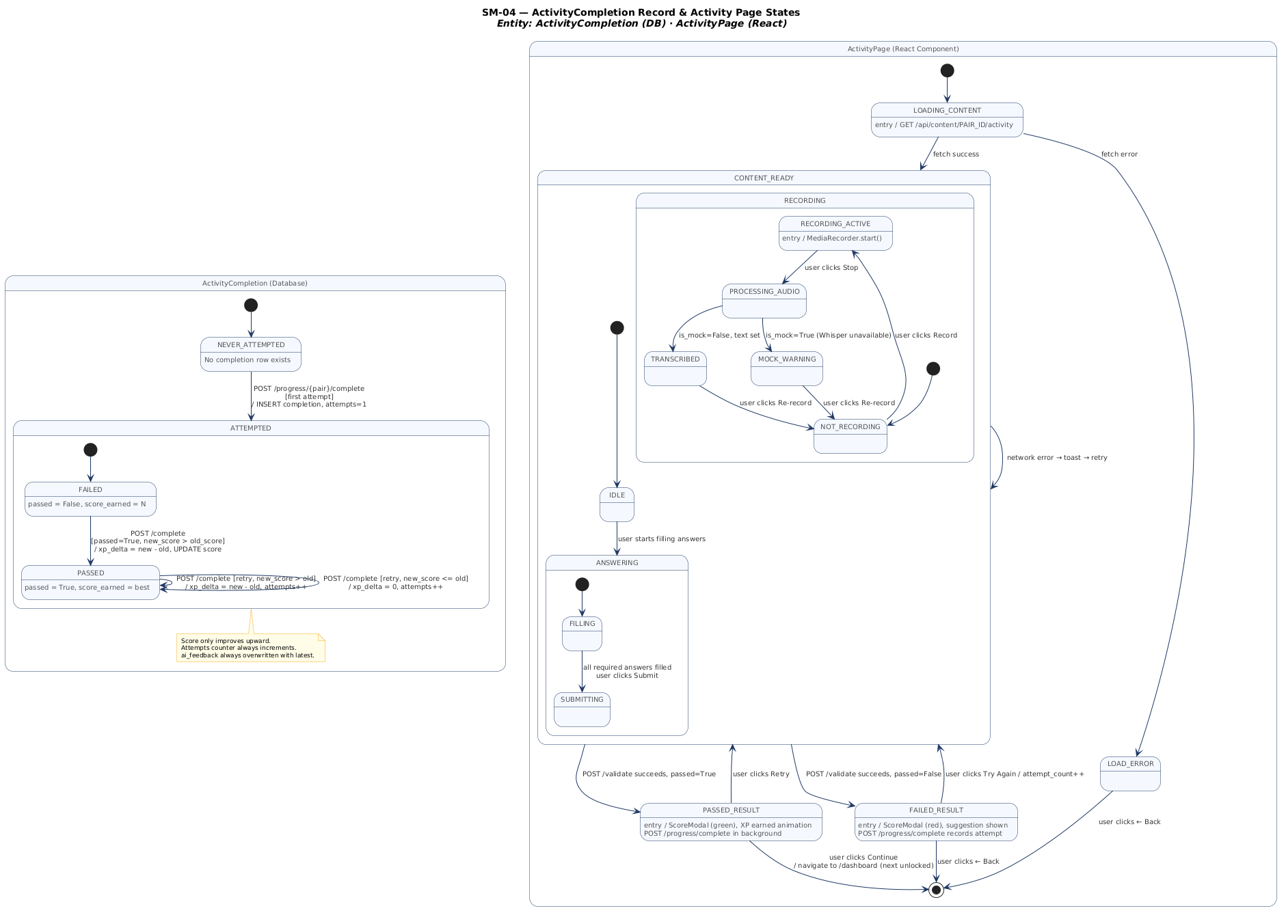

SM-05 — Service Layer State Machines
Three machines: (1) WhisperService Python module (UNINITIALIZED → AVAILABLE/UNAVAILABLE → TRANSCRIBING). (2) GroqService single API call (IDLE → BUILDING_PROMPT → CALLING_GROQ → RESULT/ERROR). (3) Redux authSlice frontend (UNAUTHENTICATED → LOADING → AUTHENTICATED/ERROR).
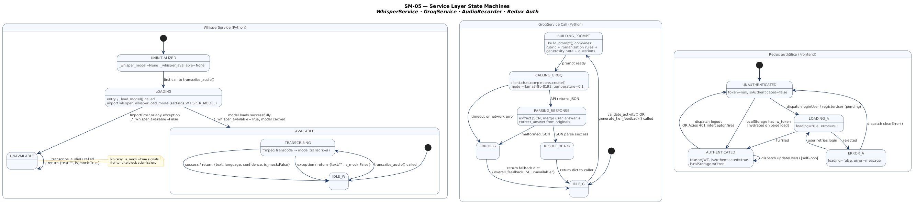

End of LearnWise Software Design Document — Version 1.0
IEEE Std 1016 · Stakeholder Presentation · April 2026

