**PANDIT DEENDAYAL ENERGY UNIVERSITY**

**SCHOOL OF TECHNOLOGY**



**Course: Data Mining**

**Project Report(Music Recommendation System using spotify dataset)**

**B.Tech. (Computer Science and Engineering)**

**Semester V**

**Submitted To Submitted By**

Rajeev GuptaRudra Kosambi (20BCP074)

Sheelkumar Patel(20BCP099)

Jay Taravia (20BCP076)

**Music Recommendation System using Spotify dataset**

**Abstract**

Digital music is now widely available compared to earlier times because to commercial music streaming services that may be accessed through mobile devices. It takes a long time to sort through all of this digital music, and it makes you feel overwhelmed by information. Therefore, it is highly helpful to create a music recommendation system that can automatically search through music archives and propose appropriate songs to consumers. By implementing a music recommender system, the music supplier can foresee and then present to their users the suitable songs depending on the traits of the music that has already been listened. In the current study, we offer a Spotify dataset-based music recommendation system based on K-Means Clustering and machine learning algorithms that can suggest ten songs based on songs the user has already heard. We provide a collaborative filtering process in this system for recommending music to the user.

**Table of Contents**

1. Introduction 3

2. Literature Review 4

3. Methodology and implementation details 5

3.1 Dataset Description 5

3.2 Data Exploration 5

3.3 Data Transformation 7

3.4 Recommendation System 8

4. Result Analysis 9

4.1 Evaluation of model 9

5. Conclusion & Future work 10

5.1 Conclusion 10

5.2 Future work 10

6. References 11

1. **Introduction**

Online music listening has becoming increasingly popular. Music listeners now have access to music whenever they want. In the modern age computing, online music subscription services have become more and more popular. Users now have easier access to an infinite number of songs. Users can access songs that are available to their premium subscribers on websites like Spotify , YouTube music, Gnana. It is important to these companies to provide their customers good user experience. One unique feature of these streaming apps is the playlist. Making a play list out of many songs might be annoying for many users. Users frequently choose the next song randomly based on a recommendation. So it essential to use a good suggestion method. Many methods for music recommendation have been created.

Spotify is the best example of how popular music streaming services have become. The user experience that an app offers to its users has a big impact on how successful the app is. A streaming application's recommendation algorithm aim is to delivering a positive user experience. Therefore, we may conclude that the Spotify recommendation algorithm significantly give very good user experience that led to Spotify's success.

To suggest songs and podcasts to users, the Spotify recommendation algorithm uses the collaborative filtering. In order to give recommendation, collaborative filtering uses similarities between users and the related or services. We'll demonstrate how to create the recommendation system using machine learning in this project.

1. **literature Review**

Multiple researches and approaches have been done in the field of music recommendation system in the past 2 decades. An overview of such works has been shown in this section.

Diego Sanchez-Moreno, Ana B. Gil Gonzalez, M. Dolores Vincete F. Lopez Batista, Maria N. Moreno Garcia made a collaborative filtering-based music recommendation system using coefficients for artists and users in 2016. In this work the sparsity problem of recommendation system without requiring user attributes and content data was solved.

In 2019 Adiyansjah, Alexander A S Gunawan and Derwin Suhartono proposed Music recommendation system based on genre using convolutional recurrent neural networks which gave out recommended music based on similarity of features of audio signal. The proposed work gave out precision of 0.712 and recall of 0.804. The Receiver operator Characteristic came out to be 0.944 and F1 score was 0.749.

Wang Wenzhen proposed Personalised music recommendation system based on hybrid collaborative filtering technology in 2019. He created a hybrid recommendation model by adding association rules and music genes to collaborative filtering. The research was helpful to give music recommendation in the field of emotional regulation and psychotherapy.

In 2010 Dmitry Bogdanov, Martin Haro, Ferdinand Furhamn, Emilia Gomez, Perfecto Herrera proposed content-based music recommendation system based on user preference examples in which they presented three content based approaches and concluded that the content based approach to recommend music did not succeed to surpass the success of music recommendation system based on collaborative filtering.

Affective Music recommendation system reflecting the mood of input image was proposed by Shoto Sasaki, Tatsunori Hirai, Hyato Ohya and Shigeo Morishima in the year of 2013. In the presented work they proposed music suggestion based on the emotions of the user which were decided by machine by processing the image of user via digital image processing. They concluded that along with the presented system it was necessary to implement functionality with which if the user decided to skip the song the system can suggest a song based on previous songs played.

1. **Methodology and implementation details**

**3.1 Dataset Description**

For this project we have used Spotify dataset that contain over 175,000 songs and 19 attributes. Dataset have following attributes.

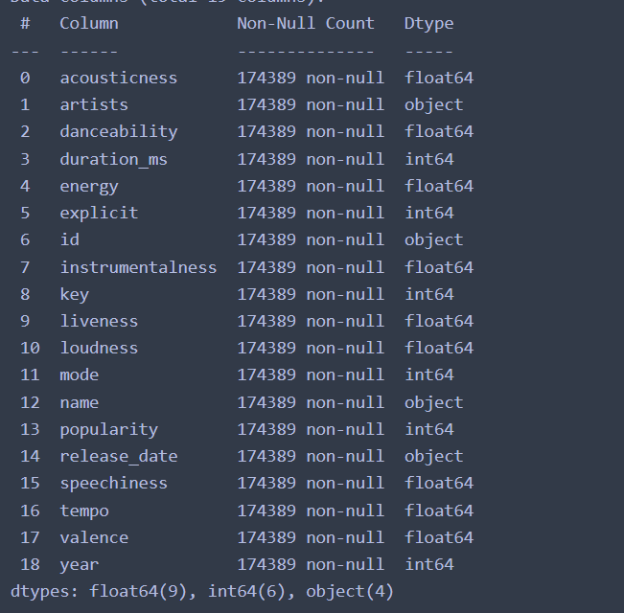

Fig-3.1

**3.2 Data Exploration**

First we’ll check if dataset contains any null values or not. So, out dataset doesn’t contain any null value to no need for filling it. Some of the columns like id," "name," "artists," "release date," and "year" aren’t significant so that we can remove them. We will be see Features correlation with dependent variable for that we’ll be using Yellowbrick package (Yellowbrick is often used to visualize the data).

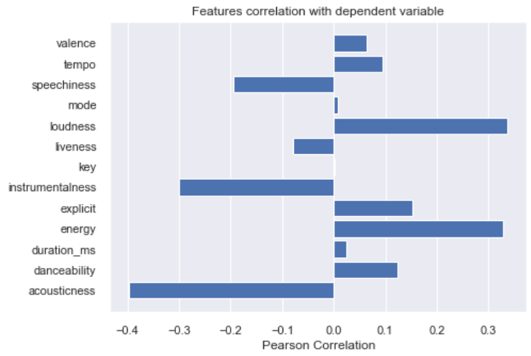

Fig-3.2

Then we’ll be seeing feature correlation using heatmap

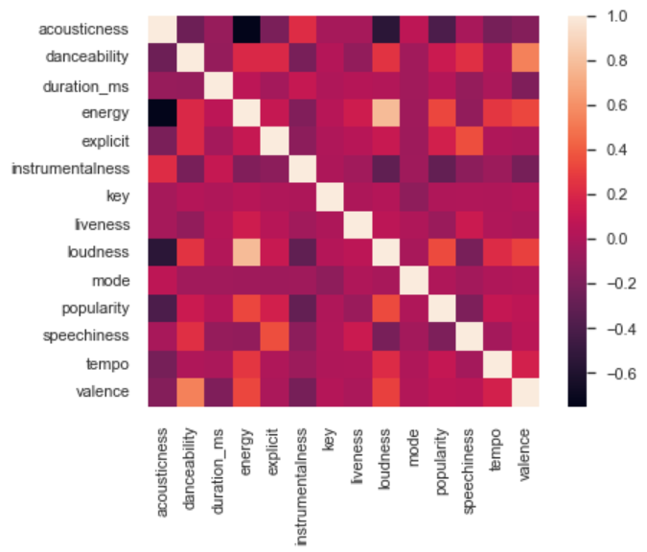

Fig-3.3

* 1. **Data Transformation**

Then we will normalize the data using MinMaxScaler (MinMaxScaler transform features by scaling each feature to a given range.) By this all the numerical columns will be normalized. For this we’ll chose int and float datatypes.

Some songs from different genres may have similar characteristics which can affect the recommendation system. For that we’ll going to create new feature by using K-means clustering.

In order to find optimal number of cluster we’ll be using Elbow method.

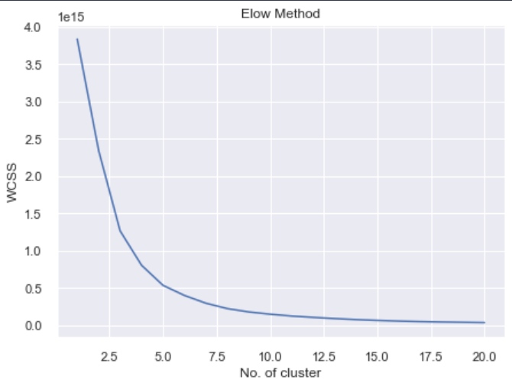

Fig-3.4

Visualizing clusters:

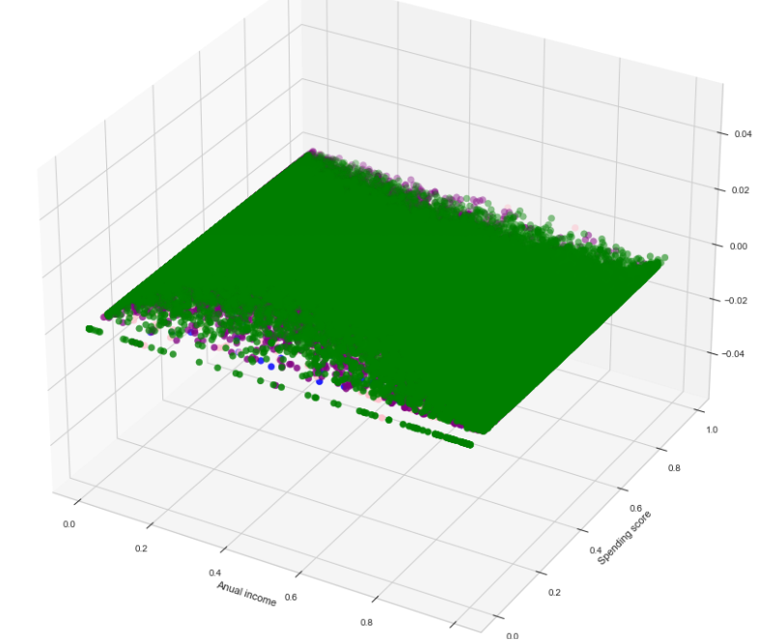

Fig-3.5

* 1. **Recommendation System**

After all the steps we’ll be predicting the songs to the user. In order to do that we’ll take input one song and how many recommendation like that song from user wants predict similar songs to the user.

For example if user give song “Lovers Rock” then user will get following

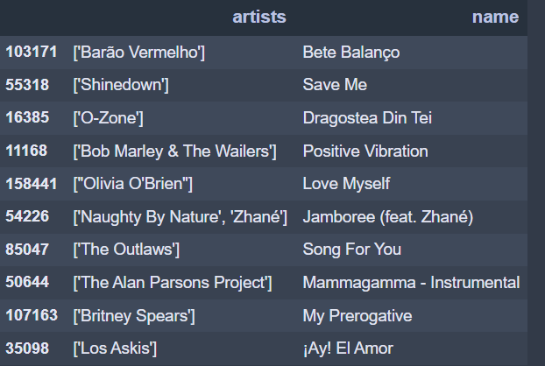

Fig-3.5

1. **Result & Analysis**

By applying the models we get the system that have frequency of similar genres who has adjacent data points and music or song are get grouped which is output of the system. Music or songs from similar genres will sound similar and came from comparable periods. The data point of song that are a user is already listened and other matching data points that are adjacent to that data point are collected and the particular song or music will be display as output to the user. By doing this user get the songs or music which are the similar to user output. This concept is used to developed a recommendation system.

For k-mean clustering silhouette score is near 0.6. The music recommendation system that we make take the input from the user and predict the 10 songs from related to that genres. And shows the output of that songs. And that output also contains song name and artist name.

1. **Conclusion**

By doing this recommendation system report we conclude that if the recommendation system is providing good user experience than traffic of user is high in that case. It is very difficult to make that type of recommendation system that make very good user experience. Spotify use the recommendation system that eliminates the problem that user facing to search for the song or music of users choice. Its suggest very appropriate results of searching song and also provide another list of songs that are similar to that song. This make good user experience and attract the most people to use this. For doing this type of recommendation system Spotify use different types of machine learning model to recommend the other songs. Spotify uses collaborative filtering algorithms. And then this models get input by user as the name of song or music and model predicts the song and give output to the user of the other song or music which are related to search. By doing this Spotify is very famous in today’s time. So if this type of music recommendation system is used then attracting the new people is easy and also the current user also stay to this Spotify app.

**Future work**

In future we can make web API that makes it easy to make web app and implement in it using python library Spotipy. And recommend songs to user.

1. **References**
2. https://www.sciencedirect.com/science/article/pii/S1877050919310646
3. https://ieeexplore.ieee.org/abstract/document/8901416/authors#authors
4. https://repositori.upf.edu/handle/10230/47004
5. https://link.springer.com/chapter/10.1007/978-3-540-72079-9_10
6. https://www.sciencedirect.com/science/article/abs/pii/S0957417416304973
7. <https://cyanite.ai/2021/09/02/how-do-ai-music-recommendation-systems-work/>
8. <https://www.scikit-yb.org/en/latest/index.html>
9. https://www.kaggle.com/code/vatsalmavani/music-recommendation-system-using-spotify-dataset/notebook