CSC 134 Fall 2020
Homework Assignment 4
Total: 100 points

I do NOT debug for students. Solving assignment problems independently is one assessment criteria of all assignments.

This homework allows students to practice the development of a database using MySQL. Homework assignment 5 will be based on the tables created in this assignment.
Section 1
Using SQL, create tables according to the given schema shown in Figure 1. The ER diagram is shown in Figure 3. You must create your database using exactly the same names for tables and attributes, using the given type. The type of each attribute is defined in Figure 2.

Customer (cid, name, address);
Orders (oid, order_date, cid) foreign key (cid) references Customer(cid);
Order_book(oid, isbn, no_of_copy) foreign key (oid) references Orders(oid), foreign key(isbn) references Book (isbn);
Publisher (pid, name, address, phone);
Book (isbn, title, btype, price, pub_date, pid)
foreign key (pid) references Publisher (pid);
Author (aid, fname, lname);
Written_by(isbn, aid)
foreign key (isbn) references Book (isbn), foreign key (aid) references Author (aid);
Editor (eid, fname, lname);
Edited_by(eid, isbn)
foreign key (isbn) references Book (isbn), foreign key (eid) references Editor (eid);

Figure 1 Schema

Customer (cid: CHAR(9), name: VARCHAR(20), address: VARCHAR(80));
Orders (oid: CHAR(9) , order_date: DATE, cid: CHAR(9))
Order_book(oid: CHAR(9), isbn: CHAR(10), no_of_copy:INT)
Publisher (pid: CHAR(10), name: VARCHAR(30), address: VARCHAR(80), phone: CHAR(10));
Book (isbn: CHAR(10), title: VARCHAR(100), btype: VARCHAR(15), price DECIMAL (10,2), pub_date: DATE, pid:CHAR(10));
Author (aid CHAR(4), fname: VARHAR(15), lname: VARHAR(15));
Written_by(isbn CHAR(10), aid CHAR(4));
Editor (eid CHAR(4), fname VACHAR(15), lname: VARCHAR(15));
Edited_by(eid CHAR(4), isbn CHAR(10))
Note: DATE is in the format of ‘yyyy-mm-dd’.
TIME is in the format of ‘HH:MM:SS’.

Figure 2. Type Definition

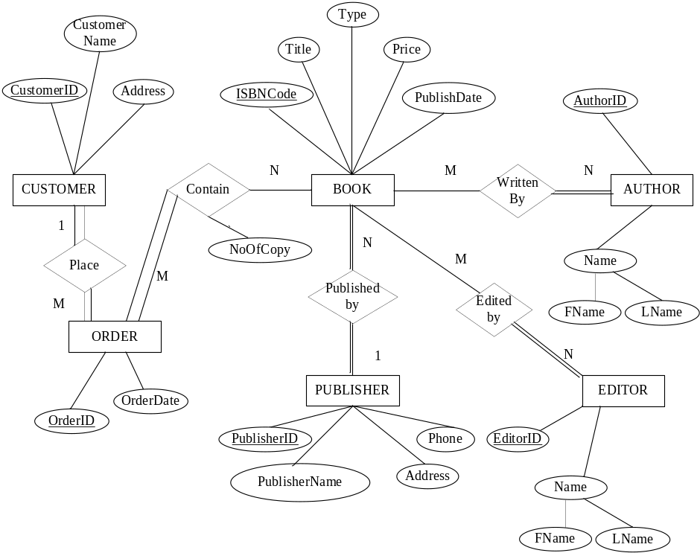

Figure 3 ER Diagram
Section 2
(1) Populate the database. Insert at least two tuples to the “Publisher” table. For each of the other tables, insert at least one record.
(2) Execute one delete statement to the “Publisher” table.
(3) Execute one update statement to the “Book” table.

Section 3
Specify the statements to drop all the tables. Pay attention to the order of the drop statements in order to drop everything successfully.

Submission

Submit the following files to Canvas. Note: Submit through any other ways, such as email attachment, will not be graded.
You must execute each statement before submit it. 0 point will be given to each non-executable.
- Create table statements (file name must be: 1_create_table.sql)
I will copy everything from this file using an Athena MySQL account (not your account) to execute it. Make sure the tables are listed in the correct order such that I can execute it without any error. For any table that cannot be created, you will lose points, even if the error caused by the incorrect order of creating table. Make sure you test it in your own MySQL account before your submission.
- Insert statements to populate database, also include one update statement and one delete statement as required by Section 2 (file name must be : 2_populate_db.sql)
- Drop tables statements (file name must be: 3_drop.sql)

