## MATLAB See Documentation online , check code in browser

The MATLAB part is more focused on

* Functions
* Types of functions

<https://www.mathworks.com/help/matlab/matlab_prog/types-of-functions.html>

* Function definition

http://cse.unl.edu/~sincovec/Matlab/Lesson%2013/CS211%20Lesson%2013%20-%20Function%20Types%20and%20Scope.htm

* function scope

<http://cse.unl.edu/~sincovec/Matlab/Lesson%2014/CS211%20Lesson%2014%20-%20Variable%20Scope%20and%20Lifetime.htm>

* nested functions

<https://www.mathworks.com/help/matlab/matlab_prog/nested-functions.html>

* Function precedence order

https://www.mathworks.com/help/matlab/matlab_prog/function-precedence-order.html

* @Function handle,

https://www.mathworks.com/help/matlab/matlab_prog/creating-a-function-handle.html

* Workspace global persistent -> to save variable .MAT before close

https://www.mathworks.com/help/matlab/matlab_prog/share-data-between-workspaces.html

* Plot (hold on, plotyy, subplot ), Grid, plotting,

<https://www.mathworks.com/help/matlab/ref/plotyy.html>

* TIC TOC

### Time Portions of Code

To estimate how long a portion of your program takes to run or to compare the speed of different implementations of portions of your program, use the stopwatch timer functions, [tic](https://www.mathworks.com/help/matlab/ref/tic.html) and [toc](https://www.mathworks.com/help/matlab/ref/toc.html). Invoking tic starts the timer, and the next toc reads the elapsed time.

tic

% The program section to time.

toc

### Time of funcions

f = @() myComputeFunction; % handle to function

timeit(f)

INTERNAL TIMER VALUE CAN BE ANYTHING NOT ZERO ALWAYS

* Anonymous function,

https://www.mathworks.com/help/matlab/matlab_prog/anonymous-functions.html

* How to improve performance of a MATLAB program (prompted me to preallocation, vectorization), .* vs *,

Ans –

Preallocation: If the matrix size is not defined prior to populating it with data through a FOR loop, memory fragmentation problems may happen since MATLAB is not aware of the final matrix size upon the conclusion of the FOR loop. Zeros(3) => 3x3 matrix

Vectorisation – speedup

* Mex functions in MATLAB

You can call your own C, C++, or Fortran subroutines from the MATLAB® command line as if they were built-in functions. These programs, called binary MEX files, are dynamically linked subroutines that the MATLAB interpreter loads and executes. The MEX file contains only one function or subroutine, and its name is the MEX file name. To call a MEX file, use the name of the file, without the file extension

* Difference between plot () and stem ().
* You have A=3x3 matrix, and you want to multiply each column with diff. number, i.e. A= [1 2 3;4 5 6; 7 8 9] you want [2 6 12;8 15 24;14 24 36]? You can use row vector [2 3 4]
* Ans .*
* Repmat
* A =
* 100 0 0
* 0 200 0
* 0 0 300
* B = repmat(A,2,3)
* B =
* 100 0 0 100 0 0 100 0 0
* 0 200 0 0 200 0 0 200 0
* 0 0 300 0 0 300 0 0 300
* 100 0 0 100 0 0 100 0 0
* 0 200 0 0 200 0 0 200 0
* 0 0 300 0 0 300 0 0 300
* Logical indexing

logInd = X < target % X = randperm(20) target = 5;

% logind contains all 1 and 0 hence logical indexing

XtargetLogical = X(logInd) % fetches the values of the 1s in logInd

<https://blogs.mathworks.com/loren/2013/02/20/logical-indexing-multiple-conditions/>

iseven = @(x) ~logical(rem(x,2)) % not(xmod2)

iseven(1:5) % ans 0 1 0 1 0

* Cross product
* Can you have a file named “filter.m”?

Ans - No already has builtin

* What is primary function and subfunction?(C)

Primary is the main

* What is difference between nested function and subfunction?(C)

x = 1  
   function t1 = intest(t)  
      t1 = t + 10  
   end  
y = intest(x)  
end  
  
Here is the same code as a subfunction:  
function t = test()  
x = 1  
y = intest(x)  
  
function t1 = intest(t)  
t1 = t + 10  
  
You must be careful with scope in nested functions as all variables  
in the parent function are global to the nested function.

* Ans - nested functions-can access variables declared inside main functions.
* What is private function?

Ans - inside private folder

* What is hf=gca; [AXES]

Ans - gca returns the current axes or chart for the current figure3https://www.mathworks.com/matlabcentral/answers/151633-gca-function-in-matlab

* What is gcf [FIGURE]

Ans – current function handle

https://www.mathworks.com/help/matlab/ref/gcf.html

"gcf, gca" is for handle for the current figure and axis

* What is event function call back? (DA)

https://www.mathworks.com/help/matlab/matlab_external/events-and-callbacks.html

* How to access data members of a structure?

https://www.mathworks.com/help/matlab/matlab_prog/access-multiple-elements-of-a-nonscalar-struct-array.html

* What are cell arrays?

https://www.mathworks.com/help/matlab/matlab_prog/access-data-in-a-cell-array.html

* C1= {}
* C2= {}
* what is C1()
* Cell indexing -> access small part of cell
* what is C1{}
* Content indexing ->acess values and can change them values _>double
* What is this code doing?

mystruct =struct('field1',{1,2,3}... 'field2',{4,5,6});

Creates a structure array with n fields

field1 = 'f1'; value1 = zeros(1,10);

field2 = 'f2'; value2 = {'a', 'b'};

field3 = 'f3'; value3 = {pi, pi.^2};

field4 = 'f4'; value4 = {'fourth'};

s = struct(field1,value1,field2,value2,field3,value3,field4,value4)

s = 1x2 struct array with fields:

f1

f2

f3

f4

1x2 here depends on values not fields

<https://www.mathworks.com/help/matlab/ref/struct.html>

* 3. gca and gcf and how to change the different properties listed under these functions.

Ans - Using operator, get, set

* Explain the reason why a script runs slow and give necessary solutions to overcome the issue.
* Matlab loop optimization
* Types of memory

https://www.mathworks.com/help/matlab/matlab_prog/strategies-for-efficient-use-of-memory.html

7) row Indexing and column indexing - A= [ 1 2 3 4] ; B= [ 5;6;7;8]; which is valid A(2) , B(2) ?

Ans - Both are valid and give result 2,6.

8)Does matlab have 0 indexing.?

Ans- No it starts with 1

10 function result=testfunc(a)

reciprocal = 1/a;

result = 2*reciprocal;

end

What will happen when I execute the following statements:

>> a=3;

>>testfunc(a)

>>reciprocal

Ans) reciprocal wont execute since its not in base-workspace .

Output of A(B>0), A and B both some matrix)

a. Program using element wise multiplication operator.

b. Program using FIND operator.

c. duplicate name of functions,

Ans - separate file or else error

g. Concatenation of arrays,

h. horzcat command

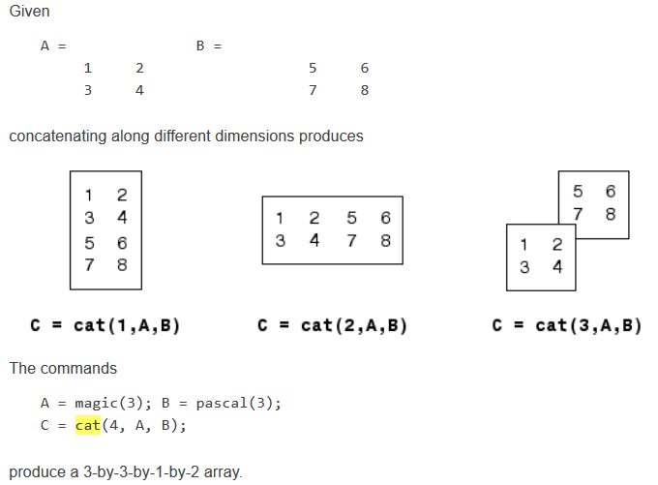

* B(1:3:16) = -10
* B =
* -10 2 3 -10
* 5 11 -10 8
* 9 -10 6 12
* -10 14 15 -10
* Is this matrix invertible? (The interviewer gave me a matrix and I had to tell him if it was invertible or not and explain why)