Instructions
Add the role of ISS to your File Server, verify it is running, and add a launch page stating the site is under construction.
Goals: Install the Role of ISS on your File Server
Deliverables:
- Provided with a time/date stamp, a screenshot of the local server showing IIS is installed
- A screenshot showing the "under construction" launch page when you visit the home page. (Timestamp required)
- A brief explanation of how you accomplished the installation, listing all of the sites you used to assist you with this project
- All screenshots should be labeled and inserted into a single Word document.

IIS Installed
Part 1: Local Server, showing IIS installed
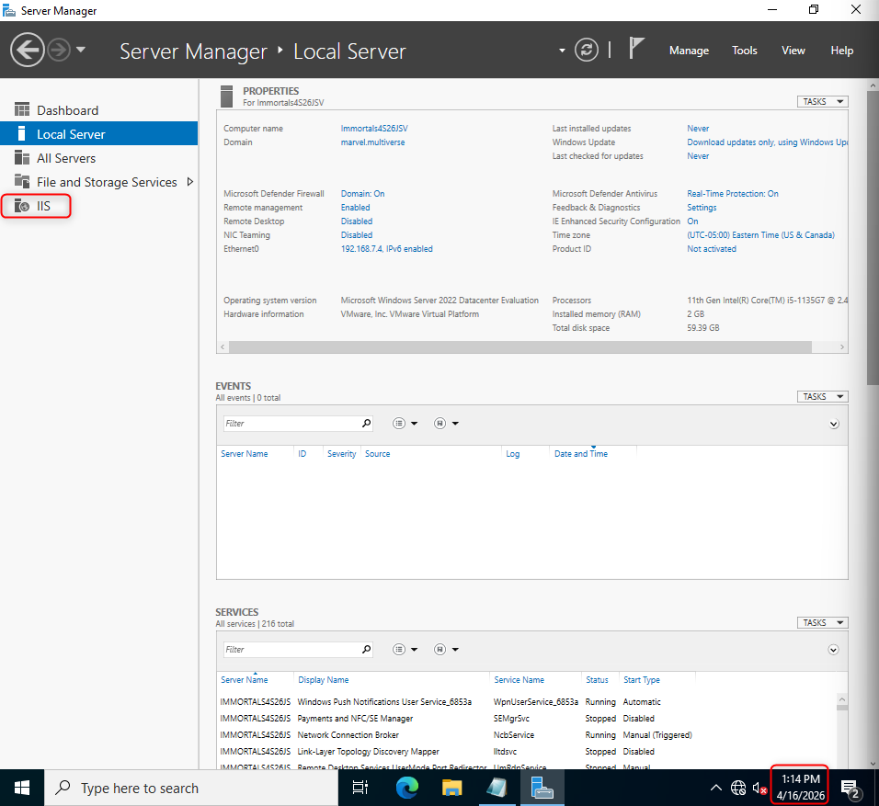
Launch Page
Part 2: Launch page, showing "under construction"
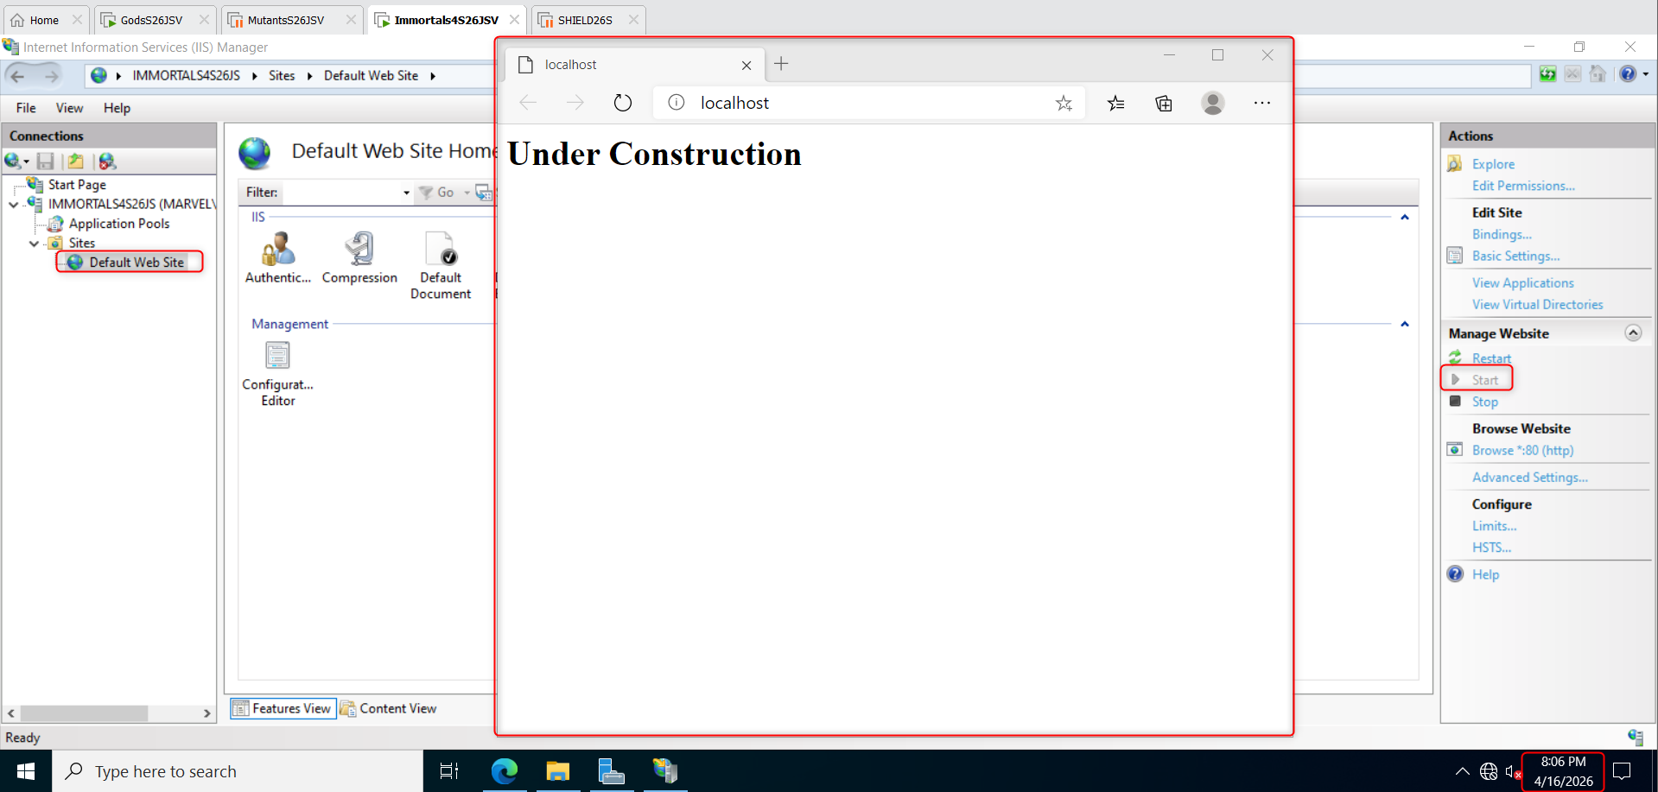

The Process
Part 3: Written Explanation of Installation Process and any website used to assist.
Below are the steps I took to successfully create the “under construction” launch page, as show above:
- First started off by deploying both my FSRM and DNS VMs.
- I searched for the Server Manager in the window search bar, then I launched the application.
- Clicked on the Add roles and features option located on the server manager dashboard.
- Clicked the next button on the following three tabs:
  - Before You Begin
  - Installation Type
  - Server Selection
- On the Server Roles tab, I selected the checkbox for Web Server (IIS) and proceeded to install the necessary features and role.
- Clicked next on the following tabs and I clicked install to add the IIS role to my server.
- After the IIS role is installed, I clicked on tools in the top right-hand corner and launched the IIS Manager.
- Then I went to file explorer and searched for the following folder C:\inetpub\wwwroot.
- Once in the folder, I removed the html file named iisstart.html.
- Then I opened notepad application and typed the following text: <h1>Under Construction</h1>.
  - This makes it a header, utilizing the header font size and boldness.
- After I added the text, I then saved the file as index.html within the C:\inetpub\wwwroot folder.
- Once the html txt file is inside the wwwroot folder, I opened edge browser and searched http://localhost. From here I can see the text “Under Construction.”

Sources
Below are the sources I used to complete this assignment; I used one website and chatgpt.
Link:
How To Install IIS In Windows Server 2022: https://www.rootusers.com/how-to-install-iis-in-windows-server-2022/
Chatgpt prompt:
