**INTI International College Penang School of Computing**

**3+0 Bachelor of Science (Hons) in Computer Science, in collaboration with Coventry University, UK 3+0 Bachelor of Science (Hons) in Computing, in collaboration with Coventry University, UK**

# Coursework cover sheet

**Section A - To be completed by the student.**

| Full Name: Oon Jay Von | |
| --- | --- |
| CU Student ID Number: 14196254 | |
| Semester: 1 | |
| Session:  **April 2023** | |
| Lecturer:  **Puteri Nursyawati Azzuri (puteri.azzuri@newinti.edu.my)** | |
| Module Code and Title:  **4067CEM Software Design** | |
| Assignment No. / Title:  **Continuous Assessment** | % of Module Mark:  **50** |
| Hand out Date:  **12 May 2023** | Due Date:  **Task 1: 02 June 2023, by 11.59pm.**  **Task 2: 07 July 2023, by 11.59pm**  **Task 3: 23 June 2023, by 11.59pm.**  **Task 4: 23 June 2023, by 11.59pm.**  **Task 5: 23 June 2023, by 11.59pm.** |
| Penalties: No late work will be accepted. If you are unable to submit coursework on time due  to extenuating circumstances, you may be eligible for an extension. Please consult the lecturer. | |
| Declaration: I/we the undersigned confirm that I/we have read and agree to abide by the University regulations on plagiarism and cheating and Faculty coursework policies and procedures. I/we confirm that this piece of work is my/our own. I/we consent to the appropriate storage of our work for plagiarism checking.  Signature(s): | |

# Section B - To be completed by the module leader

| Intended learning outcomes assessed by this work:   1. Understand and apply appropriate concepts, tools, and techniques to each stage of the software development. 2. Understand and apply design patterns to software components in developing new software. 3. Demonstrate an understanding of project planning and working to agreed deadlines, along with professional, interpersonal skills and effective communication required for software production.   5. Demonstrate an awareness of, and ability to apply, social, professional, legal, and ethical standards as documented in relevant laws and professional codes of conduct such as that of  the Malaysian National Computer Confederation. | | |
| --- | --- | --- |
| Marking scheme | Max | Mark |
| 1. User Story Mapping | 20 |  |
| 2. Setting up a GitHub |  |
| Repository | 10 |
| 3. Creating a Class diagram and |  |
| design pattern selection | 30 |
| 4. Creating a Prototype User |  |
| Interface and Usability Testing | 20 |
| 5. Discuss the ethical issue |  |
| related to the software | 20 |
| Total | 100 |  |

# Task 4 – Creating a Prototype User Interface and Usability Testing (20 marks)

Create a Prototype User Interface (hand drawn/digital) of TWO (2) important functions of the proposed system. Come up with usability testing questions. You don’t have to carry out the test, just prepare the questions. You should indicate what you are testing for in the Usability Testing.

Output – A Prototype and Usability Testing Questions. In Word format, uploaded it to GitHub. Due – Week 12 of the semester. 23 June 2023, by 11.59 pm.

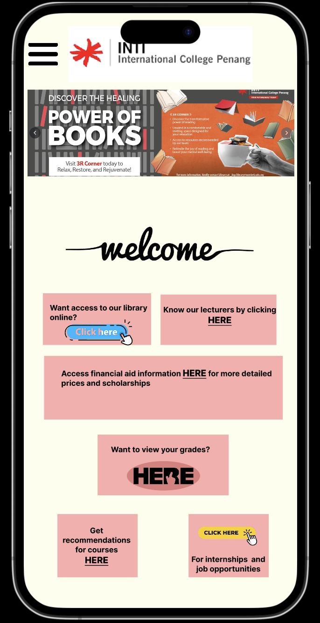

The above diagram is the prototype for the student business system for college. You can see on the top middle will be the logo for the college, on the left, there will be a 3 line button, when you click on it, it will have three button for user to press which is home, settings, and profile as below.

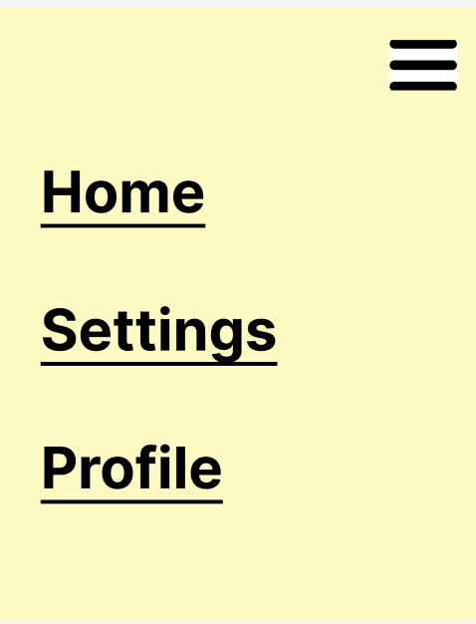

Below the college logo will be having the latest news or advertisements about the college. After that, there will be six buttons for users to press which are accessing the library, knowing lecturers, access for financial aid information, viewing user’s grades, Getting recommendations for courses, and also finding internships and job opportunities. We will be talking about only two functions later on which is the library and the get to know lecturer function.

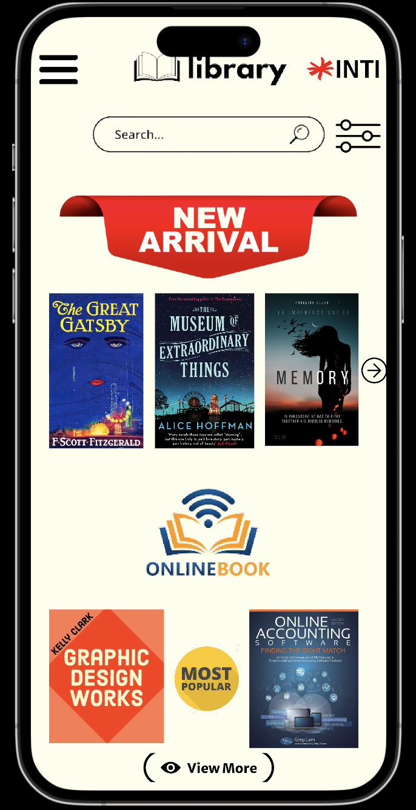

After the user clicks the access to library button, it will pop up this page. In this page user can search the resources that they want, or they can filter the resources by pressing the button beside the search bar. Below the search bar, there will be showing the new arrivals, users can see more new arrivals by pressing the arrow button. Below the new arrivals, there will be the online book which is the digital version of the textbooks. In this page it only shows the most popular, if the user wants to view more they can tap the “view more” button.

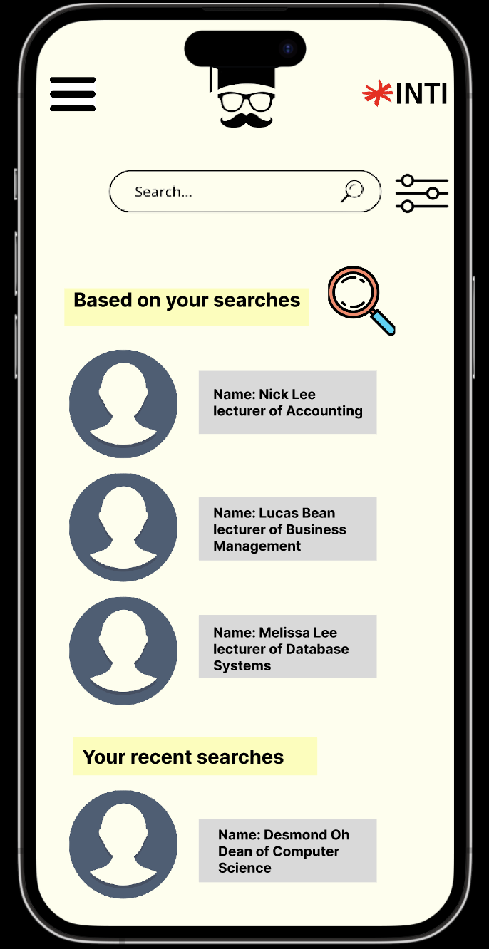

When the user clicks the get to know lecturer button, it will pop up this page. In this page, users can search the lecturer who will be teaching them or the lecturer which they want to know more about, they can even filter by programs, or courses by tapping the button beside the search bar. Below the search bar, the system will show lecturers brief information based on their searches. Below will also pop up the lecturer’s brief information that user’s searched recently.

Usability testing questions

1. How comfortable are you with using similar online platforms or systems?
2. Are the menus and options labeled in a clear and understandable way?
3. How easily can you find the books or resources you are looking for?
4. Can you easily view your grades for different courses or semesters?
5. Can you easily access information about your lecturers, such as their contact details or office hours?
6. Are there any difficulties or confusion when accessing or interpreting the financial aid information?
7. Did you encounter any problems while trying to register for recommended courses through the system? If yes, please state what you’ve encountered.
8. Is there any information or feature you would like to see improved in the course recommendation section?
9. Were there any difficulties or confusion when navigating between different sections or pages?
10. How would you rate the overall usability of the student business system?

# Marking Rubric for Continuous Assessment

|  | **Marks Below 40%** | **Marks in the range 40 – 49%** | **Marks in the range 50 – 59%** | **Marks in the range 60 – 69%** | **Marks 70% and above** |
| --- | --- | --- | --- | --- | --- |
| **User Story** | User Story Mapping | User Story Mapping | User Story Mapping | User Story Mapping | User Story Mapping done and does capture most important activities of the system. The breakdown of the user story mapping is excellent and uses software that can assist that process (For example Trello compared to Ms.  Word). |
| **Mapping** | not done or User | done at a minimum | done and does | done and does |
| **(20 marks)** | Story copied/does  not match the exact | level and does not  capture the | capture several  important activities of | capture several  important activities of |
|  | system. | important activities of | the system. The | the system. The |
|  |  | the system. | breakdown of the | breakdown of the user |
|  |  |  | user story mapping | story mapping is good |
|  |  |  | can be improved. | and uses software that |
|  |  |  |  | can assist that |
|  |  |  |  | process (For example |
|  |  |  |  | Trello compared to |
|  |  |  |  | Ms. Word). |
| **Setting up a** | GitHub repository | GitHub repository | GitHub repository | GitHub repository exist | GitHub repository |
| **GitHub** | does not exist or | exist and some of | exist and most of the | and all of the required | exist and all of the |
| **Repository** | cannot be accessed | the required files are | required files are | files are available at | required files are |
| **(10 marks)** | or the required files  are not available at | not available at the  time of access. | available at the time  of access. However | the time of access.  However the dates for | available at the time  of access. The dates |
|  | the time of access. |  | the dates does not | some files does not | on the files follows |
|  |  |  | follow the required | follow the required | the required |
|  |  |  | deadline. | deadline. | deadline. |
| **Creating a** | The Class diagram | The Class diagram | The Class diagram | The Class diagram | The Class diagram |
| **Class diagram** | does not represent | and design pattern | and design pattern | and design pattern | and design pattern |
| **and design pattern selection (30 marks)** | the required solution (contains generic or non- related classes  such as admin), the design pattern | represent the required solution but in a very general and incomplete way.  Required classes in | represent the required solution in a partial way. A few  required classes in the design are not | represent the required solution in a satisfactory way. Most  required classes are declared. | represent the required solution in an excellent way. All  required classes are declared. |
|  | suggested is not | the design are not | declared. |  |  |
|  | suitable for the given | declared. |  |  |  |
|  | problem. |  |  |  |  |

| **Creating a Prototype User Interface and Usability Testing**  **(20 marks)** | No prototype were available or the measurement for the usability testing is not clear. | The prototype cover minimalist and trivial design (such as login) and the measurements for the usability testing are not clear. | The prototype cover adequate design and several measurements for the usability testing are not clear. | The prototype cover good design and most measurements for the usability testing are clear. | The prototype cover excellent design and all measurements for the usability testing are clear. |
| --- | --- | --- | --- | --- | --- |
| **Discuss the ethical issue related to the software**  **(20 marks)** | There is no discussion on the ethical issue or only the theories are pasted back for this component. | There is an attempt to discuss on the ethical issue but no critical  analysis was done | There is an attempt to discuss on the ethical issue with some critical analysis was done | There is an attempt to discuss on the ethical issue with good critical analysis. | There is an attempt to discuss on the ethical issue with excellent critical analysis. |