**Tasks**

**Objective Questions:**

1. What is the total no. of tables present in the data?

**Answer - The total number of tables present in the data are 2 Tables (Raw data and country description)**

2.What is the total no. of attributes present in the data?

**Answer - The total number of attributes present in the data is 20 in raw data and 6 in Country description and 20 is in modified data**

3. How many categorical columns are there in the data?

**Answer - Based on the attributes, the categorical columns could be:**

**In Raw Data 14 columns**

1. **Restaurant Name**
2. **Country Code**
3. **City**
4. **Address**
5. **Locality**
6. **Locality Verbose**
7. **Cuisines**
8. **Currency**
9. **Has Table booking**
10. **Has Online delivery**
11. **Is delivering now**
12. **Switch to order menu**
13. **Price range**
14. **Rating**

**In Country description 4 columns**

1. **Country Code**
2. **Country Name**
3. **Currency**
4. **Currency Symbol**

4. The data consists of some inconsistent and missing values so ensure that the dataused for further analysis is cleaned.

**Answer -** **I made the following enhancements to the dataset:**

* **Restaurant Name Adjustments:**
  + **Replaced special character “í©” with “e”.**
  + **Removed any occurrence of “#”.**
* **Locality Modification:**
  + **Removed special character “±”.**
* **Datekey Opening Format:**
  + **Replaced underscores with slashes and converted the format to a date.**
* **Column Header Formatting:**
  + **Corrected column headers by adding spaces after each word.**
* **Average Cost for Two Update:**
  + **Addressed cases where some restaurants had a cost of 0.**
  + **Utilized a formula to update these values; replacing 0s with the average cost for the respective city.**
* **Average Cost for Two Update:**
  + **Addressed cases where some restaurants had a cost of 0.**
  + **Utilized a formula to update these values; replacing 0s with the average cost for the respective city.**
  + **Formula: =IF($S2=0,AVERAGEIFS($S:$S,$C:$C,$C2,$D:$D,$D2),$S2)**
    - **S2=0 Check if cost is 0.**
    - **AVERAGEIFS($S:$S,$C:$C,$C2,$D:$D,$D2) If true take average of that city.**
    - **$S2 false condition**
* **Cuisines Update**
  + **Addressed cases where some restaurants had a no cuisines**
  + **Highlighted and added “No Cuisines Information”**

1. Using the LookUp functions, fill up the countries in the original data using thecountry code.

**Answer - Did that using lookup function**

**Formula: =LOOKUP(C2,'country description'!$A$2:$A$16,'country description'!$B$2:$B$16)**

**Reference - In the Excel sheet named “Modified Data”, the column is labelled as “E”.**

6. Create a table to represent the number of restaurants opened in each country.

**Answer - To represent the number of restaurants opened in each country in the table created pivot table**

**Reference - In the Excel sheet named “KP1(Count of Restaurant)”**

**the pivot table that displays the number of restaurants in each country.**

7. Also, the management wants to look at the number of restaurants opened each year, so provide them with something here.

**Answer - To represent the number of restaurants opened in each year created pivot table Reference - In the Excel sheet named “KP1(Count of Restaurant)”**

**the pivot table that displays the number of restaurants opened in each year.**

8. What is the total number of restaurants in India in the price range of 4?

**Answer - In India the total number of restaurants in the price range of 4 is 388**

**Reference - In the Excel sheet named “KP1(Count of Restaurant)”**

**the pivot table that displays the total number of restaurants in the price range of 4.**

9. What is the average number of voters for the restaurants in each country according to the data?

**Answer – The Average number of voter for the restaurants in each country according to data are as follows :**

| Country | Average of Votes |
| --- | --- |
| Australia | 111.4166667 |
| Brazil | 19.61666667 |
| Canada | 103 |
| India | 137.212552 |
| Indonesia | 772.0952381 |
| New Zealand | 243.025 |
| Philippines | 407.4090909 |
| Qatar | 163.8 |
| Singapore | 31.9 |
| South Africa | 315.1666667 |
| Sri Lanka | 146.45 |
| Turkey | 431.4705882 |
| United Arab Emirates | 493.5166667 |
| United Kingdom | 205.4875 |
| United States of America | 428.2211982 |

**Reference - In the Excel sheet named “KPI2_Voter”**

**the pivot table that displays Average of Votes Per Country.**

10. Calculate the average rating for all the restaurants that have price_range < 4 and provide online delivery. Use only the “IF” function, Logical Operators, and Aggregation functions to solve this problem.

**Answer - The average rating for all the restaurants that have price_range < 4 and provide online delivery is 3.27381151**

**Formula: =AVERAGEIFS('Modified Data'!U:U, 'Modified Data'!Q:Q, "<4", 'Modified Data'!N:N, "Yes")**

**Reference - In the Excel sheet named “KPI3_Calculations”.**

11. Using Conditional formatting highlight the rows of restaurants that are located in the countries or cities that you’ve suggested to the management for opening new restaurants.

**Answer - Upon thorough examination, we’ve discovered that 59 cities within the dataset have fewer than 10 restaurants. This finding presents a strategic opportunity for management: consider opening new restaurants in these specific locations. By doing so, they can potentially tap into underserved markets and significantly expand the business’s reach.**

**For conditional formatting –**

* + - * + **Select Data:**

**Highlight the data you wish to format.**

* + - * + **Conditional Formatting:**
* **Go to the “Conditional Formatting” option.**
* **New Rule:**
* **Create a new custom formatting rule.**
* **Formula:**
* **Use the following formula: =COUNTIF($D$2:$D$9551,$D2)<10.**
* **Format Colour:**
* **Specify the formatting style that should apply when the condition is met.**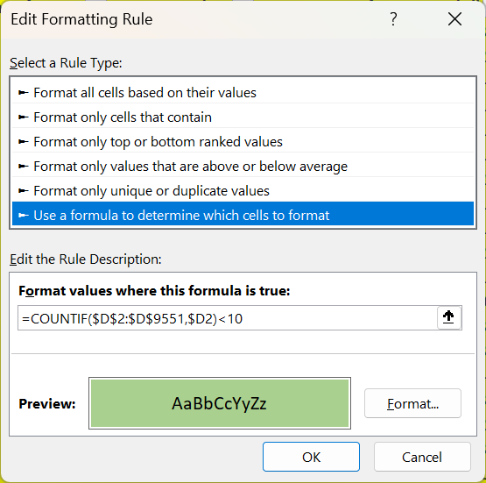

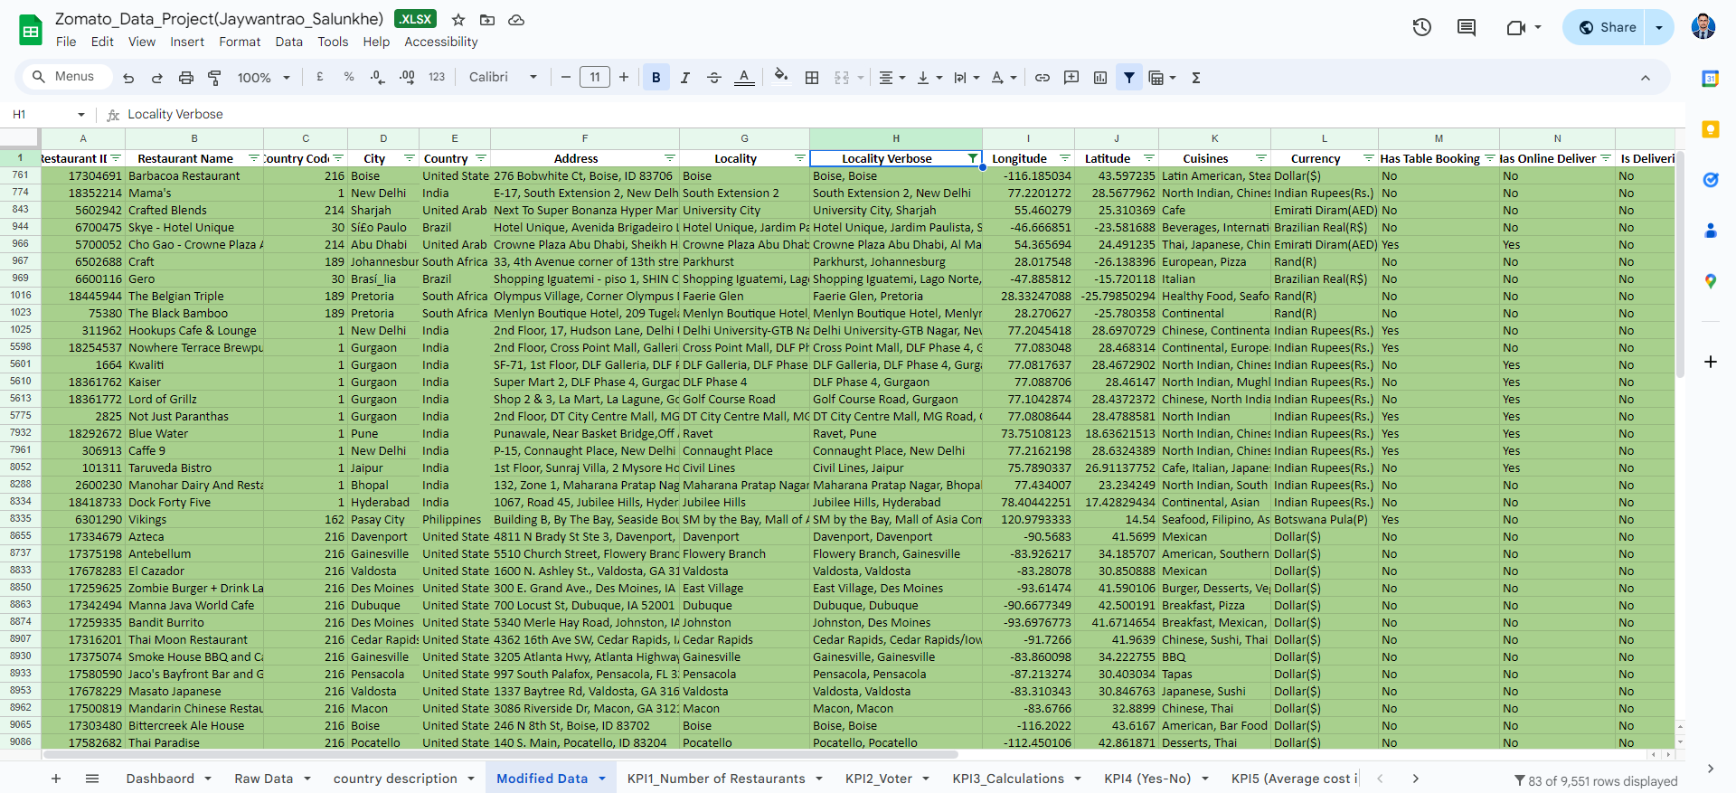

12. Create a new customized price column that consists of the abbreviation/symbol of the currency along with the Average_cost_for_two value. [Use string operations to do this task]

**Answer - Initially, I manually created a list of existing currency symbols. Next, I combined the** **VLOOKUP function with the CONCATENATE function. This combination enabled me** **to dynamically link each currency description to its corresponding symbol, resulting** **in a customized column containing the desired concatenated data.**

**Formula: =CONCATENATE(VLOOKUP('Modified Data'!$C2,'country description'!$A$2:$D$16,4,0),$S2)**

**Reference - In the Excel sheet named “Modified Data”, the column is labelled as “X”.**

13. How can you create an array formula in Excel or Google Sheets to count the number of restaurants listed that do not offer online delivery, are in the lowest price range, and have an average cost for two people less than or equal to 250 Indian Rupees?

**Answer - The count of the number of restaurants listed that do not offer online delivery, are in the lowest price range, and have an average cost for two people less than or equal to 250 Indian Rupees is 1685.**

**Formula: =COUNTIFS('Modified Data'!$N:$N,"No",'Modified Data'!$Q:$Q,1,'Modified Data'!$S:$S,"<=250",'Modified Data'!$L:$L,"Indian Rupees(Rs.)")**

**Reference - In the Excel sheet named “KPI3_Calculations”.**

**Subjective Question:**

1. Suggest a few countries where the team can open newer restaurants with lesser competition. Which visualization/technique will you use here to justify the suggestions?

**Answer – The countries where the team can open newer restaurants with lesser competition are as follows.**

* **Data Exploration Approach:**
* **I utilized a Pivot table, organizing country names as rows and including restaurant ID count and average rating as value fields.**
* **Next, I applied filters to identify countries with low competition and average ratings below 4.**
* **Insights and Recommendations:**
* **The selection of countries for consideration was meticulously reviewed, focusing on those with both low competition and average ratings below 4.**
* **The rationale behind this approach is to pinpoint regions where market entry could yield substantial benefits.**
* **Countries Recommended for New Restaurants:**
* **Australia**
* **Canada**
* **Singapore**
* **Sri Lanka**
* **Visualization Style:**
* **A “Line Chart with Markers” can help illustrate these insights effectively.**

**Reference - In the Excel sheet named “Suggestions”**

**the pivot table that Suggesting few countries where the team can open newer restaurants with lesser competition.**

2. Come up with the names of States and cities in the suggested countries suitable for opening restaurants.

**Answer - The names of States and cities in the suggested countries suitable for opening restaurants are as follows.**

* **Data Exploration Approach:**
* **I utilized a Pivot table, organizing country names and cities as rows. The value fields included restaurant ID count and average rating.**
* **Next, I applied filters to the suggested countries, focusing on cities with low competition and average ratings below 4.**
* **Cities Recommended for New Restaurants:**
* **Australia:**
  + **Armidale**
  + **Balingup**
  + **Beechworth**
  + **Dicky Beach**
  + **East Ballina**
  + **Flaxton**
  + **Forrest**
  + **Hepburn Springs**
  + **Huskisson**
  + **Inverloch**
  + **Lakes Entrance**
  + **Lorn**
  + **Macedon**
  + **Mayfield**
  + **Middleton Beach**
  + **Montville**
  + **Palm Cove**
  + **Paynesville**
  + **Penola**
  + **Phillip Island**
  + **Tanunda**
  + **Trentham East**
  + **Victor Harbor**
* **Canada:**
  + **Chatham**
  + **Consort**
  + **Vineland Station**
  + **Yorkton**
* **Singapore:**
  + **Singapore**
* **Sri Lanka:**
  + **Colombo**

**Reference - In the Excel sheet named “Suggestions”**

**the pivot table that Suggesting the names of States or cities in the countries suitable for opening restaurants.**

3. According to the countries you suggested, what is the current quality regarding ratings for restaurants that are open there?

**Answer – According to the suggested countries, the current quality regarding ratings for restaurants are as follows.**

| Average rating for selected Country | |
| --- | --- |
| Country | Ratings |
| Canada | 3.575 |
| Singapore | 3.575 |
| Sri Lanka | 3.87 |
| Australia | 3.658333333 |

* **Data Exploration Approach:**
* **I generated a new table called “Average Rating for Selected Country”.**
* **The values in this table were extracted from the “New Restaurant Suggestion” pivot table.**

**Reference - In the Excel sheet named “Suggestions”**

**the pivot table that Suggesting Average rating for selected Country**

4. Also, what is the current expenditure on food in the suggested countries, so we can keep our financial expenditure in control?

**Answer - The current expenditure on food in the suggested countries are as follows:**

* **Data Exploration Approach:**
* **I created a new table called “Expenditure on Food in Suggested Country”.**
* **The values in this table were calculated using the SUMIF formula.**
* **Currency Conversion:**
* **I converted the expenditure to USD based on the current exchange rate.**

**Formula: =SUMIF('Modified Data'!$E:$E,"Canada",'Modified Data'!$S:$S)*'country description'!$H$3**

**Formula Explanation:**

* **SUMIF('Modified Data'!$E:$E,"Canada",'Modified Data'!$S:$S):**
* **This part of the formula sums the values in the “Avg Cost of 2 People” column “S” from the “'Modified Data” sheet.**
* **It considers only the rows where the corresponding country name in column “E” is “Canada.”**
* **‘Modified Data’!$H$3:**
* **The result of the SUMIF function is then multiplied by the exchange rate located in cell H3 on the “'country description” sheet.**
* **This step converts the sum from Canadian dollars to US dollars**

| Expenditure on food in suggested country | |
| --- | --- |
| Country | Expenditure |
| Canada | $107.30 |
| Singapore | $2,305.10 |
| Sri Lanka | $152.00 |
| Australia | $375.70 |

**Reference - In the Excel sheet named “Suggestions”**

**the pivot table that suggesting Expenditure on food in suggested country**

5. Come up with the names of restaurants from the recommended states that are our biggest competitors and also those that are rated in the lower brackets, i.e. 1-2 or 2-3.

**Answer – The names of restaurants from the recommended states that are our biggest competitors and also those that are rated in the lower brackets, i.e. 1-2 or 2-3 are as follows.**

* **Data Exploration Approach:**
* **I employed a comprehensive approach using four distinct pivot tables, each focusing on a specific country.**
* **The row section includes both the Country and Restaurant Name, and I calculated the average ratings.**
* **This analysis enables a thorough evaluation of competitors based on their ratings.**
* **Competitor Evaluation Criteria:**
* **Restaurants Identified as Biggest Competitors:**
* **These establishments are marked in Green within the Excel file.**
* **They stand out as major competitors due to their highest ratings, reflecting exceptional performance in the market.**
* **Lowly Rated Restaurants:**
* **I further categorized them into two subgroups based on their average ratings.**
* **Blue Marked Restaurants: Represent establishments with moderate performance.**
* **Yellow Marked Restaurants: Indicate establishments in the lowest rating bracket, highlighting areas with significant room for improvement.**

**Reference - In the Excel sheet named “Competitor Analysis”**

6. Which cuisines should we focus on in the newer restaurants to get better feedback? Does the choice of cuisines affect the restaurant ratings?

**Answer - For improved feedback and higher restaurant ratings, recommendation of the following cuisines:**

**Culinary Strategy and Insights:**

* **Culinary Focus:**
* **Our strategic culinary focus encompasses a diverse range of cuisines: Pizza, Mediterranean, Australian, Italian, Chinese, Bakery, Seafood, American, Continental, Desserts, and Beverages.**
* **These choices are informed by a meticulous analysis using pivot tables, ensuring a menu that resonates both locally and globally.**
* **Impact on Ratings:**
* **Culinary decisions wield significant influence on ratings. We’ve conducted a two-step analysis:**
* **The first pivot table dissects country-specific restaurant ratings, guiding us in adapting to local preferences.**
* **Simultaneously, the second pivot table provides a broader global perspective, emphasizing the pivotal role of culinary choices in shaping overall customer satisfaction.**
* **Rationale for Recommendations:**
* **Our cuisine selection is rooted in data insights from pivot tables.**
* **Average ratings inform the inclusion of cuisines aligned with local tastes.**
* **Globally acclaimed choices, such as seafood and Italian cuisine, enhance the overall appeal.**
* **Decision-Making Insights:**
* **Detailed scrutiny of the first pivot table reveals trends, with seafood notably standing out in certain countries.**
* **This serves as a decision-making foundation, emphasizing the critical influence of culinary choices on ratings.**
* **The second pivot table further validates these insights globally, guiding informed adjustments based on customer feedback.**
* **Strategic Adjustments:**
* **Leveraging insights from pivot tables, our goal is to make strategic adjustments that align offerings with local preferences and global trends.**
* **This ensures the restaurant’s continued competitiveness, delivering an exceptional dining experience tailored to our diverse clientele.**

**Reference - In the Excel sheet named “Cuisines”**

**the table that suggesting which Cuisines should we focus in the newer restaurants to get better feedbacks**

7. According to our current data, should we go for online delivery and table booking? Does that affect the customer’s ratings?

**Answer -**

* **Data Exploration Approach:**
* **I utilized two Pivot tables to assess the potential for table bookings and online deliveries across all countries.**
* **The analysis was based on average ratings, with online booking and table booking as row values.**
* **Strategic Recommendation:**
* **Considering that none of the existing restaurants currently offer these conveniences, it is advisable to implement table booking and online delivery services.**
* **This strategic move could provide us with a competitive edge.**
* **However, before proceeding, conducting a survey in the respective countries to gauge consumer interest and willingness toward online delivery and table booking would be prudent.**

**Reference - In the Excel sheet named “Online Delivery & Table Booking”**

**the table that suggesting According to current data, customer’s ratings for online delivery and table booking customer’s ratings.**

8. Should the team keep the rate of cuisines higher? Will that affect the feedback? According to our data are the rates of cuisines and ratings, correlated?

**Answer –**

* **Data Exploration Approach:**
  + **I utilized a pivot table, focusing on the average cost for two and ratings. I applied country filters as suggested.**
  + **Next, I calculated the correlation coefficient between ratings and average cost, resulting in a value of 0.8208.**
* **Direction:** 
  + **The positive sign indicates a “Strong” positive correlation.**
  + **This implies that as restaurant ratings increase, there is a significant tendency for the average cost for two to also increase, and vice versa.**
* **Magnitude and Significance:** 
  + **It’s essential to recognize that the correlation is noteworthy, given its magnitude.**
  + **Therefore, the correlation analysis reveals a substantial relationship between ratings and average cost.**
* **Decision:** 
  + **Given this positive correlation, it is advisable to strategically adjust costs based on cuisine preferences and consider attractive offers to enhance customer engagement, leveraging this significant correlation.**

**Reference: In the Excel sheet named “Cuisine Cost and Correlation,” refer to the pivot table suggesting the cuisine relation with price and the rating relation with cost.**

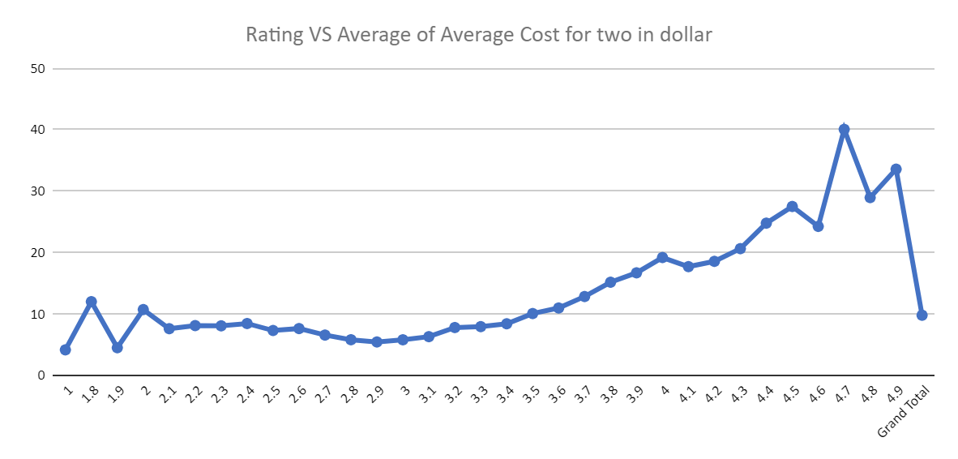

9. What is the distribution of the number of restaurants of different price ranges in all the countries?

**Answer – The distribution of the number of restaurants of different price ranges in all the countries are as follows.**

* **Analytical Approach:**
* **I employed a Pivot table, focusing on the price range in rows and the count of restaurant IDs in the values.**
* **Insights:**
* **Our findings reveal that lower price ranges have a significantly higher number of restaurants.**
* **This suggests a concentration of dining options in the more affordable price brackets.**
* **Visualization:**
* **A “Histogram” can effectively representation of the distribution across various price ranges.**
* **Distribution of Restaurants in Different Price Ranges:**

| **Price range** | **Total country** |
| --- | --- |
| 1-2' | 4444 |
| 2-3' | 3113 |
| 3-4' | 1408 |
| 4-5' | 586 |
| Grand Total | 9551 |

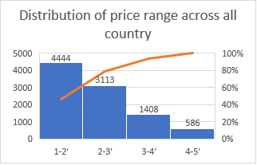

**Reference - In the Excel sheet named “Price range distribution”**

**the pivot table that Suggesting the distribution of price range across all country.**

10. Explain your approach in brief for suggesting countries/cities in order to open new restaurants, if the objective and subjective questions would have been given to assist you. [you have to give bullet pointers in order to answer this question]

**Answer –**

* **Data Exploration:**
* **Utilize pivot tables to analyses the existing restaurant data, focusing on various factors such as country, city, cuisine, average rating, and competition level.**
* **Identify Low Competition Areas:**
* **Filter the data to identify countries and cities with fewer existing restaurants, indicating lower competition in the market.**
* **Consider Average Ratings:**
* **Evaluate the average ratings of restaurants in each country and city to understand the quality of competition and customer preferences.**
* **Strategic Recommendations:**
* **Based on the analysis, recommend countries and cities where the competition is low and average ratings are below a certain threshold (e.g., 4 stars). These areas present opportunities for new restaurant ventures.**
* **Visual Representation:**
* **Use visualizations such as pivot charts, line graphs, and histograms to present the findings effectively and justify the recommendations.**
* **Culinary Preferences:**
* **Consider the cuisines that are popular in each suggested location and align them with the preferences of the local population. This ensures better feedback and customer satisfaction.**
* **Financial Considerations:**
* **Evaluate the current expenditure on food in the suggested countries to ensure financial viability and control over expenses.**
* **Competitor Analysis:**
* **Identify the biggest competitors and low-rated restaurants in the recommended areas to understand the market landscape and potential challenges.**
* **Correlation Analysis:**
* **Explore the relationship between restaurant ratings, cuisine prices, and other factors to make informed decisions regarding pricing strategies and menu offerings.**
* **Strategic Adjustments:**
* **Based on the insights gathered from the analysis, make strategic adjustments to the restaurant's offerings, pricing, and services to maximize success in the selected locations.**

**By following this approach, the recommendations for opening new restaurants will be data-driven, strategic, and aligned with the objectives of maximizing competitiveness and customer satisfaction.**