//tao solution

dotnet new sln -n DatingApp

//tao project web api

dotnet new webapi -n DatingApp.API -o DatingApp.API

//add project vao sln

dotnet sln add DatingApp.API

//vao projec

code DatingApp.API

dotnet add package Microsoft.EntityFrameworkCore

dotnet add package Microsoft.EntityFrameworkCore.Design

dotnet add package Microsoft.EntityFrameworkCore.SqlServer

dotnet tool update --global dotnet-ef

Nếu không có dotnet-ef

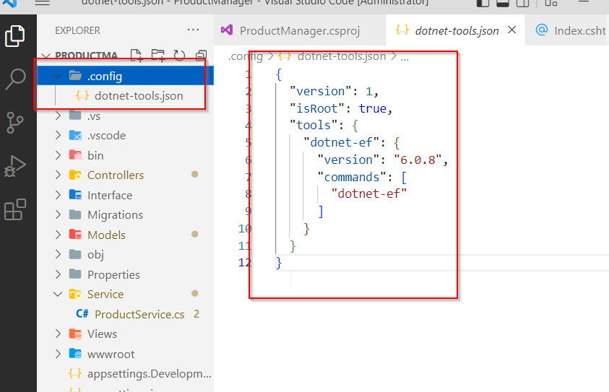

dotnet tool restore

**Migrations**

dotnet ef migrations add InitialDb -o Data/Migrations

dotnet ef database update