Hydrogen Storage Vessel Simulation — Results
Generated against 'H2 Zeolite Vessel Simulation Spec.docx'. Predictive simulation; no physical H₂ testing was performed.

1. Adsorption Isotherms
Equilibrium capacity at -78 °C for each of the four samples, Langmuir model with q_st = 6 kJ/mol.
# | Sample | q_max (wt%) | 1 bar | 5 bar | 10 bar
1 | Ca-activated powder (5A (CaA)) | 1.4098 | 0.00153 | 0.00763 | 0.01517
2 | Regular powder (4A (NaA)) | 1.0574 | 0.00115 | 0.00572 | 0.01138
3 | Ca-activated granule (5A (CaA)) | 1.0114 | 0.00110 | 0.00547 | 0.01088
4 | Regular granule (4A (NaA)) | 0.7586 | 0.00082 | 0.00410 | 0.00816
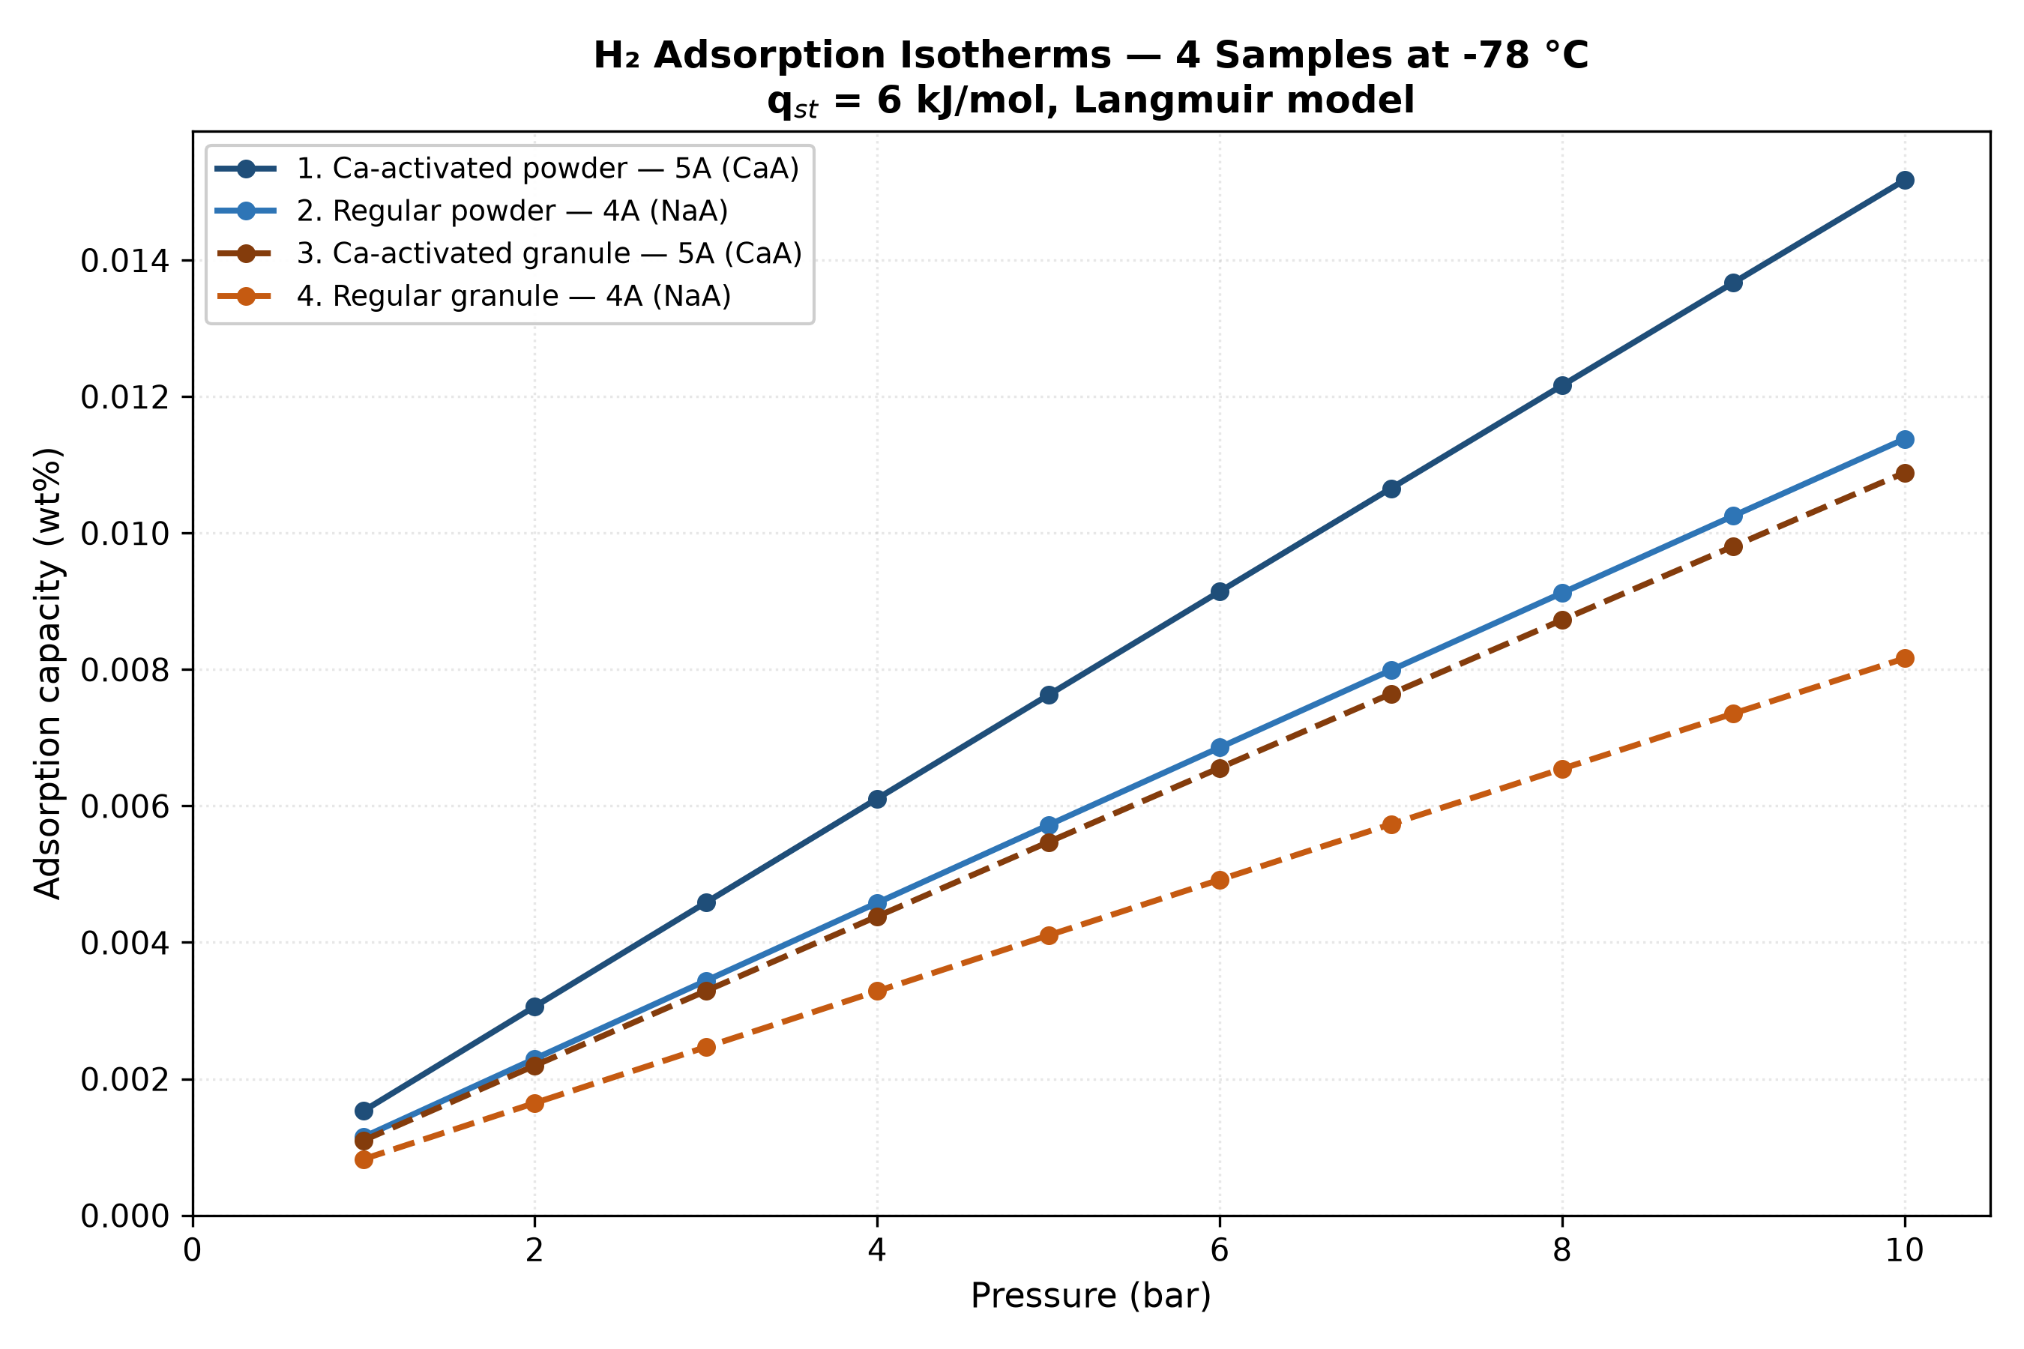

2. Duty Cycle Performance
# | Sample | Charged (g) | Working (g) | Peak P (bar) | % of DOE
1 | Ca-activated powder | 0.01896 | 0.01862 | 19.12 | 0.276%
2 | Regular powder | 0.01422 | 0.01396 | 19.00 | 0.207%
3 | Ca-activated granule | 0.01361 | 0.01336 | 18.96 | 0.198%
4 | Regular granule | 0.01020 | 0.01002 | 18.87 | 0.148%
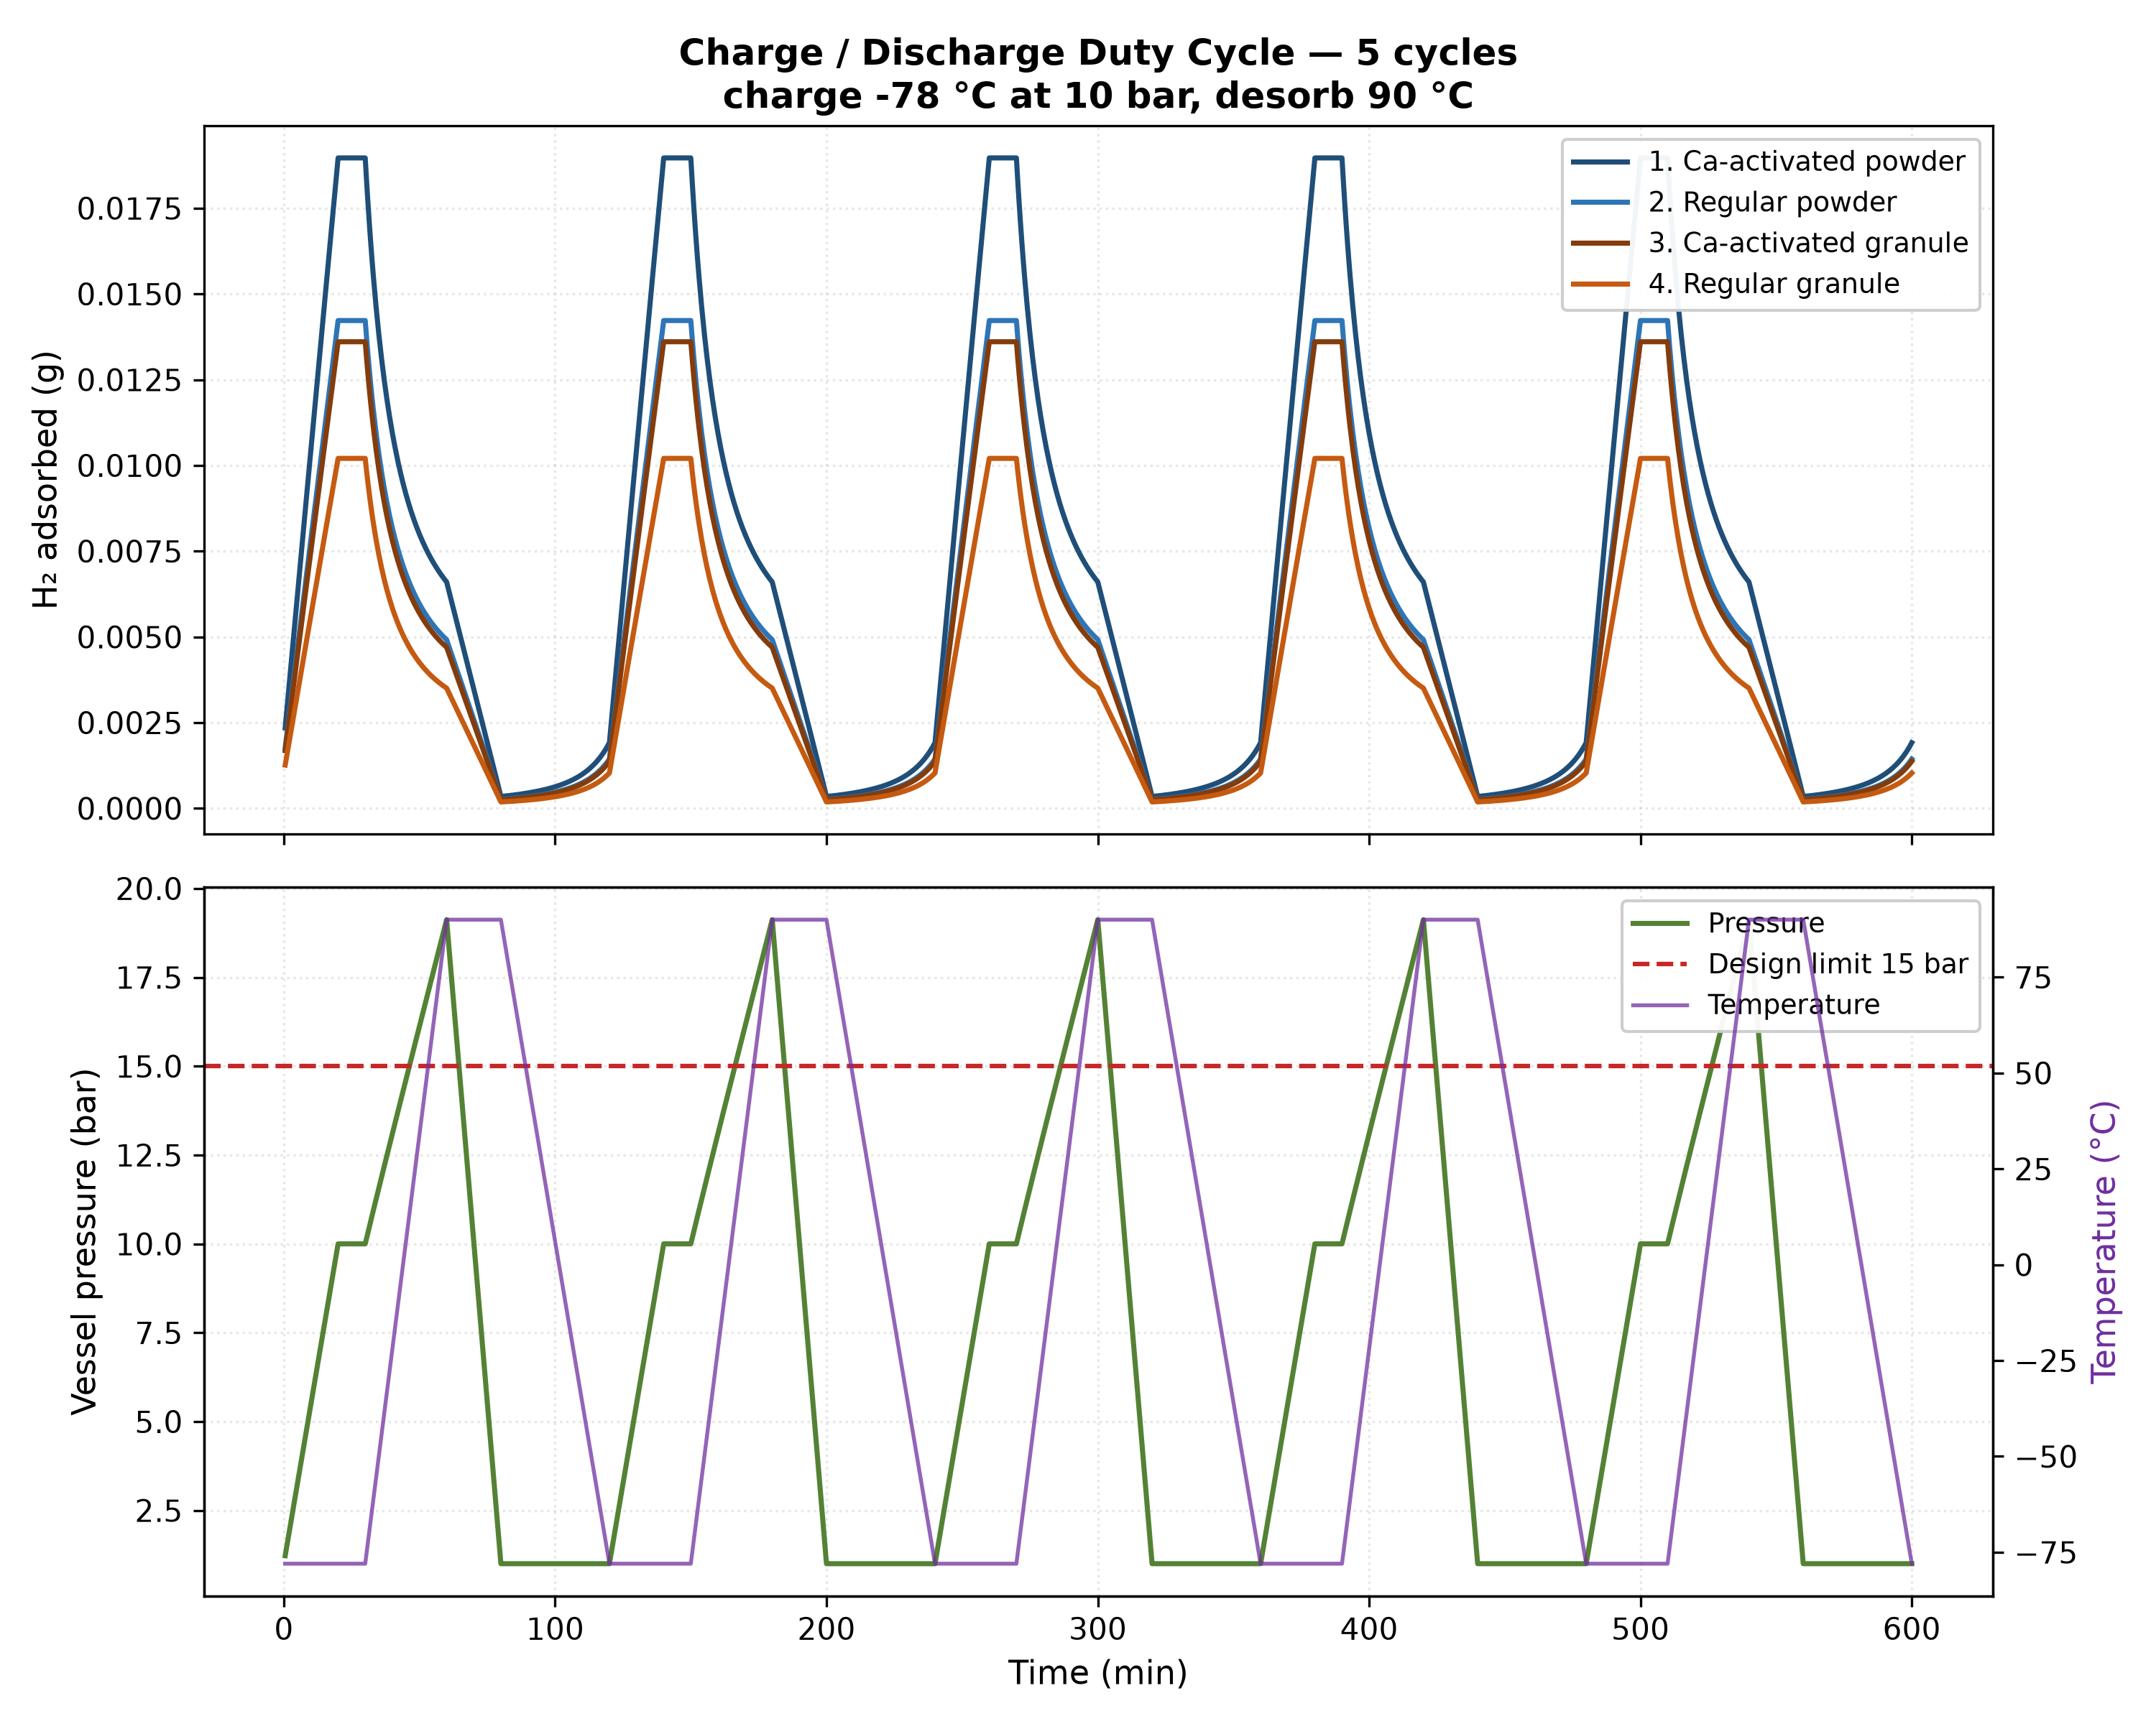

3. Findings the Specification Does Not Anticipate

Peak pressure exceeds the vessel design rating
Heating a sealed vessel from -78 °C to 90 °C at 10 bar raises pressure to 19.1 bar, against the 15 bar design rating in Section 3. Gas-law expansion alone accounts for most of it; desorbed hydrogen adds the rest. Either the outlet must be open during heating, the charge pressure reduced, or the rating raised. This is a safety item, not a modelling artefact.

Storage is dominated by compressed gas, not adsorption
At the charged state the best sample holds 0.0190 g by adsorption against 0.4481 g as free gas in the void volume — adsorption contributes only 4.1%. The sorbent is not doing the storage work at this temperature.

Distance from the DOE target
The best sample reaches 0.0152 wt%, which is 0.28% of the 5.5 wt% target named in Section 1. This is the expected result for physisorption above 77 K and should be stated directly rather than presented as a shortfall to explain away.

Cycles are identical by construction
No degradation mechanism is specified. With instantaneous equilibrium and no fade term, all five cycles return exactly the same numbers. The capacity-vs-cycle plot is therefore flat by definition and demonstrates nothing about durability. A measured or literature fade rate is needed before that plot carries meaning.

