Chapter 4: Results and Discussion

4.1 Introduction
This chapter presents and discusses the results obtained from the development and evaluation of the risk-aware visual inspection prototype. The analysis considers both model-level anomaly detection performance and the behaviour of the wider operational pipeline. This distinction is important because a detector that performs well at image classification may not necessarily produce the strongest localisation masks or the lowest workload for human operators.
The experiments were conducted using the bottle, capsule and hazelnut categories of the MVTec AD dataset. PatchCore and PaDiM were evaluated as the principal anomaly detection architectures because both methods can learn normal product appearance using defect-free training images. However, they represent normality differently. PatchCore stores representative normal patch embeddings in a memory bank and applies nearest-neighbour distance during inference, whereas PaDiM models the normal embeddings at each spatial location using multivariate Gaussian distributions (Defard et al., 2021; Roth et al., 2022).
The results are discussed in four main stages. First, the implemented inspection pipeline is summarised to establish how the individual components were connected. Second, the tested anomaly detection architectures and backbone configurations are compared using image-level AUROC and F1-score. Third, the selected architectures are evaluated within the integrated pipeline using classification, localisation and human-review measures. Finally, the operational implementation is examined through the PostgreSQL audit database, FastAPI backend, NiceGUI dashboard, quality-disposition logic and evidence-linked operator review workflow.
The chapter therefore evaluates the project at both algorithmic and application levels. This makes it possible to determine not only which architecture detected anomalies most effectively, but also how the resulting evidence supported traceable and risk-aware quality-control decisions.

4.2 Overview of the Implemented Inspection Pipeline
The completed prototype implemented the main stages defined in the project methodology. Images were first ingested and passed to the selected anomaly detector. PatchCore or PaDiM then produced an image-level anomaly score and a pixel-level anomaly map. The anomaly map was normalised and converted into a binary mask using a configurable threshold, after which morphological processing and connected-component analysis were applied to identify coherent anomalous regions.
The localisation outputs were passed to a constrained semantic interpretation stage. This stage used a fixed defect taxonomy rather than generating unrestricted descriptions. The resulting semantic label, anomaly confidence and localisation evidence were then used by the risk-classification and confidence-fusion components. Cases with low confidence, uncertain semantics, incomplete risk mappings or high risk were routed for operator review.
The risk-governed quality-disposition layer translated the available evidence into an operational recommendation. Possible outcomes included pass, reinspect, hold, quarantine, release after review, reject after review and engineering review. These recommendations did not actuate physical production equipment. Instead, they demonstrated the software-side decision logic that could later be connected to a programmable logic controller, manufacturing execution system or robotic sorting mechanism following further validation.
Inspection results were stored in PostgreSQL, together with operator-review decisions and supporting evidence. FastAPI provided structured access to the database and quality-disposition functions, while NiceGUI supplied the operator-facing interface. The final dashboard linked each selected inspection record to its annotated image, heatmap overlay, predicted mask and anomaly map. This provided a traceable connection between the model response, operator interpretation and final quality decision.
The completed workflow therefore extended beyond offline anomaly classification. It combined model inference, localisation, semantic interpretation, risk reasoning, confidence-based review gating, persistent audit storage and evidence-supported human decision-making within one modular prototype.

4.3 Anomaly Detection Architecture Comparison

4.3.1 Experimental configurations
The architecture comparison examined whether the choice of feature-extraction backbone affected the image-level performance of PatchCore and PaDiM. PatchCore was evaluated using ResNet18, ResNet50 and WideResNet50-2. PaDiM was tested using ResNet18 with its default feature configuration and ResNet50 with 100 retained features.
All configurations were evaluated on the same bottle, capsule and hazelnut test sets. The principal metrics were image-level AUROC and image-level F1-score. AUROC measured the ability of the anomaly score to rank defective samples above normal samples across decision thresholds, while F1-score measured the balance between precision and recall at the selected operating threshold.
Table 4.1: Image-level architecture comparison across the selected MVTec AD categories
Category | Model | Backbone | Retained features | Image AUROC | Image F1-score
Bottle | PatchCore | ResNet18 | Not applicable | 1.0000 | 0.9920
Bottle | PatchCore | ResNet50 | Not applicable | 1.0000 | 0.9920
Bottle | PatchCore | WideResNet50-2 | Not applicable | 1.0000 | 0.9920
Bottle | PaDiM | ResNet18 | Default | 0.9976 | 0.9839
Bottle | PaDiM | ResNet50 | 100 | 0.9952 | 0.9841
Capsule | PatchCore | ResNet18 | Not applicable | 0.9817 | 0.9767
Capsule | PatchCore | ResNet50 | Not applicable | 0.9936 | 0.9818
Capsule | PatchCore | WideResNet50-2 | Not applicable | 0.9932 | 0.9770
Capsule | PaDiM | ResNet18 | Default | 0.8975 | 0.9463
Capsule | PaDiM | ResNet50 | 100 | 0.9110 | 0.9469
Hazelnut | PatchCore | ResNet18 | Not applicable | 0.9986 | 0.9787
Hazelnut | PatchCore | ResNet50 | Not applicable | 1.0000 | 0.9928
Hazelnut | PatchCore | WideResNet50-2 | Not applicable | 1.0000 | 0.9928
Hazelnut | PaDiM | ResNet18 | Default | 0.7954 | 0.8330
Hazelnut | PaDiM | ResNet50 | 100 | 0.7761 | 0.7831

4.3.2 PatchCore performance
PatchCore produced the strongest image-level results across the evaluated categories. All three PatchCore backbones achieved an AUROC of 1.0000 and an F1-score of approximately 0.9920 on bottle. This indicates that bottle anomalies were clearly separated from normal samples and that backbone selection had little measurable effect for this category.
Greater variation was observed for capsule. PatchCore with ResNet18 achieved an AUROC of 0.9817 and an F1-score of 0.9767. Replacing the backbone with ResNet50 increased the AUROC to 0.9936 and the F1-score to 0.9818. WideResNet50-2 achieved a similar AUROC of 0.9932, but its F1-score of 0.9770 was lower than that obtained with ResNet50. The capsule results therefore provided the clearest evidence that increasing feature-representation capacity could improve anomaly separation, although the widest tested network did not automatically produce the strongest classification balance.
For hazelnut, PatchCore with ResNet18 achieved an AUROC of 0.9986 and an F1-score of 0.9787. Both ResNet50 and WideResNet50-2 increased the AUROC to 1.0000 and the F1-score to 0.9928. The results show that the deeper backbones improved performance over ResNet18, but WideResNet50-2 did not provide an additional measurable advantage over ResNet50.
Overall, the PatchCore results suggest that its memory-bank representation was effective at preserving the local normal patterns required to identify subtle product deviations. The method consistently achieved high image-level scores despite differences in object geometry and defect appearance across the three categories.

4.3.3 PaDiM performance
PaDiM performed strongly on bottle but showed greater category sensitivity than PatchCore. With ResNet18, PaDiM achieved an AUROC of 0.9976 and an F1-score of 0.9839. The ResNet50 configuration achieved an AUROC of 0.9952 and a slightly higher F1-score of 0.9841. These values were close to the PatchCore results, indicating that both normality-modelling approaches were effective for the bottle category.
The difference between the methods became more pronounced for capsule. PaDiM with ResNet18 achieved an AUROC of 0.8975 and an F1-score of 0.9463. The ResNet50 configuration increased AUROC to 0.9110, but the F1-score remained broadly unchanged at 0.9469. Although the deeper backbone improved anomaly ranking, it did not substantially improve the final classification balance.
Hazelnut was the most difficult category for PaDiM. ResNet18 produced an AUROC of 0.7954 and an F1-score of 0.8330, while ResNet50 with 100 retained features reduced these values to 0.7761 and 0.7831 respectively. The reduced performance indicates that the chosen Gaussian feature model and dimensional configuration did not capture the normal hazelnut feature distribution as effectively as PatchCore’s representative memory bank.
The PaDiM results should not be interpreted as evidence that the method lacked value within the project. Its image-level classification performance was weaker on capsule and hazelnut, but it initially produced better default localisation masks across the three categories. PaDiM therefore remained useful as a comparative detector and localisation reference.

4.3.4 Cross-category interpretation
Figure 4.1 presents the architecture comparison across all three categories. The visual comparison shows that the PatchCore configurations remained consistently close to the upper limit of the scoring range, whereas PaDiM performance varied more substantially by category.
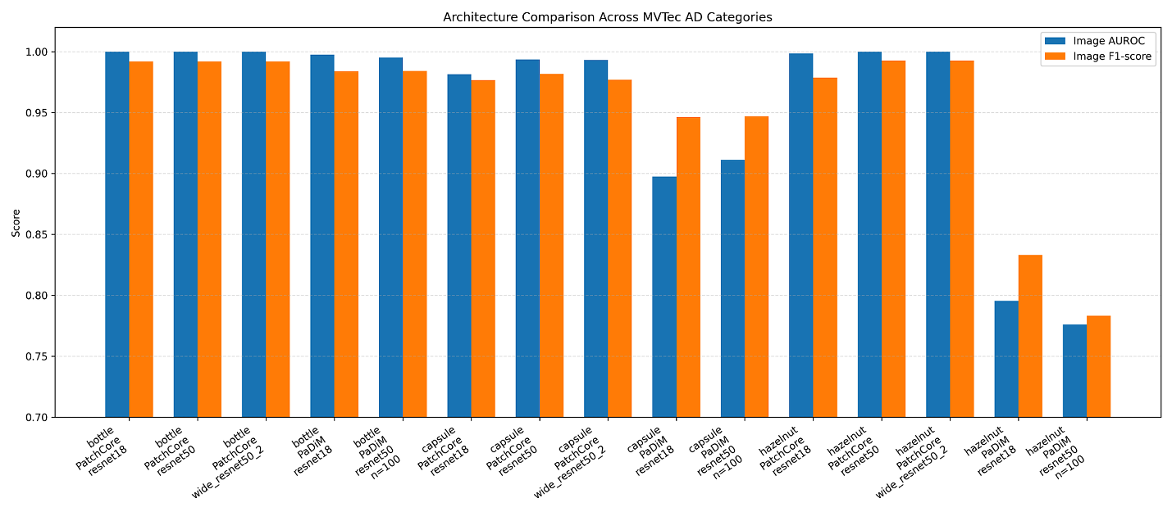
Figure 4.1: Image-level AUROC and F1-score for the evaluated PatchCore and PaDiM architectures across bottle, capsule and hazelnut.
The results also demonstrate that a larger backbone did not always guarantee improved performance. WideResNet50-2 matched ResNet50 on bottle and hazelnut but produced a lower F1-score on capsule. Similarly, PaDiM with ResNet50 improved capsule AUROC but reduced performance on hazelnut. Model selection was therefore based on consistency across categories rather than network size alone.
The comparison supports the use of PatchCore as the principal image-level detection branch of the risk-aware inspection pipeline. However, the later localisation results show that model selection cannot be based only on image-level AUROC and F1-score. Classification performance, localisation quality and operational review behaviour must be considered separately.

4.4 Selection of the Preferred Detection Architecture
PatchCore with ResNet50 was selected as the preferred image-level anomaly detection configuration for the completed prototype. This choice was based on its overall balance across the three evaluated categories rather than on a single category result.
For bottle, ResNet50 matched the best result obtained by the other PatchCore backbones, with an AUROC of 1.0000 and an F1-score of approximately 0.9920. For capsule, it produced the strongest tested combination, with an AUROC of 0.9936 and an F1-score of 0.9818. For hazelnut, it again matched the best result, achieving an AUROC of 1.0000 and an F1-score of 0.9928. No alternative configuration exceeded it consistently across the complete experiment.
WideResNet50-2 did not provide a sufficient advantage to justify its additional architectural capacity. It matched ResNet50 on bottle and hazelnut but produced a lower capsule F1-score. ResNet18 required fewer computational resources but was weaker on capsule and hazelnut. ResNet50 therefore provided the most appropriate compromise between feature quality, consistency and computational complexity for the available CPU-based environment.
The selection does not mean that PaDiM was removed from the project. Both PatchCore and PaDiM were used as anomaly detection architectures, and both contributed to the evaluation of the pipeline. PatchCore was selected as the preferred image-level detector because it produced the strongest and most consistent classification results. PaDiM remained an important comparative baseline and provided evidence that image-level detection strength does not always correspond directly to default pixel-level mask alignment.
This outcome is consistent with the different normality representations used by the two approaches. PatchCore compares test patches directly with representative normal embeddings retained in a coreset memory bank, which enables it to preserve diverse normal feature patterns and identify poorly represented test regions (Roth et al., 2022). PaDiM instead approximates normal patch embeddings through location-specific Gaussian distributions and Mahalanobis distance (Defard et al., 2021). This provides a compact statistical representation but may be less effective when the normal feature distribution is complex or when anomalous features overlap with normal variation.
The final architecture was therefore selected through empirical comparison rather than assumed suitability. PatchCore with ResNet50 provided the strongest basis for image-level decision-making and remained compatible with the localisation, semantic interpretation, confidence fusion, risk classification, human-review gating and quality-disposition stages of the wider prototype.

4.5 Integrated Image-Level Detection Results
The architecture comparison in Section 4.3 evaluated the anomaly detection models using Anomalib’s image-level AUROC and F1-score outputs. A separate evaluation was conducted after the detector outputs were integrated into the wider risk-aware inspection pipeline. This second evaluation included accuracy, precision, recall, F1-score and human-review rate.
These results should be interpreted as pipeline-level outcomes rather than a repetition of the controlled backbone comparison. The integrated evaluation measured how the detector predictions behaved after being connected to the thresholding, semantic interpretation, confidence fusion and review-gating stages.

4.5.1 Bottle results
Table 4.2 presents the integrated results for the bottle and hazelnut categories.
Table 4.2: Integrated image-level detection and review results
Category | Detector | Accuracy | Precision | Recall | F1-score | Human-review rate
Bottle | Statistical original | 0.5904 | 1.0000 | 0.4603 | 0.6304 | 0.5181
Bottle | Statistical tuned 0.7 | 0.8795 | 0.8955 | 0.9524 | 0.9231 | 0.7711
Bottle | PatchCore integrated | 0.9880 | 1.0000 | 0.9841 | 0.9920 | 0.1928
Bottle | PaDiM integrated | 0.9518 | 0.9538 | 0.9841 | 0.9688 | 0.6867
Hazelnut | Statistical original | 0.4364 | 0.8333 | 0.1429 | 0.2439 | 0.2273
Hazelnut | Statistical tuned 0.7 | 0.5545 | 0.6567 | 0.6286 | 0.6423 | 0.7636
Hazelnut | PatchCore integrated | 0.9909 | 1.0000 | 0.9857 | 0.9928 | 0.1727
Hazelnut | PaDiM integrated | 0.7182 | 0.6970 | 0.9857 | 0.8166 | 0.9000

For bottle, the original statistical detector achieved a precision of 1.0000 but a recall of only 0.4603. This indicates that the detector generated no false-positive classifications in the reported run but failed to identify a substantial proportion of the anomalous images. Its resulting F1-score was 0.6304.
Adjusting the statistical threshold to 0.7 improved recall to 0.9524 and increased the F1-score to 0.9231. However, the human-review rate also increased from 0.5181 to 0.7711. The improvement in classification performance therefore did not translate into a reduction in operator workload. Instead, a larger proportion of records satisfied one or more of the downstream review conditions.
PatchCore produced the strongest integrated bottle result. It achieved an accuracy of 0.9880, precision of 1.0000, recall of 0.9841 and an F1-score of 0.9920. Its human-review rate was 0.1928, meaning that fewer than one fifth of the bottle records were routed for manual review.
PaDiM achieved the same recall as PatchCore, at 0.9841, but its precision was lower at 0.9538. This reduced its F1-score to 0.9688. More importantly for the operational pipeline, PaDiM produced a human-review rate of 0.6867. Although the model identified nearly all anomalous bottle images, its lower precision and downstream uncertainty resulted in a substantially larger review workload.
The bottle results therefore show that recall alone was not sufficient for model selection. PatchCore and PaDiM achieved equal recall, but PatchCore combined this with perfect precision in the reported evaluation and a much lower human-review rate.

4.5.2 Hazelnut results
The distinction between PatchCore and PaDiM was more pronounced for hazelnut. The original statistical detector achieved a recall of only 0.1429 and an F1-score of 0.2439. Although its precision was 0.8333, the low recall indicates that most anomalous hazelnut samples were not detected.
Threshold tuning improved the statistical detector’s recall to 0.6286 and its F1-score to 0.6423. However, its human-review rate increased to 0.7636. This again demonstrates that improving the classification threshold did not necessarily improve the efficiency of the full inspection workflow.
PatchCore achieved an accuracy of 0.9909, precision of 1.0000, recall of 0.9857 and an F1-score of 0.9928. Its human-review rate was 0.1727, which was the lowest result among the tested integrated hazelnut configurations.
PaDiM also achieved a high recall of 0.9857, but its precision was 0.6970. This combination produced an F1-score of 0.8166. The human-review rate reached 0.9000, meaning that nine out of every ten PaDiM hazelnut records required operator review.
The high recall and comparatively low precision indicate that PaDiM was sensitive to hazelnut anomalies but also generated a larger number of false-positive responses. This behaviour is particularly important in an industrial context because false-positive detections may interrupt production, increase inspection time and place unnecessary demands on quality-control personnel.

4.5.3 Cross-category operational interpretation
Across bottle and hazelnut, PatchCore produced the strongest balance between detection performance and review efficiency. It achieved F1-scores above 0.99 in both categories and human-review rates below 0.20.
PaDiM maintained high recall but produced lower precision and much higher review rates, especially for hazelnut. This shows that a model may appear effective when judged mainly by its ability to detect anomalous items, yet still be less suitable operationally if it sends a large proportion of normal or uncertain cases to human reviewers.
The comparison also demonstrates the value of evaluating the complete inspection pipeline rather than relying only on model-level AUROC. The architecture comparison measured the quality of anomaly ranking and classification, whereas the integrated evaluation showed the effect of detector outputs on the wider semantic, confidence and governance stages.
These findings support the selection of PatchCore as the preferred image-level detection architecture. Its advantage was not limited to classification accuracy; it also reduced the workload transferred to the operator-review stage.

4.6 Localisation Performance
Image-level detection identifies whether an image is likely to contain an anomaly, but it does not measure whether the detected region corresponds accurately with the physical defect. Pixel-level localisation was therefore evaluated separately using Intersection over Union and the Dice coefficient.
Table 4.3 presents the localisation results obtained using the original mask-generation thresholds.
Table 4.3: Default localisation performance
Category | Model | Mean IoU | Mean Dice | Median IoU | Median Dice
Bottle | PatchCore | 0.3472 | 0.4928 | 0.3480 | 0.5164
Bottle | PaDiM | 0.4968 | 0.6442 | 0.4930 | 0.6604
Hazelnut | PatchCore | 0.1456 | 0.2316 | 0.1070 | 0.1933
Hazelnut | PaDiM | 0.3084 | 0.4444 | 0.3168 | 0.4811
Capsule | PatchCore | 0.1068 | 0.1671 | 0.0450 | 0.0862
Capsule | PaDiM | 0.1731 | 0.2673 | 0.1365 | 0.2403

4.6.1 Bottle localisation
Bottle produced the strongest default localisation results. PaDiM achieved a mean IoU of 0.4968 and a mean Dice score of 0.6442. PatchCore achieved a lower mean IoU of 0.3472 and mean Dice score of 0.4928.
The median results followed the same pattern. PaDiM achieved a median IoU of 0.4930 and median Dice score of 0.6604, compared with 0.3480 and 0.5164 for PatchCore. The similarity between the mean and median values suggests that the bottle results were not dominated by a small number of unusually high or low cases.

4.6.2 Hazelnut localisation
Localisation was more difficult for hazelnut. PaDiM achieved a mean IoU of 0.3084 and mean Dice score of 0.4444, whereas PatchCore achieved 0.1456 and 0.2316 respectively.
PatchCore’s median IoU of 0.1070 was lower than its mean IoU, indicating that several images produced weak spatial overlap and that a smaller number of stronger results increased the mean. PaDiM produced a median IoU of 0.3168, which was close to its mean and suggested more consistent mask alignment.

4.6.3 Capsule localisation
Capsule produced the lowest default localisation scores for both models. PatchCore achieved a mean IoU of 0.1068 and mean Dice score of 0.1671. PaDiM improved these values to 0.1731 and 0.2673.
The low scores are consistent with the visual characteristics of the capsule defects. Several defect types are small, narrow or visually subtle, making accurate binary-mask overlap more difficult. A predicted anomaly region may identify the correct general area while still extending beyond the comparatively small ground-truth mask.

4.6.4 Comparison of image-level and pixel-level performance
The default localisation results reveal an important trade-off. PatchCore was clearly stronger at image-level anomaly detection and produced lower human-review rates, while PaDiM produced better initial mask alignment across all three categories.
This difference shows that image-level and pixel-level performance measure distinct capabilities. A model may correctly determine that an image is anomalous without precisely matching the labelled defect boundary. Conversely, a model may produce useful spatial evidence but generate less reliable image-level decisions.
PaDiM’s location-specific Gaussian modelling may have contributed to its stronger default spatial alignment because deviations were evaluated relative to the expected features at each image position (Defard et al., 2021). However, the results also depended on how each continuous anomaly map was converted into a binary mask. The threshold optimisation experiments were therefore necessary before drawing a final conclusion about localisation quality.

4.7 Localisation Threshold Optimisation
The default localisation comparison used the original thresholds applied during mask generation. A threshold sweep was subsequently conducted to determine whether the continuous anomaly maps contained useful spatial information that was not captured by the initial binary conversion.
Separate thresholds were evaluated for each model and category. The threshold that produced the highest localisation overlap was retained for comparison. Table 4.4 summarises the best mean IoU and Dice results.
Table 4.4: Localisation performance after threshold optimisation
Category | Model | Best threshold | Mean IoU | Mean Dice
Bottle | PatchCore | 0.70 | 0.5929 | 0.7322
Bottle | PaDiM | 0.35 | 0.5110 | 0.6612
Hazelnut | PatchCore | 0.80 | 0.4331 | 0.5854
Hazelnut | PaDiM | 0.50 | 0.3340 | 0.4693
Capsule | PatchCore | 0.85 | 0.2979 | 0.4311
Capsule | PaDiM | 0.55 | 0.1830 | 0.2751

4.7.1 Bottle threshold optimisation
PatchCore bottle localisation improved from a mean IoU of 0.3472 to 0.5929 after the threshold was set to 0.70. Its mean Dice score increased from 0.4928 to 0.7322.
PaDiM improved more modestly. At a threshold of 0.35, its mean IoU increased from 0.4968 to 0.5110 and its mean Dice score increased from 0.6442 to 0.6612.
After optimisation, PatchCore exceeded PaDiM on both mean IoU and mean Dice. The result indicates that PatchCore’s anomaly map contained useful bottle localisation information, but the original threshold selected too much or too little of the response region.

4.7.2 Hazelnut threshold optimisation
PatchCore showed a substantial improvement on hazelnut. At a threshold of 0.80, its mean IoU increased from 0.1456 to 0.4331, while its mean Dice score increased from 0.2316 to 0.5854.
PaDiM achieved a best mean IoU of 0.3340 and mean Dice score of 0.4693 at a threshold of 0.50. These values improved upon its default results but remained below the tuned PatchCore scores.
The large change in PatchCore performance demonstrates that the original hazelnut threshold was not well matched to the distribution of its anomaly-map values. Once the stronger responses were isolated using a higher threshold, the predicted regions aligned more closely with the ground-truth defects.

4.7.3 Capsule threshold optimisation
Capsule remained the most difficult category, but PatchCore again benefited substantially from tuning. At a threshold of 0.85, its mean IoU increased from 0.1068 to 0.2979 and its mean Dice score increased from 0.1671 to 0.4311.
PaDiM achieved a smaller improvement at a threshold of 0.55. Its mean IoU increased from 0.1731 to 0.1830 and its mean Dice score increased from 0.2673 to 0.2751.
Although the tuned capsule results remained lower than those for bottle and hazelnut, PatchCore produced the stronger final overlap. This supports the interpretation that its anomaly maps identified relevant capsule regions but required a more selective threshold to prevent the binary masks from extending beyond the defect area.

4.7.4 Implications of threshold tuning
After threshold optimisation, PatchCore achieved the strongest mean localisation results across all three categories. This reversed the ordering observed under the default thresholds.
The result demonstrates that anomaly-map quality and binary-mask quality should not be treated as identical. A continuous map may contain useful spatial evidence even when the first threshold applied to it produces weak overlap. Post-processing parameters therefore form an important part of the localisation pipeline and should be evaluated independently of the underlying anomaly detector.
The category-specific best thresholds also show that one universal threshold was not optimal. Bottle required a PatchCore threshold of 0.70, hazelnut required 0.80 and capsule required 0.85. This variation reflects differences in anomaly-map intensity, defect size and object appearance.
However, the tuned scores should be interpreted with care because the thresholds were selected using the available ground-truth masks. This demonstrates the attainable benefit of calibration, but it may provide an optimistic estimate if the same images are used both to select and report the threshold. In a production study, threshold selection should be performed on a separate validation set and then evaluated on previously unseen test images.

4.8 Semantic Interpretation and Review Workload
The semantic stage mapped localisation evidence to a constrained defect taxonomy. Where the evidence was insufficient, the system returned an unknown label and routed the record for review. This behaviour reduced the risk of assigning an unsupported defect description but increased the number of cases requiring operator intervention.
A category-specific semantic fallback rule was introduced for capsule to reduce unnecessary unknown labels where the available evidence supported a broader permitted defect category. The anomaly detector was not retrained, and its classification output did not change.
Table 4.5 compares the capsule review rates before and after the semantic fallback was introduced.
The F1-scores in Table 4.5 are the integrated capsule results and are reported separately from the model-level architecture scores in Table 4.1.
Table 4.5: Effect of the capsule semantic fallback on human-review workload
Detector | Integrated F1-score | Review rate before | Review rate after
PatchCore capsule | 0.9815 | 0.6818 | 0.5152
PaDiM capsule | 0.9432 | 0.8712 | 0.8409

For PatchCore, the review rate decreased from 0.6818 to 0.5152, a reduction of 0.1666, or 16.66 percentage points. The detector-level F1-score remained unchanged at 0.9815.
For PaDiM, the review rate decreased from 0.8712 to 0.8409, a reduction of 3.03 percentage points. Its F1-score remained unchanged at 0.9432.
These results show that operational performance could be improved without changing the anomaly detector. The reduction occurred within the semantic and governance stages because fewer records were assigned an unresolved semantic state.
The larger reduction for PatchCore suggests that a greater proportion of its capsule review cases were caused by semantic uncertainty that could be resolved through the constrained fallback. PaDiM retained a much higher review rate, indicating that additional factors, including detector uncertainty or localisation behaviour, continued to trigger review.
The fallback rule was deliberately constrained. It did not generate arbitrary defect labels or suppress review in cases where the evidence remained weak. This was necessary because reducing review workload should not come at the cost of unsupported automatic decisions.
The final capsule review rates also remained consistent with the broader operational pattern. PatchCore required review for 51.52% of capsule records, compared with 84.09% for PaDiM. Capsule therefore remained more demanding than bottle and hazelnut, but the semantic update reduced the workload presented to the operator.

4.9 Risk-Governed Quality Disposition
The anomaly detection output was not treated as the final quality-control decision. Instead, the implemented risk-governed disposition layer combined the anomaly result, localised evidence, semantic interpretation, confidence values, risk classification and any available operator review to determine an appropriate operational recommendation.
The initial disposition depended on the evidence available at the time of inspection. Records with sufficiently strong and consistent evidence could receive outcomes such as PASS or PASS_WITH_MONITORING. Cases involving low confidence, an unknown semantic label, an incomplete risk mapping or a high-risk classification were assigned REVIEW_REQUIRED, HOLD, QUARANTINE or ENGINEERING_REVIEW, depending on the configured conditions.
This design prevented the anomaly detector from making an irreversible production decision on its own. The detector identified deviations from normal appearance, but the governance layer determined how that evidence should be handled within the prototype inspection process.
An operator review could subsequently modify the final disposition. For example, a record initially routed for review could be marked as a false-positive detection after examination of its supporting images. The system then changed the recommendation to RELEASE_AFTER_REVIEW. A confirmed defect could instead remain on hold or be assigned a reject-related action.
The capsule demonstration provided a representative example. The selected record was initially routed for review because its fused confidence was below the operational threshold and its semantic label remained unknown. After the operator inspected the annotated image, heatmap, predicted mask and anomaly map, the case was recorded as a false-positive release. The final quality-assurance action was consequently changed to RELEASE_AFTER_REVIEW.
This behaviour demonstrates the value of separating anomaly detection from quality disposition. A visually unusual region does not always represent a production defect requiring rejection. By preserving the original detector response while storing the operator’s decision separately, the system retained both model evidence and human judgement within the audit trail.

4.10 PostgreSQL Audit Database Validation
PostgreSQL was used to provide persistent and queryable storage for the inspection results. The completed database contained 650 inspection records generated from PatchCore and PaDiM experiments across bottle, capsule and hazelnut.
Table 4.6 summarises the number of stored records and those requiring operator review.
Table 4.6: PostgreSQL inspection-record and review summary
Category | Model | Inspection records | Requires review | Review rate
Bottle | PaDiM | 83 | 57 | 0.6867
Bottle | PatchCore | 83 | 16 | 0.1928
Capsule | PaDiM | 132 | 111 | 0.8409
Capsule | PatchCore | 132 | 68 | 0.5152
Hazelnut | PaDiM | 110 | 99 | 0.9000
Hazelnut | PatchCore | 110 | 19 | 0.1727
Total | All models | 650 | 370 | 0.5692

The database totals were consistent with the individual experiment results. PatchCore produced substantially fewer review-required records than PaDiM in each category. The difference was smallest for capsule, which remained the most demanding category for both models, and largest for hazelnut, where 90.00% of the PaDiM records required review compared with 17.27% for PatchCore.
The overall review rate was approximately 56.92%, although this aggregate value combines both models and should not be interpreted as the review workload of the selected final configuration. The more relevant operational result was that PatchCore reduced review demand consistently across the evaluated categories.
The database schema preserved the principal inspection fields, including the image identifier, product category, model name, semantic label, risk class, fused confidence and review requirement. Additional localisation, confidence and configuration evidence was retained within a structured JSONB payload.
Operator reviews were stored in a related table linked to the original inspection record by a foreign key. This allowed the initial automated assessment and subsequent human decision to remain distinct while still forming one traceable inspection history.
The PostgreSQL service was deployed through Docker Compose. Service-status checks confirmed that the PostgreSQL 16 container was running and healthy on the configured host port. The successful persistence and retrieval of all 650 records showed that the audit layer was functioning as intended.
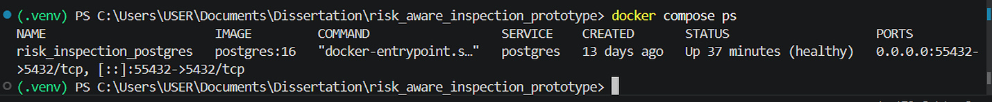
Figure 4.2: Docker Compose service status confirming the healthy PostgreSQL audit database.

4.11 FastAPI and NiceGUI Operational Validation

4.11.1 FastAPI backend
The FastAPI backend exposed the database and decision-support functions through a structured set of HTTP endpoints. These included health checking, record retrieval, individual record lookup, QA-decision retrieval, operator-review submission and database-summary reporting.
The /health endpoint returned a successful status, confirmed the PostgreSQL connection and reported the presence of 650 inspection records. This provided a direct operational check that the backend and database were communicating correctly.
The automatically generated OpenAPI interface displayed the implemented routes:
- GET /health;
- GET /records;
- GET /records/{record_id};
- GET /records/{record_id}/qa-decision;
- POST /reviews;
- GET /summary.
The API documentation demonstrated that the operational functions were not embedded solely within the graphical interface. They were exposed through a reusable backend layer that could support an alternative dashboard, external client or future integration with a manufacturing information system.
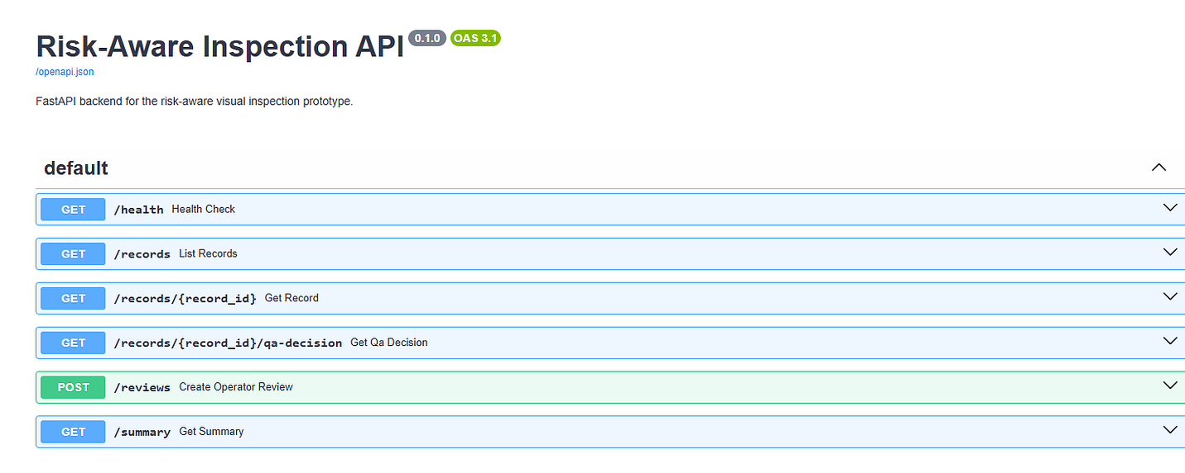
Figure 4.3: Automatically generated OpenAPI documentation for the risk-aware inspection backend.

4.11.2 NiceGUI dashboard
The NiceGUI dashboard provided the operator-facing layer of the prototype. It connected to the same PostgreSQL audit database and displayed the number of records and review-required cases for each product category and model.
The summary view showed all 650 inspection records. Its values agreed with the database queries and experiment results, providing evidence that the graphical interface was retrieving stored records rather than displaying manually entered values.
The dashboard also allowed an individual record to be loaded using its database identifier. Once selected, the interface displayed the image identifier, product category, anomaly model, semantic label, risk class, fused confidence, review requirement and reasons for escalation.
The quality-assurance section presented the current disposition and explained whether further operator action was required. Where a review had already been saved, the latest operator decision, reviewer identifier and note were displayed alongside the automated recommendation.
The completed interface therefore provided more than a record viewer. It connected anomaly evidence, governance rules and operator decisions within a single inspection workflow.
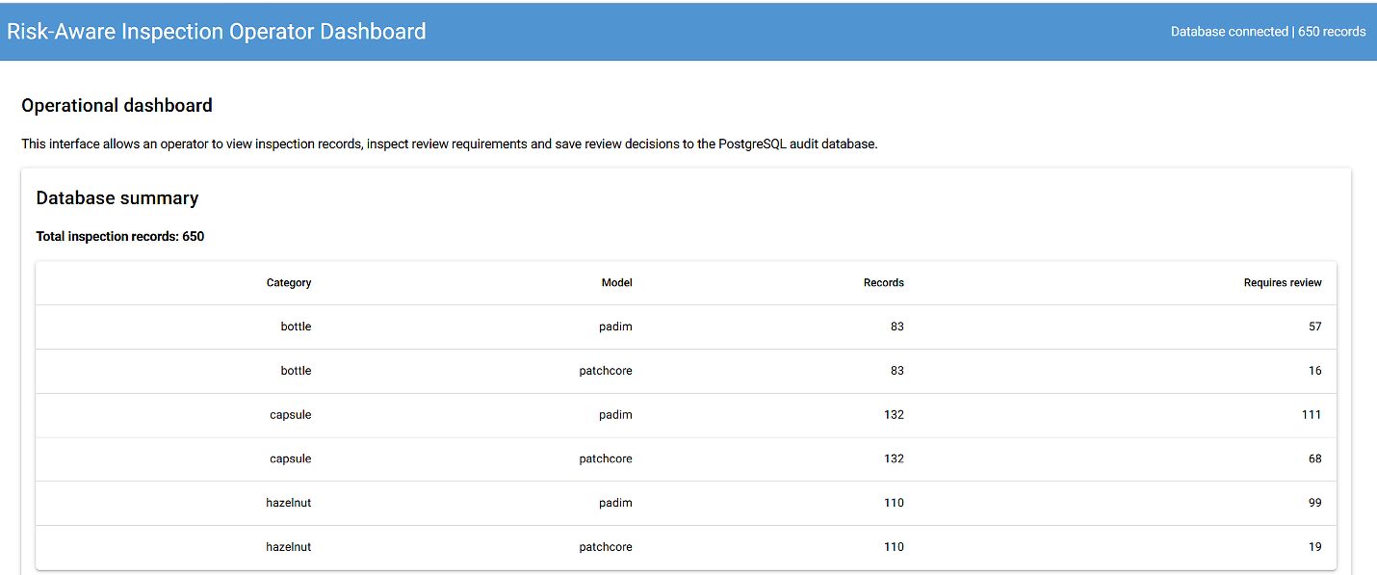
Figure 4.4: NiceGUI dashboard showing the PostgreSQL inspection-record summary by category and anomaly detection model.
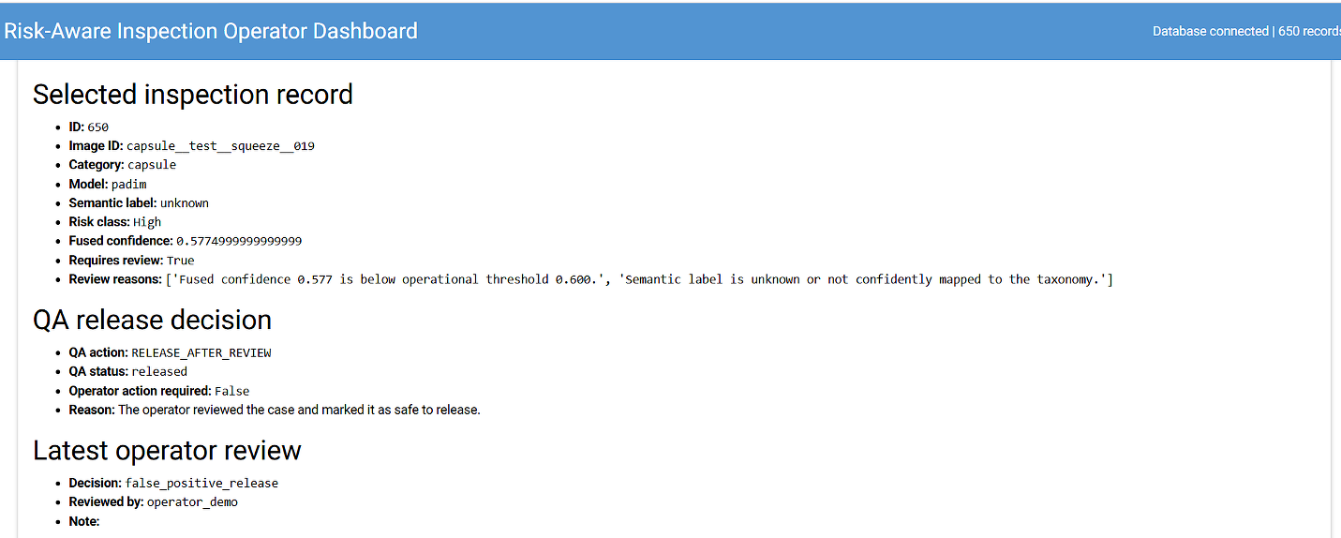
Figure 4.5: Selected capsule inspection record showing the risk-governed QA disposition and latest operator review.

4.12 Evidence-Linked Operator Review
The evidence-linked review panel was implemented to ensure that an operator did not have to make a decision using numerical scores alone. For the selected record, the dashboard located and displayed the associated visual artefacts generated by the pipeline.
The displayed evidence included:
- the annotated inspection image;
- the anomaly heatmap overlay;
- the predicted binary mask;
- the continuous anomaly map.
The annotated image identified the region selected by the localisation stage and displayed its associated confidence. The heatmap overlay showed the spatial distribution of the anomaly response over the original image. The predicted mask displayed the region retained after thresholding and morphological processing, while the anomaly map exposed the underlying continuous detector response.
The capsule example showed that the principal anomaly response was concentrated towards one end of the product. Viewing the different representations together allowed the operator to determine whether the highlighted area corresponded to a meaningful production defect, a benign visual variation or an overly sensitive model response.
This evidence was particularly important for false-positive handling. The operator could inspect the model response before selecting a decision such as false-positive release, confirmed defect or escalation for engineering review. Once saved, the decision was linked to the original database record and influenced the final QA disposition.
The evidence panel therefore established a traceable sequence from model prediction to human decision:
- the detector generated an anomaly score and map;
- the localisation stage identified a candidate region;
- the semantic and risk stages determined whether review was required;
- the dashboard displayed the supporting visual evidence;
- the operator recorded a decision;
- the decision was saved in PostgreSQL;
- the QA disposition was recalculated.
This feature addressed an important limitation of purely automated inspection. Rather than presenting an unexplained pass or fail outcome, the prototype exposed the evidence used to support the recommendation.
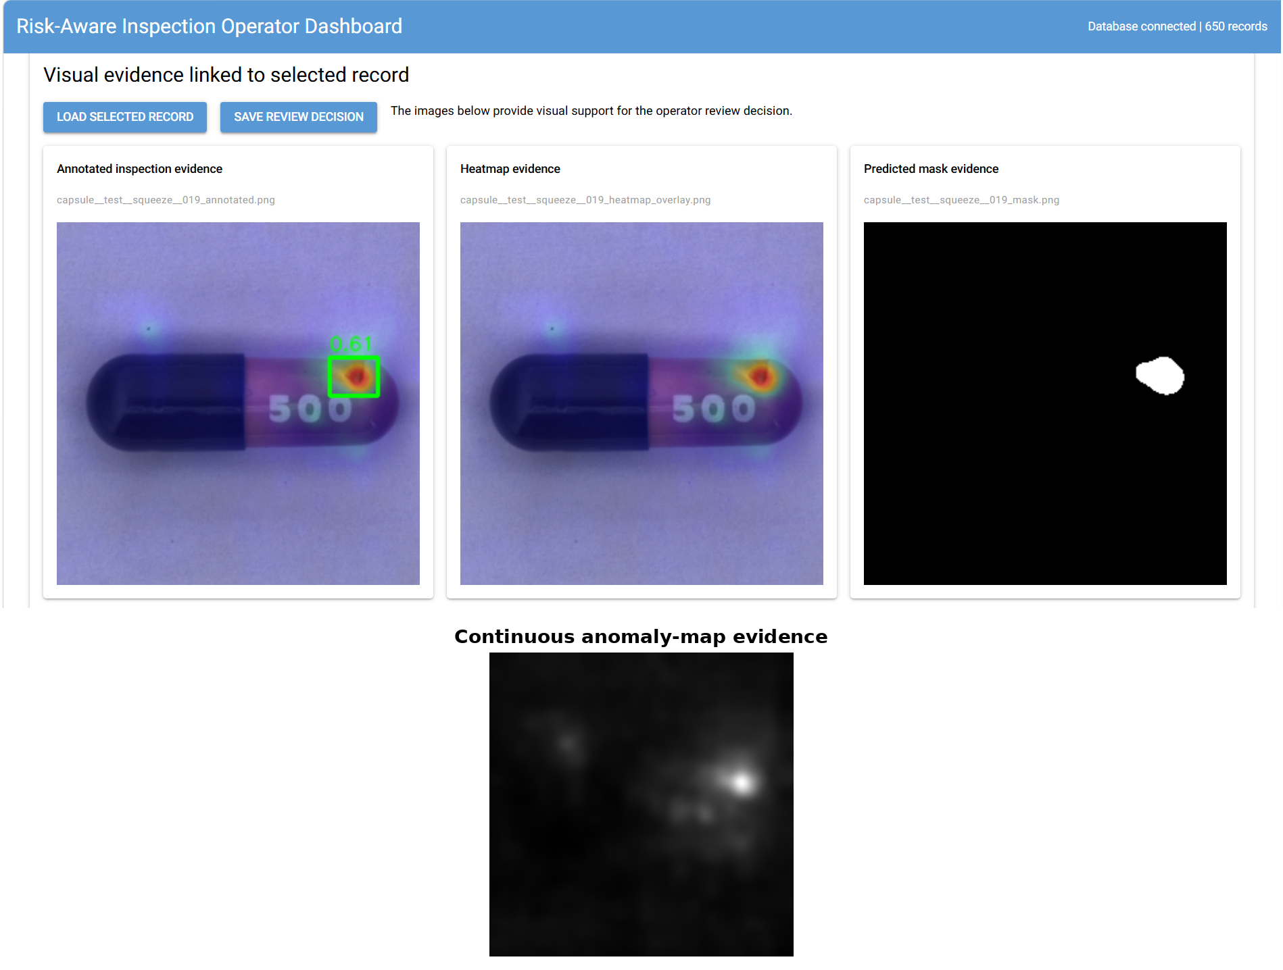
Figure 4.6: Evidence-linked operator review panel showing annotated, heatmap, mask and anomaly-map evidence for a capsule inspection record.

4.13 Scalability and Operational Relevance
The completed prototype demonstrated that anomaly detection could be connected to a wider quality-control workflow using modular software components. The detector, localisation, semantic interpretation, risk logic, audit database, API and dashboard were separated sufficiently for individual components to be modified without redesigning the entire system.
This modularity provides a basis for future scaling. The selected PatchCore detector could be replaced with an exported or accelerated implementation while retaining the database and operator-review functions. Similarly, the NiceGUI interface could be replaced by an industrial human–machine interface while continuing to use the FastAPI service.
The use of PostgreSQL provided a stronger basis for scaling than local CSV or JSON files alone. Database indexes supported filtering by fields such as category, model name, risk class and review requirement. The JSONB payload also allowed additional experiment evidence to be retained without frequent schema changes.
Docker Compose improved repeatability by separating the PostgreSQL service from the Python environments. This reduced local configuration differences and provided clear commands for service startup, health checking and shutdown.
The prototype was executed on a CPU-based computer with an Intel Core i5-8250U processor and approximately 8 GB of RAM. The successful completion of the experiments demonstrated that the workflow could be evaluated without specialised GPU hardware. However, the measured experiment times should not be interpreted as evidence of production-line throughput.
A production implementation would require benchmarking under the intended camera resolution, inspection frequency and maximum acceptable response time. GPU acceleration, model export, batch optimisation or edge-computing hardware may be required where rapid continuous inspection is expected.
The architecture comparison also has practical relevance. WideResNet50-2 did not produce a consistent performance advantage over ResNet50. Selecting ResNet50 therefore avoided adopting additional architectural capacity without measurable benefit across the complete set of experiments.

4.14 Limitations
Several limitations should be considered when interpreting the results.
First, the quantitative evaluation used only three MVTec AD categories. Bottle, capsule and hazelnut provided useful variation in product geometry and defect appearance, but they do not represent all industrial inspection conditions. The findings cannot therefore be generalised automatically to other materials, production processes or camera arrangements.
Second, the experiments used a public benchmark rather than images captured from a live production line. MVTec AD provides controlled and reproducible data, but real manufacturing environments may include changes in illumination, vibration, product orientation, lens contamination and background appearance.
Third, the architecture and threshold comparisons were carried out on a CPU-only workstation. Although this demonstrated accessibility, it limited the scope of latency and throughput testing. No claim is made that the current implementation satisfies real-time industrial timing requirements.
Fourth, the localisation threshold optimisation used the available ground-truth masks to identify the best threshold for each category and model. These results demonstrate the potential value contained within the anomaly maps, but they may be optimistic if the same samples contributed to both threshold selection and reported performance. A larger study should use separate calibration and test partitions.
Fifth, the semantic interpretation stage used engineered visual evidence and a constrained taxonomy. This supported traceability but did not provide the detailed defect recognition capability of a separately trained semantic classifier. The fallback rules were category specific and would require further validation before being transferred to new product types.
Sixth, the risk matrix represented a prototype policy rather than a manufacturer-approved Failure Modes and Effects Analysis. The assigned risk classes and disposition rules would need to be reviewed by domain specialists before operational deployment.
Seventh, operator interaction was demonstrated through controlled review examples rather than a formal user study. The interface was shown to function technically, but usability, decision time, reviewer consistency and operator trust were not measured experimentally.
Finally, the prototype did not control physical production equipment. Its outputs were recommendations and database records. Integration with a conveyor, reject mechanism, programmable logic controller or manufacturing execution system would require additional safety, cybersecurity and failure-recovery validation.
These limitations do not invalidate the reported results, but they define the scope within which the conclusions should be understood.

4.15 Chapter Summary
This chapter evaluated the anomaly detection models and the completed risk-aware inspection prototype at model, localisation and operational levels.
The architecture comparison showed that PatchCore produced the strongest image-level anomaly detection results across bottle, capsule and hazelnut. PatchCore with ResNet50 provided the best overall balance, matching the strongest result on bottle, producing the strongest capsule result and matching the strongest hazelnut result. It was therefore selected as the preferred image-level detector.
PaDiM remained competitive on bottle but produced lower image-level performance on capsule and hazelnut. It nevertheless achieved stronger localisation under the original mask-generation thresholds, demonstrating that image-level classification and pixel-level localisation represent different aspects of anomaly detection performance.
Threshold optimisation changed the localisation comparison. PatchCore improved substantially and achieved the strongest tuned mean IoU and Dice results across all three categories. This showed that its anomaly maps contained useful spatial information that was not captured by the original binary thresholds.
The integrated experiments further demonstrated that PatchCore reduced human-review workload. Its review rates were lower than those of PaDiM across bottle, capsule and hazelnut. The capsule semantic fallback produced an additional reduction without retraining or changing the detector-level F1-score.
The operational implementation was validated using 650 PostgreSQL inspection records. FastAPI exposed the database and QA-decision functions, while NiceGUI provided record summaries, selected-record inspection, review submission and evidence display. The evidence-linked panel connected annotated images, heatmaps, predicted masks and anomaly maps to operator decisions and final quality dispositions.
Overall, the results show that detector selection should not be based on one metric alone. Image-level performance, localisation, threshold calibration, semantic uncertainty and human-review workload all affected the suitability of the final system. PatchCore with ResNet50 provided the strongest overall basis for the implemented risk-aware inspection pipeline, while PaDiM remained a useful comparison and localisation reference.

