**Example at the bottom**

**Group Name: Big Dollar Bills**

**Agenda**

1. Finish lab 1

**Meeting on 16/3/2021, 20:00**

Location: Lab

Duration: 3

**Attendees**:

|  |  |  |  |
| --- | --- | --- | --- |
| Jay Zhang | Marco Tupaz | Ethan Susanto |  |
|  |  |  |  |

**Apologies:**

**Minutes**

1. Task 1 Completed
   1. Comments still need to be added
2. Task 2
   1. 70%
   2. Jay and Ethan to work on
3. READ ME
   1. Marco
4. Task 3
   1. Part 1 pretty much done
   2. Parts 2 and 3 to be done

**Action Items**

|  |  |  |
| --- | --- | --- |
| **Action** | **Person to do** | **Deadline** |
| Comment exercise 1 | Marco and Jay |  |
| Finish exercise 3 | Marco and Ethan |  |
| Finish exercise 2 | Jay and Ethan |  |
| READ ME | Marco |  |
| Comment all code | All |  |

**16/02/21 10:00-** [**https://uni-sydney.zoom.us/j/9328**](https://uni-sydney.zoom.us/j/93287055349)

**Previous Action Items**

|  |  |
| --- | --- |
| **Action** | **Outcome** |
| Admin stuff for getting access to the ACFR lab. | Returned signed form to Lesley |
| Fix ITS polygons | Fixed by changing the launch file and crop box. |
| Quantitative analysis of results. Could compare the speeds of the human driver to the existing virtual bumper/path planning code. Then compare to the new results with my program. | Done, images below |
| Print speeds onto the video | Done |
| Check which point source is being used to generate the polygons. Should be in a launch file. There should be a filtered pointcloud.  Virtual bumper, standalone launch. Set the x from -5 to 1 or 2. The points input doesn’t include the filtered PC without the roof yet.  Take a look into all the point clouds. | The launch file uses just the raw, unprocessed ‘points’. |
| Merge updated virtual bumper code | Not doing this for now, could merge is as a new branch. |

**Agenda**

1. Additional things that happened this week:
   1. A
2. Please explain how to read these launch files. Don’t understand nodelets.
3. How will performance at night be handled/discussed?
4. Just saw the filtered point cloud… very different yea. Everything makes a lot more sense.
5. How to pass the pipeline?
6. Noticed that there’s a problem with the virtual bumper/polygon generation where it can’t handle road inclines. Causes the ground to get picked up.
7. Advice for closing out this internship.

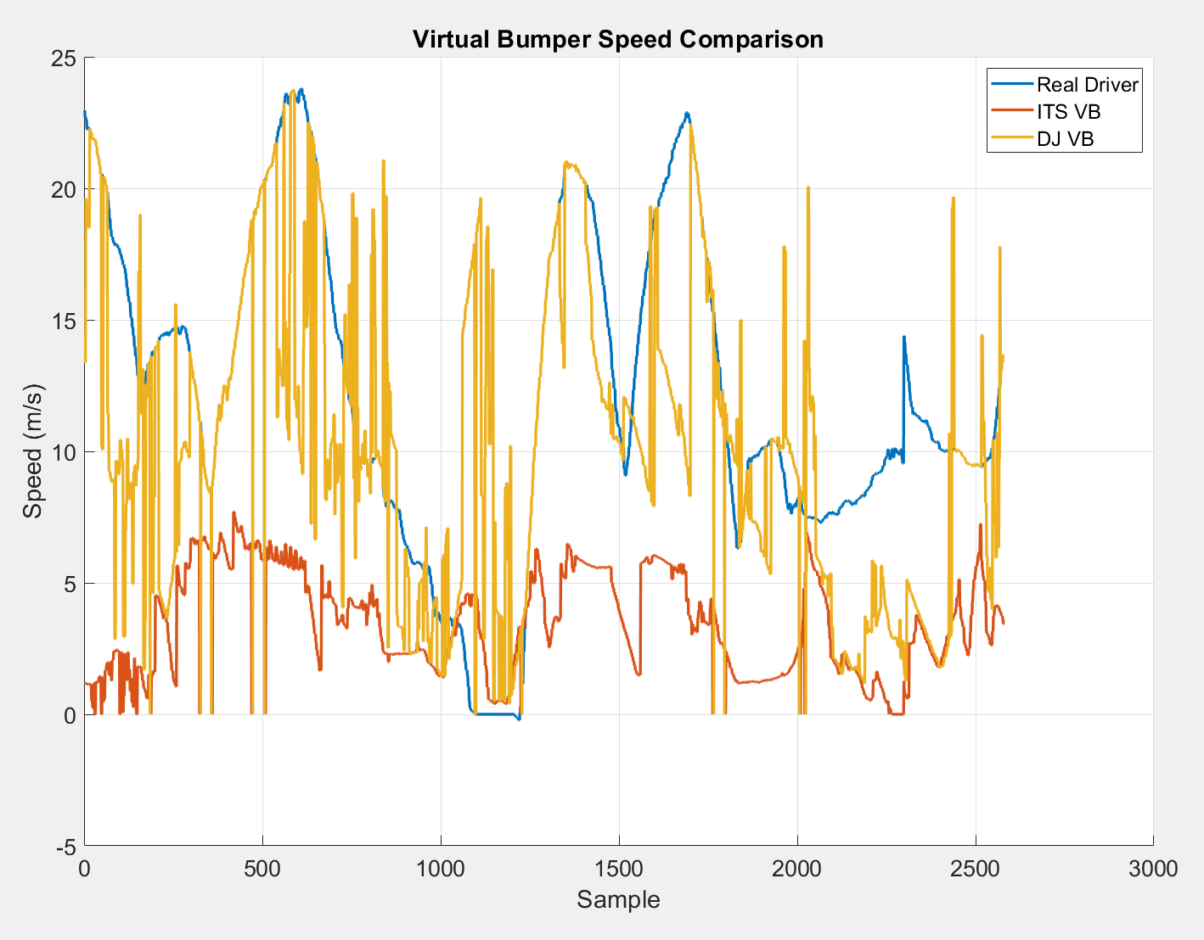

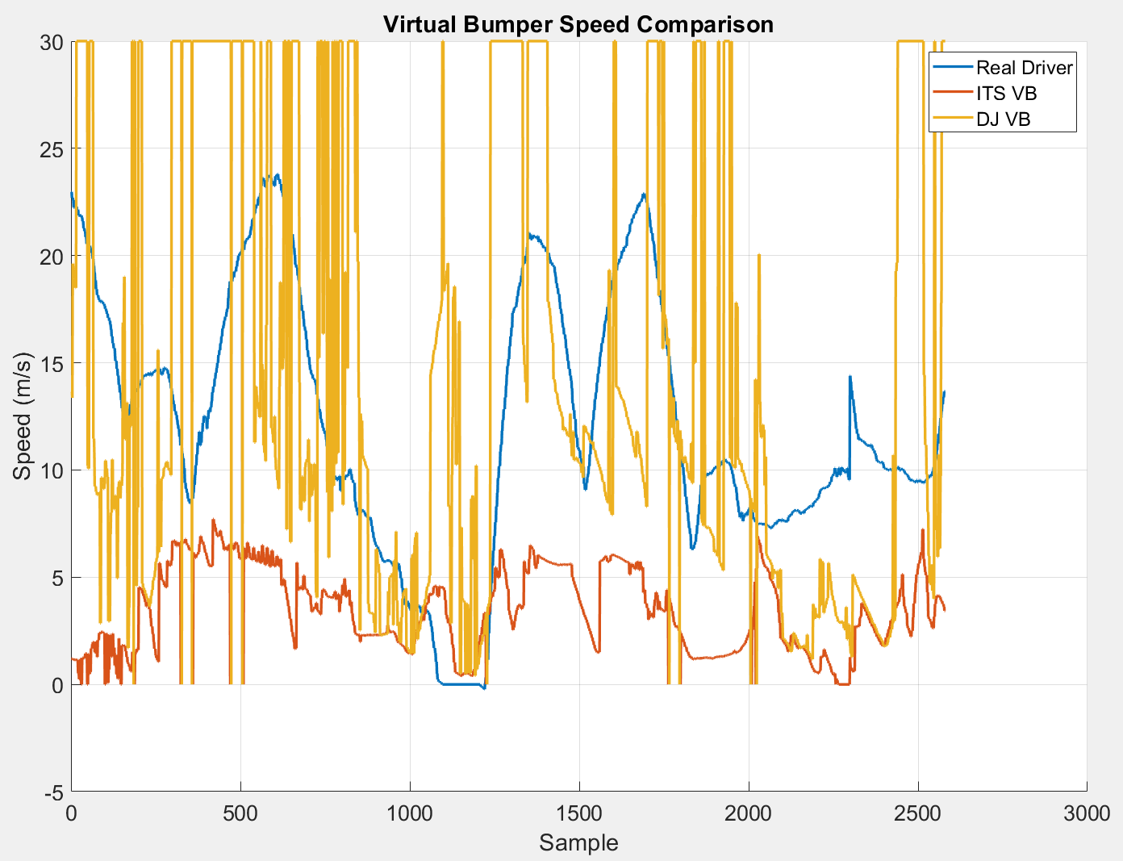

**Minutes**

1. **Additional things that happened this week:**
2. **Implement a filter of sorts** 
   1. Could apply weights to different distances
   2. Filter out High speeds, keep all low speeds. Conservative.
3. Fix the timeout related problems with the virtual bumper. Either publish empty messages or otherwise.
4. Deploy it on the car and test things qualitatively.
   1. Start thinking of some possible scenarios to put the car through.
5. Internship stuff
   1. Exit interview
   2. How great a time I had, what skills I got out of it, what was good, what could be improved.
6. Nodelets
   1. Only one node, the nodelet manager. Everything else is a plugin. Have to start a nodelet manager, then add the nodelets. The manager has a name, and the plugins have an argument of the manager name.
7. Could possibly get it formatted into a paper?
   1. Couple conferences that they publish to. ITSC is one, they’re also quite broad.
   2. Challenges with the page limit
   3. Summarise my contribution.
   4. Submission date is end of March (31st)
8. One way to achieve real time is to decouple the speed from the path planning.
   1. Analysis of my work on the virtual bumper
   2. How does it quantitatively compare with the path planning.
9. Passing the pipeline:
   1. Don’t think it’s my fault, re-ran the pipeline and it’s all good

**Action Items**

|  |
| --- |
| Re-implement the video annotation as a new node. |
| Implement a conservative filter for the virtual bumper speeds to smooth out the results |
| Think of some ways/topics to write a paper on. |
| Look into nodelets a bit more |
| Write one more section of the method. |
| Fix up the problem where the virtual bumper latches the last message, because of no timeouts. |
|  |
|  |

**Things to do later**

|  |  |
| --- | --- |
| Change the virtual bumper decision making to consider the actual path travelled by the vehicle, not just the projection. This would be a very post processing thing, want to give the system knowledge of what the human was thinking… so that the virtual bumper can properly factor in things like, we plan to drive around this person/object, so don’t need to slow down as much. |  |
| Ablation study of how the system performs with and without sections. |  |
| Figure out purging | Waiting for someone else to try it... |