****Report: Analysis of Electric Vehicle (EV) Sales, Charging Infrastructure, and Consumption****

### ****Introduction****

India is witnessing a rapid shift towards electric vehicles (EVs) as part of its commitment to sustainable development and reducing greenhouse gas emissions.

The report presents an analysis of electric vehicle (EV) infrastructure and sales trends in India for the year 2024. The study focuses on the distribution of EV charging stations across regions, yearly EV sales across various vehicle categories, and the relative share of infrastructure among regions. The objective is to derive insights into regional disparities, infrastructure adequacy, and sales growth trends in the EV sector.

#### ****Objectives****

* Analyze EV adoption trends across different vehicle types (2-wheelers, 3-wheelers, 4-wheelers, and buses).
* Study the relationship between EV charging infrastructure and electricity consumption.
* Identify key growth trends and market share distribution.
* Provide actionable insights for policymakers, industry stakeholders, and investors.

#### ****Data Overview****

**Datasets:**

**Electricity Consumption Dataset-Contains state**-level data on electricity usage (in Million Units - MU) for EVs and Heavy-Duty vehicles, along with the total electricity consumption.

**Public Charging Stations Dataset**-Details the number of operational PCS across Indian states.

**EV Sales data**-Contains data related to 2,3,4 wheeler and bus sales for years 2018 to 2024

#### ****Analysis and Insights****

##### ****1.EV Adoption Trends****

The stacked area chart highlights the growth of EVs in India across fiscal years (FY18 to FY24). Key observations include:

* Exponential Growth: EV adoption, particularly for 2-wheelers and 3-wheelers, has shown substantial growth. For instance, 2-wheelers saw an 87.6% CAGR over six years, driven by affordability, government incentives, and improved charging infrastructure.
* Buses and 4-Wheelers: Adoption rates for buses and 4-wheelers are lower but show steady progress, especially in FY23-FY24.

**Growth Rates (FY23 to FY24):**

* 2-Wheelers: 29.7%
* 3-Wheelers: 57.4%
* 4-Wheelers: 90.4%
* Buses: 86.1%

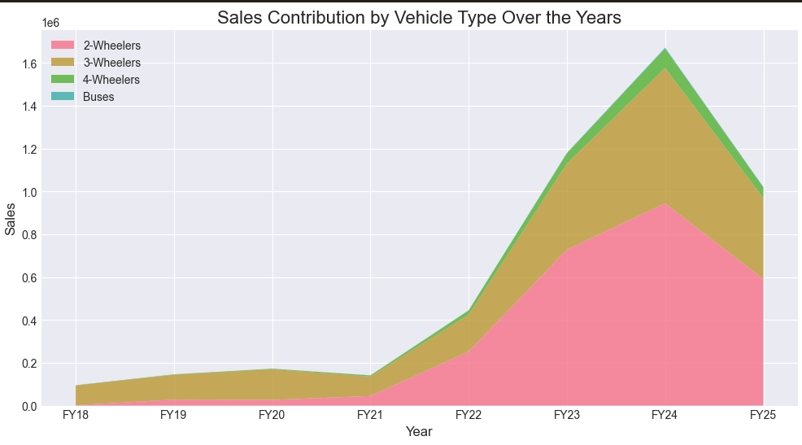

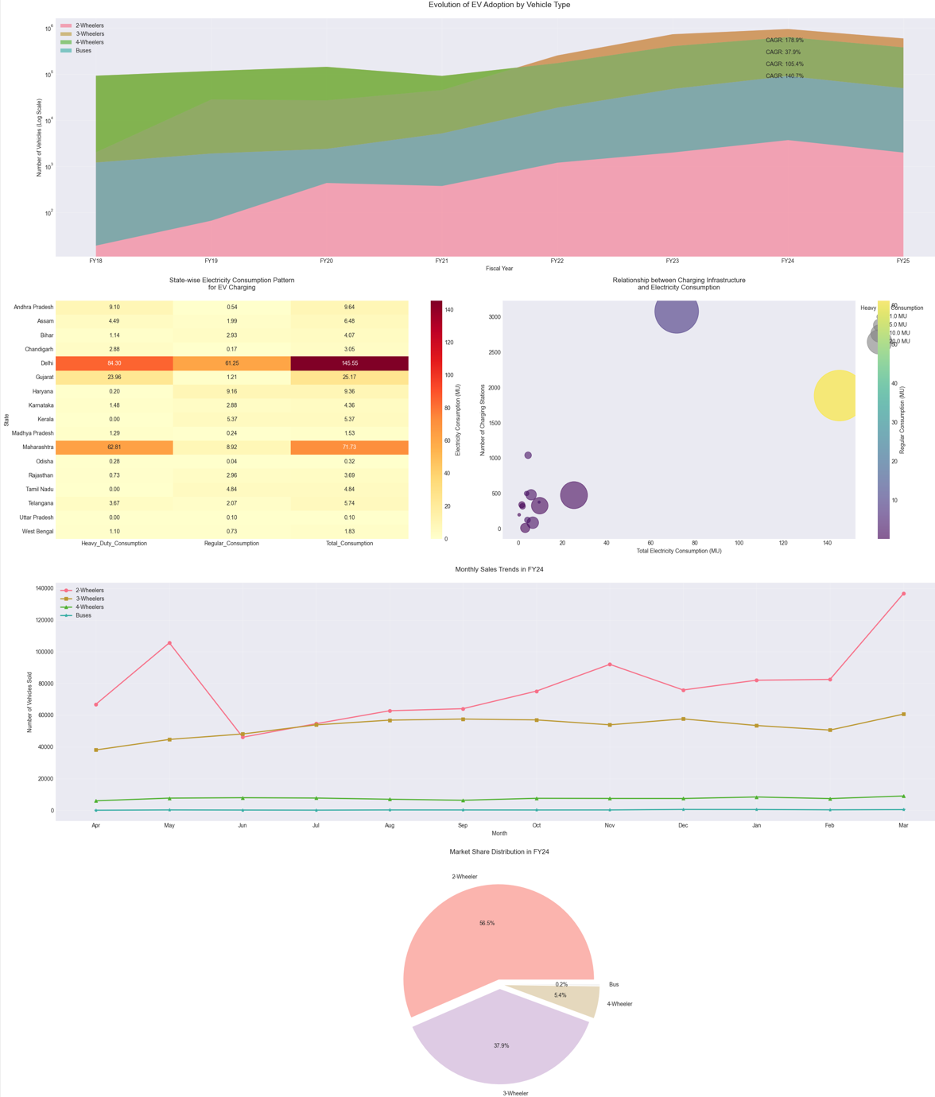

#### ****2.EV Charging Stations by Region****

* **Code Description**: A bar plot visualizes the distribution of EV charging stations across various regions in India.
* **Expected Outcome**:
  + Regions like Maharashtra, Delhi, Karnataka, and Tamil Nadu lead in the number of EV charging stations.
  + Smaller regions such as Lakshadweep and Andaman & Nicobar have minimal infrastructure.
* **Insights**:
  + Major urban and industrial regions have a significantly higher concentration of EV charging stations, supporting increased adoption of EVs.
  + Remote regions and islands require greater attention to bridge the infrastructure gap.

**Chart**: A vertical bar chart displaying the count of EV charging stations by region.

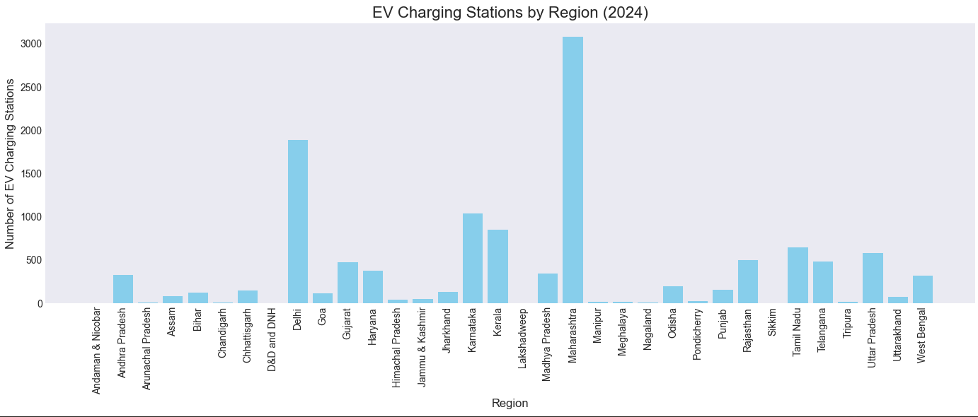

#### ****3. Top 10 Regions****

* **Code Description**: A horizontal bar plot highlights the top 10 regions with the most EV charging stations.
* **Expected Outcome**:
  + Maharashtra, Delhi, and Karnataka are the top three regions, contributing significantly to the nation's EV infrastructure.
  + Punjab and Rajasthan complete the top 10.
* **Insights**:
  + Infrastructure development is concentrated in states with higher urbanization, industrial activity, and population density.

**Chart**: A horizontal bar chart showing the top 10 regions, sorted by the number of charging stations.

#### ****4.Share of EV Charging Stations by Region****

* **Code Description**: A pie chart illustrates the proportional share of EV charging stations among all regions.
* **Expected Outcome**:
  + A few regions dominate the chart, representing the disparity in infrastructure development.
* **Insights**:
  + Policymakers need to ensure equitable infrastructure development to support EV adoption in underserved areas.

**Chart**: A pie chart showing the percentage distribution of EV charging stations across all regions.

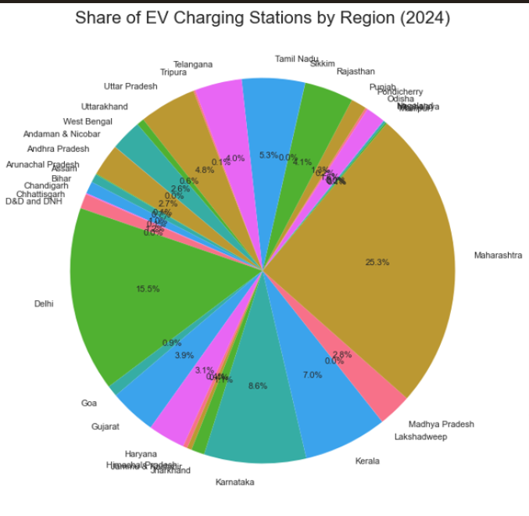

### ****5.EV Sales Analysis****

#### ****Yearly Total Sales Comparison****

* **Code Description**: A chart visualizes the yearly total sales of various EV categories (2-wheelers, 3-wheelers, 4-wheelers, and buses).
* **Expected Outcome**:
  + Sales growth is observed year-over-year across all categories, with 2-wheelers dominating.
  + 4-wheelers and buses have a relatively smaller share but are gradually increasing.
* **Insights**:
  + The dominance of 2-wheelers aligns with affordability and preference for personal transport.
  + Government policies and incentives are likely driving growth in public transport (buses) and 4-wheeler adoption.

**Chart**: A grouped chart showing yearly total sales by vehicle type.

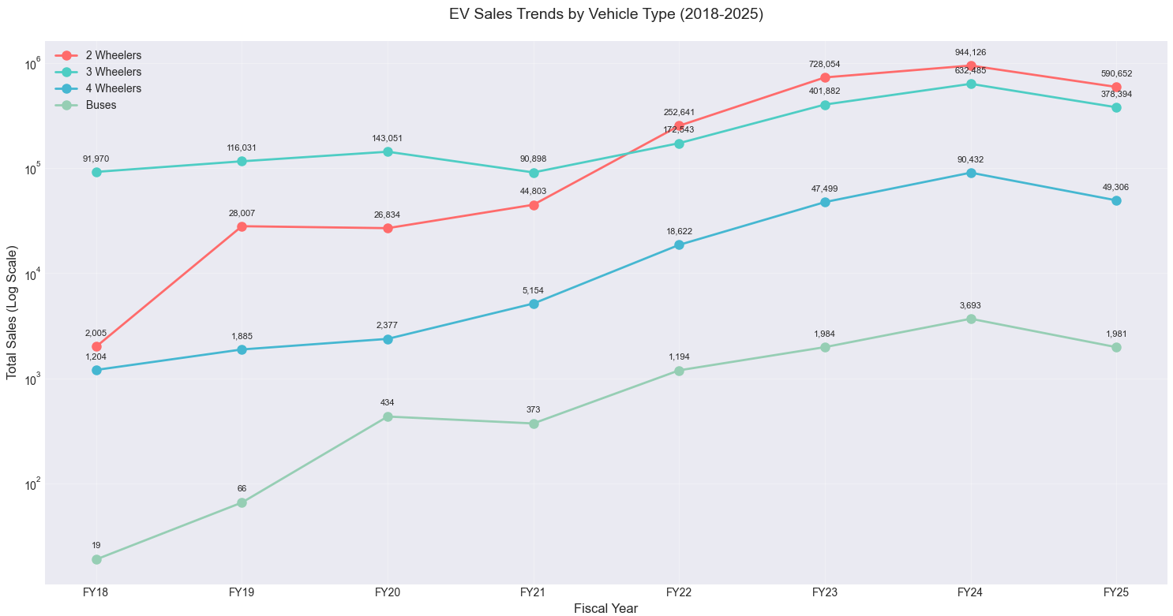

## ****6.Charging Infrastructure Analysis****

### ****Methods****

* Charging station data across states/regions was merged with electricity consumption data.
* A scatter plot was created to compare the number of operational charging stations with total electricity consumption per region.

### ****Expected Outputs****

**Scatter Plot**:

* + Positive correlation expected between charging infrastructure and electricity consumption.
  + Annotations for significant regions like **Delhi** and **Maharashtra**, which lead in infrastructure and consumption.

**Insights**:

* + High electricity consumption in states like Maharashtra indicates greater EV adoption.
  + States like **Andhra Pradesh** and **Karnataka** are emerging as hubs for EV infrastructure development.

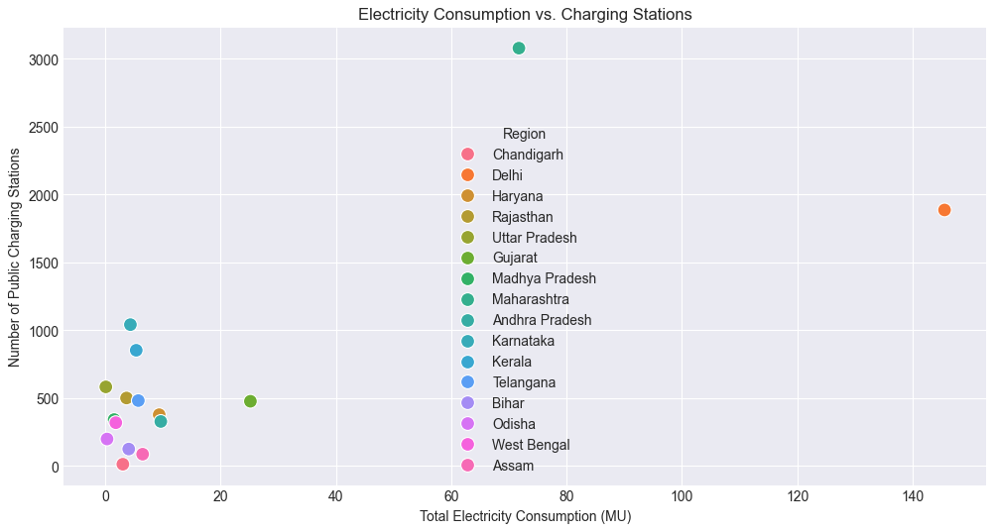

****7.Charging Station Density per Million Population****

### ****Methods****

* Population data was merged with charging station data to calculate the density of charging stations per million residents.
* Bar plots sorted states by density.

### ****Expected Outputs****

**Bar Plot**:

* + States like **Delhi** expected to show higher station density, aligning with urban density and EV adoption.
  + Larger but less populated states like **Rajasthan** may show lower density despite decent infrastructure.

**Insights**:

* + **Delhi** and **Chandigarh** demonstrate strong EV readiness with high densities.
  + Improvement areas identified for states with high population but low density, e.g., **Uttar Pradesh**.

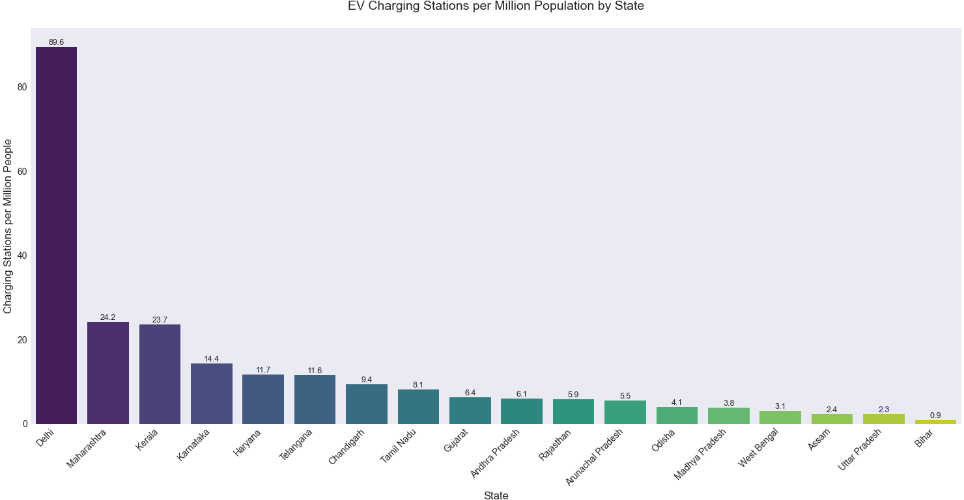

## ****8.Time-Series Decomposition of Sales Data****

### ****Methods****

* Monthly sales data was analyzed for seasonal trends and patterns using decomposition.
* Data from fiscal years was aggregated and processed.

### ****Expected Outputs****

**Decomposition Plots**:

* + **Trend**: Long-term growth in sales over years.
  + **Seasonality**: Peaks in specific months driven by promotions, holidays, or policy changes.
  + **Residuals**: Random variations not captured by trend or seasonality.

**Insights**:

* + Clear seasonality expected in **two-wheeler sales**, driven by affordability and promotions during festive seasons.
  + **Bus sales** may show smoother trends due to procurement cycles.

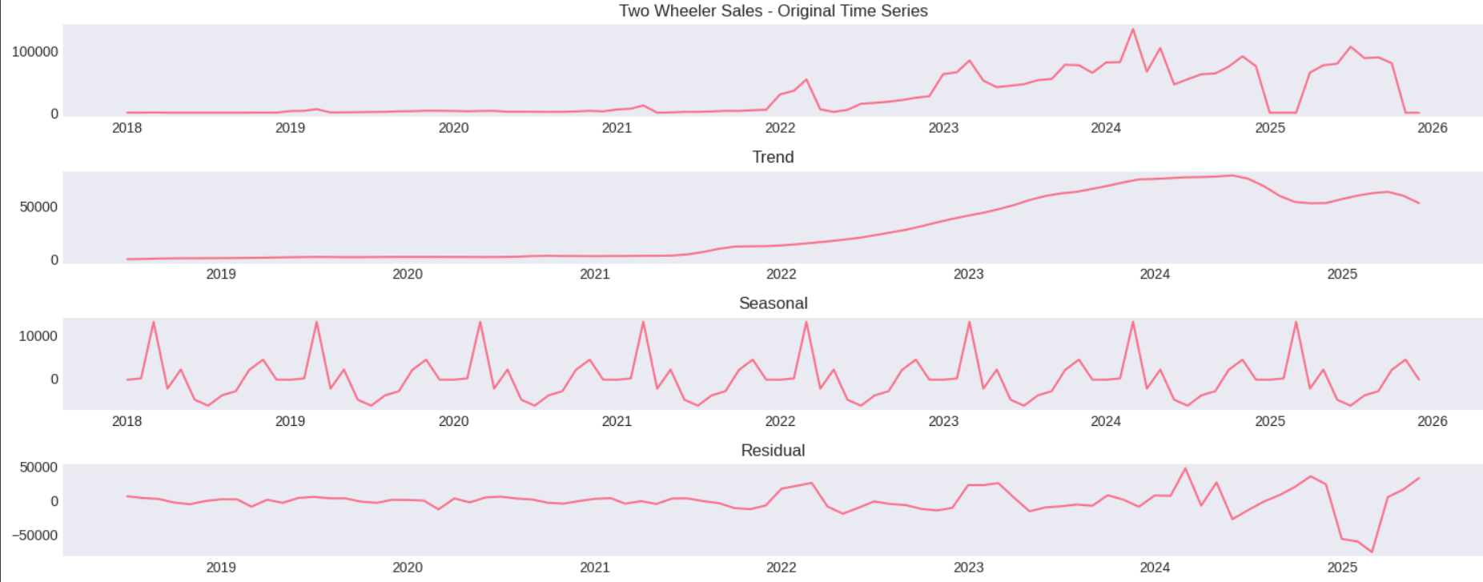

## ****9.Predictive Modeling: EV Sales Forecast****

### ****Methods****

* Features: Monthly sales from April to February.
* Target: March sales.
* Models trained:
  + **Linear Regression**
  + **Random Forest Regressor**
* Metrics used: **R² Score** and **RMSE**.

### ****Expected Outputs****

**Model Evaluation**:

* + Random Forest expected to outperform Linear Regression due to its ability to capture non-linear relationships.
  + R² scores and RMSE values presented for both models.

**Insights**:

* + Accurate short-term forecasting of EV sales helps in production planning and resource allocation.
  + Feature importance analysis (if implemented) could identify key months influencing sales.
  + 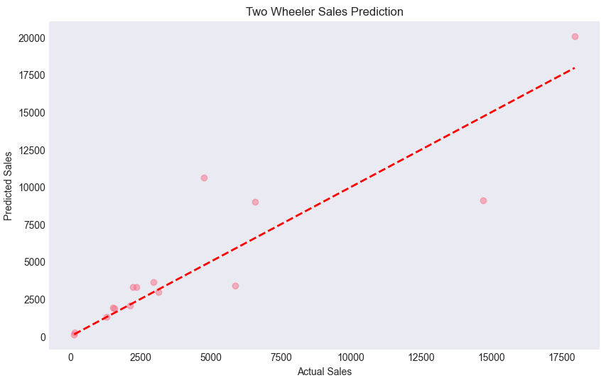
  + 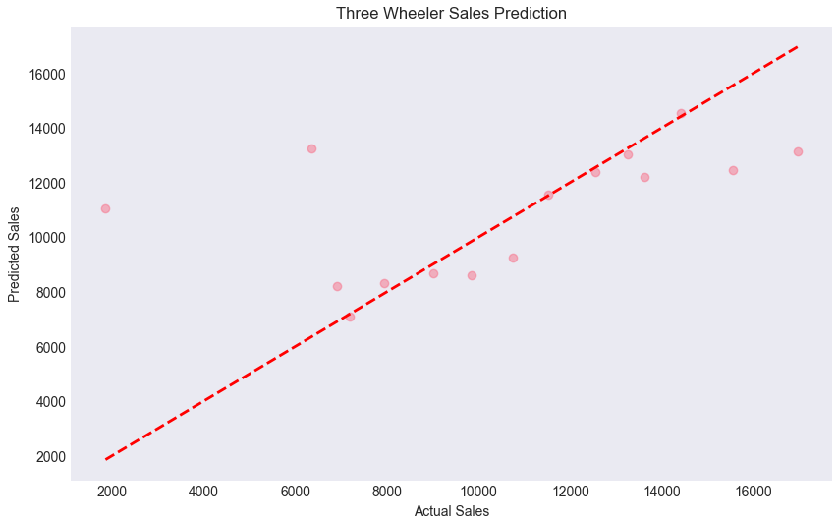
  + 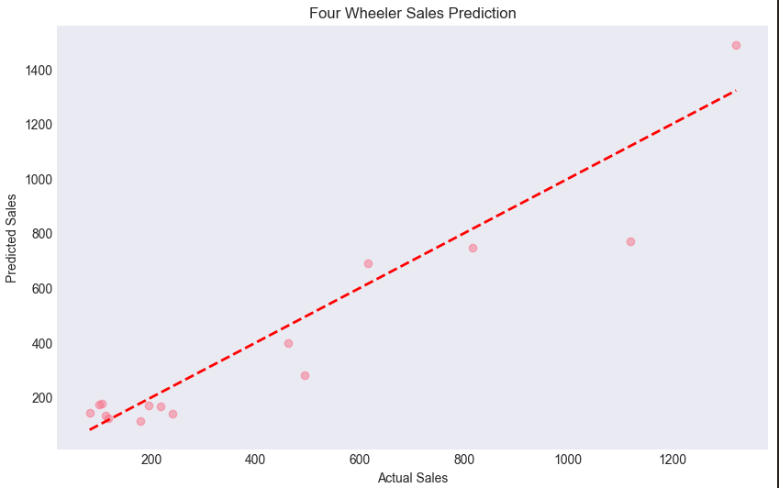

### ****10. Clustering Analysis****

Using **K-Means Clustering**:

* **Cluster 0:** States with low electricity consumption and minimal PCS (e.g., Bihar, Odisha).
* **Cluster 1:** Moderate consumption and PCS (e.g., Gujarat, Andhra Pradesh).
* **Cluster 2:** High consumption and well-established PCS (e.g., Delhi, Maharashtra).

This clustering helps policymakers prioritize regions for EV infrastructure development.

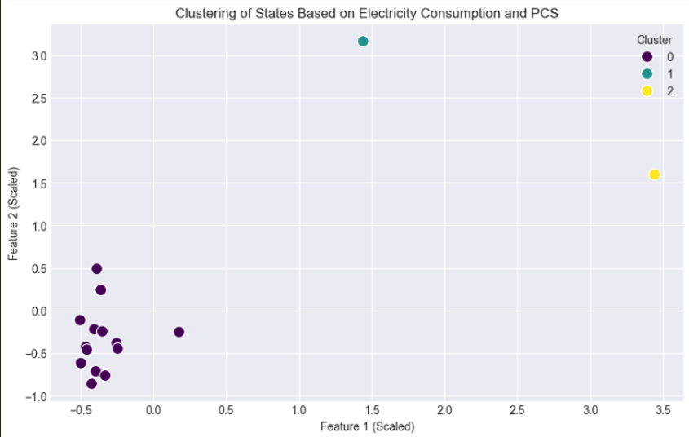

### ****11.Regression Analysis****

A **linear regression model** was built to predict total electricity consumption based on the number of operational PCS:

* **Key Findings:**
  + The regression model showed a positive correlation between the two variables.
  + Predicted electricity usage closely aligns with actual data for most states.
* **Insights:**
  + Increasing the number of PCS significantly impacts EV adoption and electricity consumption.

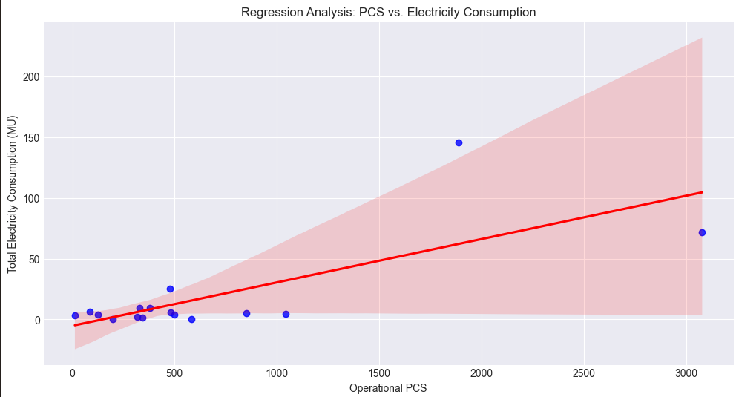

### ****12. Classification Analysis****

A **Random Forest Classifier** was developed to classify states based on high or low EV adoption:

* **Features Used:**
  + Electricity consumption by EVs and Heavy-Duty vehicles.
  + Number of operational PCS.
* **Feature Importance:**
  + PCS emerged as the most critical factor influencing EV adoption.
  + Heavy-duty vehicle electricity usage ranked second.

The model achieved high accuracy, aiding in identifying regions with potential for increased EV adoption.

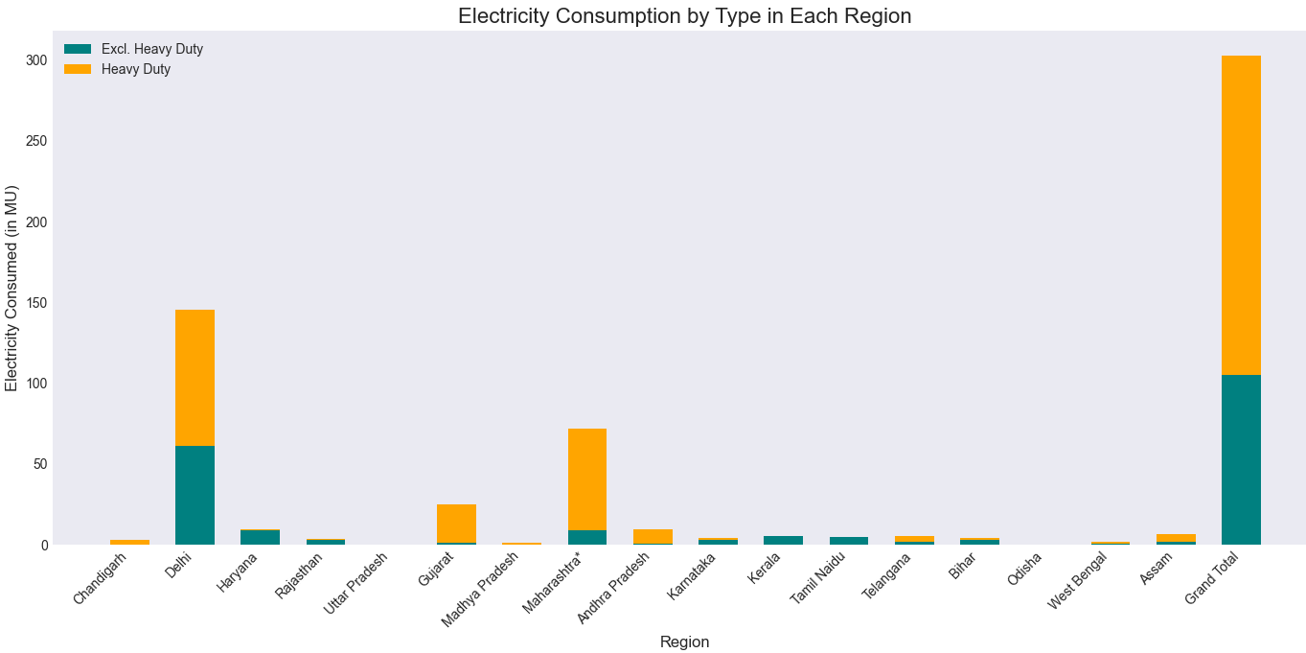

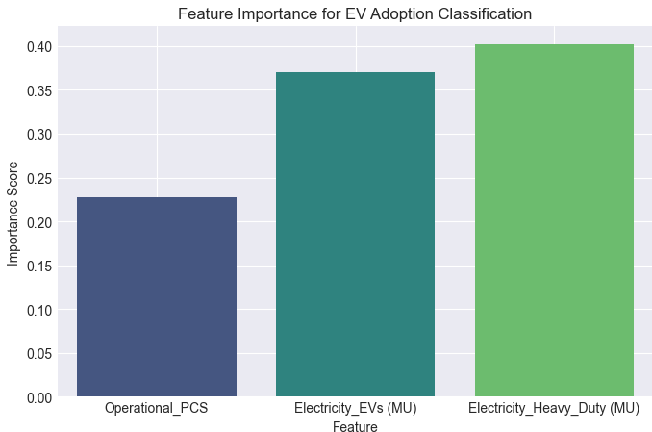

### ****13.Predictive Analysis: Monthly EV Sales****

**Objective:** Develop predictive models for monthly EV sales for Two-wheelers, Three-wheelers, and Four-wheelers.

**Steps:**

1. **Feature Engineering:** Created lag features and numerical encoding of years and months.
2. **Modeling:**
   * Trained Random Forest Regressors for each vehicle type.
   * Evaluated models using Mean Squared Error (MSE) and R-squared metrics.
3. **Results:**
   * Predictions aligned well with actual data.
   * **Two-wheelers** demonstrated higher predictability due to consistent sales trends.

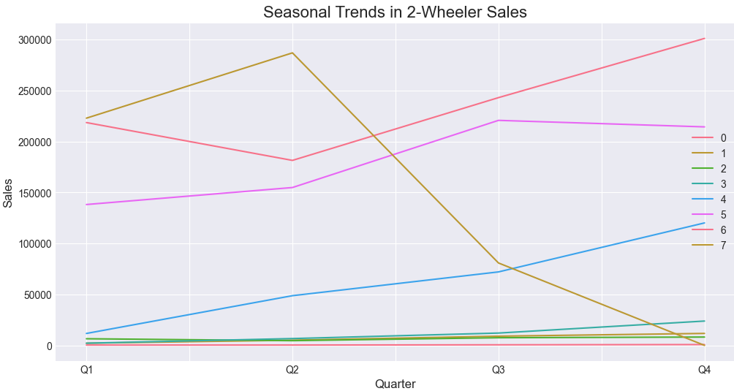

**Feature Importance:**  
Across all models, lag features (previous month’s sales) had the highest predictive power.

#### ****4 Outcomes and Insights****

1. **Electricity Consumption and PCS Deployment:**
   * States with higher PCS density consume more electricity for EVs, indicating a direct relationship between infrastructure and adoption.
2. **Clustering:**
   * Clustering provided actionable insights into infrastructure gaps, highlighting underdeveloped regions like Bihar and Odisha.
3. **Regression:**
   * Policymakers can estimate the additional electricity demand for planned PCS deployments.
4. **Predictive Models:**
   * Monthly sales predictions can assist manufacturers and distributors in inventory management and market planning.

#### ****Recommendations****

**Infrastructure Development**:

* + Prioritize setting up charging stations in underserved regions to ensure equitable access.
  + Explore renewable energy sources to power charging stations and reduce the carbon footprint.

**Policy and Incentives**:

* + Increase incentives for public transport and heavy-duty EVs to promote adoption.
  + Strengthen subsidies for EVs and charging infrastructure in rural and remote areas.

**Public Awareness and Collaboration**:

* + Conduct public awareness campaigns to accelerate the shift to EVs.
  + Encourage private-public partnerships to drive infrastructure growth and vehicle adoption.

**Resource Allocation:**

* + Focus on Cluster 1 states for medium-term EV infrastructure expansion.

**Future Work:**

* + Include additional factors such as fuel prices, EV incentives, and urbanization rates to refine predictive models.

**Real-time Monitoring:**

* + Develop dashboards for real-time tracking of electricity consumption and PCS utilization.

#### ****Conclusion****

* India's EV sector is experiencing dynamic growth, particularly in 2- and 3-wheelers. However, challenges persist in infrastructure, electricity grid capacity, and adoption of heavy-duty EVs. By addressing these gaps and leveraging favorable policies, India can accelerate its transition to a sustainable, EV-driven future.
* This analysis underscores the critical role of data-driven strategies in shaping India's EV landscape. As the sector evolves, continued monitoring and investments will be crucial to achieving widespread adoption and environmental goals.
* Also this report underscores the significance of charging infrastructure in accelerating EV adoption and provides actionable insights through clustering, regression, and classification analyses. The predictive models further equip stakeholders with tools to anticipate market trends and plan strategically.
* Maharashtra and Delhi are frontrunners in EV infrastructure, while smaller and remote regions lag behind.There is a need for more balanced infrastructure development across regions.
* Consistent growth in EV sales, especially in the 2-wheeler category, highlights consumer acceptance and market readiness.Public and commercial vehicle adoption (buses) is showing positive trends, supporting sustainable urban mobility.
* Focus on states with low charging density but high population, e.g., **Uttar Pradesh**.
* Subsidies or incentives in less penetrated markets to boost EV adoption.
* Extend forecasting to include external factors like policy changes, fuel price trends, and macroeconomic indicators.
* Develop renewable energy solutions to meet the rising electricity demand sustainably.
* Prioritize underserved states like Bihar and Odisha to ensure equitable EV adoption.
* Promote public-private partnerships to expand the charging network.
* Provide subsidies and incentives for adopting buses and 4-wheelers.
* Develop dedicated corridors for heavy-duty EVs in urban areas.
* Upgrade grid capacity in states with high EV penetration, such as Delhi and Maharashtra.
* Integrate renewable energy sources to meet increased electricity demand sustainably.
* Focus on affordable EV models to drive adoption among the middle class.
* Support local manufacturing to reduce costs and dependency on imports.