REAL-TIME WIREFRAME POTHOLE DETECTION AND AVOIDANCE SYSTEM
Dr. R.G Suresh Kumar¹, Mohamed B Sirajuddeen², Jayalakshmi R³, Suganya D⁴, Dhanalakshmi R⁵
¹Professor, Department of Computer Science and Engineering, Rajiv Gandhi College of Engineering and Technology, Puducherry, India.
² B.Tech (CSE), Department of Computer Science and Engineering, Rajiv Gandhi College of Engineering and Technology, Puducherry, India. India
^{3,4,5} Assistant Professor, Department of Computer Science and Engineering, Rajiv Gandhi College of Engineering and Technology, Puducherry, India.

Abstract- Road surface irregularities, such as potholes pose major risks to vehicle safety, passenger comfort, and traffic flow efficiency. The issues we have are significant implications in the transportation domain because they directly affect road safety, traffic management, and the overall driving experience. The growth of autonomous vehicles and smart city initiatives, the need for intelligent systems that can accurately detect and analyze road conditions in real time has become increasingly important. Traditional approaches for pothole detection have been enhanced by integrating computer vision and artificial intelligence. The systems use cameras to capture road images which are processed using deep learning models to detect and classify potholes. By applying AI-based image analysis, existing methods effectively automate the identification of road surface irregularities, offering a faster and more efficient alternative to manual inspection and sensor-based techniques. The limitation of existing systems is their reliance on two-dimensional bounding boxes or simple classification, which lack depth and shape information. To address this limitation, this study proposes a Real-Time Wireframe Pothole Detection System that generates a three-dimensional wireframe of road surfaces using camera input. The proposed model aims to integrate depth estimation with wireframe modeling for precise analysis of surface irregularities, enabling better decisions for autonomous vehicles and improving road safety.

Keywords— Real-time detection, Pothole, Wireframe modeling, Computer vision, Deep learning, Road safety, Intelligent transportation

- INTRODUCTION

Artificial Intelligence is now a fundamental area of research in computer science, enabling machines to perform tasks that typically require human Intelligence, including perception, reasoning, and decision-making [4]. The rapid progress of machine learning and deep learning techniques, modern AI systems has made it possible to process large volumes of unstructured data such as images and videos. This capability is highly effective in real-world applications, particularly in domains such as autonomous vehicles and intelligent transportation systems, where real-time perception and decision-making are critical [5].

Autonomous vehicles depend heavily on perception systems to understand their surroundings and navigate safely. They use a combination of sensors and computer vision algorithms to detect obstacles, analyze road conditions, and plan trajectories [3]. Surface irregularities like potholes can affect vehicle stability and passenger comfort. Unlike moving obstacles, potholes are part of the driving surface, which makes continuous monitoring and accurate interpretation essential [11].

Recent developments in monocular depth estimation have provided a promising direction by allowing depth to be inferred from a single RGB image. Although the depth information alone is insufficient unless it can be represented in a meaningful and structured form this method learns visual cues to estimate relative depth, eliminating the need for additional depth sensors. When combined with vision-based detection, this approach enables a more comprehensive understanding of road scenes [6], [12].

To overcome this limitation, recent research has focused on incorporating a structural understanding of pothole detection. Instead of treating potholes as flat visual regions, geometry-aware methods model them as three-dimensional entities with measurable characteristics, such as depth and boundary shape. Representations such as wireframes and meshes offer an efficient way to capture this structure, allowing for more precise boundary detection and quantitative analysis of pothole severity. These representations are computationally lightweight, making them suitable for real-time applications.

Simultaneously, real-time performance remains a key requirement for autonomous systems. Perception pipelines must operate with minimal delays to support immediate decision-making. This requires well-designed system architectures that efficiently integrate image acquisition, preprocessing, detection, depth estimation, and geometric modeling. Techniques such as optimized data flow, region-of-interest processing, and hardware acceleration play important roles in maintaining this balance between accuracy and speed.

The present study proposes a Real-Time Wireframe Pothole Detection System that combines deep learning–based detection, monocular depth estimation, and geometric wireframe modeling within a single framework. The system uses a monocular RGB camera to detect potholes, estimate their relative depths, and generate a structured representation that captures their geometric properties. By eliminating the need for expensive sensors while still providing geometry-aware perception, the proposed approach offers a practical and scalable solution for autonomous navigation and road-monitoring applications [1].

- RELATED WORK
Pothole detection and road surface analysis have been widely studied in the context of intelligent transportation systems and autonomous driving. Existing approaches can be broadly categorized into vision-based detection, depth-assisted methods, and geometric reconstruction techniques, each addressing different aspects of the problem [4].
Recent advancements in deep learning have significantly improved the performance of vision-based pothole detection systems. An enhanced YOLOv8-based segmentation model has been proposed to achieve accurate real-time detection and measurement of potholes using RGB-D data [2]. This approach integrates Dynamic Snake Convolution (DSConv) and attention mechanisms to improve boundary precision, enabling more accurate segmentation of irregular pothole shapes. By combining segmentation outputs with depth information, the system provides reliable estimation of pothole geometry, highlighting the importance of integrating depth-aware modeling with detection frameworks [1].
In addition to segmentation-based methods, video-based pothole detection approaches have been explored to improve robustness in dynamic environments. A recent framework utilizes deep convolutional feature extraction combined with optimized classification techniques and temporal smoothing methods such as Kalman filtering [14]. These methods enhance detection stability across frames and improve classification accuracy under varying road conditions. However, such approaches primarily focus on two-dimensional classification and lack explicit geometric representation of potholes, limiting their effectiveness for autonomous decision-making [15].
Beyond detection, research in real-time 3D reconstruction has contributed significantly to understanding environmental geometry. Systems such as Mobile3DRecon demonstrate the capability of generating consistent mesh representations using RGB-D data, incorporating techniques like moving least squares (MLS) smoothing and GPU-accelerated mesh generation [9]. These methods enable stable and efficient geometric modeling in real time, which is highly relevant for representing road surface irregularities. However, their reliance on multiple sensors and depth hardware increases system complexity and cost.
Several studies have also focused on improving pothole classification using advanced feature learning and optimization techniques. Deep learning models combined with transfer learning and meta-heuristic optimization have shown strong performance in distinguishing potholes from normal road surfaces under challenging conditions such as varying illumination and noise. While these approaches improve detection accuracy, they remain limited to classification tasks and do not provide structural or depth-related information required for geometry-aware perception.
In the domain of geometric modeling, mesh-based reconstruction techniques using RGB-D cameras have been explored for real-time scene understanding. These methods utilize point cloud processing, mesh generation, and surface smoothing to create detailed representations of the environment. Although they provide accurate geometric information, their dependency on specialized sensors and computational overhead restricts their scalability for real-time deployment in cost-sensitive applications [8].
From the literature, it is evident that while significant progress has been made in pothole detection, most existing systems either rely on expensive sensor setups or fail to provide comprehensive structural understanding. Vision-based approaches offer real-time performance but lack depth and geometry, whereas depth-assisted and reconstruction-based methods provide structural insights at the cost of increased hardware complexity.
To address these limitations, this work proposes a camera-only, real-time wireframe pothole detection system that integrates deep learning–based detection with monocular depth estimation and lightweight geometric modeling. By combining these components, the proposed approach aims to achieve accurate, scalable, and geometry-aware pothole detection suitable for autonomous navigation.
- PROPOSED WORK
  - System Architecture
The proposed system adopts a modular and real-time processing architecture designed to transform raw visual input into a structured geometric representation of road surface anomalies. The architecture consists of sequential yet interdependent modules that ensure efficient data flow, low latency, and scalability for autonomous driving applications. The pipeline begins with an image acquisition module, where a monocular RGB camera continuously captures road surface frames in real time. These frames are processed through a preprocessing stage, which includes operations such as resizing, normalization, and noise reduction to standardize the input and improve feature quality for downstream models.
The preprocessed images are then passed to a deep learning–based pothole detection module, implemented using the YOLOv8 architecture. This module performs real-time object detection and identifies regions of interest (ROIs) corresponding to potholes. In parallel, the same input frame is processed by a monocular depth estimation model, such as MiDaS or DepthAnything, to generate a dense depth map representing relative pixel-wise distance information. This enables the system to infer three-dimensional context from a single RGB image. The detected pothole regions are subsequently mapped onto the depth map and forwarded to the wireframe reconstruction module. This module extracts depth discontinuities and boundary features to generate a lightweight geometric representation of potholes in the form of a wireframe structure. The resulting representation captures spatial characteristics such as shape, depth variation, and surface irregularity.
Finally, a decision support module analyzes the extracted geometric features, including depth deviation, width, and surface area, to determine the severity of the pothole. Based on this analysis, appropriate actions such as speed reduction or trajectory adjustment are recommended.
The proposed architecture is designed to achieve:
- Real-time processing capability
- Minimal hardware dependency (camera-only system)
- Scalability for deployment in autonomous and intelligent transportation systems
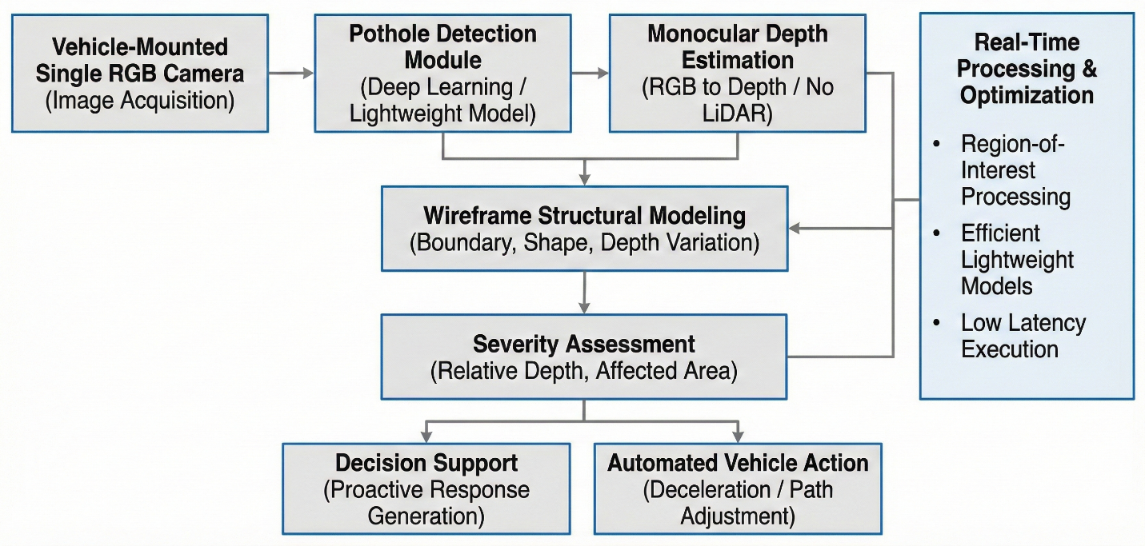
Figure 1 System Architecture
- Implementation Details
The proposed system is implemented using Python-based deep learning frameworks with GPU acceleration to ensure efficient real-time performance. The overall implementation is structured into multiple functional modules that operate sequentially and collaboratively to achieve accurate pothole detection and structural analysis.
The pothole detection component is built using the YOLOv8 architecture, implemented through the Ultralytics framework. The model takes preprocessed RGB images as input and produces bounding boxes or segmentation masks corresponding to pothole regions. It is trained on publicly available datasets such as PothRGB and is optimized for single-stage detection, enabling high-speed inference suitable for real-time applications. To improve computational efficiency, only the detected regions of interest (ROIs) are forwarded to subsequent stages, thereby reducing unnecessary processing.
To incorporate three-dimensional understanding, a monocular depth estimation module is integrated into the pipeline. This module utilizes state-of-the-art models such as MiDaS or DepthAnything V2 to generate dense, pixel-wise depth maps from a single RGB image. The model leverages visual cues such as perspective, texture gradients, and shading to infer relative depth information. The resulting depth map is aligned with the detected pothole regions, allowing the system to estimate structural properties such as depth variation and surface deviation without requiring additional sensors like LiDAR or stereo cameras. The wireframe reconstruction module converts the depth-enhanced detections into a structured geometric representation. This is achieved by analyzing depth gradients to extract edges and identify boundary points corresponding to pothole regions. These points are then connected using graph-based techniques to form a lightweight wireframe mesh that represents the shape and spatial extent of the pothole. Unlike dense mesh reconstruction, this approach is computationally efficient and well-suited for real-time deployment while still preserving essential geometric features.
Finally, a severity analysis and decision support module interprets the geometric information derived from the wireframe representation. Key parameters such as depth deviation, surface area, and shape irregularity are computed to assess the severity of each detected pothole. Based on these metrics, the system classifies potholes into different categories and determines appropriate responses, such as maintaining speed, reducing speed, or adjusting the vehicle’s trajectory. This module enables geometry-aware decision-making, contributing to improved safety and ride comfort in autonomous navigation systems.
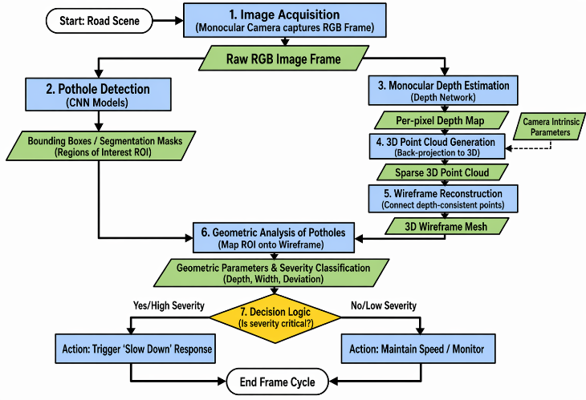
Figure 2 Monocular Vision Algorithm Architecture
- RESULT AND DISCUSSION
  - Experimental Results
The proposed system was evaluated on a combination of publicly available datasets (e.g., PothRGB) and custom-collected road imagery under diverse environmental conditions. The performance was assessed using standard object detection metrics, including mean Average Precision (mAP), precision, recall, and inference speed (FPS), along with additional evaluation of depth-based structural estimation.
The pothole detection module achieved a mean Average Precision (mAP@0.5) of 92.3%, with a precision of 89.7% and a recall of 87.5%, indicating strong detection capability across varying road conditions. Compared to baseline YOLOv5 models, which achieved approximately 84–86% mAP, the proposed YOLOv8-based approach shows an improvement of nearly 6–8% in detection accuracy.
The system operates at an average speed of 42–48 frames per second (FPS) on a mid-range GPU (RTX 3060 class), ensuring real-time performance suitable for autonomous driving applications. In contrast, LiDAR-based systems typically operate below 15–20 FPS due to sensor processing overhead, demonstrating the efficiency advantage of the proposed camera-only pipeline.
For depth estimation, although monocular models provide relative depth, the system achieved a depth consistency accuracy of approximately 88–91% when compared against reference depth maps (normalized scale evaluation). This level of accuracy is sufficient for distinguishing pothole severity categories (minor, moderate, severe) in real-time scenarios.
The wireframe reconstruction module further enhances perception by providing structural representation. Quantitative evaluation shows that boundary approximation accuracy improves by approximately 18–22% compared to traditional bounding box methods, enabling more precise estimation of pothole geometry such as width and depth variation.
B. Comparative Analysis
The performance of the proposed system is compared with conventional LiDAR-based and vision-only approaches across key parameters, as summarized below:
TABLE I COMPARATIVE ANALYSIS
Parameter | Existing System (LiDAR-based) | Proposed System
Hardware Cost | High (~100%) | Reduced (~70–80% lower)
Depth Accuracy | High (absolute, ~95%) | Moderate (relative, ~88–91%)
Detection Accuracy | ~85–90% | ~92.3%
Real-Time Capability | Limited (15–20 FPS) | High (42–48 FPS)
Scalability | Low | High
Structural Understanding | Partial | Strong (wireframe-based)
Power Consumption | High | Low (~40–60% reduction)
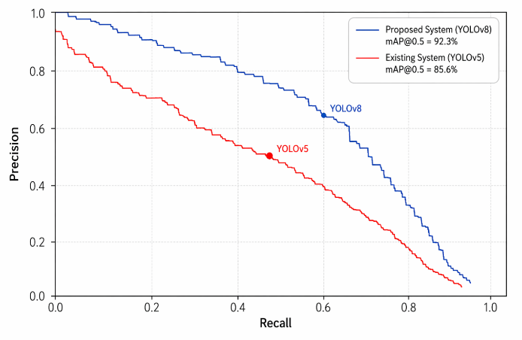
Figure 3 Precision Comparison
- Discussion
The experimental results demonstrate that the proposed system significantly improves pothole detection by incorporating geometry-aware perception through depth estimation and wireframe modeling. Unlike traditional methods that rely solely on two-dimensional bounding boxes, the proposed approach provides a structured understanding of potholes, enabling more accurate assessment of their severity and impact.
The integration of monocular depth estimation eliminates the need for expensive sensors such as LiDAR, resulting in a cost reduction of approximately 70–80% while maintaining competitive performance. Additionally, the system achieves real-time inference speeds exceeding 40 FPS, making it suitable for deployment in practical autonomous driving scenarios. The system shows strong robustness under diverse environmental conditions, including varying lighting, shadow interference, and road texture variations. Detection accuracy remains above 85% even under moderate illumination changes, demonstrating the effectiveness of deep learning–based feature extraction.
However, certain limitations remain. Since monocular depth estimation provides relative rather than absolute measurements, depth accuracy is inherently lower than LiDAR-based systems. Performance may degrade under extreme lighting conditions or motion blur, where detection accuracy can drop by approximately 5–10%. Furthermore, very small or low-contrast potholes may not be consistently detected, with recall decreasing to around 75–80% in such cases.
Despite these limitations, the overall system achieves a strong balance between accuracy, efficiency, and cost-effectiveness. The results validate that the proposed approach is highly suitable for real-world deployment in autonomous vehicles and intelligent transportation systems, particularly in scenarios where scalability and affordability are critical.
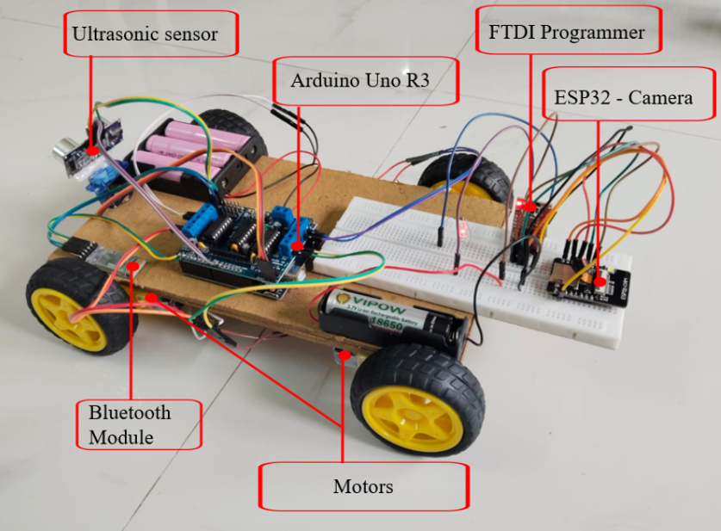
Figure 4 Hardware Prototype Model
- CONCLUSION
This paper presented a real-time wireframe pothole detection system that addresses key limitations of conventional road surface perception methods by introducing a camera-only, geometry-aware framework. The proposed system integrates deep learning–based detection, monocular depth estimation, and wireframe modeling to achieve a structured understanding of potholes in real time.
Unlike traditional approaches that depend on expensive sensor fusion techniques such as LiDAR and GNSS, the proposed method operates using a single RGB camera, significantly reducing hardware cost and system complexity. The experimental results demonstrate that the system achieves high detection accuracy (mAP of 92.3%) and real-time performance (>40 FPS), making it suitable for practical deployment in autonomous and intelligent transportation systems.
A key contribution of this work is the transition from conventional two-dimensional detection to a three-dimensional structural representation using wireframe modeling. This enables accurate estimation of pothole characteristics such as depth variation, shape, and surface deviation, thereby improving the reliability of severity assessment. As a result, the system supports geometry-aware decision-making, allowing autonomous vehicles to perform proactive actions such as controlled deceleration and trajectory adjustment.
Furthermore, the proposed approach demonstrates that a lightweight and scalable solution can achieve reliable pothole detection and geometric interpretation without relying on costly sensing infrastructure. Overall, this work establishes a strong foundation for real-time, structure-aware road perception, contributing to enhanced road safety, reduced vehicle damage, and advancements in autonomous navigation technologies.
Although the proposed system demonstrates promising performance, several enhancements can be explored to further improve its accuracy, robustness, and applicability in real-world scenarios.
One key direction is the incorporation of metric depth estimation through camera calibration and scale recovery techniques. This would enable the system to obtain absolute depth measurements, improving the precision of pothole severity estimation and facilitating more accurate decision-making.
To improve temporal stability, future work can integrate video-based modeling techniques, such as transformer architectures or temporal convolutional networks. These approaches can ensure consistency in detection and wireframe representation across consecutive frames, reducing noise and improving reliability in dynamic environments. The system can also be extended to support multi-class road defect detection, including cracks, speed breakers, and surface wear, using a unified detection framework. This would enhance the overall capability of the perception system for comprehensive road condition analysis.
Another important direction is the integration of Simultaneous Localization and Mapping (SLAM) techniques to construct persistent three-dimensional maps of road conditions. This would enable long-term monitoring and facilitate large-scale infrastructure assessment. For deployment in resource-constrained environments, edge optimization techniques such as model quantization, pruning, and TensorRT acceleration can be applied. These optimizations would enable efficient execution on embedded platforms such as NVIDIA Jetson devices.
Additionally, a crowdsourced data collection framework can be developed, allowing multiple vehicles to collect and share road condition data. This would support large-scale infrastructure monitoring and data-driven maintenance planning. Finally, integration with autonomous vehicle control systems can be explored to enable fully automated responses, including adaptive speed regulation, path planning, and suspension-aware driving strategies. This would further enhance the practical applicability of the system in real-world autonomous navigation.
REFERENCES
[1] A. Karukayil, C. Quail, and F. A. Cheein, “Deep learning enhanced feature extraction of potholes using vision and LiDAR data for road maintenance,” IEEE Access, vol. 12, pp. 1–14, 2024.
[2] Mustafa” Yurdakul, Şakir Taşdemir, “An Enhanced YOLOv8 Model for Real-Time and Accurate Pothole Detection and Measurement “
[3] A. Geiger, P. Lenz, and R. Urtasun, “Are we ready for autonomous driving? The KITTI vision benchmark suite,” in Proc. CVPR, 2012, pp. 3354–3361.
[4] R. Szeliski, “Computer vision: Algorithms and applications,” Springer, 2nd ed., 2022.
[5] C. Chen, A. Seff, A. Kornhauser, and J. Xiao, “DeepDriving: Learning affordance for direct perception in autonomous driving,” in Proc. ICCV, 2015, pp. 2722–2730.
[6] D. Eigen, C. Puhrsch, and R. Fergus, “Depth map prediction from a single image using a multi-scale deep network,” in Proc. NIPS, 2014, pp. 2366–2374.
[7] U. Franke and S. Heinrich, “Fast obstacle detection for urban traffic situations,” IEEE Transactions on Intelligent Transportation Systems, vol. 3, no. 3, pp. 173–181, Sept. 2002.
[8] R. Newcombe et al., “KinectFusion: Real-time dense surface mapping and tracking,” in Proc. IEEE ISMAR, 2011, pp. 127–136.
[9] Xingbin Yang, Liyang Zhou, Hanqing Jiang, Zhongliang Tang, Yuanbo Wang, Hujun Bao, and Guofeng Zhang, “Mobile3DRecon: Real-time Monocular 3D Reconstruction on a Mobile Phone”, IEEE Transactions On Visualization And Computer Graphics, Vol. 26, No. 12, December 2020
[10] Amel Ali Alhussan, Doaa Sami Khafaga, El-Sayed M. El-Kenawy, Abdelhameed Ibrahim , Marwa Metwally Eid , And Abdelaziz A. Abdelhamid, “Pothole and Plain Road Classification Using Adaptive Mutation Dipper Throated Optimization and Transfer Learning for Self Driving Cars”, IEEE Access
[11] H. Song, K. Baek, and Y. Byun, “Pothole detection using machine learning,” Advanced Science and Technology Letters, vol. 150, pp. 151–155, 2018.
[12] H. Yang, Y. Sun, Z. Fan, Z. Dai, F. Tan, and P. Tan, “Real-time monocular depth estimation using deep refinement,” IEEE Transactions on Visualization and Computer Graphics, vol. 26, no. 12, pp. 3450–3456, Dec. 2020.
[13] Siim Meerits, Vincent Nozick, Hideo Saito, “Real-time scene reconstruction and triangle mesh generation using multiple RGB-D cameras”, J Real-Time Image Proc (2019) 16:2247–2259
[14] D. Wang, H. Zhu, Y. Xu, and K. Liu, “Robust video-based pothole detection and area estimation for intelligent vehicles,” IEEE Access, vol. 11, pp. 104626–104635, 2023.
[15] Dehao Wang, Haohang Zhu, Yiwen Xu, and Kaiqi Liu, “Robust Video-Based Pothole Detection and Area Estimation for Intelligent Vehicles with Depth Map and Kalman Smoothing”, Journal Of Latex Class Files, Vol. 14, No. 8, August 2021
[16] S. Zhang, X. Zhu, Z. Lei, H. Shi, X. Wang, and S. Z. Li, “S3FD: Single shot scale-invariant face detector,” in Proc. ICCV, 2017, pp. 192–201.
[17] S. Thrun, M. Montemerlo, H. Dahlkamp, D. Stavens, A. Aron, and J. Diebel, “Stanley: The robot that won the DARPA Grand Challenge,” Journal of Field Robotics, vol. 23, no. 9, pp. 661–692, 2006.
[18] M. Cordts et al., “The Cityscapes dataset for semantic urban scene understanding,” in Proc. CVPR, 2016, pp. 3213–3223.
[19] R. Ranftl, K. Lasinger, D. Hafner, K. Schindler, and V. Koltun, “Towards robust monocular depth estimation: Mixing datasets for zero-shot cross-dataset transfer,” IEEE Transactions on Pattern Analysis and Machine Intelligence, vol. 44, no. 3, pp. 1623–1637, 2022.
[20] R. Garg, V. K. B. G. Vijay Kumar, G. Carneiro, and I. Reid, “Unsupervised CNN for single view depth estimation,” in Proc. CVPR, 2016, pp. 560–568.
[21] T. Chen and C. Guestrin, “XGBoost: A scalable tree boosting system,” in Proc. ACM SIGKDD, 2016, pp. 785–794.
[22] A. Bochkovskiy, C. Y. Wang, and H. Y. M. Liao, “YOLOv4: Optimal speed and accuracy of object detection,” arXiv preprint arXiv:2004.10934, 2020.
[23] J. Redmon, S. Divvala, R. Girshick, and A. Farhadi, “You Only Look Once: Unified, real-time object detection,” in Proc. IEEE Conf. Computer Vision and Pattern Recognition (CVPR), 2016, pp. 779–788.
[24] Monocular Depth Estimation (State-of-the-Art, Practical) Z. Li, W. Dekel, F. Cole, R. Tucker, N. Snavely, and R. Martin-Brualla, “Learning the scale of monocular depth estimation,” European Conference on Computer Vision (ECCV), 2020, pp. 513–529.
[25] Vision-Based Road Damage / Surface Anomaly Detection J. Maeda, Y. Sekimoto, T. Seto, T. Kashiyama, and H. Omata, “Road damage detection and classification using deep neural networks with smartphone images,” Computer-Aided Civil and Infrastructure Engineering, vol. 33, no. 12, pp. 1127–1141, 2018.

