Appointment Scheduling Module. This module manages the scheduling of dental appointments in the clinic. It allows patients to book appointments online with or without an account, while the staff can approve appointment requests, add walk-in patients, book follow-up appointments, and set the available schedule of the dentist. This module includes the guest booking pages, the appointment booking page, the appointment approval page, the walk-in and follow-up appointment pages, and the dentist schedule page.
Guest Appointment. Patients do not need an account to book an appointment. On the landing page, visitors can use the same calendar as the Patient Portal to choose a dentist, date, time, and services. Instead of logging in, the guest confirms their email address with a six-digit verification code. Every update about the appointment is then sent to that email, including a Manage my appointment link where the guest can view, reschedule, or cancel the appointment. One email can book for up to three people, such as the guest and their family members, and can have up to three upcoming appointments at a time. If the guest later signs up using the same email, their previous bookings and dental records are automatically linked to the new account.
Figure xx shows the guest booking page. On this page, the guest confirms their email and enters the details of the patient.

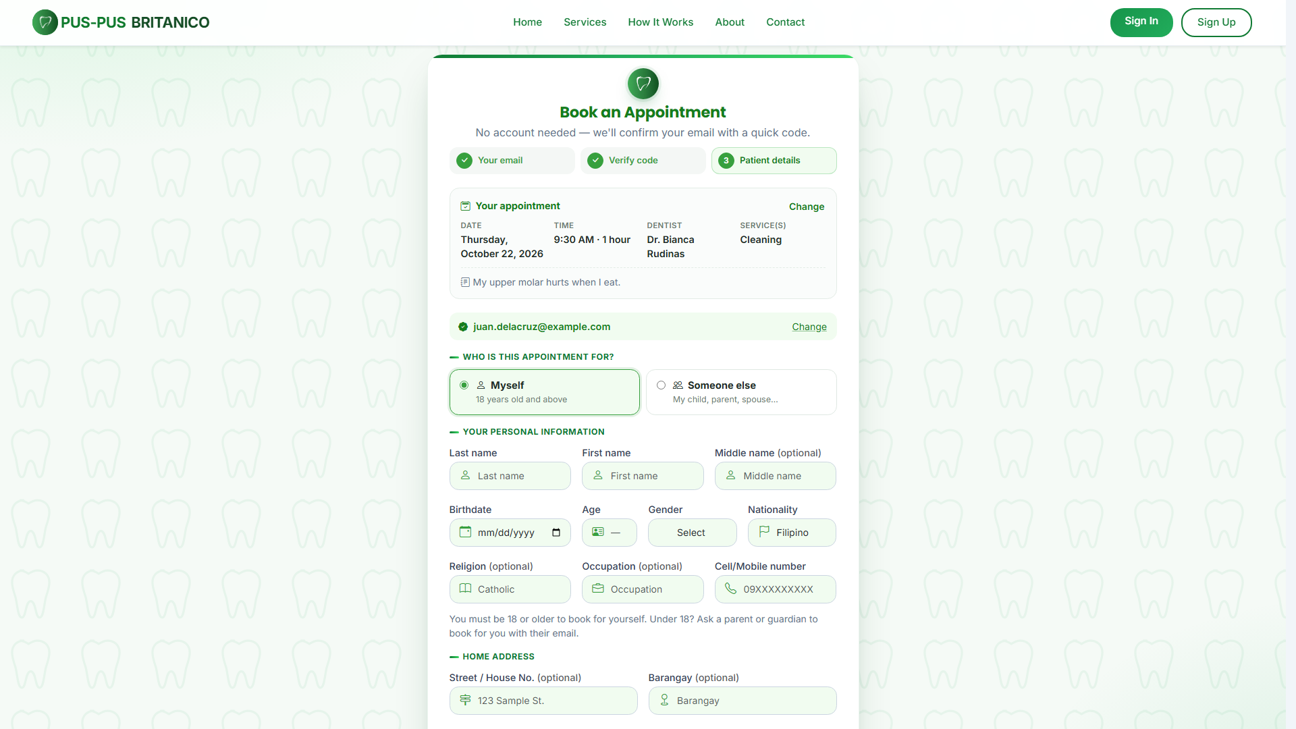
Figure xx. Screenshot of Guest Booking Page
This page shows a summary of the chosen appointment at the top, such as the date, time, dentist, services, and note, with a Change link that returns the guest to the calendar with their choices still filled in. Below it, the booking is divided into three steps: Your email, Verify code, and Patient details. In the first step, the guest enters their email address and clicks Send code. In the second step, the guest enters the six-digit code sent to their email. In the third step, the guest chooses who the appointment is for: a person already saved under the email, Myself (for guests 18 years old and above), or Someone else, such as a child, parent, or spouse. A saved person can be removed from the list after the guest confirms. The guest then fills in or confirms the patient’s personal information and medical history, agrees to the Privacy Policy and Terms, and clicks Request Appointment. Each step has a Back button that returns to the previous step. Once submitted, the appointment is saved with a Pending status, and both the guest and the clinic staff are notified.
Figure xx shows the manage appointment page. On this page, the guest can view and manage their appointment without an account.

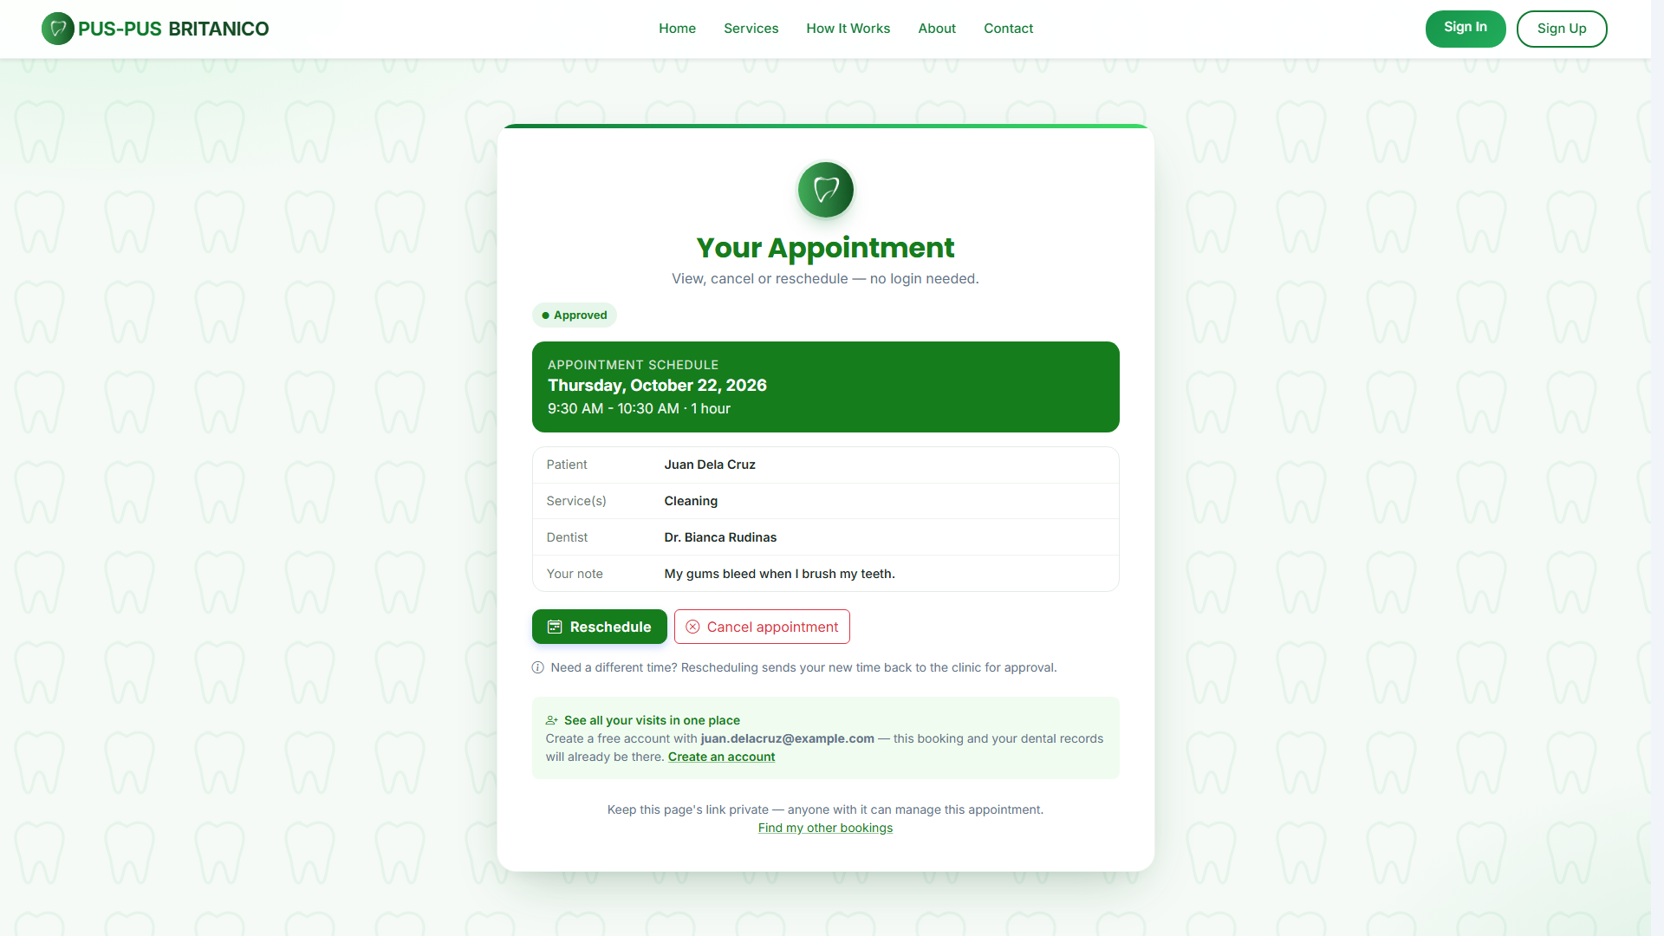
Figure xx. Screenshot of Manage Appointment Page
This page opens from the Manage my appointment link in the guest’s email, or from the Manage My Booking page, where the guest can find all their bookings by verifying their email with a code. It shows the appointment’s status, date, time, duration, patient, services, dentist, and note. The guest can reschedule the appointment by choosing a new time, which is sent back to the clinic for approval, or cancel it with an optional reason. If the clinic proposes a new time, the page shows the proposal, and the guest can accept it, keep the original time, or choose another time. The page also invites the guest to create an account using the same email so they can keep all their bookings and records in one place.
Figure xx shows the current appointment page. On this page, the patient can view and manage their current appointment.

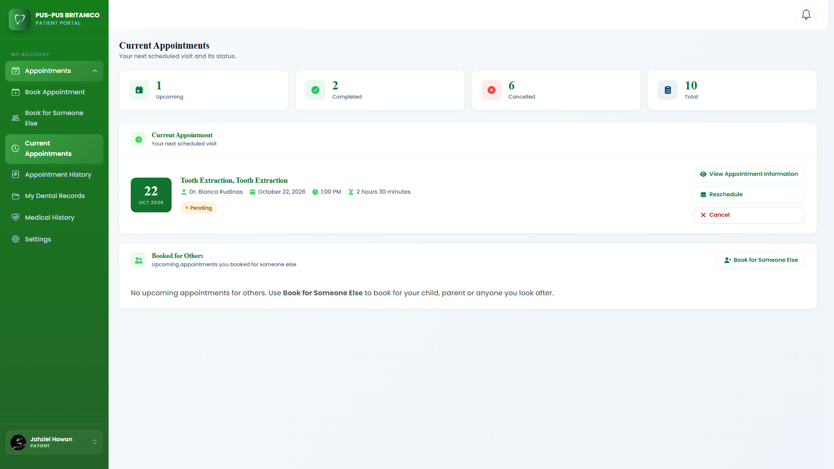
Figure xx. Screenshot of Current Appointment Page
This page shows an overview of the patient’s upcoming, completed, cancelled, and total appointments. If the patient has no current appointment, the page shows a Book an Appointment button that takes them to the calendar page. Once the patient has booked an appointment, the page shows its details, such as the service, dentist, date, time, duration, and status. The status shows as Pending while the appointment is waiting for approval, and Booked once it is approved. The page has three buttons: View Appointment Information to see the full details, Reschedule to choose a new available time from the calendar, which sends the appointment back to the clinic for approval, and Cancel to cancel the appointment. Before cancelling, the system asks the patient to confirm, because a cancelled appointment cannot be undone. If the clinic proposes a new time for the appointment, the page shows the proposal, and the patient can accept it or keep the original time. Below this, the Booked for Others section lists the upcoming appointments that the patient booked for someone else.
Figure xx shows the calendar page. On this page, the patient can view the dentist’s schedule and choose a date for their appointment.

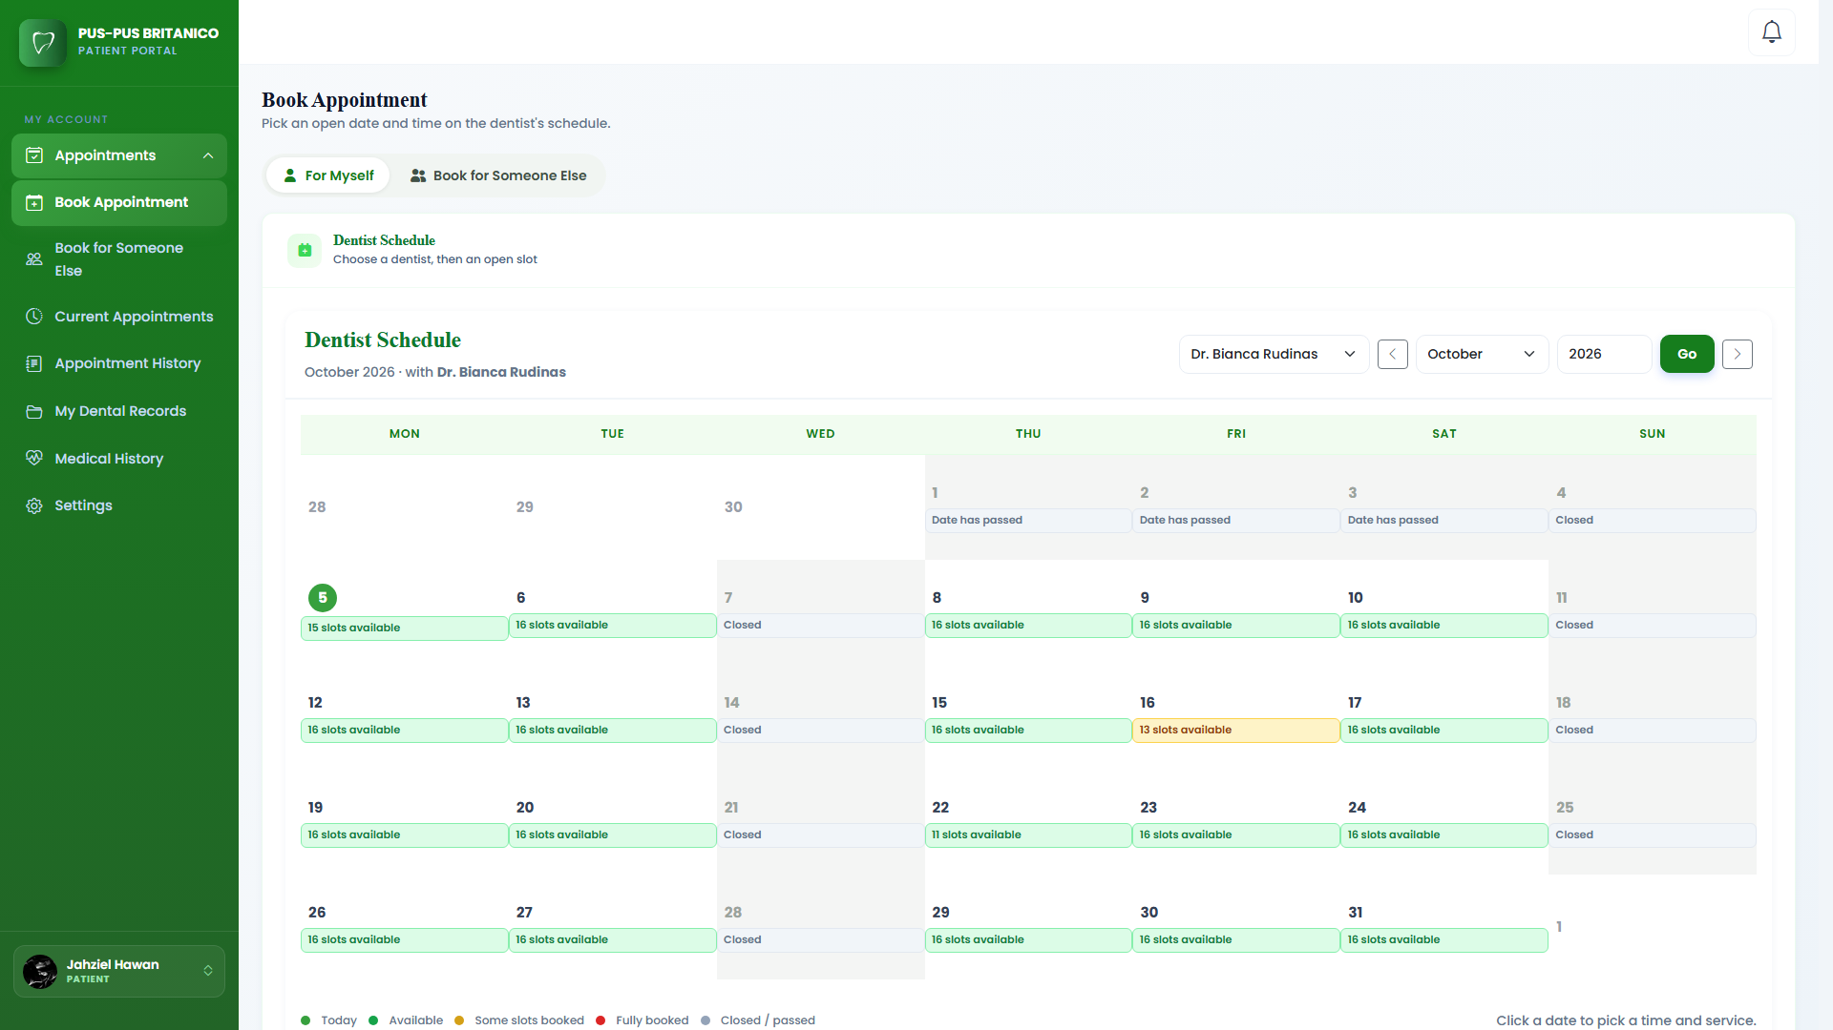
Figure xx. Screenshot of Calendar Page
This page shows the dentist’s schedule in a calendar. Using the For Myself and Book for Someone Else tabs, the patient can book an appointment for themselves or for a family member. The patient can choose a dentist from the dropdown and move to other months and years to check the schedule on different dates. The calendar uses colors to show the current date and which dates are available, partly booked, fully booked, closed, or already passed, and a legend at the bottom explains each color. The clinic’s weekly closed days and the dates closed by the clinic are marked as Closed and cannot be booked, and appointments can only be booked up to two months ahead. Each patient can have only one upcoming appointment at a time. If the patient already has one, an alert tells them they must wait until it is completed or cancelled before booking another, but they can still look at the calendar. Each date can be clicked to open a modal showing the time slots for that day.
Figure xx shows the time and service selection modal of the calendar. This modal is the first part of the booking process, where the patient chooses the time and services for their appointment.

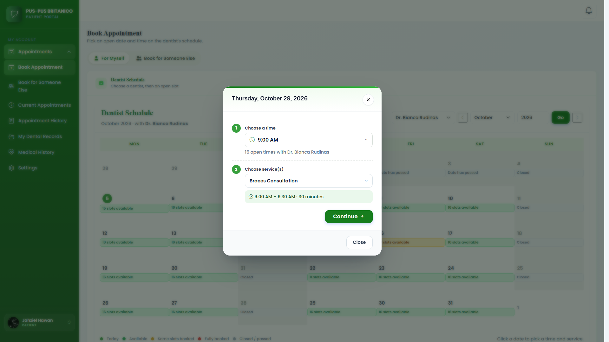
Figure xx. Screenshot of Modal of the Calendar
This modal shows the date chosen by the patient and is completed in two steps. In the first step, the patient opens the time dropdown, which lists the open start times for that day. Times that are booked, pending for another patient, not available, or already passed are not offered, and the lunch break cannot be booked. In the second step, the patient selects up to three dental services. The modal then shows the start and end time and the total duration of the appointment, and warns the patient if there is not enough open time for the chosen services. After choosing the time and services, the patient clicks the Continue button, which takes them to the second part of the modal, the appointment confirmation.
Figure xx shows the appointment confirmation modal. This modal is the second part of the booking process, where the patient reviews the details of their appointment before submitting it.

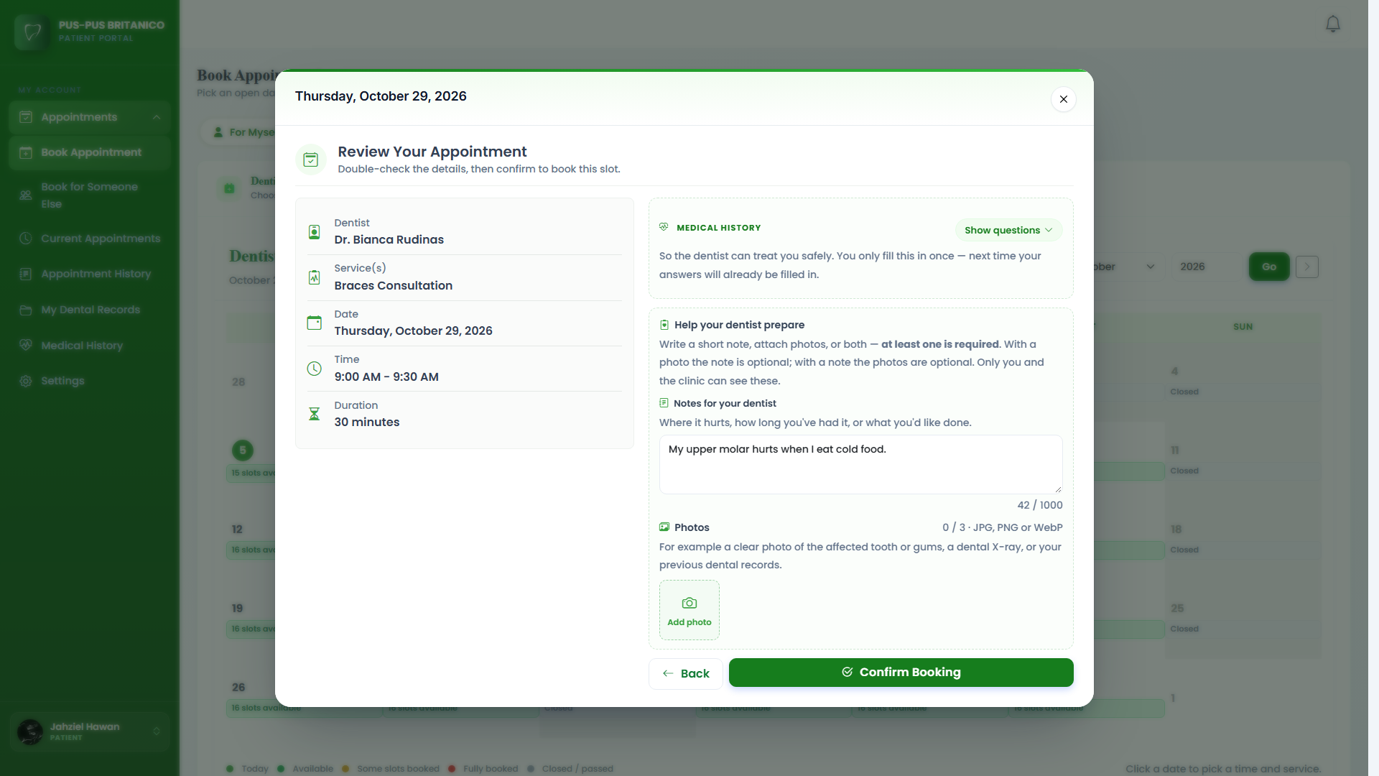
Figure xx. Screenshot of Appointment Confirmation Modal
This modal shows the details of the appointment the patient wants to book: the dentist, chosen services, date, time, and duration. The system computes the duration from the services the patient chose. To help the dentist prepare, the patient must write a short note or attach up to three photos, such as pictures of their teeth or previous X-rays. The patient also fills in their medical history. Returning patients see their last answers already filled in and only change what is different. The modal has two buttons: a Back button that returns the patient to the time and service selection modal, and a Confirm Booking button that submits the appointment. Once submitted, the appointment is saved with a Pending status, and the patient and clinic staff are both notified of the new appointment request.
Dentist Schedule Module. This module manages the weekly schedule of the clinic and the available time slots of each dentist. It shows the clinic’s weekly schedule along with the appointments in each time slot. Authorized users can close a whole day or set specific time slots as not available, and the system prevents patients from booking on dates and times that are unavailable. This module includes the dentist schedule page.
Figure xx shows the dentist schedule calendar. On this page, the Super Admin, staff, and dentist can view and manage the dentist’s schedule for the whole month.

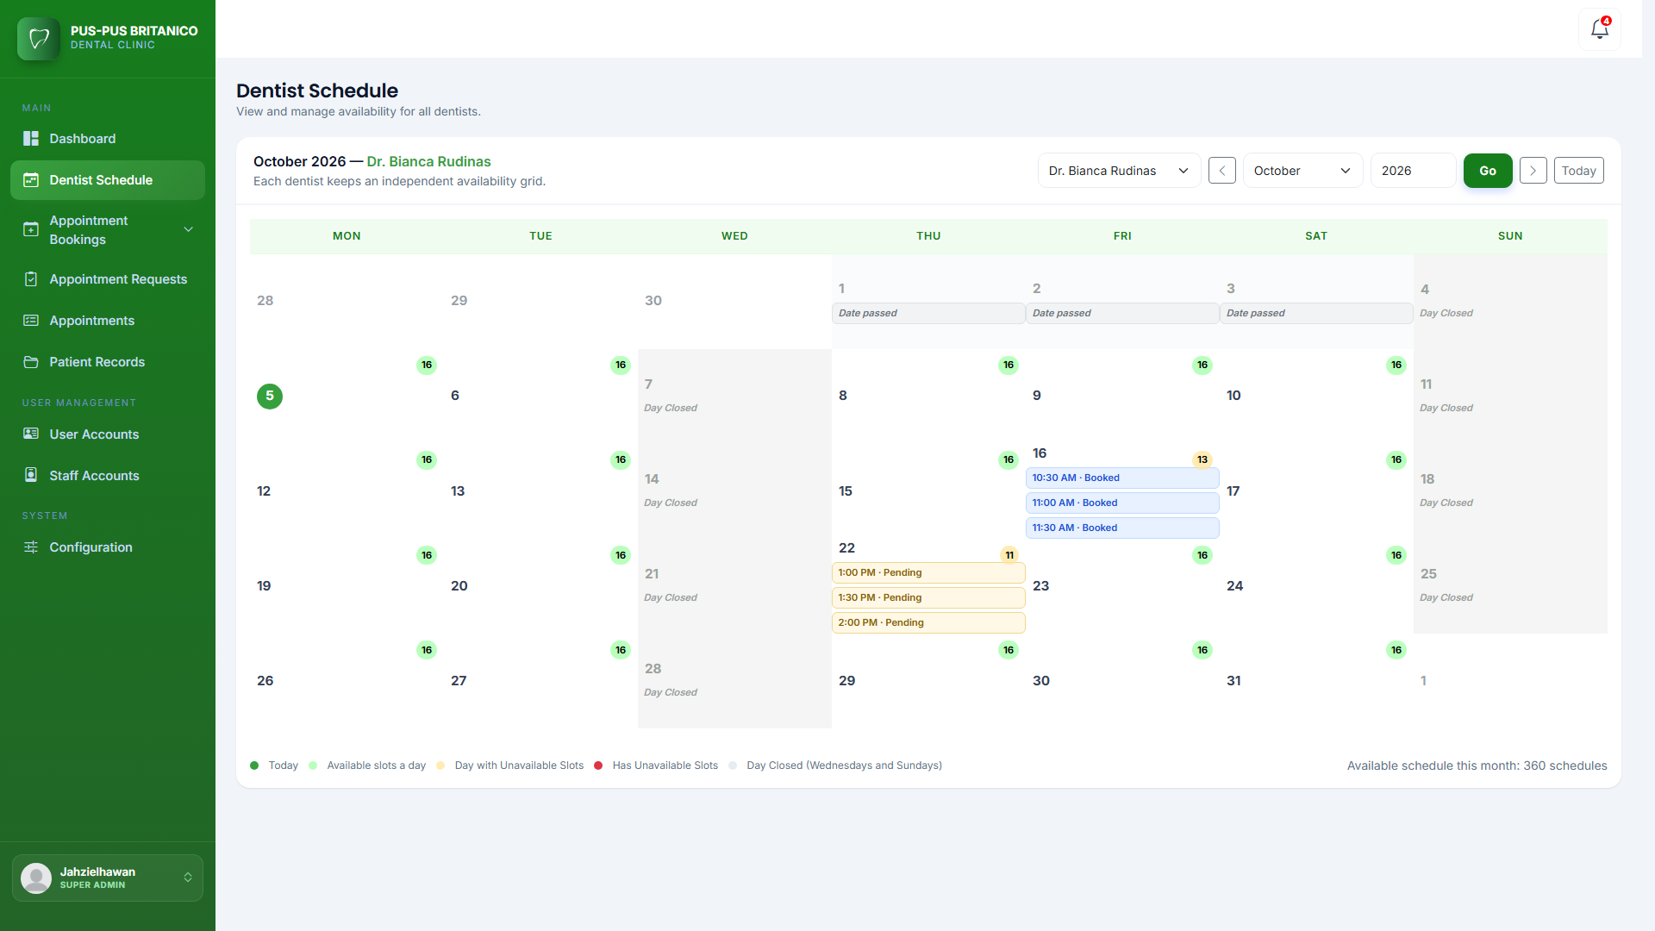
Figure xx. Screenshot of Dentist Schedule Calendar
This page shows the dentist’s schedule in a monthly calendar. The Super Admin and staff have a dropdown for choosing which dentist’s schedule to manage, since each dentist has their own schedule, while a dentist manages their own. The user can move between months using the previous and next buttons, choose a specific month and year and click Go, or click Today to go back to the current month. Each date on the calendar shows the number of available time slots and the time slots that are already booked, pending, or not available. A date is marked as Fully booked if all its time slots are taken by appointments, or Closed if the dentist is not available that day. The clinic’s weekly closed days, such as Sundays, are marked as Day Closed, and past dates show how many appointments were completed. The page also shows the total number of available schedules for the month. Each date can be clicked to open a modal where the dentist’s time slots for that day can be managed.
Figure xx shows the dentist schedule modal. On this modal, the Super Admin, staff, and dentist can manage the dentist’s available times for the selected day.

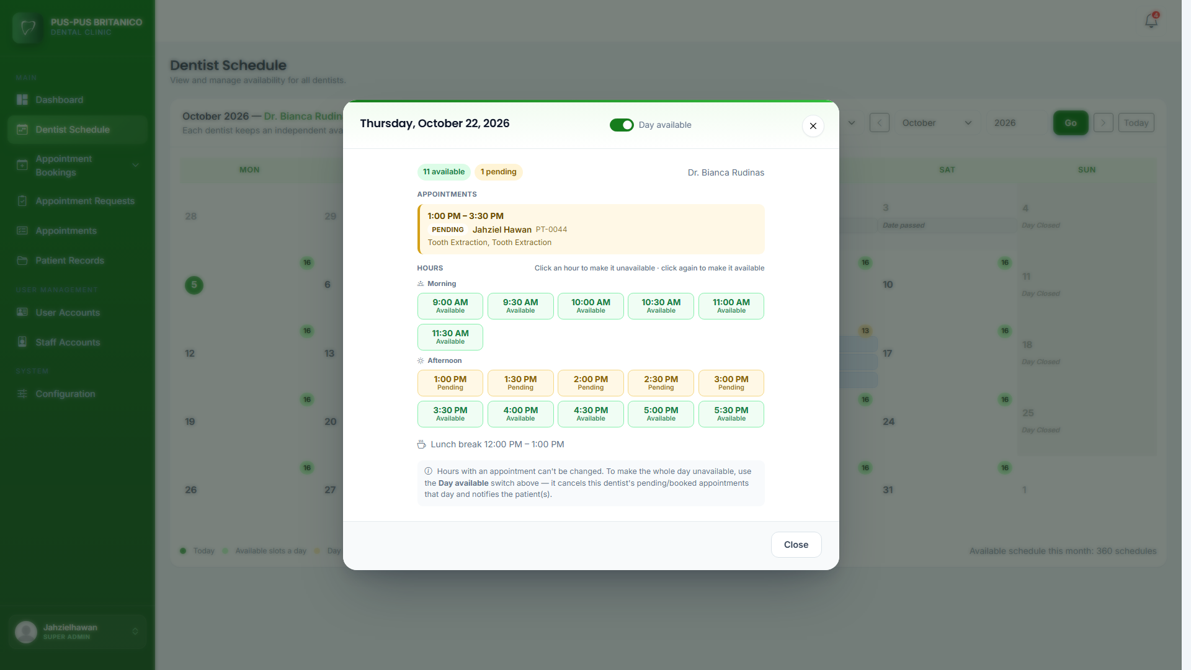
Figure xx. Screenshot of Dentist Schedule Modal
This modal shows the day and date selected and all the time slots for that day. At the top is the Day open switch. When the switch is turned off, the whole day is closed and all its time slots become not available, so patients can no longer book on that date. If there are pending or booked appointments on that day, the system asks the user to confirm first, then cancels those appointments and notifies the patients. Turning the switch back on reopens the day. Below the switch are the buttons for each time slot. Clicking a time slot changes it between available and not available, so the dentist can block specific times without closing the whole day. Time slots that already have an appointment show the patient’s name and the status of the appointment, such as Pending, Booked, or Completed, and cannot be changed. The lunch break is also shown but cannot be booked or changed.
Walk-in Scheduling Module. This module allows the Super Admin and Admin to register patients who come to the clinic without an online appointment, and to book follow-up appointments for existing patients. For a walk-in, it records the patient’s personal information, contact details, and medical history, and lets the user choose the dentist and dental services for the visit. The system then schedules the visit for the current time, or the next open time that day if the dentist is busy. Since walk-ins and follow-ups are recorded by the clinic staff, they are approved right away and do not need to go through appointment approval. This module includes the walk-in appointment page and the follow-up appointment page.
Figure xx shows the patient information form of the walk-in page. The walk-in page is divided into three steps: patient information, services, and review and confirm.

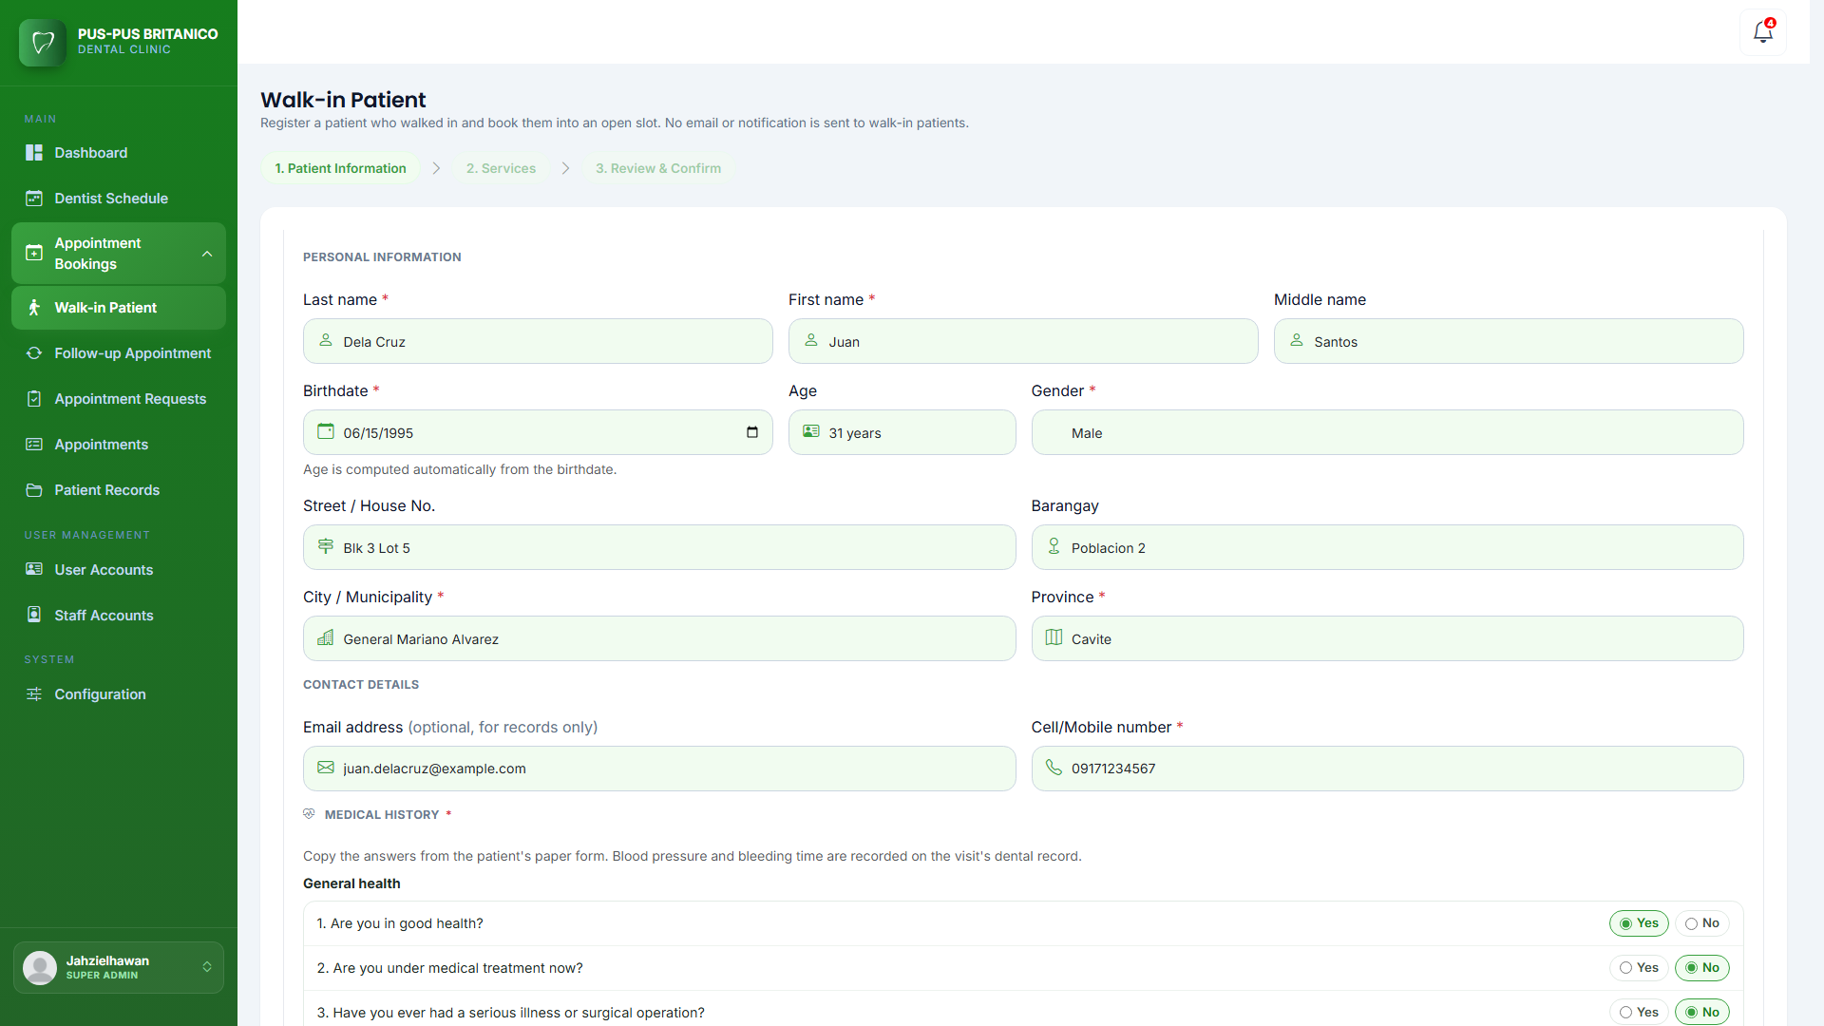
Figure xx. Screenshot of Patient Information Form
This page shows the form where the staff enters the walk-in patient’s information. It asks for the patient’s name, birthdate, gender, and home address. The system computes the age automatically from the birthdate. The contact details include the mobile number and an optional email address for records only. If the patient is under 18, the form asks for the parent or guardian’s name, contact number, occupation, and email instead of the patient’s own contact details. The form also includes the patient’s medical history, such as their general health, allergies, medications, and existing conditions. After all the required fields are filled out, the staff clicks the Continue to Services button to go to the next step.
Figure xx shows the services page of the walk-in page. On this page, the staff chooses the dentist and the services for the walk-in patient.

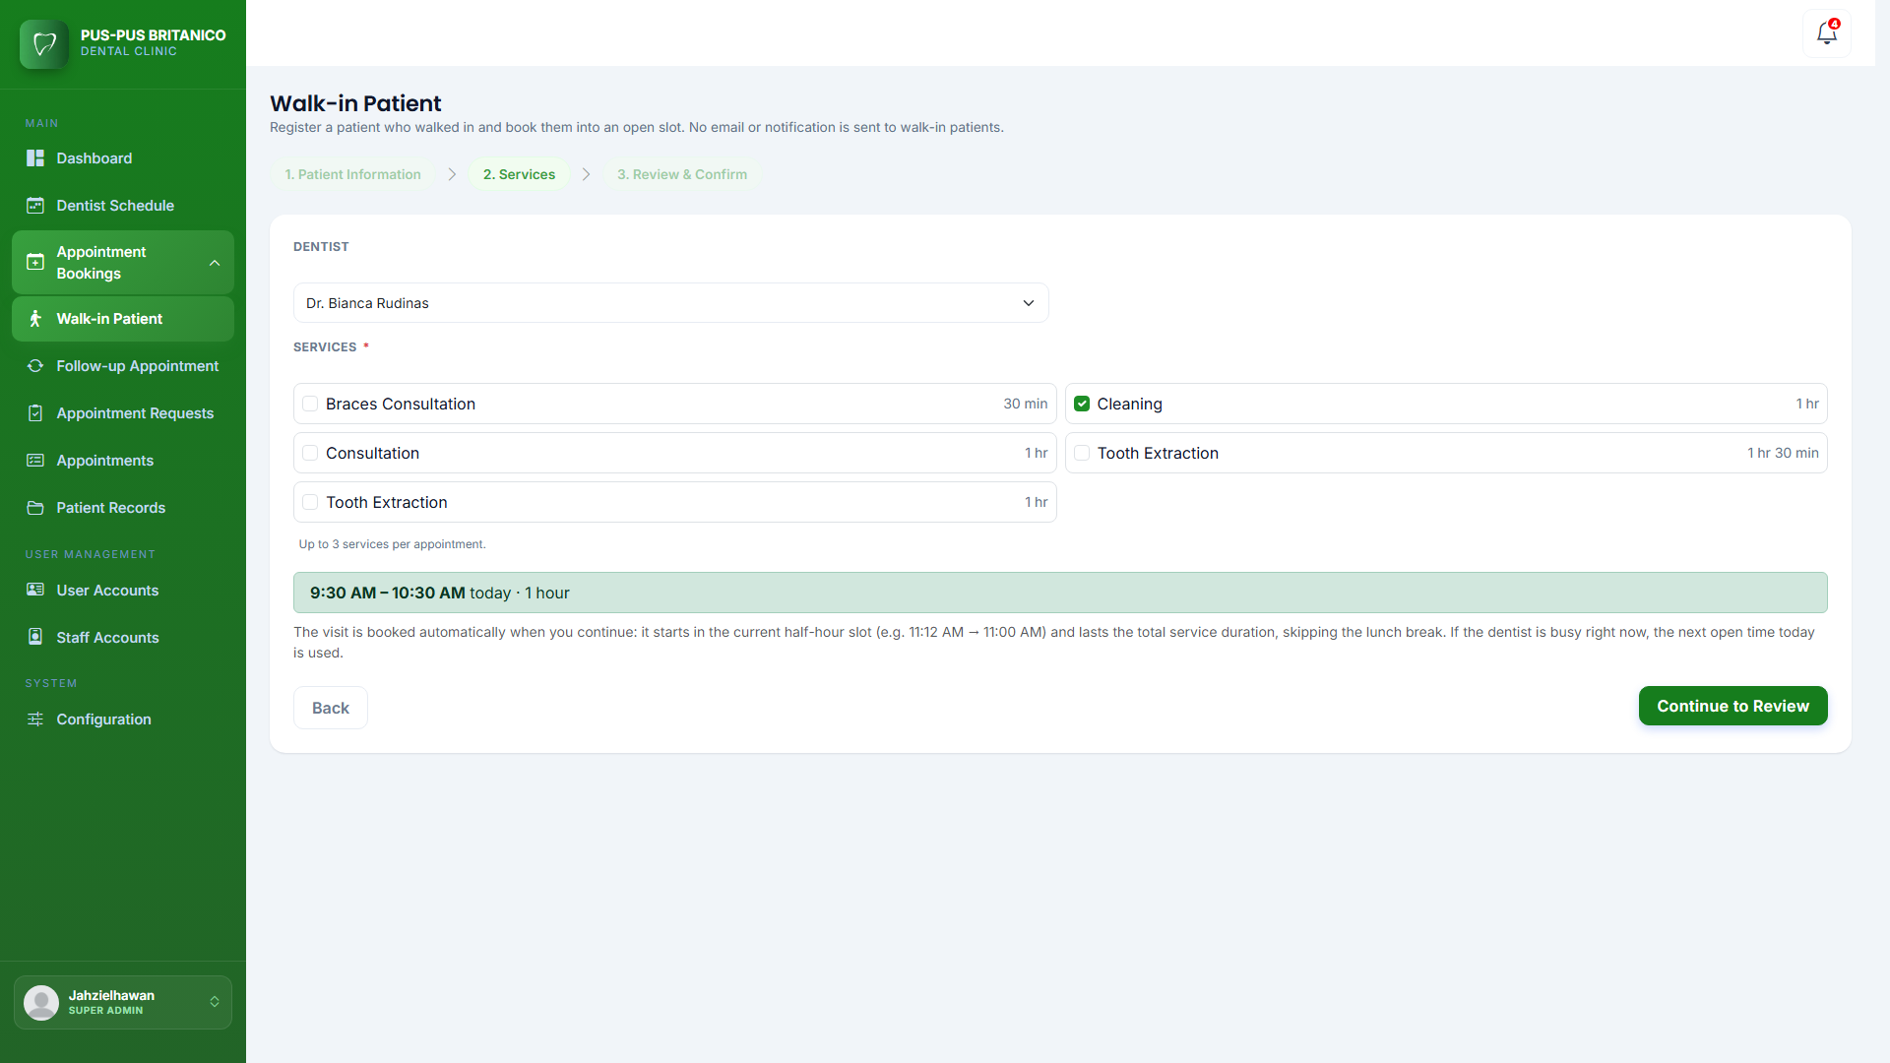
Figure xx. Screenshot of Walk-in Patient Services
This page has a dropdown for choosing the dentist and a list of the clinic’s dental services, each showing how long it takes. The staff ticks the box beside each service the patient needs, up to three services per appointment. After the services are chosen, the page shows the visit time and its total duration. It also explains how walk-in booking works: the visit starts at the current half-hour time slot and lasts for the total time of the chosen services, skipping the lunch break. If the dentist is busy at that time, the system uses the next open time that day. The page has two buttons: a Back button that returns to the patient information form, and a Continue to Review button that goes to the last step.
Figure xx shows the review and confirm page of the walk-in page. On this page, the staff checks all the details of the walk-in booking before saving it.

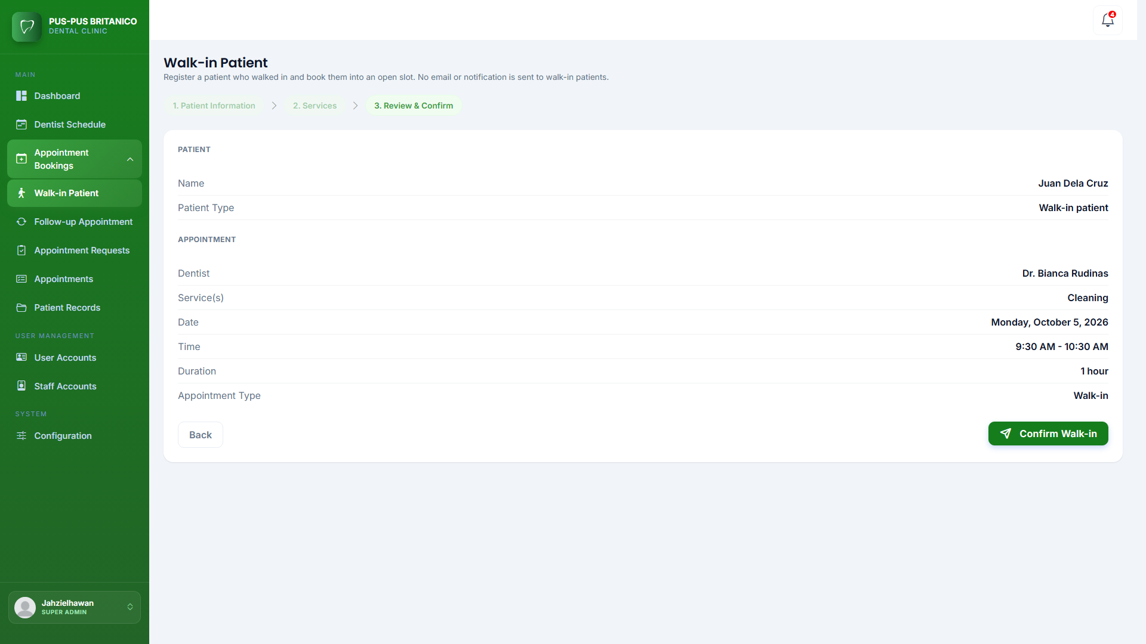
Figure xx. Screenshot of Walk-in Review & Confirm Page
This page shows a summary of the walk-in booking. It includes the patient’s name and patient type, and the appointment details: the appointment type, dentist, services, date, time, and duration. The page has two buttons: a Back button that returns to the services page, and a Confirm Walk-in button that saves the booking. Once confirmed, the walk-in appointment is saved as approved and the clinic staff are notified. No email or notification is sent to the walk-in patient because they are already at the clinic.
Figure xx shows the follow-up appointment page. On this page, the Super Admin and Admin can book a follow-up visit for an existing patient.

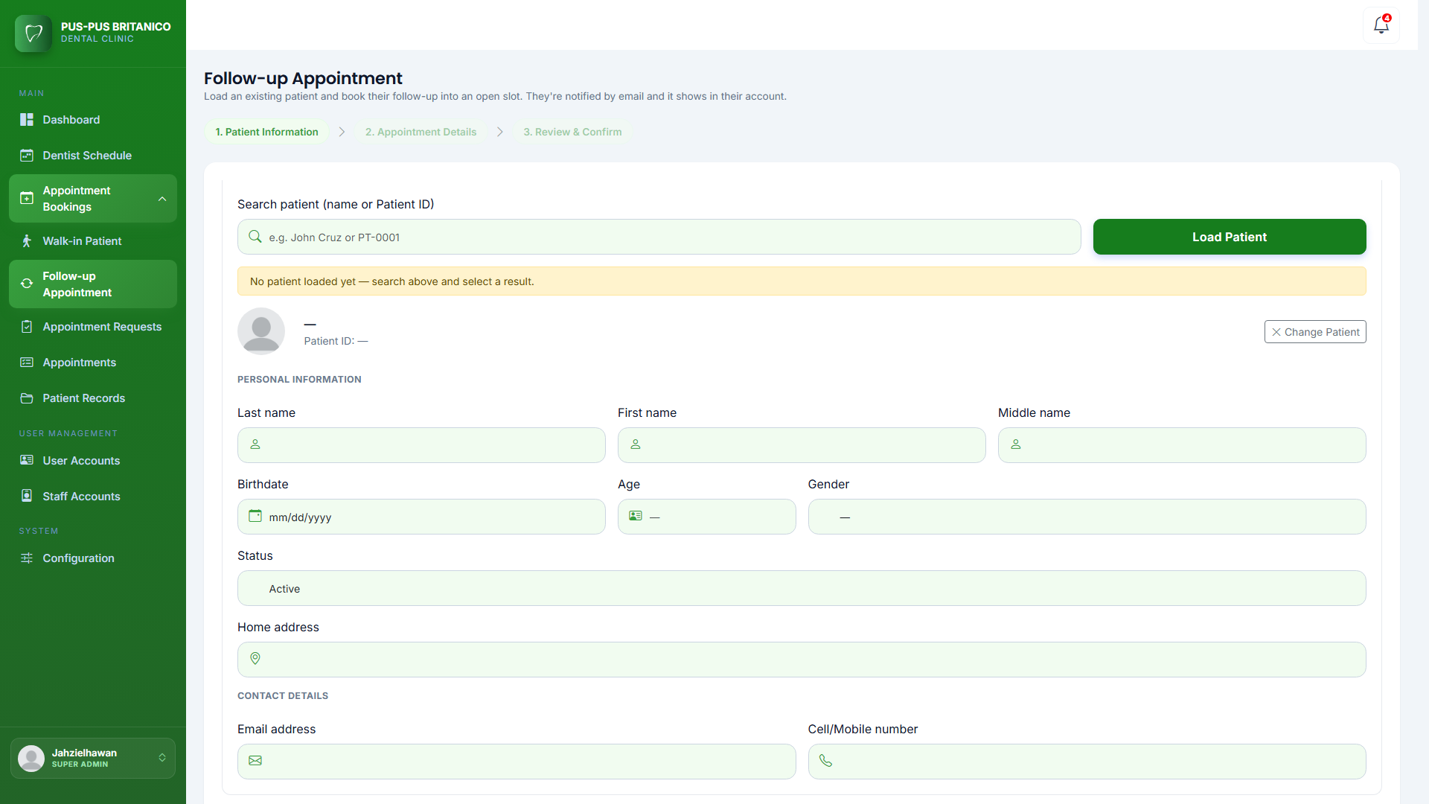
Figure xx. Screenshot of Follow-up Appointment Page
This page lets the staff search for an existing patient by name or patient ID, then choose the dentist, services, date, and time from the dentist’s calendar. The follow-up is saved as approved right away, and the patient is notified through the system and by email, or by email only if they booked as a guest.
Appointment Approval Module. This module shows the appointment requests that patients booked online and that are waiting for approval. It lets the Super Admin and Admin review each request and either approve it or decline it with a reason. The duration of each appointment is computed automatically from the services the patient chose, so the staff only needs to adjust it if necessary. After an appointment is approved or declined, the system notifies the patient through the system and by email. This module includes the appointment approval page.
Figure xx shows the appointment approval page. On this page, the Super Admin and Admin can view and manage all appointment requests from patients.

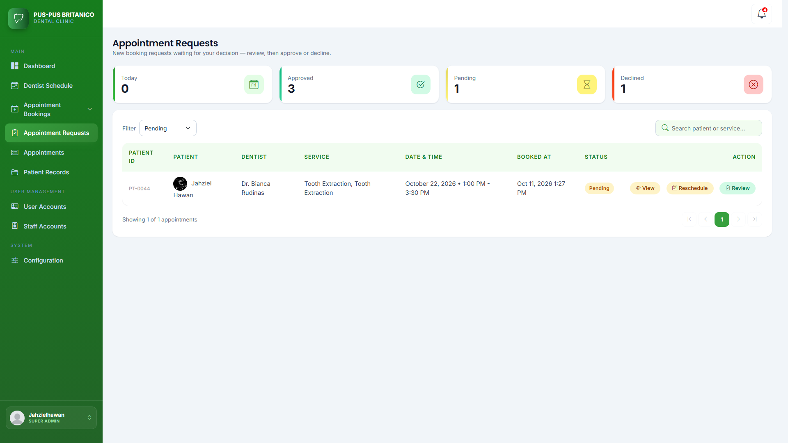
Figure xx. Screenshot of Appointment Approval Page
This page has cards at the top that show the number of appointments today and the number of approved, pending, and declined appointments. Below the cards is a table of appointment requests showing the patient ID, patient name, dentist, service, date and time, when it was booked, and its status. Walk-in and guest appointments are marked with a label. The page has a status filter to show only pending, booked, declined, completed, or cancelled appointments, and a search bar to find an appointment by patient name or service. Each row has a View button to see the appointment details, the patient’s information, medical history, and any attached photos. Upcoming pending and booked appointments also have a Reschedule button, which lets the staff propose a new date and time to the patient. Pending appointments also have a Review button that opens a modal for approving or declining the request.
Figure xx shows the appointment approval review modal. On this modal, the Super Admin and Admin can check the appointment details and decide whether to approve or decline the request.

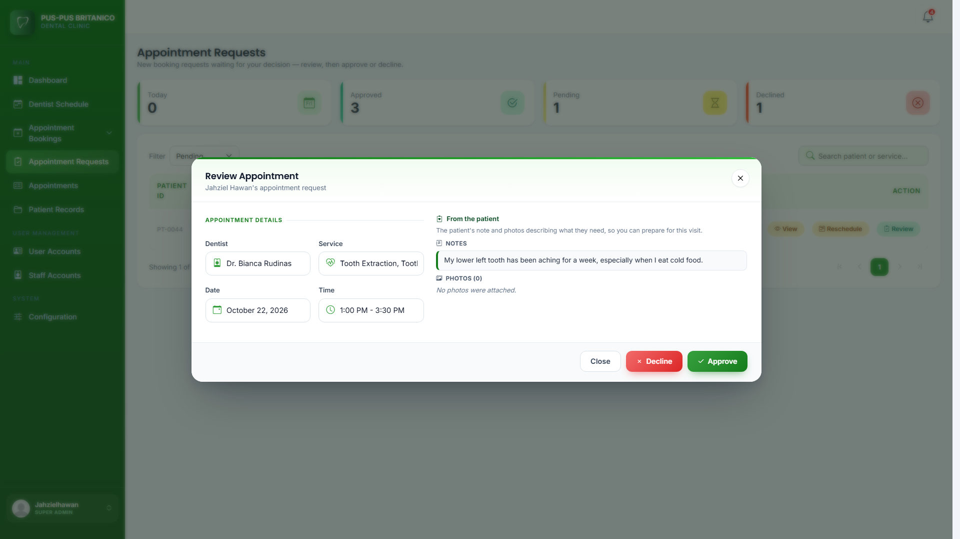
Figure xx. Screenshot of Appointment Approval Review Modal
This modal shows the name of the patient who made the request and the appointment details, such as the dentist, service, date, and time. These details are shown in read-only fields so they cannot be changed by mistake. The modal has three buttons: Close to close the modal, Decline to decline the request, and Approve to approve it. When the Approve button is clicked, a confirmation modal opens with an optional Duration field. The duration is already set from the chosen services, but the staff can adjust it if the patient’s note or photos show that the visit needs more or less time. After the staff clicks Confirm Approval, the appointment status changes to Booked. When the Decline button is clicked, another modal opens where the staff must type the reason for declining, which is sent to the patient. Declining an appointment also frees its time slot so other patients can book it.
Appointment Management Module. This module handles the appointments of the clinic after they are booked. It lets the Super Admin and Admin view all appointments, mark approved appointments as completed, reschedule appointments, and cancel appointments. Whenever an appointment is completed, rescheduled, or cancelled, the system notifies the patient through the system and by email. This module includes the appointments page.
Figure xx shows the appointments page. On this page, the Super Admin and Admin can view and manage all appointments in the clinic.

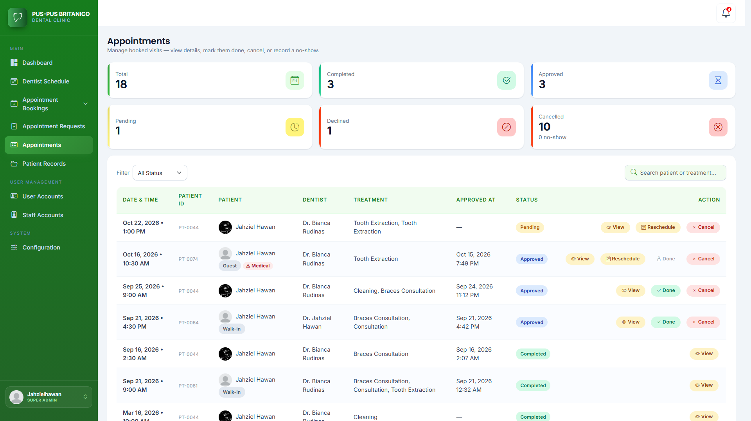
Figure xx. Screenshot of Appointment Management Module
This page has cards at the top that show the total number of appointments and the number of completed, approved, pending, declined, and cancelled appointments. Below the cards is a table showing each appointment’s date and time, patient ID, patient name, dentist, treatment, approval date, and status. Walk-in and guest appointments are marked with a label. The page has a status filter and a search bar where the user can search by patient name or treatment. Each row has up to four buttons. The View button shows the appointment details and the patient’s information. The Done button marks an approved appointment as completed, and it only appears once the appointment’s start time has arrived. The Reschedule button lets the staff propose a new date and time; the patient is notified and can accept the new time or keep the original one, and if the patient accepts, the appointment moves to the new time and stays approved. Lastly, the Cancel button opens a modal where the user chooses why the appointment is being cancelled: cancelled by the clinic (a reason is required), the patient asked to cancel, the dentist is unavailable, or the patient did not arrive, which is marked as No Show. The reason is sent to the patient, and cancelling an appointment also frees its time slot so other patients can book it.
Patient Records Management Module. This module stores and manages the dental records of the clinic’s patients. A patient record is created automatically each time an appointment is marked as completed, so every finished visit is saved in the patient’s history. Authorized users can view, search, edit, archive, and restore patient records. Each patient’s record shows their personal information, medical history, treatment records, visit history, and a dental chart for every visit. The system also automatically marks patients as Active or Inactive based on the clinic’s six-month policy: a patient becomes Inactive when their last completed visit was more than six months ago. This module includes the patient records page and the patient record history page.
Figure xx shows the patient records page. On this page, the Super Admin and Admin can view and manage the list of patients who have completed appointments in the clinic.

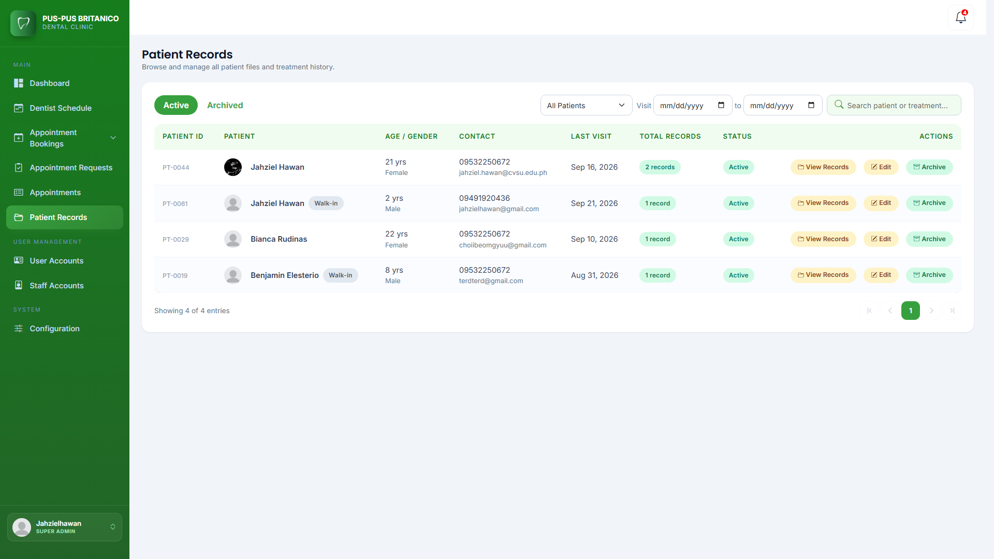
Figure xx. Screenshot of Patient Records Management Module
This page shows a table of patients who have at least one completed appointment. The table shows each patient’s ID, name, age and gender, contact details, last visit, total number of records, and status. Walk-in and guest patients are marked with a label. The page has Active and Archived tabs to separate current records from archived ones. It also has a filter to show all patients, registered patients only, walk-in patients only, or guest patients (no account) only, a date range filter for the visit date, and a search bar to find patients easily. Each row has three buttons: View Records to open the patient’s record history page, Edit to update the patient’s information, and Archive to archive the patient’s records after a reason is given. Archived records can be restored from the Archived tab.
Figure xx shows the patient record history page. On this page, the Super Admin and Admin can see all the visits and treatments of a patient.

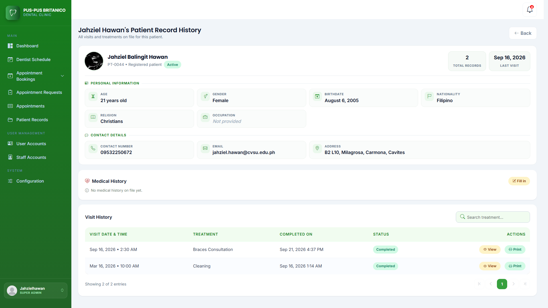
Figure xx. Screenshot of Patient Records History
This page shows a card at the top with the patient’s information, such as their name, patient ID, patient type, status, total records, last visit, age, gender, birthdate, nationality, religion, occupation, contact details, and address. If the patient is a minor, the card also shows the parent or guardian’s information. Below it is the patient’s latest medical history, which the staff can fill in or update. At the bottom is the Visit History table, which lists the patient’s completed visits with the visit date and time, treatment, completion date, and status, and has a search bar for finding a treatment. Each visit has a View button that opens a modal with the details of that visit, and a Print button for printing the record of that visit. Single visits cannot be archived on their own; to archive a patient’s records, the staff archives the whole patient from the patient records page.
Figure xx shows the patient record modal. On this modal, the Super Admin and Admin can view the details of a completed visit, including the dental chart and the dentist’s notes.

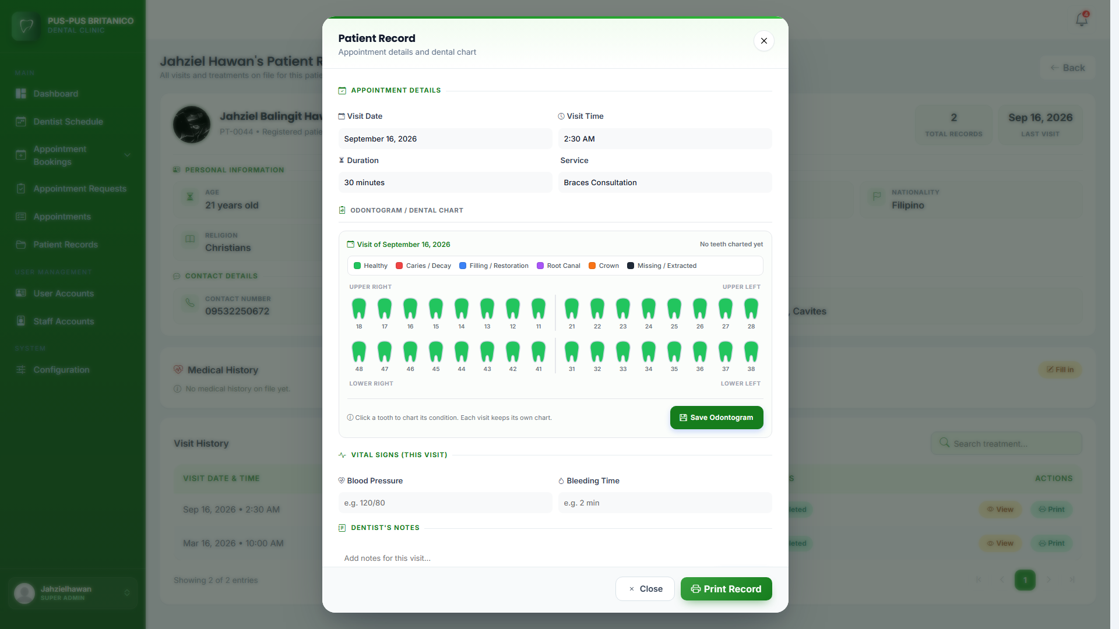
Figure xx. Screenshot of Patient Record History Modal
This modal shows the appointment details of the visit, such as the visit date, time, duration, and service. It also has an odontogram, which is a dental chart of the patient’s teeth. When a tooth is clicked, the user can mark its condition as healthy, caries or decay, filling or restoration, root canal, crown, or missing or extracted. Each condition has its own color so the patient’s dental condition is easy to see, and the chart is saved using the Save Odontogram button. Below the dental chart are the vital signs for the visit, such as blood pressure and bleeding time, and the Dentist’s Notes section, where the dentist can write notes or reminders about the visit and save them. The modal has a Close button, and the record can also be printed using the Print Record button.
Notification Module. This module keeps the users informed about the status of appointments in the clinic. It generates notifications for new appointment requests, confirmations, declines, cancellations, rescheduling, proposed new times, and completed appointments. The system also sends automated reminders to patients for their upcoming appointments: one day before, one hour before, twenty minutes before, and at the time of the appointment. Patients with an account receive notifications both in the system and by email, while guests receive them by email together with a link to manage their appointment.
Figure xx shows the notification module modal. This modal shows all the notifications of the user in the system.

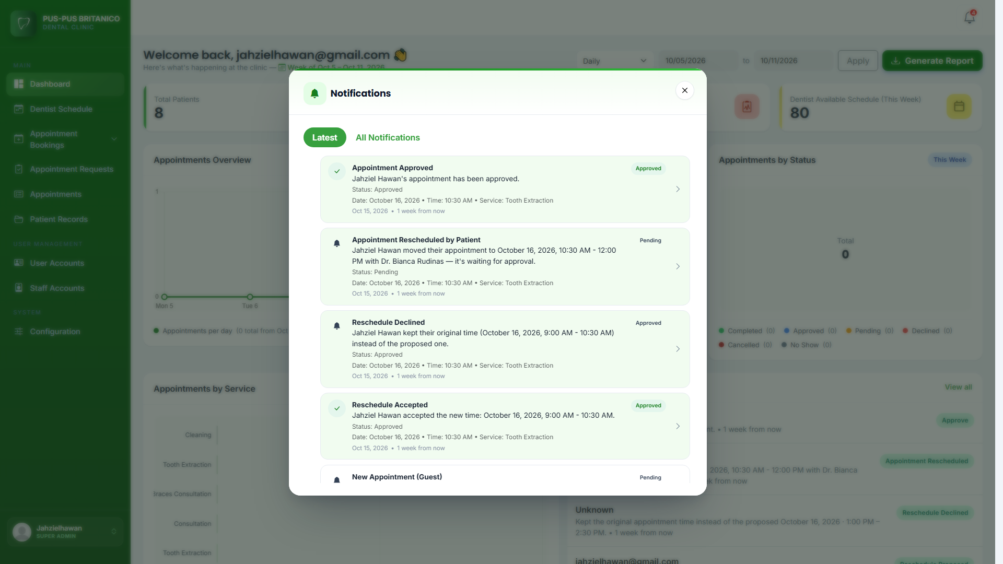
Figure xx. Screenshot of Notification Module Modal
This part of the system shows how users are notified about the status of their appointments. It is placed on the bell icon at the upper right corner of the page, which shows a red badge with the number of unread notifications. When the user clicks the bell icon, a dropdown opens with the most recent notifications. Each notification shows an icon for the type of update, a title such as Appointment Approved or Appointment Cancelled, a short message with the date and time of the appointment, and how long ago it was received. The user can click a notification to view the full details of the appointment. There is also a View all notifications link that opens the notifications modal with Latest and All Notifications tabs, where the user can see older notifications and filter them by date. Patients receive notifications when their appointment is booked, confirmed, declined, completed, cancelled, or rescheduled, as well as reminders for upcoming appointments, and these are also sent to their email. The Super Admin and staff receive notifications within the system for new appointment requests and other appointment updates.
Staff Account Management Module. This module allows the Super Admin to manage the accounts of the clinic’s staff and dentists. The Super Admin can create new accounts, assign user roles, update account information, and archive or restore accounts. New staff and dentists must verify their email address with a code the first time they log in before they can use the system, and archived accounts are not allowed to log in.
Figure xx shows the staff accounts page of the system. On this page, the Super Admin can view, search, and manage all the staff and dentist accounts registered in the clinic.

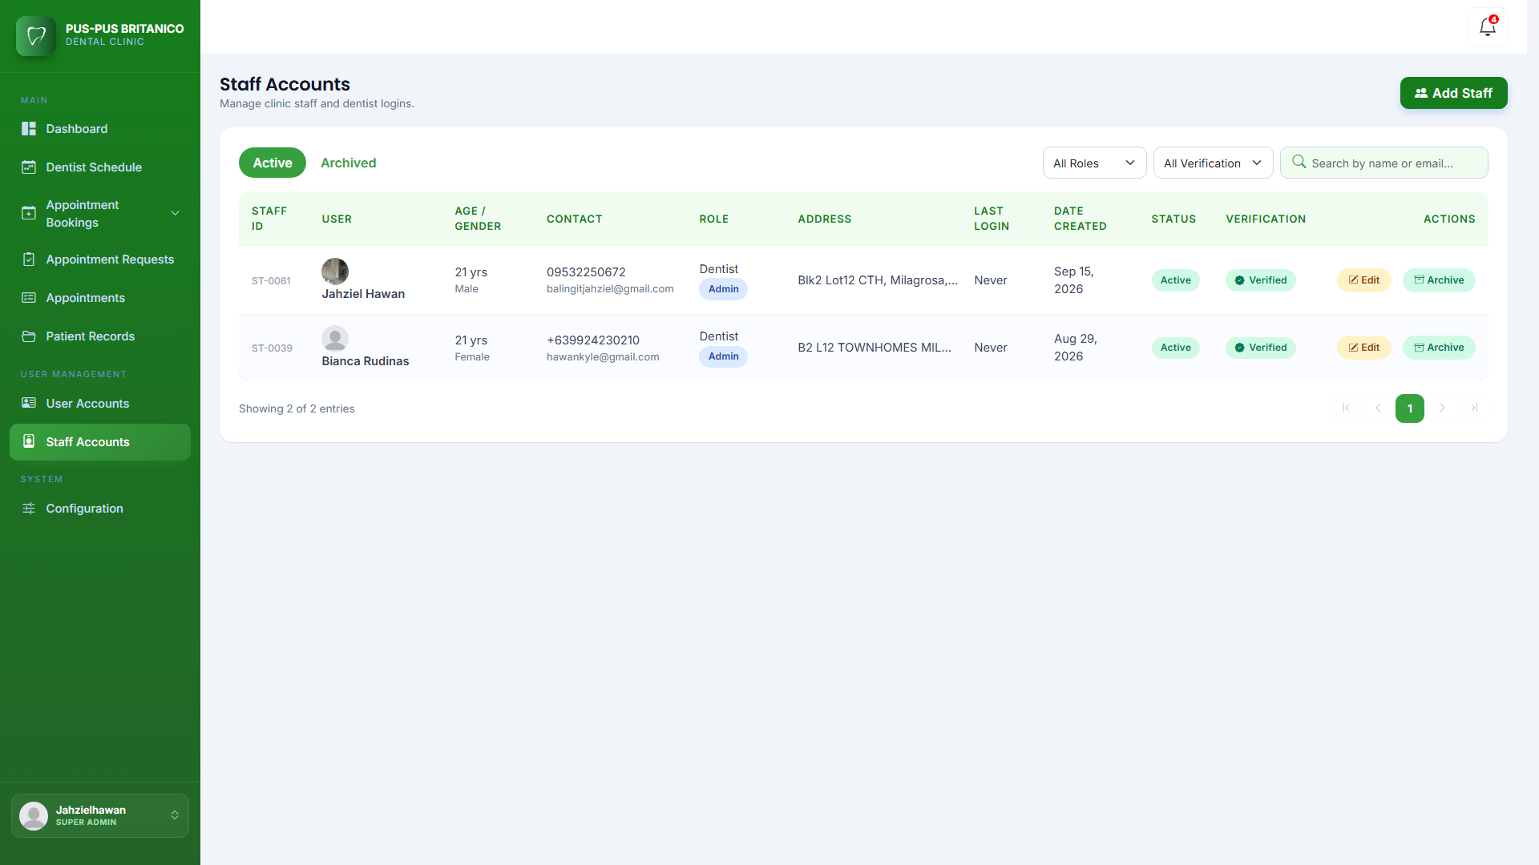
Figure xx. Screenshot of Staff Accounts Page
This page shows the list of all staff and dentist accounts in a table. The table shows each user’s staff ID, name, age and gender, contact details, role, address, last login, date created, status, and verification. The page has Active and Archived tabs to separate current accounts from archived ones, and it has filters by role and verification status and a search bar to help the Super Admin find an account easily. Each account has an Edit button for updating its information and an Archive button for deactivating it. The Add Staff button at the upper right corner of the page opens the form for creating a new account.
Figure xx shows the add user form of the staff account management module. On this form, the Super Admin can create a new staff or dentist account by entering the user’s information.

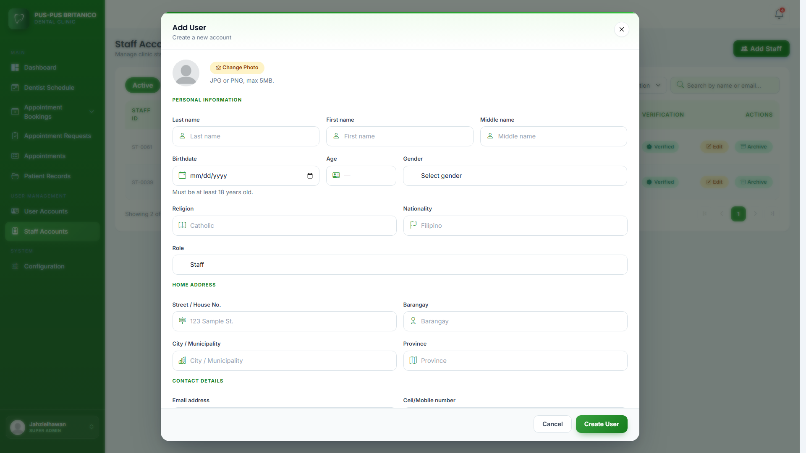
Figure xx. Screenshot of Add Staff Form
This form appears when the Super Admin clicks the Add Staff button. It is divided into sections so the information is easy to fill out. In the personal information section, the Super Admin enters the user’s last name, first name, middle name, birthdate, gender, religion, and nationality. The system calculates the age automatically from the birthdate and only accepts users who are at least 18 years old. The Super Admin then selects the user’s role, either Staff or Dentist, and enters the home address, contact number, email address, and password for the account. A profile photo in JPG or PNG format up to 5MB can also be uploaded. The system checks that all required fields are filled out correctly and that the email address is not already in use. When the Create User button is clicked, the account is saved. The new user then verifies their email address from their Staff Profile page, where a verification code is sent to their email.
User Account Management Module. This module lets the Super Admin and Admin manage the accounts of the patients. Patients create their own accounts through the sign-up page, so this module is used to view, edit, and archive or restore these accounts. Each patient is also marked as Active or Inactive. A patient becomes inactive if their last completed visit to the clinic was more than six months ago. Archived accounts can no longer log in to the system, and all changes made here are saved in the activity log.
Figure xx shows the user accounts page of the system. On this page, the Super Admin and Admin can view, search, and manage all patient accounts.

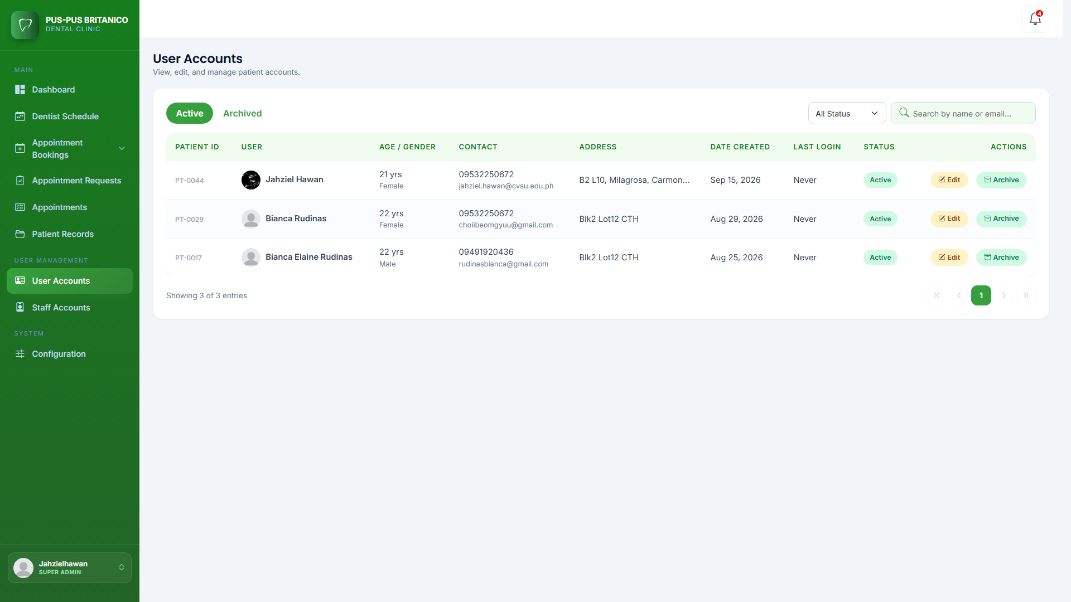
Figure xx. Screenshot of User Accounts Page
This page shows all patient accounts in a table. The table shows the patient ID, name, age and gender, contact number and email, address, date created, last login, and status. The page has two tabs, Active and Archived, to separate current accounts from archived ones. It also has a status filter to show only Active or Inactive patients, and a search bar to find a patient by name or email. Each account has an Edit button and an Archive button. The Edit button opens a form where the patient’s information, such as name, contact details, address, and profile photo, can be updated. The Archive button disables the account after a reason is given. Archived accounts can be restored from the Archived tab so the patient can log in again.
User Profile Module. This module lets patients manage their own account in the patient portal. It is found on the Settings page and has three parts: User Information, Security, and Configuration, which contains the patient’s activity log. Here, patients can view and update their personal information, change their email address and password, and see a record of their activity in the system. The patient portal also has My Dental Records, where patients can view and print the records of their completed visits, and Medical History, where they can review and update their medical information.
Figure xx shows the user information page of the user profile module. On this page, the patient can view and update their account and personal details.

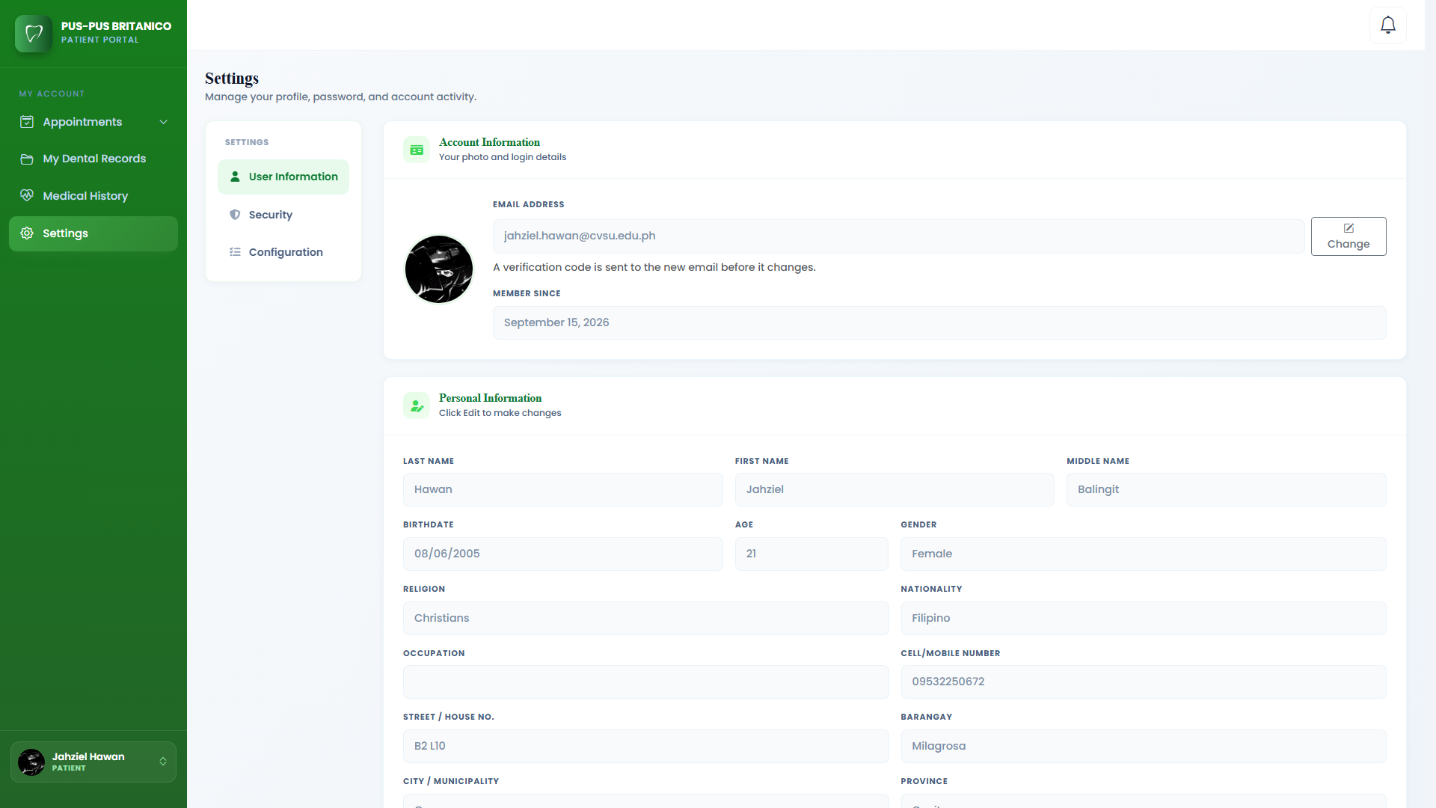
Figure xx. Screenshot of User Information Page
This page is divided into two sections. The Account Information section shows the patient’s profile photo, email address, and the date they joined. The patient can change their email address by clicking the Change button, but the new address must first be confirmed with a verification code sent to it. The Personal Information section shows the patient’s name, birthdate, age, gender, religion, nationality, occupation, mobile number, and address. The patient can click the Edit button to update these details.
Figure xx shows the security page of the user profile module. On this page, the patient can change their password to keep their account safe.

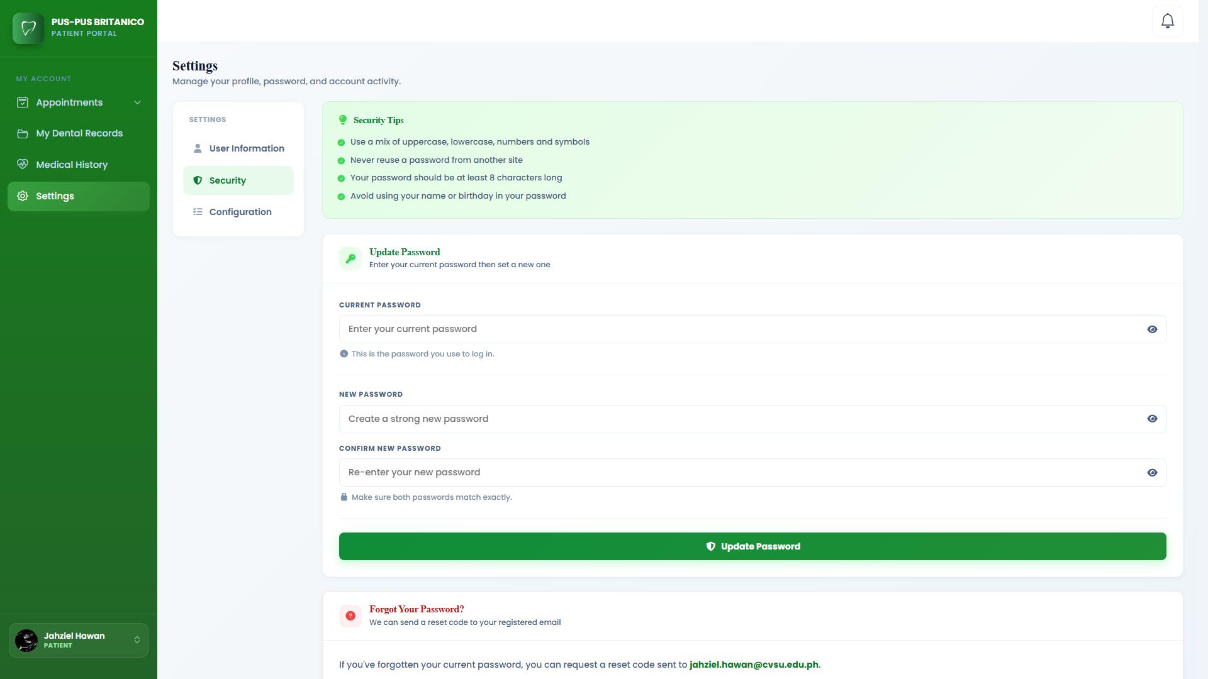
Figure xx. Screenshot of Security Page
This page shows security tips to help the patient create a strong password. To change the password, the patient enters their current password, then types the new password twice to confirm it. The eye icon beside each field lets the patient show or hide what they typed. After clicking the Update Password button, the new password is saved. If the patient forgot their current password, they can request a reset code that will be sent to their registered email.
Figure xx shows the activity log page of the user profile module. On this page, the patient can see a record of their recent actions in the system.

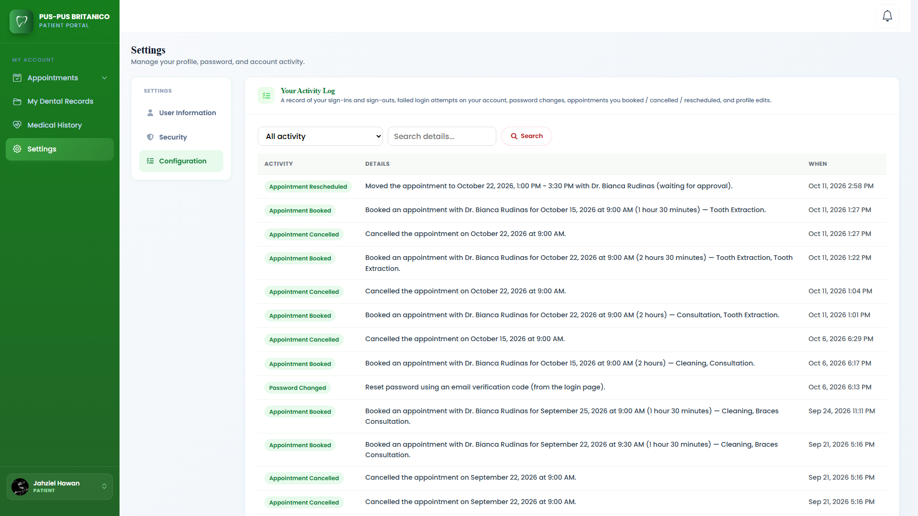
Figure xx. Screenshot of Activity Log Page
This page shows the patient’s activity in a table with three columns: activity, details, and when it happened. It records sign-ins and sign-outs, failed login attempts, password and email changes, booked, cancelled, and rescheduled appointments, and profile edits. The patient can use the dropdown to show only one type of activity, or type in the search bar to find a specific record. This helps the patient keep track of their account and notice any activity they did not do.
Configuration Module. This module lets the Super Admin manage the main settings and content of the system without changing the code. It is divided into six sections: System Information, Services, Privacy and Legal Terms, Appointment Process, Activity Logs, and Backup & Restore. Staff accounts can also manage the first four sections, while Activity Logs and Backup & Restore are for the Super Admin only. Most of the information in this module is connected to the landing page of the system. The clinic’s logo, images, details, services, terms, and booking steps that are updated here are the same ones patients and visitors see on the landing page, and any changes saved in this module show up on the landing page right away.
Figure xx shows the configuration page of the system. On this page, the Super Admin can update the clinic’s branding, images, information, and schedule settings.

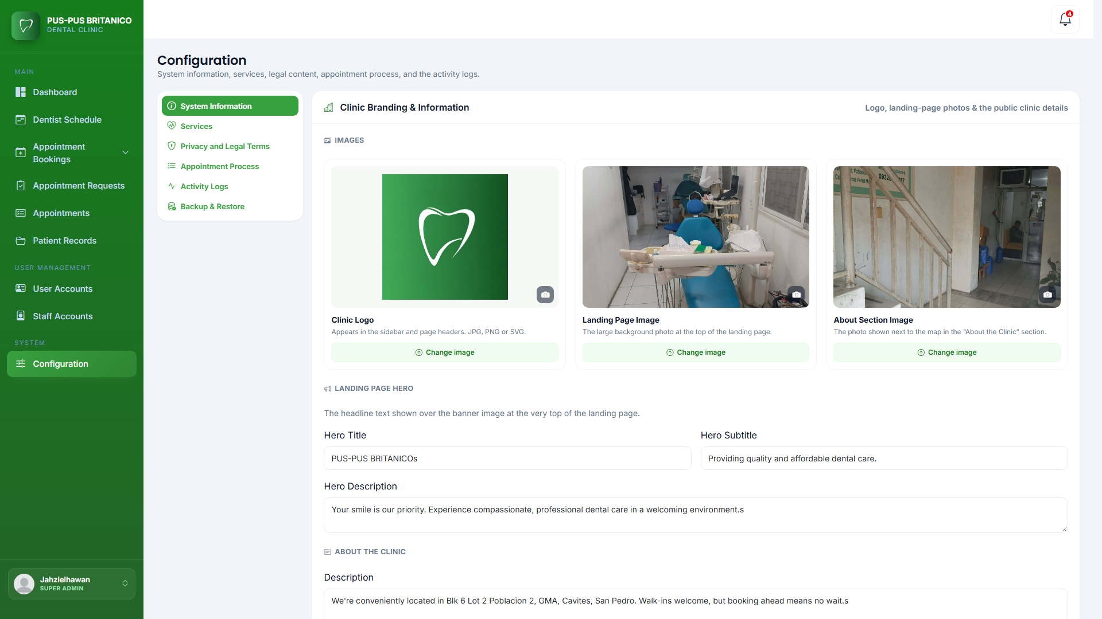
Figure xx. Screenshot of Configuration Page
This page shows the System Information section, where the clinic’s branding and details that appear on the landing page are managed. In the Images part, the Super Admin can change the clinic logo, the landing page image, and the about section image by clicking the Change image button under each one. The clinic logo appears in the sidebar and page headers, the landing page image is the large background photo at the top of the landing page, and the about section image is the photo shown next to the map in the About the Clinic section of the landing page. Below the images is the Landing Page Hero part, where the Super Admin can edit the title, subtitle, and description shown over the banner image at the top of the landing page. The page also has parts for the clinic’s description, address, and contact details, as well as the clinic’s operating days, opening and closing hours, and lunch break, which set the time slots patients can book. It also lets the Super Admin choose the weekly closed days and add specific Closed Dates, such as holidays, so patients cannot book on those days.
The menu on the left side lets the Super Admin switch to the other sections of the module. The Services section manages the dental services, their categories, and how long each one takes. The Privacy and Legal Terms section edits the text shown on the sign-up and booking pages, while the Appointment Process section edits the How to Book steps on the landing page. The Activity Logs section shows a record of every action made in the system. Lastly, the Backup & Restore section lets the Super Admin create a backup copy of the system’s records and uploaded files, save it to their computer, and restore it when needed.
Report Module. This module lets the Super Admin and Admin create reports using the data saved in the system. The user can choose the type of report, the date range, and what information to include. The report shows totals, charts, and lists that help the clinic see how many appointments were made, how many patients visited, and which services were provided. This helps the clinic keep track of its operations and make better decisions.
Figure xx shows the generate report form of the report module. On this form, the user can choose the settings of the report before it is created.

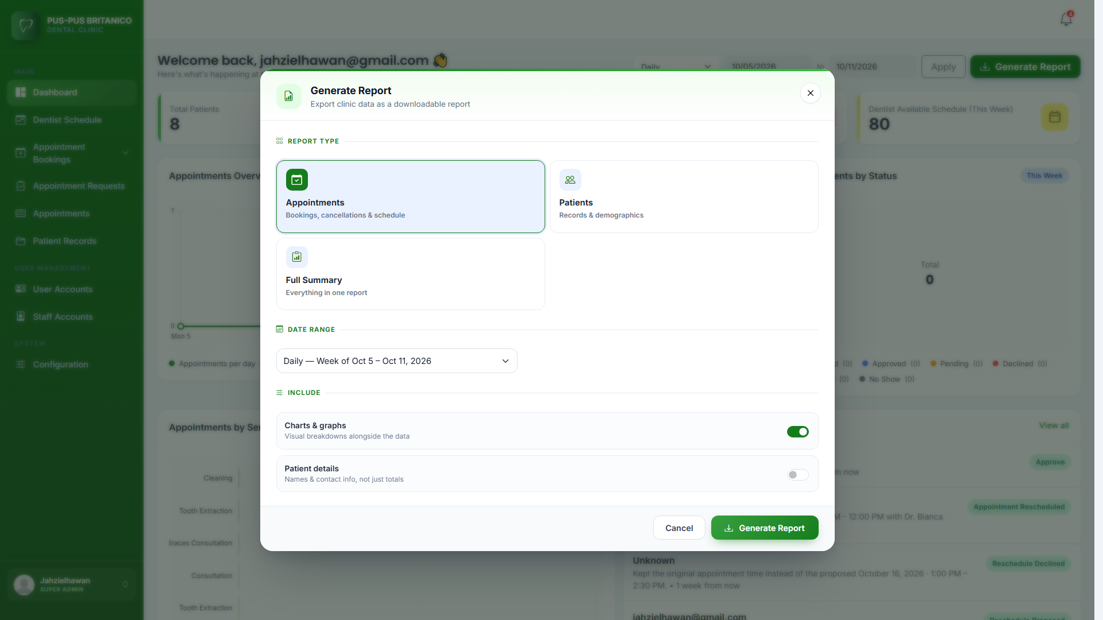
Figure xx. Screenshot of Generate Report Form
This form is divided into three parts: Report Type, Date Range, and Include. In the Report Type part, the user can choose from three types of reports. The Appointments report shows the number of pending, approved, completed, cancelled, and declined appointments, and the completed visits per service. The Patients report shows the number of patients by type (registered, walk-in, and guest), the number of male and female patients, and the treatments they received. The Full Summary report combines everything into one report. In the Date Range part, the user can choose Daily, Monthly, Quarterly, or Yearly, or set a Custom Range using the From and To dates. In the Include part, the user can turn on charts and graphs to show the data visually, and turn on patient details to include names and contact information instead of only the totals. After clicking the Generate Report button, a preview of the report opens so the user can check it before printing. Clicking Print lets the user print the report or save it as a PDF file.

