De-immunized Protein Design via a Unified, Verified MHC-II Immunopeptidome Dataset
- Dataset description
  - Overview
We have assembled MHC Class II Immunopeptidome Dataset (Unified & Verified), a large-scale, quality-controlled dataset consolidating experimentally observed MHC-II ligands from two major public sources
IEDB (Low Resolution): 740,383 records
IEDB (Standard Resolution): 364,025 records
HLA Ligand Atlas: 142,464 records
Total: 1,246,872 peptide–protein records (TSV; primary file: mhc_if_v2.tsv)
Crucially, every record is cross-verified against UniProt protein sequences with 100% sequence–coordinate consistency, enabling robust mapping from peptide-level immunopeptidome evidence to full-length protein sequence positions.
Each row links an observed ligand peptide to its source protein and includes:
Peptide sequence (peptide_seq)
MHC class fixed as Class II (hla_class = II)
Alleles (alleles, JSON array), with an explicit allele-resolution label (resolution) to distinguish generic/serotype/high-res single/dimer/mixed
Source tissue (tissues, JSON array) when available
Source protein accessions (protein_accessions, JSON array)
Verified positional grounding (peptide_position_info, JSON array): 1-based start/end coordinates (IEDB convention)
Local context (flanking_context, JSON array): 3-mer upstream/downstream residues around the peptide

  - Processing, QC, and provenance
The dataset was generated via a rigorous pipeline:
- Coordinate extraction from raw IEDB exports
- Position discovery for Atlas peptides via substring search over UniProt sequences
- Mapping all proteins to UniProt accessions and downloading >16,000 full-length sequences (FASTA available)
- Automated correction of minor coordinate shifts (~7.8k cases)
- Flank extraction directly from verified sequences
- A final global verification ensuring:
Peptide Sequence == Protein Sequence[start:end] for every retained record
Rows failing verification were removed; if a peptide occurs multiple times in a protein, all valid matches are retained.
This yields a combination: scale + strict verification + positional context, which is essential for building reliable full-length immunogenicity models.

- Research objectives
Motivation
Current epitope/ligand predictors are typically trained and evaluated on peptide-only inputs, which limits their utility for protein engineering, where practitioners need to (i) identify high-risk regions across a full protein, and (ii) redesign sequences under structural/function constraints. Meanwhile, state-of-the-art inverse folding tools (e.g., ProteinMPNN, diffusion-based inverse folding) optimize for foldability but are not immunogenicity-aware, often leaving strong MHC-II hotspots untouched, causing severe immune response – antidrug antibody.
Our goal is to build the first modular framework that injects MHC-II immunopeptidome constraints into protein inverse folding/design, enabled by our verified peptide-to-protein mapping dataset.
Aim 1: Full-length hotspot prediction from peptide-level evidence
Objective: Train a sequence-level “epitope-risk head” that takes a full-length protein sequence as input and outputs a position-wise risk map (hotspots) and an aggregated global risk score.
Aim 2: Hotspot-aware protein design via diffusion guidance
Objective: Integrate the trained risk head as a guidance module for inverse folding / generative design (diffusion-based inverse folding preferred), producing sequences that reduce predicted MHC-II hotspots while maintaining structural plausibility.
Aim 3: Modularization: plug-and-play immune constraint for the community
Objective: Release the epitope-risk head as a modular component that can be attached to different protein generative models (inverse folding, sequence diffusion, language models), enabling broad community use.

- Preliminary analyses
Data distribution analyses:
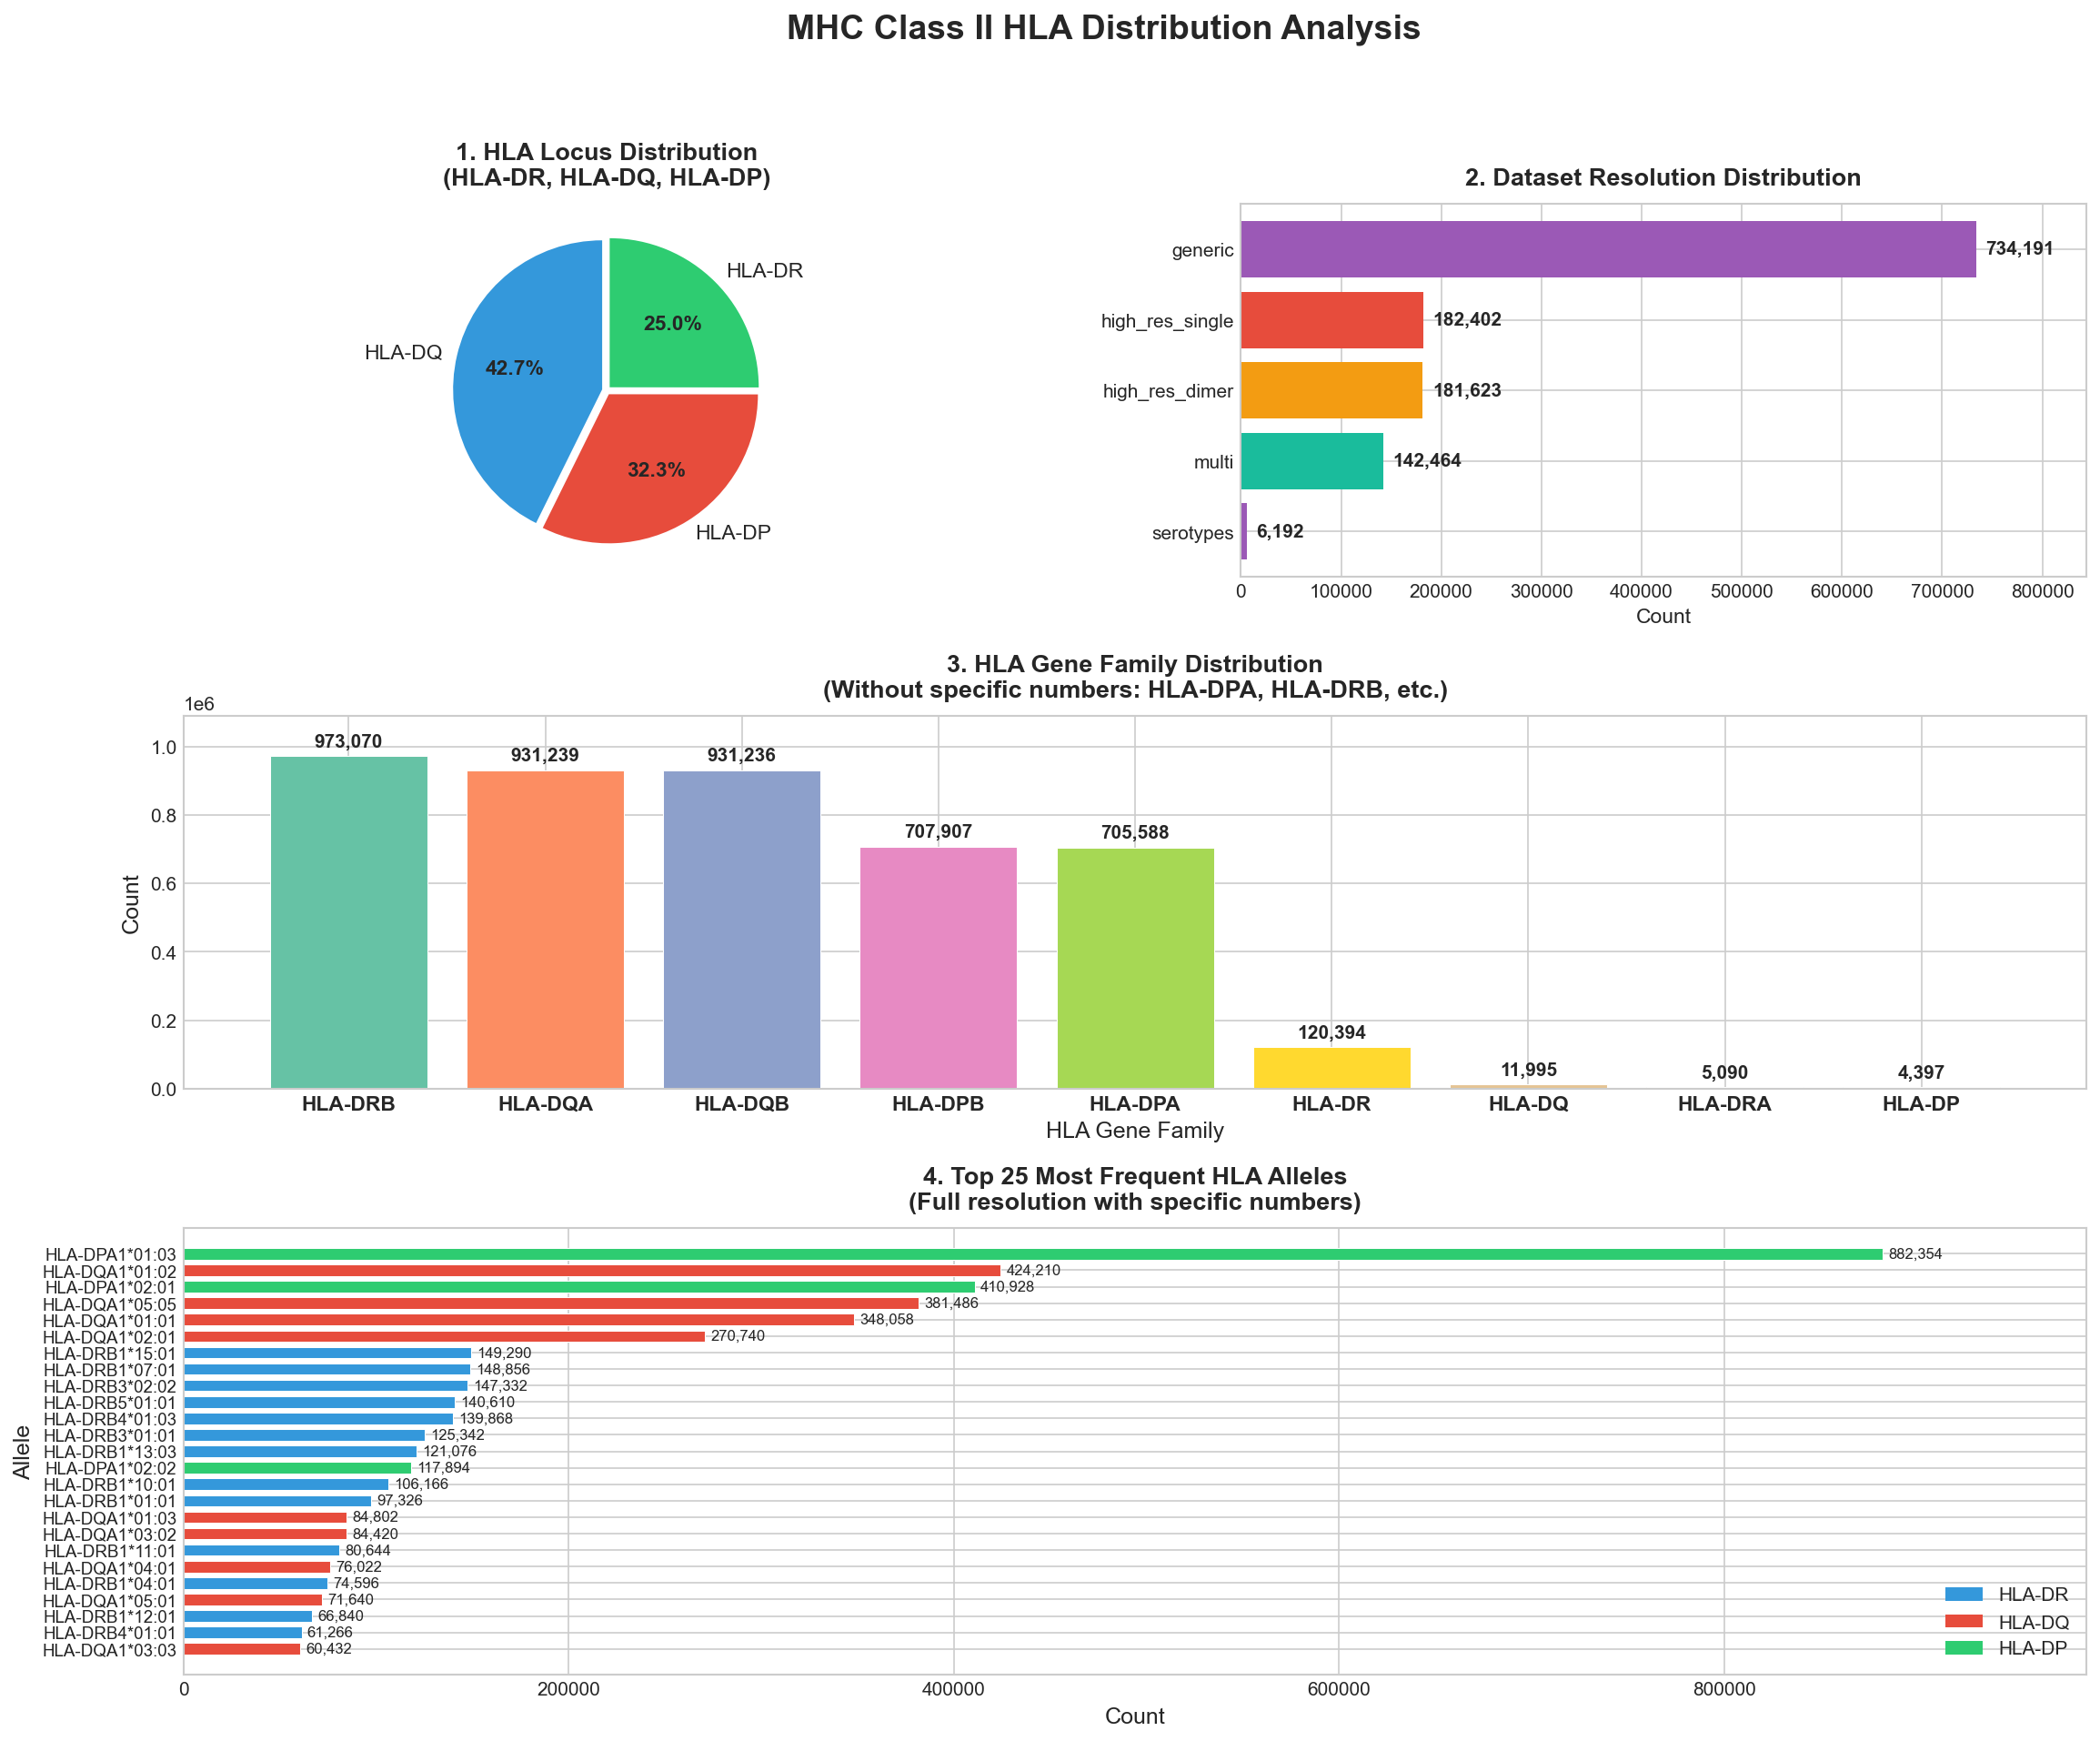
Overlap analysis: But if we consider pair overlap (peptide, allele):
 | Number | Proportion
Unique peptides | 412,158 | -
Single source | 271,345 | 65.84%
Overlap | 140,813 | 34.16%
 | Number | Proportion
Unique pairs | 708,006 | -
Single source | 707,544 | 99.93%
Overlap | 462 | 0.07%

