Effective Training Pressure Gates Recursive Knowledge Degradation in LLMs: A Multi-Axis Dose-Response Study
Julio Leite Azancort Neto
Carlos André de Mattos Teixeira
André Carlos Ponce de Leon Ferreira de Carvalho
Carlos Renato Lisboa Francês
Abstract
Recursive fine-tuning on synthetic data progressively degrades factual knowledge in large language models under common parameter-efficient settings. The conditions governing whether degradation emerges, remains bounded, or can be reversed are not well understood. Through dose-response experiments across three architectures (Qwen 2.5 1.5B, Gemma 3 1B, and Gemma 4 E2B), up to ten recursive generations, and three to six seeds per headline condition, we map adapter rank, learning rate, and synthetic exposure onto a regime structure with three zones: homeostatic, bounded, and degradative. Increasing rank produces a threshold-like transition within the tested grid; the boundary falls between effective ranks 50 and 88 for Qwen and between 3 and 6 for Gemma 3, a tenfold difference between architectures. Learning-rate sweeps under full fine-tuning reproduce the same qualitative pattern, consistent with perturbation magnitude as the operative variable rather than low-rank adaptation specifically. At intermediate capacity ($r=128$, Qwen), factual retention remains near 90% while output-distribution quality collapses threefold, revealing a dissociation invisible to scalar retention metrics. Pre-registered dose-response experiments show that reducing synthetic exposure by 50% shifts the Qwen system toward the bounded regime ($+9.2$ pp at Gen 10, 95% CI $[6.9,11.6]$, $p<0.001$) and improves endpoint retention on Gemma 3 ($+12.9$ pp, $p=0.003$) without reducing the rate of loss. The effective-training-pressure index is an exploratory post-training summary and has not been validated as a prospective predictor across architectures or datasets. Experiments use 1–2 billion parameter models; generalization to larger scales has not been established.
[orcid=0000-0003-2866-5445]
[orcid=0000-0003-1902-4347]
[orcid=0000-0002-1907-5913]
[orcid=0000-0003-0305-7662]

Introduction
Large language models are frequently adapted using synthetic data generated by language models themselves. Iterative reinforcement learning from human feedback , synthetic instruction generation , self-play, and model distillation all create recursive fine-tuning workflows in which successive model generations are trained on outputs produced by their predecessors. As the availability of high-quality human-generated text becomes increasingly constrained , these recursive workflows are becoming a common component of model adaptation pipelines.
In practice, recursive synthetic adaptation is attractive because it is inexpensive, scalable, and avoids the continuous collection of human annotations . However, every recursive update also modifies the distribution from which future training data will be drawn, creating a feedback loop in which small errors may accumulate over successive generations. For practitioners, the resulting engineering question is not simply whether recursive training degrades models, but under what conditions such degradation becomes operationally relevant.
Recent work has established that this risk is both empirically observable and theoretically grounded. Under full fine-tuning, models progressively lose distributional diversity and factual accuracy , with expected loss growing linearly across recursive generations . Similar dynamics have been observed in diffusion models and GANs , suggesting that recursive degradation is not unique to language models. Mitigation strategies based on data accumulation , verification , and loss shaping have been proposed, each operating on a different axis of the training pipeline. Together, these studies confirm that recursive degradation is a real and well-characterized phenomenon.
Despite these findings, modern adaptation pipelines rely predominantly on parameter-efficient methods such as Low-Rank Adaptation (LoRA) and its quantized variant, QLoRA , which dramatically reduce computational cost while preserving downstream performance. observed qualitatively that LoRA “learns less and forgets less,” but it remains unknown how this protective property scales under repeated recursive pressure. At what adapter capacity does the protection fail? Is the boundary between stability and degradation gradual or threshold-like? Is it universal across architectures, or backbone-dependent? To our knowledge, no systematic dose-response analysis has characterized the steepness, backbone-dependence, or reversibility of the stability boundary under parameter-efficient fine-tuning.
Rather than treating adapter rank, learning rate, and synthetic exposure as independent factors, we show that their effects on recursive stability can be understood through a single organizing principle, which we term effective training pressure. Through systematic experiments spanning three backbones (Qwen 2.5 1.5B, Gemma 3 1B, Gemma 4 E2B), a strict replace-only protocol over ten recursive generations, and multiple intervention strategies, we identify backbone-dependent transitions between homeostatic and degradative recursive regimes and show that these transitions can be controlled through multiple independently manipulated variables.
Beyond explaining the observed behavior, this perspective has practical implications for the control of recursive training systems. Existing pipelines offer little guidance for selecting adapter capacity or synthetic-data reuse policies that preserve long-term stability. By framing recursive stability as a function of effective training pressure, these findings provide a basis for monitoring, controlling, and intervening in recursive fine-tuning before substantial degradation occurs. Critically, these results suggest that recursive training stability can be influenced through configuration choices already available to practitioners, without requiring external verifiers, additional real data, or changes to the training objective, provided that the effective training pressure threshold for the target backbone has first been identified.
The main contributions of this work are:
- We provide a systematic dose-response mapping between adapter rank and recursive factual retention, measured via a subset-based retention metric ($K_{0}$, Section ), identifying a threshold-like transition within the tested grid on Qwen and replicating the same qualitative structure on Gemma 3 at a substantially lower threshold (effective rank 3–6 versus 50–88), confirmed across three or five independent seeds (six for the pooled $r=256$ estimate) for headline conditions; intermediate ablations use a single seed and are labeled descriptive.
- We report full fine-tuning learning-rate sweeps on Qwen and Gemma 3 (single seed) in which retention is lower at higher learning rates, consistent with the phenomenon responding to perturbation magnitude rather than being specific to low-rank adaptation; the Gemma 3 sweep is not monotonic.
- We present a single-seed rank $×$ learning-rate pilot grid descriptively consistent with the two axes not operating independently; multi-seed replication is needed before formal interaction claims.
- We show that output-distribution diagnostics reveal a retention/distribution dissociation at intermediate capacity, where output quality degrades substantially while factual retention remains bounded.
- We show that synthetic exposure is a third pressure axis: a pre-registered dose–response (five paired seeds) shows that the tested reductions of 10%, 25%, and 50% each raised Gen 5 retention by 3.6–4.4 pp, with the Gen 10 benefit graded ($+9.2$ pp at 50%; 95% CI $[6.9,11.6]$). On Qwen, a 50% reduction yielded a similar point estimate to halving the learning rate; formal equivalence and mechanism were not established.
The remainder of this paper reviews related work, formalizes the proposed recursive fine-tuning framework and the effective training pressure formulation, reports the empirical evaluation across recursive regimes, backbone architectures, and intervention strategies, and concludes by discussing the practical implications and limitations of the proposed framework.

Related Work
A growing body of work has investigated the effects of recursively training language models on synthetic data , together with strategies for mitigating the resulting degradation. This section reviews the literature most relevant to the present study, covering recursive model collapse, factual knowledge degradation, mitigation approaches, and parameter-efficient fine-tuning, before positioning the contribution of this work within that landscape.

Recursive model collapse
Recent work has established recursive training on synthetic data as a distinct failure mode of generative models. Empirically, demonstrated that language models trained iteratively on their own outputs exhibit irreversible distributional collapse, with the tails of the original data distribution progressively disappearing. This phenomenon extends beyond language: observed analogous quality and diversity degradation in self-consuming loops for diffusion models and GANs, suggesting that recursive collapse is a general consequence of iterative generative training rather than a language-specific artifact .
Theoretical work has formalized these observations. proved that expected test loss increases at least linearly with the number of recursive generations for any nonzero fraction of synthetic data, disrupting the neural scaling laws that underpin modern LLM training . showed convergence toward a degenerate distribution under iterated retraining, while provided a random-walk interpretation demonstrating that the probability of model improvement under recursive training is strictly less than one-half. further characterized the growth schedules required to avoid collapse in exponential-family models.
Collectively, these studies establish that recursive degradation is both empirically observable and theoretically expected under full fine-tuning or pretraining. However, they provide limited insight into where the transition between stable and degradative behavior occurs under parameter-efficient fine-tuning, or how that transition depends on controllable training variables such as update capacity and perturbation magnitude.

Knowledge degradation
Whereas much of the recursive-training literature examines statistical consequences of repeated synthetic training (distributional decay, mode collapse), a smaller body of work has focused on how recursive updates affect the retention of factual knowledge. Although not concerned with recursive training, established that pretrained language models encode factual associations accessible via probing, providing the conceptual basis for knowledge-retention evaluations. Building on this foundation, introduced the term knowledge collapse; , a non-peer-reviewed preprint, applied the term to recursive synthetic training, describing a three-stage process in which factual accuracy deteriorates while surface fluency persists. Their experiments on Gemma 3 1B under full fine-tuning identified a critical Stage B where the model retains linguistic competence but loses factual grounding. Beyond factual degradation itself, showed that properties of the recursive training stream (domain breadth, sample diversity) modulate how distribution shift unfolds across iterations, demonstrating that degradation trajectory is not fixed but depends on controllable data characteristics.
Our work is most closely related to , as both studies examine factual degradation under recursive training. However, the two works address different questions. Whereas characterize stages of knowledge collapse under recursive full fine-tuning, we map how factual retention responds as effective training pressure varies under parameter-efficient fine-tuning. These differences are reflected in the training protocol (replace-only QLoRA versus accumulated FFT) and evaluation methodology (bidirectional substring-based $K_{0}$ retention versus multi-format assessment). Although both studies include Gemma 3 1B, the different protocols preclude direct quantitative comparison.

Mitigation strategies
Recent work has shifted from characterizing recursive collapse to developing interventions that improve the stability of recursive synthetic training. These interventions operate at different stages of the training pipeline. At the verification stage, demonstrated that external filtering of synthetic data substantially improves short-term recursive stability, while also identifying a long-term convergence induced by repeated reliance on the same verifier; provided complementary theoretical analysis showing that verification is necessary for scaling with synthesized data. At the data-composition stage, showed that accumulating real data alongside synthetic generations bounds recursive error growth, preventing collapse when fresh human-generated data remains available. proved stability conditions for iterative retraining when real data constitutes a sufficient proportion of each training batch, while argued that accumulation renders collapse avoidable under realistic data-growth assumptions. At the training-objective stage, introduced Truncated Cross-Entropy (TCE), a loss function that selectively ignores high-confidence tokens during training, enabling models to remain stable under substantially larger proportions of synthetic data.
These three approaches represent distinct mitigation axes: data quality (verification), data composition (accumulation), and training objective (loss shaping). Our work identifies a complementary control axis: the dynamics of parameter updates during fine-tuning. Rather than proposing a new data-selection, verification, or loss-modification method, we investigate how changes in update capacity, perturbation magnitude, and synthetic exposure can independently influence the transition between stable and degradative behavior under strict replace-only conditions.

Parameter-efficient fine-tuning and forgetting
Parameter-efficient fine-tuning (PEFT) constrains model updates to low-dimensional subspaces. established this paradigm with LoRA, demonstrating that decomposing weight updates into low-rank matrices reduces trainable parameters by orders of magnitude without sacrificing downstream performance. The theoretical justification for such extreme parameter reduction relies on the low intrinsic dimensionality of pretrained models during fine-tuning : pretrained representations already encode task-relevant structure in a compact subspace. generalized this insight through adaptive rank allocation across layers, guided by singular value decomposition (SVD)-based importance scoring. further optimized the practical deployment of low-rank adaptation through Quantized Low-Rank Adaptation (QLoRA)’s 4-bit quantization, enabling fine-tuning of large models on consumer hardware.
Beyond computational efficiency, recent work has begun investigating how parameter-efficient adaptation influences knowledge stability. While classical continual learning literature has long studied catastrophic forgetting under sequential task updates , recent work explores stability under recursive data regimes. observed that LoRA implicitly regularizes adaptation, concluding that it “learns less and forgets less” than full fine-tuning. Recent preprints further suggest that higher LoRA ranks increase forgetting while improving plasticity , a pattern consistent with the dose-response relationship we observe. Emerging frameworks attempt to operationalize this stability through structural matrix constraints . In recursive synthetic training specifically, combined cumulative data retention with quality filtering in their Anti-Ouroboros framework. Mechanistically, this protection may relate to how transformers store factual associations: demonstrated that feed-forward layers function as key-value memories, and localized specific factual associations to individual MLP layers via causal tracing. These findings suggest that low-rank constraints on specific modules may bottleneck the network’s ability to overwrite foundational facts.
Complementing ’s observation that LoRA reduces forgetting relative to full fine-tuning, our work shows that this stability is conditional rather than universal. We empirically identify backbone-dependent pressure thresholds, determined by effective training pressure (a composite of adapter capacity, perturbation magnitude, and synthetic exposure), beyond which recursive synthetic fine-tuning transitions from bounded retention to progressive degradation.

Positioning of this work
The present study does not refute the model-collapse results of or ; it characterizes the pressure regime in which their predictions apply under practical PEFT configurations. It does not discover that LoRA mitigates forgetting ; it characterizes the boundary conditions under which this protection ceases to hold. It does not propose a general-purpose mitigation method; rather, it demonstrates experimentally that recursive stability varies systematically with effective training pressure along three axes: update capacity, perturbation magnitude, and synthetic exposure. These axes are orthogonal to the data-composition , synthetic-data verification , and loss-shaping approaches in the existing mitigation literature.
Rather than asking whether recursive synthetic training inevitably collapses or whether PEFT universally prevents forgetting, this work asks where the transition between stable and degradative regimes occurs under controlled changes in effective training pressure.

Methodology
We study the stability of recursive synthetic fine-tuning through the lens of effective training pressure: the combined effect of update capacity, perturbation magnitude, and synthetic-data exposure applied at each recursive generation. We do not treat this quantity as a single fitted scalar. Instead, we use it as an organizing framework in which each component is manipulated separately: adapter rank controls update capacity, learning rate controls perturbation magnitude, and filtering or downsampling controls synthetic exposure. This design lets us ask whether transitions between homeostatic and degradative regimes are attributable to capacity, magnitude, exposure, or their interaction.
Our experiments follow a dose-response design across these three axes, tracking factual retention and output-distribution drift over up to ten recursive generations. In the main protocol, each generation is trained only on synthetic outputs produced by the previous generation, with no real-data accumulation, replay buffer, or quality filter. This strict replace-only setting follows the recursive data-replacement paradigm studied in the model-collapse literature , while allowing us to isolate how the update mechanism changes the resulting dynamics.
The design is motivated by both practical and theoretical considerations. In practice, parameter-efficient fine-tuning via LoRA and QLoRA dominates production adaptation of large language models, yet behavior under recursive synthetic exposure remains poorly characterized beyond the observation that LoRA can “learn less and forget less” . That work does not map when this regularization remains protective and when it fails under repeated synthetic training. Theoretically, fine-tuning updates often lie in low-dimensional subspaces , suggesting that adapter rank directly modulates the effective dimensionality of the perturbation applied each generation. We operationalize this via the effective rank of the composed update matrices $BA$, following the entropy-based definition of .
Figure provides an overview of the recursive experimental pipeline. Its distinguishing feature is that pressure manipulation (Stage 3) systematically varies training intensity across multiple axes rather than evaluating a single fixed configuration. Each axis produces an independent dose-response curve, and the resulting regime classification (Stage 5) constitutes the primary empirical contribution.
Throughout this section, the following defaults apply unless explicitly noted: the training corpus contains 2,000 questions, $K_{0}$ is defined per backbone, QLoRA uses 4-bit NF4 quantization with bfloat16 (bf16) compute, and effective rank is reported as the mean across adapted matrices.

Notation.
Table summarizes all symbols used in this section and in the results. Symbols are listed in order of first appearance.
Symbol definitions used throughout the methodology and results. All adapter-level quantities ($erank$, $∥⋅∥_{F}$) are averaged across adapted LoRA modules within a model. Symbols listed in order of first appearance.
Symbol | Definition
$K_{0}$​ | Set of items in $Q$ answered correctly at generation 0; $|K_{0}|$ denotes its cardinality; values: $|K_{0}|=78$ (main Qwen runs), $|K_{0}|=46$ (Gemma 3 rank sweep), $|K_{0}|=44$ (G2 dose), $|K_{0,G4}|=76$ (Gemma 4 E2B)
$R(t)$​ | Factual retention at generation $t$: fraction of $K_{0}$ items still correct
$θ^{(0)}$​ | Pretrained backbone weights
$θ^{(t)}$​ | Adapter-augmented weights at generation $t$
$ΔW=BA$​ | Low-rank LoRA update matrix ($B∈R^{d×r}$, $A∈R^{r×d}$)
$σ_{i}$​ | $i$-th singular value of $ΔW$
$p_{i}$​ | Normalized singular weight, pi=σi/j​σj; $p_{i}≥0$ and i​pi=1
$erank(ΔW)$​ | Effective rank: exp​−i​pilogpi (Eq. )
$∥ΔW∥_{F}$​ | Frobenius norm of composed update, averaged across modules
$d(t)$​ | Parameter drift: mean absolute weight change $θ^{(t)}−θ^{(0)}$
$η$​ | Learning rate
$Π$​ | Operational pressure index: $erank(ΔW)⋅(η/{10}^{−5})$
$f$​ | Exposure dose: fraction of training items removed
$r_{H}$, $r_{D}$ | Empirically observed rank transition intervals (Qwen-specific): $r_{H}∈(64,128)$, $r_{D}∈(128,256)$; not universal thresholds
$T$​ | Evaluation horizon (10 generations in main experiments)
$ContentEff(t)$​ | Retention divided by mean synthetic response length
$Persist(t)$​ | Fraction of $K_{0}$ items whose response at generation $t$ matches generation 0
$SDI\text{-}3$​ | Synthetic Drift Index: composite of verbosity, diversity, and instability changes

Recursive replace-only protocol
Our main recursion protocol is data-recursive rather than weight-recursive. At each generation, synthetic outputs from the previous generation are used to construct the next training set, but model updates are not accumulated across generations. In the QLoRA experiments, the base model remains frozen and a fresh adapter is initialized at each generation. In the full fine-tuning (FFT) experiments, the same replace-only data recursion is used, but the full model weights are updated instead of a low-rank adapter. This design separates degradation in the synthetic data stream from artifacts caused by adapter stacking, LoRA merging, or cumulative checkpoint continuation.
Let $Q_{train}$ denote the set of training questions used to generate synthetic data. We denote by $S_{t}$ the synthetic prompt-response dataset obtained by pairing $Q_{train}$ with the model-generated responses at generation $t$. At generation 0, the base model answers $Q_{train}$ to produce $S_{0}$. For each subsequent generation $t∈\{1,…,T\}$, the protocol proceeds as follows:
- A new trainable update mechanism is initialized: a fresh QLoRA adapter for PEFT experiments, or a fresh full fine-tuning run for FFT experiments.
- The model is fine-tuned for 2 epochs on $S_{t−1}$, using standard causal language modeling loss over the formatted prompt-response sequences.
- The resulting model is evaluated on a held-out factual retention set described in Section .
- The fine-tuned model generates a new synthetic dataset $S_{t}$ by answering the same training questions $Q_{train}$ using stochastic decoding.
- The trained update and optimizer state are not carried forward. Only the newly generated dataset $S_{t}$ is used to train the next generation.
The synthetic training stream consists of 2,000 questions sampled from the TriviaQA rc.nocontext split , shuffled with fixed seed 15. A disjoint set of 200 questions is held out for factual retention evaluation. The held-out set is never used for synthetic-data generation or training. Synthetic responses are generated in batches of 8 using the model-specific chat template, with stochastic decoding (temperature 0.7, top-$p=0.9$, maximum 30 new tokens). The resulting prompt-response sequences are stored and used as the training corpus for the next generation.
For QLoRA runs, adapters are trained with learning rate ${10}^{−5}$, effective batch size 16 (micro-batch size 2 with 8 gradient-accumulation steps), bf16 precision, LoRA scaling $α=2r$, dropout 0.05, and maximum sequence length 256 tokens. No warmup, weight decay, or learning-rate scheduling is applied. FFT runs use the same recursive data protocol and evaluation procedure, but update the full model weights; FFT-specific optimizer and learning-rate settings are described in Section .
The protocol is intentionally replace-only: previous real or synthetic datasets are not accumulated, and no replay buffer is used. This contrasts with accumulation-based mitigation strategies and with loss-level interventions such as truncated cross-entropy losses . We use this strict setting to expose how recursive stability changes as a function of effective training pressure. Controlled interventions on synthetic exposure, including filtering and downsampling, are introduced separately in Section .

K0 factual retention metric
Our primary evaluation metric is K0 retention: the fraction of facts that the base model answers correctly at generation 0 and continues to answer correctly at generation $t$. This metric isolates factual loss from factual absence: models are evaluated only on facts they demonstrably possessed at the start of the recursive process.
At generation 0, the base model without any adapter is evaluated on a held-out set of 200 TriviaQA questions. Each question includes multiple valid answer aliases. A response is scored as correct if, after normalization, the predicted string contains any ground-truth alias or any ground-truth alias contains the predicted string. This bidirectional substring criterion is intended to handle short-answer variation and aliasing in TriviaQA-style factoid responses. Normalization consists of lowercasing, removing articles (the, a, an), stripping punctuation, converting written number words to digits, and collapsing whitespace. The bidirectional criterion is permissive by design: a model response of several words is more likely to contain a short alias as a substring than a single-token response. Configurations that produce longer responses (notably $r=128$ on Qwen, which generates $≈$7-word answers on average compared with $≈$2 words at $r=16$) may therefore have their retention scores modestly inflated relative to a strict exact-match scorer. The distributional dissociation observed at $r=128$ (Section ) is therefore interpreted cautiously: the factual-retention figure of $≈$89% at this rank may partially reflect scoring leniency rather than genuine knowledge preservation.
Evaluation decoding. Factual retention evaluation uses greedy decoding (do_sample=False, temperature 0, maximum 20 new tokens). This deterministic setting ensures that retention scores are reproducible across runs without additional sampling variance. Synthetic training data, by contrast, is generated with stochastic decoding (do_sample=True, temperature 0.7, top-$p=0.9$, maximum 30 new tokens) to maintain diversity in the recursive training stream. These two decoding configurations are kept strictly separate: evaluation responses are never used as training data.
The subset of held-out questions answered correctly at generation 0 defines $K_{0}$. For example, for Qwen 2.5 1.5B, $|K_{0}|=78$ out of 200 held-out questions. Other backbones have their own fixed $K_{0}$ sets (invariant within each pipeline, though Gemma 3 has two distinct sets from two pipelines), determined once at generation 0 and held constant within each experimental pipeline. The $K_{0}$ sizes are: $|K_{0}|=78$ for Qwen 2.5 1.5B and $|K_{0,G4}|=76$ for Gemma 4 E2B IT. For Gemma 3 1B IT, two evaluation sets arise from two distinct experimental pipelines: the rank-sweep experiments (Section ) use $|K_{0,rank}|=46$ items, established by the gemma3_c5correct pipeline; the dose-response experiment (G2, Section ) uses $|K_{0,G2}|=44$ items, established by the g1_rank10 pipeline. The 44-item set is a strict subset of the 46-item set: the two additional items (dataset indices 46 and 133 within the 200-item evaluation pool) were answered correctly under the gemma3_c5correct prompt template but not under the g1_rank10 template, which uses a different system-message format. All percentages for G2 are computed over $|K_{0,G2}|=44$ items; all percentages for the rank sweep are computed over $|K_{0,rank}|=46$ items. All other percentages reported in this paper are computed over the corresponding backbone’s $K_{0}$ set, with the raw fraction provided in tables wherever a single-run result is reported. The evaluation set ($|K_{0}|=78$ for Qwen; $|K_{0}|=46$ for Gemma 3) is small by NLP evaluation standards; results should be interpreted as regime-level tendencies rather than precise quantitative estimates.
At each subsequent generation $t$, only the corresponding $K_{0}$ items are used to compute retention:
$$R(t)=\frac{|\{q∈K_{0}:q\text{ correct at gen. }t\}|}{|K_{0}|}$$
Thus, a retention score of 100% means that the model preserved all factual items it answered correctly at generation 0. The metric does not measure global factual accuracy, nor does it reward acquisition of facts outside $K_{0}$; it is designed specifically to measure preservation of initially demonstrated knowledge under recursive training.
We additionally track item-level transitions within $K_{0}$. A correct-to-wrong transition (C$→$W) indicates that an initially retained fact was lost at a later generation. A wrong-to-correct transition (W$→$C) indicates that a previously lost $K_{0}$ item became correct again in a later generation. These transition counts help distinguish monotonic forgetting, temporary instability, and bounded oscillation even when aggregate retention is similar.
Because the same normalization and alias-matching procedure is applied at every generation and to every condition within each experimental pipeline, our analysis emphasizes relative retention dynamics rather than absolute TriviaQA benchmark performance. We report K0 retention as both a fraction and a percentage (e.g., 73/78 = 93.6%). For multi-seed experiments, we report per-seed values and summaries across seeds. $K_{0}$ is defined separately for each backbone and then reused unchanged within each pipeline (across rank, learning-rate, module targeting, and intervention strategies); Gemma 3 has two distinct $K_{0}$ sets from two pipelines.

Models and hardware
We conduct experiments on three small instruction-tuned transformer backbones in the 1–2B parameter range, spanning two model families. Each backbone serves a different evidential role: Qwen 2.5-1.5B is the primary model for detailed dose-response analysis, Gemma 3 1B is used for cross-architecture threshold validation, and Gemma 4 E2B is included as an additional single-seed robustness check. Architectural metadata are taken from the released model configurations. Gemma 4 E2B IT is a distinct model from Gemma 3n E2B; the two share a naming convention but differ in architecture and release lineage.
- Qwen2.5-1.5B-Instruct is the primary backbone used for the QLoRA rank sweep, full fine-tuning comparison, distributional-output analysis, and synthetic-exposure interventions. The model has 1.54B parameters, 28 transformer layers, hidden size 1536, and grouped-query attention with 12 attention heads and 2 key-value heads.
- Gemma 3 1B IT is the secondary backbone used for testing whether the regime transition generalizes outside the Qwen family. The released model configuration specifies 26 layers, hidden size 1152, and grouped-query attention with 4 attention heads and 1 key-value head. We evaluate the boundary between homeostatic and degradative regimes with five seeds at the anchor ranks ($r=4$, homeostatic, and $r=16$, degradative).
- Gemma 4 E2B IT is used as additional validation from a third backbone. The released configuration specifies 35 layers, hidden size 1536, and grouped-query attention with 8 attention heads and 1 key-value head. This architecture shares key–value projections across the final 20 of 35 layers (num_kv_shared_layers$=20$), so a LoRA adapter targeting q_proj and v_proj adapts 35 query and 15 value matrices (layers 0–14 only), for 50 adapted modules in total. We evaluate three ranks ($r=4$, $r=16$, $r=64$) with a single seed over ten generations to test whether the dose-response structure holds across a third backbone within the Gemma family.
All three backbones were retrieved from the Hugging Face Hub. The repository identifiers are listed in supplementary Table S1 and in configs/checkpoints.yaml of the replication package, so that the identical weights can be obtained.
QLoRA experiments load the base model in 4-bit NormalFloat (NF4) quantization with double quantization and bfloat16 compute dtype, following the QLoRA protocol . Full fine-tuning experiments train the model weights in bfloat16 without 4-bit weight quantization; memory usage is reduced through gradient checkpointing and an 8-bit paged optimizer rather than model quantization.
Experiments were conducted on two GPU environments. Pilot runs and low-rank sweeps ($r≤16$) were executed on a local workstation equipped with an NVIDIA GeForce RTX 3070 (8 GB VRAM); all other conditions, including the full rank sweep, FFT ablations, and multi-seed replication runs, were executed on a compute node equipped with an NVIDIA RTX 4000 Ada (20 GB VRAM). On the RTX 3070, a single QLoRA generation on Qwen 2.5-1.5B completes in approximately 3 minutes at $r=16$; on the RTX 4000 Ada, the same run completes in approximately the same time, while $r=256$ requires approximately 12 minutes and full fine-tuning approximately 25 minutes with gradient checkpointing. A complete 10-generation QLoRA run at $r=16$ completes in under one hour on either device. These timings are reported to document that the full protocol is reproducible on workstation-class hardware (see Appendix for code and data access).
Overview of the experimental pipeline. (1) Data preparation and $K_{0}$ baseline establishment across three backbones (Qwen 2.5 1.5B, Gemma 3 1B, Gemma 4 E2B). (2) Recursive training over ten generations with strict data replacement. (3) Pressure manipulation along five axes: rank, learning rate, method, module topology, and synthetic-data dose (0/10/25/50% removal). (4) Per-generation evaluation of factual retention ($K_{0}$), effective rank, response length, Distinct-$n$, MTLD, and stopword ratio. (5) Regime classification (Homeostatic, Bounded, Degradative). (6) Pressure-regime mapping: effective training pressure identified as the organizing principle for regime transitions.

Experimental axes
Our dose-response design manipulates effective training pressure along five experimental axes. Each axis targets a different component of pressure while keeping the recursive protocol, dataset, and evaluation procedure fixed. The axes are not intended to define a single scalar pressure value; rather, they isolate how different sources of pressure, i.e., update capacity, perturbation magnitude, module topology, and synthetic exposure, affect recursive stability. Table summarizes the experimental axes, the manipulated variable, and the tested range.
Experimental axes and their corresponding pressure components.
# | Axis | Variable | Range
1 | Capacity | QLoRA rank $r$ | $\{4,16,32,64,128,256\}$
2 | Magnitude | FFT learning rate | ${10}^{−6}$–$2×{10}^{−5}$
3 | Method | QLoRA vs FFT | Exploratory method comparison (no perturbation-magnitude matching), $N=3$
4 | Topology | Target modules | Attention-only vs full-linear
5 | Exposure | Training examples | $0\%$, $10\%$, $25\%$, $50\%$ removed; paired dose–response (B7: Qwen $r=256$, $n=5$; G2: Gemma 3 $r=10$, $n=3$)
The experimental design manipulates effective training pressure along five axes:
- Adapter rank (update capacity). We vary QLoRA rank across six values ($r=4,16,32,64,128,256$) on Qwen, producing adapters from 545K to 34.9M trainable parameters. The headline ranks are evaluated with multiple seeds: $r=256$ with six (G1 and G4) and $r=16$ with three under the bf16 protocol (G3); the $r=16$ value in Table is the single-seed sweep run. Intermediate ranks trace the dose-response curve with a single seed. On Gemma 3, we test $r∈\{4,10,12,14,16\}$ with five seeds at the anchor ranks ($r=4$, homeostatic, and $r=16$, degradative) and a single seed at intermediate ranks.
- Learning rate (perturbation magnitude). For full fine-tuning, we sweep the learning rate across four logarithmically spaced values (${10}^{−6}$, $5×{10}^{−6}$, ${10}^{−5}$, $2×{10}^{−5}$), selected to span one order of magnitude within the practical range commonly used for LLM fine-tuning . This range produced per-generation weight drift $d(t)$ (mean absolute change per parameter) from 0.39 to 3.48, enabling perturbation-magnitude dose-response analysis. This axis tests whether perturbation magnitude drives the regime transition independently of adapter rank.
- Method comparison (QLoRA vs FFT). We compare QLoRA $r=16$ against FFT at $LR={10}^{−6}$, selected because it produces the closest exploratory, unpaired-by-magnitude reference ($∥BA∥_{F}≈0.42$ for QLoRA; FFT drift $d(t)≈0.39$; these method-specific quantities are not directly comparable). Because these quantities measure different geometric properties, this is an exploratory comparison between training methods, not a perturbation-matched pairing. Both are run for 10 generations with three seeds.
- Module topology (supportive ablation). On Qwen, we compare attention-only modules (q_proj, v_proj) with all linear modules. This tests whether stability depends on module location or effective update capacity. Single-seed; supportive evidence only.
- Synthetic exposure (intervention). We manipulate the synthetic training stream at Qwen $r=256$, the lowest-pressure degradative configuration tested. Interventions include paired dose–response downsampling (0%, 10%, 25%, 50% removal) as the primary pre-registered experiment; length filtering and short-answer constraining were tested in a prior exploratory pilot (C1–C5; archived, not used in primary estimates). Design detailed in Section .

Effective training pressure
We use effective training pressure as a conceptual framework for interpreting recursive fine-tuning stability, rather than as a single fitted equation. The term refers to the effective perturbation imposed on the model and the synthetic training stream at each recursive generation. In our experiments, this pressure arises from three jointly contributing factors:
- Update capacity: the dimensionality of the trainable update subspace, controlled by QLoRA rank and measured through effective rank.
- Perturbation magnitude: the size of the parameter update induced by one generation of training, controlled by learning rate in FFT and approximated by the norm of the composed LoRA update in QLoRA.
- Synthetic exposure: the amount and composition of model-generated training data fed back into the next generation, manipulated through filtering or downsampling of the synthetic stream.
We do not assume a known functional form combining these components. Instead, our experiments manipulate each component separately and show that changes along any of the three axes can move the system between bounded and degradative regimes.
We abbreviate effective training pressure as ETP and distinguish two classes of variable. ETP-design variables are fixed before training and directly manipulated in our factorial design (nominal adapter rank $r$, learning rate $η$, number of training steps, and synthetic-data dose fraction). ETP-observed variables are measured after training and serve as diagnostic proxies (effective rank, mean absolute weight drift $d(t)$, response length, and SDI-3). Effective rank and drift track how much pressure was actually applied to the model, but they are not available prospectively; they therefore serve as post-hoc explanatory variables rather than pre-specified predictors. The operational index $Π=erank(ΔW)×(η/{10}^{−5})$ is reported as the mean across training generations, where $erank(ΔW)$ denotes the effective rank of the adapter weight update (see Table ). This is an exploratory post-training summary; it is not available prospectively and has not been validated as a transferable quantitative predictor across architectures or datasets.

Effective rank
To quantify update capacity beyond nominal rank, we compute the effective rank of the composed LoRA update matrices $BA$ after training at each generation. Following , the effective rank is defined as
erank(ΔW) = exp​−i​pilogpi, pi = σij​σj,
where $σ_{i}$ denotes the $i$-th singular value of $ΔW$, $p_{i}≥0$, and i​pi=1. The convention $0log0=0$ applies.
This measure captures how many singular directions carry substantial weight in the adapter update. A rank-$r$ adapter with uniformly distributed singular values reaches $erank=r$, whereas an update dominated by a single singular direction has $erank≈1$ regardless of nominal rank.
We report the mean effective rank across adapted matrices in a model. For comparisons across module-targeting schemes, we also consider aggregate effective rank, defined as the sum of effective ranks across adapted matrices. In our within-backbone rank sweeps, effective rank generally increases with nominal rank and organizes the observed transition between stable and degradative regimes better than nominal rank alone. However, raw effective-rank thresholds are not portable across architectures: Qwen remains bounded at substantially higher effective ranks than Gemma 3. We therefore treat effective rank as a within-backbone capacity measure and discuss cross-architecture normalization as a limitation in Section .

Perturbation magnitude
For full fine-tuning, we measure perturbation magnitude as the mean absolute parameter change relative to the original model weights:
d(t)=1|θ|i​|θi(t)−θi(0)|.
Here $θ^{(0)}$ denotes the original model parameters and $θ^{(t)}$ the parameters after one generation of fine-tuning. This scalar summarizes the average displacement of the model in weight space under FFT. For QLoRA, we report the Frobenius norm of the composed adapter update, $∥BA∥_{F}$; for FFT, we report mean absolute parameter drift. These method-specific parameter-space measures are not directly comparable; the FFT/QLoRA comparison in Axis 3 is therefore exploratory, not perturbation-matched.

Output-distribution diagnostics
Beyond factual retention, we track output-distribution diagnostics designed to measure how the synthetic training stream changes across recursive generations. These metrics serve two purposes. First, they detect distributional degradation that may not be captured by K0 retention alone. Second, they provide monitorable signals that could be used to audit recursive fine-tuning pipelines. We treat these diagnostics as descriptive indicators of output drift, not as standalone causal explanations for factual loss. We compute four complementary diagnostics.
Content efficiency is defined as factual retention normalized by mean response length:
$$ContentEff(t)=\frac{R(t)}{MeanLength(t)}.$$
Here, $MeanLength(t)$ is measured in words over the generated synthetic responses at generation $t$. Declining content efficiency indicates that the model produces more tokens per retained fact; stable content efficiency indicates that retention and response length remain proportionally stable.
Baseline response persistence compares the model’s normalized response at generation $t$ with its response at generation 0:
$$Persist(t)=\frac{|\{q∈K_{0}:a_{t}(q)=a_{0}(q)\}|}{|K_{0}|}.$$
High persistence indicates responses remain anchored to generation-0 outputs. Declining persistence indicates response drift even when aggregate retention remains bounded.
Lexical diversity and verbosity are measured using several corpus-level metrics, motivated by prior characterizations of neural text degeneration . Distinct-$n$ computes the ratio of unique $n$-grams to total $n$-grams; we report Distinct-1 and Distinct-2. Because Distinct-$n$ is sensitive to response length, we also compute Measure of Textual Lexical Diversity (MTLD) , a length-robust diversity estimate. We additionally track mean response length and stopword ratio to distinguish verbosity increase from content-word diversity changes.
Finally, we define the Synthetic Drift Index (SDI-3) to summarize output-distribution change across recursive generations; a positive SDI-3 score indicates cumulative distributional deterioration. The index is defined as:
$$SDI\text{-}3=log\frac{{MeanLen}_{T}}{{MeanLen}_{0}}+log\frac{{D1}_{0}}{{D1}_{T}}+ΔI ,$$
where ${D1}_{t}$ denotes the Distinct-1 unigram diversity of synthetic responses at generation $t$; ${MeanLen}_{t}$ is the mean response length in words at generation $t$; $ΔI=Instability(T)−Instability(1)$; and $Instability(t)$ denotes the fraction of training items whose normalized response differs between generation $t−1$ and generation $t$. The convention $0log0=0$ applies. The three terms correspond to verbosity increase, unigram diversity decrease, and loss of item-level response stability. SDI-3 is not proposed as a theoretical measure; it is an empirical summary statistic used to compare output drift across experimental conditions.
These diagnostics complement K0 retention by measuring distributional properties of the synthetic stream. K0 retention measures preservation of initially known facts, whereas the output diagnostics measure whether the generated training data remain short, lexically efficient, and anchored to the model’s initial responses. Throughout the paper, we interpret these metrics as signatures of distributional drift. Causal claims are reserved for explicit interventions on the synthetic training stream in Section .

Synthetic-exposure interventions
The interventions in Axis 5 test whether the degradative regime can be shifted back toward homeostasis by reducing synthetic training exposure. The primary evidence comes from two pre-registered dose–response experiments, one on each backbone.
Qwen dose–response (B7, $r=256$, $n=5$ seeds). Five paired seeds receive 0%, 10%, 25%, or 50% random downsampling of the synthetic training stream. The 0% arm serves as a within-pipeline baseline (same evaluation code, same seeds), eliminating cross-pipeline confounds. The pre-registration hash is a916ebf.
Gemma 3 dose–response (G2, $r=10$, $n=3$ seeds). An independent pre-registered experiment applies the same four dose levels to Gemma 3 1B IT at $r=10$. The evaluation set is $|K_{0,G2}|=44$ items (established by the g1_rank10 pipeline; see Section ).
A prior exploratory pilot (C1–C5) used a qualitatively different experimental design: five discrete intervention strategies (baseline, prompt constraint, length filtering, canonical extraction, and random downsampling) evaluated on a single seed with a different evaluation pipeline. When C1 and C5 from that pilot are re-run under an identical pipeline and paired seeds, the the effect of the archived C5 downsampling arm is $+1.9$ pp ($n=3$), which is not statistically distinguishable from zero. The pilot results are archived in the replication repository; they are not used in the primary effect estimates below.

Seeds, statistics, and reporting
Recursive fine-tuning experiments are computationally expensive because each condition requires multiple generations of training and data regeneration. We therefore use a small but explicit seed policy, distinguishing between multi-seed headline comparisons and single-seed supporting ablations.
All headline comparisons are evaluated with multiple independent training seeds (three for most Qwen conditions, five for Gemma 3 anchor ranks, five for B7/Qwen dose-response, and three for G2/Gemma 3 dose-response). These include the Qwen rank-sweep endpoints ($r=16$ and $r=256$), the Gemma 3 anchor ranks ($r=4$, homeostatic, and $r=16$, degradative), the QLoRA–FFT comparison, and the dose–response synthetic exposure interventions. The dose–response experiments (B7, G2) use multiple seeds at every tested dose. Supporting ablations use a single seed and are labeled as descriptive. We do not pool single-seed and multi-seed results when making headline claims.
For multi-seed conditions, we report per-seed values together with the mean and observed range. When the observed ranges of two conditions do not overlap across all seeds, we interpret this as evidence of consistent empirical separation under the present experimental protocol.
We emphasize effect sizes, ordinal dose-response behavior, and per-seed consistency. The QLoRA rank sweep and FFT learning-rate sweep are interpreted as dose-response curves across six and four levels respectively, where the ordinal consistency of the entire sweep provides stronger evidence than any single pairwise comparison.
Effect sizes are reported as absolute percentage-point gaps in factual retention. For QLoRA–FFT comparisons, gaps are reported per seed and as a mean. For synthetic-exposure interventions, we report the improvement over the 0%-removed within-pipeline baseline at the same generation; the earlier C1–C5 pilot used a different evaluation pipeline and is not used as the primary reference. We do not claim precise threshold locations or a universal effective-rank value at which degradation begins; instead, we identify the interval between adjacent tested settings where the regime transition occurs. Single-seed observations are used as exploratory or supportive evidence and are not used as standalone support for headline conclusions.

Sources of variation and experimental controls
Table maps each potential source of variation in the recursive fine-tuning setup to the experimental control used to address it. This inventory responds directly to the question of whether observed regime transitions might be attributable to confounds rather than to the manipulated axis. Controls marked with a dedicated experiment (G3, G4) are evaluated quantitatively in Section ; the remaining factors are held constant within each experimental pipeline.
The results presented in Section follow the experimental organization introduced above. They first examine capacity-gated regime transitions (Axes 1–2), then compare QLoRA and full fine-tuning (Axis 3), characterize the accompanying distributional signatures, and finally evaluate exposure interventions (Axis 5). Module topology ablations (Axis 4) are presented alongside the capacity analysis.

Results
The results are organized by experimental axis to examine how the main components of effective training pressure relate to recursive stability and degradation. We begin with the central empirical result: a clear, monotonic regime transition as adapter rank increases on Qwen, which serves as the primary backbone because it provides the highest-resolution dose-response characterization through six rank levels (evaluated through Gen5 for $r=4$,$32$ and Gen10 for the remaining four) (Section ). We then evaluate whether the same behavior generalizes across different model families (Section ), investigate whether increasing perturbation magnitude through full fine-tuning reproduces the same dose-response pattern (Section ), characterize the distributional signatures associated with above-threshold regimes (Section ), and present evidence that graded reductions in synthetic exposure (50% on Qwen 2.5 1.5B at $r=256$) substantially attenuate progressive loss; on Gemma 3 1B at $r=10$, the 50% dose improved Gen10 retention without reducing the observed rate of loss (Section ). Throughout this section, headline findings are supported by multi-seed experiments, whereas single-seed results are presented as supporting evidence.
Representative response evolution under the three recursive regimes (Qwen 2.5 1.5B, seed 15). Examples illustrate the characteristic behavior of each regime: stable retention (a), distributional drift with bounded accuracy (b), and progressive factual displacement (c). Examples were selected from the $K_{0}$ evaluation benchmark to illustrate the median behavior within each regime classification.
Figure illustrates how the same factual question produces qualitatively different response trajectories across regimes: in (a), the correct answer persists unchanged; in (b), the answer remains correct but becomes embedded in increasingly verbose filler text; in (c), the factual content is progressively displaced by unrelated or fabricated information.

Update capacity: rank dose-response
Increasing adapter rank produces a clear, monotonic decline in factual retention across the full rank sweep on Qwen 2.5 1.5B. Table summarizes K0 retention, effective rank, trainable parameters, and regime classification for each tested configuration. Across the evaluated range, three descriptive contrasts are relevant and must be kept separate. In the original single-seed rank sweep, the $r=16$ run retained 75 of 78 facts at Gen10 ($96.2\%$). The G1 replicate set at $r=256$ retained $[61, 63, 61]$ of 78 facts across three seeds (mean $79.07\%$; $79.72\%$ pooled over six seeds). We therefore do not treat the single-seed $r=16$ value as a matched replicate for $r=256$. For matched G3 bf16 pairs (same three seeds, same protocol, rank the only variable), $r=16$ retained 76/78 in all three seeds while $r=256$ retained $[61, 63, 61]/78$. The mean within-protocol gap is $18.4$ pp; with $N=3$ pairs, the exact two-sided sign test gives $p=0.25$, so this result is descriptive rather than confirmatory. For the six-seed G1$+$G4 estimate, $r=256$ retained $79.72\%±1.73$ pp at Gen10, giving a cross-protocol descriptive gap of $17.7$ pp versus the three-seed G3 bf16 $r=16$ runs (each retaining 76/78); the two protocols differ in quantization and seed assignment. The two gaps measure different quantities: the within-protocol gap isolates the rank effect under matched conditions; the cross-protocol gap compares estimates from different quantization and seed protocols.
QLoRA rank sweep on Qwen 2.5 1.5B-Instruct. The degradative endpoint ($r=256$) is replicated across six seeds (G1 + G4) to assess reproducibility.* Retention for $r=4$ and $r=32$ is reported at Gen5; all other configurations at Gen10.
Rank ($r$) | Params | Gen | Retention | Eff. Rank | $N$ | Regime
4 | 545K | 5 | 97.4% | 3.34 | 1 | Homeostatic
16 | 2.2M | 10 | 96.2% | 11.08 | 1 | Homeostatic
32 | 4.4M | 5 | 96.2% | 17.85 | 1 | Homeostatic
64 | 8.7M | 10 | 92.3% | 29.52 | 1 | Homeostatic
128 | 17.4M | 10 | 89.7% | 50.16 | 1 | Bounded
256* | 34.9M | 10 | 79.72% | 87.57 | 6 | Degradative
*Mean across six independent seeds (G1: seeds 15/137/256; G4: seeds 42/101/202); the three-seed G1 subset alone gives $79.07\%$. See §4.6.
The longitudinal trajectories (Fig. ) reveal distinct temporal dynamics across regimes.
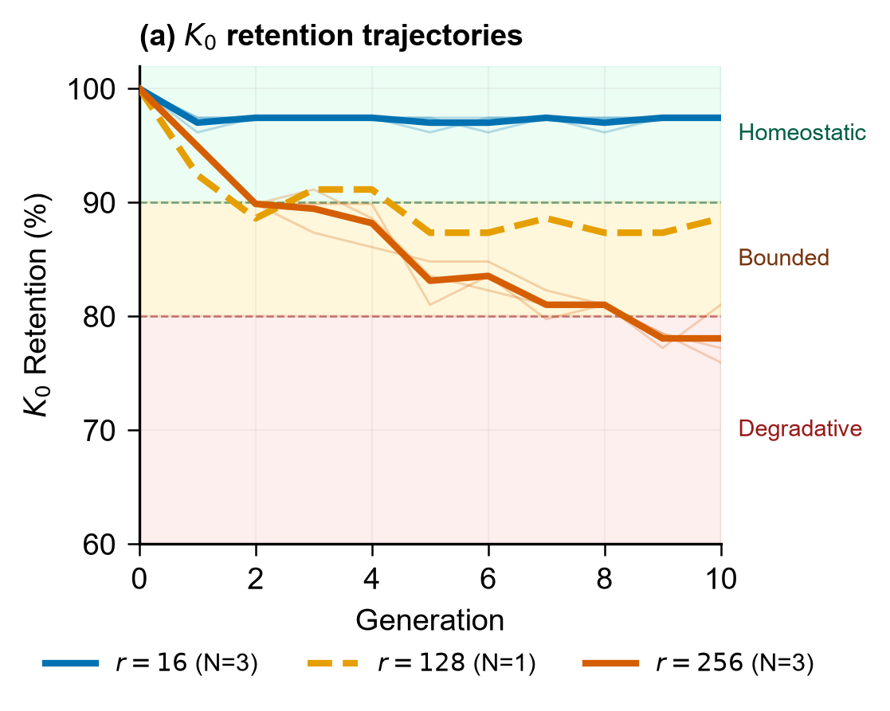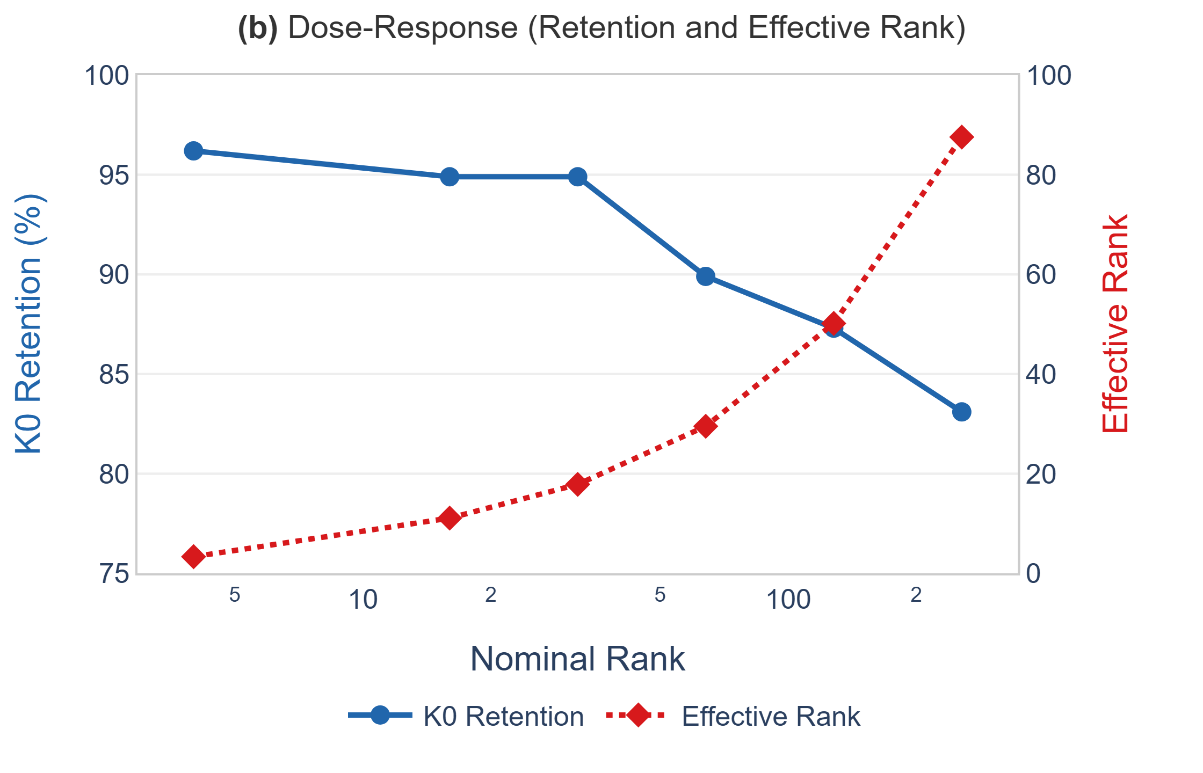
(a) Trajectories for the multi-seed runs ($r=16$: $N=3$, G3 bf16; $r=256$: $N=3$, G1); the single-seed NF4 sweep values tabulated in Table appear in panel (b). (a) K0 retention trajectories over 10 recursive generations for three representative ranks on Qwen 2.5 1.5B. Semi-transparent lines show individual seeds; solid thick lines show the per-rank mean. Background bands indicate regime classification (green: homeostatic, yellow: bounded, red: degradative). (b) Dose-response relationship: retention at last evaluated generation (Gen5 for $r=4$,$32$; Gen10 otherwise) versus nominal rank (left axis); mean effective rank versus nominal rank (right axis). Effective rank grows sub-linearly with nominal rank, indicating that increases in nominal capacity translate into progressively smaller increases in effective update dimensionality.
At $r=16$, retention stabilizes after an initial one-generation adaptation cost and remains flat through Gen10 (96.2%). At $r=128$, retention settles at $≈$89.7% by Gen5 and remains bounded through Gen10, neither recovering nor declining further. This bounded behavior distinguishes it from both the stable regime and the progressively degradative regime. At $r=256$, retention declines progressively, reaching $79.72\%$ (mean across six seeds, G1$+$G4) by Gen10 with no sign of stabilization within the observed horizon. The post-adaptation slope (Gen5 to Gen10, $N=6$) is $−1.19$ pp per generation; the three-seed G1 subset alone gives $−1.28$ pp/generation.
The dose-response curve (Fig. b) reveals several additional features. First, retention is non-increasing across the six tested ranks, spanning more than an order of magnitude in trainable parameters (545K to 34.9M), with $r=4$ and $r=32$ evaluated at Gen 5 and the remainder at Gen 10; the comparison therefore spans two horizons and is reported as ordinal rather than as a single monotonic curve. Second, the decline accelerates at higher ranks: the gap between $r=64$ (92.3%) and $r=256$ (79.07%) is substantially larger than any gap between adjacent lower-rank configurations. Third, effective rank increases sub-linearly with nominal rank (3.34 at $r=4$ to 87.57 at $r=256$), indicating that higher-rank adapters do not fully utilize their nominal capacity while still producing substantially larger effective updates.
The multi-seed experiments at $r=256$ confirm that the degradative regime is reproducible across independent training runs. Combining the original three seeds (G1: seeds 15/137/256) with a three-seed data-order control (G4: seeds 42/101/202), six independent $r=256$ runs yield a Gen10 mean of $79.72\%±1.73$ pp (95 % CI $[77.90,81.50]$, range 78.20–82.1%). The G1 three-seed mean alone is $79.07\%±1.50$ pp (95 % CI $[75.30,82.80]$). To verify that the homeostatic regime is also reproducible, we evaluated $r=16$ under the G3 bf16 protocol with the same three seeds (15/137/256); all three runs returned 97.40% Gen10 retention. The cleanest seed-level rank comparison is the G3 within-protocol design, where the same three seeds were run at both $r=16$ and $r=256$ under identical bfloat16 (bf16) precision. Per-seed Gen10 differences are $+15$, $+13$, and $+15$ correct items out of 78, a mean of $+18.4$ pp. An exact sign-flip test gives $p=0.25$ ($N=3$, bilateral); the effect is consistent in direction across all three pairs but the sample size limits formal power. The arithmetic gap between the $r=16$ and $r=256$ conditions is $17.70$ pp ($r=16$: 97.40%; $r=256$ G1$+$G4: $79.72\%$), demonstrating clear empirical separation under the present experimental protocol.
As a supportive ablation, we compared attention-only and full-linear module targeting on Qwen at a single seed. Targeting all linear modules (q,k,v,o,gate,up,down) at $r=4$ produces 4.6M trainable parameters and 97.4% Gen5 retention, matching attention-only targeting at $r=16$ (2.2M parameters, same retention). The full-linear $r=4$ adapter has a mean effective rank of 3.43, compared to 11.08 for attention-only $r=16$. This preliminary observation is consistent with effective update capacity, rather than module location or parameter count alone, being the primary predictor of regime membership. Because it is based on a single seed, we treat it as supportive evidence.
Table summarizes item-level transitions across the rank sweep. In the homeostatic regime, facts lost at one generation are recovered at similar rates (net loss $≈0$), indicating bounded oscillation rather than progressive forgetting. In the degradative regime, losses exceeded recoveries in the single seed analyzed (Table ), producing monotonic net displacement.
Item-level transitions across recursive generations on Qwen 2.5 1.5B (seed 15, ${\color{blue}\lvert K_0\rvert = 78}$). C$→$W (Correct$→$Wrong): facts lost; W$→$C (Wrong$→$Correct): facts recovered.
Rank | Gens | C$→$W | W$→$C | Net loss | Final incorrect
$r=4$​ | 5 | 1 | 0 | 1 | 2
$r=16$​ | 10 | 3 | 3 | 0 | 3
$r=32$​ | 5 | 2 | 3 | $−$1 | 3
$r=64$​ | 10 | 7 | 7 | 0 | 6
$r=128$​ | 10 | 10 | 7 | 3 | 8
$r=256$​ | 10 | 19 | 4 | 15 | 17
C$→$W and W$→$C count all observed generation-pair transitions; a single item may transition multiple times across generations, so Net loss ($=$ C$→$W $−$ W$→$C) does not equal Final incorrect. Final incorrect is the count of $K_{0}$ items answered incorrectly at the final evaluated generation (Gen 5 or Gen 10 as indicated).
The rank sweep and item-level transitions establish that increasing update capacity through adapter rank is associated with a monotonic transition across the tested grid from homeostatic to degradative recursive fine-tuning on the Qwen backbone. The following sections examine whether this transition generalizes across architectures and update mechanisms.

Cross-backbone thresholds
To test whether the regime transition observed on Qwen is architecture-specific, we evaluated corresponding rank configurations on two additional backbones: Gemma 3 1B, with five seeds at the boundary ranks over ten generations, and Gemma 4 E2B, with a single seed across three ranks as additional validation.

Gemma 3: cross-backbone replication
On Gemma 3, an analogous regime structure emerges, but at a substantially lower effective rank. Preliminary single-seed experiments identified the regime boundary between $r=4$ (effective rank $≈$3) and $r=16$ (effective rank $≈$9); higher ranks were not evaluated with multiple seeds because $r=16$ already produces clear progressive degradation, making additional high-rank conditions redundant for establishing the boundary location. Table summarizes the results. At $r=4$ (mean effective rank 3.07), Gemma 3 remains stable across five seeds through ten generations (mean Gen10 retention $94.35\%$, range 93.5–95.7%). At $r=16$ (mean effective rank 9.17), Gemma 3 enters the degradative regime across all five seeds (mean Gen10 retention $56.52\%$, range 52.2–60.9%). The ranges do not overlap at any generation from Gen1 onward, providing consistent empirical separation between the two regimes on this backbone.
The mean difference is $37.80$ pp (computed from raw item counts, $|K_{0}|=46$). Because the seed assignment across ranks is not confirmed as paired in the archived data, we report two tests: if the same five seeds were used at both ranks, the exact bilateral sign-flip test gives $p=0.0625$ ($N=5$, all five differences positive); if seeds are independent, a bilateral permutation test over $\left({10 \atop 5}\right)=252$ allocations gives $p=0.0079$. The effect size is large (Hedges $g≈13.29$) under either interpretation.
Critically, the degradation at $r=16$ does not stabilize between Gen5 and Gen10. Mean retention declines from 69.1% at Gen5 to 56.5% at Gen10, a further loss of 12.6 percentage points with no sign of plateauing. This progressive trajectory contrasts with the bounded behavior observed at $r=128$ on Qwen, where retention stabilizes near 89%. The Gemma 3 $r=16$ configuration is therefore classified as progressively degradative rather than bounded.
A notable feature of the degradative regime on Gemma 3 is that the mean effective rank remains constant at approximately 9.17 throughout all ten generations, even as retention declines from approximately 85% at Gen 1 to 57% at Gen 10. This suggests that effective rank operates as a regime gate, determining whether the system enters the degradative regime, rather than as a continuous predictor of the rate of degradation within that regime.
To localize the threshold more precisely, we additionally evaluated intermediate ranks $r∈\{10,12,14\}$ with a single seed. Intermediate ranks were evaluated only to localize the transition boundary and were therefore not extended to Gen10. All three exhibited progressive degradation at Gen5: retention of 78.3% ($r=10$, effective rank 6.37), 73.9% ($r=12$, effective rank 7.35), and 69.6% ($r=14$, effective rank 8.37). These values place the Gemma 3 regime boundary between effective ranks 3 and 6, that is, below $r=10$.
QLoRA rank sweep on Gemma 3 1B IT. Anchor ranks ($r=4$ and $r=16$), representing the homeostatic and degradative regimes respectively, are evaluated with five seeds over ten generations; intermediate ranks ($r=10,12,14$) with a single seed at Gen5 to localize the transition.
Rank | Gen | Retention | Eff. Rank | $N$ | Regime
$r=4$​ | 10 | 94.3% (N=5) | 3.07 | 5 | Homeostatic
$r=10$​ | 5 | 78.3% | 6.37 | 1 | Degradative
$r=12$​ | 5 | 73.9% | 7.35 | 1 | Degradative
$r=14$​ | 5 | 69.6% | 8.37 | 1 | Degradative
$r=16$​ | 10 | 56.5% (N=5) | 9.17 | 5 | Degradative

Gemma 4 E2B: additional validation
To provide additional validation from a third backbone, we evaluated Gemma 4 E2B across three ranks ($r=4$, $r=16$, $r=64$) with a single seed over ten generations. Table summarizes the results.
The same monotonic dose-response structure emerges: $r=4$ (effective rank 2.04) remains homeostatic at 94.7% through Gen10; $r=16$ (effective rank 5.1) exhibits bounded behavior at 88.2%; and $r=64$ (effective rank 13.3) enters the degradative regime, declining to 75.0% by Gen10. The $r=64$ configuration additionally exhibits the same distributional drift pattern observed in the Qwen degradative regime: mean response length inflates from 3.6 to 4.4 words, Distinct-1 collapses from 0.55 to 0.43, and stopword ratio increases from 0.23 to 0.28.
Because these results are based on a single seed, we treat them as additional qualitative validation rather than as a precise threshold estimate. The key observation is that a third backbone, from the Gemma model family (a different generation), exhibits the same regime structure under increasing adapter rank.
QLoRA rank sweep on Gemma 4 E2B IT (seed 15, Gen10). Single-seed results provide additional validation of the dose-response structure.
Rank | Retention | Eff. Rank | $|K_{0}|$​ | Regime
$r=4$​ | 94.7% | 2.04 | 76 | Homeostatic
$r=16$​ | 88.2% | 5.10 | 76 | Bounded
$r=64$​ | 75.0% | 13.28 | 76 | Degradative

Cross-backbone comparison
Figure presents the retention trajectories for all three backbones, enabling direct visual comparison of the regime structure across architectures.
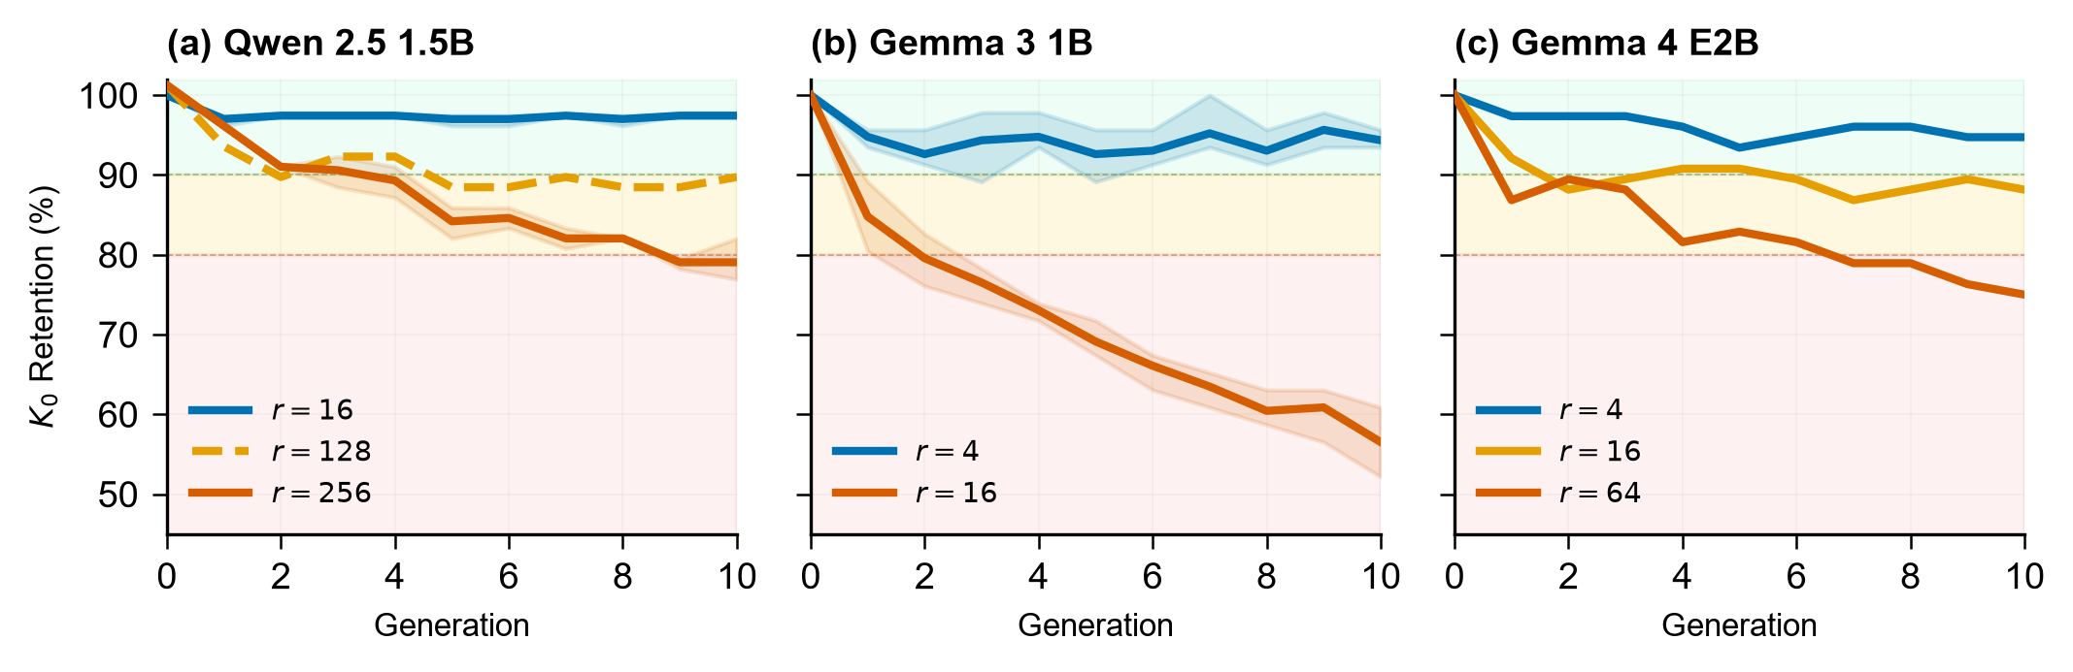
$K_{0}$ retention trajectories over ten recursive generations across three backbones: (a) Qwen 2.5 1.5B, (b) Gemma 3 1B, and (c) Gemma 4 E2B. Shaded bands show the seed range for Gemma 3 ($N=5$) and Qwen ($N=6$); Gemma 4 is a single trajectory ($N=1$, no band); solid lines show means. All three backbones exhibit consistent regime structure (homeostatic below threshold, degradative above), with the transition occurring at backbone-dependent effective-rank values.
The homeostatic-to-degradative regime transition is observed consistently across all three evaluated backbones, with consistent structure: bounded or stable retention below the threshold, progressive degradation above. However, the threshold location differs substantially across architectures. The Gemma 3 boundary lies between effective ranks 3 and 6, roughly an order of magnitude below the Qwen threshold (between effective ranks 50 and 88). The E2B threshold falls between effective ranks 5 and 13, intermediate between the other two backbones. This ordering does not correspond simply to model size (Gemma 3 1B < Qwen 1.5B < E2B 2B), indicating that the threshold is influenced by architectural or pretraining properties not captured by parameter count alone.
An attempt was made to normalize effective-rank thresholds across architectures by dividing by hidden dimension, number of layers, number of attention heads, and baseline diversity. None of these normalizations reduced the discrepancy to a common threshold. We report this as a negative result and discuss it further in Section .
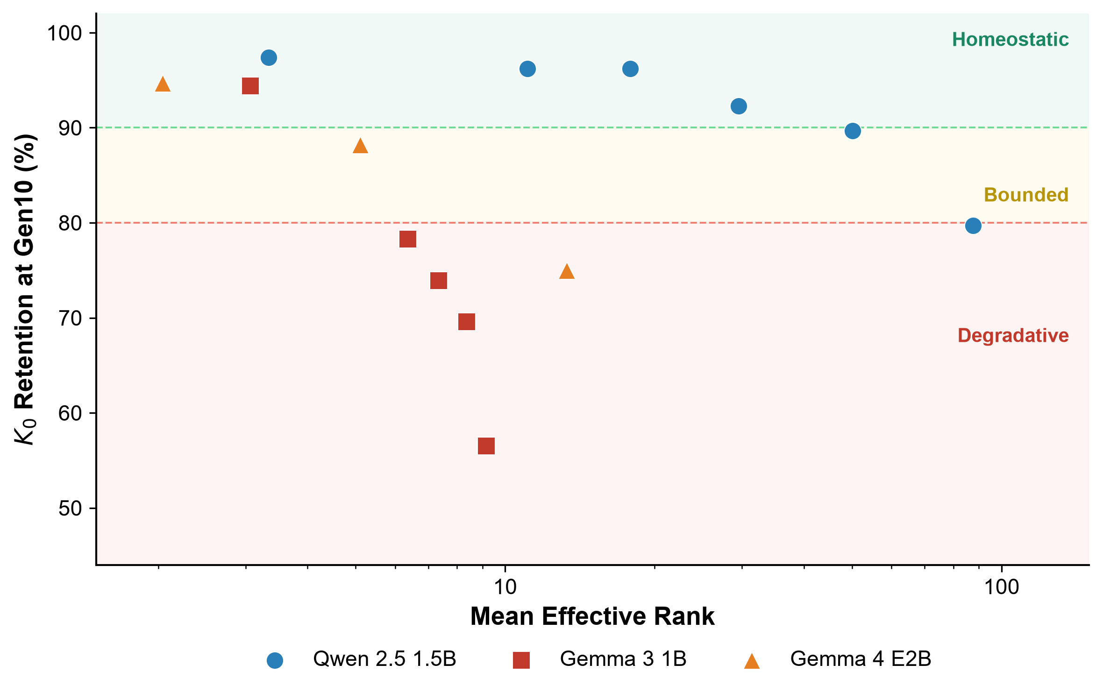
$K_{0}$ retention versus mean effective rank across three backbones. Marker shapes distinguish backbones (circle: Qwen, square: Gemma 3, triangle: E2B); colors indicate regime membership (blue: homeostatic, orange: bounded, red: degradative). The regime transition occurs at substantially different effective-rank values across architectures.
The regime structure generalizes across architectures. Figure shows three features: (i) all three backbones exhibit a transition from blue (homeostatic) to red (degradative) markers as effective rank increases; (ii) the transition occurs at substantially different x-axis positions across backbones; and (iii) the Qwen curve remains in the homeostatic region at effective ranks where Gemma 3 is already fully degradative. We next examine whether the same transition occurs when perturbation magnitude is varied independently of adapter capacity.

Perturbation magnitude: FFT comparison
The previous sections established that increasing update capacity through adapter rank shifts the system from homeostatic to degradative regimes. This section asks whether increasing perturbation magnitude through full fine-tuning, without varying adapter rank, reproduces an analogous dose-response pattern.
The learning rate was swept across four values on Qwen 2.5 1.5B under the same recursive replace-only protocol. Table shows retention at Gen3, the earliest generation at which consistent regime separation emerges across all four learning rates. Retention decreases monotonically as learning rate and weight drift increase. Drift values span nearly an order of magnitude (0.39 to 3.48), and retention decreases from 92.3% to 84.6% across this range. These results indicate that perturbation magnitude alone can drive the system toward degradation without any adapter or rank constraint.
FFT learning-rate sweep on Qwen 2.5 1.5B (seed 15, Gen3). Perturbation proxy is the mean absolute weight drift relative to the original model for FFT, and $∥BA∥_{F}$ for QLoRA. These measure different geometric properties and are not perturbation-matched; this is an exploratory method comparison. QLoRA $r=16$ is included as a reference point.
Method | LR | Pert. proxy | Gen3 Retention
QLoRA $r=16$ | ${10}^{−5}$​ | 0.42 ($∥BA∥_{F}$) | 96.2%
FFT | ${10}^{−6}$​ | 0.39 | 92.3%
FFT | $5×{10}^{−6}$​ | 1.56 | 91.0%
FFT | ${10}^{−5}$​ | 1.95 | 89.7%
FFT | $2×{10}^{−5}$​ | 3.48 | 84.6%

QLoRA versus FFT: exploratory method comparison without perturbation-magnitude matching
To compare the two update mechanisms (exploratory; perturbation magnitudes are not matched), we selected FFT at LR$={10}^{−6}$ (drift 0.39) as the lowest-tested-learning-rate FFT reference, not a magnitude-matched comparator (QLoRA $∥BA∥_{F}≈0.42$; the two measures are method-specific and not directly comparable). Both were run for 10 generations with three seeds. As illustrated in Figure , the separation between the trajectories is established after the first recursive generation and remains nearly constant thereafter.
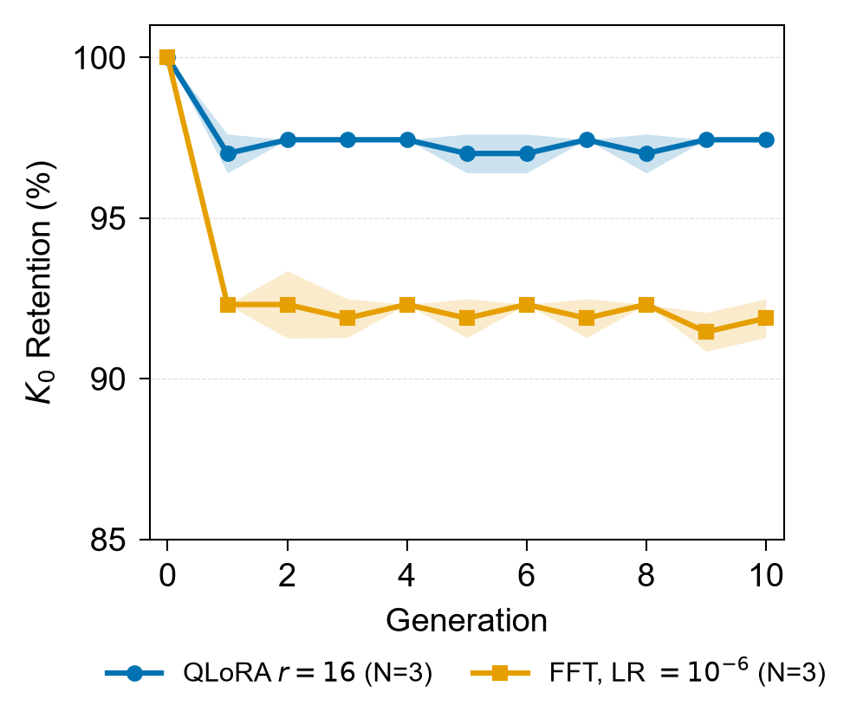
$K_{0}$ retention over 10 recursive generations for QLoRA $r=16$ and FFT at LR$={10}^{−6}$ on Qwen 2.5 1.5B. Lines show the mean across three seeds; shaded bands indicate $±$1 standard deviation.
Both methods are stable from Gen1 through Gen10, with no progressive degradation within the observed horizon. QLoRA retains a consistent advantage of approximately 5.5 percentage points (mean Gen10: QLoRA 97.4% vs FFT 91.9%). This gap emerges entirely at Gen1 and does not widen over subsequent generations. This result is therefore interpreted as a difference in one-time adaptation cost rather than a differential degradation rate: FFT incurs a larger initial factual cost when adapting to the synthetic stream, while both methods exhibit similarly stable trajectories once adapted.
QLoRA Gen10 retention is 97.4% across all three seeds; FFT achieves 91.9% (range 91.0–92.3%). The ranges do not overlap across any seed pairing.
Item-level analysis reveals an asymmetry between the two methods. Under FFT, the six $K_{0}$ items form a common loss core across seeds (all six lost in every seed-pair comparison), indicating a deterministic fragile-fact floor: these facts are consistently displaced by full-parameter updates regardless of seed. Under QLoRA, only two to three facts are lost per seed, and the overlap between facts lost by QLoRA and facts lost by FFT is zero across all seed pairs (Jaccard 0.0). In this exploratory, non-magnitude-matched comparison, QLoRA loses fewer $K_{0}$ items than FFT; item-level differences remain descriptive.
This pattern is referred to as a stable fragile-fact floor under FFT: certain facts are reliably displaced by full-parameter updates, whereas low-rank updates preserve those same facts while occasionally losing others. This observation is consistent with prior work suggesting that LoRA and full fine-tuning can produce qualitatively different update patterns even when achieving similar downstream performance . The precise mechanistic basis of this divergence in the recursive setting remains an open question for future work.

Rank and learning rate: joint dependence
The preceding analyses vary adapter rank and learning rate independently. To test whether their effects are additive or interactive, we evaluated a $3×3$ matrix on Qwen: ranks 16, 64, and 256 crossed with learning rates $5×{10}^{−6}$, ${10}^{−5}$, and $2×{10}^{−5}$. Table reports Gen5 retention for each cell, chosen as the common evaluation horizon adopted for the Gemma 3 experiments, enabling cross-backbone comparison.
Rank $×$ learning rate joint-dependence matrix on Qwen 2.5 1.5B (retention evaluated at Gen5; ${\color{blue}\lvert K_0\rvert = 78}$ items defined at generation 0, seed 15).
Rank | LR=$5×{10}^{−6}$ | LR=${10}^{−5}$ | LR=$2×{10}^{−5}$
$r=16$​ | 76/78 (97.4%) | 76/78 (97.4%) | 72/78 (92.3%)
$r=64$​ | 76/78 (97.4%) | 72/78 (92.3%) | 69/78 (88.5%)
$r=256$​ | 70/78 (89.7%) | 66/78 (84.6%) | 64/78 (82.1%)

The pattern is descriptively consistent with joint dependence (Figure ): configurations that remain stable under one learning rate become bounded or degradative under another. At $r=16$, only $LR=2×{10}^{−5}$ pushes the system below 95% retention. At $r=64$, the same degradation appears already at $LR={10}^{−5}$. At $r=256$, even the lowest evaluated learning rate ($5×{10}^{−6}$) produces measurable degradation (89.7%). Conversely, reducing learning rate partially offsets the effect of higher rank: $r=256$ with $LR=5×{10}^{−6}$ retains 89.7%, compared to 84.6% at $LR={10}^{−5}$ and 82.1% at $LR=2×{10}^{−5}$. This is consistent with the regime depending jointly on update capacity and perturbation magnitude rather than on either axis in isolation, although the single-seed design does not permit a formal interaction test.
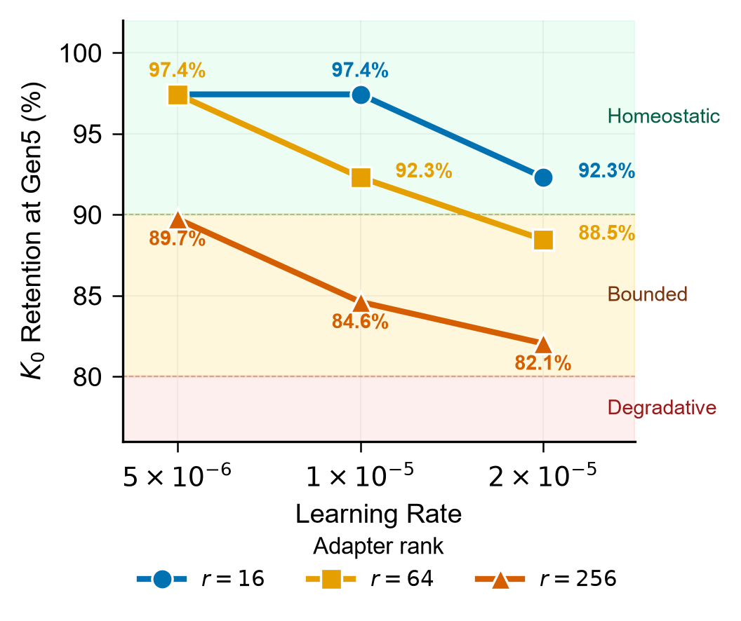
Rank $×$ learning-rate joint pattern on Qwen 2.5 1.5B (Gen5 retention). Descriptive non-parallel trends suggest that rank and learning rate may jointly determine the operating regime, but the single-seed design is hypothesis-generating rather than confirmatory.

FFT on Gemma 3 is consistent with a cross-backbone magnitude effect
To test whether the perturbation-magnitude axis generalizes beyond Qwen, we evaluated full fine-tuning on Gemma 3 1B at three learning rates. Gen5 retention was 78.3% at $LR={10}^{−6}$, 54.3% at $LR=5×{10}^{−6}$, and 63.0% at $LR={10}^{−5}$. Although the two higher learning rates do not follow a strictly monotonic pattern (possibly reflecting single-seed variability), substantially higher degradation is observed at larger learning rates compared to $LR={10}^{−6}$. This exploratory single-seed result is consistent with the perturbation-magnitude axis operating on Gemma 3 as well, but the non-monotonic pattern at $LR=5×{10}^{−6}$ limits interpretation. We treat this as descriptive evidence rather than confirmatory generalization.
Both update capacity (Axis 1) and perturbation magnitude (Axis 2) each produce dose-response relationships with factual retention. The single-seed $3×3$ grid shows descriptive evidence of joint dependence; formal interaction testing requires replication. The regime transition therefore reflects a multidimensional pressure landscape in which multiple control variables are associated with recursive stability. The next section examines how these regimes manifest in the distributional properties of the synthetic outputs.

Distributional signatures of degradation
The previous sections identified regime transitions through factual retention alone. This section asks how these regimes manifest in the distributional properties of the synthetic outputs. We apply the output-distribution diagnostics defined in Section to three representative Qwen configurations selected from the rank sweep: $r=16$, which exhibited homeostatic behavior; $r=128$, which exhibited bounded retention; and $r=256$, which exhibited progressive degradation.

Homeostatic regime ($r=16$)
In the homeostatic regime, all distributional metrics remain stable across ten generations. Mean response length increases only slightly (2.47 to 2.70 words), Distinct-1 remains above 0.63, MTLD stays above 2000, stopword ratio remains near 0.16, and baseline response persistence holds steady at approximately 36%. Content efficiency declines modestly from 0.41 to 0.35, reflecting the initial one-generation adaptation cost but no progressive drift.

Bounded regime ($r=128$)
The $r=128$ configuration reveals a dissociation between factual retention and output-distribution quality. While K0 retention remains bounded at 89.7% through Gen10, the output distribution degrades substantially: mean response length inflates from 2.47 to 7.0 words, content efficiency collapses from 0.41 to 0.13 (a threefold dilution), stopwords double from 12% to 25%, MTLD collapses from 2673 to 745, and baseline persistence falls to $5.1$% (4 of 78 items). We refer to this as a filler verbosity phenotype: the model pads responses with repetitive function words while retaining enough factual content to maintain bounded retention.
This dissociation has a practical implication: K0 retention alone does not fully capture the onset of distributional degradation. A system monitored solely by factual accuracy would classify $r=128$ as stable, while its generated outputs have already degraded substantially in efficiency, diversity, and response anchoring.

Degradative regime ($r=256$)
At $r=256$, nearly all metrics diverge from their baseline values. Mean response length increases from 2.47 to 3.6 words, content efficiency declines from 0.41 to 0.22, and baseline response persistence collapses from 33% (the $r=256$ Gen 1 baseline, lower than the 36% observed at $r=16$ due to the higher adapter capacity) to 3.8% by Gen10. Notably, MTLD increases (2673 to 3804) and stopword ratio decreases (12% to 9%), indicating that the model generates more varied vocabulary while losing factual anchoring. We refer to this as an elaborative drift phenotype: the model produces longer, lexically diverse, but factually unanchored responses.
The transition-zone configuration ($r=128$) and the lowest-pressure degradative configuration tested ($r=256$) therefore exhibit distinct distributional failure modes despite both departing from stable behavior: $r=128$ degrades through filler accumulation, while $r=256$ degrades through elaborative dispersion.
These observations motivate a descriptive three-regime taxonomy:
- Homeostatic ($r≤64$ on Qwen, retention above approximately 90%): factual retention and output-distribution metrics are both stable.
- Distributionally degraded, factually bounded ($r=128$ on Qwen): factual retention remains bounded under the bidirectional scoring criterion while output-distribution metrics degrade substantially. Because $r=128$ produces longer responses ($≈$7 words versus $≈$2 at $r=16$), the reported retention figure may partially reflect format effects (Section ); this classification is therefore interpreted cautiously.
- Factually degradative ($r=256$ on Qwen): factual retention declines progressively and output distribution drifts.
This taxonomy summarizes the observed behavior of the evaluated configurations rather than defining universally distinct categories. The empirically observed rank intervals separating regimes are $r_{H}∈(64,128)$ and $r_{D}∈(128,256)$ (Qwen-specific observations, not universal thresholds). The degradative regime ($r=256$) is qualitatively consistent with the Stage B “knowledge collapse” described by , where fluency persists while factual accuracy deteriorates. The distributionally degraded regime ($r=128$), however, represents a condition not captured by that framework: factual retention remains bounded while output-distribution quality degrades substantially. Figure illustrates the divergent trajectories across these three regimes.
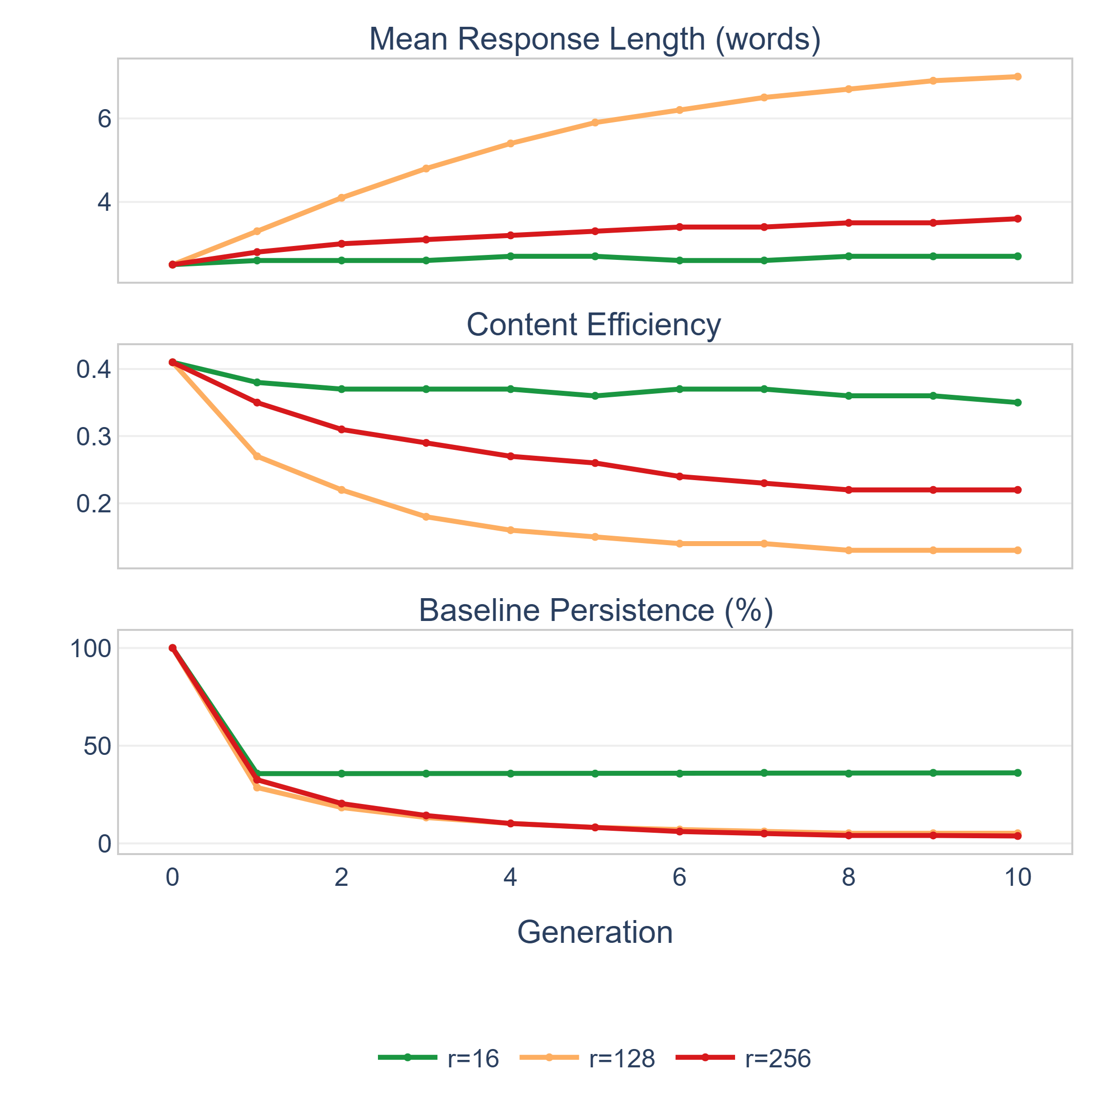
Distributional diagnostics over ten recursive generations for three representative Qwen configurations. (a) Mean response length, (b) baseline response persistence, (c) content efficiency. All three metrics diverge for $r=128$ and $r=256$ while remaining stable for $r=16$; the $r=128$ configuration is notable for strong distributional drift despite bounded factual retention.
The figure reveals three distinct patterns. For $r=16$ (homeostatic), all three metrics remain flat, confirming that the output stream is stable. For $r=256$ (degradative), all metrics diverge from baseline simultaneously with retention loss. The most informative case is $r=128$: response length doubles and content efficiency collapses to one-third of its initial value, yet factual retention remains above 89%, demonstrating that distributional degradation can proceed substantially before factual accuracy signals any problem.
To examine whether output drift precedes factual loss, we computed cross-lag correlations between mean response length at generation $t$ and retention at generation $t+1$. The raw Pearson correlation in the degradative regime is strong ($ρ=−0.965$), but robustness analyses substantially attenuate this association. After conditioning on shared temporal trend (partial correlation), the coefficient drops to $−0.22$. First-difference analysis yields $−0.43$, and the reverse-lag correlation is of comparable magnitude, indicating a bidirectional association rather than clear temporal precedence.
Output drift is therefore interpreted as a co-symptom of the same underlying high-pressure process, rather than a demonstrated causal antecedent of factual loss. Output drift remains valuable as a diagnostic signature: it is consistently present in degradative and distributionally degraded configurations, consistently absent in stable configurations, and can appear even when factual retention remains bounded, as illustrated by the $r=128$ configuration. Determining the causal relationship between output-distribution changes and factual degradation remains an open question.
The next section tests whether the third component of effective training pressure, synthetic data exposure, can shift the system back toward homeostasis at the regime boundary.

Synthetic exposure interventions
The preceding sections established that update capacity and perturbation magnitude each govern the regime transition. This section tests the third component of effective training pressure: whether reducing synthetic data exposure can shift the system back from a degradative to a near-homeostatic configuration. The primary evidence comes from the two pre-registered dose–response experiments described in Section : B7 on Qwen $r=256$ ($n=5$ paired seeds, $|K_{0}|=78$) and G2 on Gemma 3 $r=10$ ($n=3$ paired seeds, $|K_{0,G2}|=44$).
Table reports $K_{0}$ retention and the gain over the 0% within-pipeline baseline for each dose level on Qwen $r=256$.
Dose–response on Qwen $r=256$ ($|K_{0}|=78$, $n=5$ paired seeds per dose). Retention and gain ($Δ$) relative to the 0% within-pipeline baseline at Gen5 and Gen10.
Dose | Ret. (Gen5) | $Δ$ Gen5 | Ret. (Gen10) | $Δ$ Gen10 | $N_{seeds}$
0% | 85.4% | — | 79.7% | — | 5
10% | 89.0% | $+3.6$ pp | 81.5% | $+1.8$ pp | 5
25% | 89.2% | $+3.8$ pp | 84.6% | $+4.9$ pp | 5
50% | 89.7% | $+4.4$ pp | 89.0% | $+9.2$ pp | 5
$Δ$ values are computed from unrounded per-arm means; displayed values are rounded independently.
Qwen dose–response (B7). A pre-registered dose–response experiment on Qwen $r=256$ (five paired seeds; protocol registered as a916ebf before any run) shows that the Gen 10 benefit is graded: $+1.8$ pp at 10% removal ($p=0.160$, $n=5$, 95% CI $[−1.1,4.7]$), $+4.9$ pp at 25% ($p=0.0044$, 95% CI $[2.5,7.2]$), and $+9.2$ pp at 50% ($p<0.001$, 95% CI $[6.9,11.6]$). At Gen 5, the gains are smaller and more uniform ($+3.6$, $+3.8$, $+4.4$ pp; paired $t$-test $p=0.009$, $0.003$, $p<0.001$). A 50% reduction reduces the rate of progressive loss to $−0.15$ pp/generation versus $−1.13$ pp/generation at 0% (mean across five seeds), shifting the system from the degradative to the bounded regime by the criterion of Section .
The pre-registered prediction that 50% removal would match halving the learning rate (from $η={10}^{−5}$ to $5×{10}^{−6}$) was numerically similar: Gen 5 retention at dose $=50\%$ is $89.7\%$ versus $90.2\%$ at $η=5×{10}^{−6}$ (mean over three seeds; Gen 10 difference $+0.4$ pp, 90% CI $[−0.8,1.6]$). The mechanism (whether update budget or data composition) was not established; a steps-matched control was inconclusive at $n=3$.
The original C1–C5 pilot compared non-identical evaluation pipelines; when C1 and C5 are re-run under an identical pipeline and paired seeds, the effect of the archived C5 downsampling arm is $+1.9$ pp ($n=3$, not statistically distinguishable from zero). We therefore exclude the original pilot from the primary effect estimate; those results are archived in the replication repository (Section ).
Figure visualizes the retention and effect-size comparison across conditions.
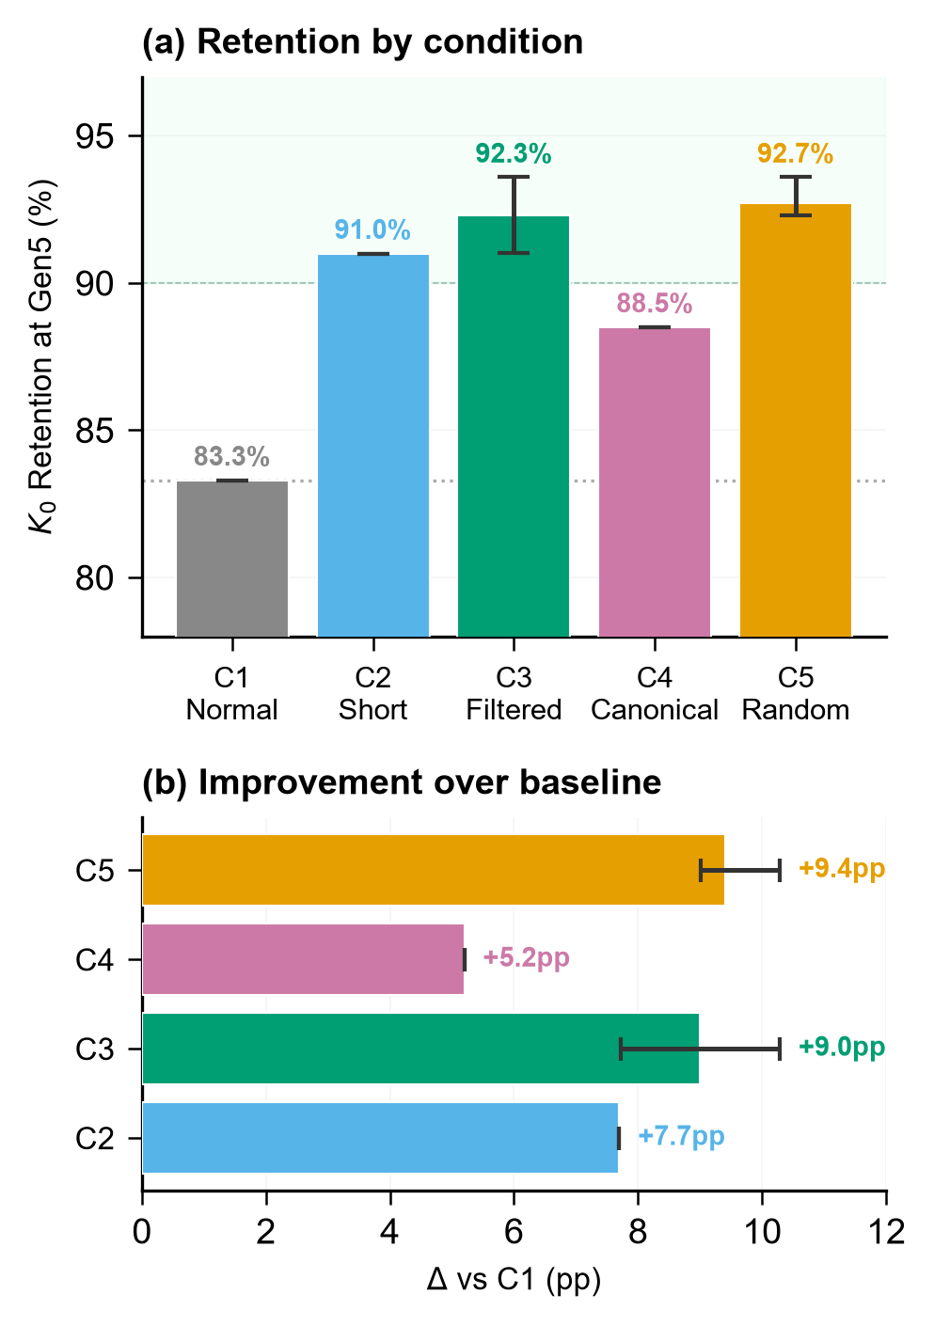
Exploratory pilot (C1–C5) on Qwen $r=256$ at Gen5, included for transparency. These results use a different evaluation pipeline from the primary dose–response experiments (B7/G2) and are not used in the primary effect estimates. (a) $K_{0}$ retention by condition. (b) Retention improvement relative to the corresponding unmodified arm; error bars reflect the range across the available pilot replicates (replicate type varies by panel; these exploratory results are not directly comparable with the main seeded experiments).
These results demonstrate that the Qwen $r=256$ configuration responds to graded exposure reduction: a 50% reduction reduces the rate of progressive loss and shifts the system to the bounded regime, whereas a 10% reduction does not. A graded retention response is also observed on a second backbone (Gemma 3 G2, see below), in a different form. The sensitivity is tested only at the configurations evaluated here and should not be interpreted as a universal property of recursive fine-tuning.
Dose–response replication on Gemma 3. A parallel pre-registered dose–response experiment on Gemma 3 at $r=10$ (G2, three seeds, four doses) shows that exposure reduction also improves retention on a second backbone. At the unmodified baseline (dose $=0\%$), Gemma 3 at $r=10$ shows progressive degradation ($78.77\%±1.27$ pp Gen10, slope $−0.91$ pp/gen). Reducing exposure by 10%, 25%, and 50% raises Gen10 retention by $+9.8$ pp ($p=0.006$, 95 % CI $[6.70,13.00]$), $+11.4$ pp ($p=0.013$, 95 % CI $[5.80,17.00]$), and $+12.9$ pp (95 % CI $[9.70,16.10]$, $p=0.003$), respectively ($n=3$ paired seeds per dose). At dose $=50\%$, the slope is $−0.91$ pp/gen (identical to the precision reported ($−0.91$ pp/generation in both arms)), indicating that no reduction in the rate of progressive loss was observed for G2 at this dose; the exposure effect manifested as a retention gain, not a slope reduction. The absolute gain at dose $=50\%$ Gen10 is larger for Gemma 3 G2 ($+12.9$ pp, $|K_{0,G2}|=44$) than for Qwen B7 ($+9.2$ pp, $|K_{0}|=78$). The two experiments used different backbones, different evaluation set sizes, and different baseline retention levels; effective rank is not portable across architectures (Section ), so we report the gains within each protocol without inferring which backbone operated at higher relative pressure.
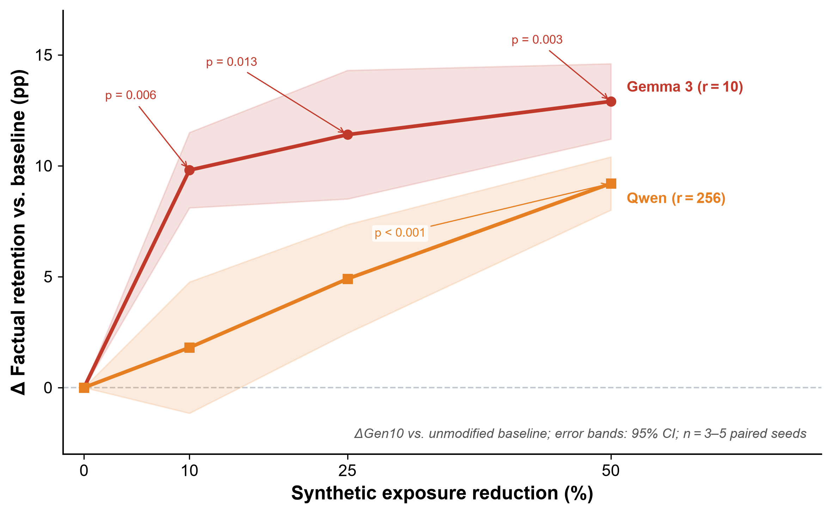
Dose–response of synthetic exposure reduction on factual retention across two backbones (Gen10, $K_{0}$-conditioned). Each curve shows the mean improvement ($Δ$pp) over the respective unmodified baseline as the fraction of synthetic training examples removed increases from 0% to 50%. Red circles: Gemma 3 1B at $r=10$ ($n=3$ paired seeds; $|K_{0,G2}|=44$). Orange squares: Qwen 2.5 1.5B at $r=256$ ($n=5$ paired seeds; $|K_{0}|=78$). Shaded bands: 95 % confidence intervals from paired $t$-tests. The absolute gain is larger for Gemma 3 G2 ($|K_{0,G2}|=44$) than for Qwen B7 ($|K_{0}|=78$); effective rank is not portable across architectures, so the two curves are reported within their respective protocols rather than as a cross-backbone pressure comparison. Dashed horizontal line: no change ($Δ=0$ pp).
Taken together, the intervention experiments show that the degradative trajectory can be attenuated under the evaluated conditions. On Qwen, a 50% reduction moved the system from the degradative to the bounded regime; on Gemma 3, it raised Gen 10 retention without reducing the rate of loss. Neither outcome constitutes a return to homeostatic behavior. These results complement the capacity and perturbation findings presented in the preceding sections. We note that verification-based approaches represent an orthogonal mitigation axis (filtering by quality rather than quantity); our exposure reduction experiments test boundary sensitivity rather than proposing a competing mitigation pipeline.
Collectively, the five experimental axes establish that recursive stability under PEFT is governed by a multidimensional pressure landscape: update capacity, perturbation magnitude, and synthetic exposure can each shift the system between regimes under the evaluated conditions; the axes may interact rather than operate in isolation, and the regime boundary is backbone-dependent. The following section interprets these findings in the context of prior work.

Experimental controls and prospective index
Quantization control (G3). Most QLoRA experiments use 4-bit NormalFloat (NF4) quantization of the base weights. To verify that the regime classification is not an artifact of NF4, we re-ran the same protocol on Qwen using standard bf16 precision and no base-weight quantization (G3, three seeds at each of $r=16$ and $r=256$). At $r=16$, bf16 returned $76/78=97.4\%$ at Gen10 against $75/78=96.2\%$ for the single-seed NF4 sweep (Table ), a difference of one item ($+1.3$ pp; the two conditions also differ in seed count); at $r=256$ the difference is $+0.00$ pp. The G1 (NF4) and G3 (bf16) runs produced identical aggregate retention counts for the matched seeds at $r=256$; run-level provenance and item-level outputs are audited separately before interpreting this agreement as evidence about quantization. The regime classification at both ranks is consistent across precision settings, but a causal conclusion about quantization awaits full provenance audit.
Data-order control (G4). To isolate seed variance from data-order variance, G4 replicates the Qwen $r=256$ protocol with three new shuffle seeds (42/101/202). Gen10 retention values are $82.1\%$, $78.2\%$, and $80.8\%$, yielding a G4 mean of $80.3\%$$±2.0$ pp. A bilateral permutation test comparing G1 and G4 gives $p=0.700$, indicating no detectable signal beyond seed-to-seed variance. Because G4 varies both data order and random seed simultaneously, $p=0.700$ does not isolate the effect of order alone; it establishes that the combined variance is statistically indistinguishable from G1. Combining G1$+$G4 gives a six-seed Gen10 estimate of $79.72\%±1.73$ pp (95 % CI $[77.90,81.50]$).
Prospective rank$×$learning-rate probe (G5). As a prospective test of whether the regime ordering generalizes to unseen rank$×$learning-rate configurations, we pre-registered three cells on Qwen 2.5 1.5B with a single seed (seed 15, five generations): a low-pressure cell ($r=128$, $η=5×{10}^{−6}$), a high-pressure cell ($r=128$, $η=2×{10}^{−5}$), and an intermediate cell ($r=32$, $η=2×{10}^{−5}$). The pre-registered classification predicted Homeostatic, Degradative, and Bounded respectively, based on the rank$×$LR grid established in §. The low-pressure cell returned $96.20\%$ at Gen5 (Homeostatic, confirmed); the high-pressure cell returned $85.90\%$ (Bounded, not confirmed; predicted Degradative); and the intermediate cell returned $89.70\%$ (Bounded, confirmed). We do not report an operational pressure index $Π$ for G5: the effective rank of each adapter was measured (mean $erank≈51$ for $r=128$, $≈16$ for $r=32$), but the pre-specification did not fix a threshold on $Π$, and the three cells were selected by nominal rank and learning rate, not by $Π$ value. Two of the three pre-specified regime classifications were confirmed; the third was not. G5 is therefore exploratory evidence for the ordering, not a confirmatory test of the full classification scheme. All three cells used a single seed; the prospective result is therefore exploratory.

Discussion
The preceding results identify consistent patterns in how recursive synthetic fine-tuning responds to changes in update capacity, perturbation magnitude, and synthetic exposure. This section interprets these findings in the context of prior work, examines what they imply for the understanding and management of recursive training systems, and discusses the limitations of the present study. The discussion is organized around four themes: the interpretation of effective training pressure as an organizing framework (Section ), the relationship between the present findings and the model-collapse literature (Section ), the diagnostic role of output-distribution changes (Section ), and the practical implications for the design and monitoring of recursive training pipelines (Section ).

Effective training pressure as framework
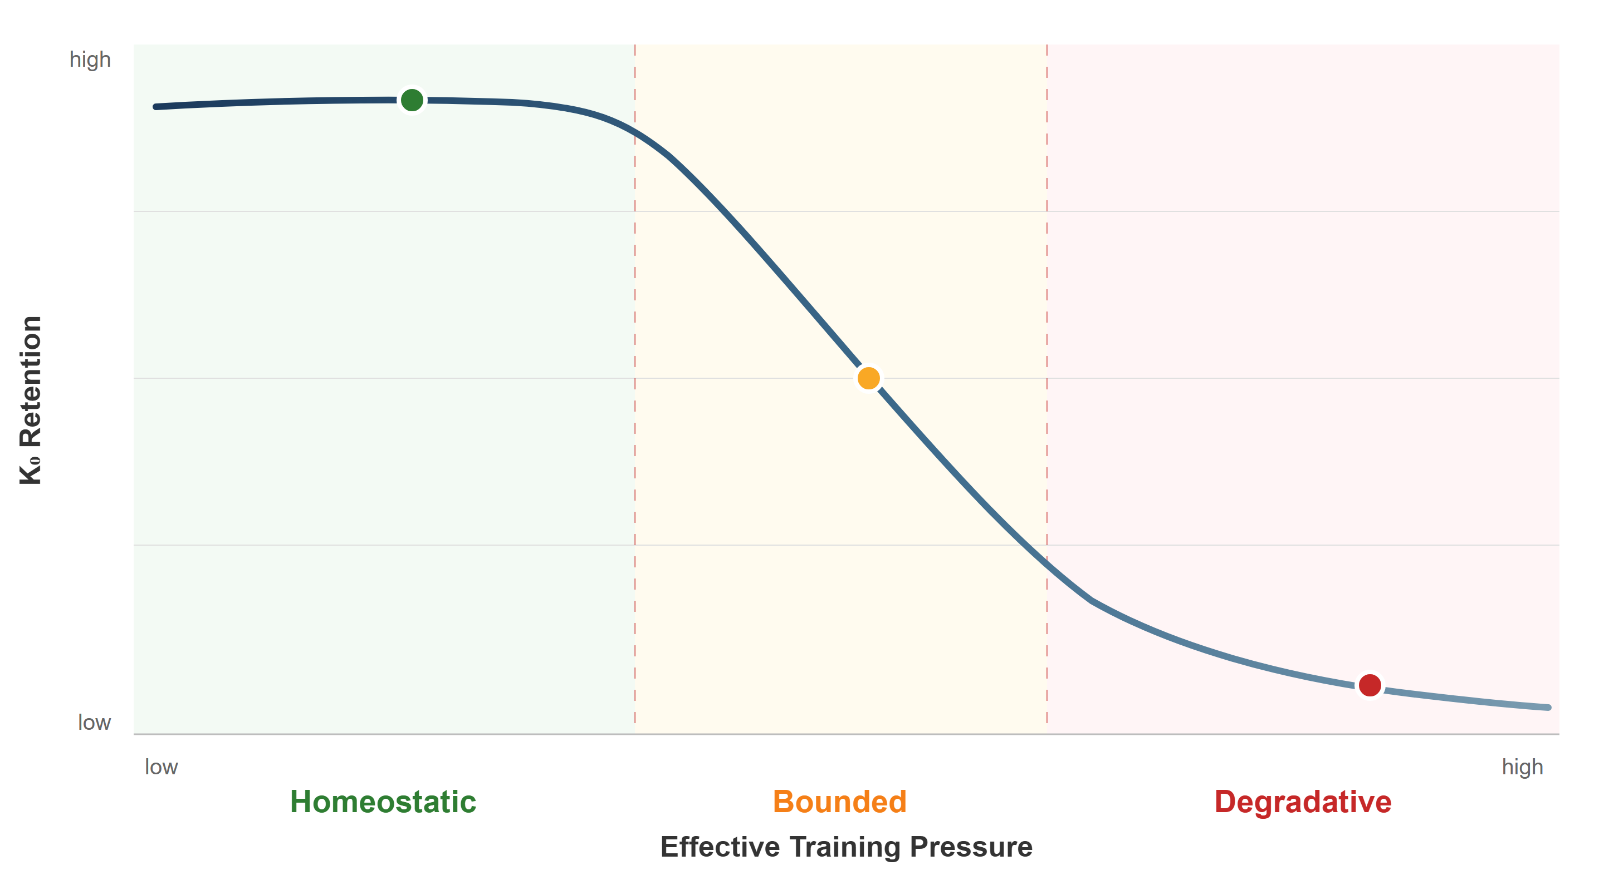
Pressure-response relationship guiding recursive fine-tuning stability. Factual retention transitions through three regimes as effective training pressure increases. Dashed lines mark backbone-dependent boundaries; the transition is threshold-like within the tested grid and its location varies by roughly an order of magnitude across architectures.
The results presented in Section converge on a consistent empirical pattern: recursive factual degradation is not observed uniformly across recursive synthetic fine-tuning, but instead emerges only when the training process operates above a backbone-dependent pressure threshold. Three independently manipulated variables, adapter rank, learning rate, and synthetic exposure, each shift the system between homeostatic and degradative behavior. The convergence of these independent manipulations is the primary empirical motivation for treating them as manifestations of a common organizing principle.
The framework is empirical rather than theoretical. We do not propose a closed-form expression that combines rank, learning rate, and exposure into a single scalar predictor. Instead, the experiments reveal that each variable independently controls the same qualitative transition. Within the tested grid, retention changes between adjacent configurations in a manner consistent with a threshold. The grid spacing bounds the resolution: adjacent tested ranks on Qwen differ by a factor of two ($r=64$, 128, 256; effective ranks 29.5, 50.2, 87.6), so the boundary can be bracketed but not resolved. The dose–response data show the same limitation from the exposure axis: a 50% reduction attenuated the Gen 5$→$10 decline to $−0.15$ pp/generation, whereas a 10% reduction did not; its slope was $−1.49$ pp/generation (on unrounded per-arm means), marginally steeper than the $−1.13$ pp/generation of the 0% arm, even though its Gen 10 retention was 1.8 pp higher. The slope response across doses is therefore not monotonic, and we report the Gen 10 retention gain and the slope change as distinct outcomes rather than as a single effect. This pattern is consistent with the system operating near a regime boundary, though the present experiments do not establish a precise threshold value that will generalize to other settings.
The contribution is the existence and reproducibility of this threshold-like transition within the tested grid, not the numerical threshold itself. The present work does not claim that the specific effective-rank values at which regimes change will generalize to arbitrary models or tasks. What appears to generalize is the qualitative structure: a pressure-dependent boundary separating stable from degradative recursive behavior, controllable through multiple axes.
The rank $×$ learning-rate joint-dependence experiment (Table ) is descriptively consistent with these axes not being independent: different combinations of rank and learning rate produce similar recursive outcomes, indicating that the regime depends jointly on both variables. This observation is compatible with interpreting effective training pressure as a multidimensional control landscape rather than a collection of separable single-variable effects. Beyond the interaction itself, two additional convergences support this interpretation: the transition boundary induced by each axis shares the same qualitative signature (threshold-like rather than gradual within the tested grid), and the same distributional drift patterns accompany degradation regardless of which axis crosses the threshold. Developing a quantitative formulation that combines update capacity, perturbation magnitude, and exposure into a single predictive scalar remains an important direction for future work.
Table summarizes how each component of the framework is supported by independent experimental evidence.
Evidence matrix: mapping framework components to supporting experiments.
Observation | Supporting evidence
Rank governs transition | Rank sweep, 6 values; $N=3$ at $r=256$ (G1); $N=1$ at $r=16$,$32$,$64$,$128$ (single-seed); $N=3$ bf16 control (G3) at $r=16$,$r=256$
Magnitude governs transition | FFT LR sweep, 4 values
Exposure reduces pressure | Dose–response 0–50%, $N=5$ seeds (pre-registered)
Threshold is backbone-dependent | Qwen vs Gemma 3 ($10×$ gap)
Drift accompanies degradation | 5 distribution metrics
Transition is threshold-like within tested grid | Rank sweep across six levels; adjacent tested ranks differ by a factor of two, so the boundary is bracketed rather than resolved
Capacity $×$ magnitude joint dependence | Rank $×$ LR matrix ($3×3$, $N=1$ per cell; descriptive)
Generalizes cross-backbone | Gemma 3 ($N=5$) + E2B rank sweep ($N=1$)
Two features of this framework merit emphasis. First, the threshold is backbone-dependent, and the two backbones are not described by the same boundary. On Qwen the tested grid places the homeostatic-to-bounded transition between effective ranks 29.5 ($r=64$) and 50.2 ($r=128$), and the bounded-to-degradative transition between 50.2 and 87.6 ($r=256$); the 50–88 interval quoted in the Abstract is the second of these. On Gemma 3, where no bounded regime was observed, the 3–6 interval is the transition from homeostatic directly to degradative. The two intervals are therefore not the same kind of object. No simple normalization by architectural parameters (hidden dimension, depth, head count) aligned these thresholds. This likely reflects properties of the pretrained backbone not captured by simple architectural dimensions. Second, the framework does not assume that the three pressure components are interchangeable or commensurable. Rank and learning rate operate through different mechanisms (subspace dimensionality versus step size), and synthetic exposure operates on the data stream rather than the update itself. Their shared effect on the regime transition is the empirical observation that motivates the framework, not a theoretical prediction.

Relation to recursive-training literature
The model-collapse literature has established that recursive training on synthetic data can produce irreversible degradation under full fine-tuning and that expected loss increases linearly with any nonzero fraction of synthetic data . Our results do not contradict these findings. Rather, they help localize the experimental conditions under which qualitatively similar degradation emerges in our recursive fine-tuning setting: the degradative configurations ($r=256$ on Qwen, $r≥10$ on Gemma 3 (including $r∈\{10,12,14\}$ at Gen 5), FFT at high learning rates) are qualitatively consistent with the collapse dynamics these works describe.
The contribution of the present work is locating where, in the space of practical PEFT configurations, the transition between bounded and degradative behavior occurs. observed that LoRA “learns less and forgets less” relative to full fine-tuning. Empirical studies of catastrophic forgetting in LLMs during continual fine-tuning have similarly observed scale-dependent forgetting patterns. Our dose-response results refine this observation: low-rank adaptation remains bounded not because LoRA prevents degradation in general, but because, in the evaluated configurations, low rank limits effective training pressure below the observed regime boundary. When rank is increased sufficiently ($r=256$ on Qwen, $r=16$ on Gemma 3), degradation emerges despite using the same PEFT method. These findings therefore provide an empirical boundary for the qualitative observation reported by , showing not only that low-rank adaptation forgets less, but also where this advantage ceases to hold.
The cross-backbone results add a dimension absent from prior work. Both and treat collapse as a property of the recursive process itself, without examining its dependence on model architecture. Our finding that the threshold differs by approximately an order of magnitude between Qwen and Gemma 3 indicates that the pretrained backbone contributes substantially to determining where the boundary lies. This is consistent with the observation by that Gemma 3 1B exhibits three-stage degradation under full fine-tuning, a finding compatible with our result that Gemma 3 has a lower pressure threshold than Qwen. However, because used a different dataset, evaluation format, and training protocol, we treat this as suggestive context rather than a controlled comparison.
The synthetic-exposure interventions connect to the data-axis mitigation literature. showed that accumulating real data across generations prevents collapse, operating on the data-composition axis. further showed that synthetic data diversity significantly impacts downstream model quality. Our dose–response results operate on a complementary axis: rather than adding real data, we reduce synthetic exposure by a graded fraction, up to 50%, and observe partial attenuation of the degradative trajectory in a lowest-pressure degradative configuration tested. Both approaches reduce recursive degradation through different intervention points in the training pipeline. They are orthogonal and potentially combinable, though their interaction has not been tested.
The present work complements rather than challenges the collapse literature by identifying the practical conditions under which bounded and degradative recursive behavior are observed in parameter-efficient fine-tuning, how the operating regime varies across backbones, and how it can be manipulated through multiple independent control axes. In this sense, the present study offers a practical response to the theoretical pessimism of prior work: recursive degradation, while real, is not inevitable under the configurations most commonly used in practice. This aligns with the recent observation by that the term “model collapse” encompasses multiple distinct phenomena, and that empirical regime characterization may be more productive than treating collapse as a monolithic threat.
To clarify the scope of the present findings, Table distinguishes what the evidence supports from what remains open.
Scope of generalization: what the present evidence supports versus what remains unknown.
Supported by evidence | Remains unknown
Regime transition exists | Threshold at larger scales
Pressure dependence | Exact functional form
Configuration-dependent boundary within the tested grid | Behavior beyond Gen10
Reproducibility (3–5 seeds) | Transfer to non-factoid tasks
Cross-backbone regime structure | Cross-architecture normalization
Capacity $×$ magnitude show joint dependence descriptively | Exposure sensitivity beyond B7/Qwen $r=256$ and G2/Gemma 3 $r=10$
Magnitude axis cross-backbone | Interaction strength at scale

Distributional degradation as a diagnostic signal
The distributional analysis in Section reveals that factual retention alone provides an incomplete picture of recursive degradation. The $r=128$ configuration on Qwen retains 89.7% of $K_{0}$ facts through Gen10 under the bidirectional scoring criterion, a level that could reasonably be interpreted as stable under a retention-only monitoring strategy. As noted in Section , this figure may partially reflect format effects for the verbose responses generated at this rank; the distributional signals discussed here are therefore independent evidence that $r=128$ is not operating stably. Yet its output distribution degrades substantially: content efficiency collapses to 0.13, baseline persistence falls to $5.1$% (4 of 78 items), and MTLD drops from 2673 to 745. This dissociation between factual retention and distributional quality provides the principal motivation for using output-distribution diagnostics as complementary monitoring signals.
Two distinct degradation phenotypes emerge at and above the transition zone. In the transition-zone configuration ($r=128$), the model accumulates filler words and repetitive function tokens while preserving enough factual content to maintain bounded retention. At high capacity ($r=256$), the model instead generates lexically diverse but factually unanchored responses. These patterns appear to represent distinct modes of distributional deterioration rather than different degrees of the same phenomenon: they differ in which metrics degrade (MTLD collapses in the first case, increases in the second) and in their relationship to factual loss (bounded in the first, progressive in the second).
The elaborative drift phenotype is not unique to Qwen: the Gemma 4 E2B $r=64$ configuration exhibits the same pattern (response length inflation from 3.6 to 4.4 words, Distinct-1 collapse from 0.55 to 0.43, stopword ratio increase from 0.23 to 0.28). Because that run used a single seed, the pattern is consistent with, but does not establish, generalization of this signature across backbone families.
The practical implication is that monitoring recursive training systems solely through factual accuracy or loss metrics risks missing the onset of distributional drift. Content efficiency, baseline persistence, and response length provide richer signals of regime departure. In the $r=128$ case, these metrics showed substantial degradation across generations during which retention remained bounded, suggesting that they could serve as earlier indicators of regime departure than retention alone.
This diagnostic value does not rest on a causal claim. The cross-lag analysis showed that after controlling for shared temporal trend, the association between output drift and subsequent retention loss weakens substantially (partial $ρ=−0.22$). The analysis suggests that output drift is a co-symptom of the same high-pressure process rather than a demonstrated causal driver. Its value lies in being observable, measurable, and consistently present in above-threshold and distributionally degraded configurations, while remaining low in stable configurations, regardless of whether it contributes to, or simply accompanies, factual degradation.

Practical implications
The results and interpretations above translate into actionable considerations for practitioners designing or monitoring recursive synthetic fine-tuning pipelines. The following discussion is organized around three operational concerns: configuration selection, runtime monitoring, and intervention design.
Regarding configuration selection, the dose-response results indicate that adapter rank is a directly controllable parameter whose effect on recursive stability was monotonic across the tested grid. For applications where recursive synthetic data reuse is anticipated, selecting a rank that places the system well below the observed pressure threshold is a practical strategy for maintaining recursive stability. On Qwen 2.5 1.5B, $r=16$ and $r=64$ showed stable retention through Gen10 under the evaluated protocol; $r=4$ and $r=32$ were evaluated only at Gen5 (single-seed, Gen-5-only ablations) and cannot be used as evidence of multi-generation stability. Although the numerical threshold is backbone-dependent, the underlying principle appears consistent across the evaluated models: lower effective training pressure is associated with greater recursive stability in the tested configurations. When full fine-tuning is required, lower learning rates reduce recursive degradation in the evaluated setting. Notably, this form of control requires no external verifier, no additional real data, and no modification to the training objective; it operates entirely through configuration choices already available to practitioners.
Regarding runtime monitoring, the $r=128$ dissociation demonstrates that factual accuracy alone is insufficient for detecting distributional drift. Based on the observed patterns, tracking at minimum mean response length, content efficiency (retention normalized by length), and baseline response persistence can help detect regime departure earlier than factual accuracy alone. Rising response length or declining content efficiency signals that the system may be departing from its stable operating regime, even if factual retention metrics appear stable. These signals are computationally inexpensive and require no additional evaluation infrastructure beyond what is already needed for generation-level quality assessment.
Regarding intervention design, the dose–response results indicate that the lowest-pressure degradative configurations tested are sensitive to graded changes in synthetic exposure. A 50% reduction strongly attenuated progressive loss on Qwen B7; on Gemma 3 G2, it improved Gen10 retention without reducing the observed rate of loss. Smaller doses (10–25%) produced partial, dose-proportional retention benefits. The archived C5 downsampling arm did not replicate under paired evaluation ($+1.9$ pp, $n=3$), indicating that marginal reductions at this level are not robustly effective in the evaluated configurations. When monitoring signals indicate regime departure, reducing the volume of the synthetic training stream through downsampling may provide a lightweight mitigation strategy under conditions similar to those evaluated here. Under the pre-registered conditions, random downsampling performed comparably to halving the learning rate. The exposure intervention improved retention under the tested schedules, but the step-matched control did not distinguish an update-budget mechanism from changes in data composition.
In summary, practitioners deploying recursive synthetic fine-tuning should consider:
- Keeping adapter rank or learning rate below the empirically characterized pressure threshold for the target backbone.
- Monitoring distributional diagnostics (output length, content efficiency, response persistence) alongside factual accuracy.
- Reducing synthetic exposure when distributional drift is detected, even before retention metrics decline.
- Calibrating pressure thresholds independently for each model architecture, as cross-backbone transfer of numerical values is unreliable.
The exposure axis was tested at one rank per backbone: $r=256$ on Qwen and $r=10$ on Gemma 3, each the lowest-pressure degradative configuration available on that backbone. Under the paired dose–response protocol both backbones responded, but in different forms: on Qwen the rate of progressive loss fell, whereas on Gemma 3 the Gen 10 retention level rose without a change in that rate. An earlier single-seed pilot on Gemma 3 at $r=16$ appeared to show no response at all, but that pilot compared arms produced by different evaluation pipelines and is excluded from the estimates reported here; whether graded doses would alter the outcome at $r=16$ remains untested. Update capacity and perturbation magnitude generalized across the evaluated backbones; exposure sensitivity is demonstrated for the two configurations tested, and its transferability to other ranks is uninvestigated. This asymmetry reinforces that effective training pressure should not be read as implying identical sensitivity along all axes across architectures.
These considerations are derived from experiments on 1–2B parameter models with factoid QA data. Their applicability to larger models, different domains, or longer recursive horizons remains to be established. They should therefore be viewed as empirically grounded design considerations rather than universal prescriptive rules.

Limitations
The interpretation of these findings is subject to several limitations.
All experiments use models in the 1–2B parameter range (Qwen 2.5 1.5B, Gemma 3 1B, Gemma 4 E2B). Whether these findings generalize to 7B, 70B, or larger models has not been established in this work. Larger models may exhibit different pressure thresholds for reasons not evaluated in the present study. This scale is consistent with prior model-collapse studies and reflects the computational constraints of running ten recursive generations with multiple seeds and configurations.
The evaluation uses a single dataset (TriviaQA) comprising short factoid question-answer pairs. TriviaQA was chosen specifically to isolate factual retention from reasoning or stylistic confounds: short answers minimize format-dependent evaluation noise, and the substring-matching criterion is resilient to changes in verbosity. The findings may not extend to long-form generation, open-ended dialogue, code synthesis, or other domains where output structure and evaluation criteria differ substantially.
The recursive horizon extends to ten generations. The long-term dynamics beyond Gen10 are unknown: configurations classified as stable over this horizon may eventually degrade given sufficient generations, and configurations classified as bounded may stabilize or worsen.
Headline comparisons use three or five independent seeds, depending on the experiment; the pooled Qwen $r=256$ estimate uses six. Supporting ablations are single-seed, limiting formal inference, particularly for the rank–learning-rate grid. Consistency across the replicated conditions does not substitute for larger-scale replication.
Cross-architecture threshold normalization was attempted using several architectural ratios, none of which aligned the thresholds between Qwen and Gemma 3 (Table ).
The raw effective-rank threshold is therefore not portable across backbones without empirical calibration, limiting its predictive utility for new architectures.
The exploratory QLoRA–FFT comparison relies on approximate proxies ($∥BA∥_{F}$ for QLoRA versus mean absolute weight drift for FFT). These quantities measure different geometric properties; this comparison between methods is exploratory and not perturbation-magnitude matched. Additionally, most QLoRA experiments use 4-bit NormalFloat (NF4) quantization. The G3 ablation re-ran the same protocol in bf16 (no base-weight quantization) and produced identical regime classifications, though a full causal conclusion awaits per-item audit. Although the quantized base remains static across generations and adapters are trained in higher precision, the interaction between quantization error and high-rank adapter updates has not been isolated. The G3 ablation provides a bf16 comparison at $r=16$ and $r=256$, though its scope is limited to Qwen and its provenance audit is ongoing; a systematic comparison across all ranks and backbones was not conducted.
The primary dose–response experiments (B7 and G2) are tested only at $r=256$ on Qwen and $r=10$ on Gemma 3. The exploratory C1–C5 pilot is archived but not used in primary estimates. Whether comparable sensitivity exists at other ranks, on other backbones, or with different datasets has not been established. Whether the same intervention would recover stability under extreme pressure (e.g., FFT at high learning rate) remains untested.
The primary mechanistic evidence operates at the output level (retention counts, response properties, cross-lag correlations); parameter-space measures (effective rank, Frobenius norms, weight drift) are also reported, though without causal attribution. No weight-level analysis of adapter update subspaces, gradient geometry, or representational drift was conducted. The causal mechanisms by which effective training pressure produces regime transitions remain outside the scope of the present study.
The output-distribution diagnostics (content efficiency, persistence, SDI-3) are evaluated only under the present experimental conditions. Their effectiveness as monitoring signals in production settings, including reliability across domains and deployment conditions, has not been assessed.
The retention metric $K_{0}$ uses bidirectional substring matching, which is intentionally permissive: a generated response counts as correct if it contains any valid alias or is contained by one. This criterion is resilient to short-answer variation and aliasing, but it may overcount retention for configurations that produce longer, more verbose responses, because a long response is more likely to contain a short alias as a substring by chance. The bidirectional substring criterion is retained as the primary metric because it better reflects the practical definition of factual recall for short-answer tasks. A strict exact-match criterion is not a valid sensitivity check for this design: $K_{0}$ is defined by the bidirectional criterion, so the denominator of any strict-EM retention ratio is backbone-specific and dataset-specific rather than a neutral baseline. Empirically, strict EM scores covary with response length in directions opposite to factual retention, measuring format convergence rather than knowledge preservation; this makes strict EM unsuitable for inter-regime comparison. The scoring leniency concern is therefore a genuine limitation: for configurations that produce verbose responses, particularly $r=128$ on Qwen ($≈$7-word answers versus $≈$2 at $r=16$), the reported retention may partially reflect format effects. This is stated as a limitation rather than controlled for.
The Gemma 4 E2B IT backbone was evaluated with a single seed at $r∈\{4,16,64\}$ (ten generations each). A single execution does not permit seed-level variance estimation or formal regime classification under the same statistical protocol applied to Qwen and Gemma 3. The E2B results are therefore treated as exploratory and supportive: they demonstrate that degradative behavior at $r=64$ is observed in a single-seed run on a second-generation architecture, but they do not constitute an independent replication of the quantitative threshold estimates.
The mechanism through which reduced synthetic exposure stabilizes recursive retention was not established. Two candidate mechanisms are plausible: the per-generation update budget (fewer training steps per generation for lower-dose conditions) and data composition (a smaller number and different selection of synthetic training examples relative to the per-generation update budget). The steps-matched control (G2b, $n=3$) was inconclusive, so the relative contribution of each mechanism remains unresolved. The effect was tested on two configurations: B7 (Qwen $r=256$, Gen10 horizon) and G2 (Gemma 3 $r=10$, Gen10). Whether the same sensitivity exists at other ranks, on other backbones, or with different training datasets has not been established.
Finally, the present work establishes which variables shift which regimes, but does not derive a quantitative formulation combining the three pressure components into a single scalar predictor. The ETP index $Π$ is an exploratory post-training summary; it is not available prospectively and has not been validated as a transferable quantitative predictor across architectures or datasets.
A prospective calibration of effective training pressure on an unseen backbone would require the following protocol, which we specify here as a concrete target for future work rather than as a result of the present study. (i) Pilot sweep: run two nominal ranks spanning roughly one order of magnitude for five recursive generations with a single seed, recording $erank(ΔW)$ per generation. (ii) Backbone-local calibration: estimate the regime boundary as the interval between the highest pilot configuration whose Gen1–Gen5 retention slope is indistinguishable from zero and the lowest whose slope is negative. (iii) Pre-specification: register, before any further run, two configurations on opposite sides of the calibrated interval, together with the outcome criterion and the decision rule. (iv) Held-out evaluation: execute both configurations to Gen10 with at least three seeds. (v) Reporting: report the pre-registered prediction, the observed classification, and any discrepancy, irrespective of direction. Steps (i)–(ii) cost approximately two pilot runs per backbone. The present study performed neither the pre-specification nor the held-out evaluation on an unseen backbone. This per-backbone procedure is also the practical alternative we propose to the architectural normalizations in Table , none of which aligned the thresholds across backbones.

Conclusion
Through systematic dose-response experiments across three backbones, ten recursive generations, and multiple seeds, we identified effective training pressure as an organizing framework for recursive stability under parameter-efficient fine-tuning. The index $Π$ quantifying this pressure is an exploratory post-training summary; it is not available prospectively and has not been validated as a transferable quantitative predictor across architectures or datasets. The central finding is that recursive degradation is a pressure-gated phenomenon: increasing update capacity, perturbation magnitude, or synthetic exposure can each shift the system from homeostatic to degradative behavior, with the transition being threshold-like within the tested grid, backbone-dependent, and reproducible across the seeds evaluated. Cross-backbone replication further indicates that degradation in the above-threshold regime is progressive and does not stabilize within the observed horizon. Pre-registered dose–response experiments on two backbones show that a 50% reduction in synthetic exposure substantially attenuated progressive loss on Qwen 2.5 1.5B at $r=256$; on Gemma 3 1B at $r=10$, it improved retention at Gen 10 without reducing the observed rate of loss. The archived C5 pilot arm, evaluated in a different pipeline, did not replicate under paired conditions ($+1.9$ pp, $n=3$). This sensitivity is backbone-dependent. Distributional diagnostics further reveal that output quality can degrade substantially before factual loss becomes apparent.
The practical implication is that recursive degradation need not be an inevitable consequence of training on synthetic data. The boundary between stability and degradation can be controlled through configuration choices already available to practitioners, provided that the relevant backbone-dependent pressure threshold has been identified. The contribution is the identification of this reproducible regime structure, not the specific numerical thresholds, which are expected to vary across architectures, scales, and tasks.
Future work should scale these experiments to larger models (7B+), extend the evaluation to diverse output domains, and develop a quantitative formulation that unifies the observed pressure components into a predictive model. Weight-level analysis of adapter update geometry could illuminate the mechanistic basis of the observed transition, and combining multiple pressure-reduction strategies within a single pipeline could reveal whether their effects are additive or interactive.

Appendices

Project repository and data access
The replication package is archived at the links below (release v1.0.3 contains items (i)–(iii) and earlier versions of the scripts; items (iv)–(v) reflect the HEAD commit and will be deposited in the next release). The current state of the repository contains:
- the consolidated per-seed results files (one JSON per seed per arm, covering G1–G5, 27 multi-seed training runs (G1: 3, G2: 12, G3: 6, G4: 3, G5: 3), plus 20 B7 dose–response runs and 5 C1–C5 pilot runs; single-seed ablation runs are not counted in the 27; one run is one configuration–seed trajectory evaluated to its protocol-specific generation horizon);
- the training configuration files for each experimental arm;
- the evaluation protocol, question partition identifiers, and the $K_{0}$ baseline sets for each backbone;
- the analysis and table-generation scripts, including scripts/analysis/make_all.py, which regenerates all reported statistics, tables, and figures from the consolidated results files and verifies each value against the paper (all reported values verified against the per-seed results on the HEAD commit); and
- the notation and rendering audit script scripts/analysis/glyph_audit.py.
The revised manuscript, response-to-reviewers letter, and updated analysis scripts from the current submission are not yet included in that release and will be deposited in a subsequent version.
The archive permits reproduction of all reported statistics and figures from the consolidated per-seed results files. It does not include raw token-level predictions, trained adapter checkpoints, or base-model weights. Raw token-level predictions and adapters are not included because they exceed practical size limits for data repositories; base-model weights are not redistributed and must be obtained from the original distributors. Repository identifiers and revision hashes for the base models are listed in supplementary Table S1.
- Zenodo (permanent, citable):
Concept DOI (all versions, resolves to the latest): https://doi.org/10.5281/zenodo.23145361
Version v1.0.4 DOI (this paper): https://doi.org/10.5281/zenodo.23185146
- GitHub (version-controlled):
- https://github.com/Jazancort/llm-knowledge-collapse-replication
- (release v1.0.4; includes consolidated results, analysis scripts, figure scripts, and audit checks)
Running python scripts/analysis/make_all.py from the package root in the current checkout regenerates the aggregated results, tables, and figures from the archived per-seed data, and checks each regenerated value against the value reported in the paper. Running python figs/src/fig9_dose_response.py regenerates Figure at 300 dpi. Base-model weights are obtained from their original distributors and are not redistributed; repository identifiers and revision hashes are listed in supplementary Table S1.

Available at https://huggingface.co/google/gemma-4-e2b-it; see for the technical report.
Three Gen5$→$Gen10 slopes for Qwen $r=256$: $−1.19$ pp/generation (G1+G4, $N=6$), $−1.28$ pp/generation (G1, $N=3$), and $−1.13$ pp/generation (dose–response 0% arm, $N=5$). All slopes are endpoint differences, $(R(10)−R(5))/5$, on unrounded per-arm means.
See the footnote in Section for the three Gen5$→$Gen10 slopes for Qwen $r=256$ and the estimation convention.

