SYSTEM & TOOLS SETUP GUIDE
For Appium Environment & Tools Lead

STEP 0 — Check Your System
- Windows 10/11 recommended
- At least 8GB RAM
- Enough free space on C: (10–20GB for Android Studio + emulator)

STEP 1 — Install Python
- Go to the Python Website
Open your browser and visit:
👉 https://www.python.org/downloads/
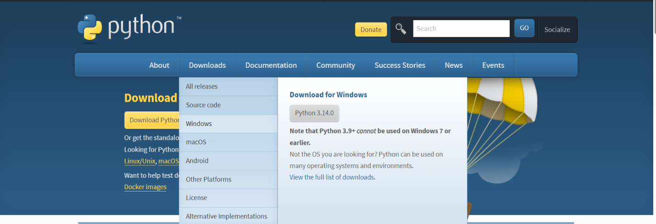

- Click Download Python 3.13.x (the version you have is fine)
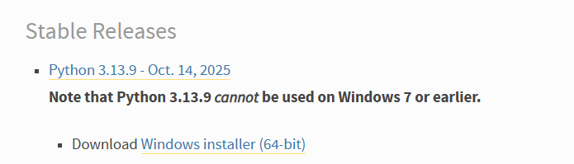
- Run the installer
Double-click the downloaded file:
python-3.13.x-amd64.exe
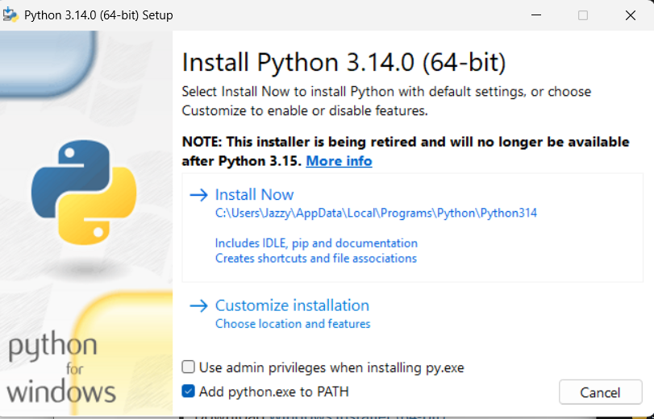

- IMPORTANT: Check “Add Python to PATH”
Before clicking Install:
✔ Check the option: “Add Python to PATH”
This makes Python accessible from Command Prompt.
- Click Install Now
Wait for the installer to complete.
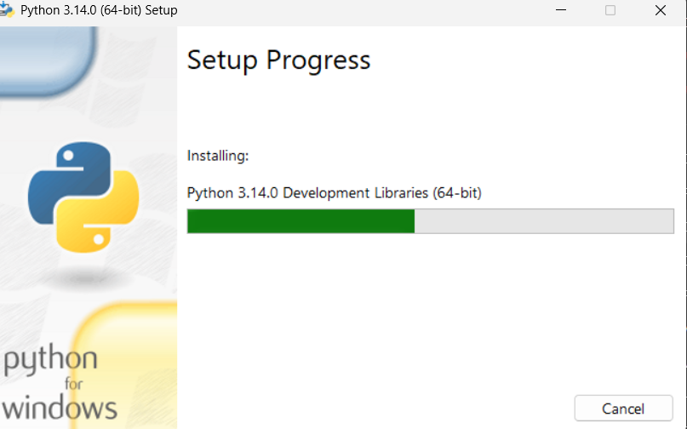

- Verify Python installation
Open Command Prompt and type:
python --version
Expected output:
Python 3.13.5
Also check pip (Python package manager):
pip --version
Expected output example:
pip 25.x.x or 24.x.x
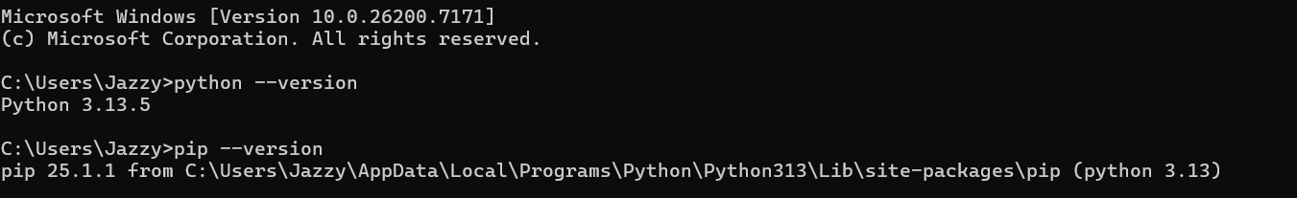

7. Install Appium Python Client (Required for Test Automation)
This library allows Python scripts to communicate with Appium Server.
Open Command Prompt and run:
pip install Appium-Python-Client
Verify installation:
pip show Appium-Python-Client
You should see output like:
Name: Appium-Python-Client
Version: 4.x.x

STEP 2 — Install Node.js
1. Check if Node.js is already installed
Open Command Prompt and type:
node -v
npm -v
- If you see version numbers (e.g., v24.11.1 / 11.6.2) → Node.js is already installed and you can skip to Appium setup.
- If you see an error like 'node' is not recognized as an internal or external command → Node.js is not installed. Proceed to the next step.

2. Download Node.js
Visit:
👉 https://nodejs.org/en/
Download:
Click Windows Installer (.msi) under LTS (Recommended for Most Users) — this is the 64-bit version for modern Windows PCs.
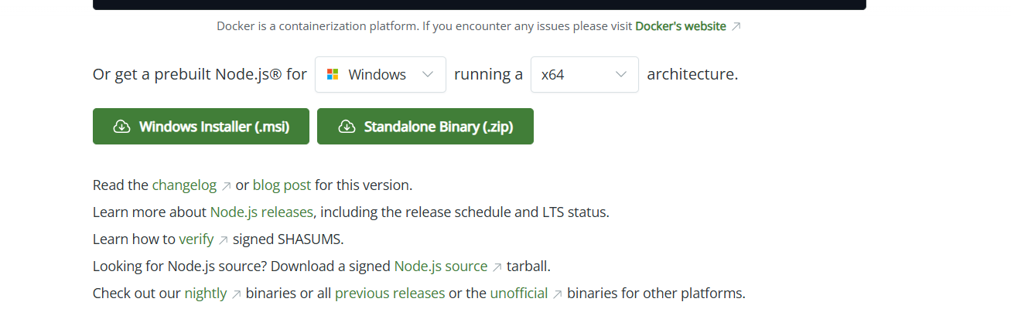
❌ Do not download the Standalone Binary — it’s for advanced users only.

3. Install Node.js
Double-click the installer:
node-vxx.x.x-x64.msi
During installation:
✔ Accept the License
✔ Leave default settings
✔ Ensure "Add to PATH" is selected
✔ Click Install

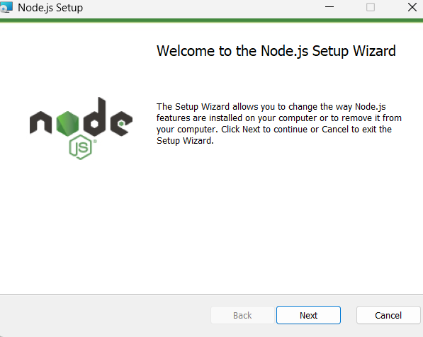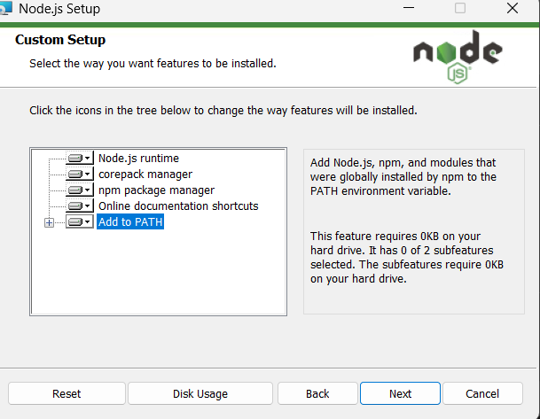

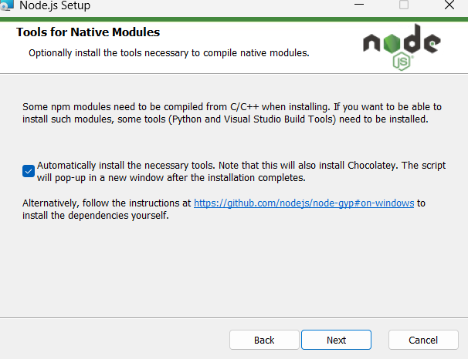

4. Verify Node.js installation
Open a new Command Prompt (old one won’t detect the new PATH).
Run:
node -v
npm -v
You should see something like:
v24.11.1
11.6.2
✅ If versions appear → Node.js is installed correctly and ready for Appium
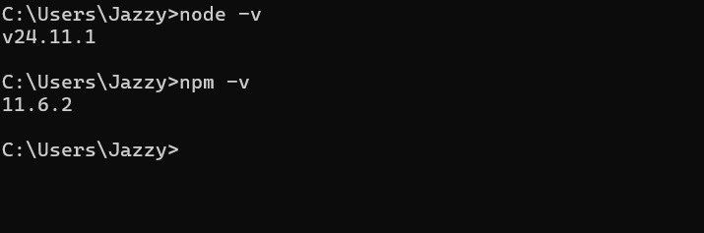

STEP 3 — Install Appium Server GUI
- Download Appium Server GUI
Go to the GitHub releases page:
👉 https://github.com/appium/appium-desktop/releases
Download:
✔ Appium-Server-GUI-windows-1.22.3-4.exe
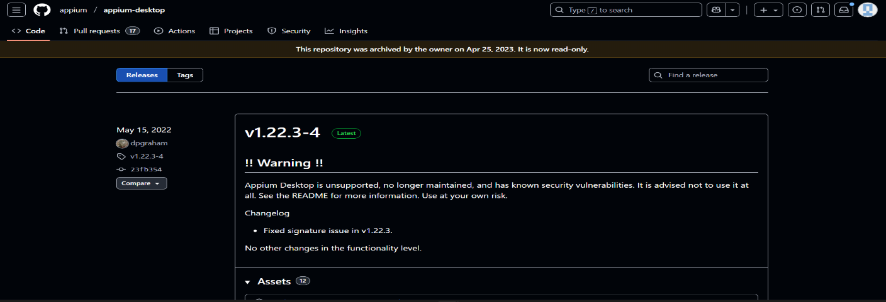
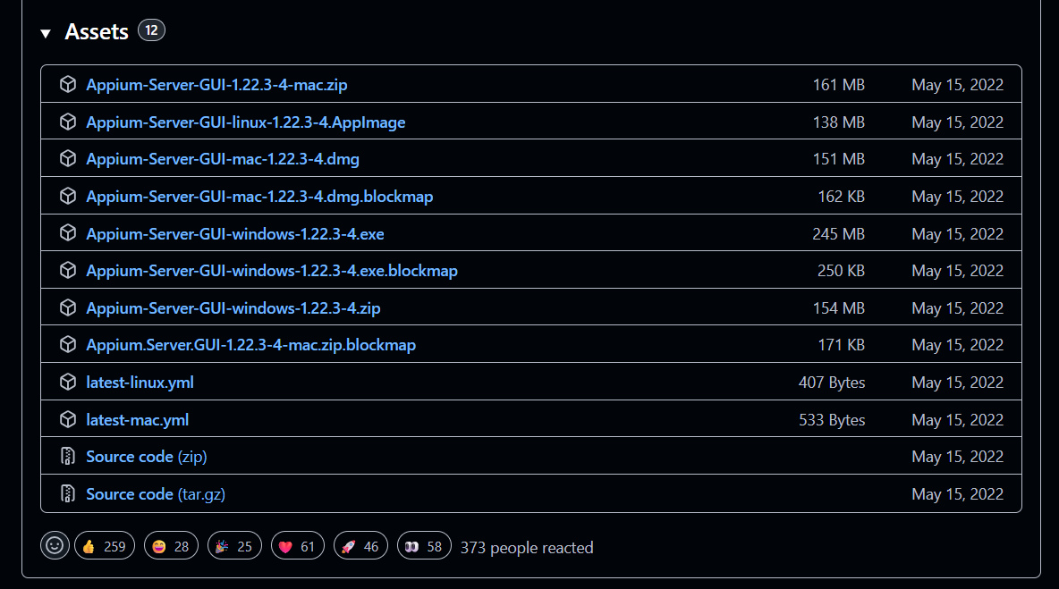

- Install Appium Server GUI
- Double-click the installer:
Appium-Server-GUI-x.x.x.exe
- Click Next → Next → Install
- Wait for installation to complete
- Launch Appium Server GUI

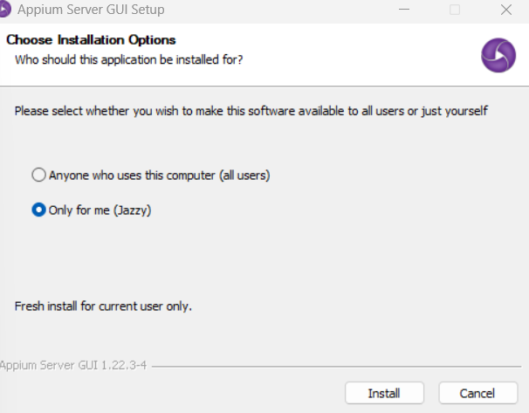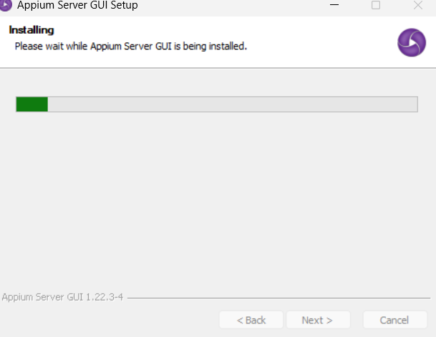

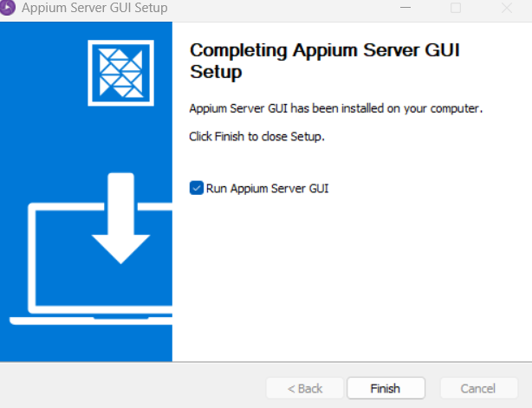

- Start the Appium Server
When Appium Server GUI opens:
- Select the Simple tab (beginner-friendly preset).
- Make sure the Host and Port is set to:
Host: 0.0.0.0 (this is fine for local use)
Port: 4723 (default Appium port)
- Click Start Server.
- You should see a green log/status message like:
Appium REST http interface listener started on 0.0.0.0:4723
Appium server started
Note: The default host 0.0.0.0 means Appium listens on all network interfaces. This is fine for running scripts locally with an emulator.

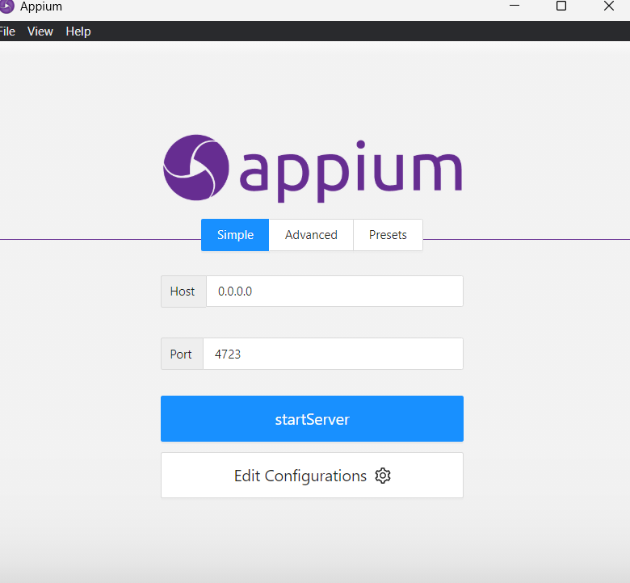
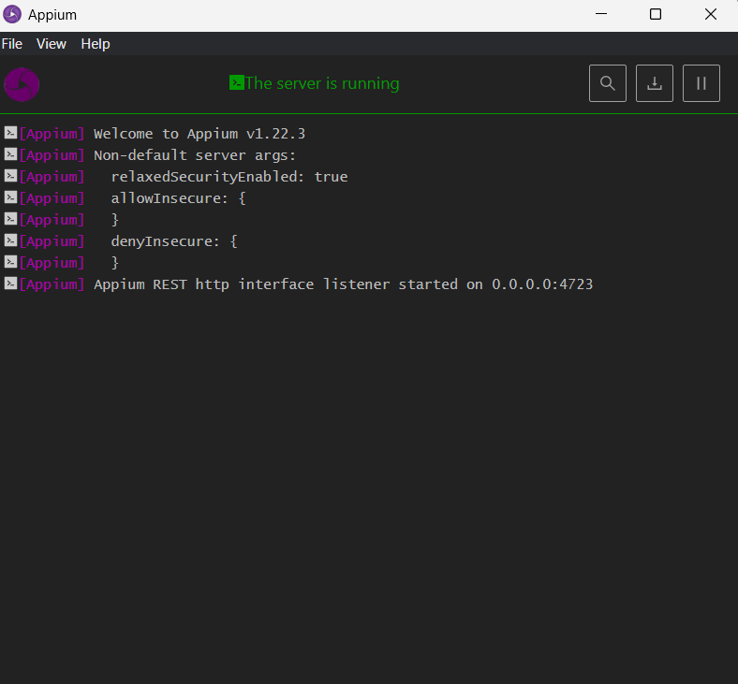

- Verify Appium is Running
- Open a web browser
- Enter the URL:
http://127.0.0.1:4723
- You may see JSON with an error like status: 9 or No route found.
✅ This is normal — Appium is a REST API server, not a web page.
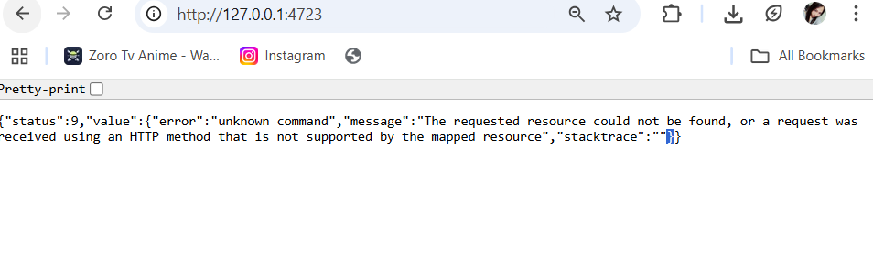
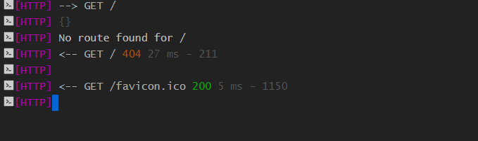

Note: “Accessing Appium via a browser may show a 404 or status:9 JSON message — this is expected behavior. The server is running correctly and ready for test scripts.”

STEP 4 — Install Android Studio + Android Emulator (VERY IMPORTANT)
- Download Android Studio
- Open your browser and visit:
👉 https://developer.android.com/studio
- Click the button “Download Android Studio Otter” and agree to the terms.

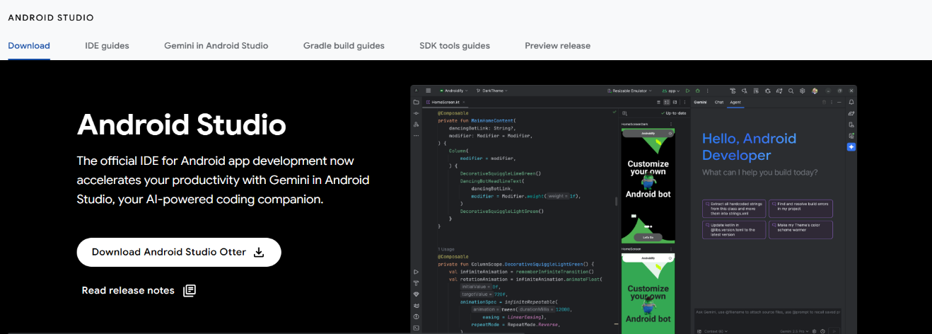

- Run the Installer
- After downloading, open the installer:
android-studio-*-windows.exe
- During installation:
  - Default configuration settings
  - Choose start Menu folder
  - Click Install

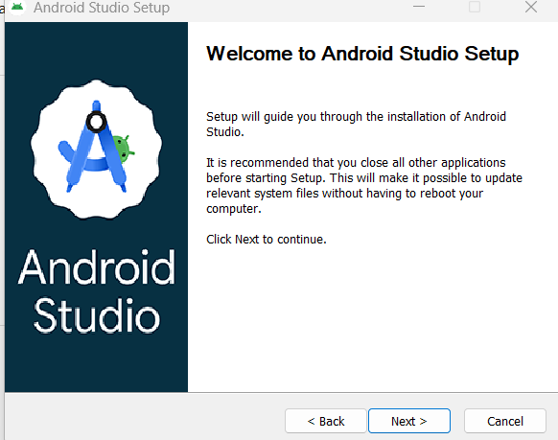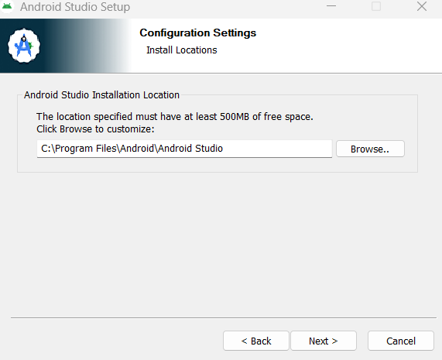
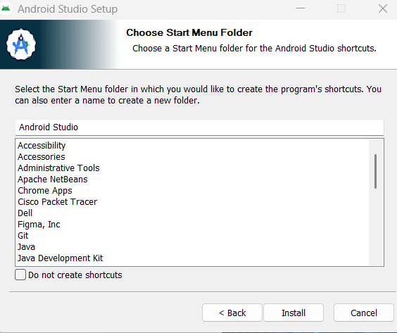
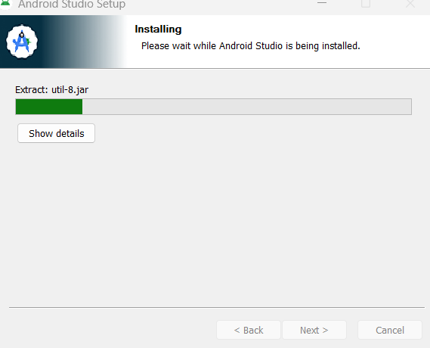
- Disable Usage Statistics
- A window may appear asking:
“Allow Google to collect usage data for Android Studio and its related tools?”
- Select:
✔ Don’t send usage statistics
- Click Next to continue

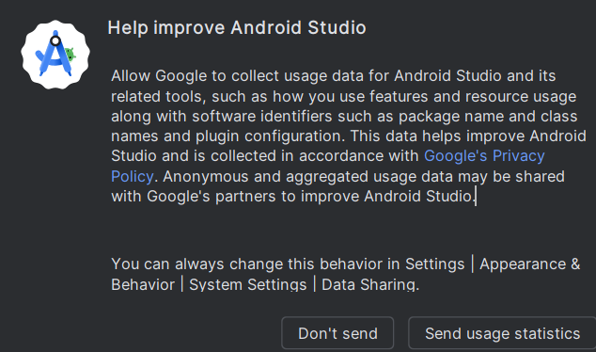

- Choose Setup Type
- Window appears:
“Choose the type of setup you want for Android Studio”
- Select:
✔ Standard — recommended (installs default components, emulator, SDK, and UI theme)
- Click Next to continue.

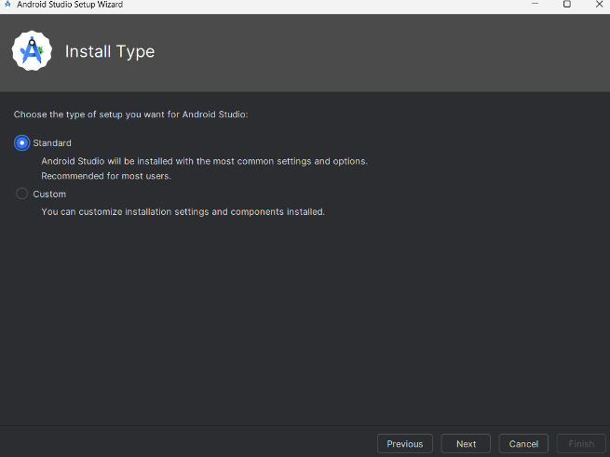

- Accept Android SDK License
- During installation or first launch, the following may appear:
“Android Software Development Kit License Agreement”
- To proceed, select:
✔ Accept
- Click Next to continue.
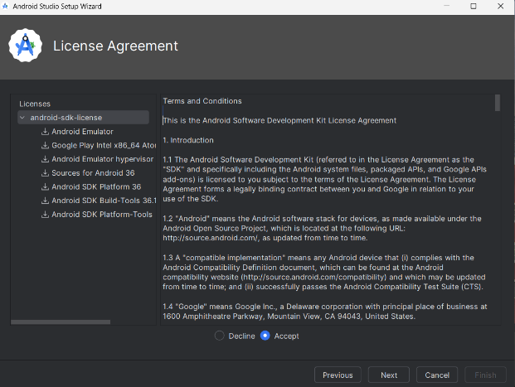

- Download Components:
- Android Studio will now download required components:
  - Android Emulator (latest version)
  - APIs system image (Intel x86_64)
  - selected SDK tools
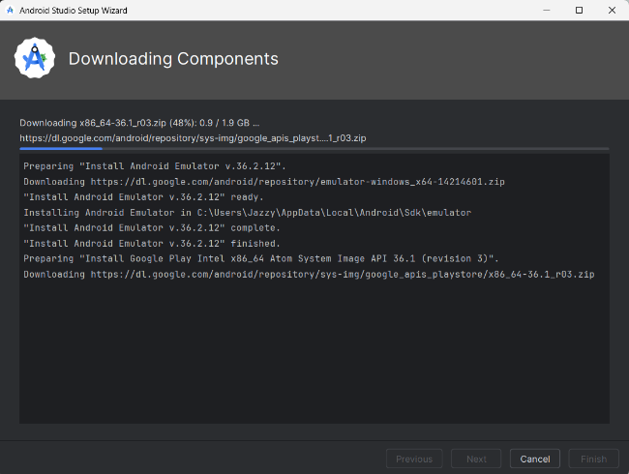

- Create Android Emulator (AVD)
Open Virtual Device Manager
- From the Android Studio Welcome Screen → More Actions → Virtual Device Manager
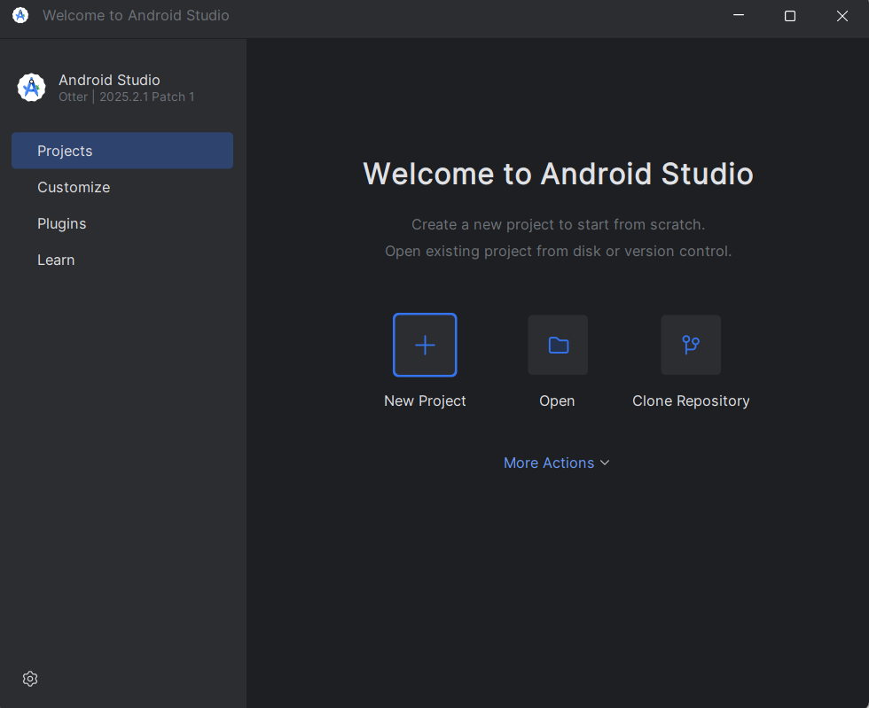
Create a New Virtual Device
- Click Create Virtual Device (+ icon)
- Under Phone →Pixel 8, select a device from the list
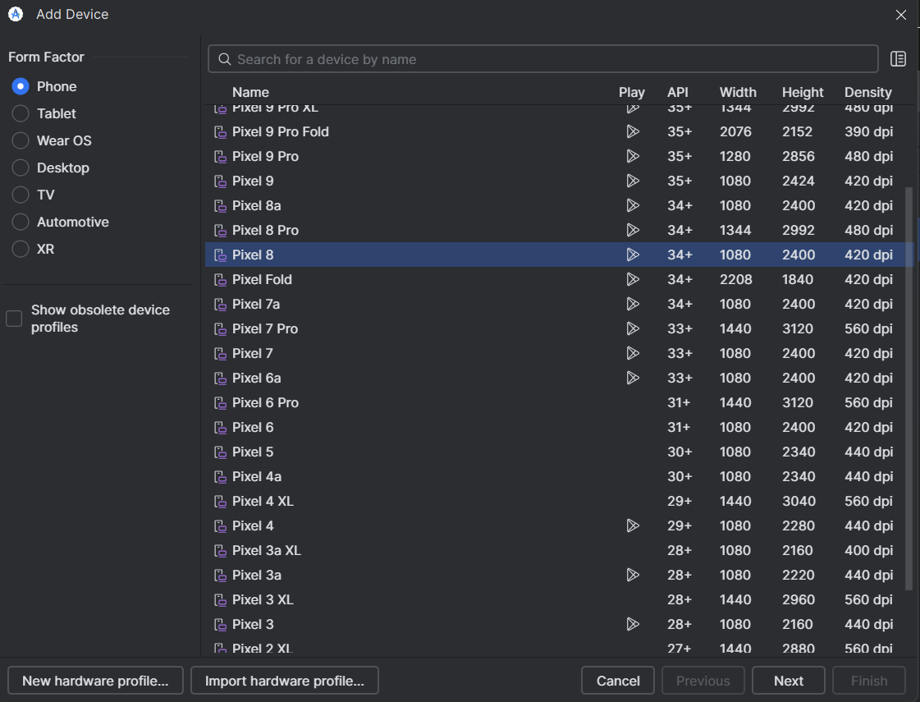

- Click Next
Select a System Image
In the system image list:
✔ Choose:
- API Level: 34
- Android Version: Android 14 (UpsideDownCake)
- Image Type: Google Play
- ABI: x86_64
So the correct selection is:
Android 14 (API 34) – Google Play – x86_64
Important notes:
- Make sure it has the Google Play icon
- Make sure the architecture is x86_64
- DO NOT enable:
  - “Show system images with SDK extensions”
  - “Show unsupported system images”
When you see:
system-images;android-34;google_apis_playstore;x86_64
→ this is the correct one.
Click Next → Finish.
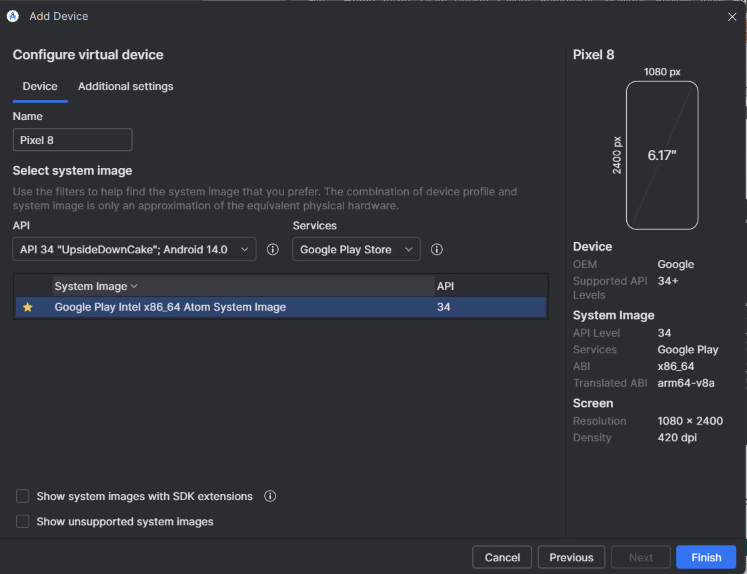

Launch the Emulator
- Back in AVD Manager, click the ▶ Play button next to your newly created device
- Wait for the emulator to fully boot to the Android home screen
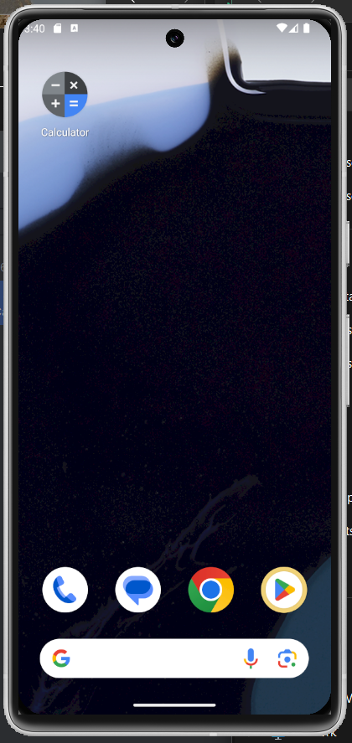

Installing Google Calculator (IMPORTANT)
Some Android 14 Google Play images do NOT include Calculator by default.
Install it manually:
- Open Google Play Store inside the emulator
- Sign in if required
- Search for Google Calculator
- Install it
Verify installation using ADB:
adb shell pm list packages | findstr calculator
Expected output:
package:com.google.android.calculator
This ensures Appium can launch the Calculator app for automation.

- Set ADB Path and Verify Emulator
- Locate the platform-tools folder
- Open File Explorer (Windows + E)
- Navigate step by step:
C:\Users\Jazzy\AppData\Local\Android\Sdk
- C: → Users → Jazzy → AppData → Local → Android → Sdk
- ⚠️ Note: The AppData folder is hidden by default.
  - To see it, in File Explorer, click View → Show → Hidden items
- Inside the Sdk folder, you should see a folder named:
platform-tools
  - This folder contains adb.exe and other tools
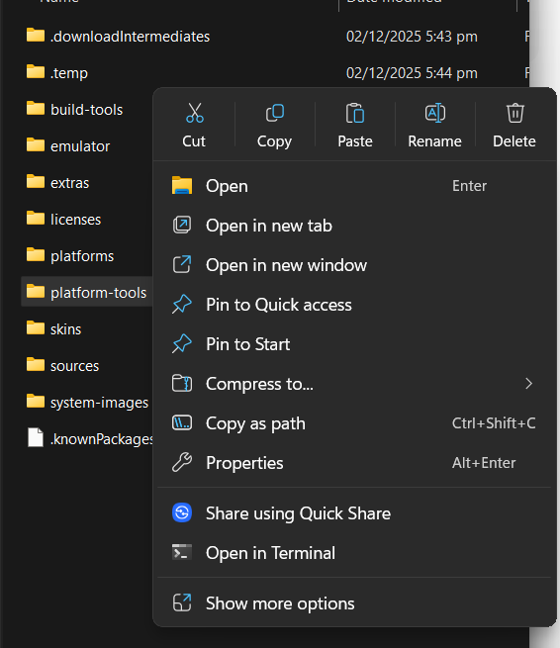
- Add platform-tools to System PATH
- Press Windows + R, type sysdm.cpl, press Enter
- Go to Advanced → Environment Variables
- Under System Variables, scroll and select Path → Edit → New
- Add the full path to platform-tools:
C:\Users\Jazzy\AppData\Local\Android\Sdk\platform-tools
- Click OK → OK → OK to save changes
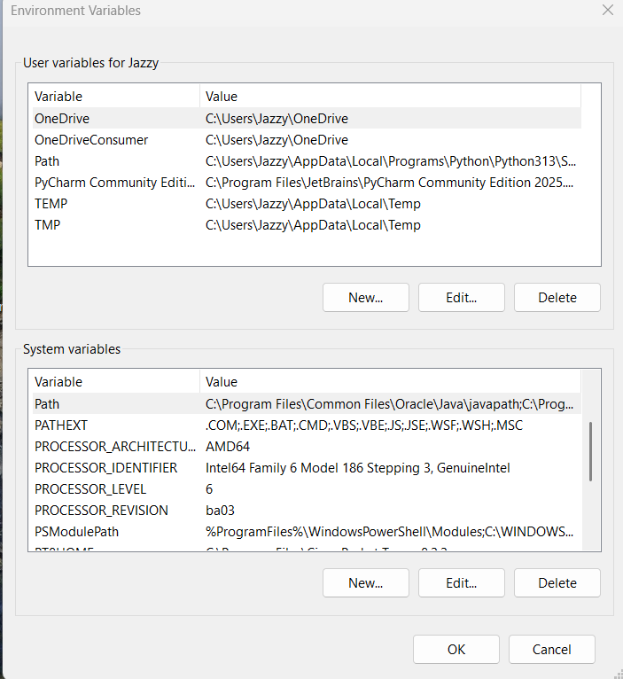
- Verify ADB works
- Open a new Command Prompt (important: must be a new one)
- Type:
adb devices
- You should see output like:
List of devices attached
emulator-5554 device
✅ This confirms your emulator is recognized and ADB is working
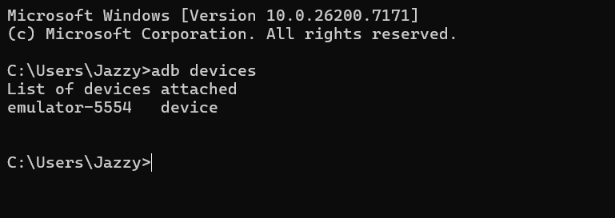

STEP 5 – Install Appium Inspector
Now you are ready to install the GUI inspector.
Go to:
https://github.com/appium/appium-inspector/releases
Download the latest Windows file:
Choose this one:
✅ Appium-Inspector-2025.11.1-win-x64.exe
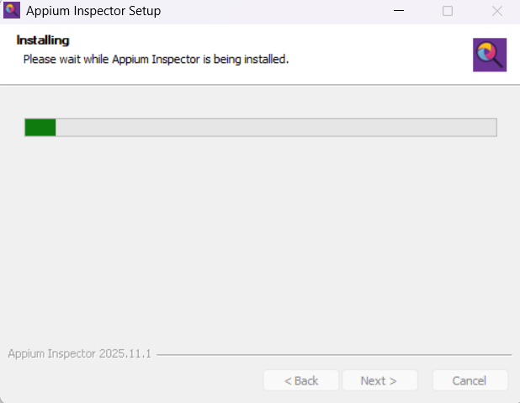
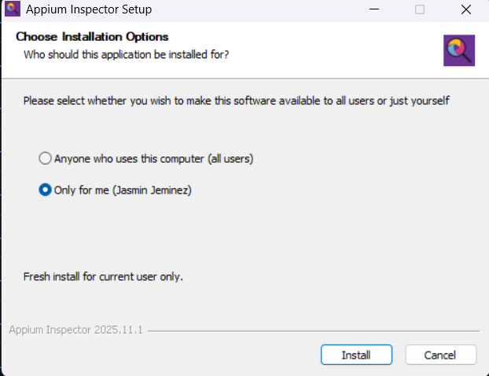
Open and install normally.
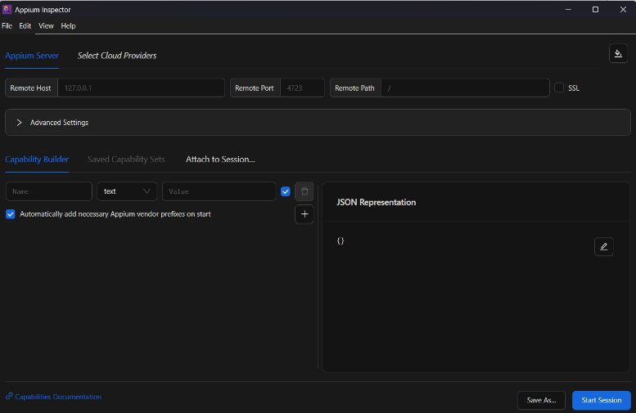
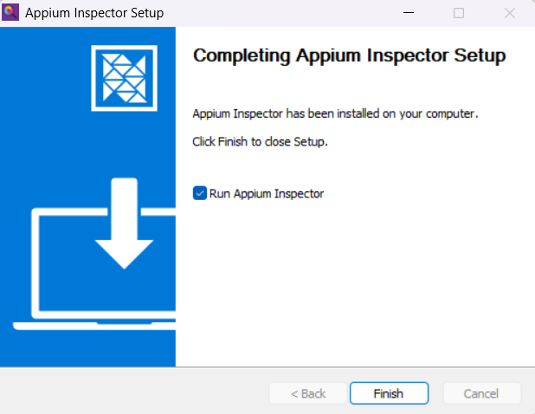
- Launch Appium Inspector
- You will see a configuration screen:
Fill in these:
Remote Host: 127.0.0.1
Port: 4723
Remote Path: / (default)

STEP 5 — Install Appium Inspector (WITH Screenshot Placement)
Now you are ready to install the GUI inspector.
1. Download Appium Inspector
Go to:
👉 https://github.com/appium/appium-inspector/releases
Download the latest Windows file:
✔ Appium-Inspector-2025.11.1-win-x64.exe
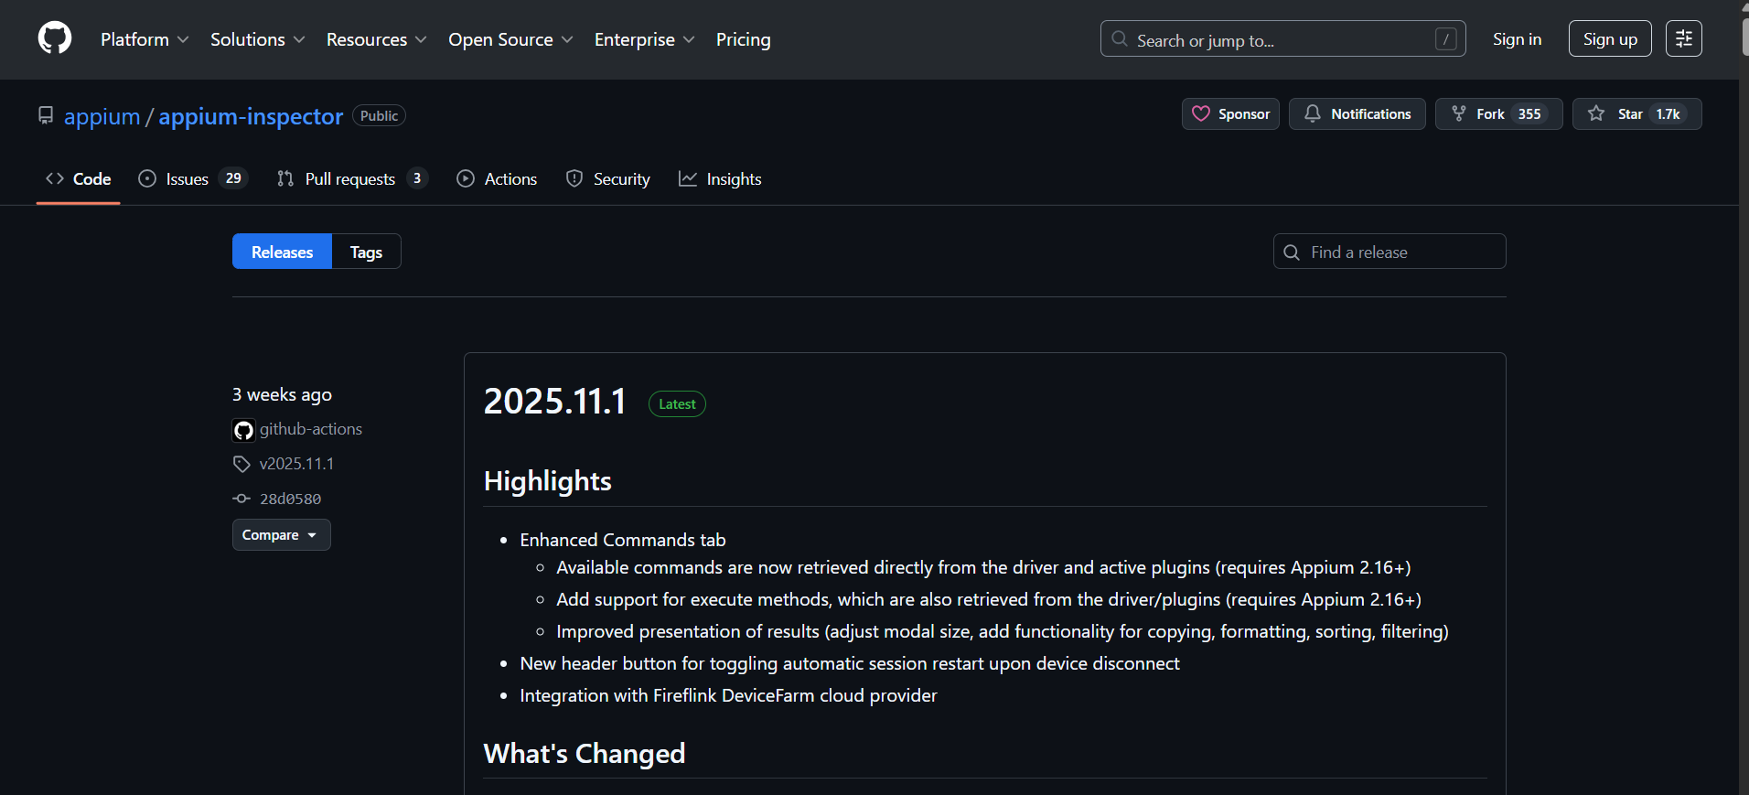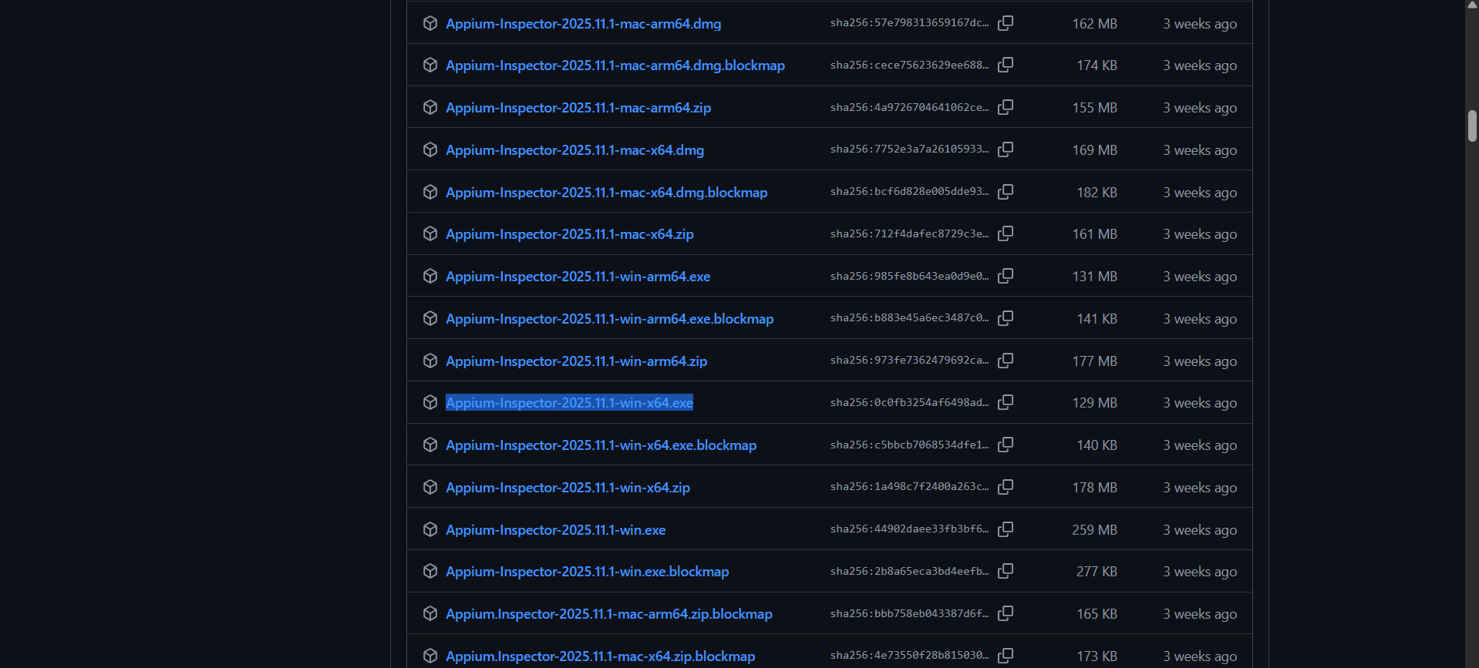

2. Install Appium Inspector

• Open the installer
• Click Next → Next → Install
• Wait for installation to finish
• Launch Appium Inspector

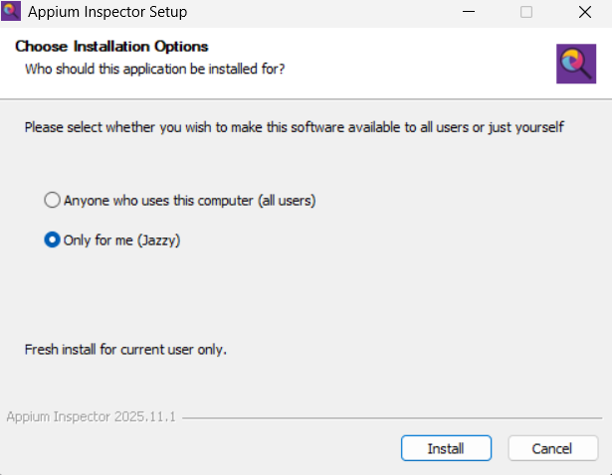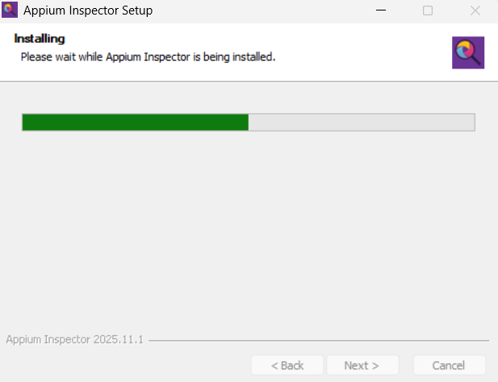

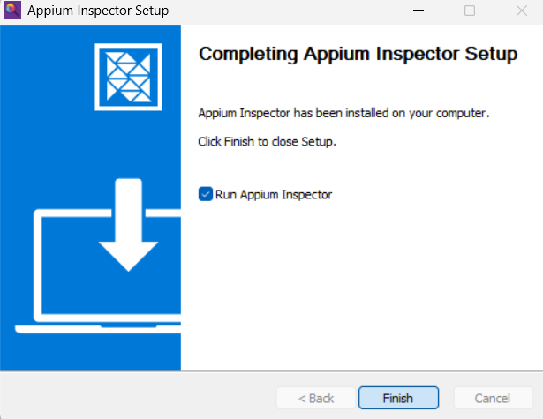

STEP 6 — Configure Environment Variables (VERY IMPORTANT)
This is the step your professor will absolutely expect to see because:
- Appium requires Java JDK
- Android requires SDK paths
- Appium Inspector + UiAutomator2 require JAVA_HOME
You already fixed these on your system, so now we will just document them properly.
Below is a ready-to-paste section you can add directly to your documentation.

Configure Environment Variables (JAVA, ANDROID, ADB)
For Appium to work correctly with Android, several environment variables must be set on Windows. These allow Appium, ADB, and Appium Inspector to locate the Android SDK and Java JDK.
Follow these steps carefully:

6.1 — Open Environment Variables
- Press Windows + R
- Type: sysdm.cpl
- Go to Advanced tab
- Click Environment Variables
⭐ 6.2 — Add User Variables for Android SDK (FULL DETAILED VERSION)
Appium needs to know where your Android SDK is installed.
Android Studio installs the SDK in a specific folder by default.
We will locate that folder, confirm it exists, and then add the required environment variables.

🔍 Step A — Locate the Android SDK Folder
Android Studio installs the SDK automatically the first time you install or run the program.
To locate it:

1. Open File Explorer
Press Windows + E or click the folder icon.

2. Navigate to your user folder
Go to:
C:\
└─ Users\
└─ Jazzy\

3. Enable Hidden Items (IMPORTANT)
The AppData folder is hidden.
- At the top of File Explorer, click View
- Click Show
- Check Hidden items
Now you will be able to see the AppData folder.
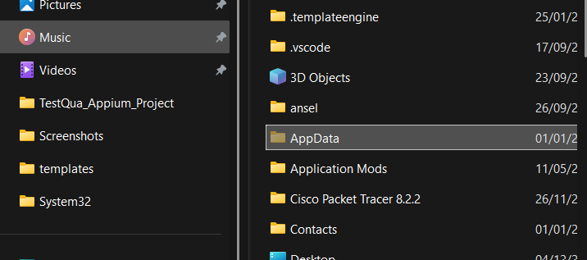

4. Navigate to the Android SDK path
Follow this path step by step:
C:\Users\Jazzy\AppData\Local\Android\Sdk
Breakdown:
- C: → your main drive
- Users → Windows user folders
- Jazzy → your Windows account
- AppData → hidden folder
- Local → local settings
- Android → installed by Android Studio
- Sdk → the Android SDK directory

5. Verify the Sdk folder exists
Inside the Sdk folder, you should see subfolders like:
- platform-tools
- emulator
- build-tools
- platforms
- system-images
Most importantly:
✔ platform-tools must be there
✔ It must contain adb.exe
This confirms your Android SDK installation is correct.

🟢 Step 7— Add SDK Paths to Environment Variables
Now that you have confirmed the location of the SDK, add it to your user environment variables.

1. Open Environment Variables Window
- Press Windows + R
- Type: sysdm.cpl
- Press Enter
- Go to the Advanced tab
- Click Environment Variables

2. Add the following User Variables for Jazzy:
Click New:
Variable Name | Variable Value
ANDROID_HOME | C:\Users\Jazzy\AppData\Local\Android\Sdk
ANDROID_SDK_ROOT | C:\Users\Jazzy\AppData\Local\Android\Sdk

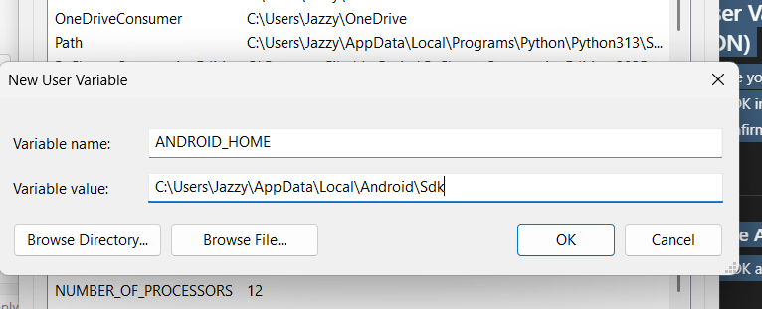
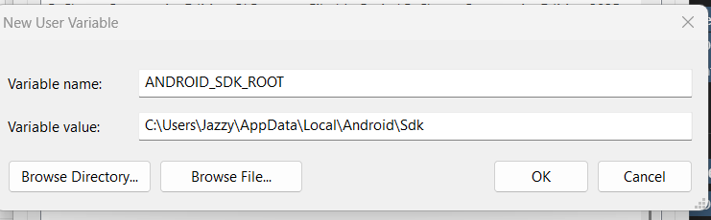
Click OK after entering each one.
✔ These variables allow Appium and ADB to locate the installed Android SDK.

🟢 Step 8 — Verify Your Variables
Open a new Command Prompt and type:
echo %ANDROID_HOME%
echo %ANDROID_SDK_ROOT%
Expected result:
C:\Users\Jazzy\AppData\Local\Android\Sdk
C:\Users\Jazzy\AppData\Local\Android\Sdk
If both match the SDK folder path exactly → setup is correct.

⭐ STEP 6.3 — Add JAVA_HOME (FULL DETAILED VERSION)
Appium requires Java because its Android automation engine (UiAutomator2) runs on Java.
Therefore, we must correctly find the installed Java Development Kit (JDK) and set the JAVA_HOME variable.
Below is the complete process for locating Java and adding the correct environment variables.

🔍 A. How to Find Your Installed Java JDK Folder
1. Open File Explorer
Press Windows + E.
2. Go to the Java installation directory
Navigate to:
C:\Program Files\Java
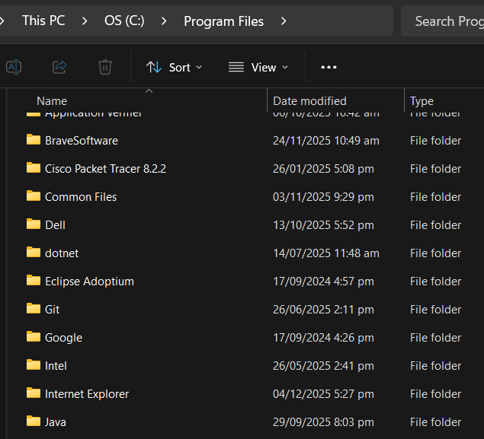

3. Identify the correct JDK folder
Inside the folder, you may see several entries:
Example:
- jdk-23 ✔ (valid JDK)
- jdk-22 ✔ (valid JDK)
- jre1.8.0_311 ✘ (NOT valid for Appium — this is JRE only)
- java8path ✘
- java17 ✔ (if it's a JDK)
✔ Choose a folder that starts with jdk-
Example (your system):
jdk-23
4. Verify this is really a JDK
Open the bin folder:
C:\Program Files\Java\jdk-23\bin
Inside you MUST see:
java.exe
javac.exe
- java.exe → Java runtime
- javac.exe → Java compiler (only exists in JDK, not JRE)
If both exist → this is the correct JDK for Appium.

🟢 B. Add the JAVA_HOME Variable
Once you confirm your JDK folder, follow these steps:
1. Open the Environment Variables window
- Press Windows + R
- Type: sysdm.cpl
- Press Enter
- Go to Advanced tab
- Click Environment Variables…
2. Under User variables for Jazzy
Click New (or Edit if JAVA_HOME already exists)
Fill in:
Field | Value
Variable Name: | JAVA_HOME
Variable Value: | C:\Program Files\Java\jdk-23
⚠️ IMPORTANT:
Do NOT add “\bin” at the end.
JAVA_HOME must point to the JDK root folder only.
Correct:
C:\Program Files\Java\jdk-23

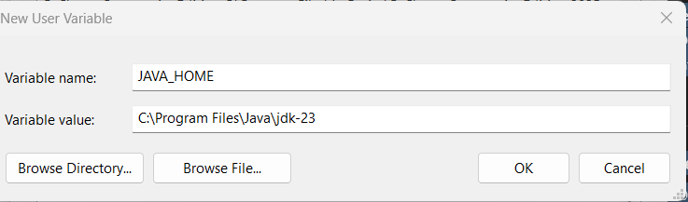
⭐ STEP 6.4 — Add Java to the System PATH
Adding Java’s bin folder to PATH makes it possible to run java and javac from ANY Command Prompt window.
1. In the Environment Variables window
Under System Variables, scroll and find:
Path
Select it → click Edit
2. Click New
Add:
%JAVA_HOME%\bin
Using %JAVA_HOME% ensures that if you change Java versions in the future, PATH updates automatically.
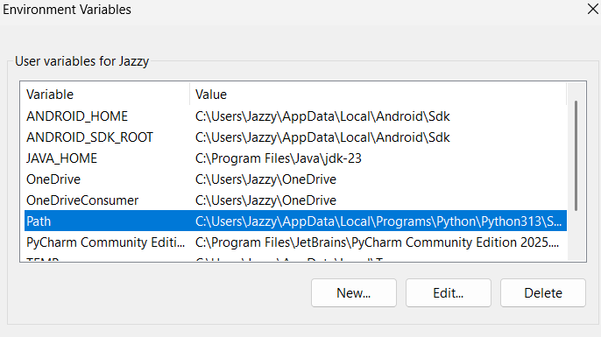

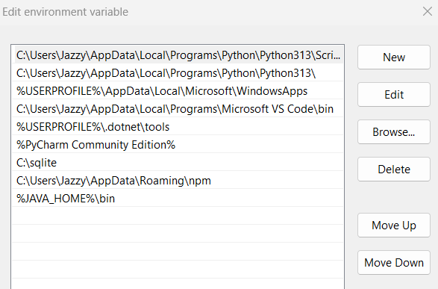

3. Click:
- OK
- OK
- OK
to save everything.

🟢 STEP 6.5 — Verification (IMPORTANT)
Open a new Command Prompt (must be NEW after editing PATH) and type:
✔ Test JAVA_HOME:
echo %JAVA_HOME%
Expected:
C:\Program Files\Java\jdk-23
✔ Test Java version:
java -version
Expected output example:
java version "23.0.1"
Java(TM) SE Runtime Environment...
Java HotSpot(TM) 64-Bit Server VM...
✔ Test compiler:
javac -version
Expected:
javac 23.0.1
If these commands work correctly →
🎉 Your Java setup is perfect and ready for Appium.

STEP 9 -- Configure Appium Inspector Connection
After doing everything.
- Launch Appium Inspector.
- On the Appium Server tab, fill in:
Field | Value
Remote Host | 127.0.0.1
Remote Port | 4723
Remote Path | /wd/hub
The Remote Host and Port must match the Appium Server GUI (Host: 0.0.0.0 or 127.0.0.1, Port: 4723).
The Remote Path /wd/hub is the default Appium endpoint.
Make sure the option “Automatically add necessary Appium vendor prefixes on start” is checked in the Capability Builder.

4. Adding Desired Capabilities in Appium Inspector
Inside Appium Inspector, go to Capability Builder and enter the following values:
Name | Type | Value
platformName | text | Android
automationName | text | UiAutomator2
deviceName | text | emulator-5554
appPackage | text | com.google.android.calculator
appActivity | text | com.android.calculator2.Calculator
noReset | boolean | true
fullReset | boolean | false
Make sure the option "Automatically add necessary Appium vendor prefixes on start" is enabled.
This allows Appium Inspector to automatically convert capability names to the correct format.

Generated JSON (Appium-Ready)
Appium Inspector will convert your input into the final JSON structure used when starting a session:
{
"platformName": "Android",
"appium:automationName": "UiAutomator2",
"appium:deviceName": "emulator-5554",
"appium:appPackage": "com.google.android.calculator",
"appium:appActivity": "com.android.calculator2.Calculator",
"appium:noReset": true,
"appium:fullReset": false
}

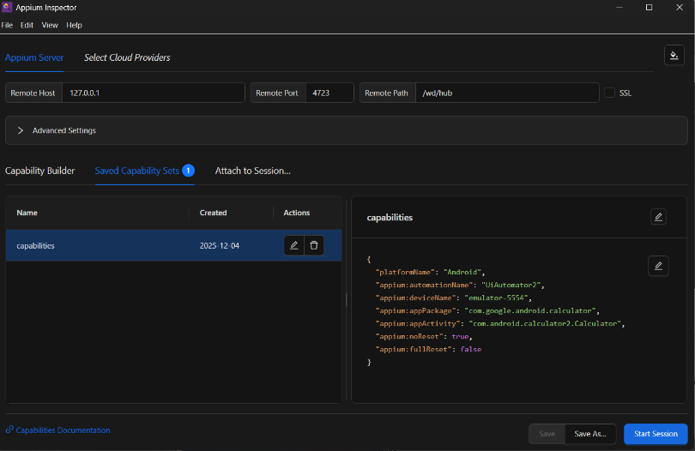

5. Start Inspector Session
• Make sure emulator is running (adb devices shows emulator-5554 device in command prompt)
• Make sure Appium Server GUI is running
• Click Start Session
