ProChef
Easily Create and Share High-Quality Recipes

Team Lead : Jason Januar – 300393865 (100% Contribution)
CSIS 3375-001
Table of Contents
1. Introduction 3
2. Background Research 3
3. PACT Framework 4
4. Value Proposition 5
5. Requirements Gathering 5
5a. Objectives / Goals 5
5b. Choice of User Study and User Sample 6
5c. Survey Draft 6
5d. Data Visualization and Analysis 9
5e. Insights 16
6. Requirements Generation 17
6a. Personas 17
Persona 1 : John 17
Persona 2 : Jean 18
Persona 3 : Jane 19
Persona 4 : Johnny 20
6b. Requirements Generation 21
Individual Persona Analysis 21
6c. Master List of Requirements 22
7. Synthesis of Requirements Gathering and Generation 23
7a. Must Haves (Core App Features) 23
7b. Should Haves (Dealbreakers) 23
7c. Could Haves (Novelty Features) 24
7d. Want to Haves (Additional Features) 24
8. Design 25
8a. Design Patterns 25
8b. Figma Workflow 25
8c. Screenshot of All Screens 26
Splash Screen 26
Login and Registration Screen 27
Home Screen 28
Recipe Screen 29
Step-by-Step Cooking Screen 30
Search Screen 31
Community Screen 32
Add Recipe Screen 33
Nutrition & Meals Screen 34
Meal Planner Screen 35
Pantry & Shopping Screen 36
Shopping Screen 37
Bookmarks Screen 38
User Settings Screen 39
9. Designer Based Prototype Evaluation 40
User Journey Map 40
10. User-Based Prototype Evaluation 41
10a. Objectives 41
10b. Choice of User Study 41
10c. Prototype Evaluation Instructions 41
10d. Prototype Evaluation Survey Draft 43
10e. Data Visualization and Analysis 44
10f. Insights from Results 51
11. Design Changes based on Prototype Evaluation 52
11a. Changes Needed 52
11b. Changes Made 52
12. Conclusion 52
13. AI Usage 53
14. Work Log 53
15. Prototype Demo Link 56
16. References 56

1. Introduction
This is a recipe app with social media aspects. The user would be able to create recipes and share them online with other users. The user would be able to interact with other users such as leaving likes and comments on each other’s recipes and being able to join communities of users with similar food preferences or dietary restrictions.
The app would greatly help users to find recipes and procure the ingredients to cook them. The user can take a picture of their pantry and the app would find recipes that can be made using the available ingredients. The user can click a recipe and instantly order any missing ingredients through online shopping. The app would also gradually adapt and learn the user’s food preferences, thus as users keep using the app it will eventually be personalized and the app will be able to accurately find recipes that it believes the user would love. Ultimately, the app would allow the user to focus on cooking the recipes and eating the food as it will do all the other chores for the user.
What makes our app unique is that it also gives the opportunity for the user to create professional looking recipes. Our app would give tools for the user to easily create recipes that are more than a simple to-do list. For example, the user would be able to record snippets of the meal creation process and the app would attach the videos to each step of the instruction. The app would also have tools that makes recipe creating easy, such as the ability to take a picture of your ingredients and extract the data using image recognition and the ability to type your recipe instruction using speech-to-text analyzers. The motto for our app is “feel like a professional chef in your own kitchen”.

2. Background Research
We performed market research by trying out several recipe apps that would be our competitor in the marketplace. Specifically, we looked up the keyword “recipe” on Google Playstore and tried out the top 12 free apps for 15-30 minutes each. Some of the apps we tried out has some features locked behind a paid “pro” version but for this research we simply try out the free version.
The biggest market competition might be the SideChef app[1], which has almost every feature that we wanted to include in our app and are implemented in a high quality. The one thing this app lacks is a way for users to create recipes with video footage which is why we decided to pursue that as our novel feature.
Another market competition is the Tasty app[2], which is purely a recipe viewer and does not allow the creation of a user’s own recipes but it’s such a high quality that we deem to be a competition for the users who don’t plan on making their own recipes.
Samsung Food[3] is another app that is a mix of a recipe viewer and social media. While we don’t think it’s as high quality as SideChef or Tasty, it is another competition in the market. It doesn’t help that is has a recognizable brand (Samsung) which can be enticing to some users.
For apps that gave us inspiration, one is the SuperCook app[4]. The app is largely a simple recipe keeper, but it has a feature where it can add ingredients to the pantry using audio-to-speech systems. This made us realize that not all users are comfortable with typing on their small phone and so adding audio-to-speech mechanisms for our input functions is a nice accessability feature to have.
On the topic of accessability, the [5] app has an AI assistant that allows users to generate recipes by describing them in a more conversational way which can be more comfortable for some users. It also allows a user to take a picture of a finished meal and attempt to discern what ingredients are used to create said meal, which is an interesting idea though it’s not very accurate in our testing.
Several apps (Tasty[2], ReciMe[6], CookBook[7] and Mealime[8]) allows the users to transfer their shopping list to the InstaCart app[9] which is a grocery shopping app that has an API available for other apps to use. This is a neat idea to allow users to easily buy ingredients for their recipes and is something that we plan on incorporating to our app.
Several apps allow the user to export a recipe as a pdf file but one of them, Recipe Keeper[10], allows the user to export a large selection of recipes at once to create a cookbook pdf file which can be printed to create a physical cookbook. This is an interesting idea that can allow the user to share recipes with friends and families that aren’t technologically savvy.
Another interesting feature is the import from video feature of ReciMe[6]. Most recipe keepers allow importing of recipes from websites and photos but ReciMe also includes a way to import recipes from YouTube videos using audio-to-text systems. This doesn’t work perfectly but might be an interesting idea to check out.
Other apps that we’ve done research for are My Recipe Box[11], Paprika Recipe Manager 3[12], and COOKmate[13]. These are market competition, but they’re on the lower end of quality so we don’t deem them to be a tough competition. And we didn’t manage to get any interesting new ideas or perspectives from them.

3. PACT Framework
People : We’re targetting anyone who wants to cook for themselves. Despite the app name, we’re more focused on targetting home chefs that want to feel like a professional chef instead of actual professional chefs.
Activity : Our users will use our app to assist them in cooking.
Context : Our app would be capable of accomodating chefs of any skill level from beginners to experts. We’re also accomodating all forms of temporal availability, from people who only have time to cook fast foods to people that are willing to make meals with long prep times.
Technologies:
For users wanting to find recipes, our app provides a streamlined way for users to look up what they want. While users can always directly search for a specific recipe, the app provides tools to help users that are unsure of what they want to cook or eat, such as a tool to look up recipes based on the available ingredients on the user’s pantry. The app will also memorize the user’s history of recipes so that it can personalize the experience by adapting to the user’s perceived dietary preferences.
For users wanting to create recipes, our app provides tools to streamline the creation of a high-quality recipe page which includes instruction videos, text-to-speech mechanisms, image recognition systems, and spell checkers. The user would also be able to share their recipes to others and receive evaluation in the form of ratings and comments.

4. Value Proposition
Look up all kinds of high-quality recipes from simple fast foods to fancy and complex dinners. Or, share your own recipes using our tools that can streamline the creation of professional-looking recipes. With the ProChef app, you too can feel like a professional chef at your own home.

5. Requirements Gathering

5a. Objectives / Goals
- Demographic
  - Identify user age range and household condition
    - GOAL: See if user demographic affects the other metrics identified in the survey
  - Identify users eating behaviors (prefer cooking or ordering food)
    - GOAL: Determine which user are chefs. Survey result of chefs will have higher weight since they’re our target demographic.

- Social Media Use
  - Identify if which social media does the user use (if any) and how often do they use it
    - GOAL: most popular social media will help be the inspiration for our app to determine the feel our app would want to have
  - Identify users social media behaviour (do they often post themselves or prefer just viewing other people’s content)
    - GOAL: determine how many users are likely to be interested in creating and sharing recipes, detemine how much emphasis our app would want to put to that aspect
  - Identify how influential social media is to the user’s cooking life (do they follow recipe-sharing accounts, do they share food photos or recipes themselves, etc)
    - GOAL: same as previous objective, but more directly specific to cooking stuff

- AI Opinions
  - Identify user opinion on AI usage
    - GOAL: app will need to have AI for some features but we want to determine if we should proudly showcase the AI usage or keep it low-key
- Use of Existing Competitors
  - Identify if users currently use a competing recipe app. If yes, which ones? If no, are you interested in using one in the future?
    - GOAL: We’ve done market research on the most popular apps but we’d like to have a better idea on which apps are our competition and try to make our app novel specifically against those apps.

5b. Choice of User Study and User Sample
We chose a survey since it’s simpler to do and we didn’t found a reason to use an interview model. Since our app target a rather general audience of “people who cook” we didn’t target a specific user sample and simply asked whoever was available between our friends and family members. Our survey does not have a dual perspective. Our app does have 2 possible perspectives which are content creators and content consumers but we decided that it was not necessary to have 2 different surveys for this.

5c. Survey Draft

ReciPro User Opinion Survey
We here in the ReciPro team are developing ReciPro, a recipe keeping app that would double as a social media app where users can create and share recipes with each other. Our app aims to transform the user’s social and culinary life by providing them tools to easily create and share high quality recipes with video and audio guides, it will be as if they’re teaching the viewers in person. As such, we would like to ask you some questions which would help us improve the user experience of the app and determine which aspects should we focus upon. Thank you in advance for taking your time to fill this survey.
How old are you? (choose one)
- < 20
- 21-30
- 31-40
- 41-50
- 51-60
- > 61
Do you live alone?
- Yes
- No
- Prefer not to say
Which of these options best describe your eating lifestyle? (choose one)
- I almost exclusively cook for myself, I rarely eat at restaurants or order food
- I prefer cooking for myself but sometimes still eat at restaurants or order food
- I both cook and eat out, I’m not more inclined to do one or the other
- I sometimes cook for myself but prefer eating out at restaurants or ordering food
- I almost never cook, I almost exclusively eat at restaurants or order food

Which of these social media sites do you use (choose any amount)
- X (formerly known as twitter)
- Instagram
- Facebook
- Snapchat
- TikTok
- YouTube
- Pinterest
- Reddit
- Other
- I do not use any social media

Which of these social media do you use most often? (choose one)
- (Show same options as previous question)

Which of these bests describe your behavior in social media? (choose one)
- I only post my own content and rarely look at other people’s content
- I prefer posting my own content more than looking at other people’s content
- I post my own content but also look at other people’s content
- I rarely post my own content, I prefer looking at other people’s content
- I only look at other people content and never post anything myself

Which of these best describe how social media affect your culinary life? (choose any amount)
- I often share recipes on social media
- I often look up recipes on social media
- I don’t do either of the above

Which of these bests describe your feelings of AI integration in applications (choose one)
- I enjoy using AI tools to increase productivity
- I’m indifferent to the presence of AI in applications
- I actively avoid apps that has AI in it
Do you use a recipe app? (choose one)
- yes
- no
(if no) Would you be interested in using a recipe app in the future? (choose one)
- Yes
- no
(if yes) Which one of these apps do you use? (choose any amount)
- (show all 12 apps that we perform market research on)
- Other

Which features in a recipe app that are most important to you (choose up to 3)
- Easily look up recipes
- Nutrition tracker
- Meal planner
- Online shopping app integration
- Pantry tracker
- Easily create your own recipes
- Easily import recipes from other sites
- Recipes with video tutorials
- Text-to-Speech recipe reader
- Leaving likes and comments to recipes
- Joining communities/groups of users with similar food interests
- Easily share recipes to external social media apps
- Other ____

Are there anything else you’d want to say to us? (optional open ended question)

5d. Data Visualization and Analysis
Sample Size: 10 People
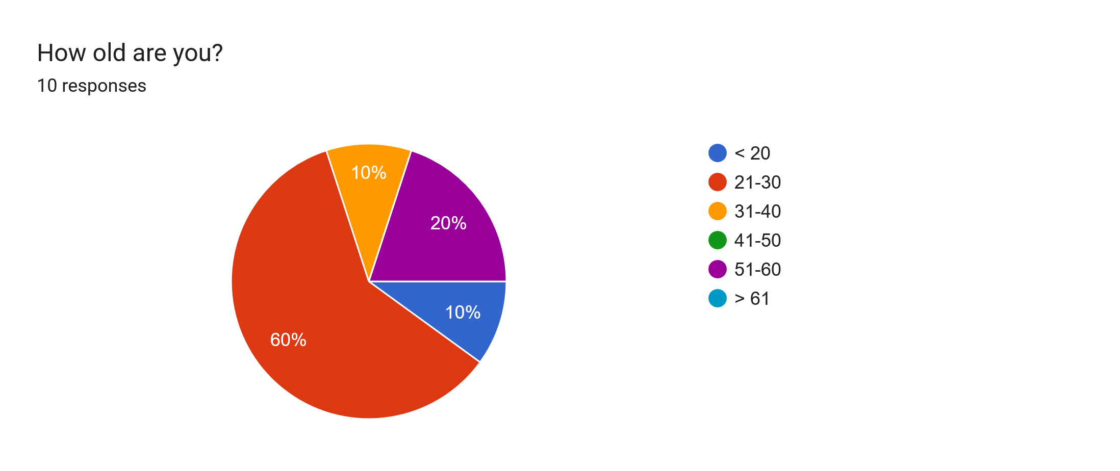
Using: (<20) = 15, (21-30) = 25, (31-40) = 35, (41-50) = 45, (51-60) = 55, (>61) = 65
- Mean : 31
- Median : 25
- Mode : 25 (60%)
- Std Dev (σ) : 12.806

Among the people we surveyed, the majority (60%) are in the age range of 21-30. If we also include the one person that is below 20 years old then 70% of our survey responders are in the young adult (below 30 years old) age range. So, we’ll be looking at our survey results from the perspective of young adult responders.

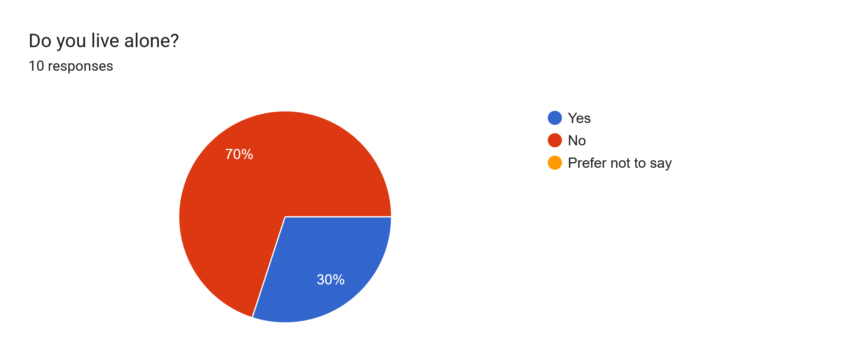
Using: Yes = 1, No = 0
- Mean : 0.3
- Median : 0
- Mode : 0 (70%)

The majority of our users doesn’t live alone, which might affect their cooking lifestyle.

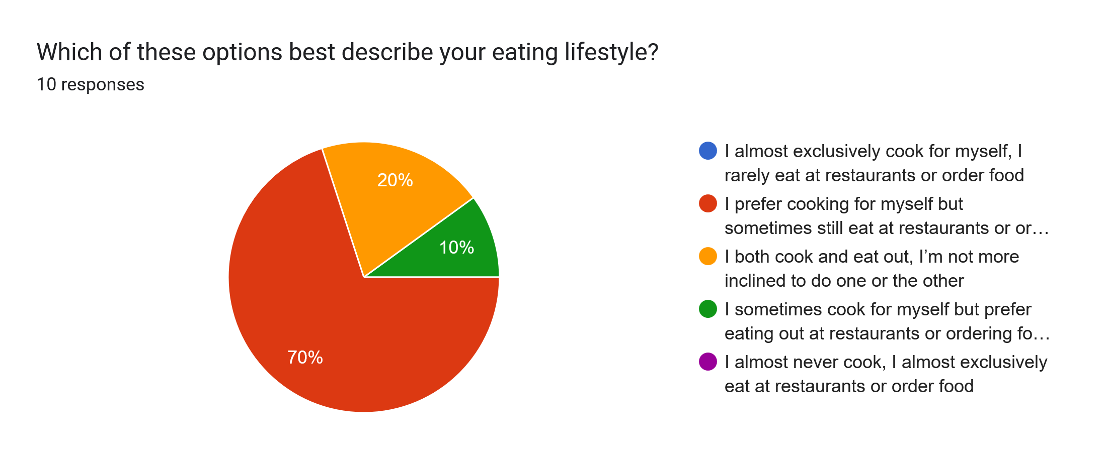
Using: Exclusively cook = 5, Mostly cook = 4, Equal = 3, Rarely Cook = 2, Never Cook = 1
- Mean : 3.6
- Median : 4
- Mode : 4 (70%)
- Std Dev (σ) : 0.663

The majority of our survey responders (70%) mostly cook over eating at restaurants. And 20% of them equally cook and eat outside. So the majority of our survey responders do cook on a regular basis.

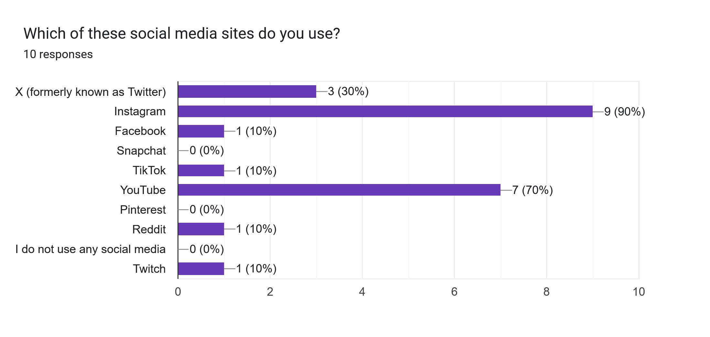
3 Highest Frequency:
- 1: Instagram (90%)
- 2: YouTube (70%)
- 3: X/Twitter (30%)

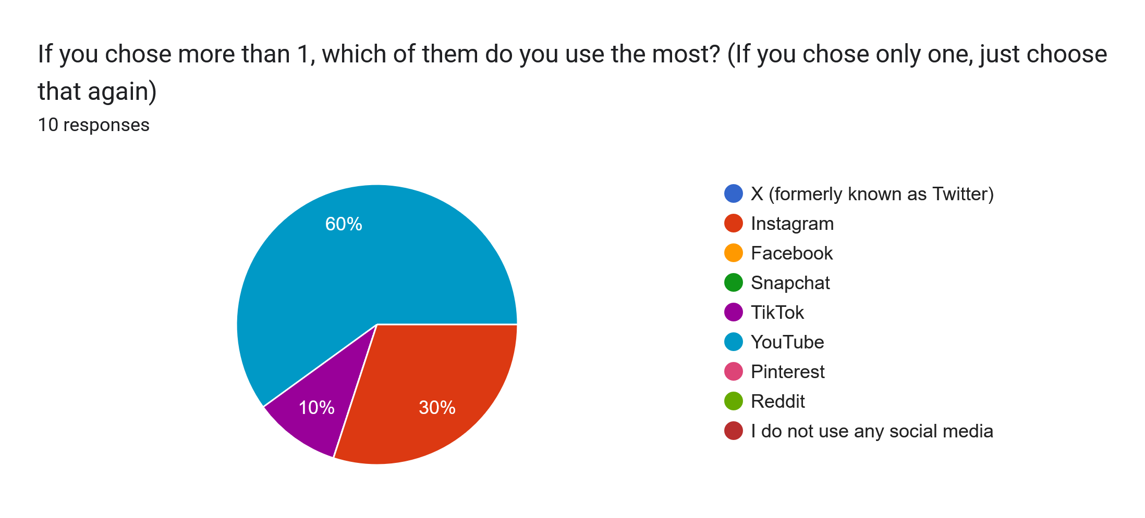
3 Highest Frequency:
- 1: YouTube (60%)
- 2: Instagram (30%)
- 3: TikTok (10%)

Most of our responders uses Instagram though the most used social media is YouTube.

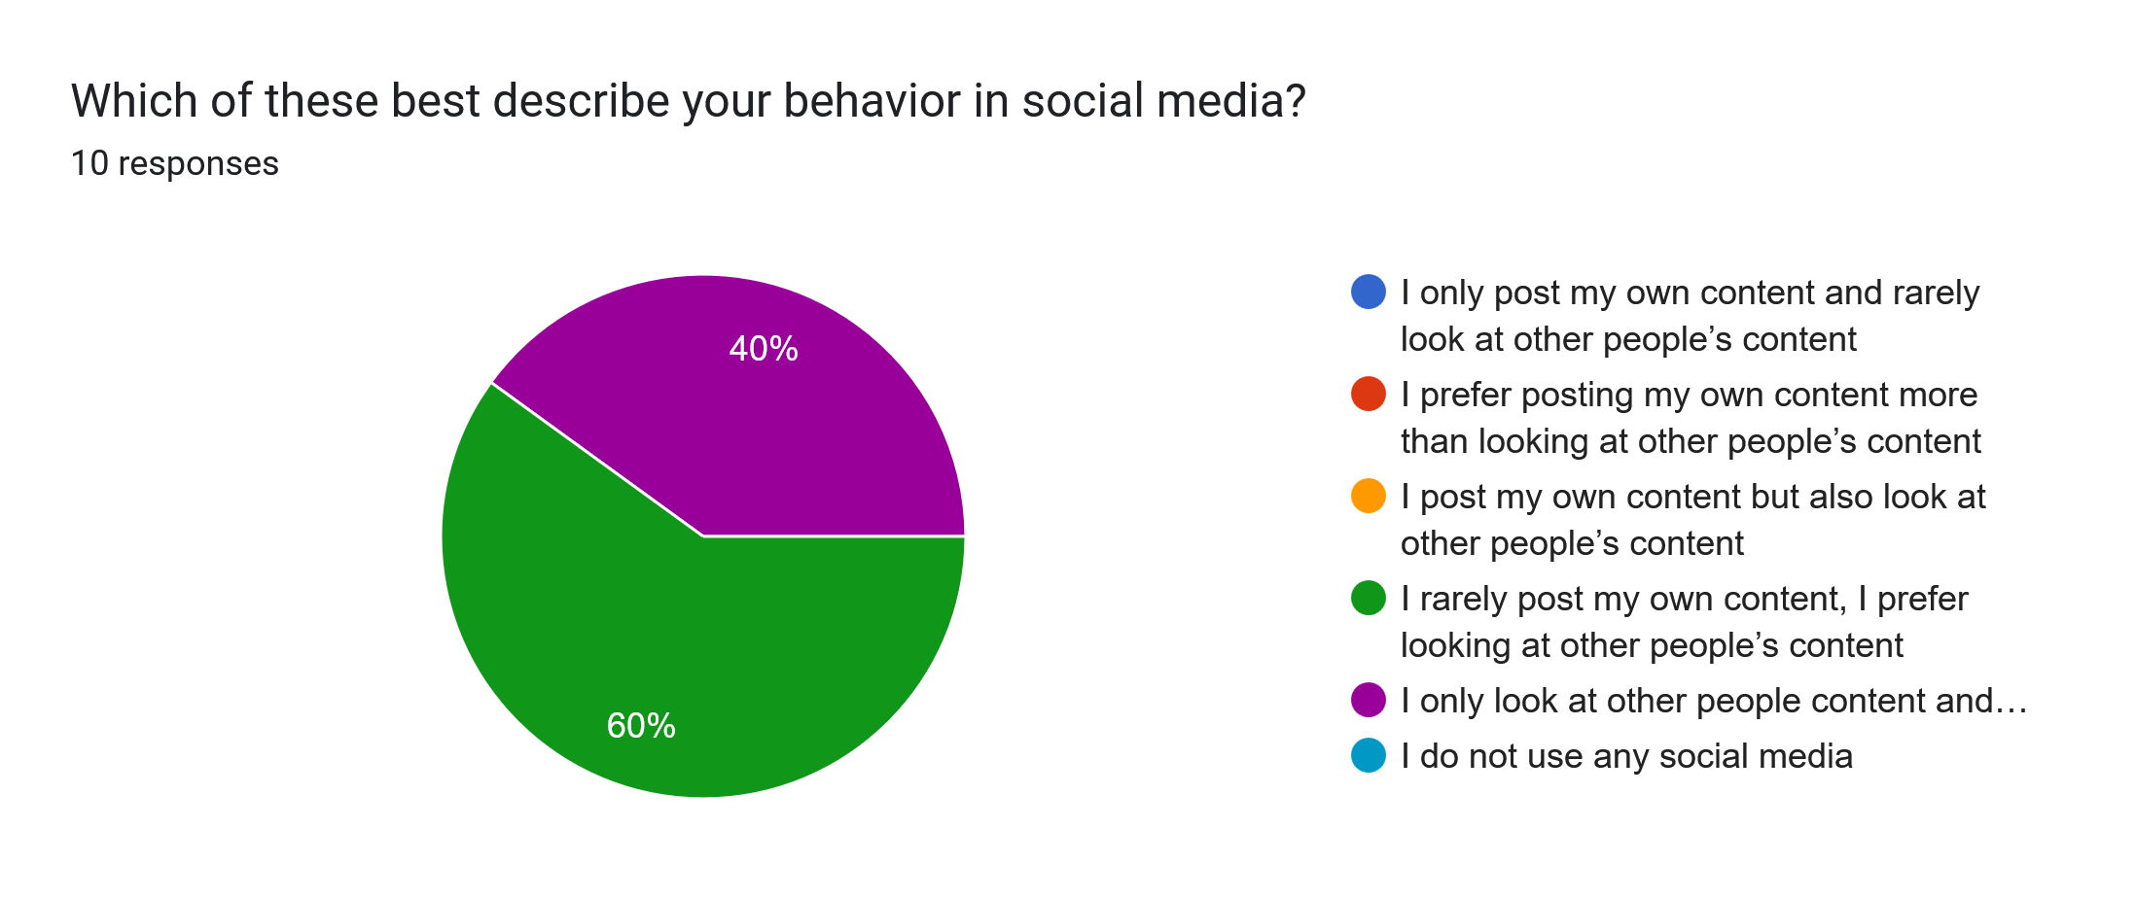
Using: Only Create Content = 5, Mostly Create Content = 4, Equal = 3, Rarely Create Content = 2, Never Create Content = 1, Don’t Use Social Media = 0
- Mean : 1.6
- Median : 2
- Mode : 2 (60%)
- Std Dev (σ) : 0.489

Most of our responders prefer looking at other people’s content instead of producing their own content in social media.

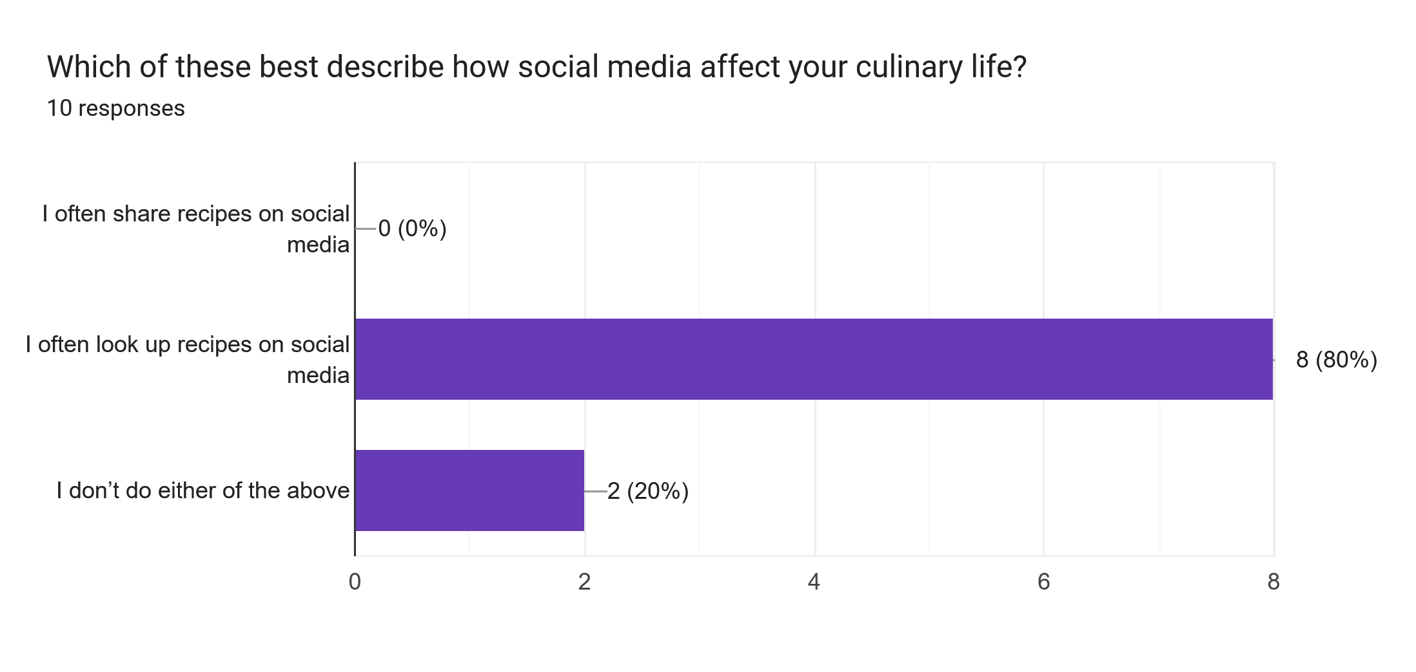
Most Common Answer: I often share recipes on social media (80%)

Most of our responders often looks up recipes on social media, though none of them share their own recipe which matches the social media behavior mentioned previously.

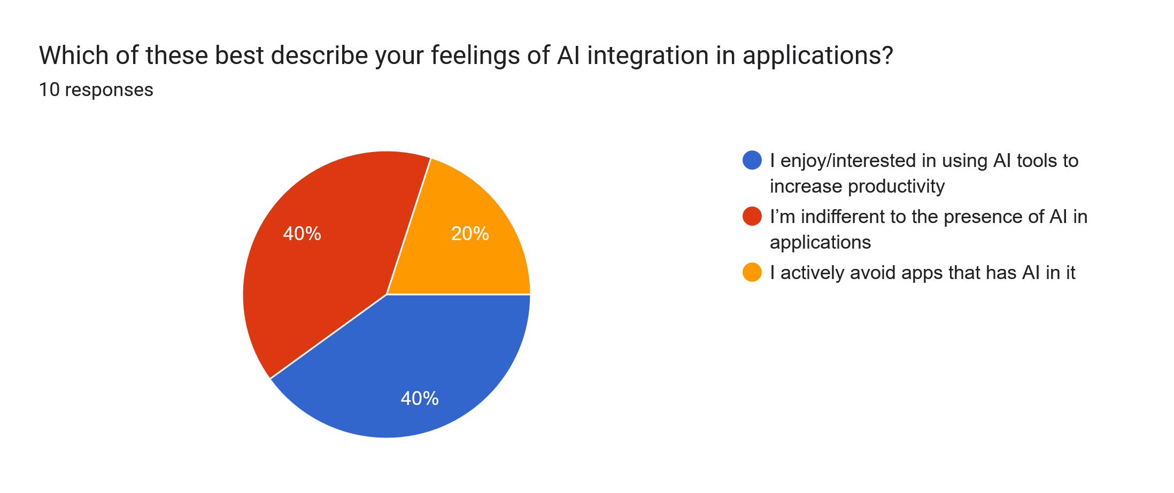
Using: Enjoy AI = 1, Indifferent to AI = 0, Avoid AI = -1
- Mean : 0.2
- Median : 0
- Mode : 0 and 1 (both 40%)
- Std Dev (σ) : 0.748

Most of our responders either enjoy AI or indifferent to them. Only a few of them avoids AI in apps.

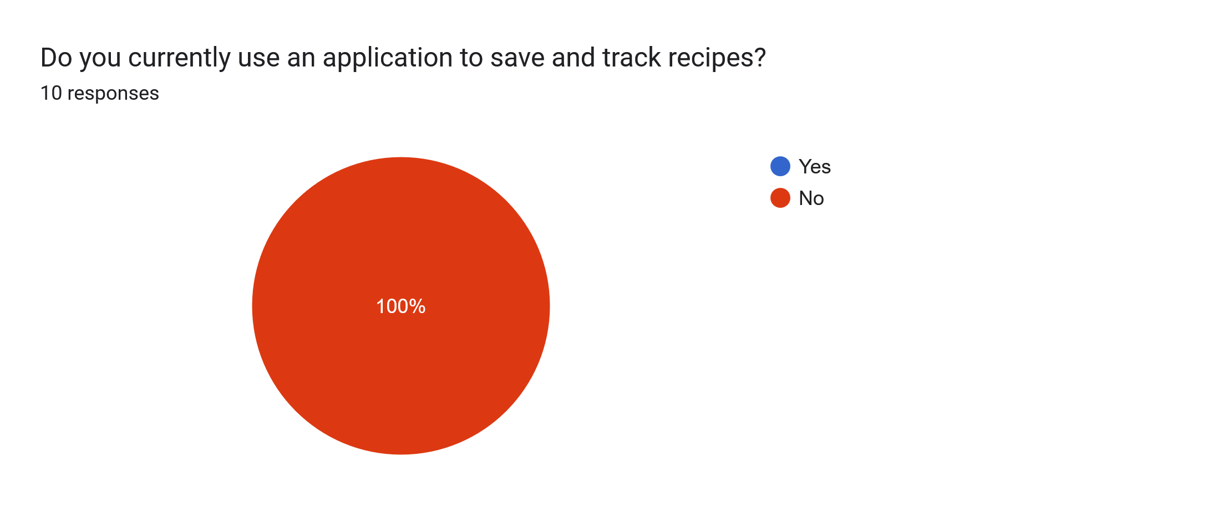
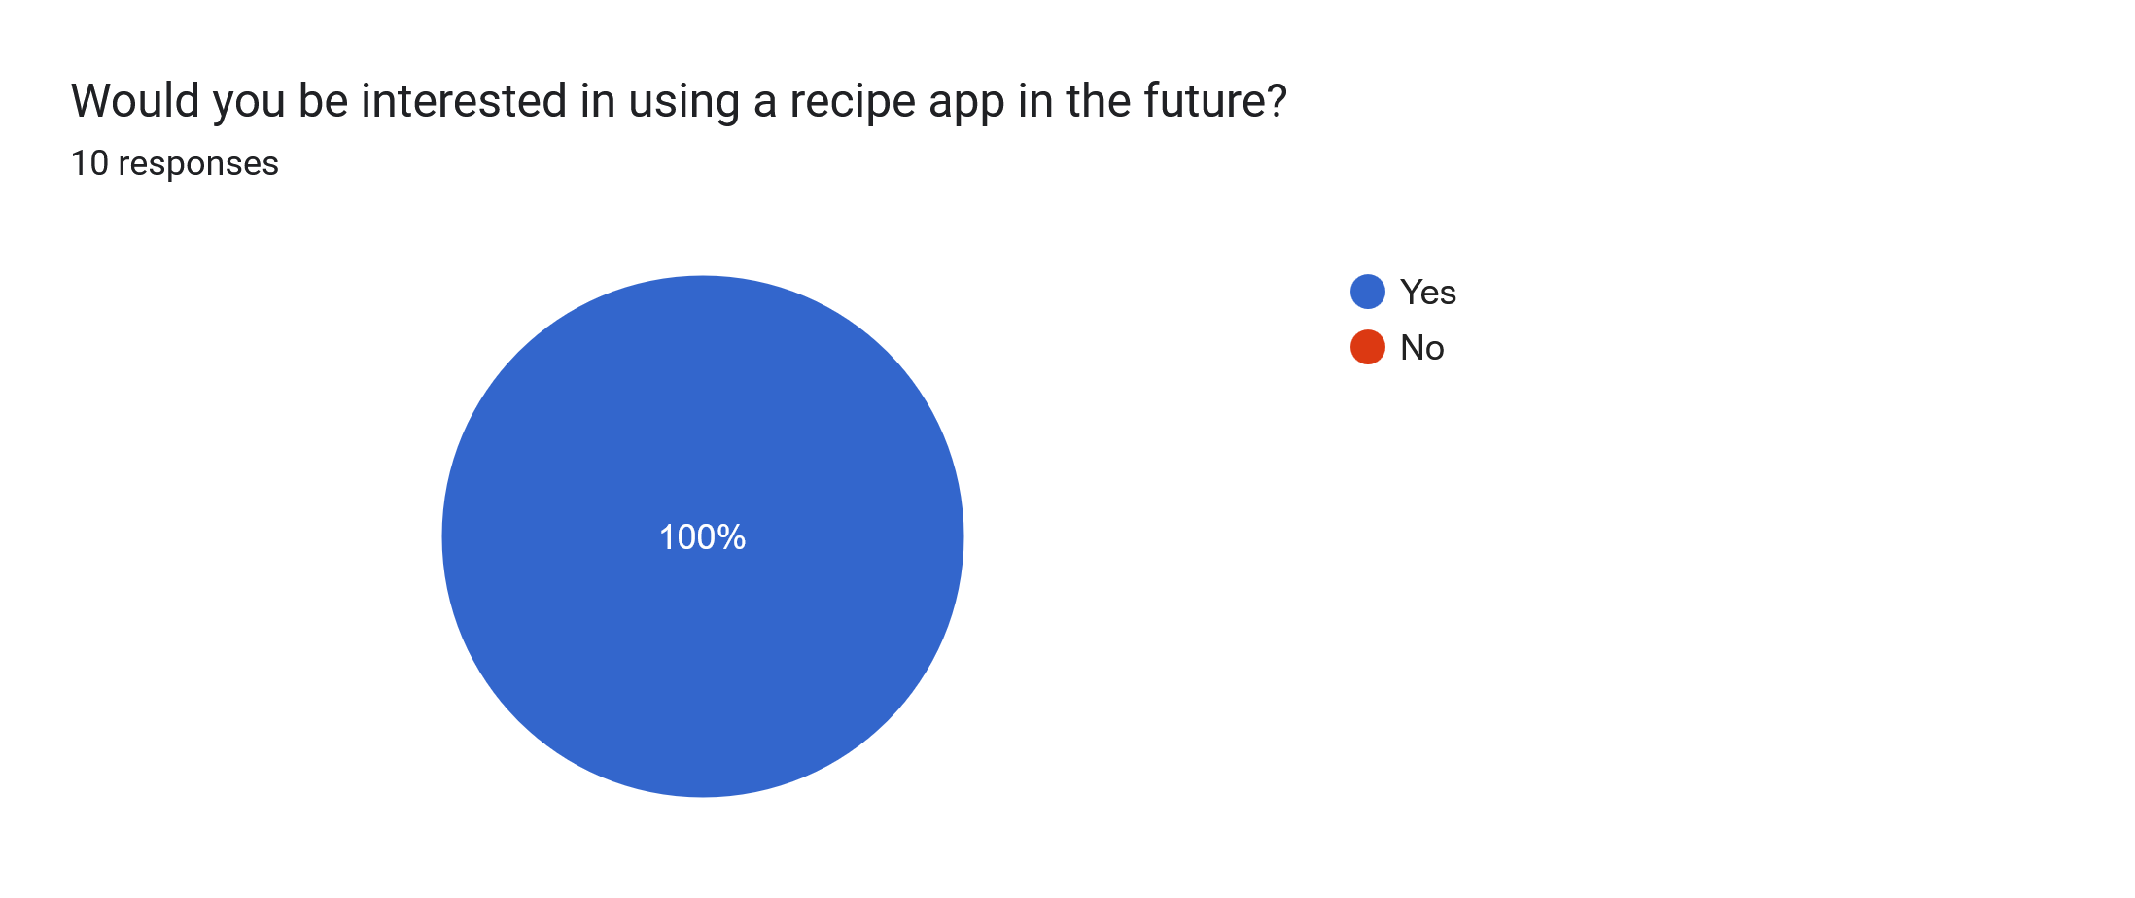
None of our responders are currently using a recipe app, which also means we didn’t get any survey results on the question of which recipe app is the most used. All of them are interested in using one in the future though.

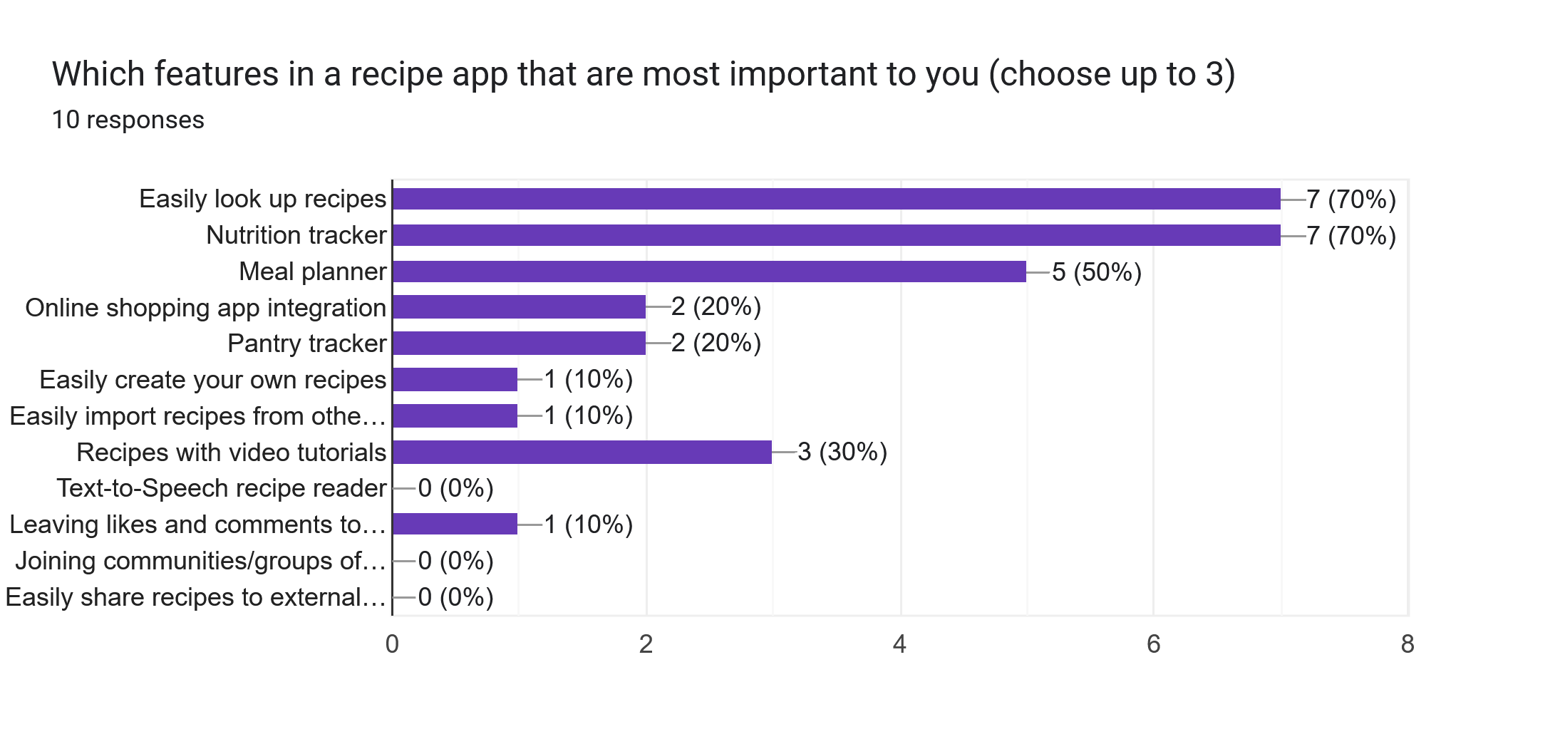
Highest Frequency:
- 1: Easily Look Up Recipes (70%)
- 2: Nutrition Tracker (70%)
- 3: Meal Planner (50%)
- 4: Recipes with Video Tutorials (30%)

The above bar chart shows which features are the most desired in a recipe app, which are recipe lookup, nutrition tracker, and meal planner. This matches the social media behaviour survey above where most of our respondents prefer consuming content instead of creating their own.

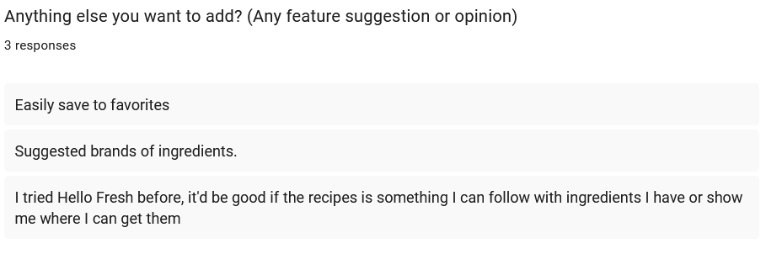
From our open ended questions, we got some more suggestions for features.

The first one, “easily save to favorites”, can be added to our app as it seems simple to add.

The second one, “suggested brands of ingredients”, might be more difficult to add as we’re not sure how would we rate each brand. Perhaps we can add a voting system where users can comment and vote on each brand? But that might cause a PR dispute against said brands so it’s something to consider.

The third one seems to want a ‘pantry tracker’ and ‘shopping cart’ feature which we’ll take into account for our app.

5e. Insights
- Overall most of the respondents fit the criteria of our target users, which are young adults who often cook for themselves. The fact that a lot of them doesn’t live alone might also suggest that they live in a decently sized household which suggests that they might have a decently well equipped kitchen so most of them are likely experienced cooks.
- The preferred social media of our respondents are YouTube and Instagram, so the content they seek seems to mainly be in the form of short to medium length videos. For the social media elements in our app we might condiser putting a bigger emphasis on video content (which incidentally will also be a novelty feature against the competing apps we reviewed in our market research)
- Our respondents are mainly content consumers, which is to be expected as content consumers are more prevalent than content creators. This means that at least at the very start of our app’s lifetime we won’t be seeing much content (recipes) created by users. Thus, our app would either need a pre-made list of recipes as a buffer, or integrate with a pre-existing social media to import content from there (or both).
- Most of our respondents are either indifferent or excited about AI so we shouldn’t shy about proudly showcasing any AI features in our app.
- None of our respondents are using a recipe app but are interested in using them in the future. Though we didn’t get any insight about which competitor is popular from this survey, this is a nice confirmation that there is still spot in the marketplace for our app.
- For the most desired features, one of them is “easily look up recipes”. In hindsight this probably shouldn’t be included as an option as this is the core feature of our app. But it does confirm once again that our users mainly desire to consume content instead of creating their own.
- Other popular requests are nutrition tracker, meal planner, and video tutorials. Video tutorials in particular reinforces that our users seek content in a video format.
- The open ended questions also yields some other requested requirements that we’ll add to our list of requirements, but perhaps as a “tertiary/bonus” requirement that we’ll implement if we have left over resources after the other requirements are met.

6. Requirements Generation

6a. Personas

Persona 1 : John
- Age 35 male
- Office worker
- Not normally an active person but recently started to work out
- Often eats fast food because he felt cooking is way to time consuming
- Recently found out that his cholesterol levels are high
- Want to start cooking for himself for health reasons

- John recently downloaded a recipe app to learn how to cook
- Because he usually eats at fast food restaurants, he’s not used to spending a lot of time to cook so he looks up recipes that’s easy and fast to prepare
- The recipe app gives him a list of recipes, and he sorts them based on nutrition values, prioritizing high protein food for his workouts
- He eventually settled on a chicken breast recipe that seems simple to prepare
- He wants to compliment the meal with vegetables, so he also asks the app to look up vegetable recipes that would complement this meal both flavour-wise and nutrition-wise
- He found a spinach recipe that he thinks he’ll like and adds that to his menu
- He then views the ingredient list and adds any ingredient he doesn’t own to a shopping cart, and then uses the app to order them online to be delivered
- He then prepares the meal using the app to guide him on how to cook it, the app uses text to speech to tell him the instructions and also providing a timer whenever needed
- Afterwards he uses the app to rate the meal based on how much he liked the flavours
- He repeats this process for several days, trying out a different meal each day and the app gradually learns the type of meals he likes based on his search specifications and rating
- Eventually he stops using the search function as the app has learnt his preferences and has started to recommend recipes that matches his preferences in the home page.
- From here onwards John mostly doom scrolls the home page and would often quickly find a recipe that he’d like

Persona 2 : Jean
- 55 years old female
- Housewife
- Lives with her husband, children have recently graduated high school and moved out
- Used to cook nutritious meals for her children, does it less often nowadays
- Often browses social media to learn new recipes
- Interested in finding friends of likeminded hobbies

- Jean opens the recipe app and checks out the home page for the trending recipes.
- She saves any ones she’s interested in to a “try later” list before going to the community tab where she had joined a group filled with people with similar food preferences
- She checks out the meals that other people had cooked and saves any recipe she thinks she’ll like
- The app then notifies her that a friend of her is planning to cook a difficult recipe and is looking for someone to help her cook
- She agrees and the app notifies her friend and sets up a chat between them
- After arranging the schedule, they agree to meet up on a later date. The app orders the ingredients and splits the bill between the two
- The app also suggests food that might compliment the meal, though they decided against it
- On the agreed day, they cooked the meal together. They also decided to record their cooking experience which the app automatically helps edit the video.
- They uploaded the video to their community group with the app marking the video as a group effort

Persona 3 : Jane
- 20 years old female
- College student, also works as a dishwasher part time
- Lives in a shared apartment with 2 roommates
- Mostly cooks for herself or sometimes cooks with her roommates

- Jane just came home from the supermarket, she has bought some ground beef and beansprouts.
- She wanted to cook something with it, so she takes out her recipe app and takes a picture of her groceries.
- The app then adds her groceries to her pantry which contains ingredients she previously added and currently owns.
- She then asks the app to looks up recipes that can be made with the ingredients in her pantry, specifying that she wants one with the ground beef as the main ingredient.
- She doesn’t find any recipe that she desires so she asks the app to also look up for recipes that are only missing 1-2 ingredients.
- She then sorts the recipes by the price, the app only takes account the price of the ingredients that she’s missing
- She finds a recipe she favours and the apps gave her an option to order the missing ingredients online
- She however refuses and asks the app to show all nearby shops that has the ingredients. The app then shows the list of nearby shops while also showing their prices and branding.
- She then goes and buys them and have the app added them to the pantry too
- Afterwards she decided to also cook for her roommates and asks the app to adjust the ingredient amount to fit a meal for three. The app adjusts the recipe accordingly.
- Jane cooks the meal and eats it with her roommates, of which one of them enjoys it so much that she asks for the recipe. Jane uses the app to share the recipe with her.

Persona 4 : Johnny
- 44 years old male
- Lives with his family of four
- Head chef of an Italian restaurant for 10 years, has cooking experience of 30 years
- Doesn’t use social media but recently his daughter has been checking out recipes from social media and recommended him to try sharing his recipes too

- Johnny downloads the app and registers an account. The app asks what he intends to achieve to with the app and Johnny specifies that he’s more interested in sharing his own recipes than looking at other’s recipes.
- The app then guides him to create his first recipe, he decides to try create a simple spaghetti recipe
- The app asks him for an ingredient list and he verbally says the ingredients which the app parses using the speech-to-text interpreter.
- The app then does the same for the instructions. However, some of his instructions were vague and the app asks for more details for the steps.
- The app asks Johnny to add tags to his recipe, and recommends some tags based on the title, ingredients, and instructions such as “Italian” and “simple”
- The app then suggests Johnny to record a video of him cooking the recipe which helps make the recipe looks more professional. Johnny then sets up the phone to record himself cooking said recipe.
- The app then automatically edits the video for Johnny, segmenting the video to match each step of the instruction, cutting off parts that it deems unimportant, and fast-forwards each step to make it concise.
- The app also notices that Johnny has added salt to the recipe in the video and notifies him that he forgot to add salt to the ingredient list. Johnny then asks the app to add it to the ingredient list.
- Johnny then views the recipe that he has created assisted with the app and after he was satisfied, he posts it.
- Afterwards the app suggests that Johnny complete his profile. As he intends to post recipes, the app recommends that Johnny should specify his cooking experience or any cooking-related jobs to help convince people to try his recipe, which he does.
- The recipe got some traction which made Johnny happy, he then started sharing more recipes.

6b. Requirements Generation

Individual Persona Analysis
John | Jean | Jane | Johnny
- Adult male  - Office worker  - Lazy  - Unhealthy food choices  - Not physically active  - Inexperienced at cooking  - Likely doesn’t have many kitchen utensils or utilities apart from the bare minimums  - Recently started to be aware of his health issues  - Recently started working out  - Want to improve his lifestyle and health  - Doesn’t challenge himself  - Open to change but does it slowly | - Older Female  - Stay-at-home Housewife  - Lonely  - Bored (children recently moved out, might suddenly feel like she has too much free time)  - Plenty of cooking experience in a household setting  - Sociable  - Looking for friends  - Loves sharing | - Young female  - College student  - Works a part time job  - Lives with 2 roommates  - Budget minded  - Picky eater  - Not Lazy  - Attention to detail  - Gets along with her roommates  - Generous (shares her food) | - Middle aged family man  - Head chef, 30 years of cooking experience  - Skilled  - Has a well-equipped kitchen  - Doesn’t use social media  - Interested in sharing cooking knowledge  - Meticulous  - Gives vague instructions (maybe isn’t used to viewing cooking from a non-chef perspective)  - Isn’t used to technology (reliant on the app to do the heavy work)  - Open to suggestions  - Not stubborn  - Enjoys positive feedback

6c. Master List of Requirements
- Login/Registration
- Goals: do they want to look up recipes, or share recipes
- Personalization: App gradually learns user food preferences through history, recommend complimentary dishes to meals
- Home Screen: Display trending recipes, recipes that fits user preferences, doomscrolling
- Filtering / Sorting: Based on price, nutrition, tags (e.g. Italian), main ingredient, allergies, skill level requirement, necessary kitchen tools/utensils, look for dishes that compliment another dish
- Social Media Aspects: posts, communities, friend groups, cooking collaborations, recipe sharing, experience sharing (share cooking experience or food photos), perhaps connect experienced cooks with users who are interested in learning, sharing with external social media (and vice-versa: import content from external social media)
- Input: written, speech-to-text, image-to-text, app provides suggestions
- Nutrition Tracker: Keep track of food nutrition, image analysis of nutrition labels, allow keeping track of nutrition from external food (made without the app), alert users if nutrition goals aren’t met, track history of health metrics (e.g. weight, blood pressure, cholesterol level, blood sugar), suggest dietary improvement based on health and nutrition
- Pantry: keep track of food owned, keep track of quantity and expiration dates
- Shopping List: allow ordering ingredients in app (or integrate external shopping app), allow searching for nearby shops that has ingredients
- Video Editing: for recipes or for social media post, app assisted video editing
- Kitchen Assistant: Meal size adjustment (ingredient quantity dynamically adjusts), text-to-speech assistant (with speech-to-text input), timers that match recipe needs, audiovisual tutorials, recommend complimentary additions, integration with smart cooking devices, suggest replacement ingredients if missing or an ingredient need to be avoided e.g. because allergy
- Notifications: give suggestions when users creating a meal, notify users if someone liked their created content

7. Synthesis of Requirements Gathering and Generation

7a. Must Haves (Core App Features)
- Advanced Recipe Lookup: filter/sort by category, price, nutrition, main ingredient, skill level, required tools, or based on other dishes (look for complimentary dishes)
- Recipe Display: show meal size, ingredients (adjusts based on meal size), step-by-step preparation
- Recipe List: show list of trending recipes on home page. Allow saving recipes to cookbooks or favorites list.
- Recipe Creator: create recipes by hand, or import recipes from other sources (other social medias)
- Social Media Aspects: recipes are depicted as social media posts, with the recipe creator leaving a short comment on the recipe and other users able to leave feedback on the recipe (likes and comments)
- Nutrition Tracker: track nutrition intake, track other health metrics: weight, blood pressure, blood sugar, etc..., allow users to add their own categories/metrics
- Meal Planner: allow planning of meals, integrate with calendar apps, track nutrition of meals for the nutrition tracker
- Other Core Features: user account (register/login), syncing between devices, pre-made recipe list as a buffer when the app launches (to avoid lack of content before users start posting their own recipes)

7b. Should Haves (Dealbreakers)
- Accessibility: speech-to-text input, image-to-text input
- Video Media: for both consumers and creators, put emphasis on video elements. For consumers: prioritize video content, posts show small preview of video, recipes have video tutorials. For creators: AI assisted video editing to help integrate video element to created content.
- Pantry Tracker: Keep track of owned ingredients: what brand they are, what nutrition content they have, their quantity, their expiration date. Allow user to seek recipes that can be made using existing ingredients. Allow image-to-text input.
- Advanced Nutrition Tracker: allow users to use image-to-text to parse nutrition of ingredients by picture, show exact nutrition values if users take a picture of the ingredient’s branding or nutrition label, have prebuilt online-accessible database of nutrition estimates for food without nutrition labels
- Shopping List and Cart: keep track of want-to-buy ingredients. Allow automatically add ingredients needed for a recipe or meal (excluding ingredients already in the pantry). Allow users to find nearby stores that contain ingredients in the shopping list. Add online shopping integration (could just integrate an external app for this).

7c. Could Haves (Novelty Features)
- Personalization: recipes featured on home screen slowly adapts to user preferences based on history
- Notifications: alert user if nutrition goals are at risk of not being met (suggest dietary improvements), alert users if certain core pantry ingredients (e.g. salt and pepper) are running out, alert users if people like their recipes
- Kitchen Assistant: AI assistant to help recipe preparation. Text-to-speech instructions, can receive instructions with speech-to-text, provide timers if necessary or if asked
- Customization: Allow users to customize app features, e.g. to disable AI assistant for users who dislike AI

7d. Want to Haves (Additional Features)
- Brand Voting: Allow users to leave reviews of certain brands of food, so that other users can evaluate the quality of a brand
- Collaborations: Allow user to seek out other users who want to cook the same food together
- Communities: Allow creation of social media groups or communities for users with similar food preferences to share recipes with each-other.

8. Design

8a. Design Patterns
We kept my design simple and mostly used existing design patterns from the Android Material 3 Theme asset pack. Said asset pack has design patterns common amongst android apps so we decided to keep it to ease user experience as it shouldn’t be too different from other android apps.
We made most of the important screens navigatable from the top and bottom app bars so that users never feel like they have to perform more than 1-2 clicks to reach a screen they desire.
We mainly used existing icons from the Material 3 Asset pack to avoid making user relearn icons that are already familiar to them. But we still made custom icons when there are no preset icons that suit said functionality. We also ended up adding labels to most icons to better clarify their functionality.
For our primary colors, we decided upon green. We were contemplating between red (to represent meat) and green (to represent vegetables) and we decided green is better as green is also associated with nature and plants and thus give a sense of “freshness” to our app which would be suitable for cooking.

8b. Figma Workflow
We worked on the prototype on Figma on a daily basis, trying to work at least 1 hour each day. We started by creating the “base” model of each screen to map out their navigation. Then we created simulated functionality for some of the screens that we felt needed interactivity.
We first tried to developed a prototype with fully simulated functionality. But after realizing that it would cause the development to exceed the deadline more than it already did, we decided to cut that and leave some of the “less important” screens as simply static screens. We also ended up deprecating the “new account” simulation and just assume all users are returning users due to time constraints.

8c. Screenshot of All Screens

Splash Screen
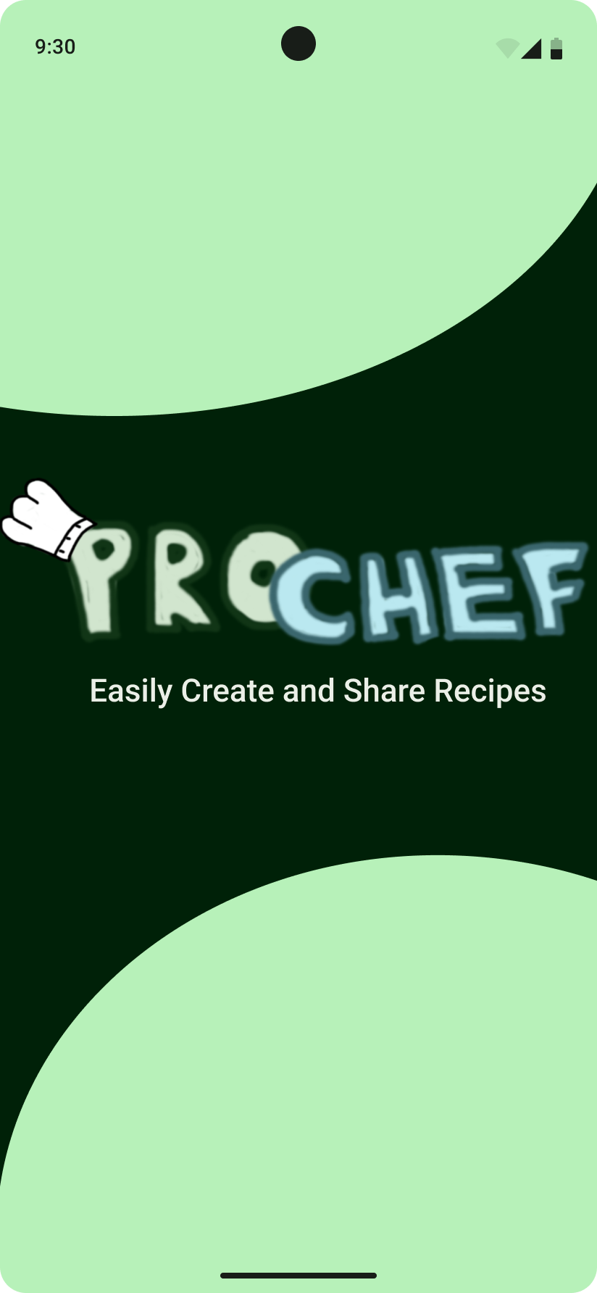

Login and Registration Screen
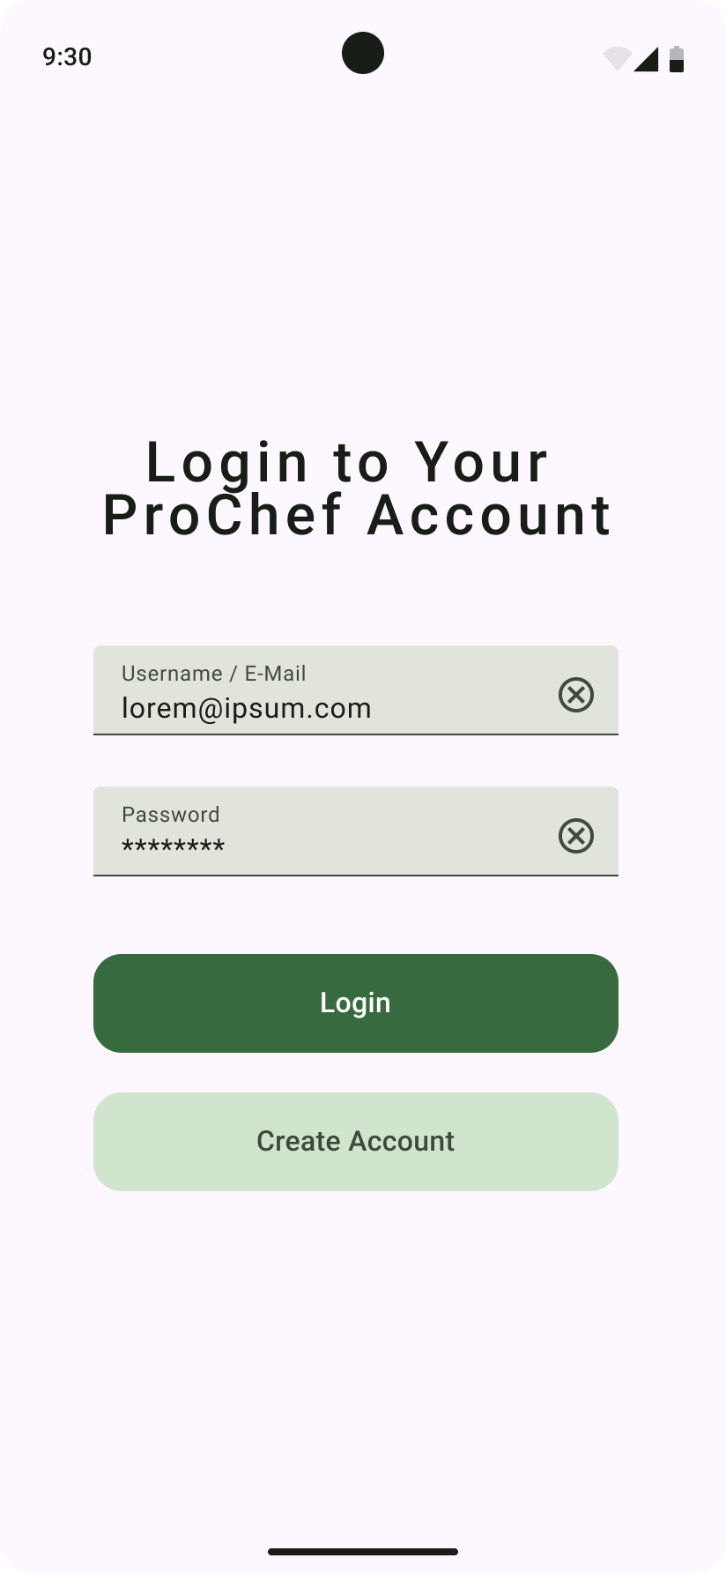
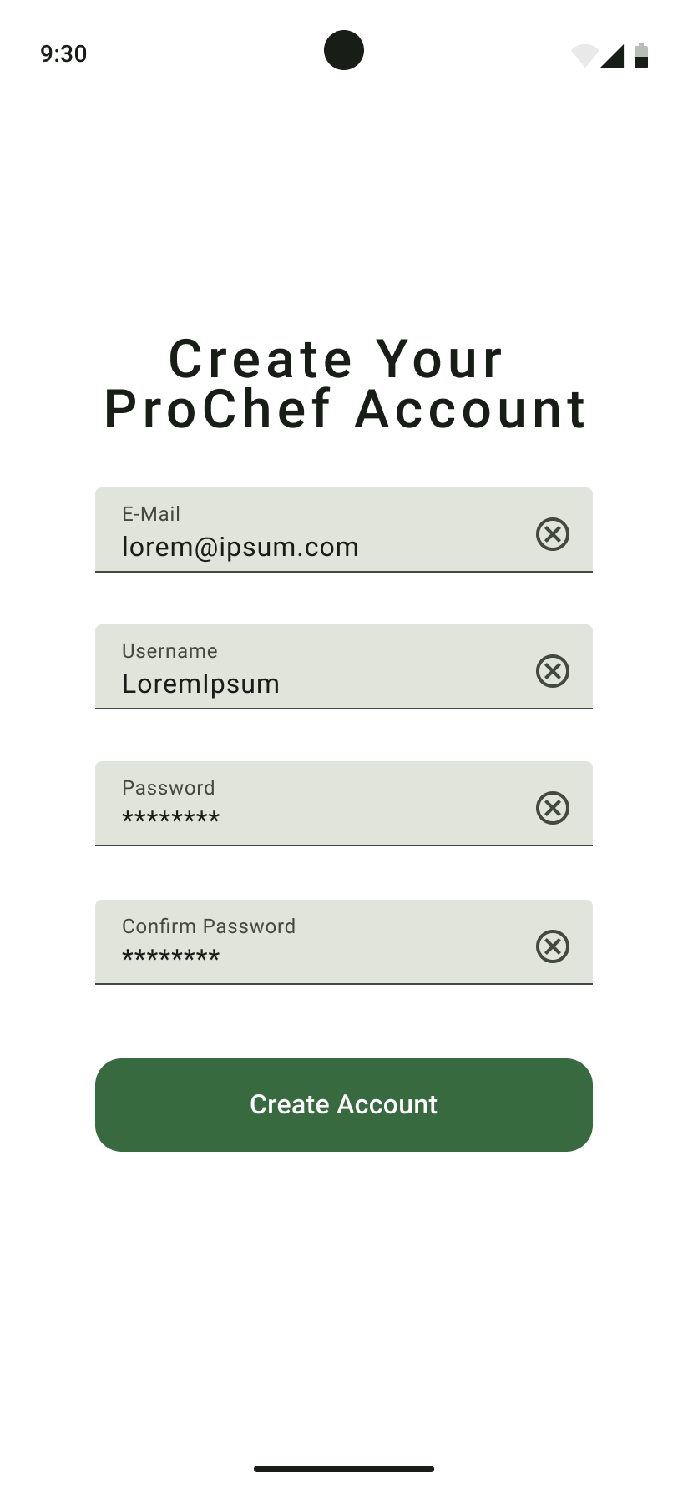

Home Screen
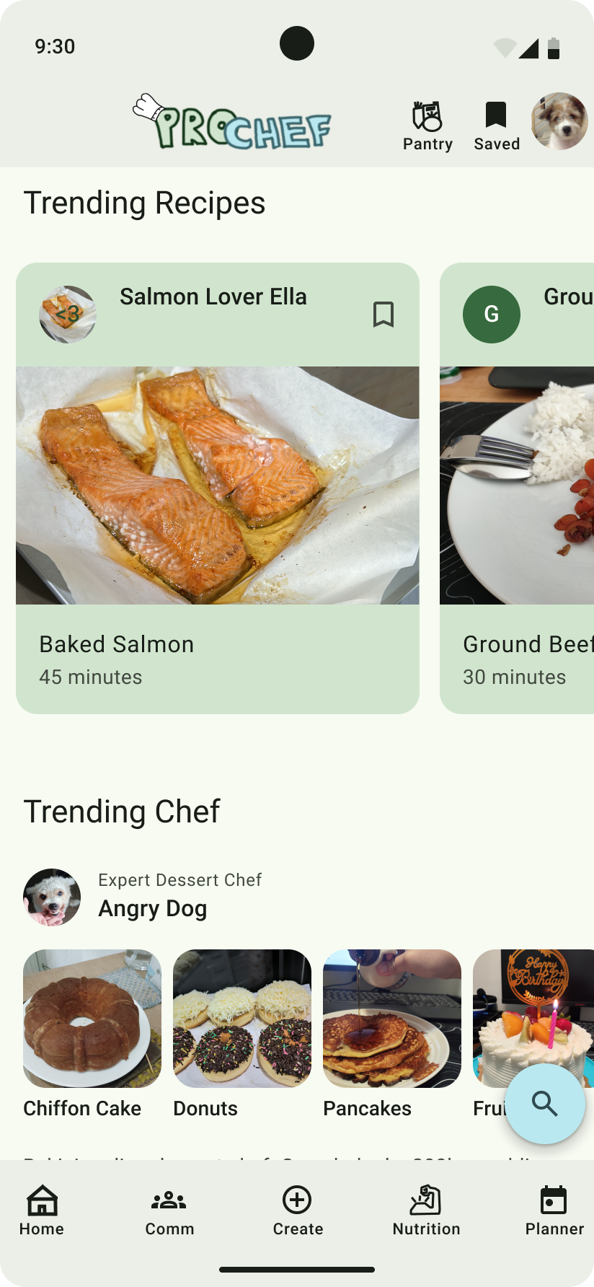
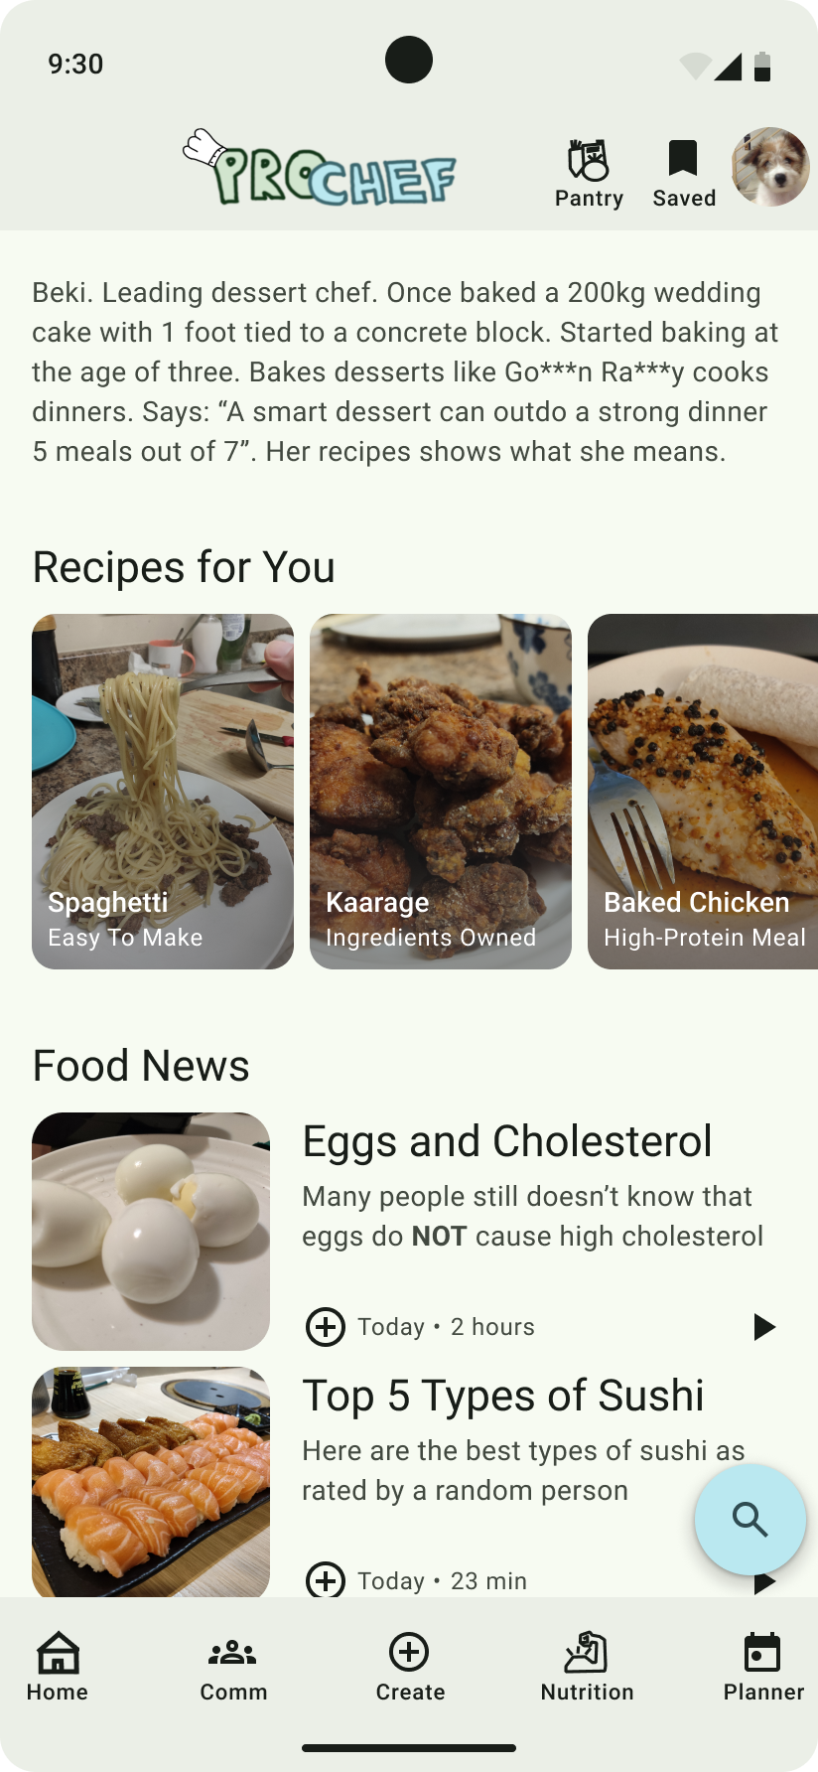

Recipe Screen
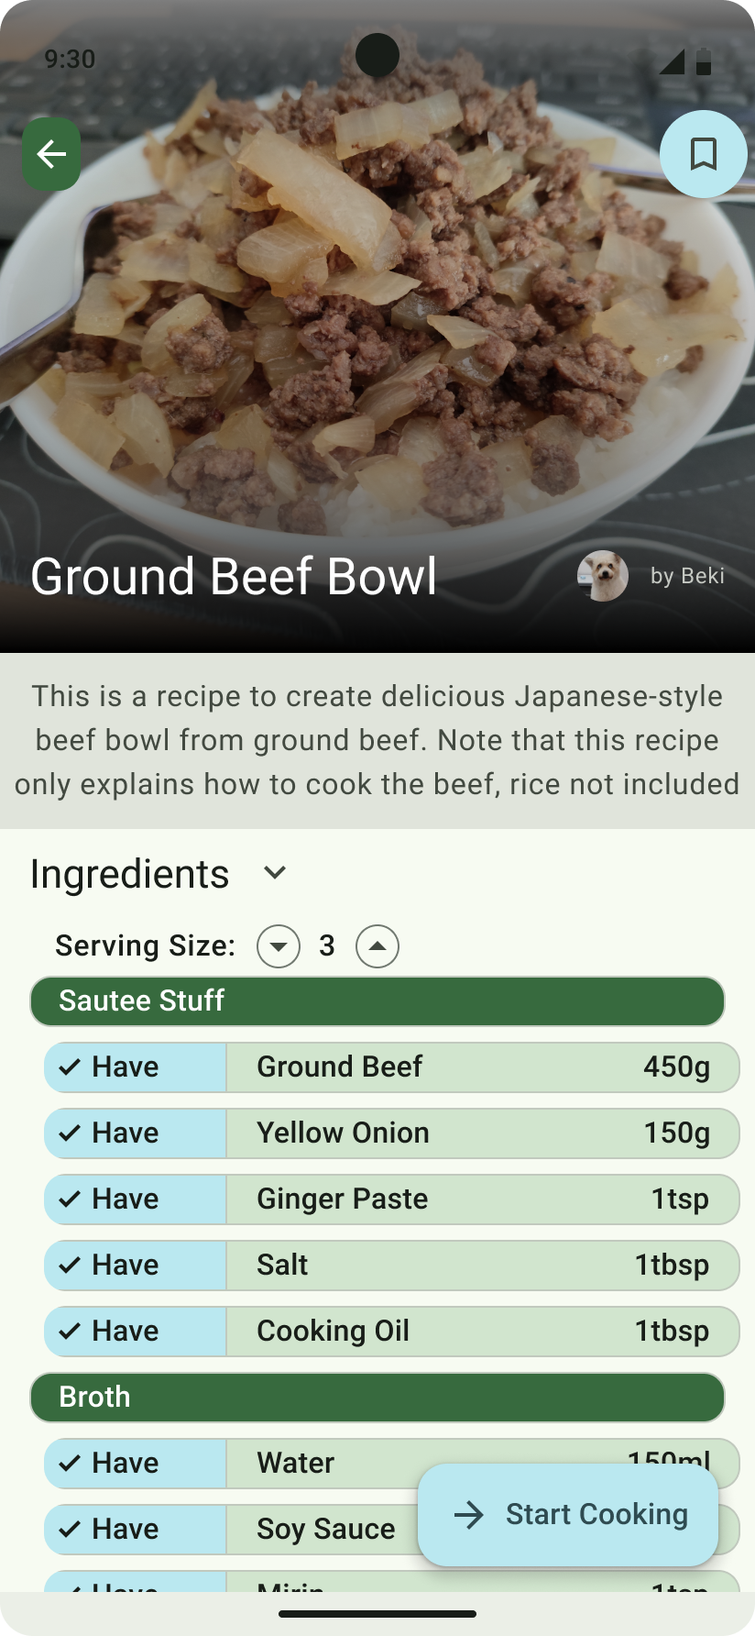
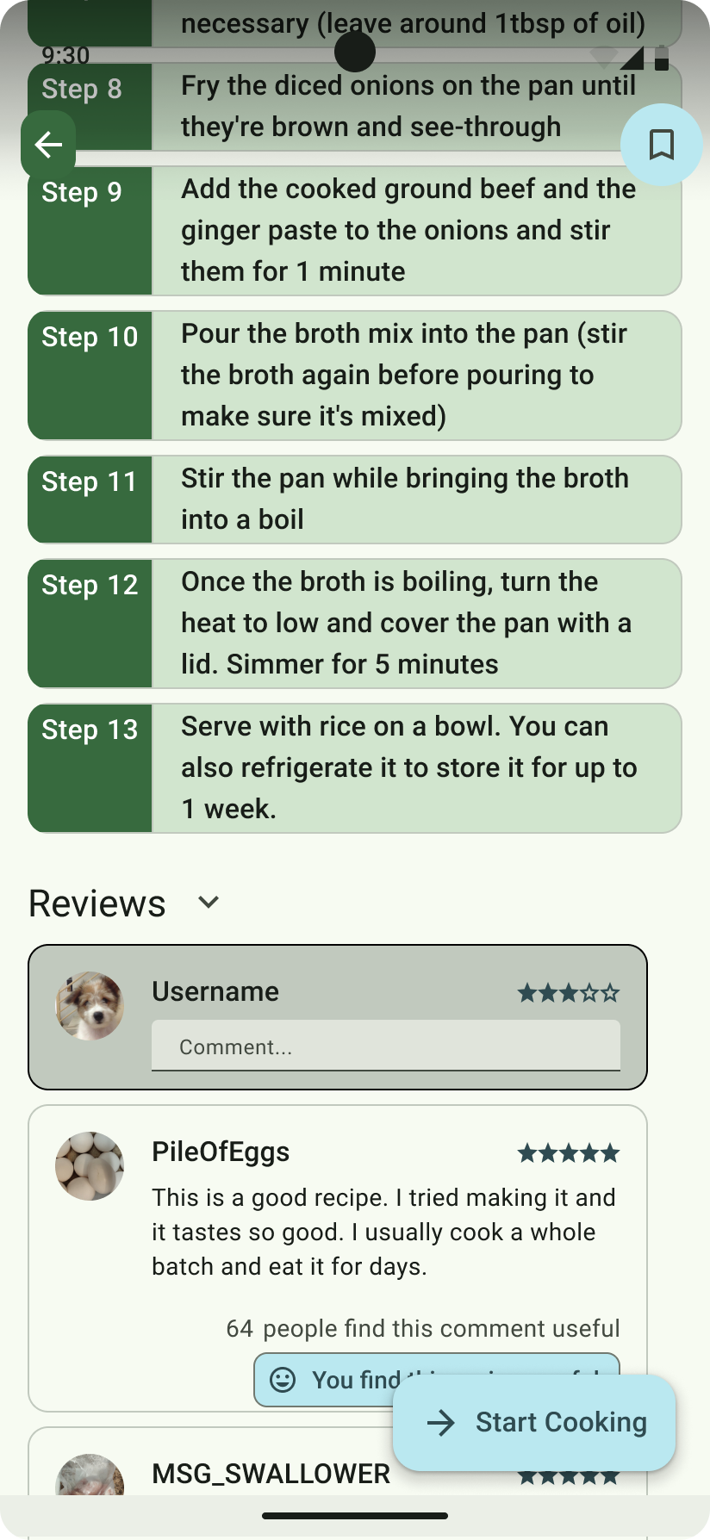

Step-by-Step Cooking Screen
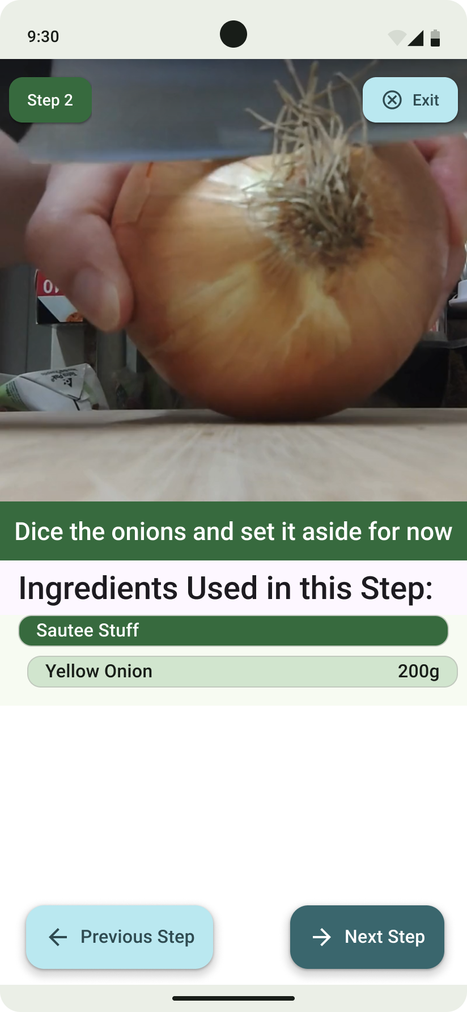
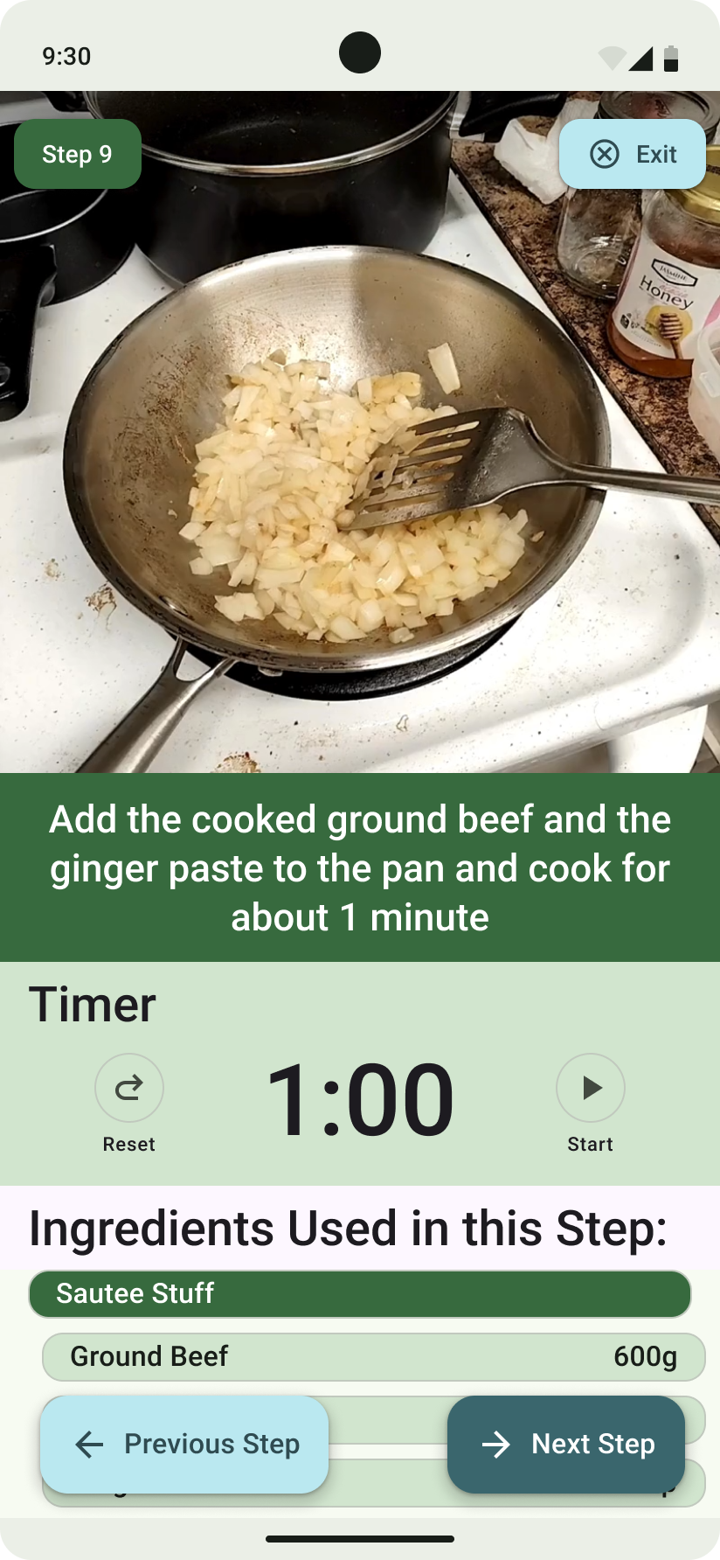

Search Screen
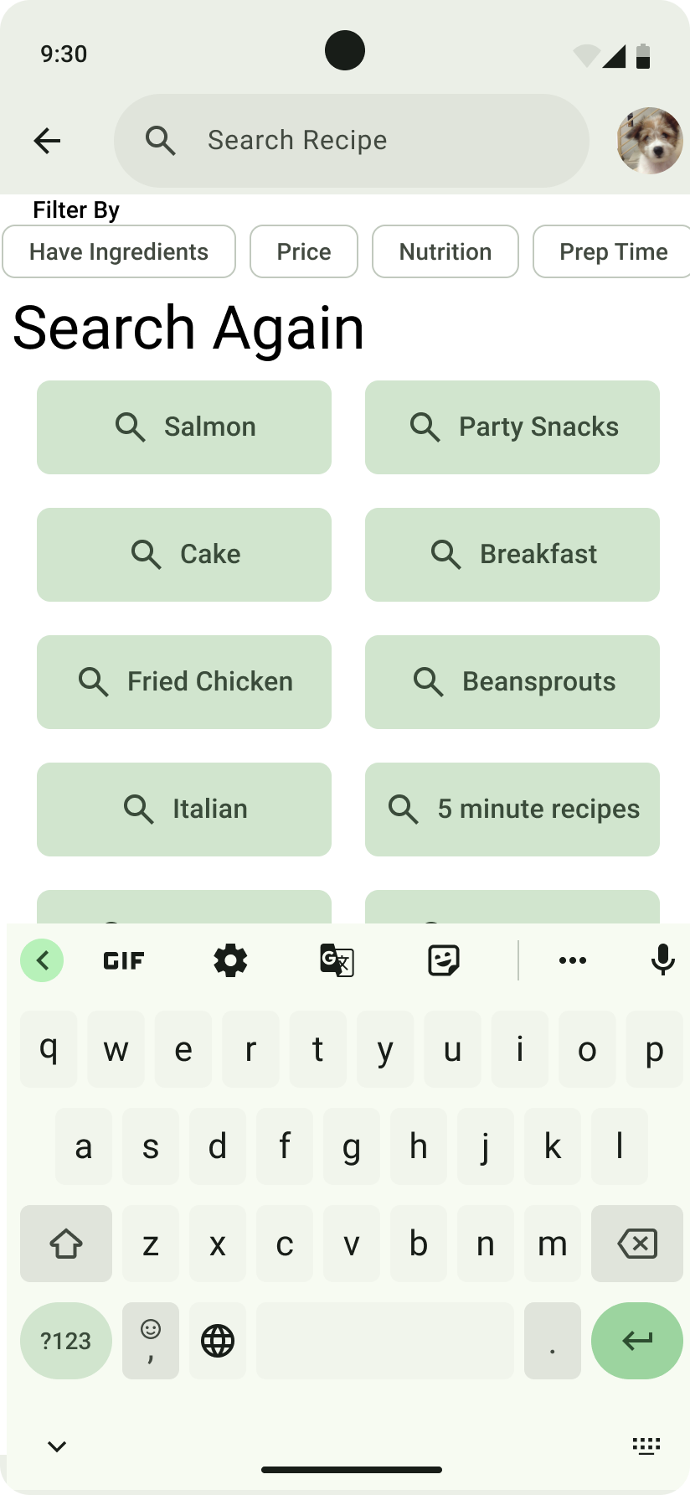
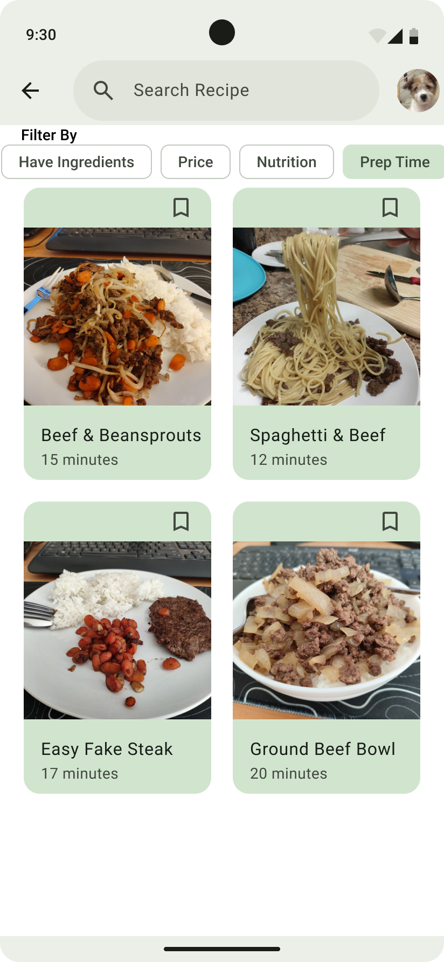

Community Screen
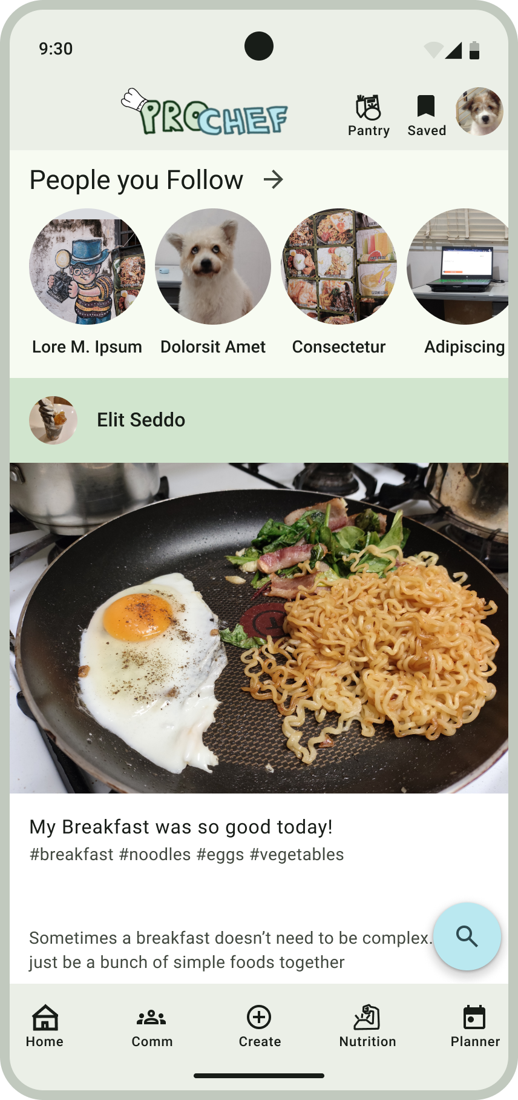
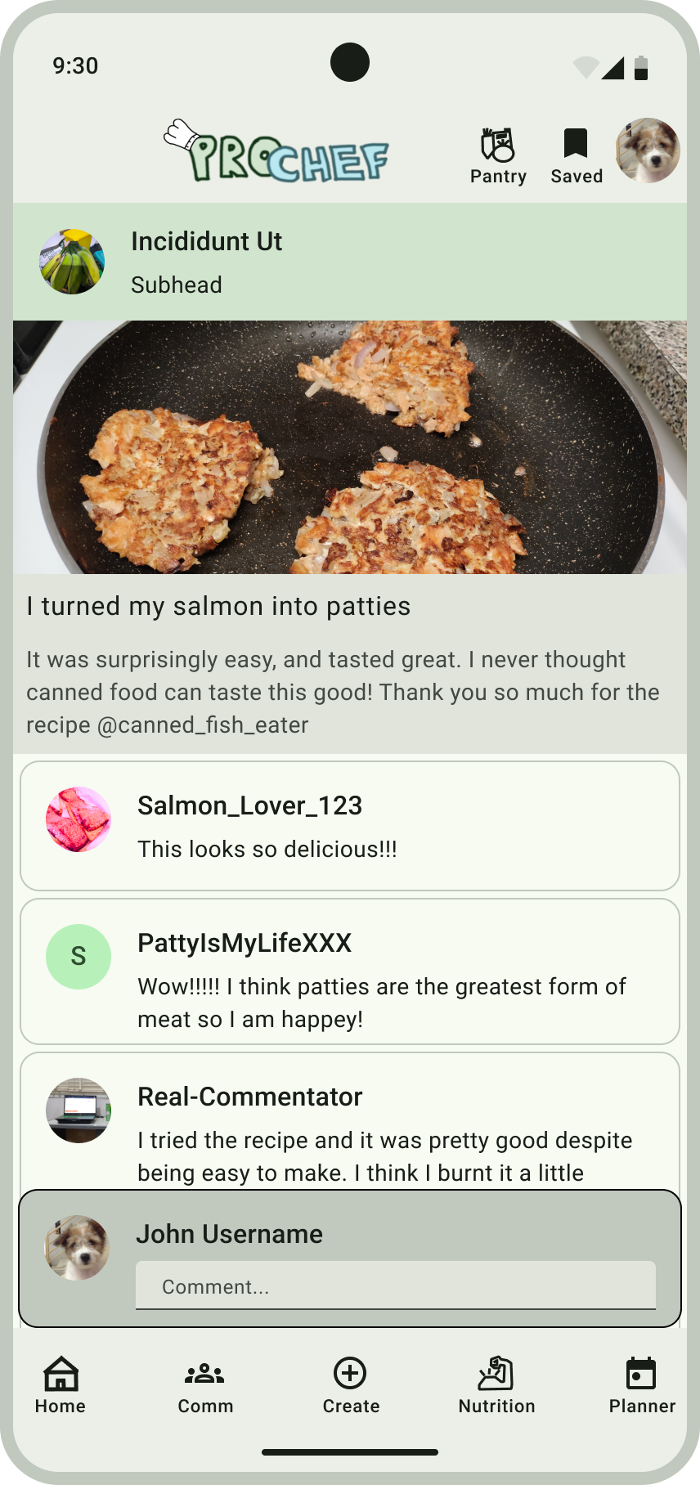

Add Recipe Screen
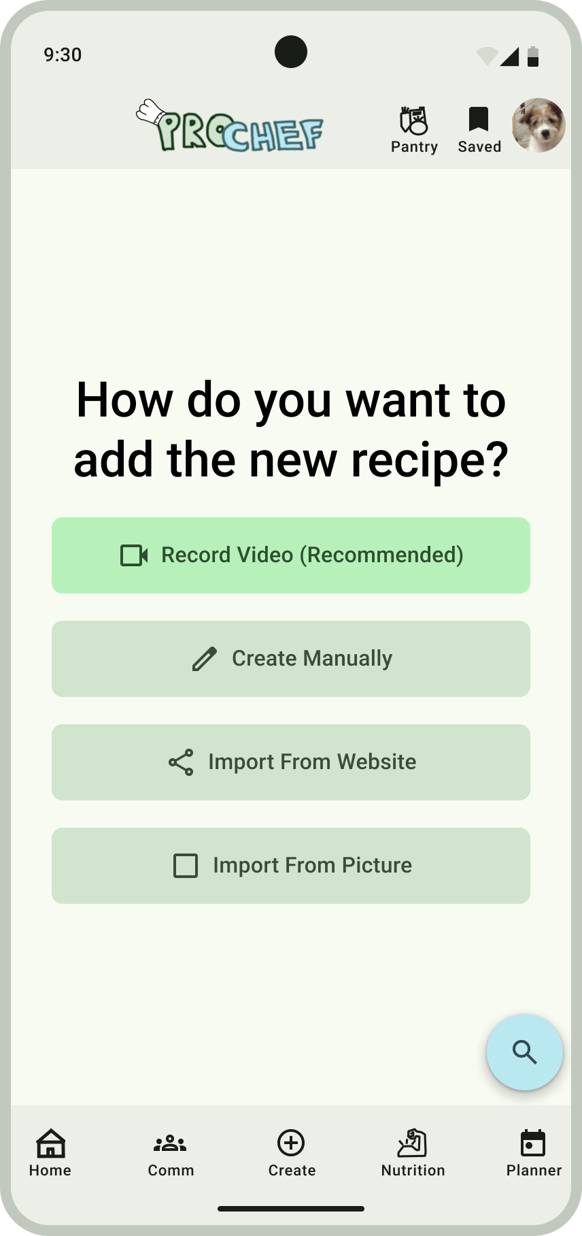

Nutrition & Meals Screen
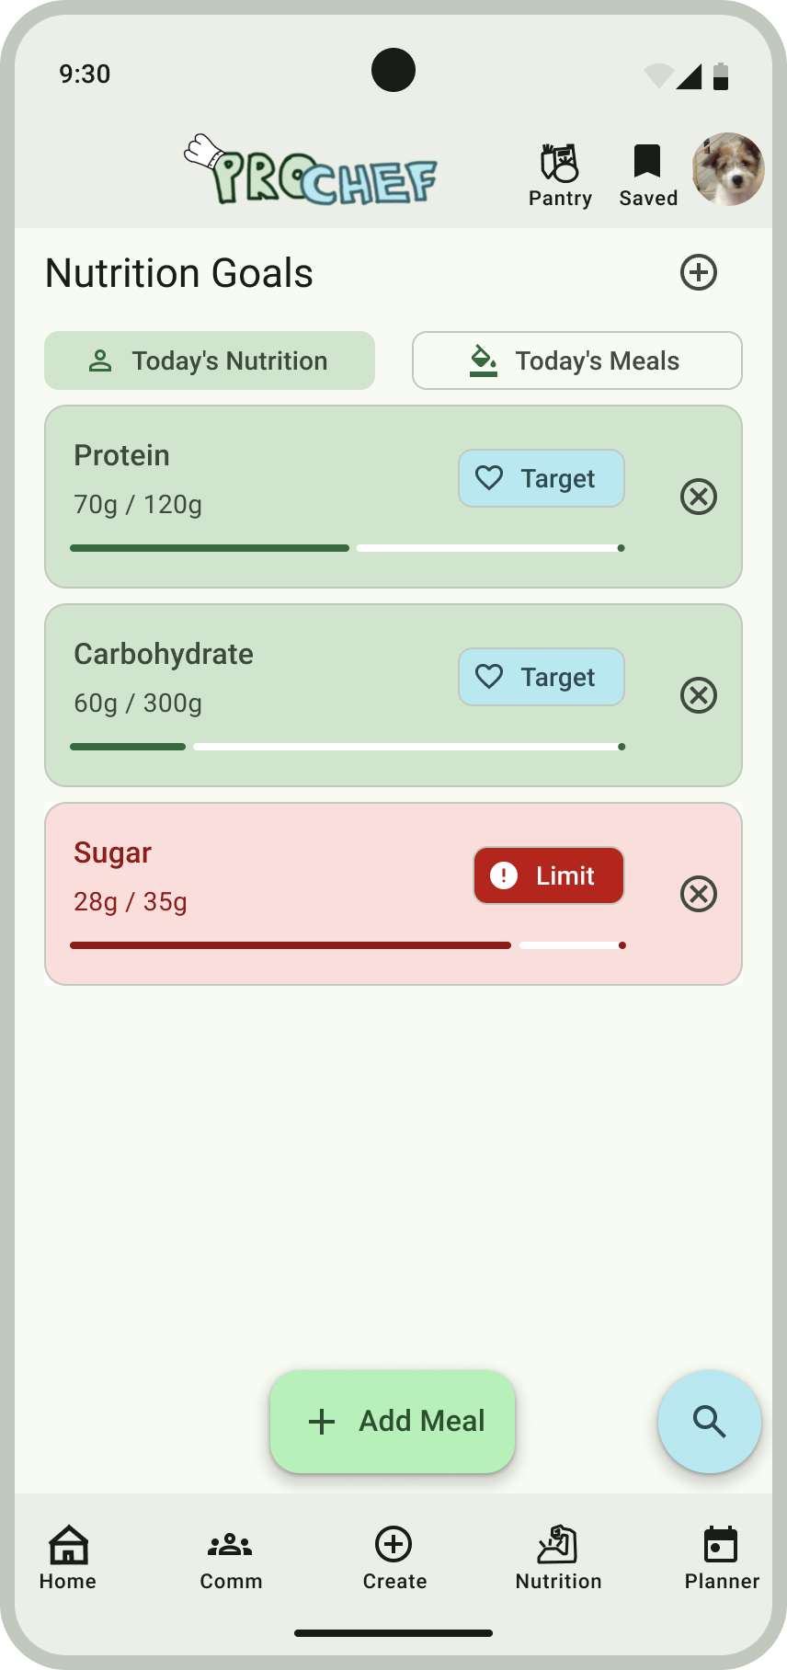
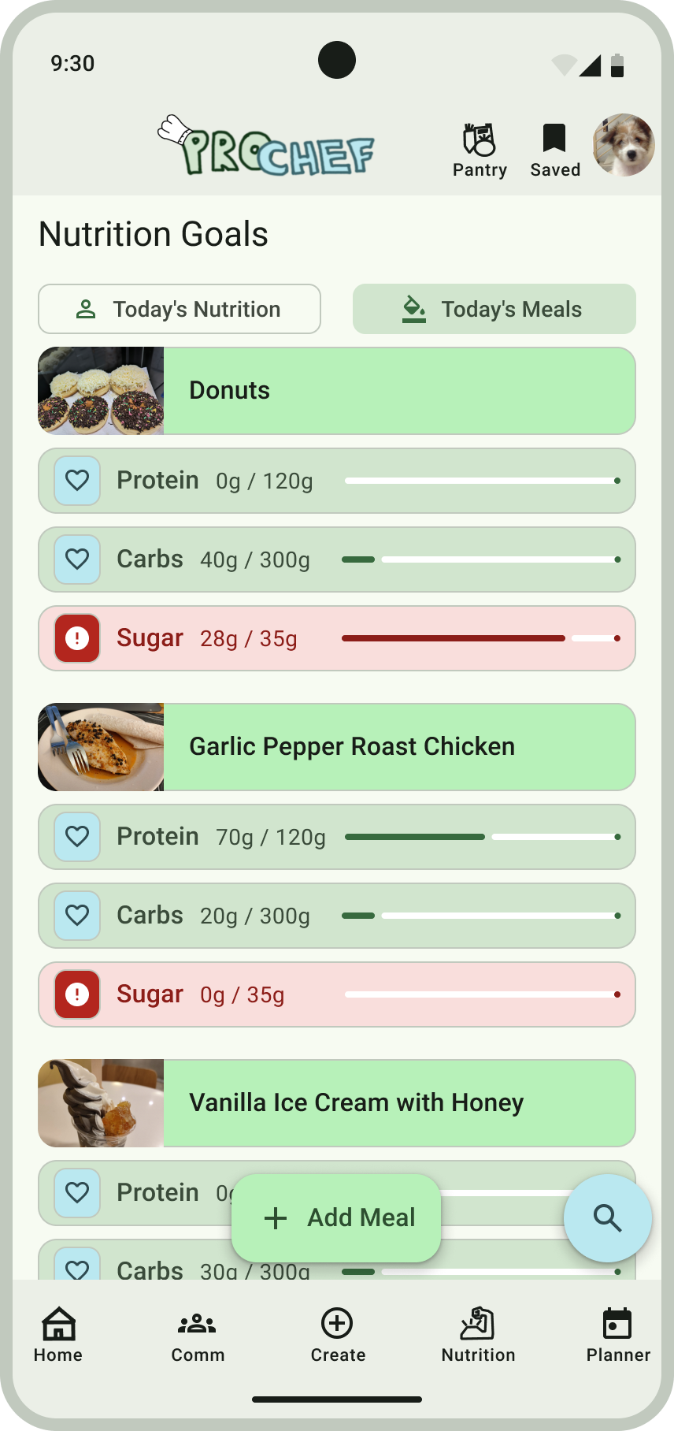

Meal Planner Screen
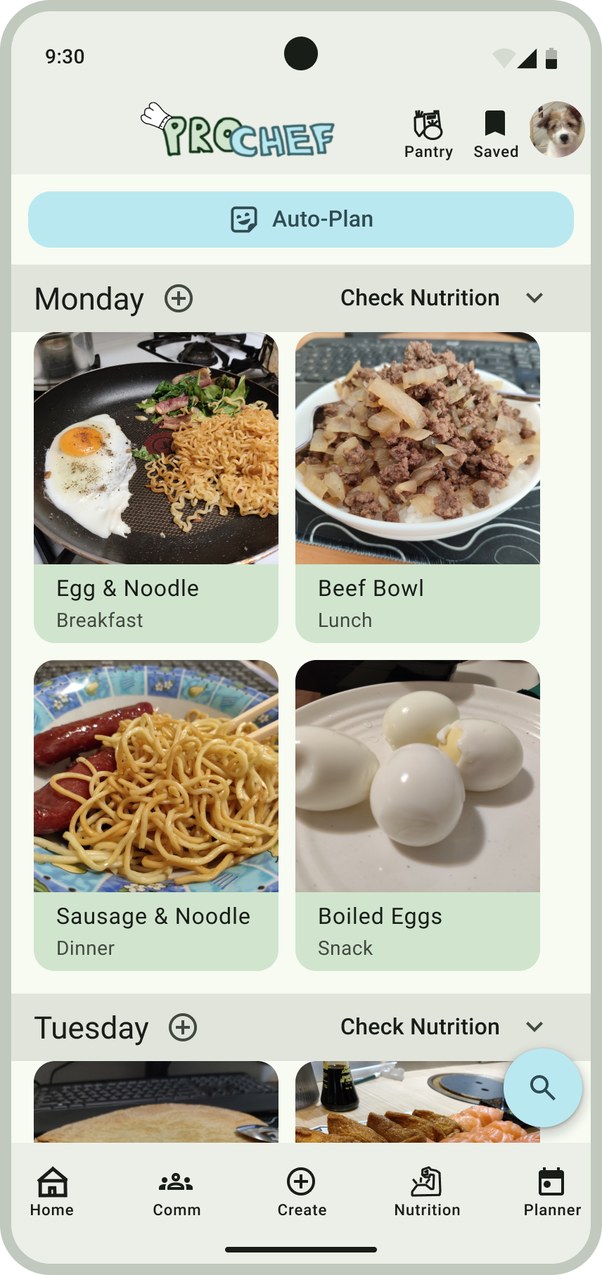
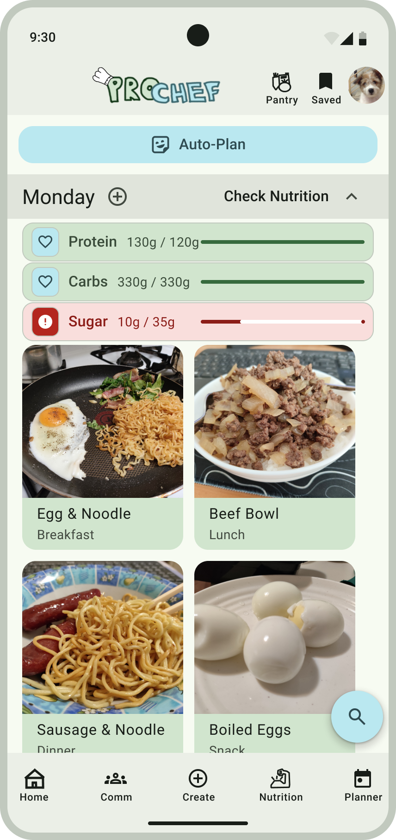

Pantry & Shopping Screen
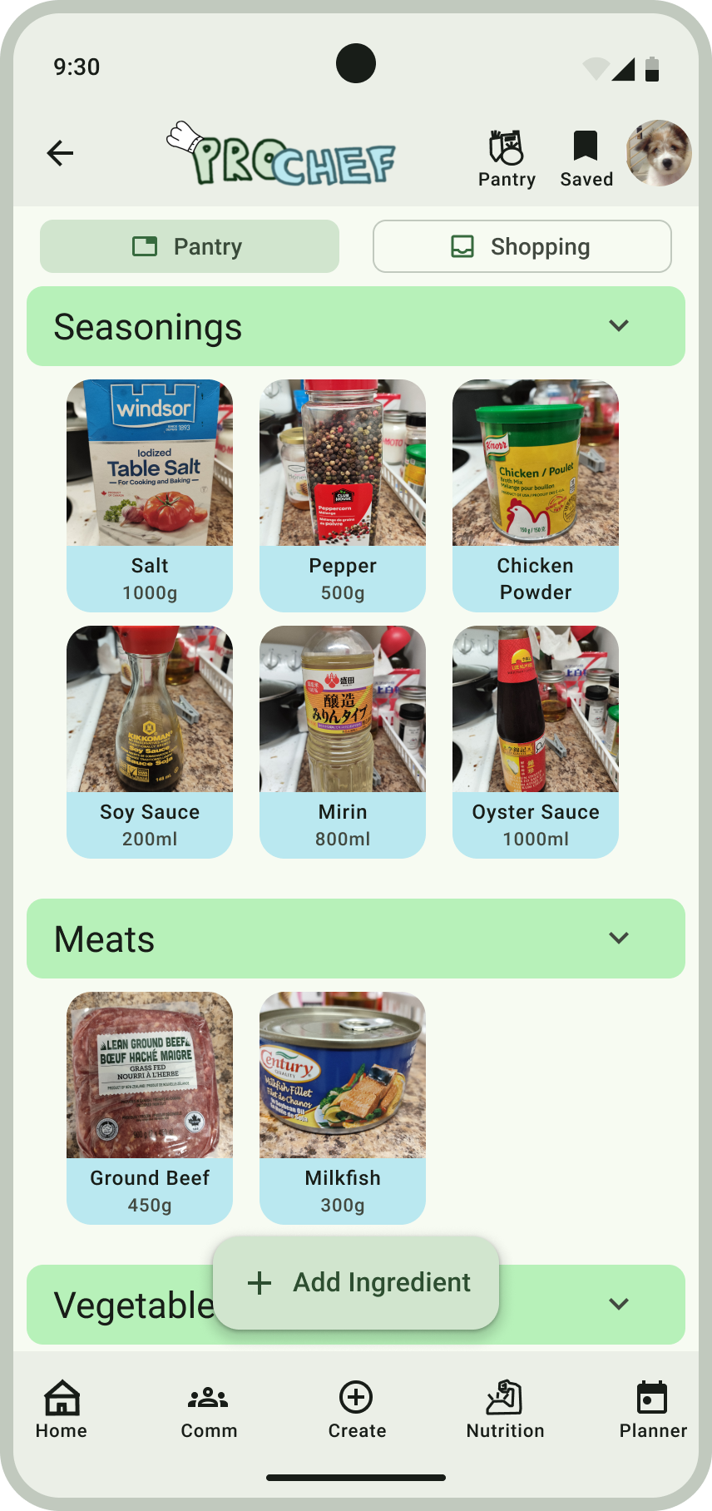
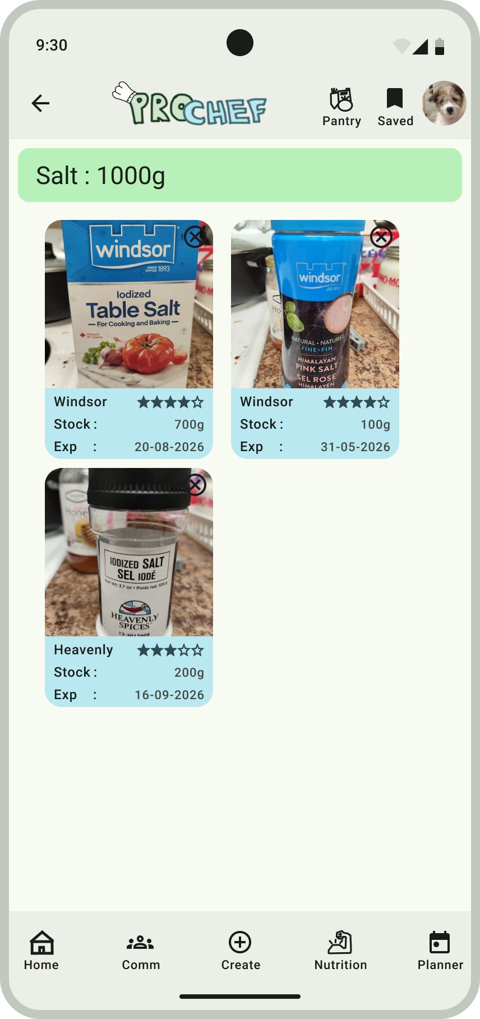

Shopping Screen
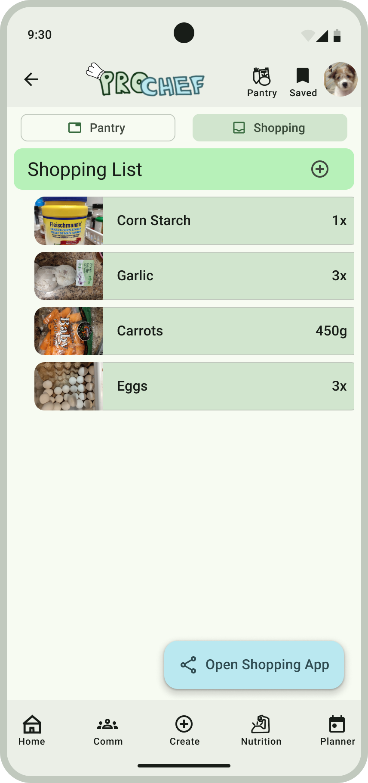

Bookmarks Screen
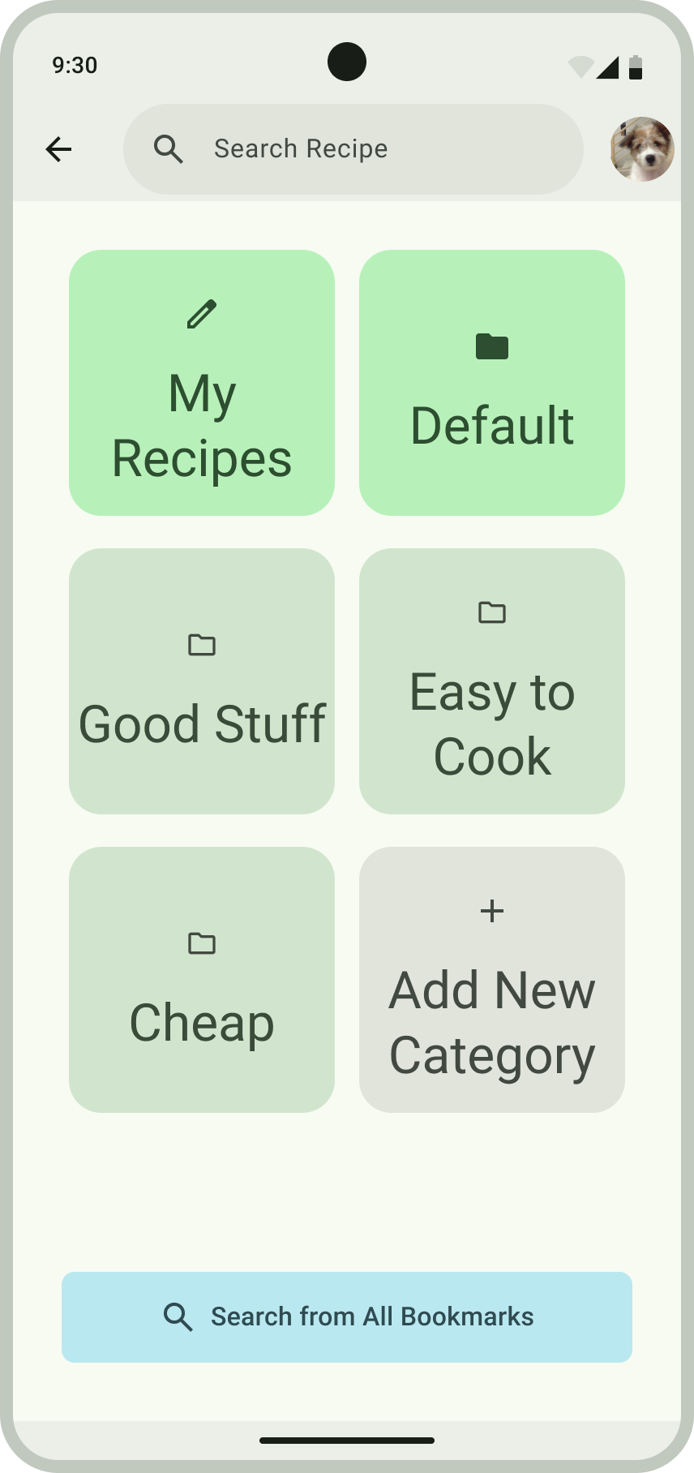
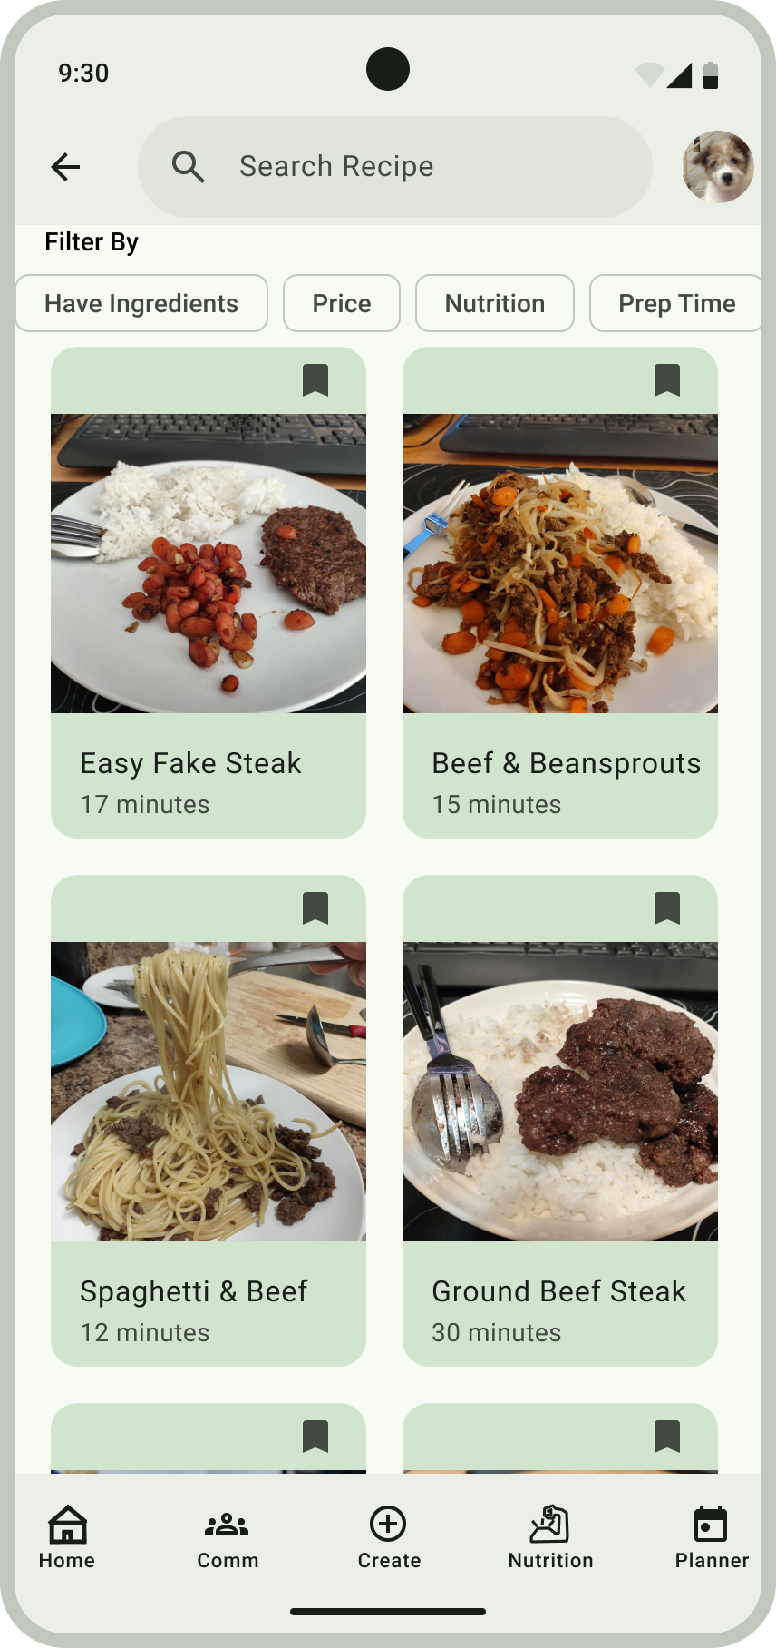

User Settings Screen
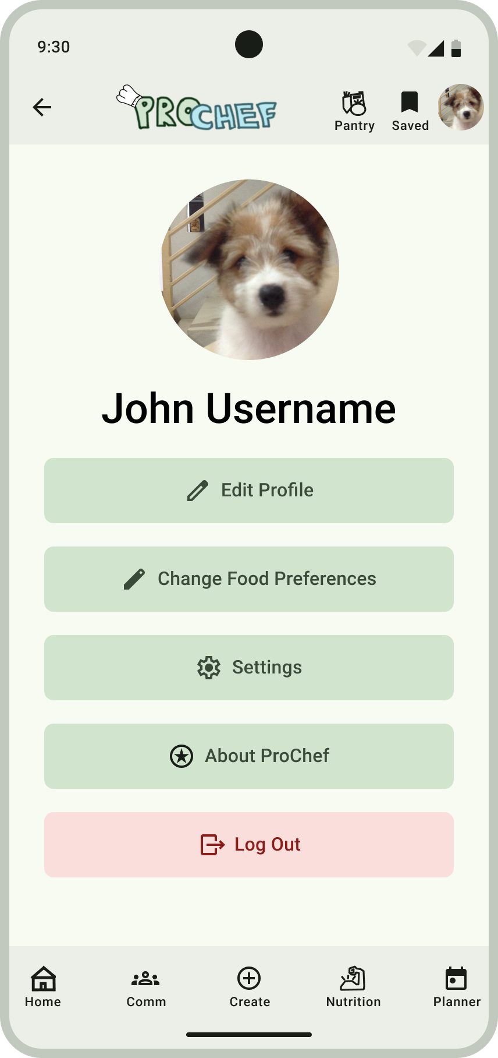

9. Designer Based Prototype Evaluation

User Journey Map
 | Want to start cooking for themselves ⟹ | Learning how to Cook ⟹ | View and Share Achievements ⟹ | Achieve Goal
User Thoughts  and  Emotions | Unsure but motivated | Having fun learning something new everyday. Curious about learning more new recipes | Excited to share cooking journey. Happy to achieve nutrition goals. | Feel proud of own achievements. Inspired to start sharing their own recipes.
User  Actions | Finding recipes  to cook. Set up preferences. Setting up nutrition goals. | Cooking recipes they’re  interested in. | Share cooked food. Check nutrition goals every day. | Start experimenting with modifying recipes. Start creating their own recipes.
User Interactions and Touch Points | View home and community for  recipe ideas, bookmark recipes, setting up meal plan that achieves nutrition goals. | Use app to learn how to cook recipes. Keep track of their pantry and use app to order missing ingredients. | Post cooked recipes and check comments. Have app notify when nutrition goals isn’t achieved. | Continues to use app to find more recipes. Start sharing their own customized recipes.
User Achievements | Finding recipes of both their favorite foods and new foods | Feels great to eat your own cooking. Learn new recipes every day. | Receive positive feedback and advice from user comments. Achieves  nutrition goals. | Has become a competent chef. Better health. Starts to share their own recipes.

10. User-Based Prototype Evaluation

10a. Objectives
- Find how the user feels about the intuitiveness of the navigation in the app
- Find user opinion of the visual design of each screen on our app
- Find user opinion on the ease of using specific functionalities of our app
- Ask users for any further suggestions

10b. Choice of User Study
Same as our requirements gathering survey, our target audience is a general “people who cook” audience so we simply asked whoever available between friends and family members.
For our survey we used a controlled lab prototype testing. Our users would use the app on the Figma app while following a list of specific instructions (instead of being allowed to do what they want). We chose this because we simply created a Figma prototype instead of a working prototype and as such not all functionalities are implemented and it can only show a very linear version of a user’s functionality. So an on-field prototype testing is not possible for our app and as such a lab testing is the only option.

10c. Prototype Evaluation Instructions
I. Checking out recipe options
- Login to the account
- Check out the home page
- Try bookmarking a trending recipe
- Go to community page
- Scroll through posts
- Check out the comments on last post

II. Checking out a recipe
- Click on a recipe
- Check out the recipe
- Click the start cooking button
- Check out the recipe step-by-step instructions
- Take a picture of the finished food and post it on the social media

III. Creating a recipe using video
- Go to the create recipe screen
- Click the create with video option
- Read the instructions
- Record a video of you cooking (this is simulated by the prototype)
- Check out the recipe generated by the app

IV. Using the nutrition tracker
- Go to the nutrition tracker screen
- Click the add a nutrition goal button
- Click the calculate button to auto-calculate nutrition based on weight
- Click the add meal button
- Add a meal using the photo option
- Go to meals screen to check out the meals you’ve eaten today and their nutrition values

V. Using the meal planner
- Go to meal planner screen
- Use the auto-planner to generate a meal plan
- Check out the planned meals
- Check out the nutrition values

VI. Checking out the pantry
- Go to the pantry screen
- Check out your pantry
- Click on the salt to check out the various brands of salt you own
- Click on the shopping cart to see your shopping list

10d. Prototype Evaluation Survey Draft
Give a grade from 1-5 for each of these:
- How intuitive are the navigation buttons
- How interesting are the things displayed on the main menu screen
- How good are the appearance of the community screen (the social media posts)
- How well the recipe screen describes the recipe
- How easy it was to follow the step-by-step of the recipe
- How easy it was to use the recipe creator
- How well the nutrition page describes your nutrition goals
- How easy it was to add a nutrition goal
- How easy it was to add a meal on the nutrition page
- How easy it was to use the auto-plan function on the meal planner page
- How well does the meal planner display your meals
- How well does the pantry screen display your pantry
- How well does the pantry detail screen display your pantry details (the salt one)
- How does the shopping list page looks

Open ended question
- Any other suggestions you want to give us?

10e. Data Visualization and Analysis
Sample Size: 5 people
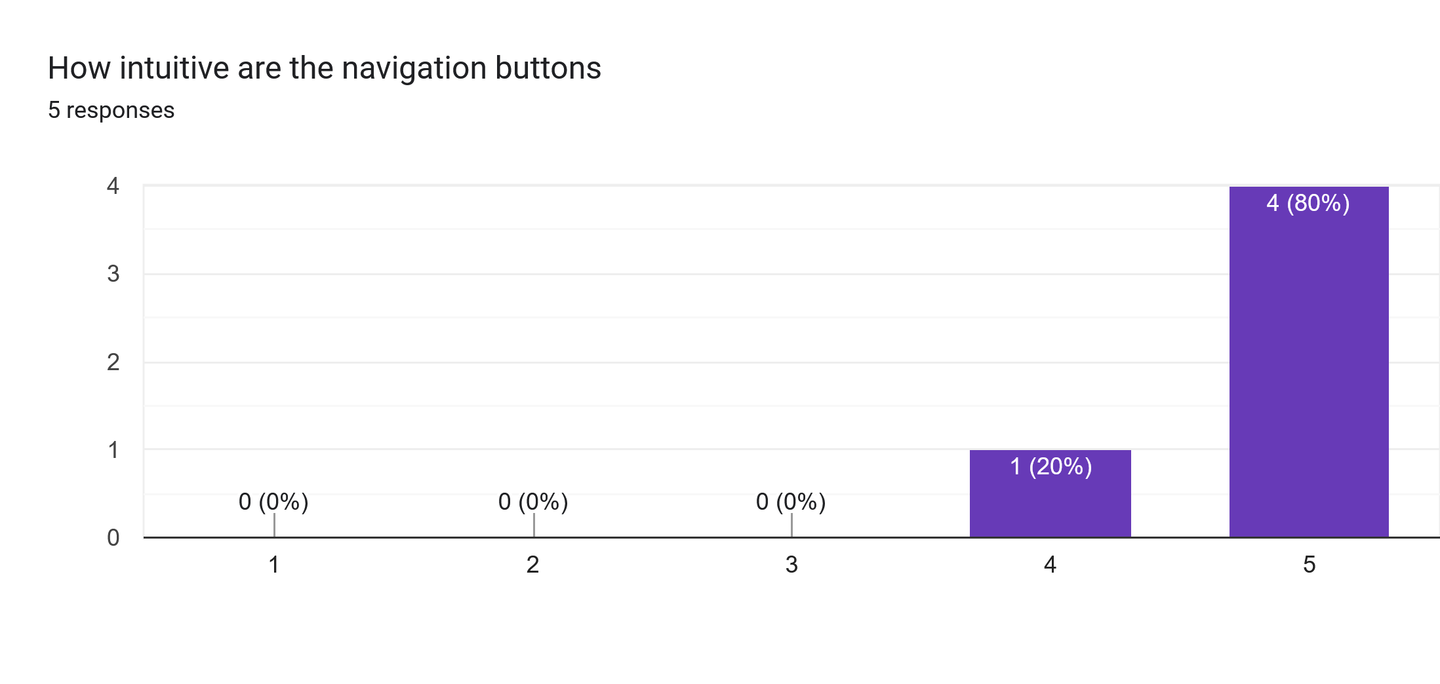
- Mean : 4.8
- Median : 5
Our users generally find navigation to be intuitive.

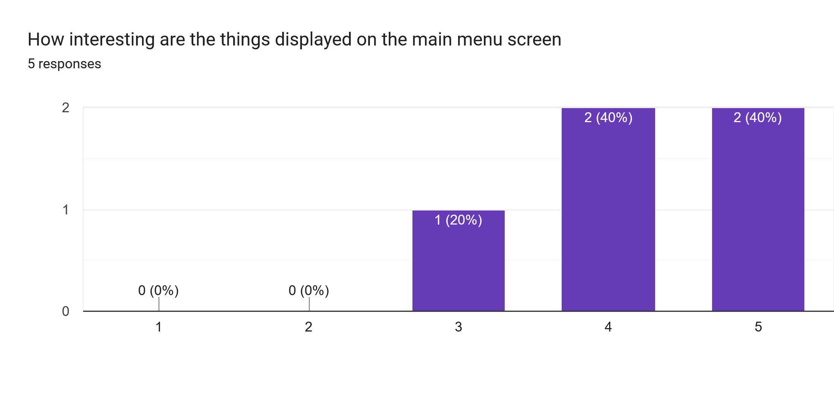
- Mean : 4.2
- Median : 4
Our users generally find the items displayed on the main menu screen to be interesting
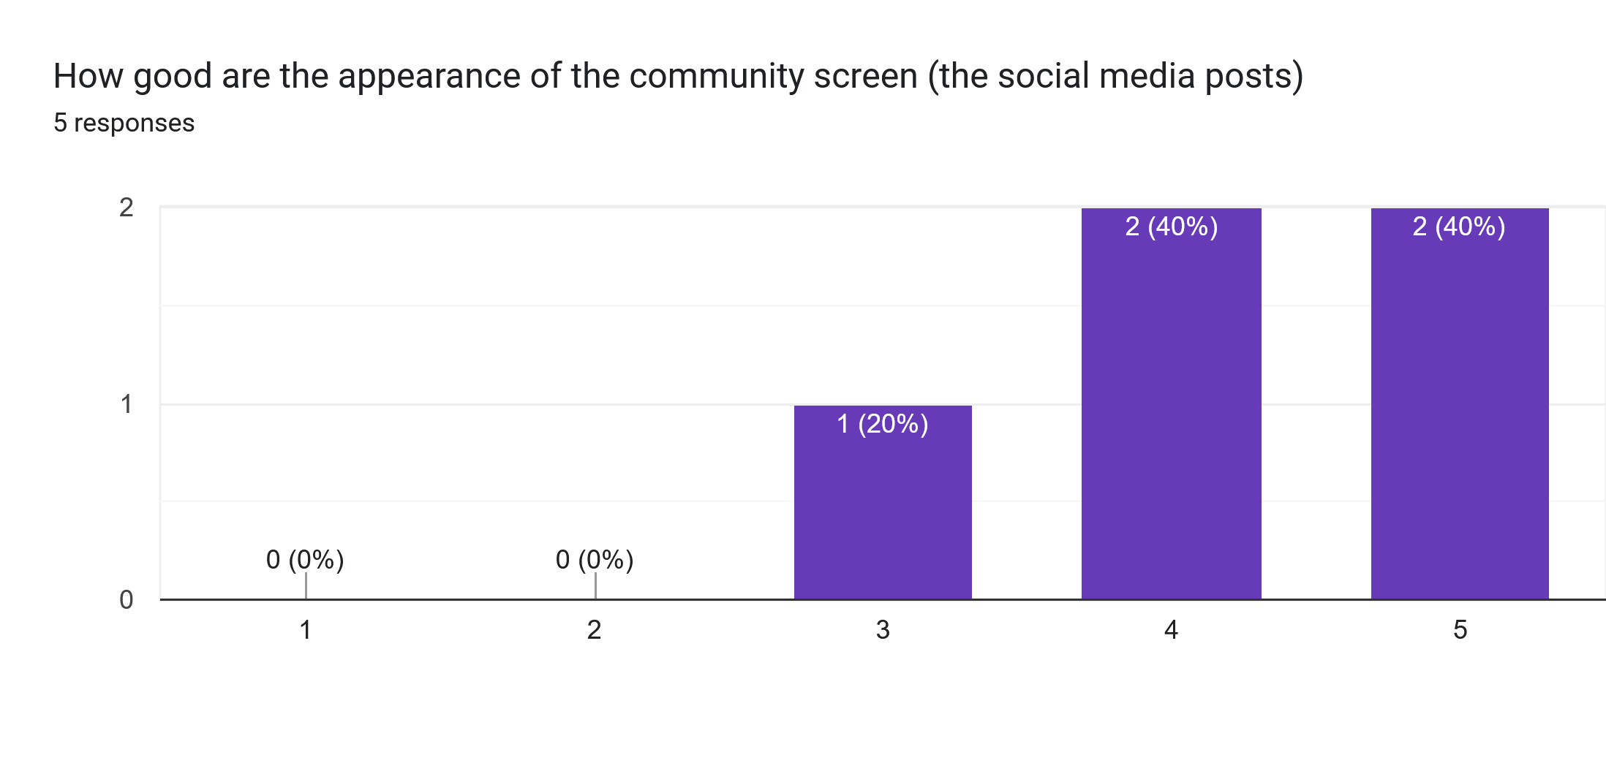
- Mean : 4.2
- Median : 4
Our users generally liked the appearance on the community screen

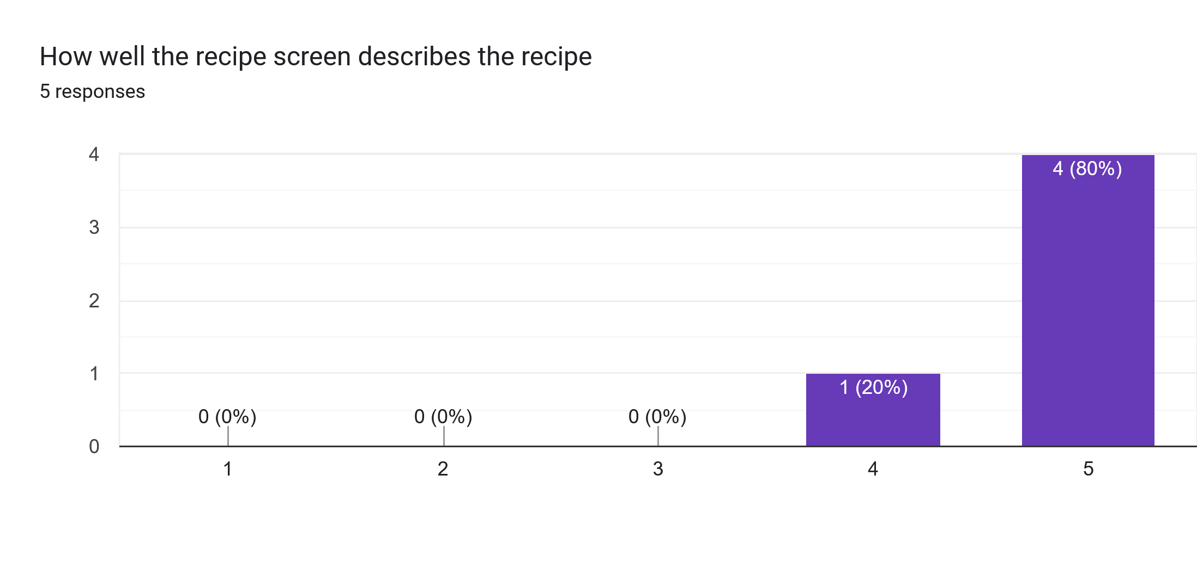
- Mean : 4.8
- Median : 5
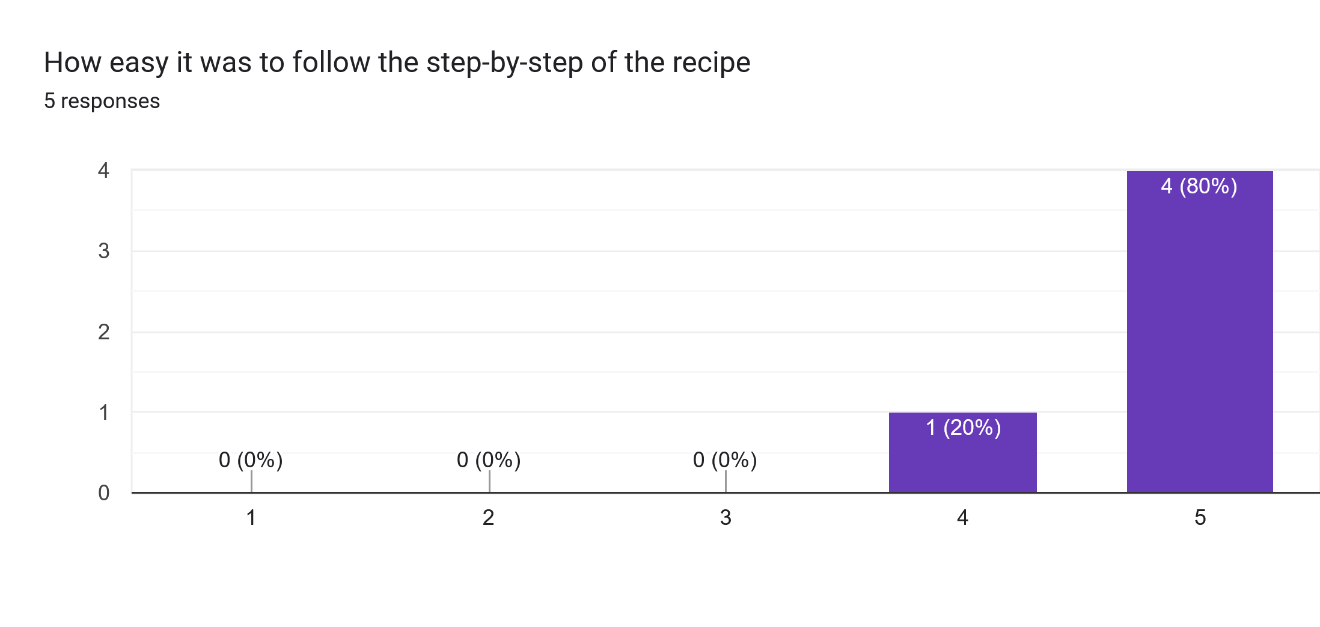
- Mean : 4.8
- Median : 5
Our users generally didn’t find any difficulty on following the recipe screens

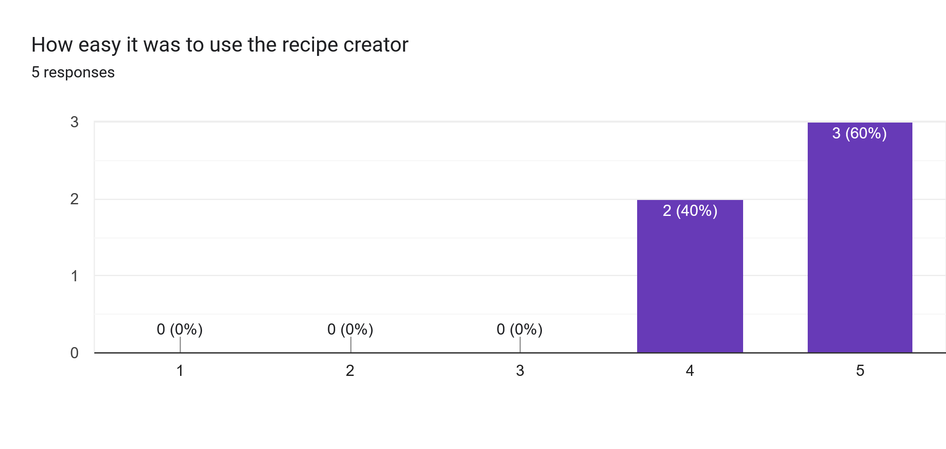
- Mean : 4.6
- Median : 5
Our users didn’t find any difficulty with our recipe creation screens

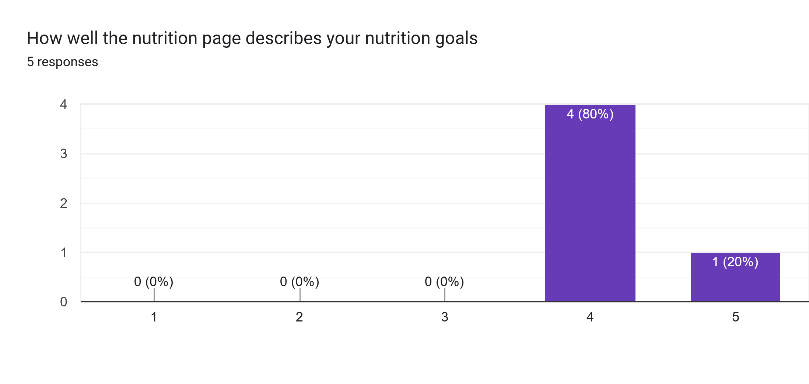
- Mean : 4.2
- Median : 4
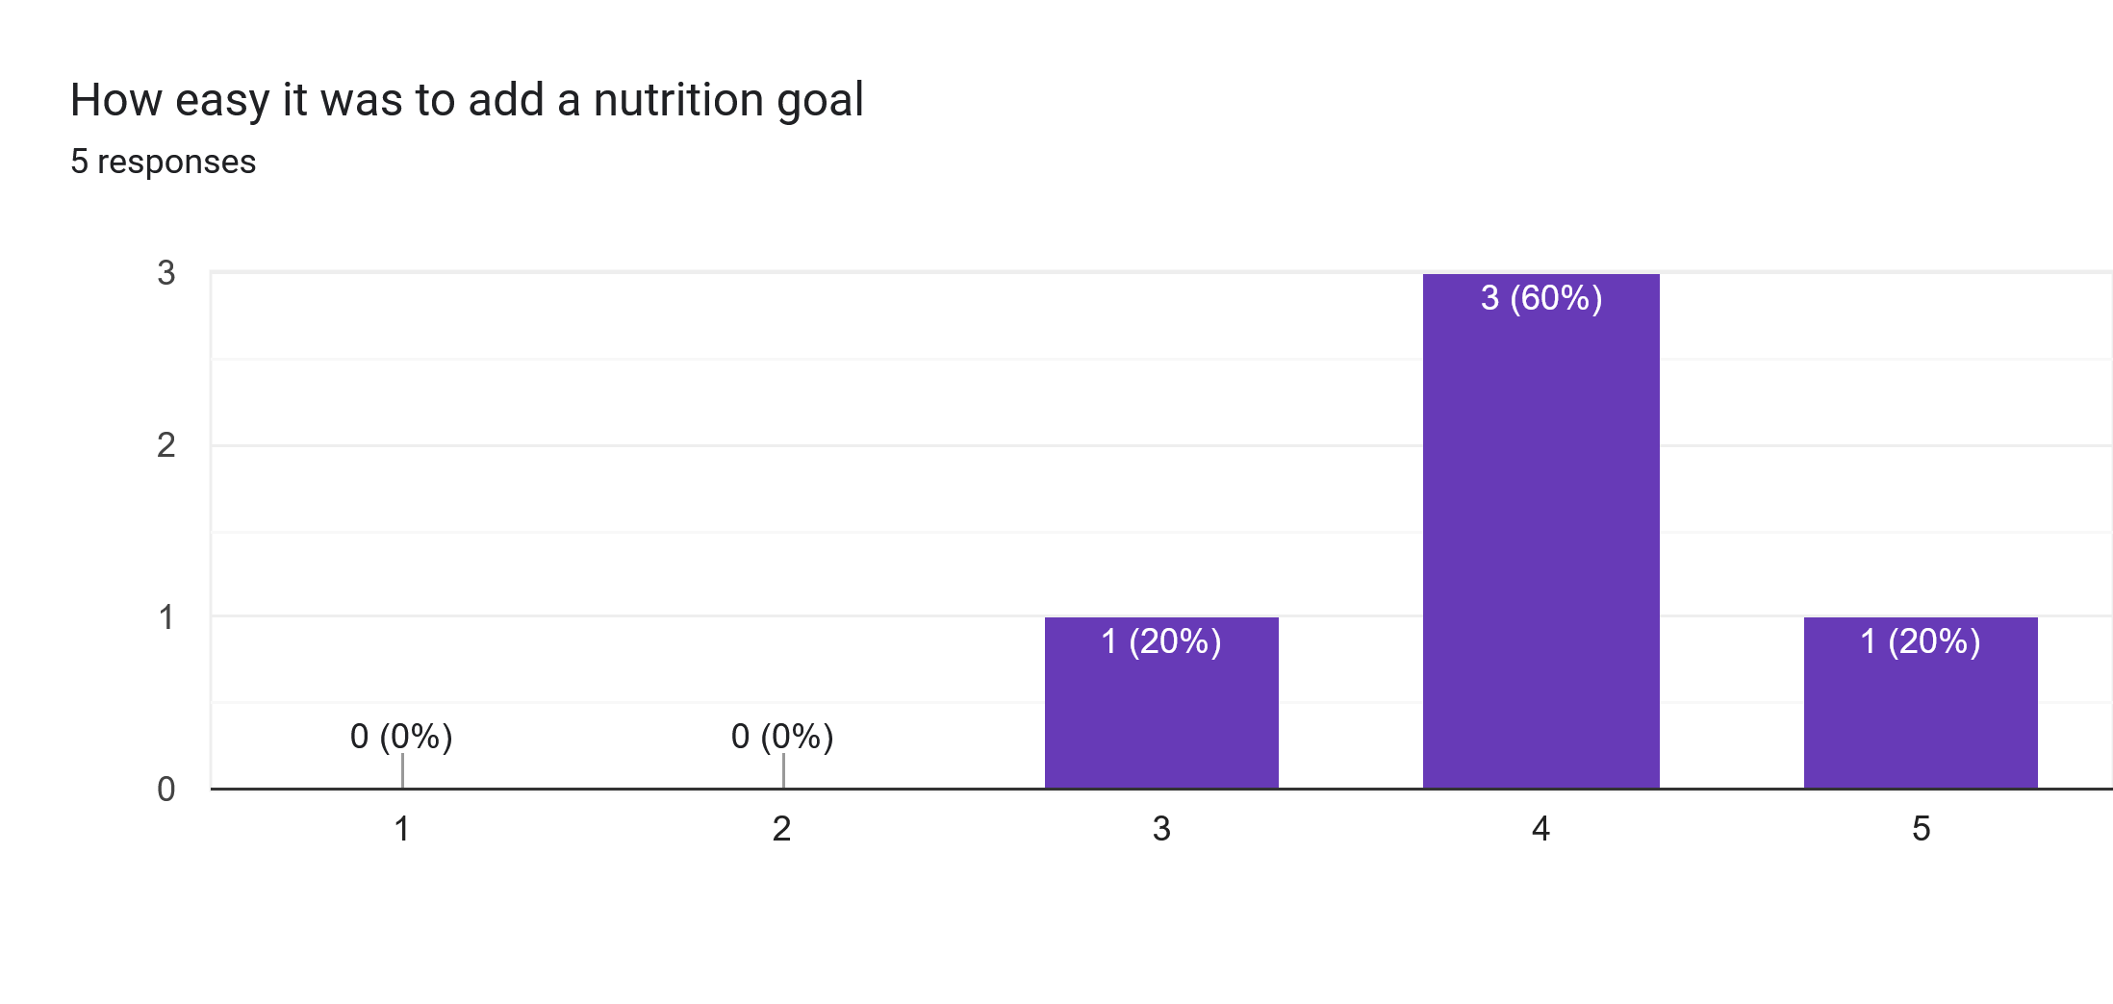
- Mean : 4.0
- Median : 4
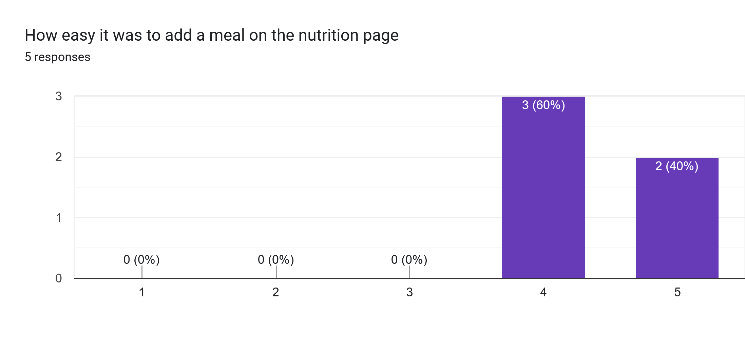
- Mean : 4.4
- Median : 4
Our users didn’t give as high of a score for our nutrition screens It’s still a good review but perhaps these screens has room for improvement.
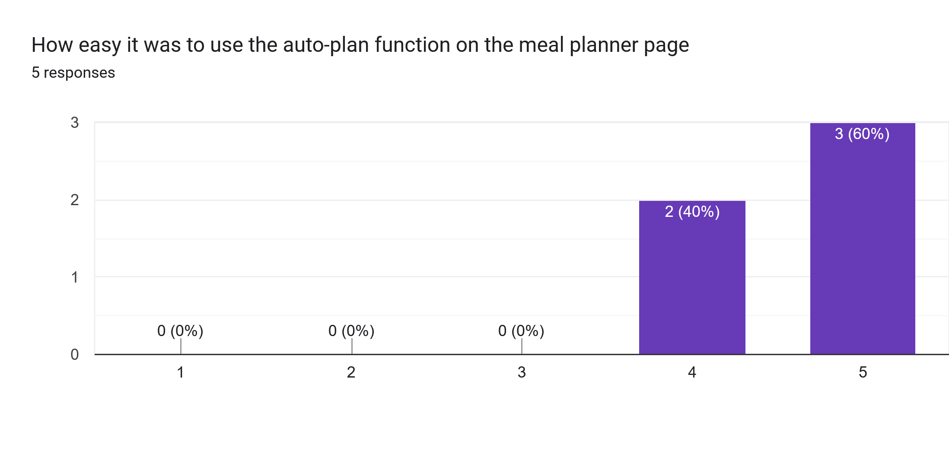
- Mean : 4.6
- Median : 5
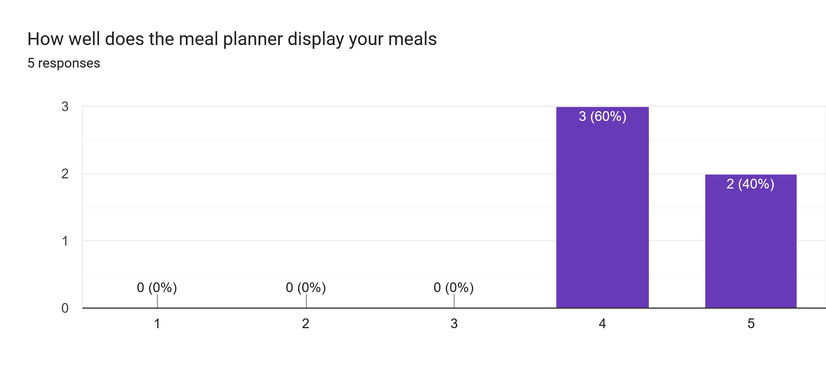
- Mean : 4.4
- Median : 4
Our users has no problem with our meal planner screens, though the display has room for improvement.

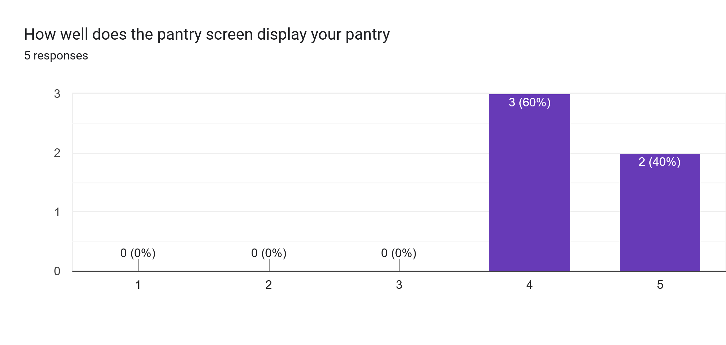
- Mean : 4.4
- Median : 4
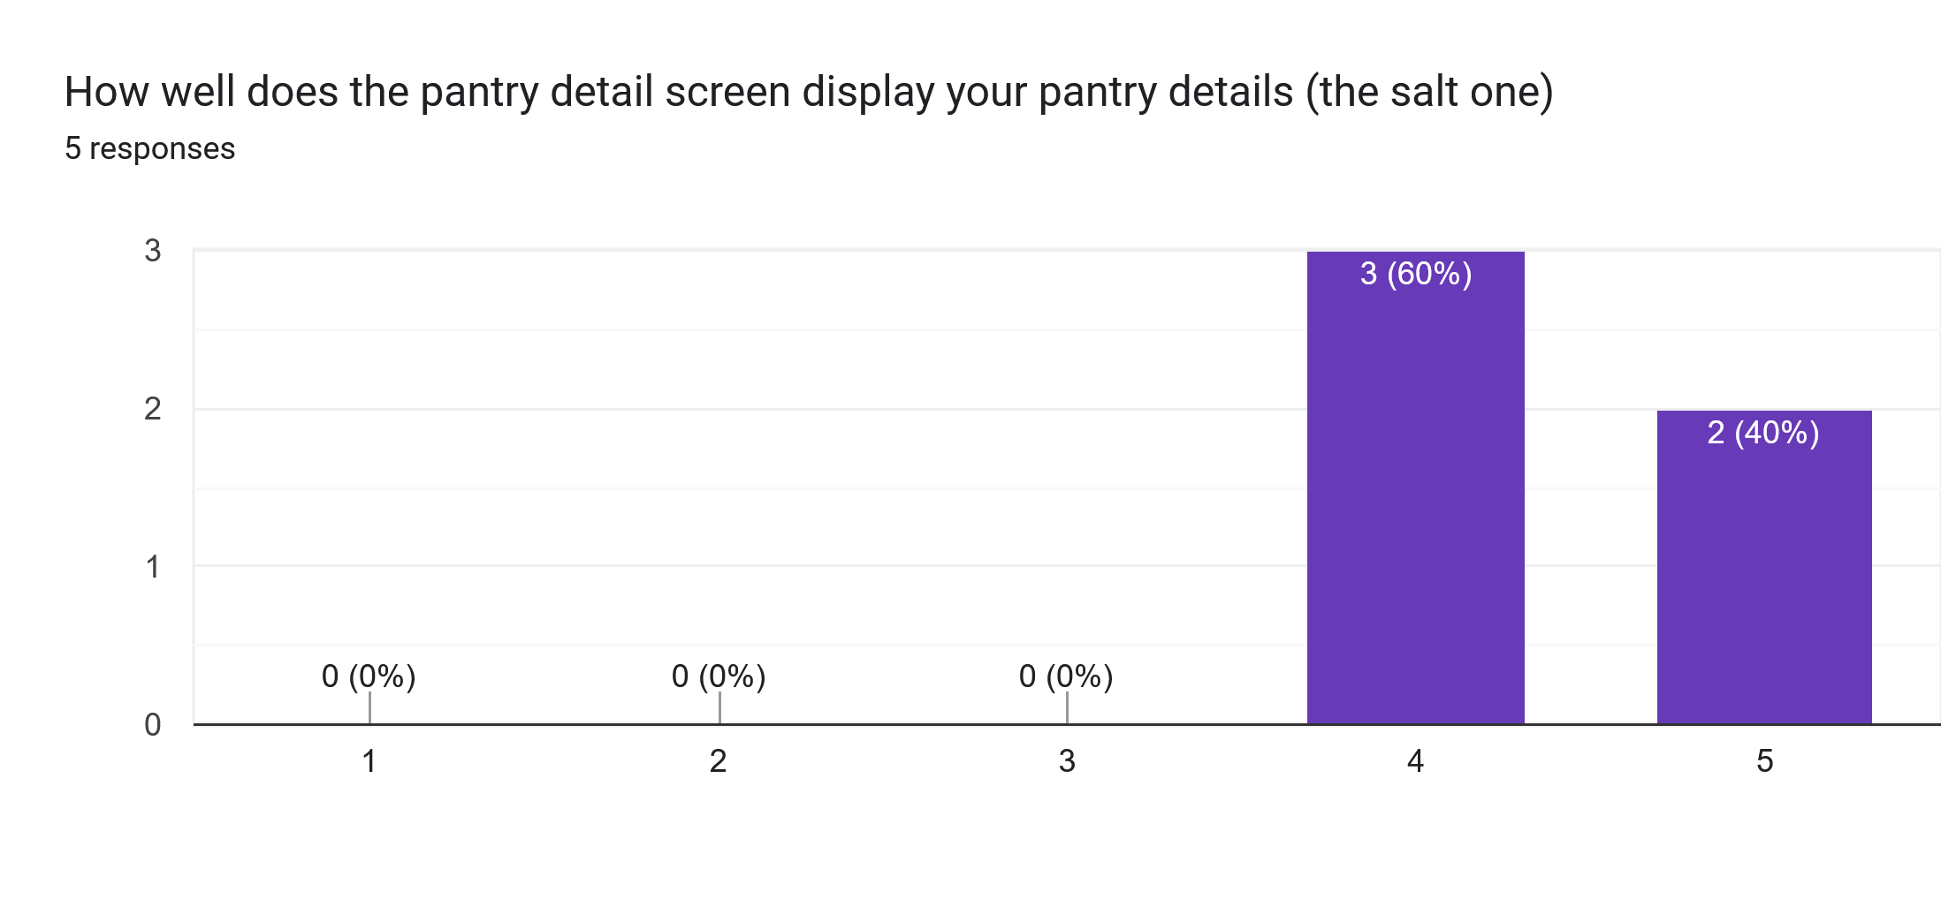
- Mean : 4.4
- Median : 4
Our users has no problem with our pantry screens, but there’s room for improvement.

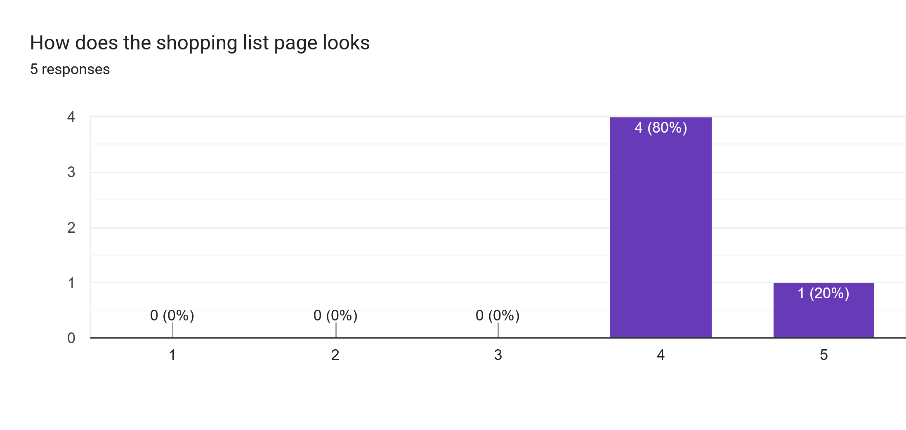
- Mean : 4.2
- Median : 4
The shopping list also has room for improvement

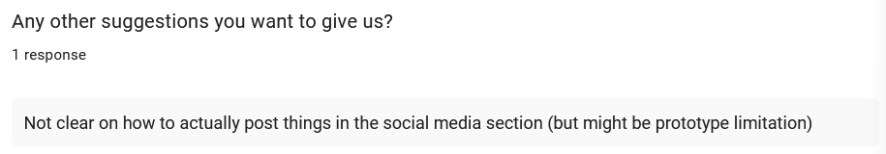
One user pointed out that we forgot to implement a way to post things in the social media section on our prototype. We ourselves also just realized this from the user journey mapping we created after prototype development.

10f. Insights from Results
Overall, our prototype received good reviews from our users. Some screens have room for improvement, especially on the visual design aspects, but our app is generally well received by the userbase. Though as a user pointed out, we forgot to implement a post social media functionality to our app which is something that needed to be revised.
However, we need to point out that our prototype evaluation is a lab-tested evaluation using specific instructions and done with friends and families as user sample with a sample size of only 5. Thus, it’s possible our user opinions are slightly biased.
Also, all of our testers have also undertook the requirements gathering survey. And as found on said survey, none of our users have used a recipe app before. Thus they’re testing our app without being able to compare it’s functionality to competition in the marketplace.

11. Design Changes based on Prototype Evaluation

11a. Changes Needed
- Finish up the unfinished new user registration (which allow user to set up their preferences)
- Add method of posting to the social media screen
- Improve overall visual design of nutrition screen
- Improve overall visual design of meal planner screen
- Improve overall visual design of pantry and shopping screens
- Implement functionality to app to modify user preferences

11b. Changes Made
Unfortunately, we weren’t able to make any new changes to the prototype as our prototype development severely exceeded the preferred deadline by several days and we ended up only being able to perform prototype evaluation 1 day before the submission deadline.

12. Conclusion
The project development didn’t go so well. Our prototype development exceeds the deadline by a lot and we only manage to complete it 2 days before the submission deadline which means we only had 1 day to perform prototype evaluation and finalizing the project report. And even then, our prototype has many features incomplete with some screens being simply static screens.
The main culprit for the slow development is mainly the lack of direction for our app design. We knew what features we want out app to have but we didn’t have a clear vision on how we want to implement said features, making it hard to actually develop the prototype. We also overthunk a lot of design decision for the sake of making our app unique and not just a copy of another app, when in hindsight features such as the search screen and the meal planner probably didn’t need to be unique.
Our lack of experience in using the tool Figma also didn’t help as many times in development we ended up spending a lot of time to perform a task only to later find out that there’s an easier way to do it in Figma, so we felt that we wasted a lot of time doing more work than needed.
But ultimately we’re glad that we managed to complete our project by the deadline, even if only barely. There are many rooms for improvement, especially regarding the prototype development speed, but overall we’re proud of our project.
The prototype demo can be found on this Figma prototype link. As mentioned, the prototype is incomplete and the user experience is mostly static so if you want to try it out, we recommend following the same instructions as the prototype evaluation instructions.

13. AI Usage
No AI was used in the development of our project.

14. Work Log
Jason Januar (Performed 100% of work as a solo designer):
Date | Hours | Description of Work
26th Jan 2026 | 1 | Created rudimentary project proposal
27th Jan 2026 | 0.5 | Market Research on Recipe Keeper app [10]
27th Jan 2026 | 0.5 | Market Research on Tasty app [2]
27th Jan 2026 | 0.5 | Market Research on ReciMe app [6]
27th Jan 2026 | 0.5 | Market Research on Samsung Food app [3]
28th Jan 2026 | 0.25 | Market Research on SuperCook app [4]
28th Jan 2026 | 0.25 | Market Research on My Recipe Box app [11]
28th Jan 2026 | 0.25 | Market Research on Cookpad app [5]
28th Jan 2026 | 0.25 | Market Research on Paprika Recipe Manager 3 app [12]
29th Jan 2026 | 1 | Market Research on SideChef app [1]
29th Jan 2026 | 0.25 | Market Research on CookBook app [7]
29th Jan 2026 | 0.25 | Market Research on COOKmate app [13]
29th Jan 2026 | 0.25 | Market Research on Mealime app [8]
30th Jan 2026 | 1 | Refined proposal introduction based on market research
30th Jan 2026 | 1 | Refined PACT framework and value pitch
31st Jan 2026 | 0.25 | Create GitHub Repository
12th Feb 2026 | 0.5 | Obtaining verification to use Figma for Education
12th Feb 2026 | 0.5 | Trying out Figma and learning the basics
13th Feb 2026 | 1.5 | Learned more about Figma Prototyping from the official tutorial[14]
13th Feb 2026 | 1.5 | Identify survey objectives
15th Feb 2026 | 2 | Practice runs of making tutorial video of Figma
16th Feb 2026 | 1 | Created Figma tutorial video
16th Feb 2026 | 0.5 | Upload video and create Figma Tutorial document
17th Feb 2026 | 3 | Created survey draft
26th Feb 2026 | 1 | Created actual survey on Google Forms and asked around
2nd Mar 2026 | 1 | Created 2 personas for persona analysis
7th Mar 2026 | 1 | Created 2 more personas for persona analysis
8th Mar 2026 | 1.5 | Created Requirements Document Framework (contains all rcontents besides the actual requirements analysis)
9th Mar 2026 | 1.5 | Requirements Generation
9th Mar 2026 | 1.5 | Visualized and Analyzed Survey Results
9th Mar 2026 | 0.5 | Discover and List Insights from Survey Results
9th Mar 2026 | 0.5 | Synthesized Requirements from Requirements Gathering and Requirements Generation
21st Mar 2026 | 0.25 | Create Placeholder Splash Screen on Figma (start of prototyping)
21st Mar 2026 | 0.5 | Create Login and Create Account Screen on Figma
22nd Mar 2026 | 2 | Develop rough idea of screens and navigation map for new user experience (preferences customization and such)
22nd Mar 2026 | 2 | Create New User Feature Carousel on Figma (placeholder images)
22nd Mar 2026 | 1 | Create Food Preferences Selector Screen on Figma
22nd Mar 2026 | 0.5 | Create Utensils Selector Screen on Figma
23rd Mar 2026 | 0.25 | Create Allergy Selector Screen on Figma
23rd Mar 2026 | 0.5 | Create Recipe Component and Recipe Carousel Component (placeholder images for now)
23rd Mar 2026 | 1 | Create Screens and Buttons to complete the new user experience (content still empty but will mostly be pictures I’ll need to take later)
25th Mar 2026 | 0.5 | Took photos and videos to be used as images in the prototype
25th Mar 2026 | 0.5 | Created App Bars
25th Mar 2026 | 1 | Create Community Page (doomscrolling)
26th Mar 2026 | 1.5 | Took more footage to be used as prototype images
27th Mar 2026 | 0.5 | Created small recipe component for UI
27th Mar 2026 | 1.5 | Created Search Screens
28th Mar 2026 | 0.5 | Learned how to create frameworks so that Figma development should go much smoother
28th Mar 2026 | 1 | Fleshed Out Home Screen
28th Mar 2026 | 0.25 | Improve search screens visuals
29th Mar 2026 | 3 | Replace most placeholder images and text to dummy text and images that better resemble real app posts. Also general UI polishing.
30th Mar 2026 | 1 | Improved Components
31st Mar 2026 | 0.75 | Developed Component for Nutrition Tracker
31st Mar 2026 | 0.5 | Developed base nutrition screen
1st Apr 2026 | 0.5 | Modularize some elements into components to improve consistency of appearance across screens
1st Apr 2026 | 1 | Create placeholder screens for all the remaining not-yet-created screens to fully implement most navigation buttons. Now, most navigation buttons are functional, just that some of the screens they arrive at are still empty.
1st Apr 2026 | 1 | Developed base meal planner screen (might still be incomplete)
2nd Apr 2026 | 0.5 | Created Simple User Settings App (probably won’t bother with simulating functionality with this one, just static screen)
2nd Apr 2026 | 1 | Developed components for ingredient list
2nd Apr 2026 | 0.5 | Created Pantry Screen
3rd Apr 2026 | 0.5 | Created Bookmarks Screen
3rd Apr 2026 | 0.25 | Created Add Recipe Selection Screen
3rd Apr 2026 | 0.5 | Add basic scrolling display for home and community screen
3rd Apr 2026 | 1 | Add flow to simulate adding a new nutrition goal to nutrition screen
4th Apr 2026 | 1 | Create comment and review components for user comments/reviews
4th Apr 2026 | 0.5 | Create comment section screen for social media posts
4th Apr 2026 | 2 | Finished up simulation for nutrition screen (Adding meals, showing meals, and warning notification)
5th Apr 2026 | 1 | Finished up Meal Planner Screen
5th Apr 2026 | 0.5 | Started working a little on the Recipe Screen
6th Apr 2026 | 1.5 | Developed Pantry and Shopping Screen
6th Apr 2026 | 1 | Developed most of Recipe Screen (except step-by-steps which will be the biggest section of it)
6th Apr 2026 | 1 | Developed most of Create Recipe simulation (just haven’t completed the final screen).
7th Apr 2026 | 0.5 | Developed prototype evaluation draft
8th Apr 2026 | 1.5 | Finished up base recipe screen and add simulated drag flow
8th Apr 2026 | 0.5 | Add alternative recipe screen for missing ingredients simulation
9th Apr 2026 | 1 | Finished Recipe Creator Screen
9th Apr 2026 | 0.5 | Created the first step-by-step screen (will serve as a template for the rest of them)
10th Apr 2026 | 1.25 | Finished Step-by-Step Screen
10th Apr 2026 | 0.5 | Created a logo and refined splash screen
10th Apr 2026 | 1 | Created custom logos for some navigation buttons (only for ones where material kit asset pack doesn’t have a suitable logo) and fix navigation flow that caused by changing logos
10th Apr 2026 | 0.25 | Created the prototype evaluation survey on google forms
11th Apr 2026 | 2 | Prototype evaluation
11th Apr 2026 | 0.5 | Finished the design part of the final report
11th Apr 2026 | 1 | Analyzed prototype evaluation survey results and finished the prototype evaluation part of the final report.
11th Apr 2026 | 1 | Created user journey map.
11th Apr 2026 | 1.5 | Finished final report. Also uploaded to GitHub and updated ReadMe file

15. Prototype Demo Link
https://www.figma.com/proto/ZTrEo2SOgswRbCJsn76SJX/W26_3375_S001_G5_ProChef?node-id=0-1&p=f&viewport=341%2C537%2C0.48&t=6ud6abyx0kiOuiWH-0&scaling=min-zoom&content-scaling=fixed&starting-point-node-id=10%3A139

16. References
References
1: Recipe Keeper, Tudorspan Limited, https://play.google.com/store/apps/details?id=com.tudorspan.recipekeeper
2: Tasty, BuzzFeed, https://play.google.com/store/apps/details?id=com.buzzfeed.tasty
3: ReciMe: Recipes & Meal Planner, ReciMe, https://play.google.com/store/search?q=recime&c=apps
4: Samsung Food: Meal Planner, Samsung, https://play.google.com/store/apps/details?id=com.foodient.whisk
5: SuperCook - Recipe Generator, SuperCook, https://play.google.com/store/apps/details?id=com.supercook.app
6: My Recipe Box: My Cookbook, CmonApp, https://play.google.com/store/apps/details?id=fr.recettetek
7: Cookpad recipes, homemade food, Cookpad Inc (UK), https://play.google.com/store/apps/details?id=com.mufumbo.android.recipe.search
8: Paprika Recipe Manager 3, Hindsight Labs LLC, https://play.google.com/store/apps/details?id=com.hindsightlabs.paprika.android.v3
9: SideChef: Recipes & Meal Plans, SideChef, https://play.google.com/store/apps/details?id=com.sidechef.sidechef
10: CookBook - Recipe Manager, CookBook Co., https://play.google.com/store/apps/details?id=com.cookbook.cbapp
11: COOKmate - My recipe organizer, Maadinfo Services, https://play.google.com/store/apps/details?id=fr.cookbook
12: Mealime Meal Plans & Recipes, Mealime Meal Plans Inc, https://play.google.com/store/apps/details?id=com.mealime
13: Figma Learn, Figma, https://help.figma.com/hc/en-us/sections/360006534454-Create-prototypes

