**QR Code Anzeiger, Scanner, Send and Print**

**Implementation**

**Directories for WwwQrCode**

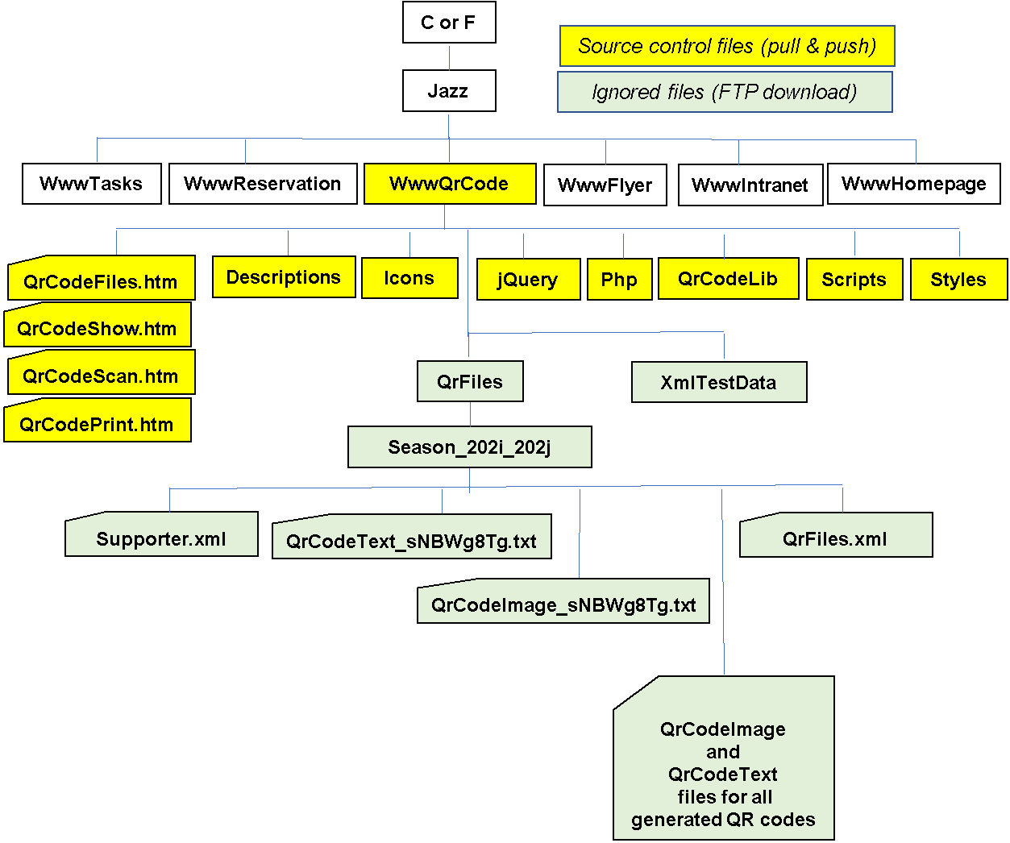

**QR Code Send & Print**

***Overview startup functions***

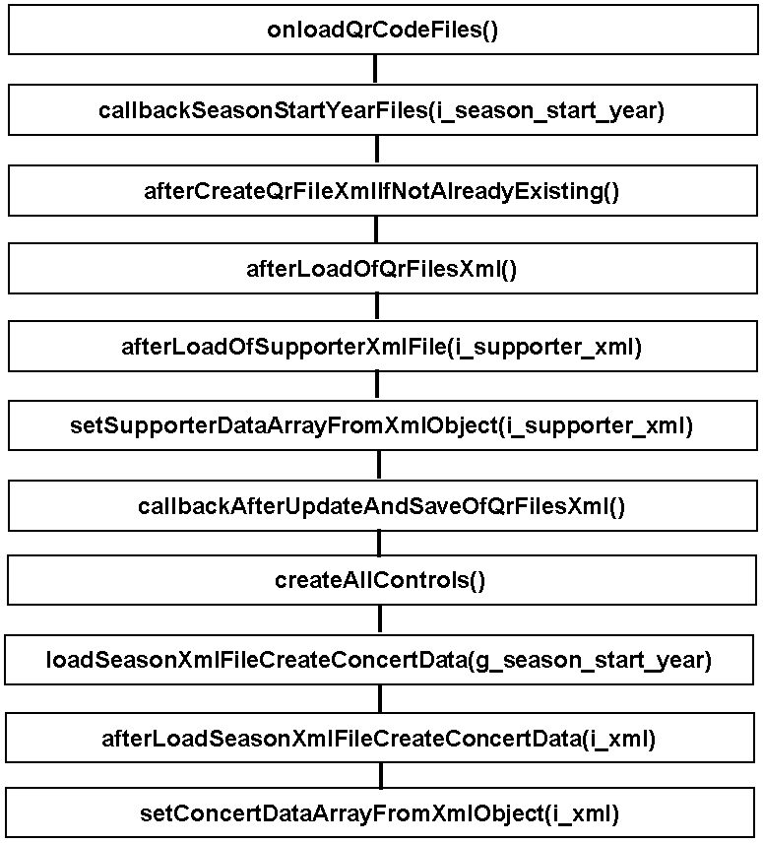

***Overview event functions***

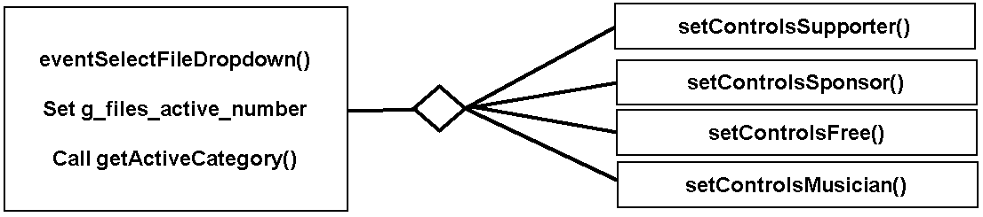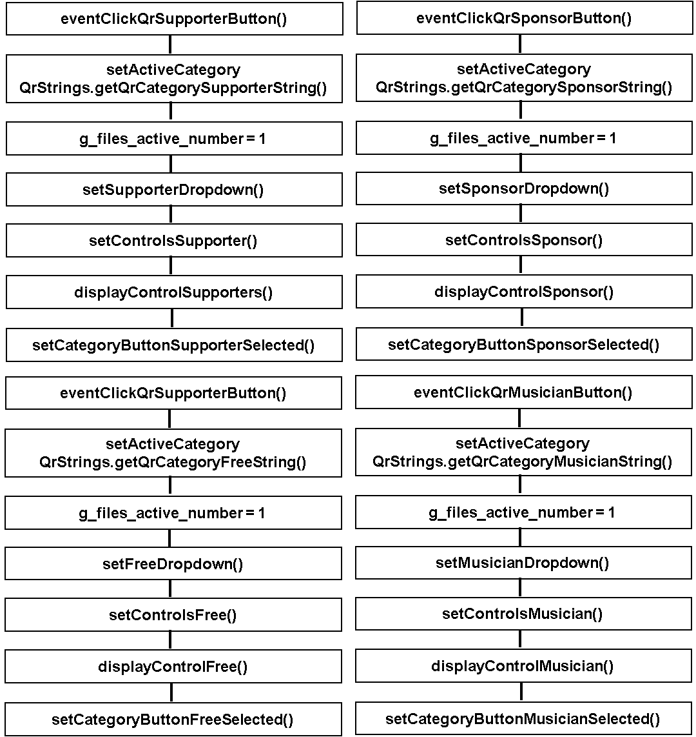

***Supporter data from application Adressen to application QR Code***

1. Registration of the supporter contribution

The supporter pays the "fee" and the jazz club register the amount in the Windows application Adressen

2. Upload of XML file to the server directory QrCode/QrFiles/Season_202i_202j

An XML file is created with data for all persons that have contributed to the jazz club. Not only the persons that have paid enough to become a supporter.

The XML file is uploaded by the checkin (save) after any change in Adressen.

To which season directory it will be uploaded is determined on the contribution field Beitrag-202i-202j of the record in the JazzLiveAdressen.csv file.

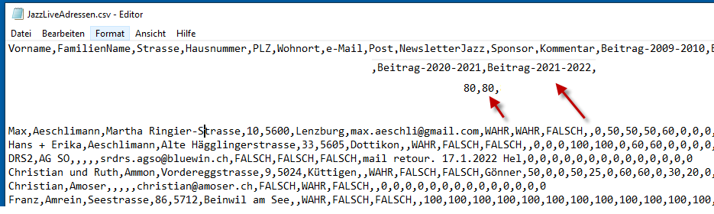

The first registered "fee" for a new season changes the upload directory, i.e. probably short before the first concert of the season.

For the first uploaded XML file Supporter.xml of a new season the application Adressen also creates the new directory on the server.

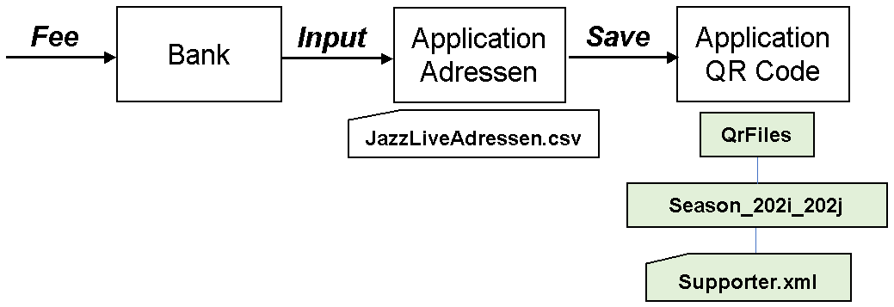

**File Supporter.xml**

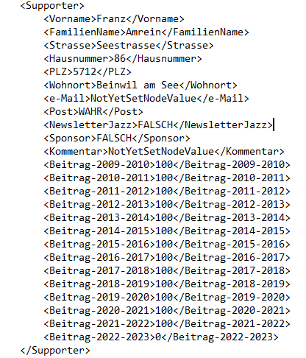

**Determine the current/active season for application QR Code**

This years defines the directory /www/QrCode/QrFiles/Season_202i_202j where the files Supporter.xml, QrFiles.xml and the text files QrCodeImage_*dowload-code*.txt QrCodeText_*download-code*.txt are.

The season start year is determined by the function ***getSeasonStartYear***. Input data to this function is the name of a callback function.

A callback function is necessary while the further execution (creating and uploading QR text files) must wait until the PHP function Php/***SeasonStartYear.php*** has executed and returned the season start year.

The PHP function ***SeasonStartYear.php*** tests with first the current date year and then the previous year if there is a file ***Supporter.xml*** in the directory ***Season_202i_202j.*** When the file is found the season start year is returned.

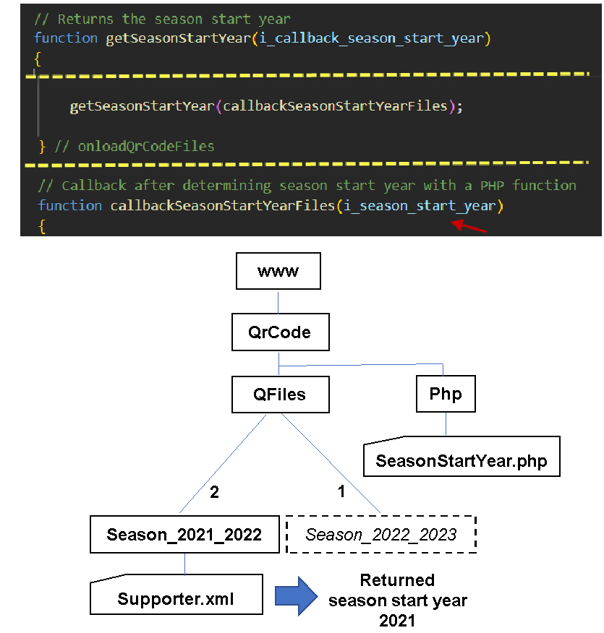

Load of the QR files XML file (QrFiles.xml)

//

// For each supporter (each object in array g_supporter_data_array) an image file

// with the QR code and a text file with the text of the QR be created in the

// directory QrCode/QrFiles/Season_20NN_20MM.

// The file QrFiles.xml (in the same folder) registers the names of all files that

// have been created. Not the full name though. Only the 'download code' that

// the supporter become so that the QR code can be downloaded. The 'download code'

// defines the file name.

// The constructor function of class QrFilesXml loads the QR files XML file, i.e.

// downloads the file and create an XML object corresponding to the XML file.

// The function callbackSeasonStartYearFiles creates the QrFilesXml object

//

// 5. Load of the supporter XML file (Supporter.xml)

//

// The constructor function for class SupporterXml loads the file Supporter.xml.

// The function afterLoadOfQrFilesXml creates the XML object, and the (callback)

// function afterLoadOfSupporterXmlFile is called when the object is created

//

// 6. Creation of an array SupporterData objects (g_supporter_data_array)

//

// There is a class SupporterData that hold information about a supporter.

// Objects in the array g_supporter_data_array are only for persons that paid

// QrStrings.getSupporterContributionLimitValue() or more.

// Function setSupporterDataArrayFromXmlObject creates g_supporter_data_array.

// This function called by afterLoadOfSupporterXmlFile

//

// 7. Upload and register QR code files for new supporters

**QR Code Show (Anzeiger)**

**QR Code Scanner**

**QR Code Print Batch**

**Supporter in der Adressen-Datenbank**

Jemand ist Supporter, d.h. kommt auf der Supporter-Liste, wenn den der finanzieller Beitrag (Betrag) grösser als null (0) ist.

Eine Supporter-Karte kriegt der Beitragsträger wenn der Betrag 60 Franken oder mehr ist.

In der Datenbank gibt Datensätze (Records) für Zwei Personen. Einige mit einem Beitrag für eine Person und einige für zwei Personen.

Ex-Vorstandsmitglieder müssen Eintritt nicht zahlen, aber ein paar unterstützen uns und sind auf der Supporter-Liste. Ich nehme an, sie kriegen keine Supporter-Karte.

Telefonnummer ist nicht registriert in der Adressen-Datenbank. (Du Hanni hast eine Idee mit Natel-Nummer)

Die XML Datei, die an den QR Code Webseiten exportiert wird, enthält Beitrag Daten für alle Saisons. Nicht nur für die aktuelle Saison. Die Liste wird aber exportiert zum aktuellen Saison Ordner. Zum Beispiel /www/QrCode/QrFiles/Season_2021_2022.

In der Adressen Applikation kann die exportierte Datei angeschaut werden: Output ‘Supporter.xml’ wählen.

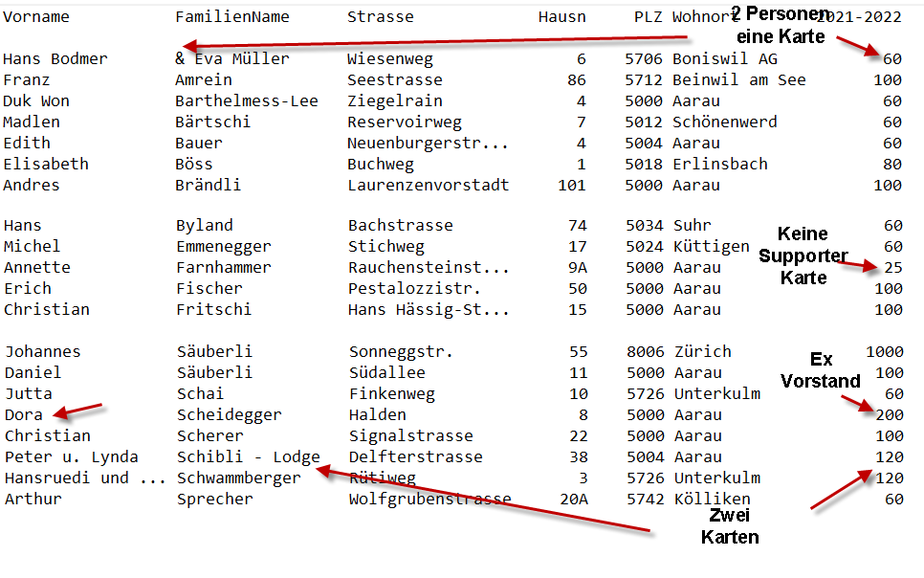

**Ideas**

***Local file in the computer***

Names of persons should not be in Internet (on the server).

Would it be possible to generate QR codes from a local file?

Some links reading files with JavaScript

https://stackoverflow.com/questions/41155325/how-to-read-a-text-file-saved-on-my-computer-using-javascript

https://ourcodeworld.com/articles/read/191/how-to-read-a-computer-file-using-javascript-in-the-browser

https://www.html5rocks.com/de/tutorials/file/dndfiles//

https://web.dev/read-files/