**DOCUMENTATION**

**Project Name:**  Richfield Chairs

**Project Members:** M. Jazzel Mehmood, Fabiha Hanif

**Project Requirements:**

* The Home Page should be created making use of Sections with a suitable logo, the header section can be added which will show images chairs.
* The site must contain the links to navigate through any category for the information.
* The site should display a menu which will contain the options for brief introduction about the various furniture’s available, location of the shop and any other information if required.
* The information should be categorized according to the brand names of the chairs like if a User wants to see only “LEO” chairs or any other companies chairs then he/she can click on a Link/button/menu etc and can see only that Brand chairs.
* When a user selects any particular brand, a list of chairs for that brand will be displayed
* A brief summary of features of the chairs should be displayed on the WebPage along with the picture but detailed Features should be stored in Individual Word documents which can be downloaded or viewed by the User who wishes to see the same.
* There should be a “Contact Us” page which will have the Address of the company which should be displayed using GeoLocation API Sand the email address which when clicked will invoke the local mail client from where they can send an email.

**User Manual**

**“ The Main Page “**

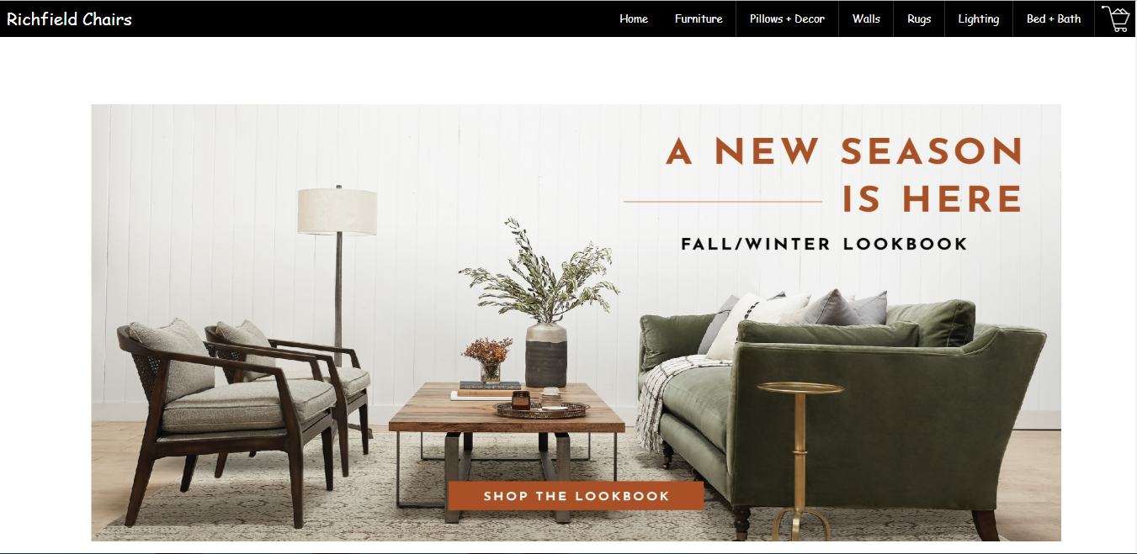

* The main page contains header, navigation bar, a shopping cart button, content page and footer.
* A dropdown menu is attached with navigation bar which on mouse hover, on navigation links, appears on the screen.
* Shopping cart button is linked with another content which appears on mouse click and it shows which products you are about to buy.
* Content page shows some information about new items and sales.
* Footer contains links (such as, Contact, Career.. Etc.) which on click shows information about the company and more facts about it.

**“ The Navigation Bar and Menu “**

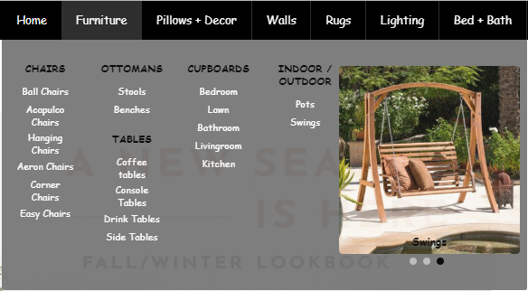

* Navigation bar contains links for categories of furniture which on mouse hover shows a dropdown menu.
* Menu contains different categories and their further type available.
* On click on types in menu content appears which shows the pictures of that type.

**The Content Page**

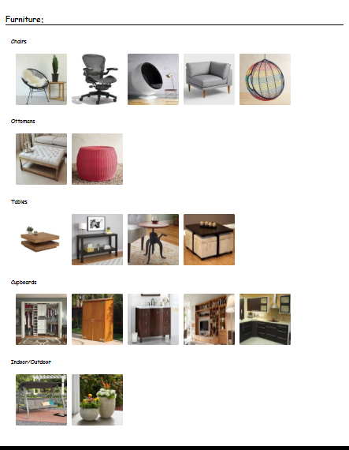

* The content page shows all types of furniture available and on click on any type will show you the products available of that type.
* You can click on any type and any product to view it’s detail or to add in the shopping cart.
* You can check the cart again through the cart button available in header.

**The Shopping Cart**

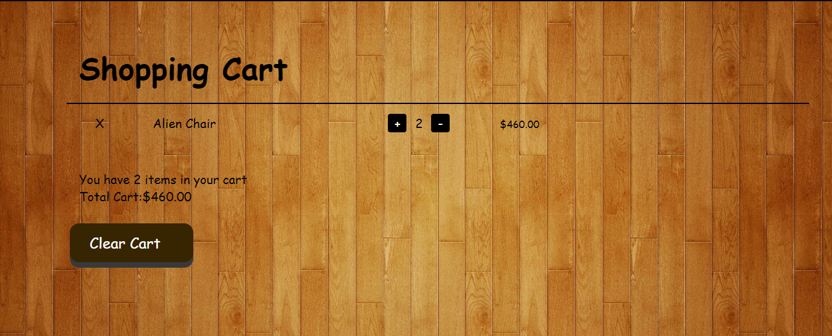

* The shopping cart shows all the products you are buying.
* You can increase or decrease the count of any product.
* You can also remove an item from cart.
* Or you can simply click on CLEAR CART to empty your shopping cart.

**The Footer**

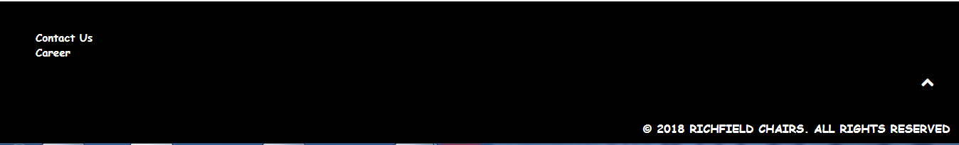

* The footer shows links of Contact and Career page which on click show the contact of that page.

**Developer’s Manual**

**“ Header + Navigation Bar “**



* Header contains a name of application and navigation bar, which contains different categories of products.
* For the name, there is a tag of <font> </font> which is floated on the left side.
* For the Cart icon on the header, there is a button created which has a background of cart icon and is floated on the right side.
* For the navigation pane, it is also floated right but after the cart icon.
* The navigation pane contains buttons which on mouse hover displays a dropdown menu.
* Dropdown menu also contains buttons which on mouse click displays the content of that particular category.
* Every button in navigation bar works as tab-links and content as tab-content.
* Through the JAVASCRIPT the tablinks change the class of the displayed content to “not active” and change the class of that content you want to see to “active”.
* This functionality shows the content of every category on mouse click.
* The CART button is also linked to a content which shows the SHOPPING CART (which contains the products you have stored to your cart.)

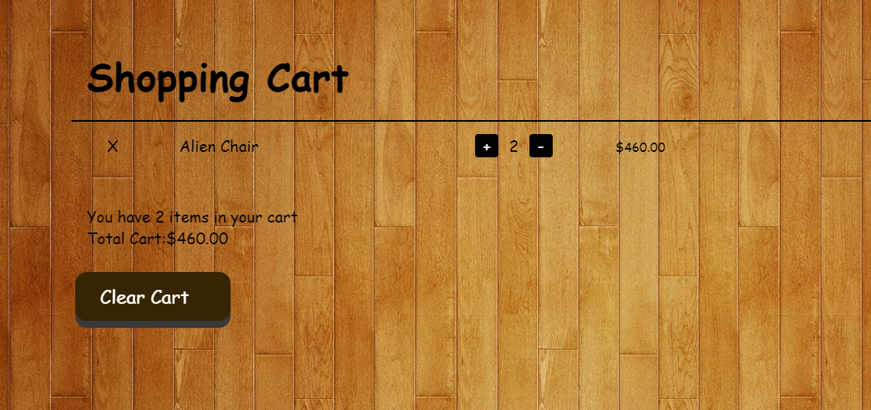**“ Shopping Cart “**

* The shopping cart works on JAVASCRIPT and a little bit JQUERY.
* The functions to store data, to add data and to delete data from the cart are created with JAVASCRIPT.
* It also has a function to store data in Local Storage of your browser with JSON.
* And it also loads your saved cart from local storage if you haven’t cleared or bought anything.
* On the content page:
  + The cross button for deleting the whole product.
  + The Count option for increasing or decreasing the quantity of product.
  + And a clear cart option to clear the whole cart
* JQUERY is used to display the products saved in the cart on the content linked to the CART button.

**“ CONTENT “**

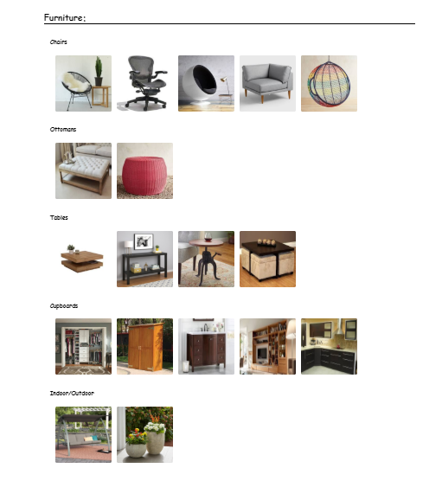

* The content works on JAVASCRIPT which appears on mouse click of the button linked to particular content.
* On mouse click at another link the previous content disappears and a new content appears.

**“ FOOTER “**

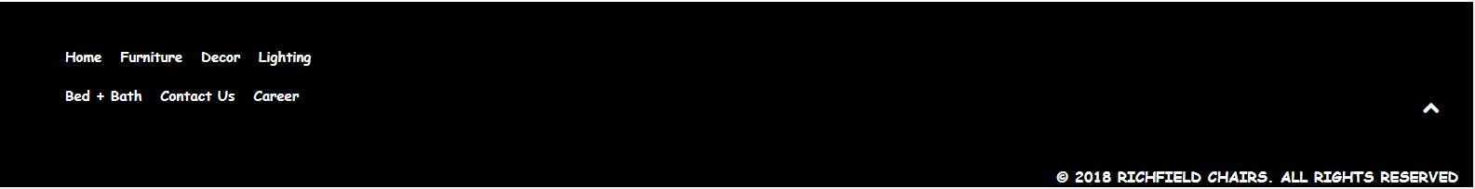

* The footer contains links for functioning the application through bottom.
* It contains the same links as in navigation bar but it also has a link to contact us and career page.

**“ @MEDIA QUERY “**



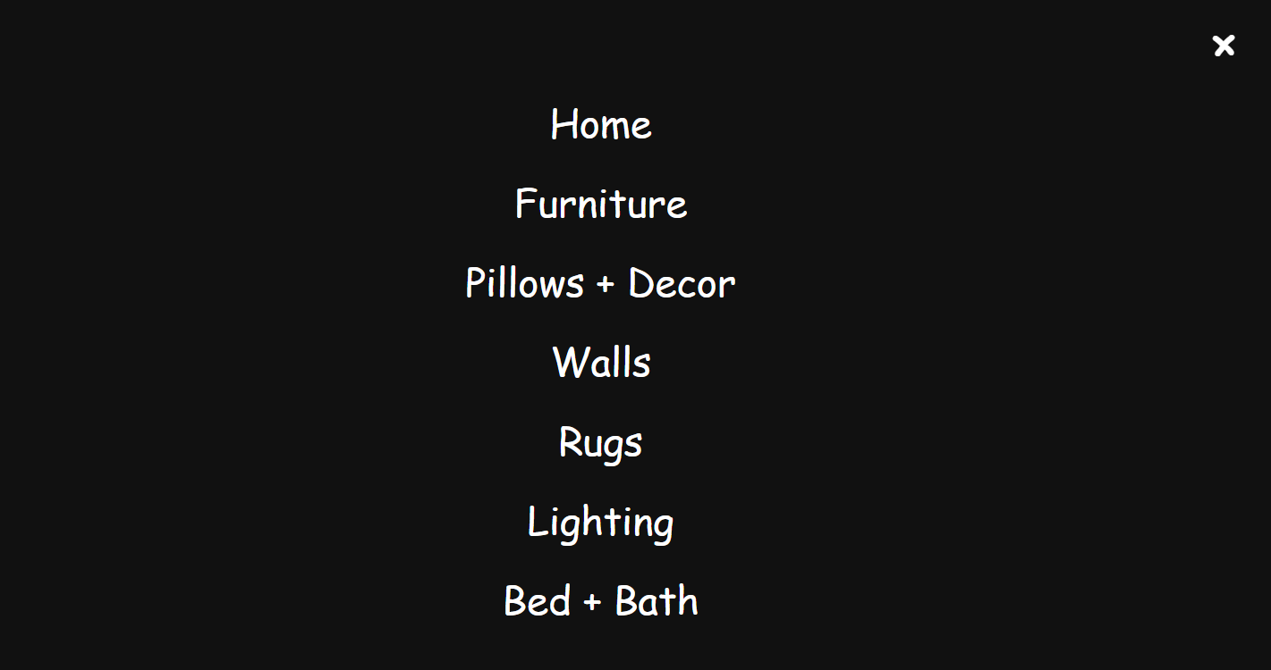

* 3 media queries are used for the mobile tablets and for bigger screens.
* The navigation bar for the mobile and tablets works on a button which appears only in mobile and tablet and on click on the button the overlay comes from the left side which shows the Navigation page.