v0.2
zVaults | ZOTH
Institutional Yield Infrastructure
Stablecoin Native RWA Yield, Tokenized Vaults, and Regulated Fund Structure
Zoth is a stablecoin-first neobank, the financial operating system for on-chain economies. This proposal covers zVault, Zoth's live institutional RWA yield infrastructure: a turnkey stack for launching tokenized, yield-bearing vaults, with an optional regulated fund layer for strategies that need one.
Zoth's edge is its partner network:
- Intellistake (CSE-listed),
- Bakkt (NYSE-listed, ICE-owned),
- LuLu Group International,
- Paxos
- Gauntlet

What makes Zoth unique
Zoth is a privacy-first, stablecoin-led neobank stack for the Global South and the agentic economy: that abstracts on-chain complexity to deliver sustainable yield, payments, and card services to non-crypto-native users, on institutional-grade infrastructure under a compliant, regulated framework.
Unlike providers that offer only a legal structure, a marketplace, or isolated technology, Zoth operates the full fund infrastructure: administration, custody, compliance, investment management, and reporting. The infrastructure is modular, so a customer adopts only the component that fits its requirement.

Traction
Metric | Figure
Peak TVL | $75M
Average monthly TPV | $40M+
Community | 1M+ across channels
Customers | 40+, including Standard Chartered Group, Plume, SingularityDAO, Lulu Group
Strategic partnerships | 25+, including Bakkt, Intellistake (CSE-listed), Chainlink, Huma

Recent Media Coverage
- Zoth raises strategic capital from Taisu Ventures, Luca Netz, and JLabs Digital
- Zoth enters into a strategic partnership with CSE listed Intellistake group to bring Stablecoin & RWA infra to capital markets
- Zoth Acquires Neemo Finance accelerating path to $1B market cap
- Zoth Unveils zPayments for Real-Time Stablecoin Payments with a $100M Road Map (Fox40)
- Stablecoins are becoming the new M&A battleground, here's who could be next (CB Insights)
- Zoth secures $15M token commitment from Bolts Capital (EIN Presswire)
- Zoth partners with Haven1 in $75M alliance to accelerate RWA adoption
- Zoth is featured in the top 10 protocols by TVL growth in the last 7 days

zVault
zVault lets institutions launch a tokenized, yield-bearing vault on Zoth's infrastructure without building vault contracts, custody, compliance, or a frontend.
Who it is for:
- Funds and strategists running yield strategies across TradFi and DeFi. This covers payment financing, delta-neutral basis, DeFi leverage and looping, and treasury bills. zVault supplies the contracts, custody, and regulated structure to issue these strategies as tokenized vaults.
- Chains launching native yield products for their ecosystem. zVault supplies the full backend, so a chain can bring RWA and DeFi yield to its users without building vault, custody, bridging, or compliance infrastructure in-house.

zVault stack
The zVault ecosystem provides institutional-grade vault infrastructure and a built-in distribution network for DeFi and RWA strategists to launch, manage, and scale yield vaults without building from scratch, so the strategy team focuses on alpha generation. The setup is modular.
Vault infrastructure layer
- Faster launch: go live in 3 to 4 weeks.
- Built-in distribution: marketplace access to institutional and retail capital through the Zoth network, including customers such as Olea (Standard Chartered Group), BlackOpal, and Deploy Finance.
- Enterprise-grade security: MPC custody, multiple signatories, withdrawal policies, execution guardrails, pre-audited smart contracts, and real-time risk monitoring with automated actions.
Regulated fund layer (FAAST)
- Speed to market: launch a compliant fund in under 4 weeks, not months.
- Cost efficiency: 70% saving against traditional fund setup and operating costs.
- Regulated structure: Segregated Portfolio Company (SPC) governed under the Cayman Islands Monetary Authority and the BVI Financial Commission, with built-in fund backend operations and compliance management.
- Low-touch operations: Zoth runs the backend, with multiple signatories and a risk-optimized redemption policy; licensed fund administrators safeguard investor interest.
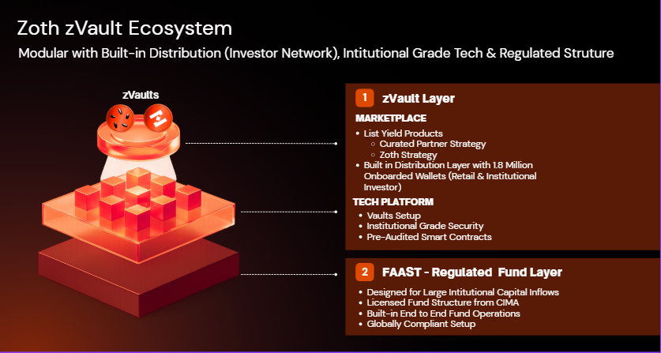

zVault at a glance
Token model | zTOKEN, an ERC-20 interest-bearing token priced by on-chain NAV
Live vaults | zOPAL (Base)
Custody | ForDefi MPC, multi-signatory
Compliance | Chainalysis sanctions oracle, contract-level screening
Regulated wrapper | FAAST (CIMA and BVI), optional
Strategy partners live | BlackOpal, Superstate

zVault Architecture
A zVault is a layered smart-contract system, not a single contract. Responsibilities are split across distinct contracts so that each does one job and the boundaries between them are auditable. The architecture is deployment-agnostic: every vault launched on the protocol reuses the same contract set, regardless of its underlying strategy. The design separates what must stay open and transparent (the token, the price feed) from what must stay tightly controlled (role administration, upgrades, custody authority).

zTOKEN
The zTOKEN is an ERC-20 representing a proportional share of the vault's NAV, the interest-bearing claim described earlier. New tokens can be created only by the DepositVault and destroyed only by the RedemptionVault, each through a dedicated minter / burner role assigned to that contract alone. No other address can mint or burn. Compliance is enforced on the token itself: every transfer, including mint and burn, is screened against the greenlist, blacklist and sanctions list before it executes.

SECURITY
zVaults are operated under a layered security framework that treats key custody, internal access, platform infrastructure, and on-chain activity as separate control domains, each independently enforced so a failure in one does not cascade into the others.
- Zoth has established partnerships with ForDeFi as the leading MPC wallet providers to ensure fund managers have access to battle-tested, enterprise-grade custody infrastructure.
- The contracts are audited by ENTERSOFT, an independent blockchain security firm, before deployment and on an ongoing basis as the codebase evolves.
- On-chain activity is monitored in real time by Cyvers, with automated alerting and response to anomalous transactions and threats.
- The protocol does not assume its deployed contracts stay configured as intended; it checks. An automated routine reads the on-chain state of every vault contract on a fixed daily schedule compares each critical parameter against its expected, governance-approved value.
Access technical docs here: https://docs.zoth.io/zoth/zvaults/
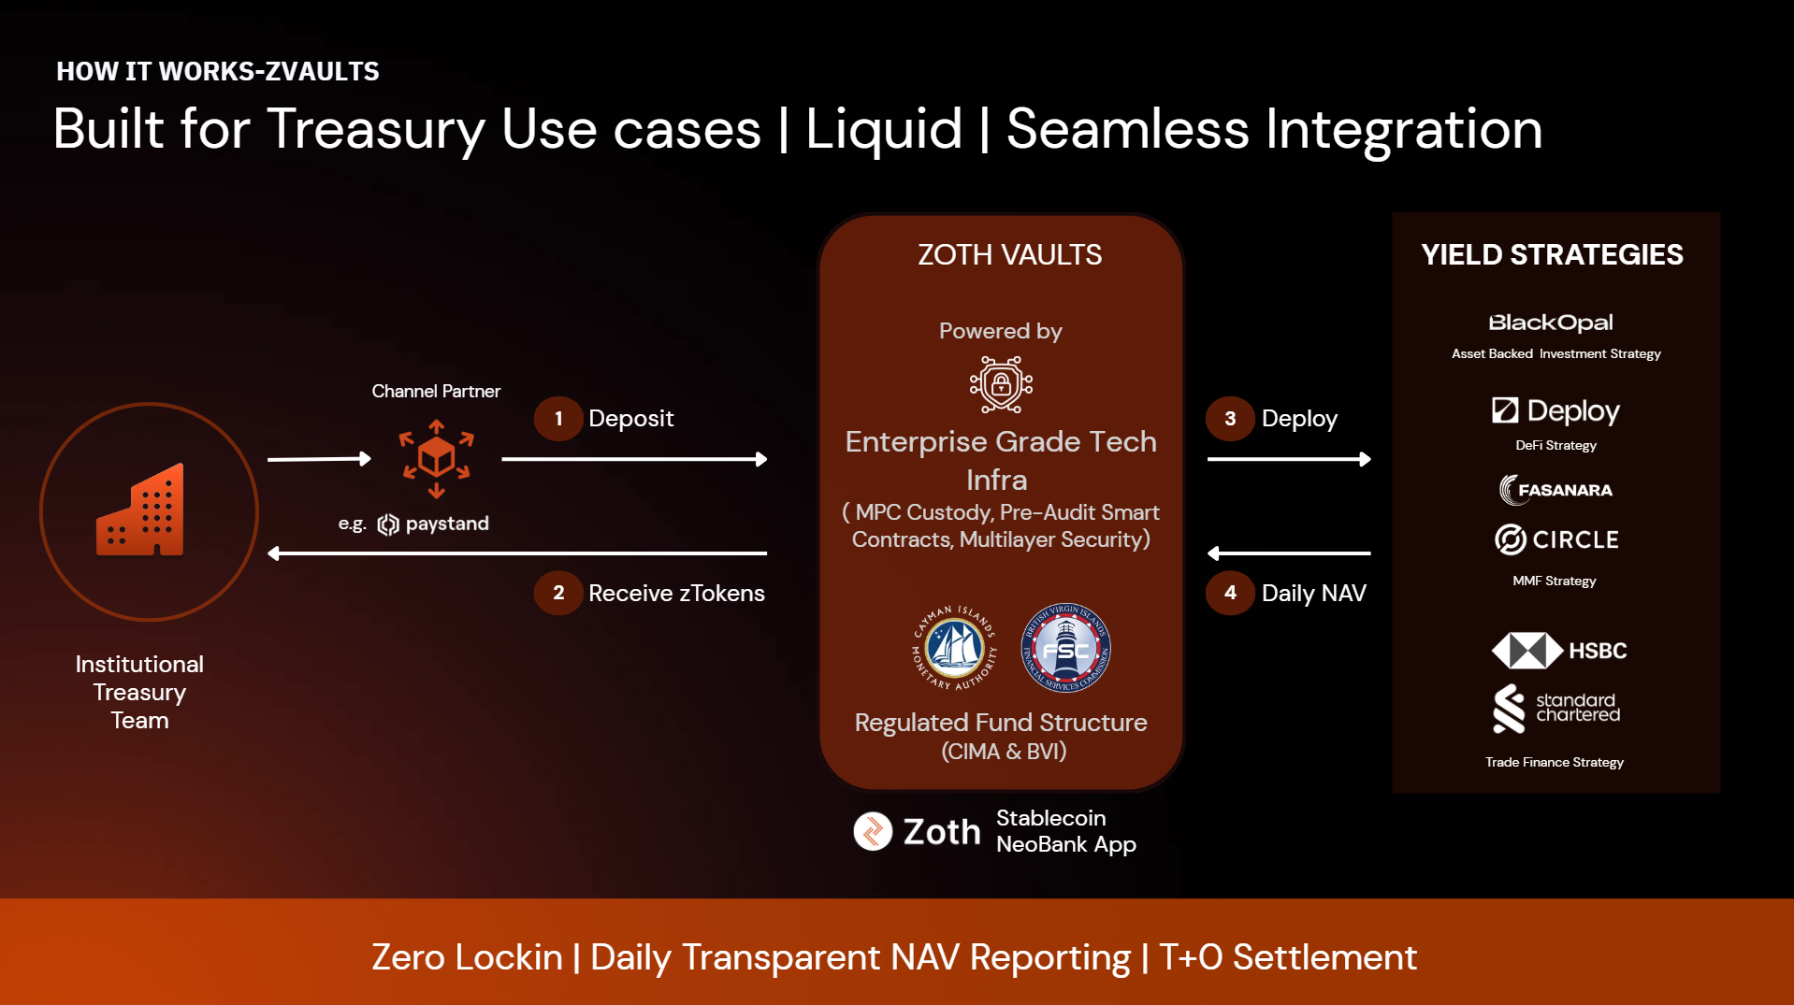

Distribute with zVaults
zVaults is a marketplace for vetted vaults. Every vault clears Zoth's framework on security, scalability, compliance, and yield value before it reaches retail and institutional customers, so a distributor can adopt a listed vault without running that diligence itself. In return, Zoth provides distribution through its network of neobanks, fintechs, and exchanges.
This distribution is live. One of North America's largest neobanks recently integrated zOPAL from zVaults to bring a high-yield, RWA-backed product to its customers and open a new revenue line for itself. Zoth brings distribution to
Centralized Crypto Platforms
- Tier-1: Binance, Bybit, OKX, Coinbase, Kraken
- Tier-2: CoinDCX, Mudrex
Neobanks
- Tier-1: Paystand, Paysafe
- Tier-2: Fassat, Blend

Case study: a neobank distributing zOPAL
The neobank held a growing base of customer stablecoin balances used for dollar exposure, local-currency protection, and cross-border payments, but those balances earned nothing productive. Existing stablecoin yield was either sub-4%, too low to offset inflation and FX pressure, or higher-yield at the cost of transparency and liquidity.
It integrated zOPAL, a structured RWA-backed vault on zVault infrastructure, linked to short-duration Brazilian credit-card receivables settled through Visa and Mastercard acquiring rails. The allocation delivered:
Feature | Detail
Yield | Up to 12% APY from real receivables cash flows
Loyalty layer | Zocta Points, a separate reward layer up to 4%, distinct from vault interest
Redemption | Daily, average under 30 minutes, 1 to 5 business days for larger requests
Maturity | Approximately 45-day average receivable maturity
FX | BRL exposure hedged to USD via NDFs
The commercial split. From a vault targeting up to 12%, the neobank passed roughly 10% to its customers, well above the sub-4% they earned before, while retaining a spread of around 200 bps as a new platform revenue layer.
Impact on $10M of eligible balances (illustrative)
Product | Customer APY | Annual customer yield on $10M
Existing product | 4% | $400,000
zOPAL RWA vault | 10% | $1,000,000
Illustrative model assuming $10M eligible balances and 200 bps economics. Actual balances and commercial terms remain confidential.
Why it worked
- No lock-ins, full liquidity: capital stayed accessible on demand while yield was maximized.
- Higher security: enterprise-grade, multi-layer custody and controlled execution.
- Third-party trust: Baa3 investment-grade rating from Cicada Partners for underlying strategy.

Criteria to onboard
zVault onboarding is permissioned. A vault inherits Zoth's distribution, custody, and compliance, so the strategy behind it has to meet a defined bar before launch. The criteria fall into two sets: eligibility, which qualifies the strategy, and operating terms, which govern how the vault behaves once live.

Eligibility
Criterion | Requirement | Rationale
Risk rating | A credit risk rating on the strategy (see Credit risk rating framework) | Independent assessment sets the loss expectation the vault is underwritten against
Liquidity | Minimum $5M in committed or addressable strategy liquidity | Below this, redemption guarantees and a meaningful TVL floor cannot be supported
Smart contract audit | Underlying strategy contracts audited by a recognized firm | A vault is only as safe as the code beneath it; unaudited strategy contracts are not onboarded
Regulated structure | A regulated fund structure, or adoption of Zoth's FAAST wrapper | Institutional capital and the FAAST substrate require a regulated base; where a strategy lacks one, FAAST supplies it
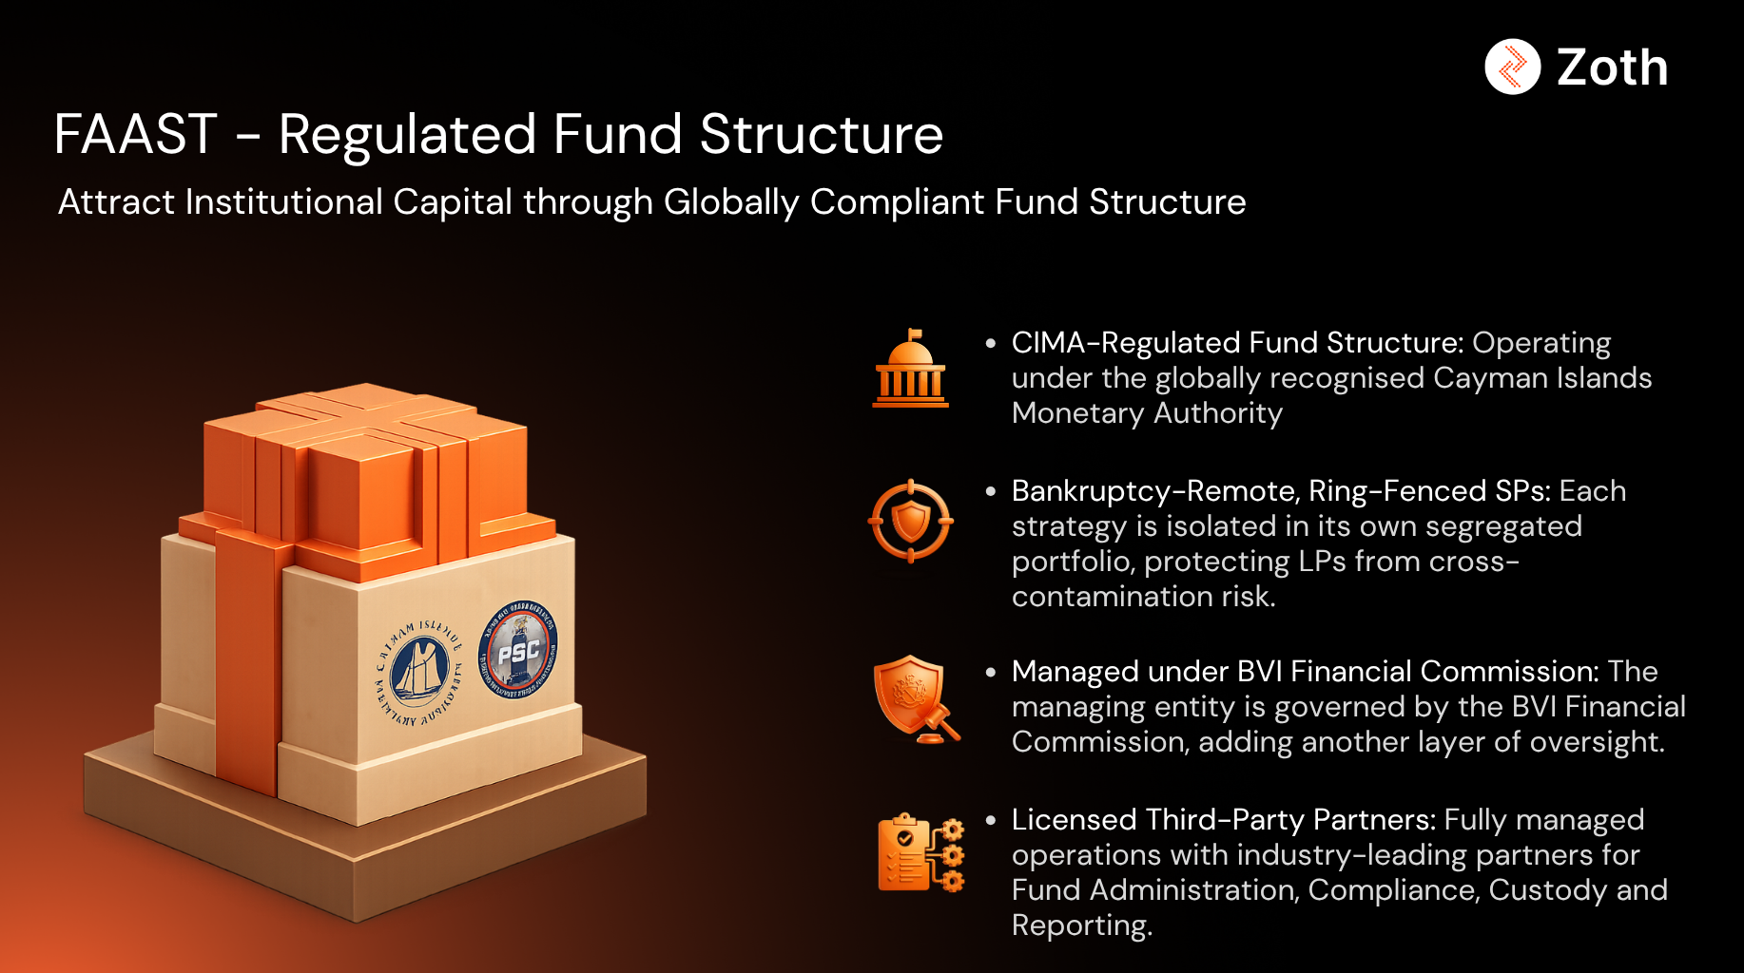

Operating terms
Term | Standard | Rationale
Lock-ups | None | Depositor capital stays liquid; lock-ups break the neobank spend-and-settle model
Redemption queue | Maximum T+5 business days | Caps settlement time so depositors and integrators can model a hard ceiling
Pricing | On-chain NAV via oracle | Price is verifiable on-chain, gated by tolerance and staleness bounds, never set off a private feed

Credit risk rating framework
Vault onboarding on zVault is permissioned and gated by a credit risk framework that every strategy must clear before launch. The framework exists to protect depositors and the platform: every strategy is assessed against the same dimensions before any capital is taken, and the rating it earns sets the terms it operates under.
A strategy that already carries a credit risk rating from a recognized framework can present it for review. A strategy that does not can still launch: Zoth extends its partnerships with credit risk rating organizations to rate the product before it goes live, so the absence of a prior rating is a step in the process rather than a barrier.

What the framework assesses
The assessment is built on the internal ratings-based (IRB) parameter set used in institutional credit risk: probability of default, loss given default, exposure at default, and effective maturity. zVault extends that core with the structural and operational dimensions that matter for an on-chain vault.
Dimension | What it covers
Probability of default (PD) | Likelihood the underlying borrowers, counterparties, or issuers fail to meet their obligations over the assessment horizon
Loss given default (LGD) | Share of exposure expected to be lost if a default occurs, after recovery
Exposure at default (EAD) | Amount outstanding and at risk at the point of default
Effective maturity (M) | Weighted time to repayment of the exposure; longer maturities carry more risk and raise the capital a strategy is assessed against
Expected and unexpected loss | The modeled central loss (PD x LGD x EAD) and the deviation from it under stress, which sizes the buffer a vault must hold
Concentration risk | Diversification across borrowers, sectors, geographies, and maturities; single-name and segment caps
Counterparty risk | Quality and dependency of the counterparties the strategy relies on for execution, settlement, and custody
Collateral and security | Nature, quality, and enforceability of any collateral, guarantees, or structural protections behind the exposure
Liquidity profile | How quickly positions can be unwound to meet redemptions, and the size of the liquidity buffer relative to the queue
Settlement and operational risk | Risk in the settlement path and in day-to-day operations, including the rails the cash flow depends on

Properties of the rating
- Mandatory before launch: no vault is deployed without a completed rating, whether supplied by the strategy or arranged through Zoth's partners.
- Independent: the rating is produced by a third-party framework, not self-reported by the strategy.
- Sets the operating terms: the rating informs the liquidity buffer, concentration caps, and redemption parameters the vault runs under.
- Ongoing, not one-time: ratings are monitored against early-warning indicators and refreshed as the strategy and market conditions move, with stress testing applied to gauge resilience.
- Transparent: the rating basis is disclosed to depositors so risk is visible rather than implied.

Tokenized risk assessment
The rating partner delivers the assessment as a tokenized risk score: the underlying scorecard is published on-chain so the rating, and the parameters behind it, are verifiable rather than held in a private report. The score is scoped to the strategy and refreshed on a defined cadence, which lets a depositor inspect the basis of a vault's rating at any time. The scorecard groups the parameters under four pillars.
Pillar | Parameters
Assets | Diversification; portfolio quality; liquidity; counterparty concentration; counterparty quality; base currency risk
Capital | Cash flow leverage; balance sheet leverage; seniority; quality of outside capital; systemic importance
Quality | ROIC and track record; retention rates and customer stickiness; historical and trending CAGRs; cash flow; pricing power; business competitiveness and strategy; complexity
Management | Incentive alignment; legacy, reputation, and franchise position; intangibles; transparency; consistency of reporting; opacity of reports; excess reports
Each pillar is scored and the pillars combine into the overall grade. The same scorecard is used across strategies, so a creator's vault is rated on the identical basis as every other vault on the platform.

How ratings are expressed
Credit rating agencies translate a credit assessment into a standardized grade. The three agencies most widely referenced are Moody's, S&P, and Fitch. Each runs its own scale, but the scales map closely to one another and split into two bands: investment grade, where default risk is low, and speculative grade, where it is materially higher. The boundary sits at Baa3 on the Moody's scale and BBB minus on S&P and Fitch; anything at or above that line is investment grade.
Band | Tier | Moody's | S&P / Fitch
Investment grade | Highest quality | Aaa | AAA
Investment grade | High quality | Aa1, Aa2, Aa3 | AA+, AA, AA-
Investment grade | Upper medium | A1, A2, A3 | A+, A, A-
Investment grade | Lower medium | Baa1, Baa2, Baa3 | BBB+, BBB, BBB-
Speculative | Speculative | Ba1, Ba2, Ba3 | BB+, BB, BB-
Speculative | Highly speculative | B1, B2, B3 | B+, B, B-
Speculative | Substantial risk | Caa | CCC
Speculative | Near or in default | Ca, C | CC, C, D
The grade carries direct consequences for a vault. An investment-grade strategy can support a tighter liquidity buffer and broader concentration limits; a speculative-grade strategy is held to stricter caps or is not onboarded. The tier also sets depositor expectations: the same rating language used across traditional fixed income lets an allocator price a zVault strategy against instruments it already understands.
The framework is why zOPAL is anchored to a strategy carrying an external investment-grade rating, Baa3 from Cicada Partners, and why every subsequent vault passes the same assessment before launch.

zVault ecosystem
The zVault thesis is proven by what runs on it. zOPAL is live; further vaults are in build or structuring, each with a named partner supplying the strategy and a distinct asset class. Four asset classes run on one contract set: a payment-financing fund, a stablecoin curator, a BTC protocol, and a gold issuer, each launched on zVault rather than building its own infrastructure.

Ecosystem at a glance
These underlying strategies are not closed. A new creator can take one as a building block and blend it with its own, composing a vault of vaults rather than sourcing every strategy from scratch. zoUSD is the first instance: Gauntlet blends its curated USDC allocation with zOPAL inside a single vault. This composability lets curators stand up differentiated products using strategies already proven on the platform.
Vault | Asset | Strategy partner | Class | Status | Target net yield
zOPAL | USDC | BlackOpal, Superstate | Payment financing + basis | Live, Base | ~12%
zoUSD | USDC | Gauntlet | Curated stablecoin | Structuring | ~7% blended
zBTC | WBTC, LBTC, cbBTC | Lombard | BTC carry | Structuring | up to ~6% on BTC
zPAXG | PAXG, PAXGy | Paxos | Leveraged gold yield | In discussion | 6 to 10% net

zOPAL with BlackOpal
zOPAL is the first live zVault, deployed on Base. It allocates across BlackOpal's LiquidStone II payment-financing strategy, backed by Brazilian credit-card receivables, and Superstate's USCC market-neutral basis trade, running the full deposit, NAV, and redemption cycle in production. Zoth anchored its first vault to BlackOpal because the yield comes from cleared card flows, not weaker credit.
Asset | USDC
Strategy | LiquidStone II payment financing, Superstate USCC basis
Chain | Base
Status | Live
Yield source | Real off-chain credit and basis returns

The strategy is operated through BLACKOPAL ONCHAIN CREDIT FUND 1 LTD. SAC, financing merchant credit across Brazil and connecting into the country's $750 billion credit-card payments market. It holds $11.6M in AUM, with 0.0% credit default and a 12.5% average APY. The two sleeves split as follows:
- 50 to 75% in short-term Brazilian credit-card receivables. The yield sleeve.
- 25 to 50% in a liquid, regulated strategy currently anchored by Superstate USCC. The liquidity sleeve.
How financing works
- In Brazil, 62 to 79% of consumer purchases are paid in installments, across six to seven 30-day cycles.
- BlackOpal finances these receivables for merchants, capturing the arbitrage in the spread.
- The fund targets a 45-day average repayment window or less from low-risk merchants such as restaurants, groceries, and gas stations, and excludes e-commerce, gambling, and subscriptions to limit fraud and chargebacks.
- Funding is approved against confirmed card-transaction receivables and disbursed automatically to merchants.
- Receivables settle directly through Visa and Mastercard, so the pool holds cleared card transactions, not unverified credit.
To Zoth, the merchant screen is the real risk control: keeping high-dispute categories out is what keeps the loss rate near zero.
Why the receivables carry a low risk profile
- 0% historical default across all receivables purchased to date.
- 50% of fund assets sit in USD; the remaining BRL/USD exposure is fully hedged through Non-Deliverable Forwards (NDFs).
- BlackOpal LiquidStone II holds a Baa3 investment-grade rating (Cicada Partners).
- BlackOpal is setting up a CVM-regulated FIDC sub-fund in Brazil, the standard onshore structure for pooling and funding receivables.
Certainty of repayment
BlackOpal is the registered beneficiary of each receivable in Brazil's C3 Registry, the receivables infrastructure mandated by the Brazilian Central Bank. Repayments route directly to the fund at settlement, never passing through the merchant, with settlement finality reinforced by BCB Resolution 522. The fund collects on money already moving inside the card-settlement system, which is the core reason Zoth anchored zOPAL to it.
Liquidity and redemptions
- The Superstate USCC sleeve (25 to 50%) is liquid and market-neutral, held as the redemption buffer.
- An operational stablecoin buffer covers routine redemptions on demand.
- Requests are accepted any day with no lock-up and settled FIFO: average redemption under 30 minutes, with a 1 to 5 business day window for larger requests.
Redemption obligations are fulfilled by BLACKOPAL ONCHAIN CREDIT FUND 1 LTD. SAC, the fund managing the underlying strategy. As a Segregated Account Company, its assets are legally ring-fenced from any other account the entity runs, insulating zOPAL holders from liabilities elsewhere in the structure.

zoUSD with Gauntlet
zoUSD is the first vault of vaults on zVault. It blends Gauntlet's USD Alpha vault, gtUSDA, with zOPAL inside a single zTOKEN: gtUSDA contributes a curated, risk-managed DeFi stablecoin yield, and zOPAL contributes payment-financing return. Gauntlet brings the curation methodology and risk framework on its allocation; zVault supplies the contracts, custody, distribution, and the zOPAL strategy as a building block.
Asset | USDC
Strategy | Gauntlet gtUSDA (USD Alpha) blended with zOPAL
Allocation | 70% gtUSDA, 30% zOPAL
Partner role | Curation and risk management of the gtUSDA allocation
Status | Structuring
Target yield | ~7% net blended

How the blended APY is calculated
The vault APY is the allocation-weighted average of the two sleeves: (70% x gtUSDA APY) + (30% x zOPAL APY), net of fees. An indicative sleeve yields this blend to approximately 7% net. The weighting can be tuned within governance-approved bounds as each sleeve's yield moves.

zBTC with Lombard
zBTC is a Bitcoin-denominated yield vault. BTC is supplied as collateral, USDC is borrowed against it, and the borrowed stablecoin is deployed into zOPAL, so the yield comes from the carry while the BTC position is preserved. Lombard anchors distribution as a liquid-staking partner alongside Threshold and Base. The wedge is that a holder earns institutional yield without selling or surrendering custody of the underlying BTC.
Asset | WBTC, LBTC, cbBTC
Strategy | BTC collateral, USDC borrow, zOPAL carry
Partner role | Liquid-staking distribution
Status | Structuring
Target yield | up to ~6% net on BTC

zPAXG with Paxos
zPAXG is a curated leveraged yield vault on tokenized gold, built for family-office demand. PAXG is supplied as collateral, stablecoins are borrowed against it, and the borrowed stablecoin is deployed into curated yield strategies. Gold price exposure is preserved on 100% of the deposited collateral, so a holder earns yield without giving up the underlying gold position. PAXG is the first asset given the existing Zoth-Paxos relationship and the regulated backing that the target family-office tier requires.
Asset | PAXG, PAXGy
Strategy | PAXG collateral, stablecoin borrow, curated yield deployment
Partner role | Regulated tokenized-gold issuance
Status | In discussion
Target yield | 6 to 10% net, gold exposure preserved

Three-tier product stack
- Tier 1, tokenized gold: PAXG in its existing form. No yield.
- Tier 2, yield-bearing wrap: gold-leasing exposure, targeting around 3% from lease rates.
- Tier 3, leveraged vaults: three to four vaults at launch, each operated by an institutional fund manager, at roughly 70% LTV, targeting 6 to 10% net. The tiers stack, and a family office allocates each slice where it wants.
Distribution is the wedge: Zoth brings family-office BD coverage across five priority geographies and CEX integration for the yield product, with the pitch to shift physical and ETF gold allocation into the tokenized layer and route a portion into the leveraged vaults. For Paxos, this drives PAXG supply growth and positions PAXG as the productive-collateral standard among regulated tokenized gold.

What the ecosystem demonstrates
Multiple asset classes, multiple partners, one infrastructure layer. A payment-financing fund, a stablecoin curator, a BTC protocol, and a gold issuer each chose to launch on zVault rather than build vault infrastructure themselves. For a prospective creator the signal is direct: the stack is proven across asset types, and the partner roster is the diligence reference.

zOPAL Vault Performance Report
Zoth’s first live yield vault on Base. The vault prices a single NAV per zOPAL token and targets an annualized yield of approximately 12 percent. The figures below are drawn from the on-chain NAV oracle and describe realized performance over the period.

Summary
Metric | Value
Reporting period | 23 Mar 2026 to 21 Jun 2026
Daily NAV readings | 89
Starting NAV | 1.000000
Current NAV | 1.015664
Current APY | 12.34%
Trailing 30 day average APY | 10.62%
Peak APY | 12.48%

NAV has risen from 1.000000 at inception to 1.015664, a cumulative gain of 1.57 percent across 89 daily readings. The path divides into three distinct phases.
Illustrative Returns: $1,000,000 at Inception
A 1,000,000 dollar deposit at inception, when NAV was 1.000000, mints 1,000,000 zOPAL tokens. Held unchanged, those tokens are worth $1,015,664.19 at the current NAV, an earned gain of $15,664.19 since inception. The gain is NAV appreciation alone, with no additional deposits and no action by the holder.
Date | Stage | NAV | Position value | Earned
2026-03-23 | Deposit (inception) | 1.000000 | $1,000,000.00 | $0
2026-04-16 | Yield activation | 1.000569 | $1,000,568.63 | $568.63
2026-05-01 | Early ramp | 1.001596 | $1,001,596.43 | $1,596.43
2026-05-15 | Reaches target band | 1.005119 | $1,005,118.61 | $5,118.61
2026-06-01 | Mature regime | 1.008876 | $1,008,876.32 | $8,876.32
2026-06-21 | Current | 1.015664 | $1,015,664.19 | $15,664.19
Roughly nothing accrued during the first three weeks of warm-up, about 1,600 dollars through the April ramp, and the remainder across May and June once the vault settled into its target band.
Net of fees. No separate vault fee was applied during the period, so NAV is what the holder keeps. If a management or performance fee is later charged at the vault level, the net figure reduces accordingly.
Forward context. A full year at the current 12.34 percent run-rate on the same 1,000,000 dollars is approximately $123,362. This is illustrative and forward-looking, not a realized figure.

Full dataset available at request or publicly accessible onchain
Timestamp (UTC) | NAV | APY
2026-06-16 06:30 | 1.014380 | 10.44%
2026-06-17 06:30 | 1.014705 | 12.29%
2026-06-18 06:30 | 1.015029 | 12.30%
2026-06-19 06:30 | 1.015353 | 10.56%
2026-06-20 06:30 | 1.015664 | 12.33%
2026-06-21 06:30 | 1.015664 | 12.34%

Summary
Zoth is a stablecoin-first neobank, the financial operating system for on-chain economies. This proposal covers zVault, Zoth's live institutional yield infrastructure: a turnkey stack for launching tokenized, yield-bearing vaults, with an optional regulated fund layer for strategies that need one.
Zoth's edge is its partner network:
- Intellistake (CSE-listed),
- Bakkt (NYSE-listed, ICE-owned),
- LuLu Group International,
- Paxos
- Gauntlet
Who it is for:
- Funds and strategists running yield strategies across TradFi and DeFi. This covers payment financing, delta-neutral basis, DeFi leverage and looping, and treasury bills. zVault supplies the contracts, custody, and regulated structure to issue these strategies as tokenized vaults.
- Chains launching native yield products for their ecosystem. zVault supplies the full backend, so a chain can bring RWA and DeFi yield to its users without building vault, custody, bridging, or compliance infrastructure in-house.
What is included in the stack:
- zVault on-chain contracts: Deposit, redemption, NAV update, and access-control logic for each vault.
- MPC custody, with ForDefi. Institutional key management, with multi-signer approval on every movement of funds.
- Cross-chain bridging, EVM and non-EVM. Assets move to the chain the product launches on inside a single flow.
- Security and risk monitoring, with Cyvers. Continuous detection across the contract and custody surface.
- Regulated Structure as Segregated Portfolio Company (SPC) governed under the Cayman Islands Monetary Authority and the BVI Financial Commission, with built-in fund backend operations and compliance management.
- Credit risk rating. Independent assessment of the credit underlying each strategy.
What you achieve with zVaults:
- Faster launch: go live in 3 to 4 weeks.
- Cost efficiency: 70% saving against traditional fund setup and operating costs.
- Configurable fee logic at the vault level, across management, platform, and withdrawal fees.
The zVault Ecosystem: For a prospective creator the signal is direct: the stack is proven across asset types, and the partner roster is the diligence reference.
- [LIVE] zOPAL is the first live zVault, deployed on Base. It allocates across BlackOpal's LiquidStone II payment-financing strategy, backed by Brazilian credit-card receivables, and Superstate's USCC market-neutral basis trade. The AUM in strategy is $20.5M, with 0.0% default rate, 12.2% current APY.
- [STRUCTURING] zPAXG is a curated leveraged yield vault by Paxos on their tokenized gold, built for family-office demand. PAXG is supplied as collateral, stablecoins are borrowed against it, and the borrowed stablecoin is deployed into curated yield strategies.
- [STRUCTURING] zoUSD with Gauntlet is the first vault of vaults on zVault. It blends Gauntlet's USD Alpha vault, gtUSDA, with zOPAL inside a single zTOKEN: gtUSDA contributes a curated, risk-managed DeFi stablecoin yield, and zOPAL contributes payment-financing return.

Criteria to launch zVault:
To maintain consistent standards of risk management, operational security, and investor protection, all prospective vaults are subject to a formal onboarding and assessment process.

Capital Requirements: Strategies must demonstrate institutional-scale viability, with a minimum investment capacity of $5 million.

Security : All underlying strategy contracts must undergo independent security audits prior to onboarding. The following Audit companies are

Asset Authorization: Each vault must define its approved asset universe prior to launch. Only assets explicitly approved during onboarding may be deposited, held, or deployed by the vault. The addition of new assets requires a formal review and policy update process.

Custody Segregation: Vault creators must maintain a clear segregation of responsibilities across custody environments. Separate MPC vaults must be designated for:
- Investor subscriptions and capital inflows
- Strategy deployment and treasury operations
- Investor redemptions and distributions
No single MPC environment may be authorized to perform all functions across the asset lifecycle.

Portfolio Concentration Limits: To mitigate concentration risk, zVault applies asset-level exposure guidelines:
  - Chain Concentration
- Ethereum Mainnet: Up to 100% of NAV
- EVM L2s: Base, Arbitrum, OP Up to 100% of NAV
- Non EVM: Movement, Aptos Up to 100% of NAV
- For any other chain, it needs prior mandate

Asset-Level Exposure
- USDC and USDT: No concentration limits
- WBTC and WETH: No concentration limits
- PAXG, XAUT: No concentration limits
- All other assets: Prior approval or maximum allocation of 25% of AUM

Transparency Requirements: Vault issuers must provide:
- Comprehensive Terms & Conditions (T&Cs)
- Strategy disclosures and risk documentation
- A publicly accessible transparency dashboard for ongoing monitoring of vault performance and allocations

Risk Limits: Eligible strategies are expected to operate within predefined risk limits:
- Maximum peak-to-trough drawdown: 10%
- Maximum monthly drawdown: 5%

Commercials

Commercials
Pricing follows the regulated-fund choice. A strategy that already operates a regulated fund takes zVault alone. A strategy that needs a regulated fund takes zVault with FAAST, where Zoth provides the structure.
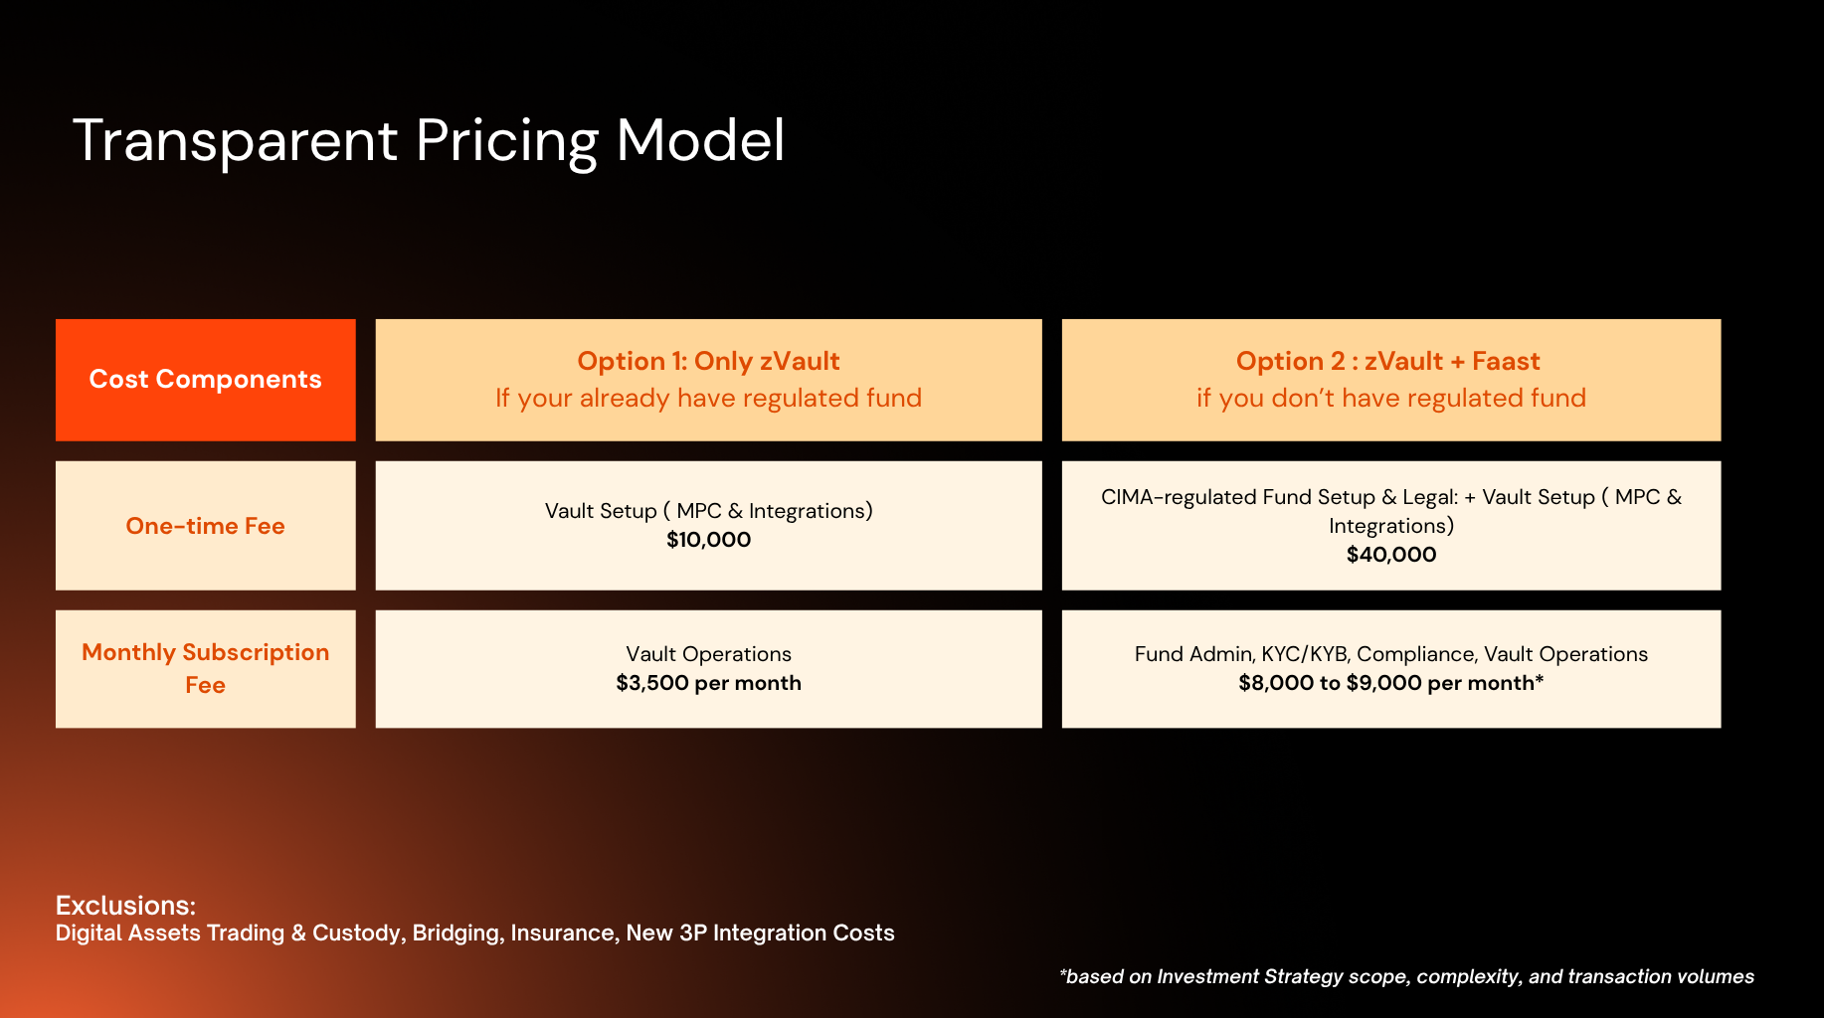

Option 1: zVault (bring your own regulated fund)
For strategies that already hold a regulated fund structure. Zoth supplies the vault infrastructure, custody, compliance, and distribution.
- One-time setup fee: waived.
- Subscription fee (vault and tech infrastructure): $3,000 per month per vault.
On elevation to a strategic partnership, alignment to the partner chain's incentive-program criteria, and inflows above $10M TVL into the vault, the monthly subscription fee may be fully subsidized.

Option 2: zVault + FAAST (regulated fund provided)
For strategies that need a regulated fund. Zoth provides the FAAST structure (a Segregated Portfolio Company under CIMA and BVI) on top of the same vault infrastructure. Pricing is the FAAST fee plus the zVault infrastructure fee.
FAAST, choose one fee structure
Structure | One-time setup | Subscription (admin + operations)
Optimized one-time setup | $20,000 | $6,500 per month
Optimized monthly recurring | $40,000 | $5,000 per month
Plus zVault infrastructure: the same $3,000 per month per vault from Option 1 (setup waived).
On elevation to a strategic partnership, alignment to the partner chain's incentive-program criteria, and inflows above $10M TVL into the fund or vault, the monthly subscription fees may be fully subsidized.
Note: Zoth does not separately charge the strategy partner for distribution. The model may instead charge end users a performance fee, platform fee, or withdrawal fee depending on the yield strategy.

zOPAL

zOPAL
zOPAL is the first live zVault, deployed on Base. It allocates across BlackOpal's LiquidStone II payment-financing strategy, backed by Brazilian credit-card receivables, and Superstate's USCC market-neutral basis trade, running the full deposit, NAV, and redemption cycle in production. Zoth anchored its first vault to BlackOpal because the yield comes from cleared card flows, not weaker credit.
Asset | USDC
Strategy | LiquidStone II payment financing, Superstate USCC basis
Chain | Base
Status | Live
Yield source | Real off-chain credit and basis returns

The strategy is operated through BLACKOPAL ONCHAIN CREDIT FUND 1 LTD. SAC, financing merchant credit across Brazil and connecting into the country's $750 billion credit-card payments market. It holds $11.6M in AUM, with 0.0% credit default and a 12.5% average APY. The two sleeves split as follows:
- 50 to 75% in short-term Brazilian credit-card receivables. The yield sleeve.
- 25 to 50% in a liquid, regulated strategy currently anchored by Superstate USCC. The liquidity sleeve.
How financing works
- In Brazil, 62 to 79% of consumer purchases are paid in installments, across six to seven 30-day cycles.
- BlackOpal finances these receivables for merchants, capturing the arbitrage in the spread.
- The fund targets a 45-day average repayment window or less from low-risk merchants such as restaurants, groceries, and gas stations, and excludes e-commerce, gambling, and subscriptions to limit fraud and chargebacks.
- Funding is approved against confirmed card-transaction receivables and disbursed automatically to merchants.
- Receivables settle directly through Visa and Mastercard, so the pool holds cleared card transactions, not unverified credit.
To Zoth, the merchant screen is the real risk control: keeping high-dispute categories out is what keeps the loss rate near zero.
Why the receivables carry a low risk profile
- 0% historical default across all receivables purchased to date.
- 50% of fund assets sit in USD; the remaining BRL/USD exposure is fully hedged through Non-Deliverable Forwards (NDFs).
- BlackOpal LiquidStone II holds a Baa3 investment-grade rating (Cicada Partners).
- BlackOpal is setting up a CVM-regulated FIDC sub-fund in Brazil, the standard onshore structure for pooling and funding receivables.
Certainty of repayment
BlackOpal is the registered beneficiary of each receivable in Brazil's C3 Registry, the receivables infrastructure mandated by the Brazilian Central Bank. Repayments route directly to the fund at settlement, never passing through the merchant, with settlement finality reinforced by BCB Resolution 522. The fund collects on money already moving inside the card-settlement system, which is the core reason Zoth anchored zOPAL to it.
Liquidity and redemptions
- The Superstate USCC sleeve (25 to 50%) is liquid and market-neutral, held as the redemption buffer.
- An operational stablecoin buffer covers routine redemptions on demand.
- Requests are accepted any day with no lock-up and settled FIFO: average redemption under 30 minutes, with a 1 to 5 business day window for larger requests.
Redemption obligations are fulfilled by BLACKOPAL ONCHAIN CREDIT FUND 1 LTD. SAC, the fund managing the underlying strategy. As a Segregated Account Company, its assets are legally ring-fenced from any other account the entity runs, insulating zOPAL holders from liabilities elsewhere in the structure.

Vault Performance Report
Zoth’s first live yield vault on Base. The vault prices a single NAV per zOPAL token and targets an annualized yield of approximately 12 percent. The figures below are drawn from the on-chain NAV oracle and describe realized performance over the period.

Summary
Metric | Value
Reporting period | 23 Mar 2026 to 21 Jun 2026
Daily NAV readings | 89
Starting NAV | 1.000000
Current NAV | 1.015664
Current APY | 12.34%
Trailing 30 day average APY | 10.62%
Peak APY | 12.48%

NAV has risen from 1.000000 at inception to 1.015664, a cumulative gain of 1.57 percent across 89 daily readings. The path divides into three distinct phases.
Illustrative Returns: $1,000,000 at Inception
A 1,000,000 dollar deposit at inception, when NAV was 1.000000, mints 1,000,000 zOPAL tokens. Held unchanged, those tokens are worth $1,015,664.19 at the current NAV, an earned gain of $15,664.19 since inception. The gain is NAV appreciation alone, with no additional deposits and no action by the holder.
Date | Stage | NAV | Position value | Earned
2026-03-23 | Deposit (inception) | 1.000000 | $1,000,000.00 | $0
2026-04-16 | Yield activation | 1.000569 | $1,000,568.63 | $568.63
2026-05-01 | Early ramp | 1.001596 | $1,001,596.43 | $1,596.43
2026-05-15 | Reaches target band | 1.005119 | $1,005,118.61 | $5,118.61
2026-06-01 | Mature regime | 1.008876 | $1,008,876.32 | $8,876.32
2026-06-21 | Current | 1.015664 | $1,015,664.19 | $15,664.19
Roughly nothing accrued during the first three weeks of warm-up, about 1,600 dollars through the April ramp, and the remainder across May and June once the vault settled into its target band.
Net of fees. No separate vault fee was applied during the period, so NAV is what the holder keeps. If a management or performance fee is later charged at the vault level, the net figure reduces accordingly.
Forward context. A full year at the current 12.34 percent run-rate on the same 1,000,000 dollars is approximately $123,362. This is illustrative and forward-looking, not a realized figure.

Full dataset available at request or publicly accessible onchain
Timestamp (UTC) | NAV | APY
2026-06-16 06:30 | 1.014380 | 10.44%
2026-06-17 06:30 | 1.014705 | 12.29%
2026-06-18 06:30 | 1.015029 | 12.30%
2026-06-19 06:30 | 1.015353 | 10.56%
2026-06-20 06:30 | 1.015664 | 12.33%
2026-06-21 06:30 | 1.015664 | 12.34%

Frequently Asked Questions
Which stablecoin does the zOPAL vault accept for deposit?
USDC is the deposit asset for the zOPAL vault.
What does a depositor receive at deposit?
An ERC-20 interest-bearing vault token. Its unit price appreciates as the underlying strategies generate yield. There is no manual claiming.
What is the token called?
zOPAL.
Who issues it?
Minting is performed exclusively by the DepositVault contract following a valid deposit, and burning exclusively by the RedemptionVault. Zoth operates the vault infrastructure.
Who is the legal obligor to redeem it back into the underlying stablecoin?
Redemption is a contractual on-chain process: zOPAL is burned and USDC is returned to the oracle NAV from vault custody. Vault operations sit with the Zoth operating entity, which controls the vault and MPC custody. The redemption obligation sits with the underlying strategy, run by BlackOpal through the BlackOpal Onchain Private Credit Fund 1 Ltd. SAC, which processes the aggregated redemption requests.
Is the token transferable, restricted, whitelisted, or only redeemable?
zOPAL is a standard ERC-20 token and is freely transferable between wallets. As a security control, every redemption request is screened so that no wallet flagged as critical risk can redeem.
How does yield accrue: token appreciation, rebasing, periodic distribution, or another mechanism?
Through token appreciation, measured as NAV. There is no rebasing and no distributions to claim. NAV updates once daily, so yield compounds automatically into the token price.
What documentation governs the deposit, token, and redemption process?
The product requirements document and technical architecture document cover the full deposit, token, and redemption mechanics. https://docs.zoth.io/zoth/zvaults/
Are there any gates, lockups, redemption queues, NAV delays, withdrawal limits, or liquidity windows?
Deposits are instant at any size, with no lockups. On redemption, the average request is processed in under 30 minutes; large redemption requests settle within 1 to 5 business days, processed first come first served. Requests submitted over a weekend are processed the following Monday.
What legal entity stands behind the product, and is an agreement required to deposit or redeem?
zOPAL is a permissionless product, so no agreement is required to deposit or redeem. Where a counterparty's internal process requires one, Zoth's entity, METACO INTELLIGENCE CORPORATION, governed under the laws of Panama, can execute an NDA and any required partnership agreement.

