zVaults

What are zVaults?
zVaults are the foundational infrastructure layer of the Zoth protocol: specialized, yield-generating investment vehicles that bring institutional fund management on-chain. Each zTOKEN is an ERC-20 compliant, interest-bearing token whose price appreciates over time to reflect yield accrued from the vault's underlying strategies.
zTOKENs are not stablecoins. Where a stablecoin holds fixed value parity, a zTOKEN behaves as a tokenized fund share: each token is a proportional claim on the vault's net asset value (NAV), and its value moves with the NAV as the strategies perform. This share-based model mirrors conventional mutual fund and hedge fund structures, with blockchain settlement adding transparency, composability, and efficient settlement.
A zVault can run a single strategy or combine several. zOPAL, the first live vault, allocates across two: BlackOpal's LiquidStone II credit strategy and Superstate's market-neutral basis trading. Each vault carries a defined mandate and risk profile, so investors and auditors can assess exposure against clear parameters rather than an open-ended basket.
zVaults draw exposure from across these strategy categories:
Strategy category | Exposure
Real-World Asset (RWA) | Tokenized traditional assets like ETFs, gold etc: commodities, secured lending, equity positions
DeFi Strategy | On-chain yield via liquidity provision, lending, derivatives, and trading
Private Credit and Lending | Direct credit facilities and structured lending arrangements
Geographic-Specific | Strategies focused on a particular jurisdiction or region

Fund managers retain full operational control over strategy execution and may deploy capital across any DeFi protocol, network, or asset within their vault's mandate.

How to Make Your Yield Product Legally Compliant
A zVault can be plugged into a compliant stack with FAAST whenever its creator wants a regulated legal substrate behind the token. The vault is the technical layer: an ERC-20 interest-bearing token, deposit and redemption contracts, NAV-based pricing, and MPC custody. It works on its own. FAAST is a separate legal layer a vault creator opts into on top of those rails.
FAAST is a regulated fund structure operated as a Segregated Portfolio Company (SPC) under the Cayman Islands Monetary Authority (CIMA) and the BVI Financial Commission. It runs as a fully managed legal framework: independent directors hold governance, a licensed fund administrator processes subscriptions and redemptions and calculates NAV, an appointed custodian holds the assets, and an external auditor verifies them. The SPC form lets the fund hold assets and liabilities in separate, walled-off portfolios, which is what delivers ring-fenced, bankruptcy-remote protection. A vault plugged into FAAST therefore sits inside a structure that meets the governance, NAV reporting, and asset-segregation standards professional allocators expect.
This is the distinction from most yield infrastructure. Other providers ship the technical rails and stop there: smart contracts, a token, a yield source, with the legal wrapper left to the creator. Zoth provides both. A team can launch a zVault on technical rails alone, or plug it into FAAST and get a regulated fund structure underneath the same token.
What each layer provides:
Layer | What it provides
zVault (technical architecture) | ERC-20 interest-bearing token, deposit and redemption contracts, NAV-based pricing, MPC custody, on-chain transparency
FAAST (legal architecture) | Regulated fund structure under CIMA and BVI, Segregated Portfolio Company isolation, independent fund administrator, custodian, auditor, ring-fenced and bankruptcy-remote protection

When a vault creator plugs into FAAST, the vault gets its own segregated portfolio inside the SPC. Capital flowing through the on-chain contracts maps to a regulated fund position: assets are custodied and administered under the fund's mandate, NAV is attested by an independent administrator, and token holder claims are isolated from protocol insolvency and from other vaults' performance. The same on-chain token now carries a legal claim on regulated, audited assets.
This combination is the differentiator. Institutional allocators need a regulated structure, independent NAV attestation, segregation, and bankruptcy remoteness before they can deploy, and smart contracts alone do not deliver any of it. Technical-only infrastructure leaves that allocator to either stay off-chain or accept unsecured protocol risk.

zVault Architecture
A zVault is a layered smart-contract system, not a single contract. Responsibilities are split across distinct contracts so that each does one job and the boundaries between them are auditable. The architecture is deployment-agnostic: every vault launched on the protocol reuses the same contract set, regardless of its underlying strategy. The design separates what must stay open and transparent (the token, the price feed) from what must stay tightly controlled (role administration, upgrades, custody authority).

The Five Layers
The protocol stacks into five horizontal layers, from upgrade control at the top to external integrations at the bottom.
Layer | Contracts | Responsibility
Proxy | ProxyAdmin | Owns all upgradeable proxies. Multisig-controlled. Enables upgrades without state migration
Access control | ZothAccessControl, FunctionsAccessControl | Single source of truth for roles. ZothAccessControl governs vault and token roles; FunctionsAccessControl governs oracle roles
Token and oracle | zTOKEN, PriceOracle | The ERC-20 NAV-share token (upgradeable) and the non-upgradeable NAV price feed
Vault layer | DepositVault, RedemptionVault | DepositVault mints the zTOKEN against deposits; RedemptionVault burns it and returns deposit asset.
External | Screener | Screens addresses and correctly identifies risks before authorizing transactions.
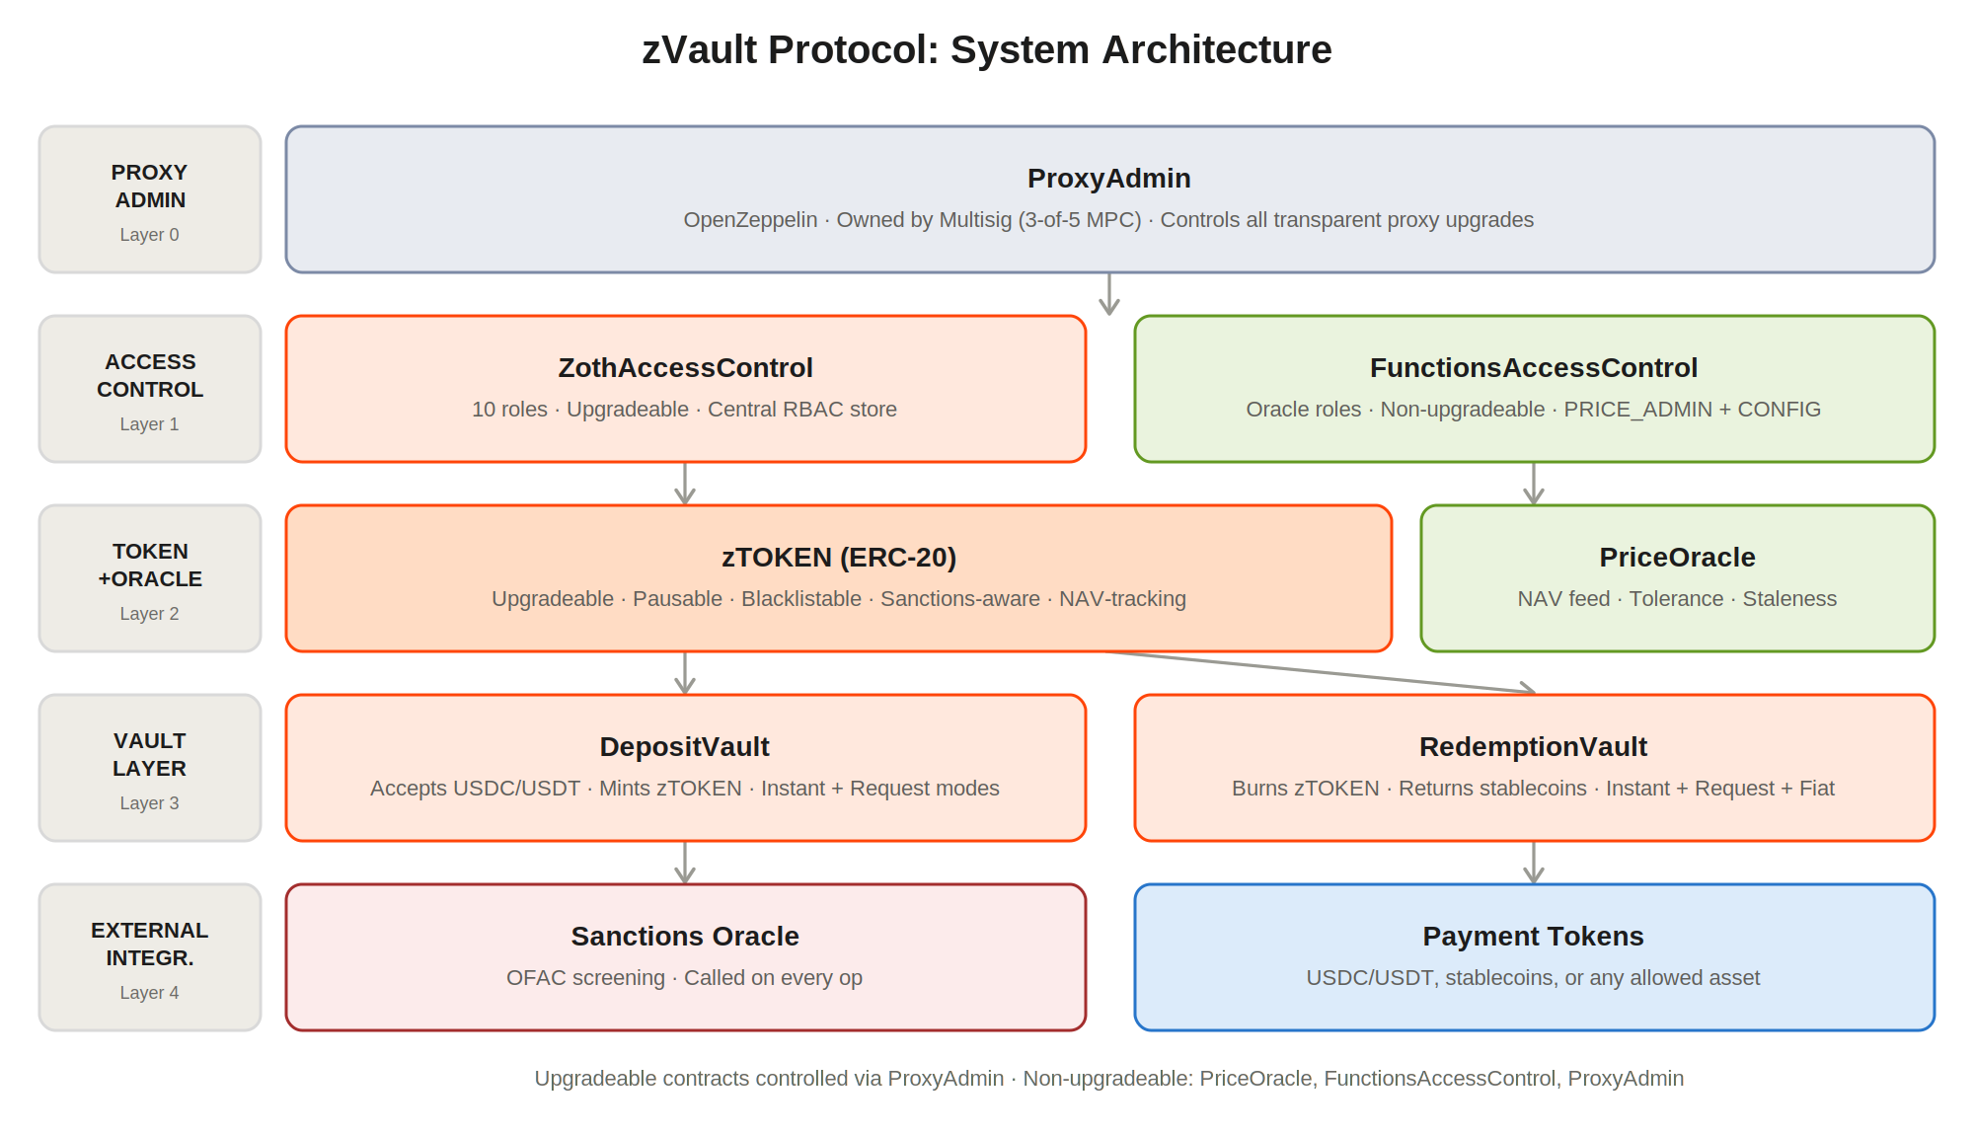

The Seven Contracts
Contract | Type | Upgradeable | Purpose
ZothAccessControl | Access | Yes (proxy) | Central role management for all contracts
zTOKEN | Token | Yes (proxy) | ERC-20 interest-bearing token with compliance controls
DepositVault | Vault | Yes (proxy) | Accepts deposits, mints the zTOKEN
RedemptionVault | Vault | Yes (proxy) | Burns the zTOKEN, returns deposit assets.
PriceOracle | Oracle | No | NAV price feed with tolerance and staleness checks
FunctionsAccessControl | Access | No | Role management scoped to the oracle
ProxyAdmin | Admin | No | Controls all proxy upgrades

Centralized Access Control
Every guarded action in the protocol checks a role against a single contract, ZothAccessControl. This concentrates risk by design: compromise of ZothAccessControl is compromise of the entire protocol, which is why the roles it administers are held by separate keys rather than any single one. The custody and signing model that enforces that separation is set out under Operational Security. Additionally oracle roles live in a separate access-control contract, FunctionsAccessControl, so the price feed's authority does not share a control surface with the vaults.

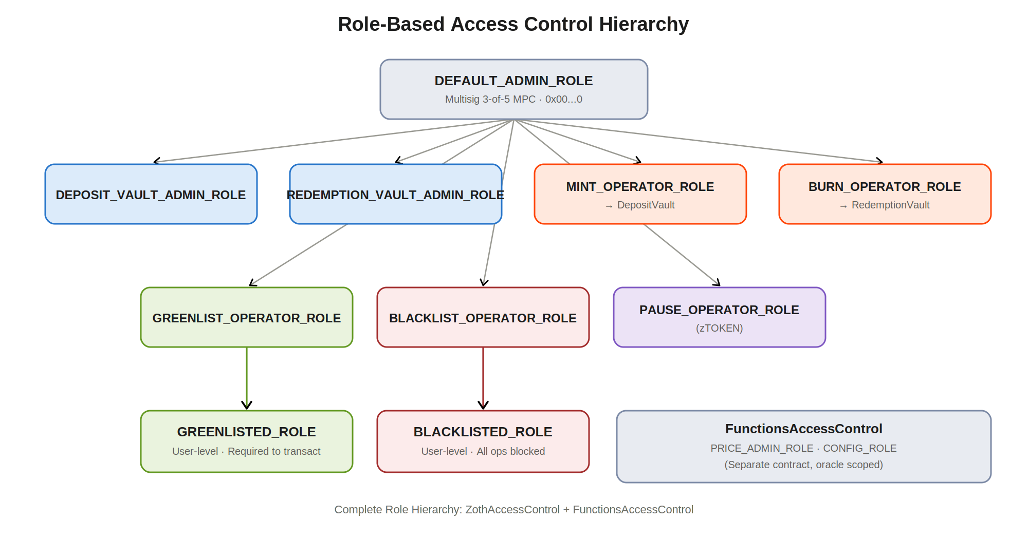

ZothAccessControl Roles
Role | Assigned to | Capabilities
DEFAULT_ADMIN_ROLE (0x00...0) | Protocol multisig | Grant and revoke all roles. Update sanctions oracle. Emergency override. Transfer ProxyAdmin.
DEPOSIT_VAULT_ADMIN_ROLE | Ops wallet (MPC) | Approve and reject deposit requests. Configure fees, limits, supply cap. Add and remove payment tokens. Pause DepositVault.
REDEMPTION_VAULT_ADMIN_ROLE | Ops wallet (MPC) | Approve and reject redemption requests. Configure redemption fees. Set requestRedeemer address. Pause RedemptionVault.
GREENLIST_OPERATOR_ROLE | Compliance wallet (MPC) | Grant or revoke GREENLISTED_ROLE for individual addresses.
BLACKLIST_OPERATOR_ROLE | Compliance wallet (MPC) | Grant or revoke BLACKLISTED_ROLE for individual addresses.
GREENLISTED_ROLE | Greenlisted user wallet | Required to call depositInstant, depositRequest, redeemInstant, redeemRequest. Fiat redemptions always require this role.
BLACKLISTED_ROLE | Blocked wallet | Prevents deposits, redemptions, and zTOKEN transfers, both send and receive.
MINT_OPERATOR_ROLE | DepositVault contract | Can call zTOKEN.mint(). Assigned automatically to DepositVault at deployment.
BURN_OPERATOR_ROLE | RedemptionVault contract | Can call zTOKEN.burn(). Assigned automatically to RedemptionVault at deployment.
PAUSE_OPERATOR_ROLE | Ops wallet (MPC) | Can call zTOKEN.pause() and unpause() to halt all token transfers.

FunctionsAccessControl Roles (Oracle)
Role | Assigned to | Capabilities
DEFAULT_ADMIN_ROLE | Protocol multisig | Manage PRICE_ADMIN and CONFIG roles within FunctionsAccessControl.
PRICE_ADMIN_ROLE | NAV update wallet (MPC) | Call setPrice() on PriceOracle. Must be a dedicated MPC wallet separate from vault admins.
CONFIG_ROLE | Ops wallet (MPC) | Modify oracle parameters: tolerancePercent, priceDecimals, maxStaleness.

Token, Mint, and Burn
The zTOKEN is an ERC-20 representing a proportional share of the vault's NAV, the interest-bearing claim described earlier. New tokens can be created only by the DepositVault and destroyed only by the RedemptionVault, each through a dedicated minter / burner role assigned to that contract alone. No other address can mint or burn. Compliance is enforced on the token itself: every transfer, including mint and burn, is screened against the greenlist, blacklist and sanctions list before it executes.

Price Oracle and Safety Bounds
NAV is published to the non-upgradeable PriceOracle by a dedicated multisig in a 3-of-5 MPC configuration. The oracle is deliberately immutable to maximize trust in the price feed. It enforces two guards; a tolerance check rejects any submitted price that deviates from the current price by more than a configured bound, blocking sudden manipulation. On read, a staleness check reverts if the price has not been refreshed within a configured window, halting all vault activity rather than letting deposits and redemptions execute against an outdated NAV.

Compliance Built Into the Contracts
Compliance is not a separate service bolted on; it is inherited into the vault and token contracts, so the compliance sequence runs inside the same transaction as the operation it guards and a failure reverts the whole transaction. This places the compliance perimeter at the contract level, where it cannot be bypassed by interacting with the contracts directly. The gates themselves (greenlist, blacklist, and sanctions) are detailed under Access Control.

Upgradeability
Four of the seven contracts are upgradeable behind proxies; the price path (PriceOracle and FunctionsAccessControl) is deliberately fixed. Upgrade authority rests solely with ProxyAdmin, which is owned by the multisig. The upgrade mechanism and its governance are detailed under Smart Contract Security.

Key Separation and Deployment Handover
Authority over a live vault is distributed across separate keys by design, never merged, so no single role concentrates control and no single compromise is protocol-wide. The contracts are deployed by a temporary key that is decommissioned at handover, after which no standing single-key authority over a live vault exists. The custody and signing mechanics that enforce this are detailed under Operational Security.

Why Capital Moves from On-Chain Contracts to MPC Custody
zVaults route deposited capital out of their on-chain contracts and into MPC-controlled custody by design, not as a workaround. The reason is structural: the strategies that generate zVault yield execute off-chain, and the custody model has to match.
A pure DeFi vault can hold and deploy capital entirely within smart contracts, because its strategies live on-chain. zVault strategies do not. Real-world credit, regulated fund positions, and market-neutral basis trades on centralized venues cannot be executed by a contract. To reach them, capital must leave the contract. The architecture is therefore split into two layers, each doing only its job:
As a further, more robust security measure, the underlying capital is held off-chain. Smart contracts are inherently at risk: any capital held on-chain is only as safe as the code holding it, and the threat surface keeps widening as AI lowers the cost of finding and exploiting new attack vectors. Concentrating deposited capital inside a contract makes that contract a standing target. Moving capital into threshold MPC custody removes it from that surface, so a contract-level exploit cannot reach the underlying funds.
Layer | Function | Property
Contract layer (DepositVault, RedemptionVault, zTOKEN) | Accepts deposits, mints tokens, processes redemptions, prices the token against attested NAV | Permissionless and fully transparent on-chain
Custody and deployment layer (MPC) | Holds the underlying capital and deploys it into the regulated fund and its strategies | Threshold-controlled, off-chain execution

Custody uses MPC rather than a single operational wallet so that moving funds requires a quorum of independent signers and no individual can act alone. The full custody and signing model is set out under Operational Security.
This split protects token holders.The structure gives holders a verifiable link between off-chain assets and on-chain value, while the contract layer stays open and auditable and custody movements stay constrained by the MPC quorum and the fund's mandate.
The result is deliberate: users interact with permissionless, transparent contracts, while institutional capital is secured and deployed through MPC custody under a regulated fund.

Core Flows
The protocol exposes a small set of core flows: depositing stablecoins to mint a zTOKEN, redeeming a zTOKEN to exit, and updating the NAV the token is priced against. Every flow runs through the compliance sequence and the price safety bounds described elsewhere in this document; the descriptions below cover the operational path of each.

Deposit Flow
A deposit mints the vault's zTOKEN against accepted stablecoins. Two paths exist, both minting the same token.
Path | When used | Outcome
Instant deposit | Default path for standard deposits | Compliance and slippage checks pass, any fee is separated, and the zTOKEN is minted to the user in a single transaction
Request deposit | Large deposits above the daily instant limit, or where review is required | Stablecoins are held and a pending request is created with no tokens minted, until the fund admin approves at the current rate; rejection returns the funds

Whether a vault offers the instant path, the request path, or both is entirely the fund manager's choice. The contracts support either, so the deposit model is configured to match the vault's strategy and review requirements rather than fixed by the protocol.

Instant Deposit
On the instant path the user sets a minimum acceptable output, so the mint reverts if the NAV moves unfavorably between quote and execution. Deposited capital is then deployed into the vault's strategy by the fund manager and begins generating yield. The full sequence is shown below.
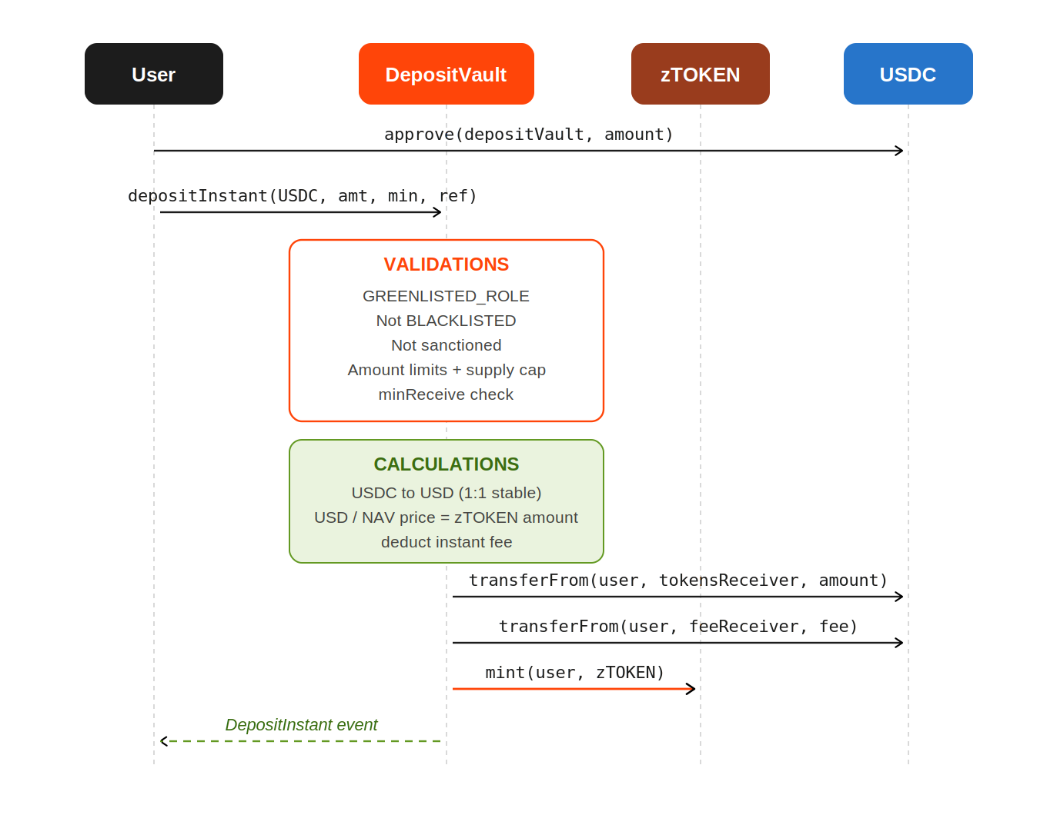

Request Deposit
The request path is used for large deposits above the daily instant limit, or when admin review is required. The user's stablecoins are held by the vault until the request is resolved. Compliance is checked at request creation; on approval the vault mints at the admin-set rate, validated against the oracle within variation tolerance. The flow has two outcomes, approve and reject.
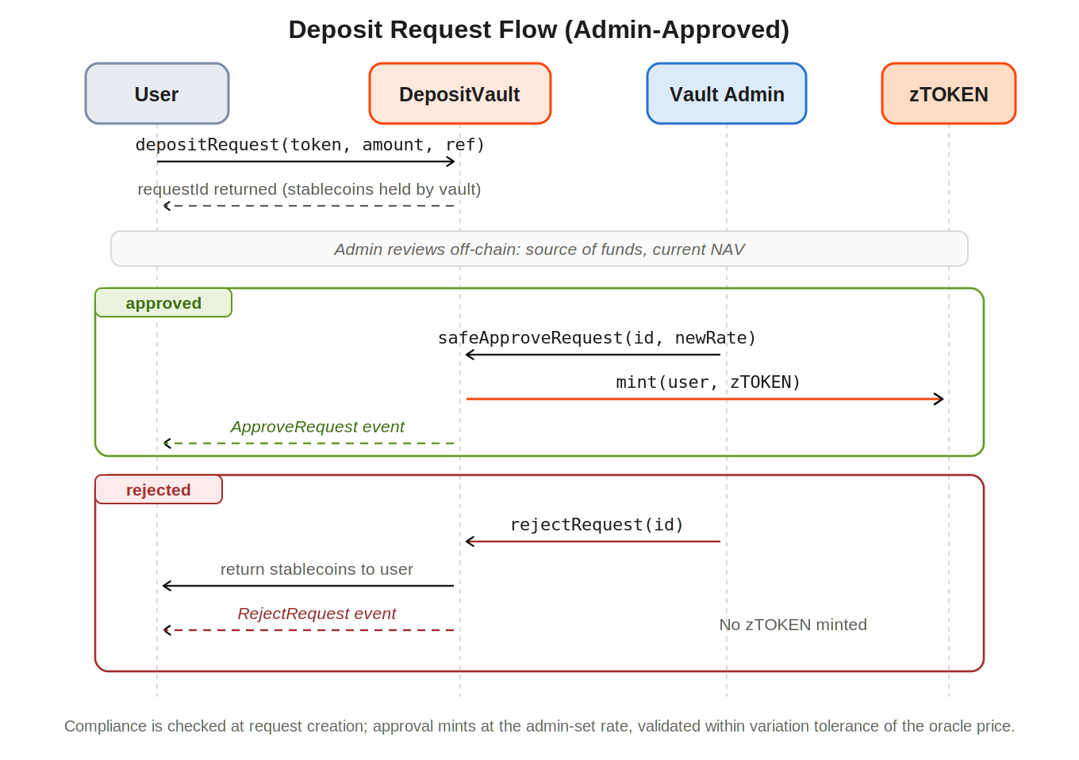
Step | Actor | Action
1 | User | Call depositRequest(token, amount, referrerId). Stablecoins transferred to the vault. requestId returned.
2 | DepositVault | Create a pending request object. No tokens minted yet. Emit DepositRequest event.
3 | Admin | Review the request off-chain. Validate source of funds and current NAV.
4a (approve) | Vault Admin | Call safeApproveRequest(requestId, newRate). Rate must be within variationTolerance of the oracle price. If valid, mint zTOKEN to the user and emit ApproveRequest.
4b (reject) | Vault Admin | Call rejectRequest(requestId). Stablecoins returned to the user. No zTOKEN minted. Emit RejectRequest.

Redemption Flow
zTOKEN redemption is built around the security considerations that arise across the technical and operational flows of a real-world-backed vault. Because capital is deployed off-chain into managed strategies, the current model handles redemption as a request rather than an unconditional on-chain swap, which keeps it aligned with how the underlying assets actually settle and removes the attack surface of assuming instant liquidity against off-chain positions. The contracts also support instant and fiat variants, available per vault.
Path | Status | How it settles
Request redemption | Current model | The zTOKEN is locked and a request is created; the fund manager settles from the strategy and returns stablecoins once positions clear, processed FIFO with no per-user limit
Instant redemption | Currently disabled | Where the vault's buffer allows, the user redeems directly from the stablecoin buffer in one transaction; carries a higher fee than a request, reflecting the liquidity cost of immediate settlement
Fiat redemption | Currently disabled | A request variant that settles off-chain to fiat rather than returning stablecoins on-chain, subject to its own fee

Whether a vault offers request redemption, instant redemption, fiat redemption, or any combination is entirely the fund manager's choice, set against the liquidity profile of the strategy: a vault holding a deep buffer can offer instant redemption, while a vault in less liquid positions operates on requests with a defined settlement window. The same contracts accommodate either, so redemption behavior tracks the strategy rather than being fixed by the protocol.
The redemption value of a zTOKEN is set by the oracle-reported vault NAV, so users receive fair value reflecting the vault's current positions. Yield is already compounded into that value through NAV appreciation, as described under What are zVaults.

Instant Redemption
On the instant path a user redeems directly from the vault's liquidity buffer in a single transaction: the user approves the vault to spend the zTOKEN, calls redeemInstant, and receives stablecoins net of fee once the compliance and limit checks pass. The full sequence is shown below.
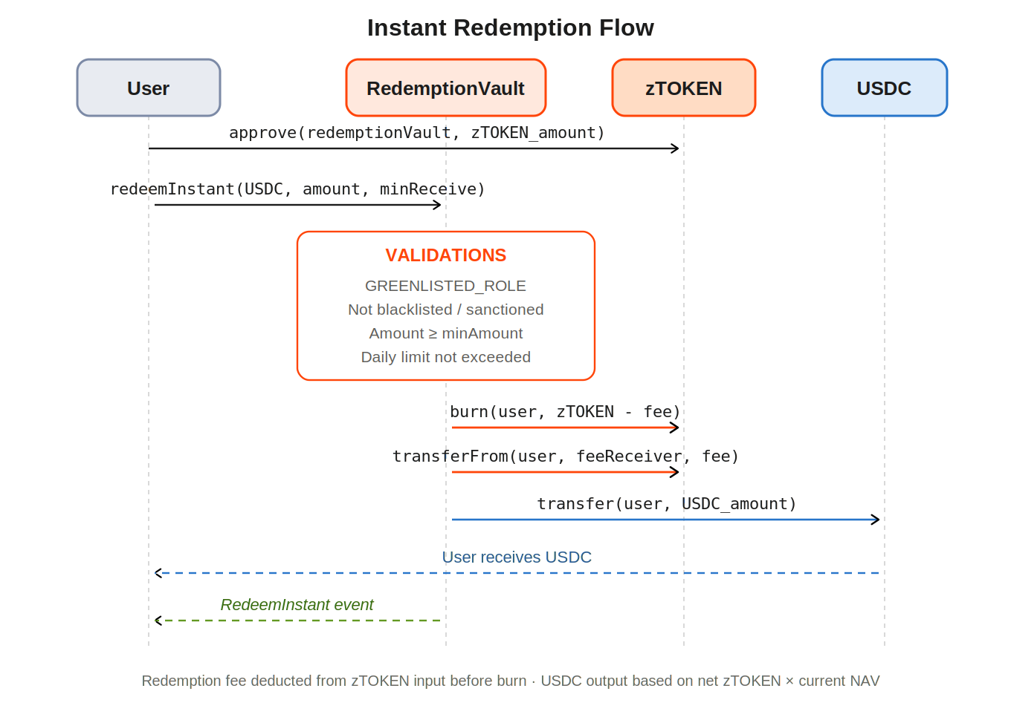
Step | Actor | Action
1 | User | Call approve(redemptionVault, zTOKENAmount) on the zTOKEN contract.
2 | User | Call redeemInstant(USDC, zTOKENAmount, minReceiveAmount) on RedemptionVault.
3 | RedemptionVault | Validation: greenlist, blacklist, and sanctions checks. Amount is at least minAmount. Daily instant limit not exceeded.
4 | zTOKEN | burn(user, zTOKENAmount - fee). Tokens destroyed.
5 | zTOKEN | transferFrom(user, feeReceiver, fee). Redemption fee deducted.
6 | USDC | transfer(user, usdcAmount). Stablecoins sent from the vault buffer to the user.
7 | RedemptionVault | Emit RedeemInstant event. Transaction complete.

The redemption fee is deducted from the zTOKEN input before burning. USDC output equals the net zTOKEN (after fee) multiplied by the current oracle NAV. The instant redemption fee can be greater than or equal to the standard request redemption fee.

Request Redemption
The request path handles redemptions that settle from the vault's strategy rather than the instant buffer. The user approves the vault on the zTOKEN and calls redeemRequest; the vault escrows the net zTOKEN and takes the fee at request creation, then an admin approves or rejects. The flow has two outcomes.
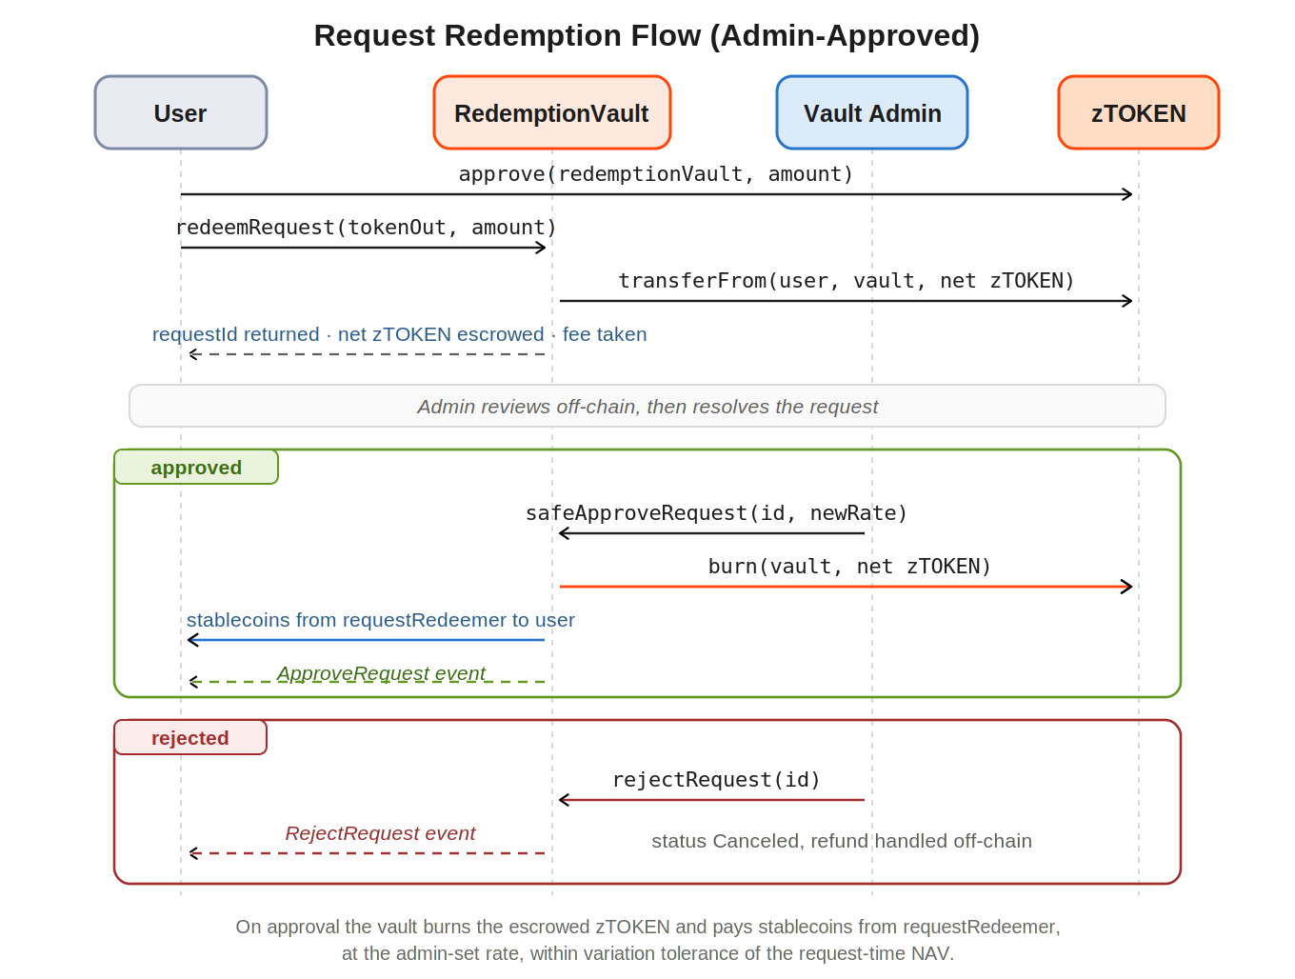
Step | Actor | Action
1 | User | Call approve(redemptionVault, amountZTokenIn) on the zTOKEN contract.
2 | User | Call redeemRequest(tokenOut, amountZTokenIn) on RedemptionVault. Passes greenlist, blacklist, sanctions, and pause checks.
3 | RedemptionVault | Validate amount is at least the minimum and compute fee. Pull the net zTOKEN into escrow and send the fee in zTOKEN to feeReceiver. Snapshot the NAV rate, store a pending request, emit RedeemRequest, and return a requestId. No burn yet.
4a (approve) | Vault Admin | Call safeApproveRequest(requestId, newZTokenRate). Rate must be within variationTolerance of the request-time snapshot. Burn the escrowed zTOKEN, pay stablecoins from requestRedeemer at the approved rate, and emit ApproveRequest.
4b (reject) | Vault Admin | Call rejectRequest(requestId). Set status to Canceled and emit RejectRequest. The zTOKEN refund is handled off-chain; there is no automatic on-chain return.

NAV Price Update Flow
A zTOKEN is priced against the vault NAV, which is refreshed on a fixed cadence by a dedicated update multisig. The figure is sourced one of two ways: off-chain from the vault's strategy or fund administrator, or on-chain from an independently verified oracle service. Each submission is then gated by the tolerance and staleness bounds described under Price Manipulation Protection, so deposits and redemptions never execute against an outdated or manipulated NAV. The result is a price holders can verify on-chain rather than take on trust.
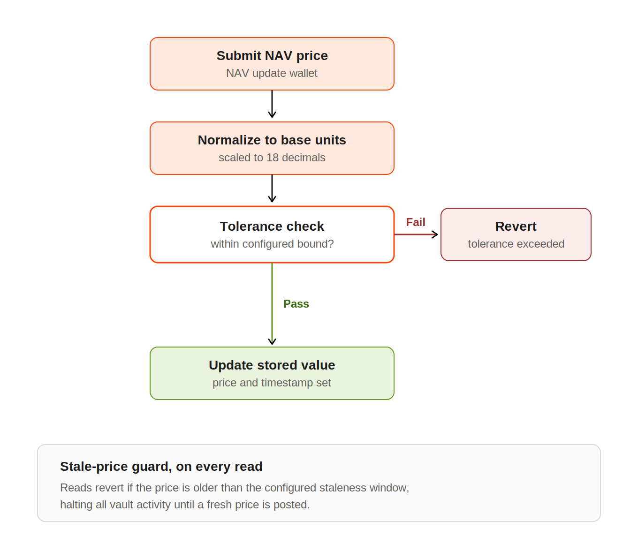

Access Control: Greenlisting and Blacklisting
Every deposit, redemption, and token transfer in a zVault passes through a compliance sequence before it executes. The sequence has three gates, checked in order, and a failure at any gate reverts the entire transaction:
Gate | Controls | Default state | On failure
Greenlist | Who is permitted to enter | Configurable per vault (off = permissionless) | Reverts: not greenlisted
Blacklist | Which addresses are blocked | Always on | Reverts: blacklisted
Sanctions | OFAC-sanctioned addresses, via external oracle | Always on | Reverts: sanctioned

Greenlisting and blacklisting are inverses. Greenlisting is an opt-in allowlist that a vault can switch on to restrict participation to an approved set. Blacklisting is an always-on blocklist that bars specific bad addresses. The sanctions gate sits alongside both as an automated external check through Chainanalysis OFAC sanction list.
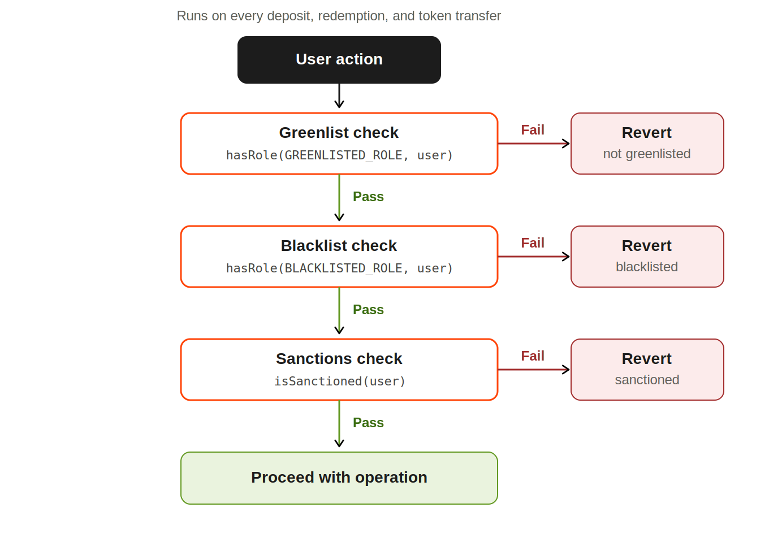

Greenlisting
Greenlisting is a per-vault access toggle. With the greenlist off, the gate is skipped entirely and any wallet can transact, so the vault operates permissionlessly. With it on, only addresses holding greenlisted status can deposit or redeem, and every other wallet's operation reverts. The same contracts support both modes through a single setting, so a vault's access posture follows its strategy rather than being hardcoded.
This is an address allowlist, not identity verification. Greenlisting records which wallet addresses may transact with a vault; it does not require or imply KYC. A vault can run fully permissionless with the greenlist disabled, which is the intended posture for open retail vaults, or run with it enabled where a specific strategy or jurisdiction requires participation to be limited to a known set of addresses, such as during a controlled beta or for a restricted institutional vault.
Greenlisted status is granted and revoked by a dedicated screening operator, held in a separate wallet from the protocol's admin and price-update authorities so that access decisions cannot be made from a single concentrated key.

Why a zVault Implements Blacklisting
The blacklist is the protocol-controlled blocklist that extends protection beyond the automated sanctions gate. The sanctions oracle only covers OFAC-sanctioned addresses, a narrow set; it does not flag wallets for risk exposure such as mixer interactions, darknet-market association, or links to high-risk venues, and it cannot act on a wallet that has been compromised. Blacklisting lets the protocol restrict a specific address from interacting with the vault, which protects the remaining holders, maintains the vault's AML and sanctions posture, and prevents a flagged actor from continuing to transact. Because the check also runs on token transfers, a flagged wallet cannot move its tokens to a clean address to escape the restriction.

When an Address Is Blacklisted
Blacklisting is a deliberate, manually executed action, distinct from the automated sanctions gate. The intended triggers are addresses the sanctions oracle does not catch but that present unacceptable risk:
Trigger category | Example
High-risk counterparty exposure | Significant flow to or from sanctioned or high-risk exchanges
Illicit-source association | Mixer or tumbler interactions, darknet-market links
Compromise or malicious use | A wallet known to be compromised or acting against the vault
Legal or regulatory order | An address subject to a court or regulatory directive

The precise risk thresholds that move an address from flagged to blacklisted, the role authorized to execute it, and the review and appeal process are governed by a screening policy that is being finalized. Until that policy is set, the blacklist trigger is not yet codified, and this is a known open item rather than a shipped rule.

What Happens When an Address Is Blacklisted
A blacklisted address fails the blacklist gate, so any operation it attempts reverts before executing. It cannot deposit, cannot redeem through any path, and cannot transfer its tokens. The tokens are not seized: they remain in the wallet but are frozen from movement for as long as the address holds blacklisted status. The restriction is on the address, not the vault, so all other holders continue to transact normally.

Redemption While Blacklisted
Because the blacklist gate reverts every standard operation, a blacklisted address has no self-service, on-chain route to redeem. It cannot even submit a redemption request, because the request call itself runs the compliance check and reverts.
Recovery, where permitted, is handled off-chain and case by case, not by the contract. Two cases separate cleanly. For a genuine sanctions match, funds cannot be returned, because doing so would itself breach sanctions law, and the freeze stands. For a risk-based blacklist, particularly a wrongly flagged legitimate user, the path back is a manual review; on a satisfactory outcome the address is removed from the blacklist by the authorized operator, after which the standard redemption flow becomes available again, or the team processes an administered redemption to the verified user. The review and appeal mechanics are part of the screening policy still being finalized.

Smart Contract Specification
This section specifies the externally callable functions of each contract, the access role each requires, and what each does.

ZothAccessControl
Central role store for the entire protocol. All other contracts call hasRole() against this contract. A role granted here is immediately effective in every contract without redeployment.
Function | Access | Description
initialize() | Once (deploy) | Sets up initial roles for the deployer. Must be called exactly once via the proxy initializer.
grantRole(role, account) | Role admin | Assign a role to an address.
revokeRole(role, account) | Role admin | Remove a role from an address.
grantRoleMult(roles[], accounts[]) | Role admin | Bulk role assignment. Useful during deployment setup.
revokeRoleMult(roles[], accounts[]) | Role admin | Bulk role removal. Used to decommission the deployer key.
hasRole(role, account) | View (public) | Returns true or false. Called by all other contracts on every guarded action.

zTOKEN
ERC-20 token representing a proportional share of the vault's NAV. The token price starts at parity and moves with the NAV as the strategies perform. Holders never claim; value is reflected automatically in the token's redemption value.
Function | Access | Description
initialize(ac, sanctions) | Once (deploy) | Links the token to ZothAccessControl and the sanctions oracle.
mint(to, amount) | MINT_OPERATOR | Create new tokens. Called exclusively by DepositVault after a valid deposit.
burn(from, amount) | BURN_OPERATOR | Destroy tokens. Called exclusively by RedemptionVault after a valid redemption.
pause() | PAUSE_OPERATOR | Halt all transfers globally. Emergency use only.
unpause() | PAUSE_OPERATOR | Resume transfers after a pause.
transfer(to, amount) | Token holder | Standard ERC-20 transfer. Checks sender and recipient against the blacklist and sanctions list.
setMetadata(key, data) | DEFAULT_ADMIN | Store arbitrary bytes32 key to bytes metadata on-chain.

Transfer Restrictions
Every transfer, including mint and burn, must pass all five conditions at once:
- Sender is not blacklisted.
- Sender is not sanctioned.
- Recipient is not blacklisted.
- Recipient is not sanctioned.
- The contract is not paused.

DepositVault
Accepts USDC/USDT deposits and mints zTOKEN. Supports two deposit paths: instant (atomic, single transaction) and request-based (admin-approved, for large deposits).
Function | Access | Description
depositInstant(token, amount, minReceive, referrer) | Greenlisted | Atomic deposit. Stablecoins transferred and zTOKEN minted in the same transaction.
depositInstant(..., recipient) | Greenlisted | Mint zTOKEN to a different address. Both depositor and recipient must be greenlisted.
depositRequest(token, amount, referrer) | Greenlisted | Create a pending deposit request. Returns a requestId. No tokens minted until an admin approves.
approveRequest(id, rate) | DEPOSIT_VAULT_ADMIN | Approve a pending request at the specified exchange rate. Mints zTOKEN.
safeApproveRequest(id, rate) | DEPOSIT_VAULT_ADMIN | Same as approveRequest but validates the rate is within variationTolerance of the oracle price. Preferred.
rejectRequest(id) | DEPOSIT_VAULT_ADMIN | Cancel a pending request. Returns stablecoins to the user. No zTOKEN minted.
addPaymentToken(...) | DEPOSIT_VAULT_ADMIN | Register a new accepted stablecoin with its TokenConfig.
removePaymentToken(token) | DEPOSIT_VAULT_ADMIN | Deregister a payment token.
setMaxSupplyCap(cap) | DEPOSIT_VAULT_ADMIN | Update the maximum total zTOKEN supply allowed.
pause() / unpause() | DEPOSIT_VAULT_ADMIN | Emergency halt and resume of all vault operations.

RedemptionVault
Burns zTOKEN and returns stablecoins. Supports instant redemption (from the liquidity buffer), request-based (admin-approved), and fiat off-ramp paths.
Function | Access | Description
redeemInstant(token, amount, minReceive) | Greenlisted | Atomic redemption from the vault's liquidity buffer. Burns zTOKEN and returns stablecoins immediately.
redeemRequest(token, amount) | Greenlisted | Create a pending redemption request. zTOKEN locked. Returns a requestId.
redeemFiatRequest(amount) | Always greenlisted | Create a fiat redemption request. Off-chain settlement. Subject to fiatAdditionalFee and fiatFlatFee.
approveRequest(id, rate) | REDEMPTION_VAULT_ADMIN | Approve a pending request. Burns zTOKEN and transfers stablecoins from requestRedeemer to the user.
safeApproveRequest(id, rate) | REDEMPTION_VAULT_ADMIN | Same, with a tolerance check on the rate. Preferred.
rejectRequest(id) | REDEMPTION_VAULT_ADMIN | Cancel the request. Returns the locked zTOKEN to the user.
setRequestRedeemer(addr) | REDEMPTION_VAULT_ADMIN | Set the source address for stablecoins used in request approvals.
setFiatAdditionalFee(fee) | REDEMPTION_VAULT_ADMIN | Update the percentage fee applied to fiat redemptions.

PriceOracle
Stores and validates the current NAV price for the zTOKEN. Non-upgradeable to maximize trust. Price is expressed in configurable decimal units (default: cents) and normalized to base-18 when read by vault contracts.
Function | Access | Description
setPrice(price) | PRICE_ADMIN_ROLE | Submit a new NAV price. Runs the tolerance check. Reverts with ToleranceExceeded if the deviation is too large.
getDataInBase18() | View (public) | Returns the current price normalized to 18 decimals. Reverts with StalePrice if the last update is older than maxStaleness.
setTolerancePercent(bps) | CONFIG_ROLE | Update the maximum allowed price deviation in basis points.
setPriceDecimals(decimals) | CONFIG_ROLE | Update the input decimal precision (must be 18 or fewer).
setMaxStaleness(seconds) | CONFIG_ROLE | Update the maximum age of a valid price in seconds.
getPriceAge() | View (public) | Returns seconds elapsed since the last price update.
isPriceStale(maxAge) | View (public) | Returns true if getPriceAge() is greater than maxAge.

Smart Contract Security
Beyond the access-control and compliance design described earlier, a zVault carries an explicit set of defensive controls: a graduated emergency-response system that can halt activity at the precise scope a situation requires, and a controlled upgrade path that lets the protocol fix issues without disrupting live vaults. Both are governed by the same separated-key model, so no defensive action depends on a single party.

Emergency Controls
Emergency authority is graduated rather than all-or-nothing. The protocol can intervene at the narrowest scope that addresses a threat, from disabling a single function up to freezing all token movement, which contains incidents without halting more of the system than necessary.
Control | Function | Access | Effect
Pause a single vault function | vault.pauseFn(selector) | Vault admin | Targeted: disables one operation, for example instant deposits, while the rest of the vault runs
Pause an entire vault | vault.pause() | Vault admin | Halts all operations on that vault
Pause token transfers | zTOKEN.pause() | Pause operator | Stops all transfers, mints, and burns of the token globally
Blacklist an address | grantRole(BLACKLISTED_ROLE, address) | Blacklist operator | Blocks a specific address from every operation
Replace the sanctions oracle | setSanctionsList(newOracle) | Default admin (multisig) | Points the protocol at an updated sanctions screening source

Each control is gated to a distinct role held in a separate wallet, so triggering an emergency action requires the corresponding authority and no single key can exercise all of them.

Upgradeability and the Proxy Pattern
Four contracts (ZothAccessControl, the zTOKEN, DepositVault, and RedemptionVault) use OpenZeppelin's transparent proxy pattern. ProxyAdmin, owned by the multisig, is the sole account that can trigger an upgrade, and it lets the protocol ship security fixes and improvements without migrating user balances or redeploying live vaults. The PriceOracle and FunctionsAccessControl are deliberately non-upgradeable, fixing the price path in place to maximize trust in the NAV feed.
Upgrades intentionally carry no on-chain time-lock, so the protocol can respond immediately to a critical vulnerability rather than waiting out a delay window while funds are at risk. To keep that capability from becoming an unchecked authority, all non-emergency upgrades follow an internal governance process with team review before execution, and the upgrade key itself is the multisig rather than any single signer.

Daily On-Chain Configuration Checks
The protocol does not assume its deployed contracts stay configured as intended; it checks. An automated routine reads the on-chain state of every vault contract on a fixed daily schedule (the vaults, the price oracle, the access-control store, and the proxy admin) and compares each critical parameter against its expected, governance-approved value. The parameters under watch include deposit and withdrawal limits, fee settings, the supply cap, pause status across the token and vaults, the oracle's tolerance and staleness bounds, and the configured oracle and sanctions addresses. Any drift between the on-chain configuration and the approved baseline raises an alert for the operations team to investigate, so an unauthorized or accidental parameter change is caught within a day rather than discovered after it has been exploited.
Critical role assignments are part of the watched configuration. Each pass verifies that:
- DEFAULT_ADMIN_ROLE is held only by the multisig, never the deployer key.
- ProxyAdmin ownership resolves to the multisig address.
- The mint-operator role is held only by the DepositVault proxy address.
- The burn-operator role is held only by the RedemptionVault proxy address.
- PRICE_ADMIN is held only by the dedicated NAV-update MPC wallet.
- GREENLIST_OPERATOR is held only by the compliance MPC wallet.
- CONFIG_ROLE is held only by the approved ops wallet, since it can change the oracle's tolerance, staleness, and decimals.

Price Manipulation Protection
The protocol guards the NAV price and execution with on-chain bounds, each set per vault. The tolerance and staleness checks both treat a value of zero as disabled, so the daily configuration check verifies that neither has drifted to zero or away from its approved value.
Protection | Mechanism | Configuration
Tolerance check | A newly submitted price must fall within the tolerance bound of the current price, or the submission reverts | Configurable by the fund manager
Staleness check | Price reads revert if the last update is older than the staleness window, halting vault activity until a fresh price is posted | Configurable by the fund manager
Variation tolerance | When an admin approves a redemption request, the supplied rate must fall within the variation tolerance of the oracle price | Configurable by the fund manager
Min receive | The user sets the minimum acceptable output on a deposit or redemption; the transaction reverts if the result falls below it | Set by the user per transaction

Alongside the bounds themselves, the daily check confirms the supporting oracle state has not drifted:
Check | Verify | Risk if it drifts
priceDecimals | Matches the decimals the fund administrator reports NAV in | A mismatch silently mis-scales every price, producing a NAV wrong by orders of magnitude with no revert
Price freshness | Current price age sits well below the staleness window | Near the window the next read reverts and halts all vault activity; catching it early avoids an outage
Current price | Price is set and sits within an expected band | An unset price reverts all reads; a price far outside band signals a bad feed even when each update passed tolerance
Access-control pointer | Resolves to the expected access-control contract | A wrong pointer changes who can post prices and change the bounds above

External Security Reviews
The contracts are audited by independent blockchain security firms before deployment and on an ongoing basis as the codebase evolves. Each review examines contract logic, access controls, and integration points, and the findings are tracked to resolution rather than treated as a one-time gate. This provides continuous external assurance over the protocol's integrity, separate from the internal review that governs upgrades.
Reports are published at https://github.com/0xZothio/zVault/blob/dev/audits/ENTERSOFT.pdf.

Operational Security
zVaults are operated under a layered security framework that treats key custody, internal access, platform infrastructure, and on-chain activity as separate control domains, each independently enforced so a failure in one does not cascade into the others.

Custody and Key Management
The highest-privilege layer. Control over vault funds and protocol state is held in multi-party computation (MPC) wallets, never single keys.
- Threshold custody: privileged wallets require a 3-of-5 signing quorum, so no individual can move funds or change protocol state alone.
- Hardware-only signing: the highest-authority signers are restricted to hardware wallets.
- Role separation: super-admin, vault-admin, screening, and NAV-update authorities are held by distinct wallets, so no single role concentrates control.
- Out-of-band confirmation: each privileged transaction is approved by the required quorum on a live video call before it is signed.
- Minimal deployment footprint: the temporary key used to deploy the contracts is decommissioned once setup completes, leaving no standing single-key authority over live vaults.

Personnel Security
- Vetting: every team member completes a background check before joining.
- Ongoing awareness: the team receives continuous security advisories and periodic targeted training to stay current on emerging threats.

Internal Access Control
- Zero Trust: access to internal systems is granted per request and per identity, not by network location.
- Hardware-backed authentication: privileged access requires a hardware security key, so a stolen password or phishing attempt alone cannot grant entry.
- Compartmentalized access: critical cloud and infrastructure accounts are segmented and reachable only from dedicated, hardened machines.
- Endpoint monitoring: corporate devices run continuous detection and response with behavioral analysis and rapid containment.

Platform and Infrastructure
- Environment isolation: staging and production are fully separated, so development activity cannot reach live systems.
- Edge protection: the public application sits behind DDoS mitigation, a web application firewall, rate limiting, API protection, and enforced TLS.
- Verified authorship: Git commits require cryptographic signatures from hardware-backed keys, confirming authorship and preventing unauthorized code changes.
- Supply-chain scanning: the CI/CD pipeline scans third-party dependencies for known vulnerabilities before any deployment.

On-Chain Monitoring and Audit
Independent pre-deployment audits are covered under Smart Contract Security; the controls below are the continuous, runtime layer that operates once a vault is live.
- Continuous on-chain monitoring: real-time surveillance of contract interactions, fund flows, and vault-share movements flags anomalous behavior as it happens.
- Pre-execution screening: transactions are simulated and screened before execution to block malicious smart-contract interactions.

