**MONGO DB**

**Assignment-1**

Gogineni Jaswant

21BCE1199

**Creating Table and Inserting records:**

CREATE DATABASE ORG1;

SHOW DATABASES;

USE ORG1;

CREATE TABLE Worker (

WORKER_ID INT NOT NULL PRIMARY KEY AUTO_INCREMENT,

FIRST_NAME CHAR(25),

LAST_NAME CHAR(25),

SALARY INT(15),

JOINING_DATE DATETIME,

DEPARTMENT CHAR(25)

);

INSERT INTO Worker

(WORKER_ID, FIRST_NAME, LAST_NAME, SALARY, JOINING_DATE,

DEPARTMENT) VALUES

(001, 'Monika', 'Arora', 100000, '14-02-20

09.00.00', 'HR'),

(002, 'Niharika', 'Verma', 80000, '14-06-11

09.00.00', 'Admin'),

(003, 'Vishal', 'Singhal', 300000, '14-02-20

09.00.00', 'HR'),

(004, 'Amitabh', 'Singh', 500000, '14-02-20

09.00.00', 'Admin'),

(005, 'Vivek', 'Bhati', 500000, '14-06-11

09.00.00', 'Admin'),

(006, 'Vipul', 'Diwan', 200000, '14-06-11

09.00.00', 'Account'),

(007, 'Satish', 'Kumar', 75000, '14-01-20

09.00.00', 'Account'),

(008, 'Geetika', 'Chauhan', 90000, '14-04-11

09.00.00', 'Admin');

CREATE TABLE Bonus (

WORKER_REF_ID INT,

BONUS_AMOUNT INT(10),

BONUS_DATE DATETIME,

FOREIGN KEY (WORKER_REF_ID)

REFERENCES Worker(WORKER_ID)

ON DELETE CASCADE

);

INSERT INTO Bonus

(WORKER_REF_ID, BONUS_AMOUNT, BONUS_DATE) VALUES

(001, 5000, '16-02-20'),

(002, 3000, '16-06-11'),

(003, 4000, '16-02-20'),

(001, 4500, '16-02-20'),

(002, 3500, '16-06-11');

CREATE TABLE Title (

WORKER_REF_ID INT,

WORKER_TITLE CHAR(25),

AFFECTED_FROM DATETIME,

FOREIGN KEY (WORKER_REF_ID)

REFERENCES Worker(WORKER_ID)

ON DELETE CASCADE

);

INSERT INTO Title

(WORKER_REF_ID, WORKER_TITLE, AFFECTED_FROM) VALUES

(001, 'Manager', '2016-02-20 00:00:00'),

(002, 'Executive', '2016-06-11 00:00:00'),

(008, 'Executive', '2016-06-11 00:00:00'),

(005, 'Manager', '2016-06-11 00:00:00'),

(004, 'Asst. Manager', '2016-06-11 00:00:00'),

(007, 'Executive', '2016-06-11 00:00:00'),

(006, 'Lead', '2016-06-11 00:00:00'),

(003, 'Lead', '2016-06-11 00:00:00');

**ALTER TABLE Workers RENAME TO Workers;**

**Questions:**

1. SELECT FIRST_NAME AS WORKER_NAME FROM Worker;

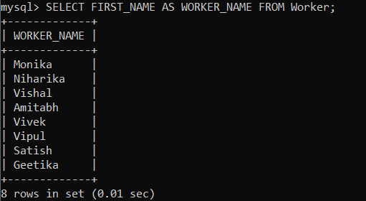

1. SELECT UPPER(FIRST_NAME) FROM Worker;

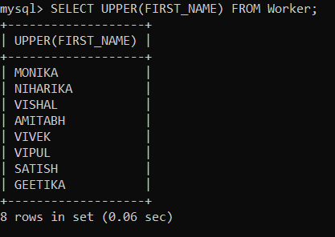

1. SELECT DISTINCT DEPARTMENT FROM Worker;

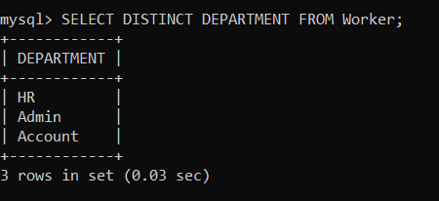

1. SELECT SUBSTRING(FIRST_NAME, 1, 3) FROM Worker;

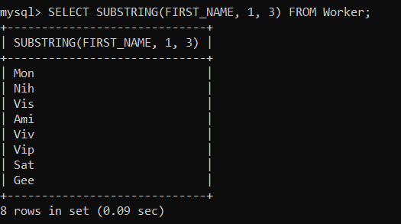

1. SELECT POSITION('a' IN FIRST_NAME) FROM Worker WHERE FIRST_NAME = 'Amitabh';

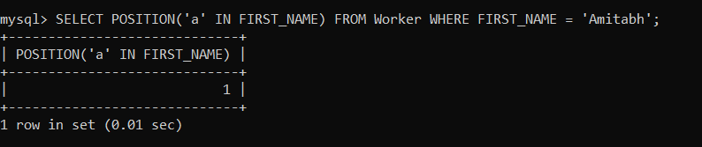

1. SELECT RTRIM(FIRST_NAME) FROM Worker;

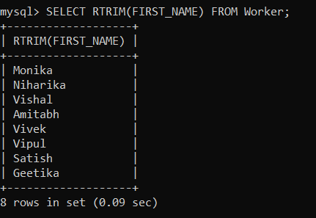

1. SELECT LTRIM(DEPARTMENT) FROM Worker;

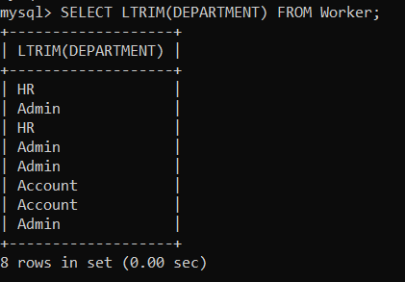

1. SELECT DISTINCT DEPARTMENT, LENGTH(DEPARTMENT) AS LengthOfDepartment FROM Worker;

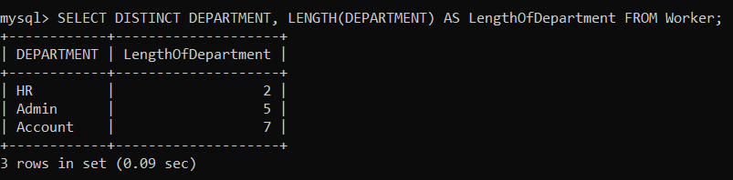

1. SELECT REPLACE(FIRST_NAME, 'a', 'A') FROM Worker;

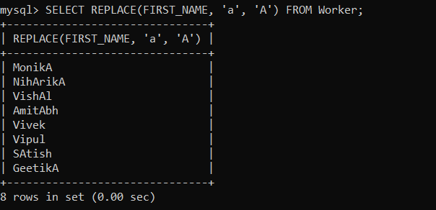

1. SELECT CONCAT(FIRST_NAME, ' ', LAST_NAME) AS COMPLETE_NAME FROM Worker;

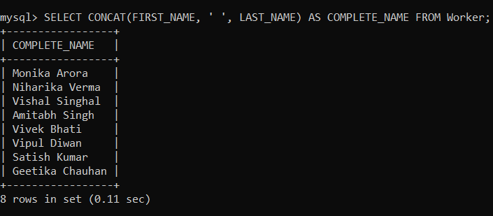

1. SELECT * FROM Worker ORDER BY FIRST_NAME ASC;

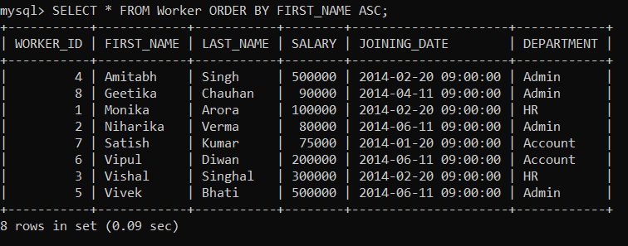

1. SELECT * FROM Worker ORDER BY FIRST_NAME ASC, DEPARTMENT DESC;

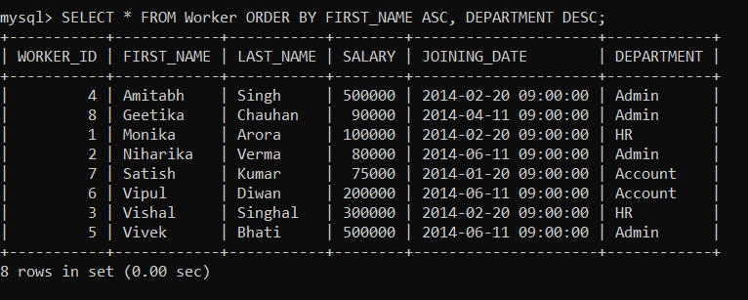

1. SELECT * FROM Worker WHERE FIRST_NAME IN ('Vipul', 'Satish');

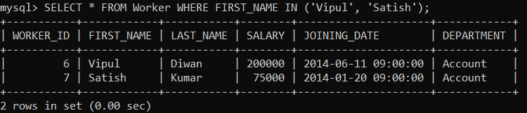

1. SELECT * FROM Worker WHERE FIRST_NAME NOT IN ('Vipul', 'Satish');

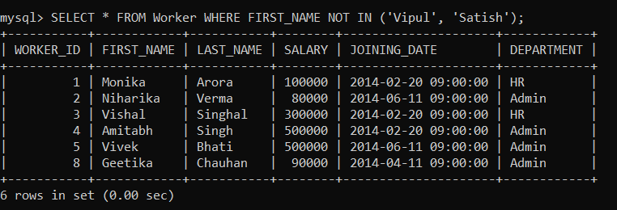

1. SELECT * FROM Worker WHERE DEPARTMENT = 'Admin';

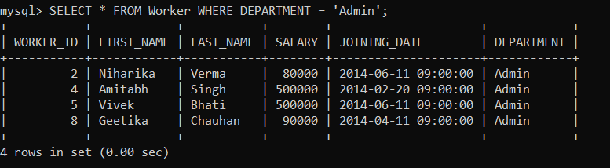

1. SELECT * FROM Worker WHERE FIRST_NAME LIKE '%a%';

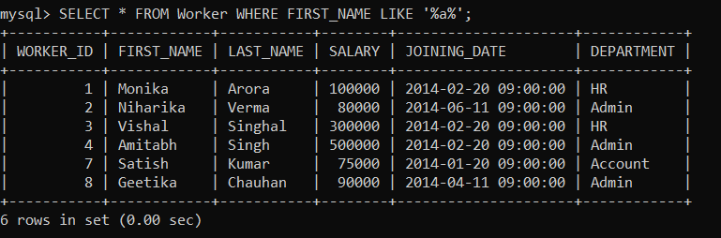

1. SELECT * FROM Worker WHERE FIRST_NAME LIKE '%a';

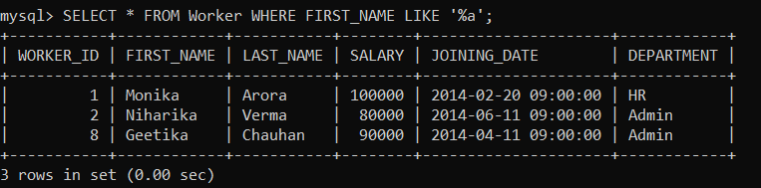

1. SELECT * FROM Worker WHERE FIRST_NAME LIKE '_____h';

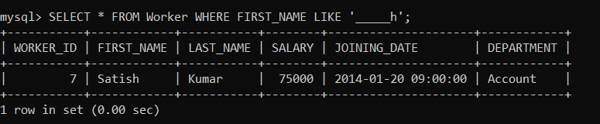

1. SELECT * FROM Worker WHERE SALARY BETWEEN 100000 AND 500000;

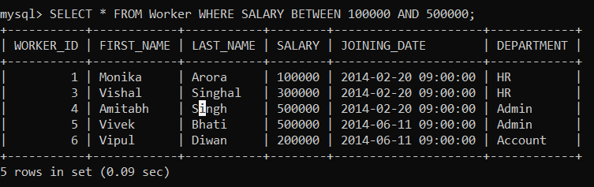

1. SELECT * FROM Worker WHERE JOINING_DATE BETWEEN '2014-02-01' AND '2014-02-28';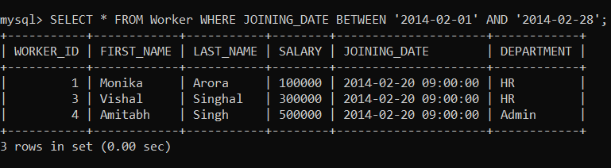
2. SELECT COUNT(*) FROM Worker WHERE DEPARTMENT = 'Admin';

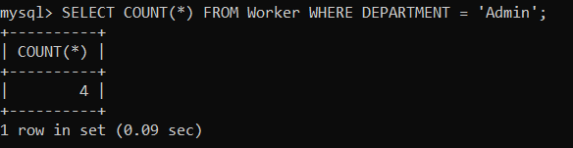

1. SELECT FIRST_NAME FROM Worker WHERE SALARY BETWEEN 50000 AND 100000;

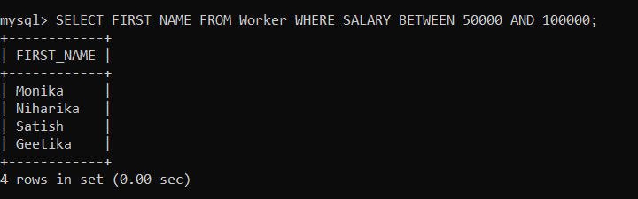

1. SELECT DEPARTMENT, COUNT(*) AS 'Number of Workers' FROM Worker GROUP BY DEPARTMENT ORDER BY COUNT(*) DESC;

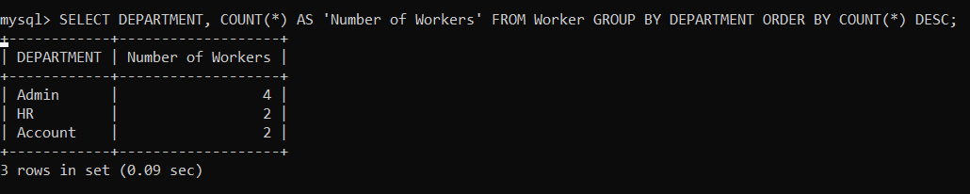

1. SELECT * FROM Worker, title WHERE worker_title = 'Manager';

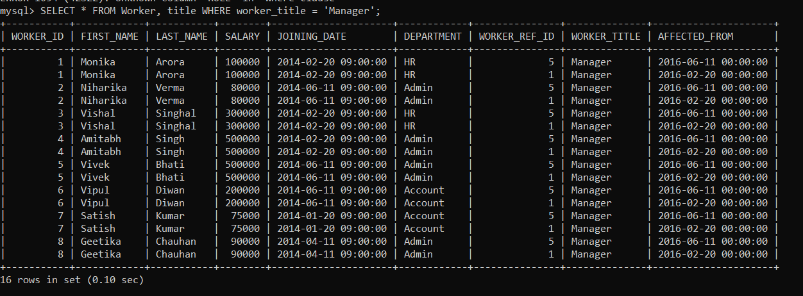

1. SELECT FIRST_NAME, LAST_NAME, COUNT(*) FROM Worker GROUP BY FIRST_NAME, LAST_NAME HAVING COUNT(*) > 1;

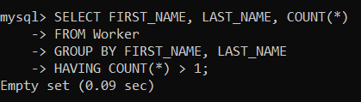

1. SELECT * FROM Worker WHERE WORKER_ID % 2 != 0;

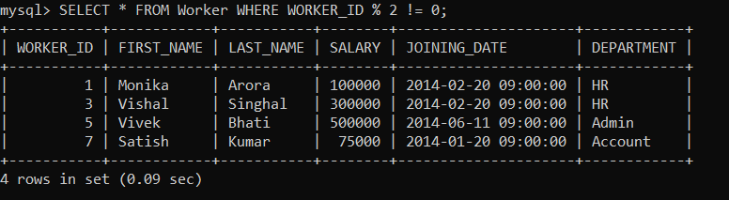

1. SELECT * FROM Worker WHERE WORKER_ID % 2 = 0;

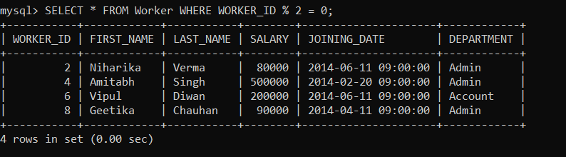

1. CREATE TABLE NewTable LIKE Worker;

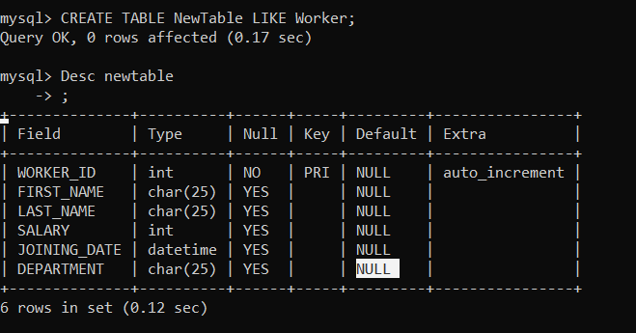

1. SELECT w.* FROM Worker w INNER JOIN Bonus b ON w.WORKER_ID = b.WORKER_REF_ID;

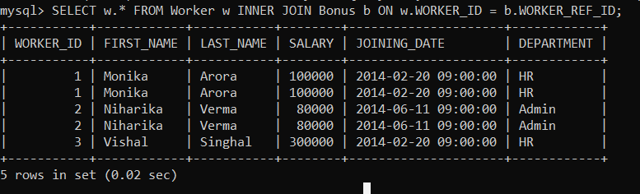

1. SELECT * FROM Worker WHERE WORKER_ID NOT IN (SELECT WORKER_ID FROM Bonus);



1. SELECT NOW();

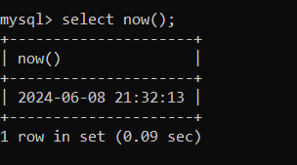

1. SELECT * FROM Worker LIMIT 10;

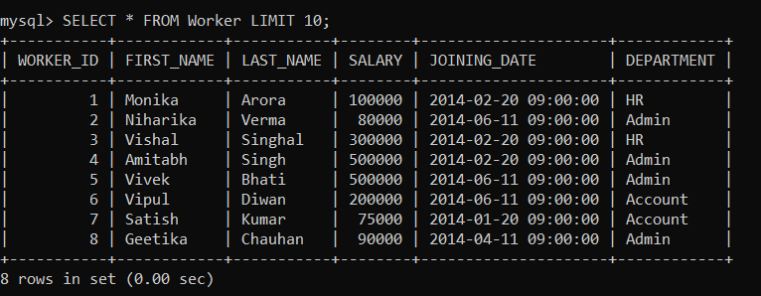

1. SELECT DISTINCT SALARY FROM Worker ORDER BY SALARY DESC LIMIT 1 OFFSET 4;

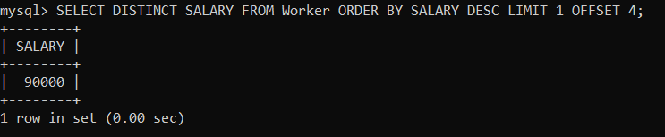

1. SELECT SALARY FROM Worker ORDER BY SALARY DESC LIMIT 4, 1;

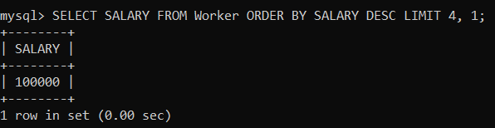

1. SELECT * FROM Worker WHERE SALARY IN (SELECT SALARY FROM Worker GROUP BY SALARY HAVING COUNT(*) > 1);

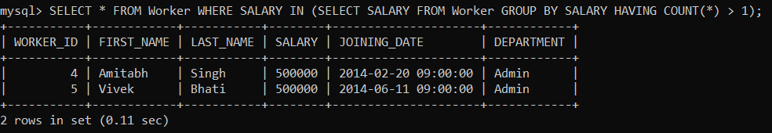

1. SELECT DISTINCT SALARY FROM Worker ORDER BY SALARY DESC LIMIT 1 OFFSET 1;

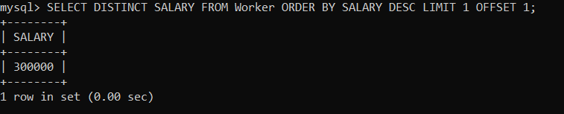

1. SELECT * FROM Worker where worker_id=1 UNION ALL SELECT * FROM Worker where worker_id =1;

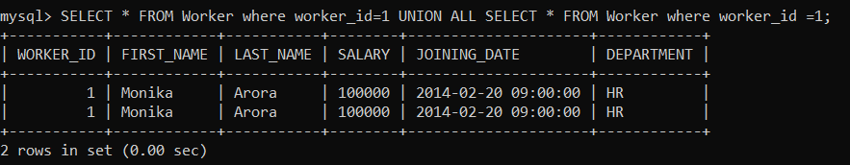

1. SELECT w.* FROM Worker w INNER JOIN Bonus b ON w.WORKER_ID = b.WORKER_REF_ID;

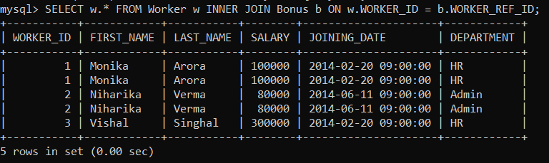

1. SELECT * FROM Worker LIMIT 4;

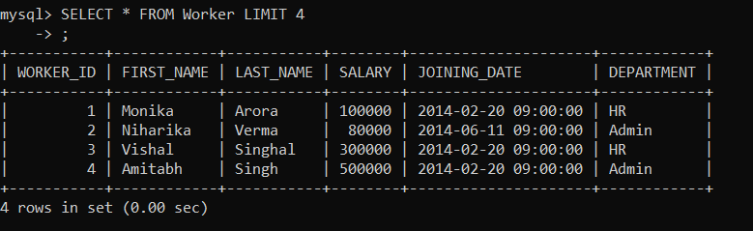

1. SELECT DEPARTMENT FROM Worker GROUP BY DEPARTMENT HAVING COUNT(*) < 5;

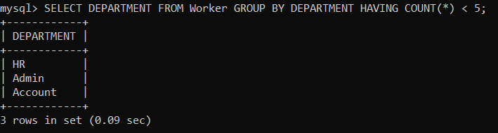

1. SELECT DEPARTMENT, COUNT(*) AS Num_of_Employees FROM Worker GROUP BY DEPARTMENT;

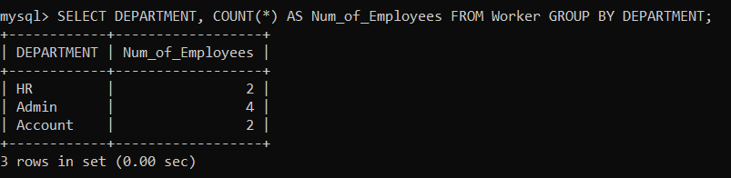

1. SELECT * FROM Worker ORDER BY WORKER_ID DESC LIMIT 1;

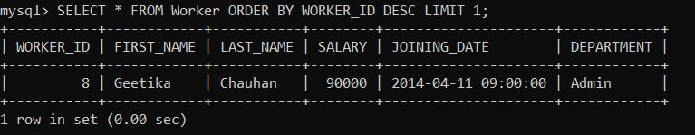

1. SELECT * FROM Worker LIMIT 1;

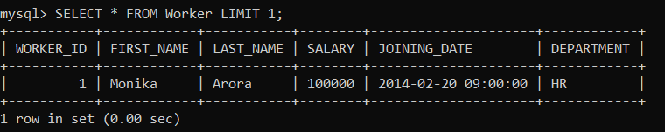

1. SELECT * FROM (SELECT * FROM Worker ORDER BY WORKER_ID DESC LIMIT 5) AS sub ORDER BY WORKER_ID ASC;

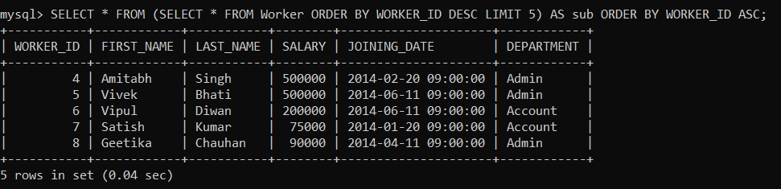

1. SELECT FIRST_NAME, LAST_NAME FROM Worker WHERE (DEPARTMENT, SALARY) IN (SELECT DEPARTMENT, MAX(SALARY) FROM Worker GROUP BY DEPARTMENT);

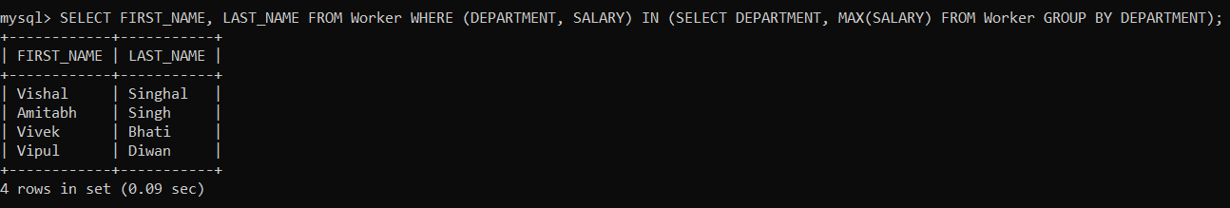

1. SELECT DISTINCT SALARY FROM Worker ORDER BY SALARY DESC LIMIT 3;

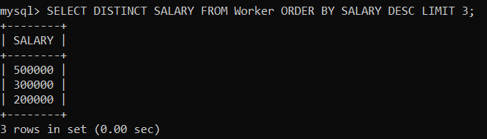

1. SELECT DISTINCT SALARY FROM Worker ORDER BY SALARY ASC LIMIT 3;

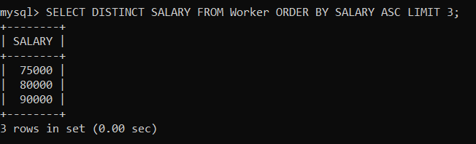

1. SELECT DISTINCT SALARY FROM Worker ORDER BY SALARY DESC LIMIT 2, 1;

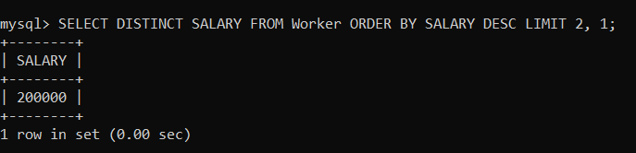

1. SELECT DEPARTMENT, SUM(SALARY) AS Total_Salary FROM Worker GROUP BY DEPARTMENT;

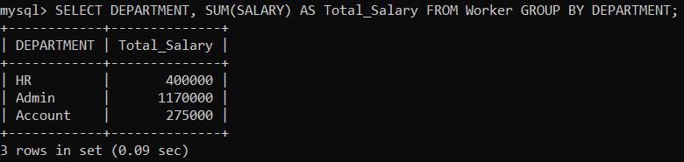

1. SELECT FIRST_NAME, LAST_NAME FROM Worker WHERE SALARY = (SELECT MAX(SALARY) FROM Worker);

