Michael Bailey
Dr. Satterfield
Mod 7
June 15, 2026

IT 230 Final Project Part II

1. Program Functionality and Screenshots
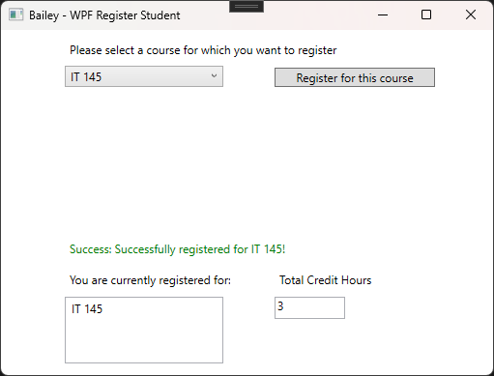
- Description of Screenshot 1: This screenshot demonstrates a successful registration scenario within the running WPF application. Selecting a valid class from the drop-down combo box menu and clicking the registration action button maps the input to instantiate and confirm the selection. The program carries out the required math operations, updating the cumulative total credit hours box text element to 3, adding the course object directly to the visual registration list box item sequence, and printing a green confirmation notification across the interface.
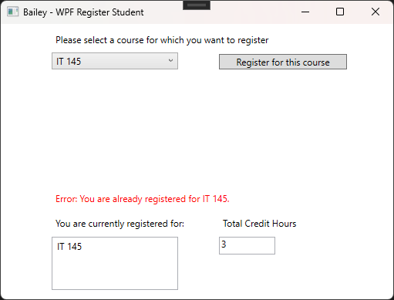
- Description of Screenshot 2: This screenshot demonstrates the runtime enforcement of the duplicate registration business rule logic constraint. When an operation is sent to register for an educational course that already occupies a line inside the list box control sequence, a looping branching statement structures an equality evaluation. The system catches the matching text output string layout, prevents secondary duplicate entry processing, and outputs a clear red validation error message onto the interface window.
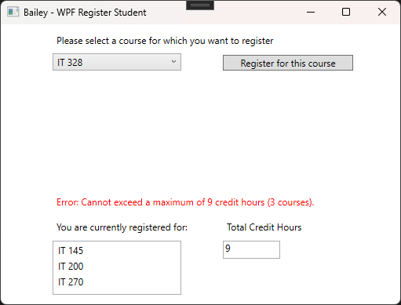
- Description of Screenshot 3: This screenshot displays the verification checking of the maximum credit hour capacity rule limits. After three distinct courses are submitted to establish a cumulative score of 9 credit hours inside the text control box, any subsequent registration request triggers conditional control logic. The Boolean checks intercept the method processing before addition math can execute, blocking the overflow state and displaying a sharp red error alert alerting that a user cannot register for more than 9 credit hours.

2. App Code-Behind Source Code (MainWindow.xaml.cs)
using System;
using System.Collections.Generic;
using System.Linq;
using System.Text;
using System.Threading.Tasks;
using System.Windows;
using System.Windows.Controls;
using System.Windows.Data;
using System.Windows.Documents;
using System.Windows.Input;
using System.Windows.Media;
using System.Windows.Media.Imaging;
using System.Windows.Navigation;
using System.Windows.Shapes;

namespace WPFRegisterStudent
{
/// <summary>
/// Interaction logic for MainWindow.xaml
/// </summary>
public partial class MainWindow : Window
{
Course choice;

// Global variables to track state across button clicks
private int totalCredits = 0;
private const int MAX_CREDITS = 9;
private const int COURSE_CREDITS = 3;

public MainWindow()
{
InitializeComponent();

// Sets your last name as the first printed text in the window title bar
this.Title = "Bailey - WPF Register Student";
}

private void Window_Loaded(object sender, RoutedEventArgs e)
{
Course course1 = new Course("IT 145");
Course course2 = new Course("IT 200");
Course course3 = new Course("IT 201");
Course course4 = new Course("IT 270");
Course course5 = new Course("IT 315");
Course course6 = new Course("IT 328");
Course course7 = new Course("IT 330");

this.comboBox.Items.Add(course1);
this.comboBox.Items.Add(course2);
this.comboBox.Items.Add(course3);
this.comboBox.Items.Add(course4);
this.comboBox.Items.Add(course5);
this.comboBox.Items.Add(course6);
this.comboBox.Items.Add(course7);

// Start the textbox off displaying 0 total credit hours
this.textBox.Text = totalCredits.ToString();
}

private void button_Click(object sender, RoutedEventArgs e)
{
// Reset message styles at the start of each click
label3.Content = "";
label3.Foreground = Brushes.Red;

// 1. Map User Input & Validate Selection
if (this.comboBox.SelectedItem == null)
{
label3.Content = "Error: Please select a course from the drop-down menu.";
return;
}

choice = (Course)(this.comboBox.SelectedItem);

// 2. Boolean Logic: Check for Duplicate Registration Business Rule
foreach (Course registeredCourse in this.listBox.Items)
{
if (registeredCourse.ToString() == choice.ToString())
{
label3.Content = $"Error: You are already registered for {choice.ToString()}.";
return;
}
}

// 3. Boolean Logic: Check Credit Limit Business Rule (Max 9 Credits)
if (totalCredits + COURSE_CREDITS > MAX_CREDITS)
{
label3.Content = "Error: Cannot exceed a maximum of 9 credit hours (3 courses).";
return;
}

// 4. Program Math Operations & UI Code Updates (If checks pass)
totalCredits += COURSE_CREDITS;
this.textBox.Text = totalCredits.ToString();

// Add the confirmed course object to the registration list box
this.listBox.Items.Add(choice);

// Output confirmation message in Green
label3.Foreground = Brushes.Green;
label3.Content = $"Success: Successfully registered for {choice.ToString()}!";
}
}
}

